Table of Contents
1.Circuit elements 2
1.1. ADAS1000 2
1.2. TMP102 2x 3
1.3. Voltage regulator ADP151 3
SMD 10 uF ceramic X5R capacitors for voltage regulator 4
1.4. SMD 100 nF Decoupling capacitors 4
1.5. SMD Electrolytic capacitor 4
1.6. SMD LED 4
1.7. SMD resistors 4
1.8. Crystal 4
C1 C2 capacitors material considerations 5
External XTAL feedback resistor EXFR 7
Rext Rs Considerations 9
PCB considerations 9
2. Power supply 11

Circuit elements

Evaluation board zotero://attachment/1849/

ADAS1000
zotero://attachment/21683/
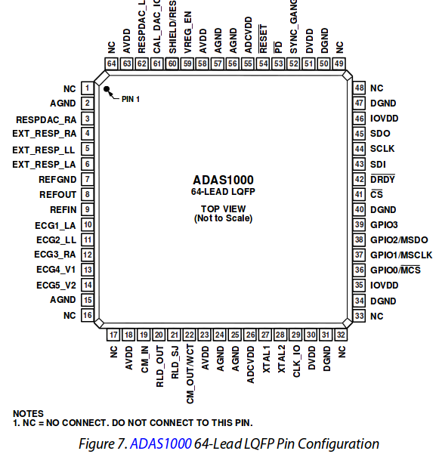

TMP102 2x
zotero://attachment/17918/

Voltage regulator ADP151
zotero://attachment/1693/
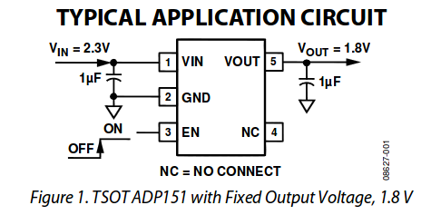
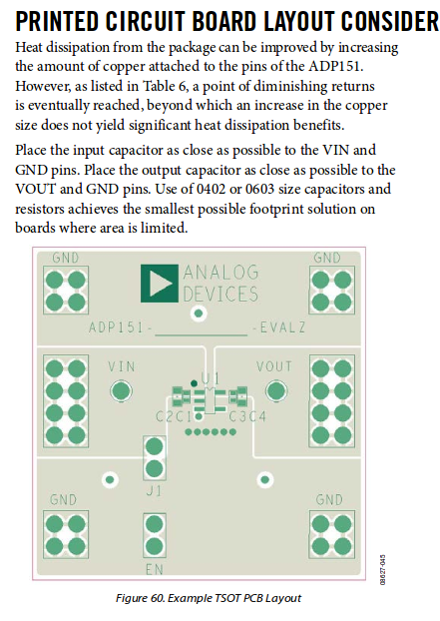

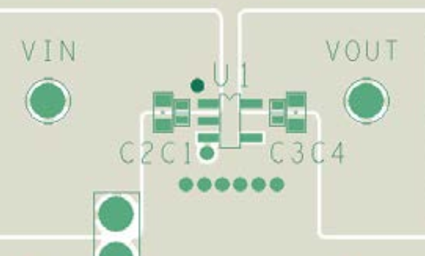

SMD 10 uF ceramic X5R capacitors for voltage regulator
zotero://attachment/1833/ Analog Devices capacitor selection guide

SMD 100 nF Decoupling capacitors

SMD Electrolytic capacitor

SMD LED

SMD resistors

Crystal
Taken from Evaluation board zotero://attachment/1849/
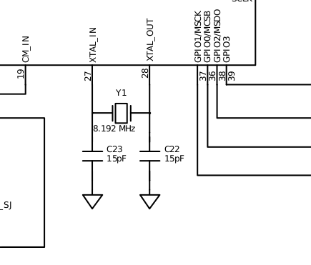

Used elements
XTAL: http://www.digikey.de/product-detail/de/9C-8.192MAAJ-T/887-1417-1-ND/2207999
zotero://attachment/1842/
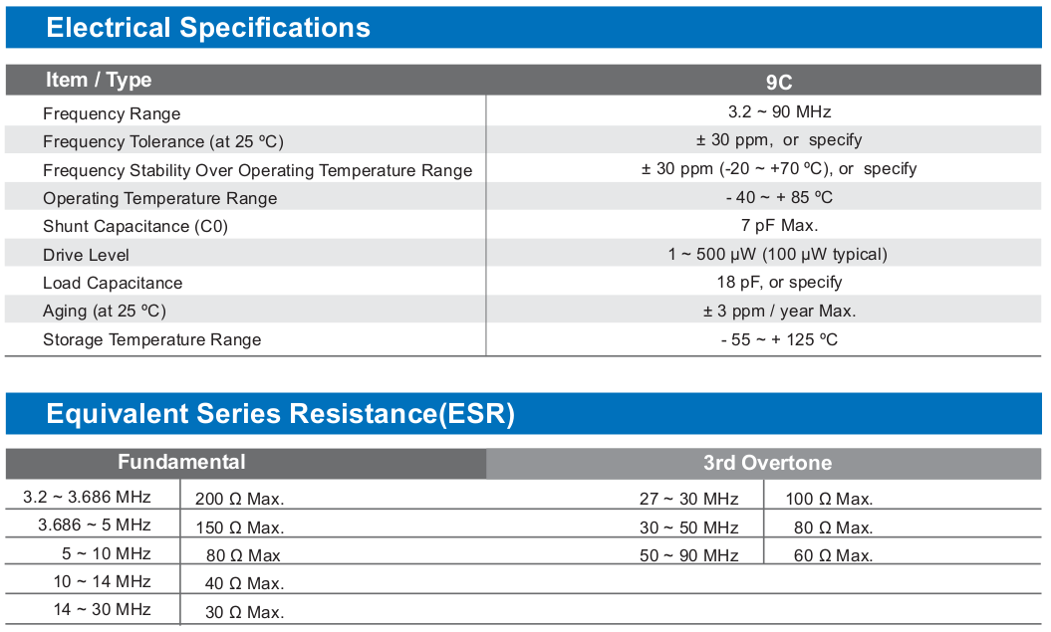
C1, C2 capacitors: http://www.digikey.de/scripts/DkSearch/dksus.dll?Detail&itemSeq=146780475&uq=635310865927933829 they are 25 pF as 26 pF are not on the market.
Alternative is http://www.digikey.de/scripts/DkSearch/dksus.dll?Detail&itemSeq=146784924&uq=635311026012633185 22 pF

Calculations

Crystal frequency = 8.192 MHz, Package: HC49UP in Eaglr Crystalhc49up http://www.standardcrystalcorp.com/pdf%5Cc-3.pdf
DigiKey: http://www.digikey.de/product-detail/de/9C-8.192MAAJ-T/887-1417-1-ND/2207999
Crystal calculations: http://www.st.com/st-web-ui/static/active/en/resource/technical/document/application_note/CD00221665.pdf or zotero://attachment/1712/

Every crystal datasheet lists something called the Load Capacitance (CL). In the case of the crystal above, it’s 18 pF. C1 and C2 need to match this Load Capacitance, with the following formula being the key:
CL = (C1 * C2) / (C1 + C2) + Cstray
CL=18 pF Cstray =5 pF

(C1*C2)/(C1+C2)=13 pF
C1=26 pF C2=26 pF
http://www.wolframalpha.com/input/?i=%28C1*C2%29%2F%28C1%2BC2%29%3D13
ADAS1000 crystal documentation zotero://attachment/21683/ page 51

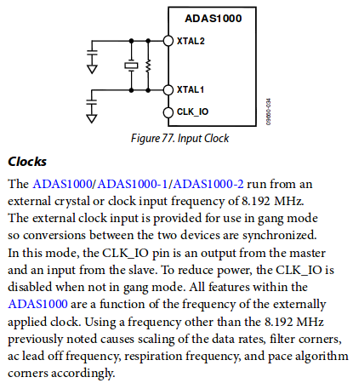
C1

C2
EXFR

C1 C2 capacitors material considerations
http://www.avrfreaks.net/index.php?name=PNphpBB2&file=viewtopic&t=28818
  ka7ehk
  Posted: Apr 28, 2005 - 08:51 PM
  Joined: Nov 22, 2002
  Posts: 13436
  Location: Tangent, OR, USA
For the crystal, ceramic. For best temperature stability, use NP0 type. But, if the timing only needs to be accurate enough for something like UART serial, then almost any ceramic type is OK.
Tantalum is good for the processor power. Keep the distance between the cap and the main pins (power & ground) as short and beefy as practical. You should not need both a regulator output cap and a Vcc bypass unless the regulator is more than a few inches from the processor. For the very best bypassing (especially if you need to pass FCC/CE emissions tests), add a 0.1uf ceramic close to the micro, and use the tantalum a bit further, where it can do a good job for the whole board.
For reset, you can use almost anything of the right value. Ceramic or film should be OK. Electrolytics are probably too large (value) to be useful there.
My opinion -
Jim

  mneary
  Posted: Apr 28, 2005 - 10:03 PM
  Joined: Sep 25, 2003
  Posts: 2189
  Location: Los Angeles, USA
My work is all commercial, and I'm responsible for reviewing the designs of others as well. Everything I do is for FCC class B, and we achieve good margins..
For the crystal, use a capacitor with a Zero in its name (i.e. C0G or NP0) [CERAMIC]. Minimize signal length, e.g. try to use small capacitors too.
For microprocessor bypass, use a ceramic capacitor between 0.01 and 0.1 uF on each power/ground pair. These should be as close as possible to those pins. If this isn't practical, do it anyway. (Although most people don't use radio receivers between 1 MHz and 300 MHz any more, I do, and avoiding a dirty project is too easy.)
The worst errors I find are at the voltage regulator. Engineers like to follow rules of thumb, but no two thumbs are alike. The data sheet almost always outlines specific requirements for each part. Ignore the data sheet at your peril. Often the vendor also supplies a suggested layout. If they don't, just try to leave the shortest possible traces between the regulator and its bypass. Some regulator data sheets require a minimum ESR for stability, in which case Tantalum actually might not be right.
As mentioned earlier, electrolytics aren't suitable for reset, in addition to being high value, their ESR is usually unacceptable..

http://electronics.stackexchange.com/questions/39103/selecting-loading-capacitor-values-for-32-khz-crystal
The most important thing to keep in mind is that the capacitor should be tight tolerance with an appropriate dielectric material (one that isn't highly temperature dependent, such as NP0/C0G).

External XTAL feedback resistor EXFR
In ADAS1000 documentation the EXRF is shown but on the powering documentation it its not: zotero://attachment/1847/
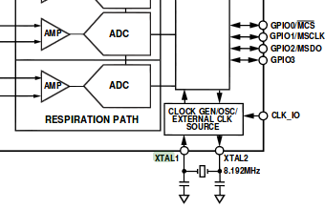

Adruino uses external XTAL feedback resistor although it is not in the ATMEGA328-P PU documentation: http://www.atmel.com/images/atmel-8271-8-bit-avr-microcontroller-atmega48a-48pa-88a-88pa-168a-168pa-328-328p_datasheet.pdf page 28

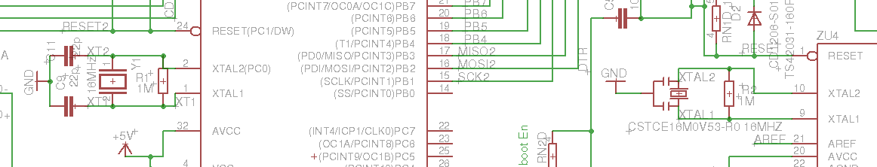

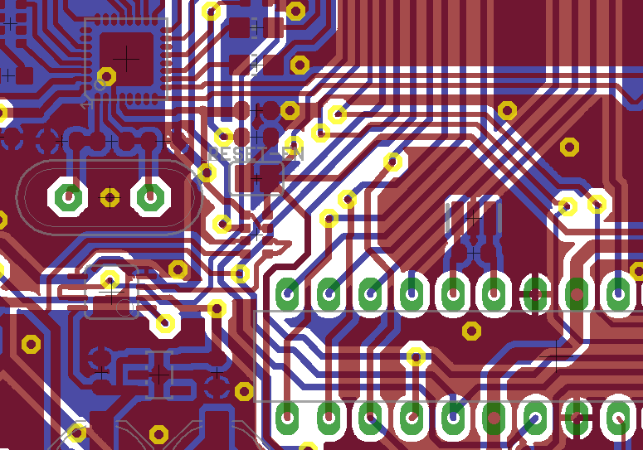

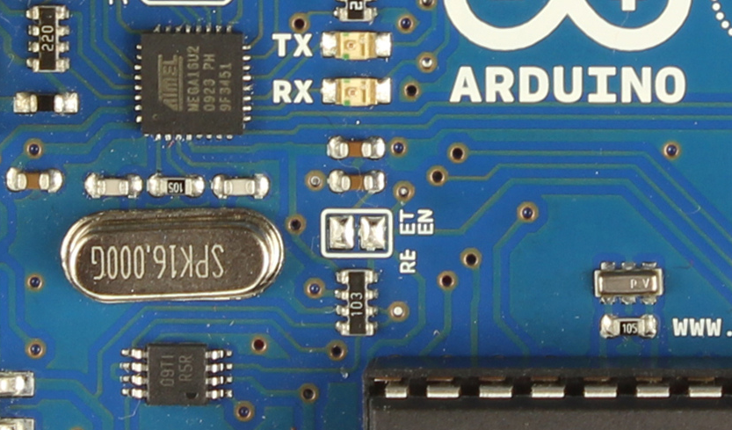
EFR

Rext Rs Considerations
zotero://attachment/1840/
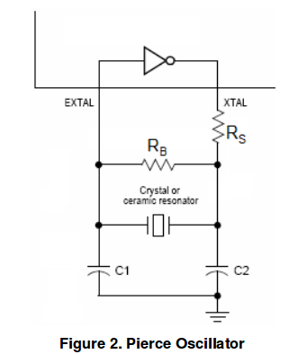
Crystal overdrive is very unlikely with modern ICs because they operate now at very low voltages.

PCB considerations
zotero://attachment/1712/ page 21

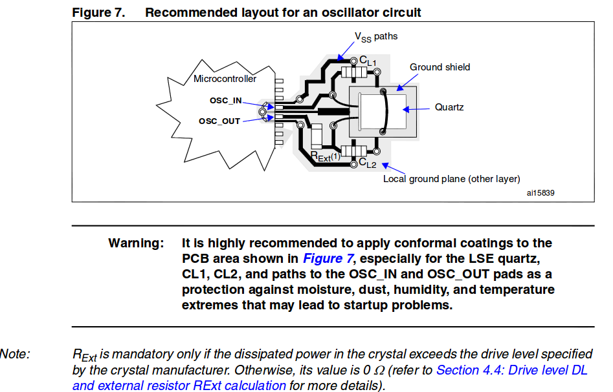

zotero://attachment/1824/

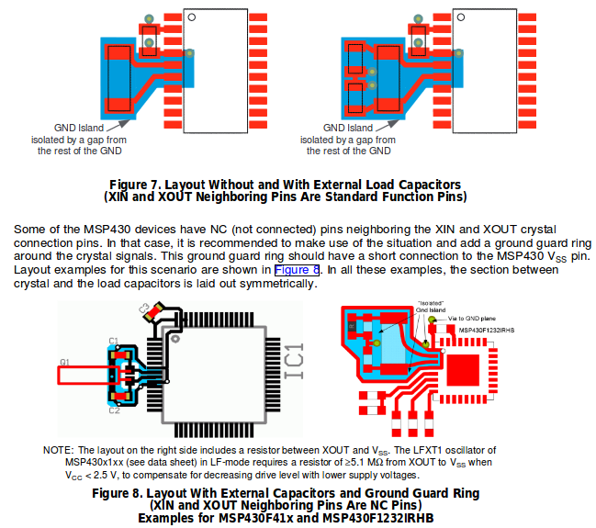

Power supply

zotero://attachment/1847/

zotero://attachment/21683/ page 76

ADAS1000 Power supply
+5 V from raspberry pi goes to ADP151 voltage regulator which sets output voltage to +3.3 V. According to data sheet the regulator needs ceramic concentrators to achieve better stability. 1 uF is recommended but 10 uF will be used.

