University of Oregon - GEOG 485/585 – Remote Sensing 1 – Fall 2021

Lab Assignment #1: Exploring Census Bureau data in Python

Objectives: In this lab, we will explore tabulated Census Bureau data using Python.

Logistics:

Date assigned: Week 1
Date due: Before the beginning of Week 2 lab
Points: 100 points
Deliverables: Post a PDF document on Canvas with all answers and necessary graphics using the answer sheet given to you. Your responses are expected to be in complete, grammatically correct sentences based on knowledge gained from lecture, reading, and lab exercises. Remember that many of the questions have multiple parts so make sure you answer all parts of the questions.

Preface:

The lab instructions will be available on Canvas (https://canvas.uoregon.edu/) and the class network drive (details below). Data used in labs are not posted on canvas and should be accessed through the SSIL network (you can also remotely connect to this network from off campus, following these instructions).

The class data is available at the following path:

R:\GEOG490_XXXXX_XX\Class_Data\Lab1\

You should store your work in a separate folder for each lab on your local computer. Note: I recommend anything you save on your local computer should also be backed up to a USB stick or Dropbox account at the end of each session. Your folder should have the following path (except has your own SSIL username):

R:\GEOG490_XXXXX_XX\Student_Data\Your_Username

For this lab, create a “Lab1” folder in which to store your work inside your user folder.
Your lab write-up and any additional materials should be turned in online to the course
website on canvas.uoregon.edu. Lab questions are due by the start of the next lab, but it is
suggested you do these questions first thing.

Lab overview:
- Clone our first GitHub repository
- Learn about Census Bureau data structures
- Calculate some statistics using the pandas library

1. Make a new environment

https://docs.conda.io/projects/conda/en/latest/user-guide/tasks/manage-environments.html

- conda env create -f /path/to/environment.yml
- conda activate lab1

2. Clone a useful GitHub repository

Clone the censusdata repo to your local student folder from GitHub:

- git clone https://github.com/jtleider/censusdata.git

3. Add new repo to PYTHONPATH

- Open Spyder
- Tools → PYTHONPATH manager → +Add path → navigate to the censusdata folder → click choose
- Type import censusdata in the console and it should run without errors

4. Review Census geographic units

https://www2.census.gov/geo/pdfs/reference/GARM/Ch2GARM.pdf

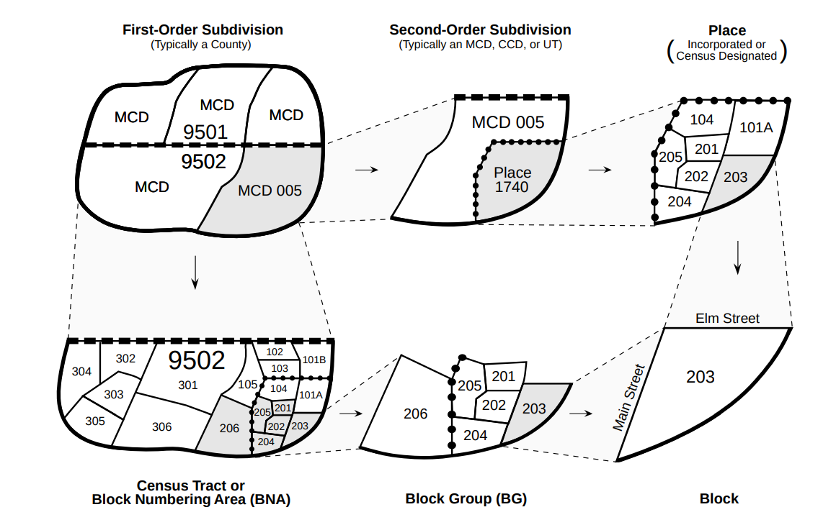

5. Review Census variable codes

6. Unemployment in Lane County, Oregon

As a first example, let's suppose we're interested in unemployment for block groups in Lane County, Oregon. To download data, we need to identify the relevant tables containing the variables of interest to us. One way to do this would be to refer to the ACS documentation which can be found here: https://api.census.gov/data/2019/acs/acs5/variables.html

In our case we are interested in the variable B23025 which contains employment status for the population that is 16 years and over.

- censusdata.printtable(censusdata.censustable('acs5', 2019, 'B23025'))

After identifying relevant variables, we now need to identify the geographies of interest. We are interested in block groups, so first we look for the geographic identifier (FIPS code) for Oregon, then the identifiers for all counties to find Lane County:

- censusdata.geographies(censusdata.censusgeo([('state', '*')]), 'acs5', 2019)
- censusdata.geographies(censusdata.censusgeo([('state', '41'), ('county', '*')]), 'acs5', 2019)

Now that we have identified the variables and geographies of interest, we can download the data using censusdata.download and compute variables for the percent unemployed.

- lane_blocks = censusdata.download('acs5', 2019, censusdata.censusgeo([('state', '41'), ('county', '039'), ('block group', '*')]),['B23025_003E', 'B23025_005E'])
- lane_blocks['percent_unemployed'] = lane_blocks['B23025_005E'] / lane_blocks['B23025_003E'] * 100

Next, we show the 30 block groups in Cook County with the highest rate of unemployment:

- lane_blocks.sort_values('percent_unemployed', ascending=False).head(30)

Now let’s see where these block groups are located.

7. Download shapefile of Census tracts

- Navigate to https://www.census.gov/cgi-bin/geo/shapefiles/index.php?year=2021&layergroup=Census+Tracts
- Select Oregon and Download and save in your student folder
- Right-click on the zipped folder and unzip

Note that I was having no luck getting it to download at the block group level.

The solution:
(1) it was a variable name problem, needed "B01001_001E" instead.
(2) also had to change tabletype to "detail", don't know why this makes a difference.

Variables for block groups here:
https://api.census.gov/data/2019/acs/acs5/variables.html

Excellent guide can be found here:
https://api.census.gov/data.html

Sort values

