University of Oregon - GEOG 485/585 – Remote Sensing 1 – Fall 2021

Lab Assignment #1: Exploring Census Bureau data in Python

Objectives: We will explore Census Bureau data using Python using cenpy.

Logistics:

Date assigned: Week 1
Date due: Before the beginning of Week 2 lab
Points: 100 points
Deliverables: Post a PDF document on Canvas with all answers and necessary graphics using the answer sheet given to you. Your responses are expected to be in complete, grammatically correct sentences based on knowledge gained from lecture, reading, and lab exercises. Remember that many of the questions have multiple parts so make sure you answer all parts of the questions.

Preface:

The lab instructions will be available on Canvas (https://canvas.uoregon.edu/) and the class network drive (details below). Data used in labs are not posted on canvas and should be accessed through the SSIL network (you can also remotely connect to this network from off campus, following these instructions).

The class data is available at the following path:

R:\GEOG490_XXXXX_XX\Class_Data\Lab1\

You should store your work in a separate folder for each lab on your local computer. Note: I recommend anything you save on your local computer should also be backed up to a USB stick or Dropbox account at the end of each session. Your folder should have the following path (except with your own SSIL username):

R:\GEOG490_XXXXX_XX\Student_Data\Your_Username

For this lab, create a “Lab1” folder in which to store your work inside your user folder.
Your lab write-up and any additional materials should be turned in online to the course
website on canvas.uoregon.edu. Lab questions are due by the start of the next lab.

Lab overview:
- Learn about Census Bureau data variables and geographic units
- Compute unemployment rate in Lane County, Oregon using just a few lines of code
- Calculate some statistics using the pandas library
- Visualize our data in QGIS

We will be relying heavily on cenpy which is a package that enables automatic download of US Census Bureau data and formats it as a geopandas DataFrame in Python. More information about this package can be found here, here, and the GitHub repo.

1. Make a new environment

https://docs.conda.io/projects/conda/en/latest/user-guide/tasks/manage-environments.html

- conda env create -f /path/to/lab1/environment.yml
- conda activate lab1

2. Review Census geographic units

https://www2.census.gov/geo/pdfs/reference/GARM/Ch2GARM.pdf

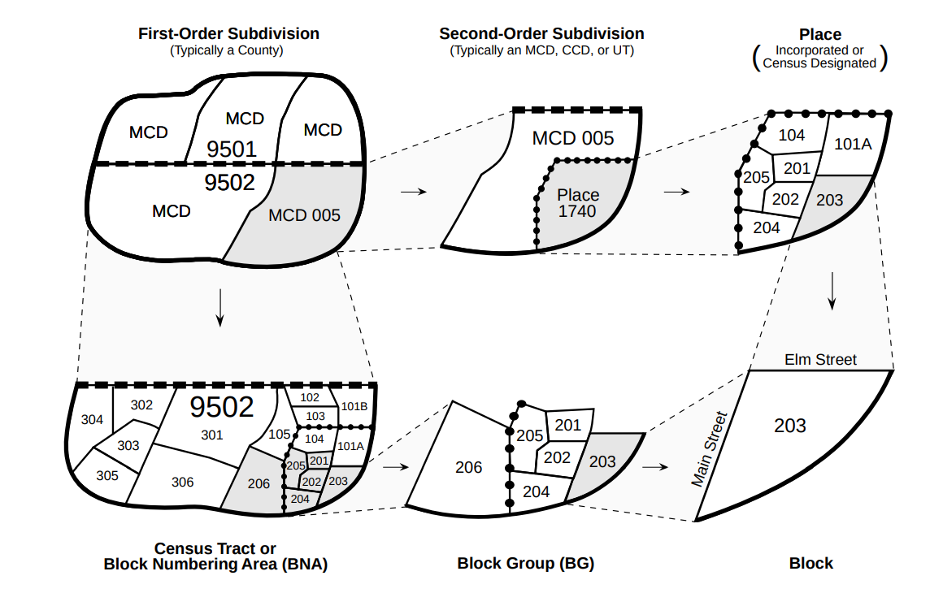

3. Review Census variable codes

4. Unemployment in Lane County, Oregon

As a first example, let's suppose we're interested in unemployment at the tract level in Lane County, Oregon. To download data, we first need to identify the relevant variables of interest to us. One way to do this is from the ACS documentation which can be found here: https://api.census.gov/data/2019/acs/acs5/variables.html

In our case we are interested in the variable B23025 which contains employment status for the population that is 16 years and over. After identifying relevant variables, we can download the data and compute variables for the percent unemployed:

- lane = products.ACS(2019).from_county('Lane County, OR', level='tract', variables=['B23025_003E', 'B23025_005E'])
- lane['percent_unemployed'] = lane['B23025_005E'] / lane['B23025_003E'] * 100

Now let’s look at some summary statistics:

- lane['percent_unemployed'].describe()

We can also plot this easily:

- f, ax = plt.subplots(1, 1, figsize=(10,10))
lane.plot('percent_unemployed', ax=ax, cmap='plasma')

But it is sometimes useful to export the data for viewing in GIS software:

- lane.to_file('/path/to/student_folder/lane_unemployment.shp')

5. Visualizing data in QGIS

Open QGIS and install the QuickMapServices plugin which provides some basemaps for locating our data.

- Plugins → Manage and Install Plugins
- Search for “ QuickMapServices” and Install Plugin

When the plugin is installed, we will display the OpenStreetMap (OSM) basemap in our QGIS workspace. OSM is a free editable geographic database of the world.

- Web → QuickMapServices → OSM → OSM Standard

Add lane_unemployment.shp to your QGIS workspace and change the Symbology of the layer so that the unemployment data is represented by a colorscale.

**********************************************************************************************************
Question 1 (10 points): Copy and paste your map to your answer document. Which tract has the highest unemployment percentage in Lane County? How many people are unemployed in this tract?
**********************************************************************************************************

**********************************************************************************************************
Question 2 (40 points): Produce your own chloropleth map for a city, county or state showing a Census variable (or derived variable) of your choice. Copy and paste your map to your answer document with a short description of what your map shows.
**********************************************************************************************************

