**Database Assessment Template**

**Step 1: Planning**

**Task 1**

*Design the fields for your table using the outline below. To generate more rows, tap on the <tab> key when you get to the last cell in the table. Use as many or as few rows to design your database table, name each field and give it an appropriate data type and maximum size. When designing fields, consider any extra requirements that the restaurant may have*

|  |  |  |
| --- | --- | --- |
| **FIELD NAME** | **DATA TYPE** | **SIZE** |
| Id | Integer |  |
| Name on Label | String | 20 |
| Name of Item | String | 20 |
| Category | String | 20 |
| Colour | String | 20 |
| DateFound | DateTime |  |
| TimeFound | Time | 7 |

**Task 2**

*Look at Resource B on the task sheet. Produce wireframe designs for each webpage, showing how the information will be displayed and where the data will display when querying the database. Annotate the diagrams with information about what each item / area is for.*

*Note that your designs do not have to follow the example layout provided on the task sheet.*

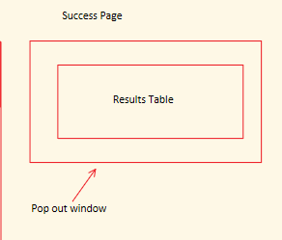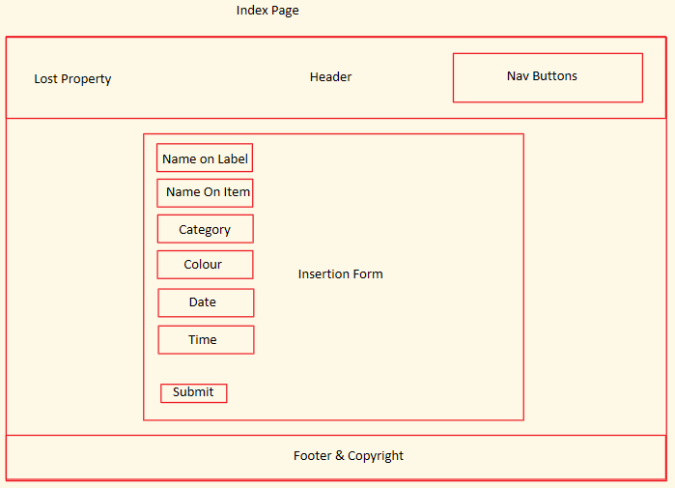

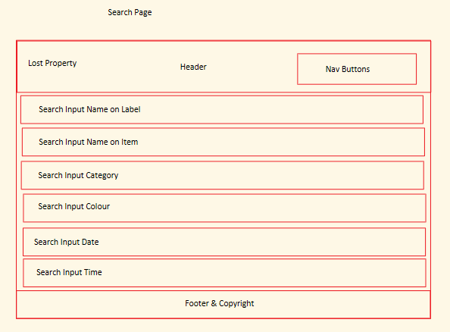

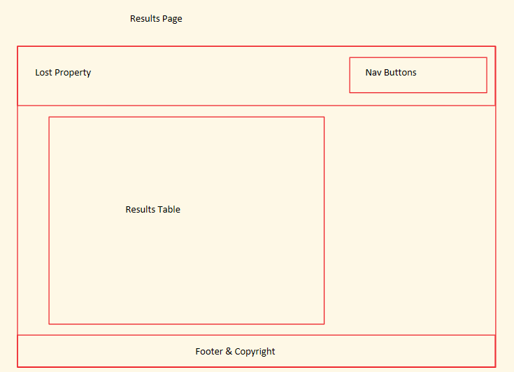

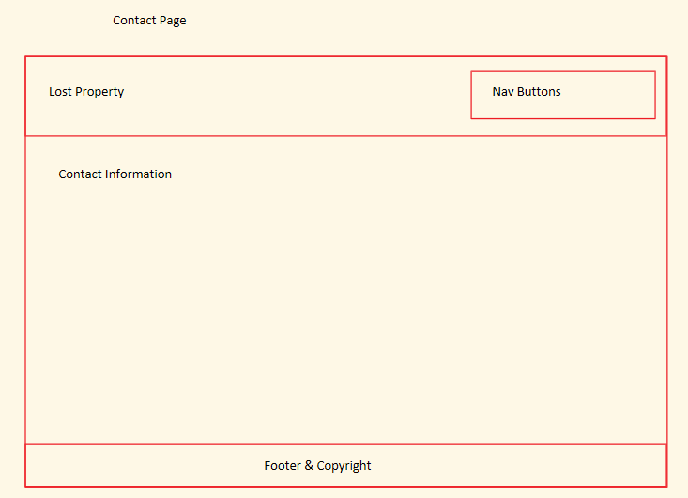

**Task 3**

*Design the required queries for your database. You might find the following table useful.*

Query Name: qrySelectNameOnLabel

Purpose: Find Name on label from user input

|  |  |  |
| --- | --- | --- |
| **SELECT** | **FROM** | **WHERE** |
| ALL | tblLostProperty | NameOnLabel LIKE(%NameOnLabelUserInput%) |

Query Name: qrySelectNameOnItem

Purpose: Find Name on Item from user input

|  |  |  |
| --- | --- | --- |
| **SELECT** | **FROM** | **WHERE** |
| ALL | tblLostProperty | NameOnItem LIKE(%NameOnItemUserInput%) |

Query Name: qrySelectCategory

Purpose: Find category from user input

|  |  |  |
| --- | --- | --- |
| **SELECT** | **FROM** | **WHERE** |
| ALL | tblLostProperty | Category = CategoryUserInput |

Query Name: qrySelectColour

Purpose: Find colour from user input

|  |  |  |
| --- | --- | --- |
| **SELECT** | **FROM** | **WHERE** |
| ALL | tblLostProperty | Colour = ColourUserInput |

Query Name: qrySelectTime

Purpose: Find time from user input

|  |  |  |
| --- | --- | --- |
| **SELECT** | **FROM** | **WHERE** |
| ALL | tblLostProperty | Time = TimeUserInput |

Query Name: qrySelectDate

Purpose: Find category from user input

|  |  |  |
| --- | --- | --- |
| **SELECT** | **FROM** | **WHERE** |
| ALL | tblLostProperty | Date = DateUserInput |

Query Name: qryCurrentDate

Purpose: Find Date from current date

|  |  |  |
| --- | --- | --- |
| **SELECT** | **FROM** | **WHERE** |
| ALL | tblLostProperty | date = Date.now |