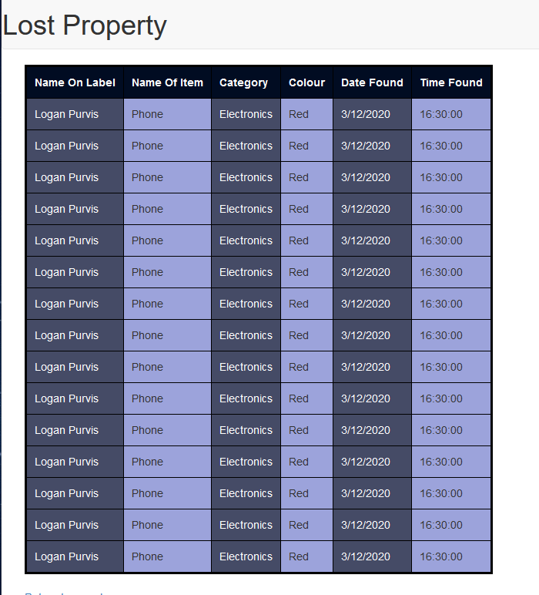Originally my results table had alternating colours in columns. However, after getting peer review, I found that this made the table more difficult to read, as it was difficult to distinguish between the different entries.

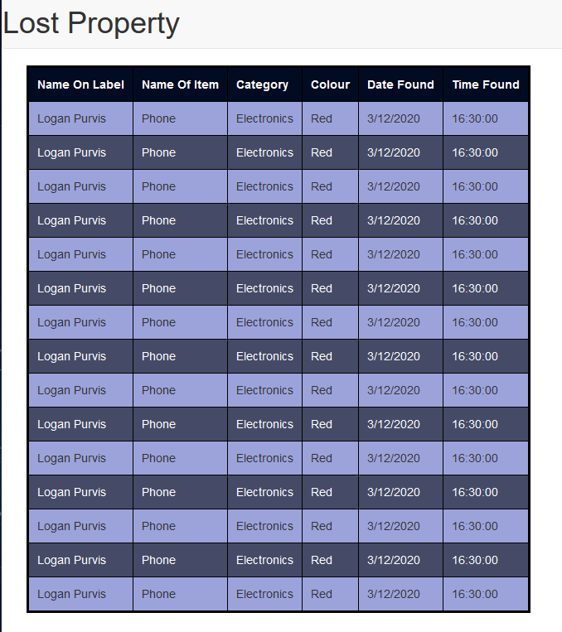

I changed the alternating colours to be in rows, allowing the user to distinguish between data entries more easily.

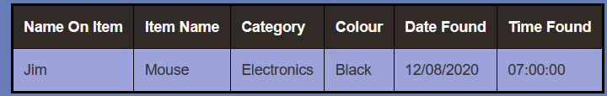I changed the column names, Name on label to Name on Item, and name of Item to Item name. I did this after peer review which revealed that the two column names were confusing due to their similarity.

These new column names prevent confusion due to their difference and more closely match what they represent.