Name: Max Gordon
Date: 4/23/20
19.03 Elevens Lab Worksheet
Directions: Make note of your responses to the following questions as you work through the activities and exercise in the lesson.
Activity 6 Questions

- List all possible plays for the board 5♠ 4♥ 2♦ 6♣ A♠ J♥ K♦ 5♣ 2♠
5♠ + 6♣
5♣ + 6♣
- If the deck is empty and the board has three cards left, must they be J, Q, and K? Why or why not?
Yes, because you can only remove the face cards in sets of three, and everything else needs to be removed in sets of two if there are three cards left they all have to be face cards. On top of that, the three cards will all have to be unique because they get removed in unique trios, so it must end in a unique trio.
- Does the game involve any strategy? That is, when more than one play is possible, does it matter which one is chosen? Briefly explain your answer.
The order that you make plays doesn’t matter because the next cards that slide in after one play, will not affect the next, so if you have a choice it doesn’t matter which one you pick.
Activity 7 Questions

- What items would be necessary if you were playing a game of Elevens at your desk (not on the computer)? List the private instance variables needed for the ElevensBoard class.
You would just need a deck of cards, and hands to move them.
The private instance variables are the cards on the board and the deck.
- Write an algorithm that describes the actions necessary to play the Elevens game.

First the deck must be shuffled and then 9 cards dealt out. And then it should check if any matches can be made with the 9, if not it will end the game. It will then allow the user to pick cards and remove them from the game (if they are 11s or face cards), and after each iteration it checks for any moves and if there aren’t then it ends the game. Once the deck is emptied, the user wins.

- In the partially-implemented ElevensBoard.java file, does the class contain all the state and behavior necessary to play the game? Explain.

No, it needs the isLegal, anotherPlayIsPossible, anotherPlayIsPossible, and containsJQK methods.
- ElevensBoard.java contains three helper methods. These helper methods are private
because they are only called from the ElevensBoard class.

  - Where is the dealMyCards method called in ElevensBoard?

It is called in the constructor and in the newGame methods
  - Which public methods should call the containsPairSum11 and containsJQK
methods?
isLegal and anotherPlayIsPossible

 | 0 | 1 | 2 | 3 | 4 | 5 | 6 | 7 | 8
cards | J♥ | 6♣ | null | 2♠ | null | null | A♠ | 4♥ | null
returned  list | 0 | 1 | 3 | 6 | 7
  - Suppose that cards contains the elements shown below. Trace the execution of the cardIndexes method to determine what list will be returned. Complete the diagram below by filling in the elements of the returned list, and by showing how those values index cards. Note that the returned list may have less than nine elements.

  - Which one of the methods that you identified in question 4b above needs to call the cardIndexes method before calling the containsPairSum11 and containsJQK methods? Why?

anotherPlayIsPossible, because it needs to get the indexes of all the other cards on the boards so it can determine if there is an 11 pair or a JQK set.
Activity 8 Questions
- Discuss the similarities and differences between the games Elevens, Thirteens, and Tens.
In thirteens, face cards have numerical values so j=11, q=12, and k=13. And pairs of cards that add up to 13 are removed (so kings can be removed alone), the board has 10 cards.
In tens, cards can are removed by adding the point values to 10, but tens and face cards can only be removed by having 4 of the same rank (i.e. 4 kings), the board has 13 cards
- The instance variables for cards and deck are declared in the Board class. But it is the ElevensBoard class that "knows" the board size, and the ranks, suits, and point values of the cards in the deck. How do the Board instance variables get initialized with the ElevensBoard values? What is the exact mechanism?

Within the ElevensBoard class, it has class constants that it uses to instantiate the Board abstract class, the Board abstract class just holds that data in its instance variables.
- List the abstract methods in Board.java. These methods are implemented in ElevensBoard. Do they cover all the differences between Elevens, Thirteens, and Tens as discussed in question 1? Why or why not?
Yes, because the only two “checks” you need to perform is whether a given move is legal and whether there are any legal moves left
Activity 9 Exercise Results
- After running the ElevensGUIRunner.java class, describe what you see and experience. Take a picture of the screen and paste it below, if you like, along with the description.
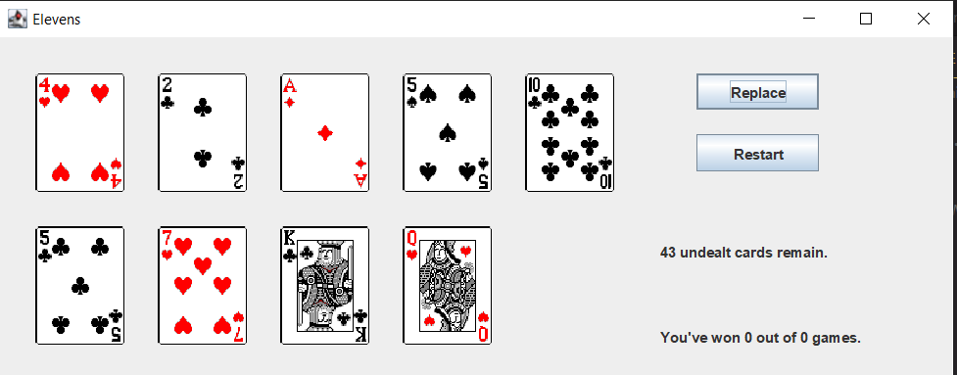
I played a few rounds and it seemed like it all worked, I didn’t notice any bugs with it
Activity 9 Questions
- The size of the board is one of the differences between Elevens and Thirteens. Why is size not an abstract method?
because size is a getter method so it doesn’t change the data, the board size is determined by the int size passed into the constructor
- Why are there no abstract methods dealing with the selection of the cards to be removed or replaced in the array cards?
Because they are generic methods that can be called by another methods. They just take indexes to do their work so any method can generate the indexes and pass them through to the method.
- Another way to create "IS-A" relationships is by implementing interfaces. Suppose that instead of creating an abstract Board class, we created the following Board interface, and had ElevensBoard implement it. Would this new scheme allow the Elevens GUI to call isLegal and anotherPlayIsPossible polymorphically? Would this alternate design work as well as the abstract Board class design? Why or why not?

public interface Board
{
boolean isLegal(List<Integer> selectedCards);

boolean anotherPlayIsPossible();
}
Yes it would allow isLegal and anotherPlayIsPossible to be called polymorphically. But it would require more code in ElevensBoard dealing with the logic, if tens, elevens, and thirteens didn’t share as much logic, it may be a better choice, but because they are all play similarly, it is better to use an abstract method.

