DDC BOOKS – XÂY DỰNG ỨNG DỤNG WEB BÁN SÁCH TRỰC TUYẾN
TÍCH HỢP AI CHATBOT VÀ QUẢN LÝ BÁN HÀNG THÔNG MINH
Nguyễn Phú Cường - 2201140016, lớp: 1C-22C
Đồng Duy Đông - 2201140023, lớp: 1C-22C
Nguyễn Khoa Đăng - 2201140022, lớp: 1C-22C
Giáo viên hướng dẫn: Nguyễn Xuân Thắng
Tóm tắt: Bài viết trình bày quá trình thiết kế và xây dựng ứng dụng web bán sách trực tuyến DDC Books sử dụng framework Django (Python). Hệ thống tích hợp đầy đủ các chức năng thương mại điện tử như quản lý giỏ hàng, đặt hàng, theo dõi đơn hàng, mã giảm giá, Flash Sale giới hạn thời gian, danh sách yêu thích và tìm kiếm gợi ý tức thì. Điểm nổi bật của hệ thống là AI Chatbot tư vấn sách thông minh sử dụng API Claude (Anthropic) kết hợp kỹ thuật RAG (Retrieval-Augmented Generation), cho phép tra cứu đơn hàng, gợi ý sách theo sở thích cá nhân và thiết lập cảnh báo giá. Bên cạnh đó, hệ thống còn hỗ trợ module chat thời gian thực giữa khách hàng và nhân viên, cùng bảng điều khiển thống kê doanh thu dành cho nhân viên quản trị.
DDC BOOKS - BUILDING AN INTELLIGENT ONLINE BOOKSTORE WEB APPLICATION
WITH AI CHATBOT AND SMART SALES MANAGEMENT
Abstract: This paper presents the design and implementation of DDC Books, a full-featured online bookstore web application built with the Django framework (Python). The system integrates comprehensive e-commerce capabilities including cart management, order placement, real-time order tracking, coupon discounts, time-limited Flash Sales, wishlists, and instant AJAX search suggestions. The project's key contribution is an intelligent AI Book Advisory Chatbot powered by the Claude API (Anthropic) with Retrieval-Augmented Generation (RAG), enabling personalized book recommendations, order tracking, and price alert subscriptions. The platform further includes a real-time customer-staff chat module and a revenue analytics dashboard. Results demonstrate that the application meets the operational demands of a medium-scale online bookstore while validating the potential of LLM-based AI in e-commerce.
1. Introduction
The rapid growth of e-commerce has transformed the retail landscape globally. In Vietnam, the Vietnam E-Commerce Association (VECOM, 2023) reported that digital commerce revenue exceeded USD 20 billion in 2023 with an annual growth rate of approximately 25%. As consumers increasingly shift to online shopping for convenience and variety, traditional bookstores face mounting pressure to establish a competitive digital presence.
Despite this growth, many online bookstore platforms remain limited in their ability to provide personalized shopping experiences. Users must manually browse extensive catalogs without intelligent guidance, and customer support typically relies on slow manual responses. There is a clear opportunity to leverage recent advances in Large Language Models (LLMs) and Retrieval-Augmented Generation (RAG) to create smarter, context-aware e-commerce experiences.
This project presents DDC Books, a web-based online bookstore built with Django 6.0, featuring an AI-powered chatbot that combines the Claude API (Anthropic) with real-time database retrieval to deliver personalized book recommendations, intelligent order tracking, and price alert management. The platform is designed to serve three distinct user roles - customers, staff, and administrators - each with tailored features and access controls. This paper outlines the system's architecture, key implementation decisions, and the results achieved.
2. Literature Review
Recommender systems have been a central topic in e-commerce research since Resnick and Varian (1997) introduced the concept of collaborative filtering. Ricci et al. (2011) provided a comprehensive survey of recommendation techniques, distinguishing between collaborative filtering, content-based filtering, and hybrid approaches. These traditional methods, while effective, require substantial training data and computational resources, making them difficult to deploy in smaller e-commerce contexts.
The emergence of Large Language Models (LLMs) such as GPT-4 (OpenAI, 2023) and Claude (Anthropic, 2024) has introduced a new paradigm for conversational AI in commercial applications. API-based AI integration, as discussed by AllThingsDev (2024), allows developers to leverage state-of-the-art language capabilities without maintaining complex machine learning infrastructure. This approach significantly reduces development complexity while enabling sophisticated natural language understanding.
Lewis et al. (2020) introduced Retrieval-Augmented Generation (RAG), a technique that combines retrieval from a knowledge base with generative language model responses. This approach is particularly valuable in e-commerce contexts where the AI must provide accurate, up-to-date product information rather than relying solely on pre-trained knowledge that may be outdated or inaccurate. RAG has since become a foundational technique for building reliable AI assistants in domain-specific applications.
In the context of Django-based web development, Forcier et al. (2008) established foundational patterns for the MVT (Model-View-Template) architecture that remains central to the framework. Recent studies in Vietnamese computing education (Nguyen & Tran, 2022) have highlighted the effectiveness of Django for rapid development of full-stack web applications in academic settings. However, there is limited research exploring the integration of LLM-based chatbots within Django applications for e-commerce use cases, which this project aims to address.
3. Claude AI
Claude is a family of advanced large language models developed by Anthropic, a safety-focused AI research company. Designed with a "Constitutional AI" training approach, Claude is optimized for being helpful, harmless, and honest (Anthropic, 2024). The model family spans multiple capability tiers - Haiku, Sonnet, and Opus - allowing developers to balance response quality with inference cost and latency.
For this project, the claude-sonnet-4-20250514 model was selected due to its superior instruction-following capability, strong support for Vietnamese language, and efficient context window utilization. Claude Sonnet delivers high-quality responses while maintaining practical response times suitable for a real-time chat interface. The model supports streaming responses via Server-Sent Events (SSE), enabling a natural "typing" effect in the chat interface without blocking the user interface.
A key feature utilized in this project is Claude's ability to process detailed system prompts containing structured, real-time data. By injecting the customer's order history, wishlist, recently viewed books, and live inventory data into the system prompt before each API call, the chatbot can provide responses that are factually grounded in the actual state of the database - a core principle of the RAG approach. Claude also reliably follows structured output instructions, enabling the backend to parse special tags such as [SET_PRICE_ALERT], [TRACK_GUEST_ORDER], and [SUGGESTIONS] from its responses to trigger corresponding backend actions.
Despite its strengths, Claude shares limitations common to all LLMs, including occasional hallucinations and potential biases from training data. To mitigate these risks, the system enforces strict rules in the system prompt - explicitly prohibiting the model from fabricating book titles or prices not present in the provided database context.
4. Methodology
4.1. Use Case Diagram
The DDC Books system is designed around four primary actors interacting with the application through distinct sets of use cases:
Anonymous User (Guest): Can browse the book catalog, search and filter by category/price/year, view book details, add items to cart (session-based), proceed to checkout, and track orders using order ID and registered phone number. Guests can also interact with the AI Chatbot in guest mode without logging in.
Authenticated User (Customer): Inherits all guest capabilities plus access to a persisted wishlist, order history with detailed tracking, a personal profile with avatar management, coupon application during checkout, real-time chat with staff, and the full AI Chatbot with personalized context including wishlist and order history. Customers can also rate AI chatbot responses (thumbs up/down) and set price alerts for books.
Staff: Can access the Staff Dashboard with revenue charts, manage all orders (confirm, pack, ship, cancel, confirm delivery), manage the book catalog (CRUD operations), configure Flash Sale settings, manage coupon codes, respond to customer chat sessions, and view all customer accounts' chat history.
System / Claude AI: Acts as an internal actor that receives structured prompts constructed by the Django backend (containing live database context) and returns streaming AI responses that are parsed and stored in the database.

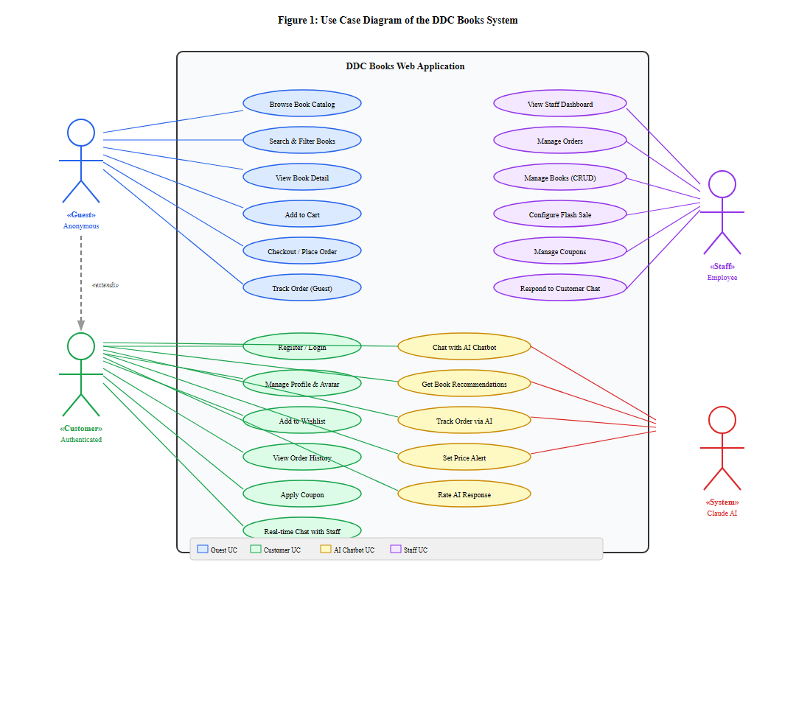
Figure 1: Use Case Diagram of the DDC Books System

4.2. Workflow
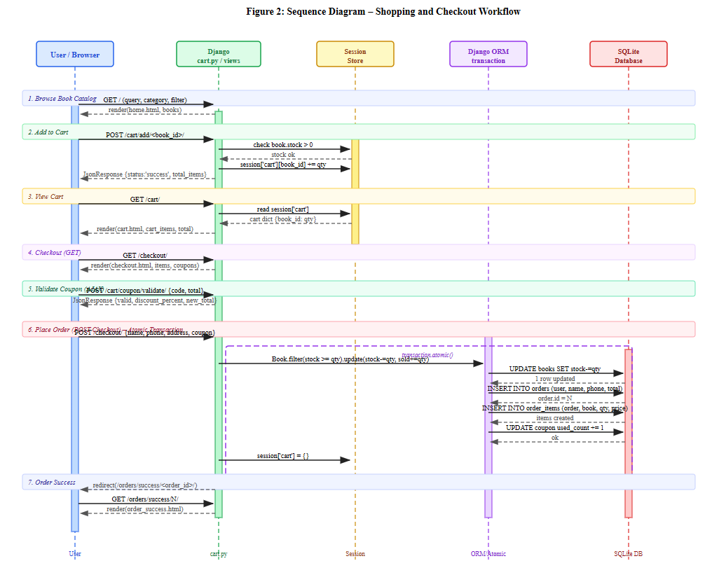
The system follows two primary workflows. The shopping workflow begins when a user browses or searches for books on the homepage. After adding items to the session-based cart, the user proceeds to checkout where the system validates input, applies any coupon codes, and executes an atomic database transaction to decrement stock, increment sold_count, and create the Order and OrderItem records simultaneously. Upon success, an order confirmation page is displayed.
Figure 2: Sequence Diagram - Shopping and Checkout Workflow
The AI Chatbot workflow is more complex and central to the project's contribution. When a user submits a message to the chatbot, the backend (ai_chat.py) performs a multi-step context-gathering process before calling the Claude API. This process implements the RAG (Retrieval-Augmented Generation) pattern as illustrated below:
Step 1 - Context Retrieval: The system queries the database to collect the user's recent orders (with tracking history), wishlist (with category frequency analysis for preference inference), recently viewed books (from session storage), RAG search results (keyword-based book search matching the user's query), new arrivals, and bestsellers.
Step 2 - Prompt Construction: All retrieved context is serialized into a structured system prompt that instructs Claude to act as the DDC Books AI assistant, providing explicit store policies, customer data, and book inventory as grounding context.
Step 3 - Streaming Response: The backend opens an HTTP connection to the Anthropic API with stream=True and yields Server-Sent Events (SSE) chunks to the client in real time, creating a smooth typing animation effect.
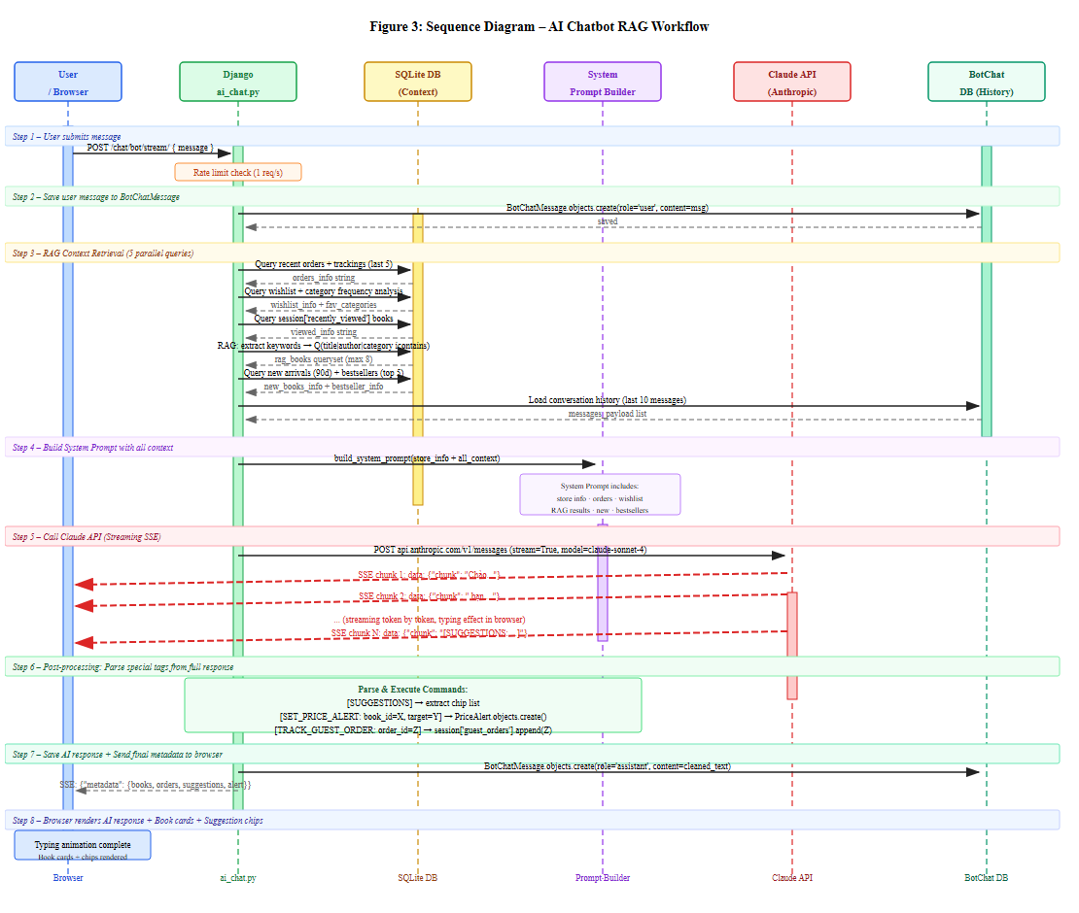
Step 4 - Post-processing: After streaming completes, the backend parses special command tags from Claude's response ([SET_PRICE_ALERT], [TRACK_GUEST_ORDER], [SUGGESTIONS]) and executes the corresponding database operations before returning metadata to the client.
Figure 3: Sequence Diagram - AI Chatbot RAG Workflow
4.3. Django Framework and System Architecture
DDC Books is built on Django 6.0, leveraging its MVT (Model-View-Template) architecture pattern. The project follows a modular views structure where each feature domain is separated into its own Python module: home.py handles the main catalog with filtering and search; cart.py manages the session-based shopping cart and atomic checkout; orders.py handles order status display; auth.py manages user registration, login, and profile updates; ai_chat.py contains the full AI Chatbot pipeline; chat.py manages real-time customer-staff communication; staff.py handles all staff management features; and wishlist.py manages the book favorites system.
The data layer is managed through Django's ORM with SQLite as the database backend, making the application easy to set up and portable across development environments. The system defines twelve core models: Book, Category, Profile, Order, OrderItem, OrderTracking, Coupon, ChatSession, ChatMessage, BotChatSession, BotChatMessage, FlashSaleConfig (singleton pattern), and PriceAlert. Relationships between models use Django's ForeignKey, OneToOneField, and ManyToManyField to enforce relational integrity at the ORM level.
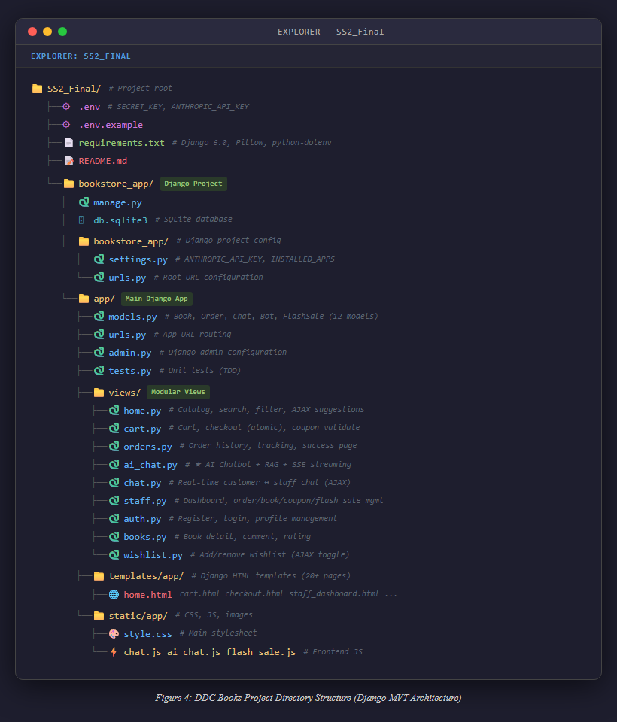
Figure 4: Django Project Structure and Module Organization
Access control is enforced at the view level using Django's built-in decorators. The @login_required decorator protects customer-only endpoints such as wishlist and profile management. Staff-exclusive views use a custom @user_passes_test(is_staff) decorator that checks group membership. This role-based access control (RBAC) system supports four distinct permission levels: Anonymous Guest, Authenticated Customer, Staff, and Administrator (superuser).
4.4. AI Chatbot with Retrieval-Augmented Generation
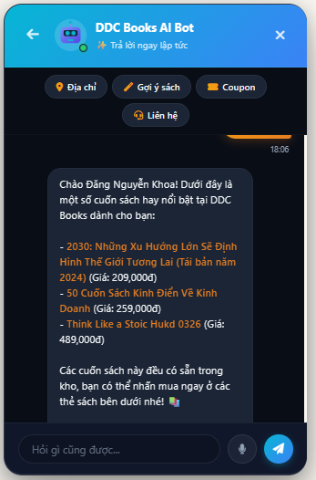
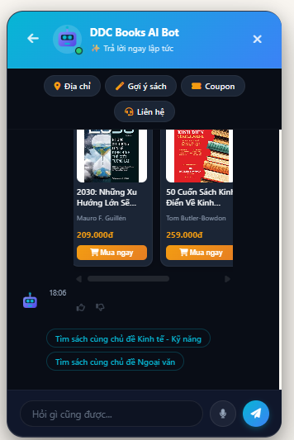
The AI Chatbot module is the system's primary innovation. Rather than relying on static knowledge embedded in the language model, the system dynamically retrieves relevant data from the live database before each API call - a core RAG pattern. The keyword extraction pipeline uses Python regular expressions to remove Vietnamese stopwords and extract meaningful search terms, which are then used to query books by title, author, and category using Django's Q objects for flexible OR-query composition.

Figure 5: AI Chatbot Interface - Book Recommendation Response
The system constructs a comprehensive system prompt for each API call that includes: store information (address, hours, policies), customer identity and role, recent order history with tracking messages, wishlist with inferred category preferences, recently viewed books from session, RAG search results, new arrivals, bestsellers, and HTML link formatting rules. This approach ensures Claude's responses are always grounded in real, current data rather than hallucinated information.
Conversation history persistence is achieved by storing all messages in the BotChatSession and BotChatMessage models. The 10 most recent conversation turns are retrieved and included in each API call, allowing Claude to maintain conversational context across multiple exchanges. A rate limiter (1 request/second) and an offline fallback mode (mock responses when no API key is configured) ensure robustness in all deployment scenarios.
4.5. Real-time Features: Chat and Flash Sale
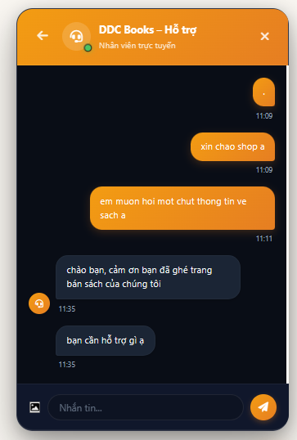
The customer-staff real-time chat module is implemented using an AJAX polling approach. Each authenticated customer has exactly one ChatSession (OneToOne with Django User). The customer's browser polls the /chat/poll/ endpoint at a short interval to check for new staff messages. Staff can simultaneously manage multiple customer sessions from a unified inbox that displays unread message counts and last message previews. All messages are persisted in the ChatMessage model with read status tracking.

Figure 6: Real-time Customer-Staff Chat Interface
The Flash Sale system uses a singleton FlashSaleConfig model (always pk=1) that staff can configure via a dedicated management page. The is_running_now property computes in real time whether the sale is active based on the current server time and the configured start/end hours, correctly handling overnight ranges (e.g., 22:00-02:00). When active, discounted prices are shown across the catalog with a countdown timer rendered via client-side JavaScript.

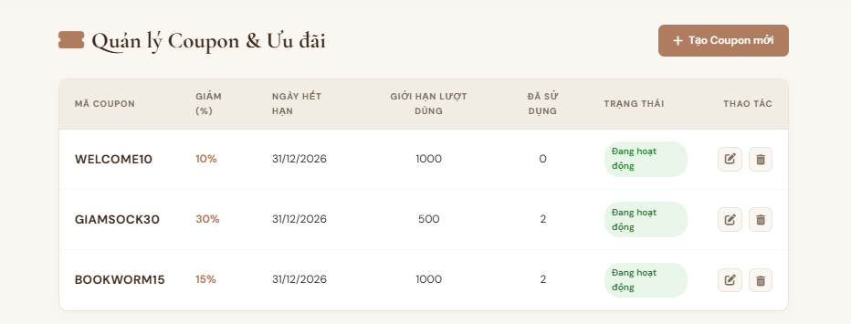
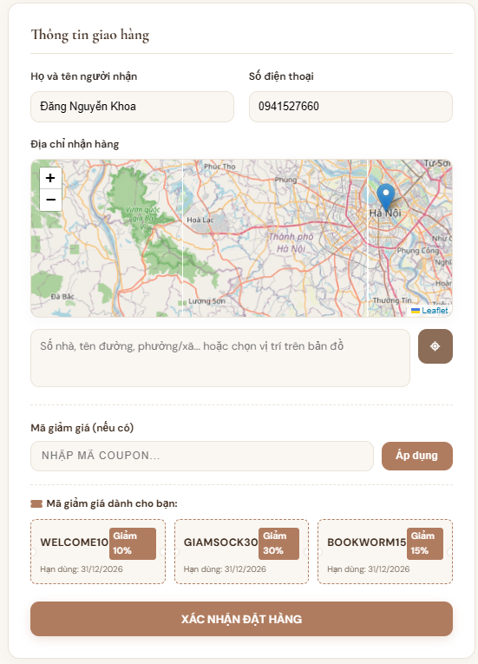
CUSTOMER VIEW (REGISTERED)
STAFF VIEW
Figure 7: Flash Sale Configuration Panel (Staff) and Active Flash Sale Display (Customer)
5. Results and Discussion
The DDC Books application was successfully implemented with all planned features operational. The homepage provides a filterable, searchable book catalog with instant AJAX search suggestions, category and price range filters, and a recently viewed books section. The interface is designed to be responsive and visually appealing with a dark-mode aesthetic and smooth micro-animations.

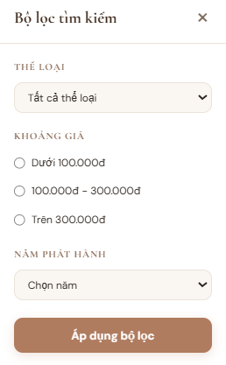
Figure 8: DDC Books Homepage - Book Catalog with Search and Filter
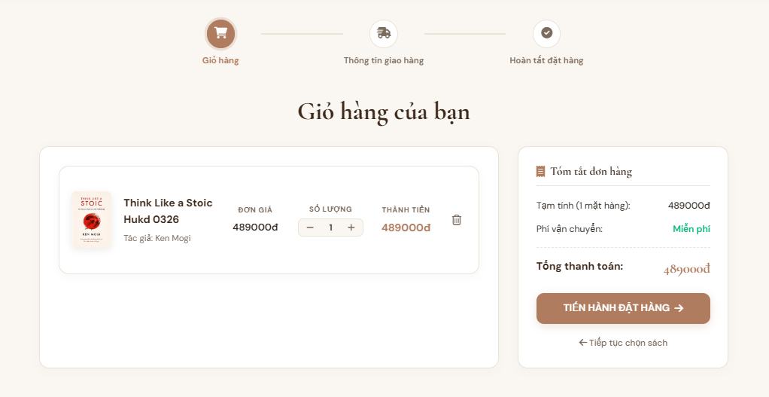
The checkout system handles the full purchase flow including cart management, delivery information collection, coupon validation via AJAX, and atomic order creation. The system correctly enforces stock limits and prevents overselling through database-level transactions. Order tracking provides step-by-step delivery status updates that customers can view from their order history page.
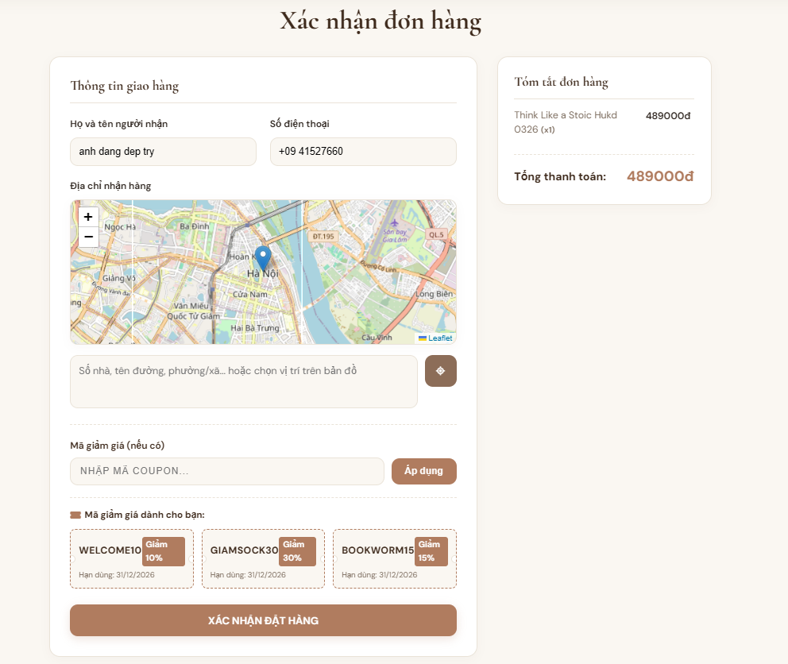
Figure 9: Shopping Cart and Checkout Page

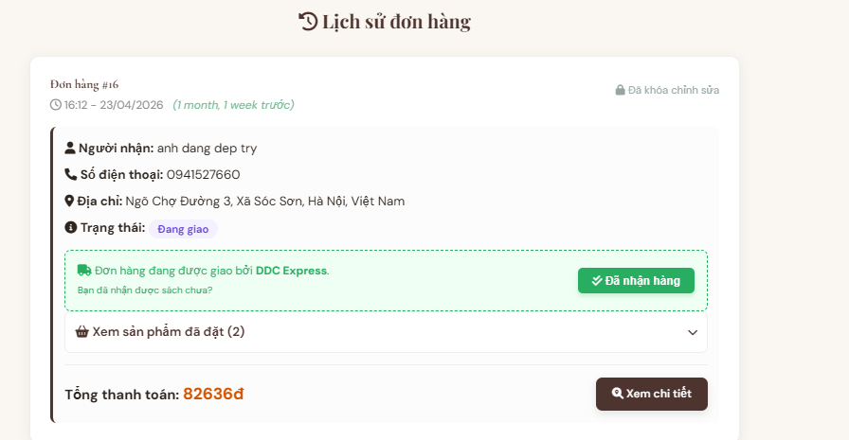
ORDER HISTORY

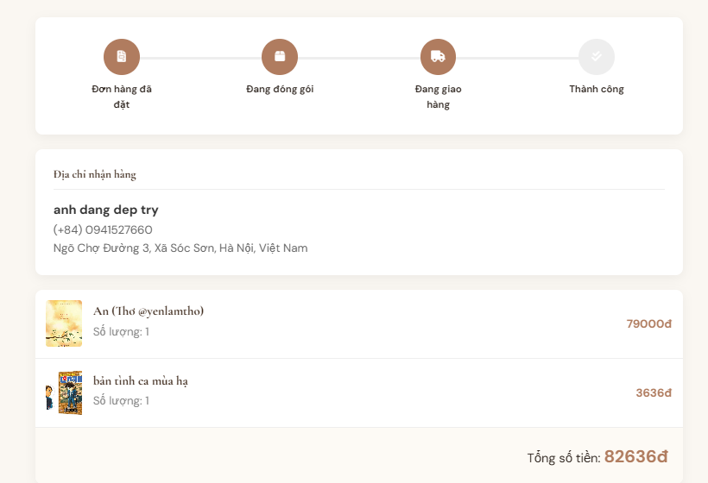
ORDER TRACKING
Figure 10: Order Tracking and Order History Page
The AI Chatbot demonstrated strong performance across its core use cases. When tested with natural language queries about book recommendations, the chatbot correctly retrieved relevant books from the database and returned HTML-formatted responses with clickable links, author information, and prices. Order tracking queries returned accurate status information matching the database records. The offline fallback mode ensured functionality even without an active API key, making development and testing more accessible.
The Staff Dashboard provides a comprehensive management interface with Chart.js visualizations of 7-day revenue trends, top-5 bestselling books, and order status distribution. The order management workflow correctly transitions orders through their lifecycle states and generates tracking records at each status change. The coupon management system allows staff to create time-limited discount codes with usage limits, which are validated in real time during customer checkout.
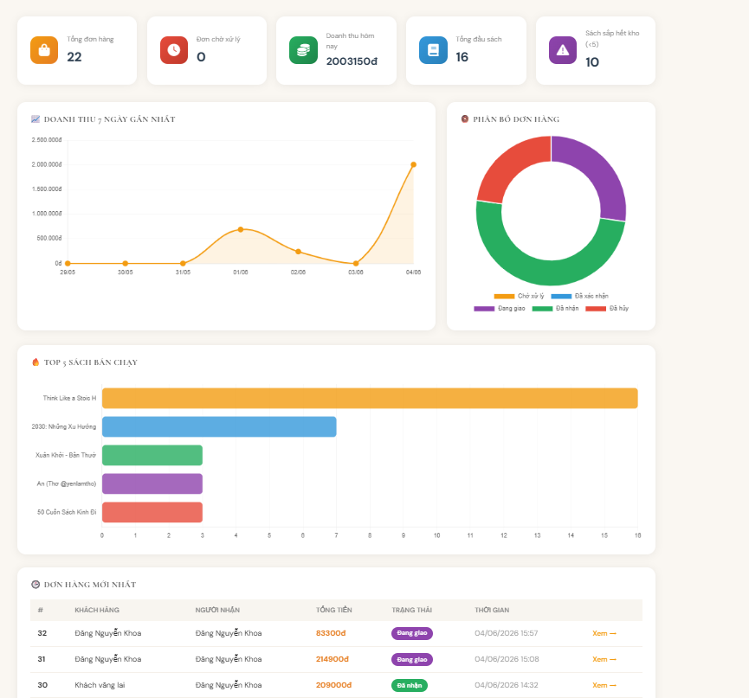
Figure 11: Staff Dashboard - Revenue Charts and Order Management
Unit testing was conducted using Django's TestCase framework, covering model property calculations (is_new, Coupon.is_valid, FlashSaleConfig.is_running_now), view-level functionality (cart operations, checkout flow, coupon application, wishlist management), and authentication/authorization (registration, login, staff access control). All test cases passed, validating the correctness of the core business logic implementation.
6. Conclusion
This project successfully demonstrates the development of a comprehensive online bookstore web application integrating modern AI capabilities. DDC Books combines Django's robust MVT architecture with the Claude API and RAG technique to deliver a system that goes beyond traditional e-commerce platforms. The key contributions include: (1) a complete e-commerce pipeline with atomic transaction safety; (2) an AI chatbot grounded in real-time database context using RAG; (3) a streaming SSE-based response system creating a natural conversational experience; (4) a comprehensive staff management portal with revenue analytics; and (5) a modular, maintainable codebase with unit test coverage.
The RAG-based chatbot implementation proved to be the most technically significant component. By dynamically injecting live database context into each Claude API call, the system avoids the hallucination problem common in LLM-only approaches, providing factually accurate product information, pricing, and order status. The special command tag parsing mechanism ([SET_PRICE_ALERT], [TRACK_GUEST_ORDER]) demonstrates an innovative pattern for using LLMs as orchestrators that trigger backend business logic through natural language output.
Future development directions include: upgrading the real-time chat to WebSocket using Django Channels for improved efficiency; integrating online payment gateways (VNPay, MoMo); implementing a collaborative filtering recommendation engine to complement the AI chatbot; adding push notification delivery for PriceAlert subscriptions; and extending the platform to a mobile application. The project demonstrates that combining modern web frameworks with LLM APIs provides an effective and accessible path to building intelligent, personalized e-commerce applications suitable for both commercial deployment and academic research.
REFERENCES
1. Anthropic. (2024). Claude API Documentation. Anthropic. https://docs.anthropic.com
2. AllThingsDev. (2024, September 27). Transform your travel planning with the AI Trip Planner API. https://blog.allthingsdev.co/2024/09/27/revolutionize-your-travel-planning-with-the-ai-trip-planner-api/
3. Django Software Foundation. (2024). Django Documentation (Version 6.0). https://docs.djangoproject.com
4. Forcier, J., Bissex, P., & Chun, W. J. (2008). Python Web Development with Django. Addison-Wesley Professional.
5. Lewis, P., Perez, E., Piktus, A., Petroni, F., Karpukhin, V., Goyal, N., ... & Kiela, D. (2020). Retrieval-Augmented Generation for Knowledge-Intensive NLP Tasks. Advances in Neural Information Processing Systems, 33, 9459-9474.
6. Nguyen, H. T., & Tran, V. B. (2022). Ung dung hoc may trong he thong goi y san pham thuong mai dien tu. Tap chi Khoa hoc va Cong nghe Viet Nam, 64(4), 45-52.
7. OpenAI. (2023). GPT-4 Technical Report. arXiv:2303.08774.
8. Resnick, P., & Varian, H. R. (1997). Recommender systems. Communications of the ACM, 40(3), 56-58. https://doi.org/10.1145/245108.245121
9. Ricci, F., Rokach, L., & Shapira, B. (2011). Introduction to Recommender Systems Handbook. In F. Ricci et al. (Eds.), Recommender Systems Handbook (pp. 1-35). Springer.
10. Vietnam E-Commerce Association (VECOM). (2023). Vietnam E-Commerce Index Report 2023. VECOM.

