Register the resource of ContainerRegistry

**az cloud set --name AzureChinaCloud  
az cloud set --name AzureCloud**

**az login**

**az provider register --namespace Microsoft.ContainerRegistry --wait**

**az provider show -n Microsoft.ContainerRegistry**

**Global site**

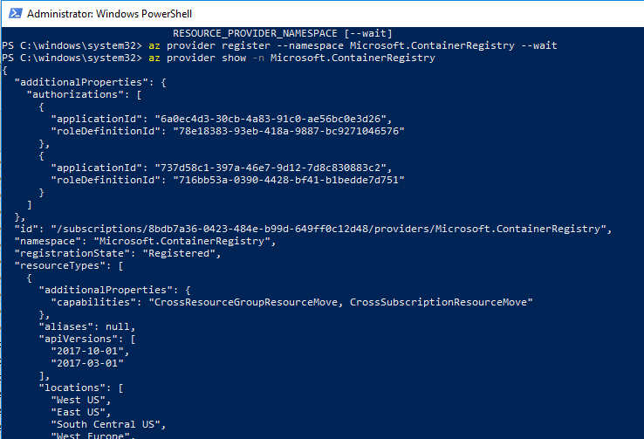

**Mooncake site**

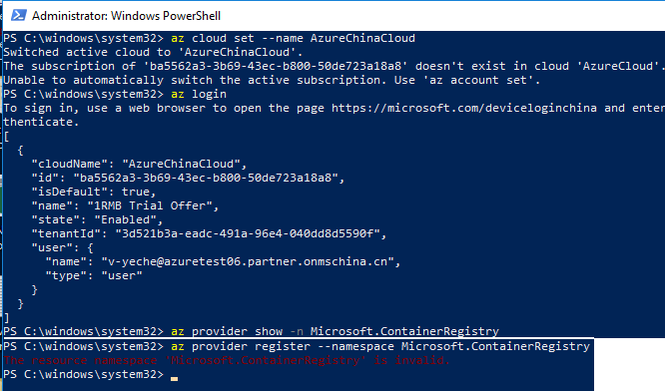

**Create Container Registry on Global site**

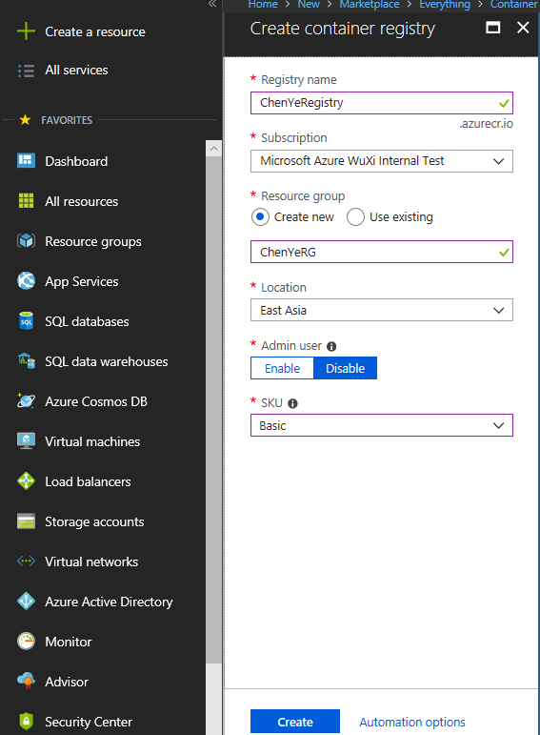

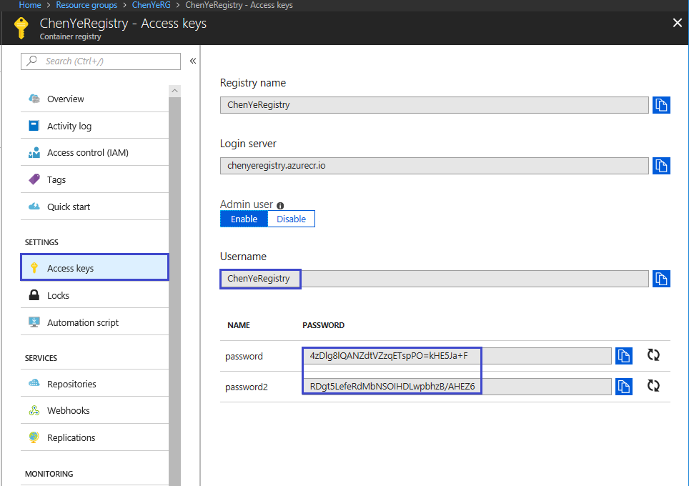

登录到 ACR

**docker login --username <username> --password <password> <login server>**

将映像推送到 ACR

**docker pull microsoft/aci-helloworld**

**docker tag microsoft/aci-helloworld <login server>/aci-helloworld:v1**

**docker push <login server>/aci-helloworld:v1**

**PowerShell**

**Get-Module –ListAvailable AzureRM**

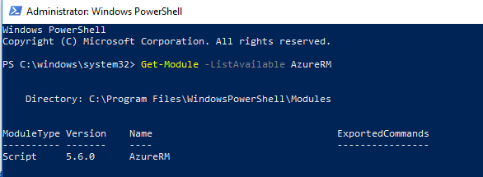

**Install-Module -Name AzureRM –AllowClobber –Force**

**Import-Module -Name AzureRM**

**Get-Module AzureRM -ListAvailable | Select-Object -Property Name,Version,Path**

**Get-InstalledModule -Name "AzureRM" -RequiredVersion 5.6.0 | Uninstall-Module**

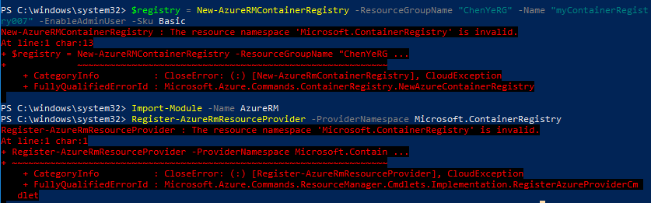

**URL articles/container-registry/container-registry-get-started-powershell**

**Connect-AzureRmAccount –Environment AzureChinaCloud**

**$registry = New-AzureRMContainerRegistry -ResourceGroupName "ChenYeRG" -Name "myContainerRegistry007" -EnableAdminUser -Sku Basic**

**$creds = Get-AzureRmContainerRegistryCredential -Registry $registry**

**$creds.Password | docker login $registry.LoginServer -u $creds.Username --password-stdin**

**docker pull microsoft/aci-helloworld**

**$image = $registry.LoginServer + "/aci-helloworld:v1"**

**docker push $image**

**2． container-registry-get-started-azure-portal.md**

