**Get-AzureRmResourceProvider -ListAvailable | Select-Object ProviderNamespace, RegistrationState**

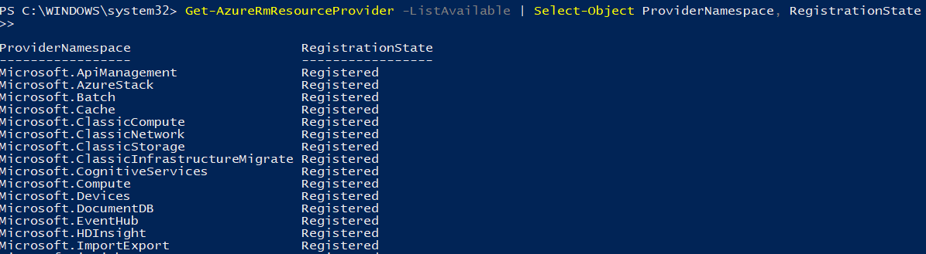

**Register-AzureRmResourceProvider -ProviderNamespace Microsoft.HDInsight**

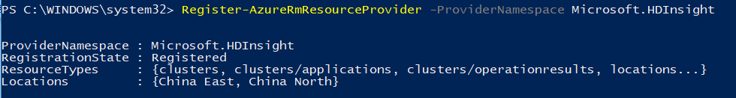

**Create HDInsight**

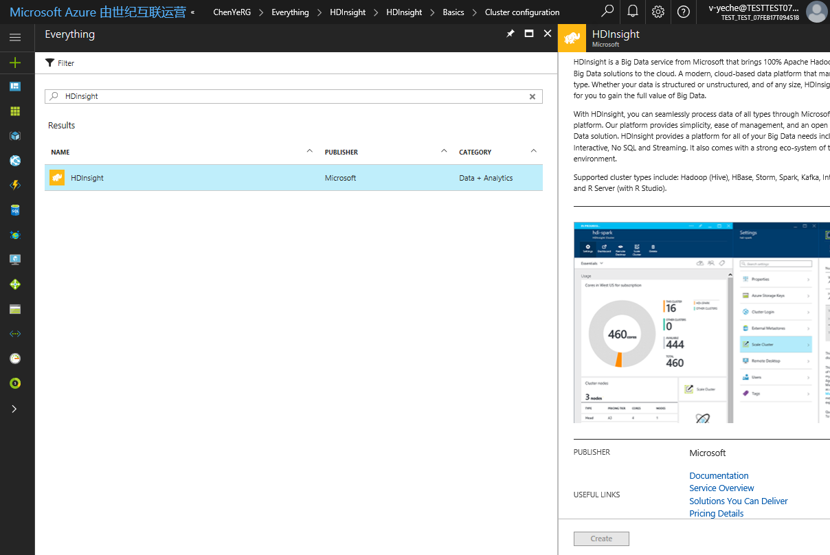

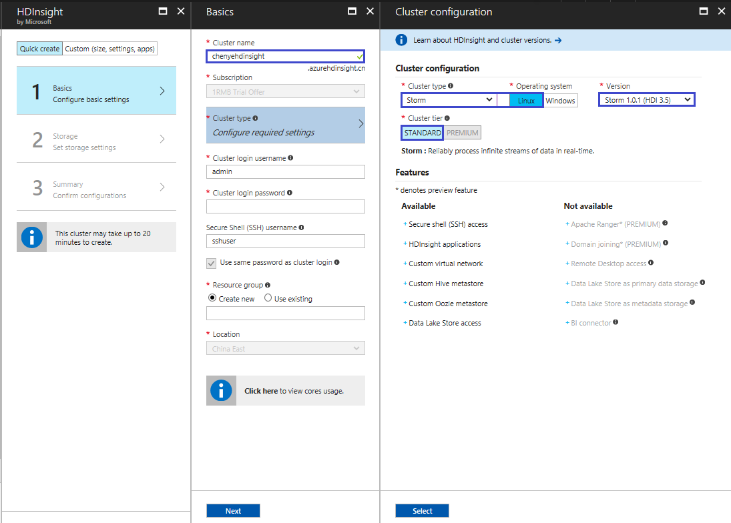

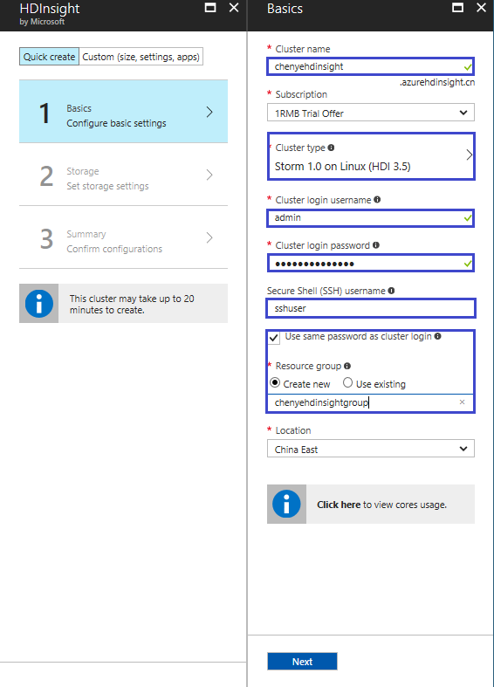

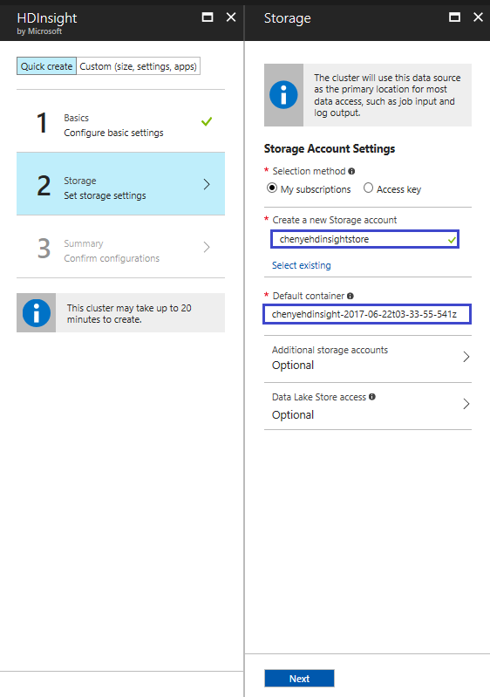

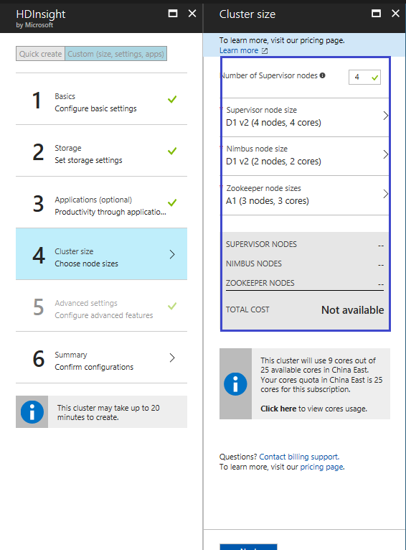

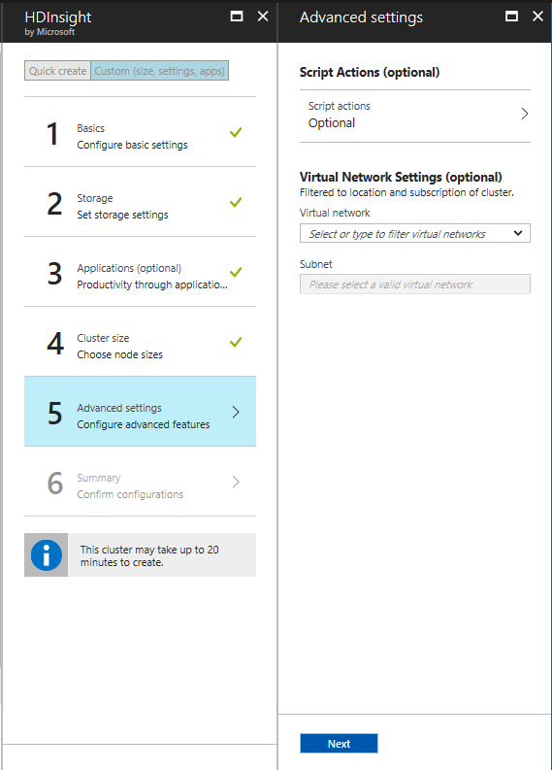

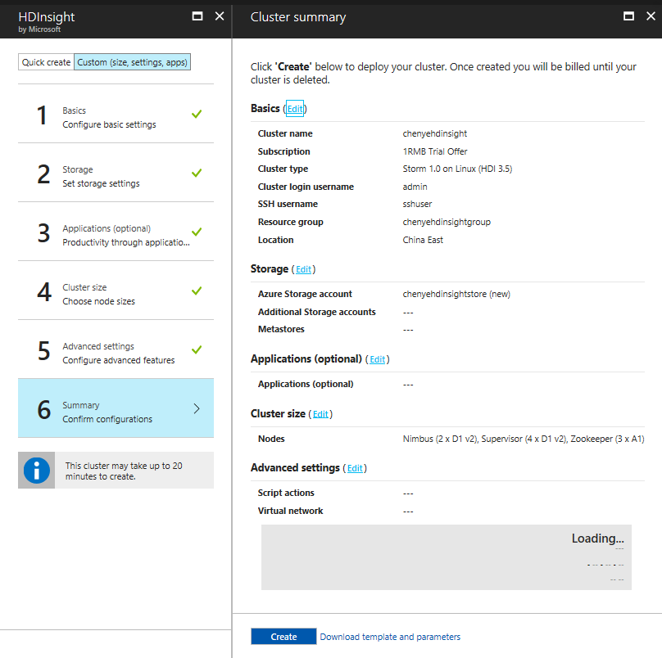

**Open git shell or other tools you favour.**

**ssh** [sshuser@chenyehdinsight-ssh.azurehdinsight.cn](mailto:sshuser@chenyehdinsight-ssh.azurehdinsight.cn)

sudo **storm jar /usr/hdp/current/storm-client/contrib/storm-starter/storm-starter-topologies-*.jar org.apache.storm.starter.WordCountTopology wordcount**

**https://chenyehdinsight.azurehdinsight.cn/stormui/index.html**

