Kubernete Walkthrought in global site.

**az account set --subscription ca27492a-4abb-4065-a62c-0b9d76fce88a**

**az aks create --resource-group ChenYeNRG --name cyAKSCluster --node-count 1 --enable-addons monitoring --generate-ssh-keys**

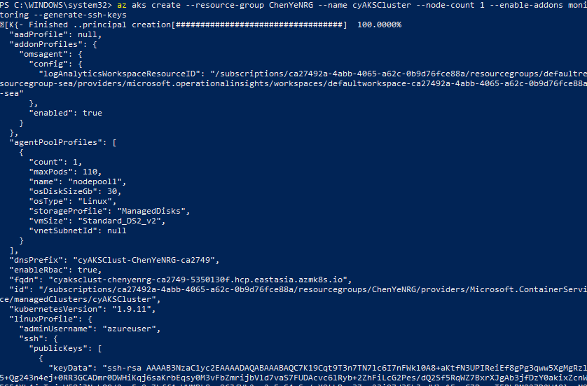

**az aks get-credentials --resource-group ChenYeNRG --name cyAKSCluster**

**kubectl get nodes**

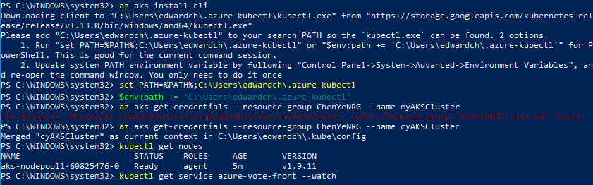

**kubectl apply -f azure-vote.yaml**

**Note: Please refer to azure-vote.yaml file content.**

**apiVersion: apps/v1**

**kind: Deployment**

**metadata:**

**name: azure-vote-back**

**spec:**

**replicas: 1**

**selector:**

**matchLabels:**

**app: azure-vote-back**

**template:**

**metadata:**

**labels:**

**app: azure-vote-back**

**spec:**

**containers:**

**- name: azure-vote-back**

**image: redis**

**resources:**

**requests:**

**cpu: 100m**

**memory: 128Mi**

**limits:**

**cpu: 250m**

**memory: 256Mi**

**ports:**

**- containerPort: 6379**

**name: redis**

**---**

**apiVersion: v1**

**kind: Service**

**metadata:**

**name: azure-vote-back**

**spec:**

**ports:**

**- port: 6379**

**selector:**

**app: azure-vote-back**

**---**

**apiVersion: apps/v1**

**kind: Deployment**

**metadata:**

**name: azure-vote-front**

**spec:**

**replicas: 1**

**selector:**

**matchLabels:**

**app: azure-vote-front**

**template:**

**metadata:**

**labels:**

**app: azure-vote-front**

**spec:**

**containers:**

**- name: azure-vote-front**

**image: microsoft/azure-vote-front:v1**

**resources:**

**requests:**

**cpu: 100m**

**memory: 128Mi**

**limits:**

**cpu: 250m**

**memory: 256Mi**

**ports:**

**- containerPort: 80**

**env:**

**- name: REDIS**

**value: "azure-vote-back"**

**---**

**apiVersion: v1**

**kind: Service**

**metadata:**

**name: azure-vote-front**

**spec:**

**type: LoadBalancer**

**ports:**

**- port: 80**

**selector:**

**app: azure-vote-front**

**kubectl get service azure-vote-front --watch**