Create Internal Load Balancer

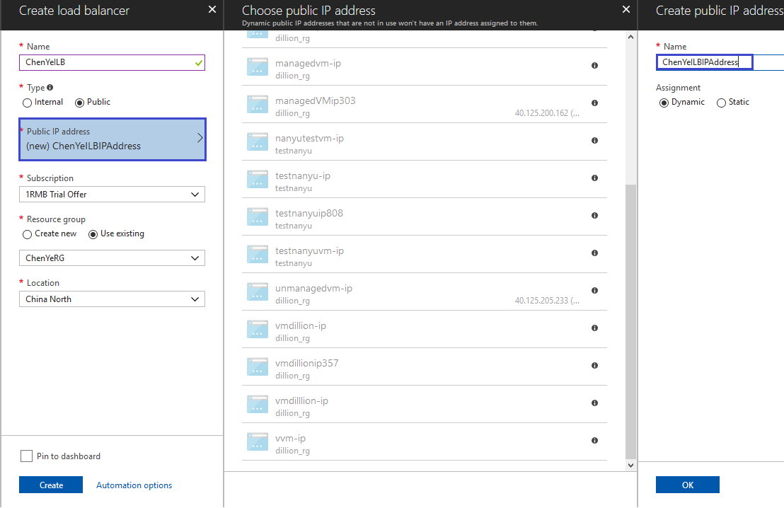

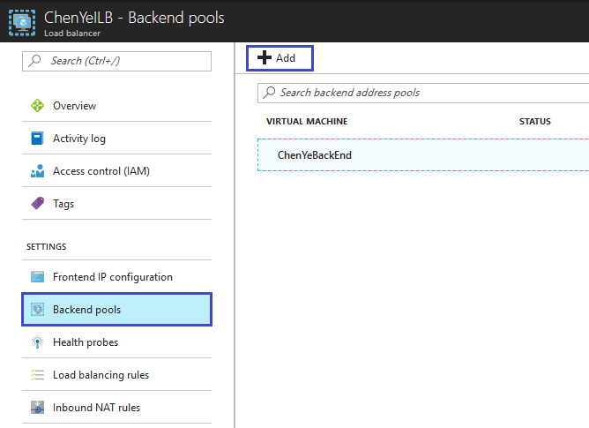

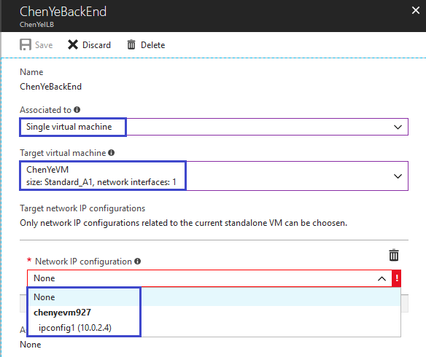

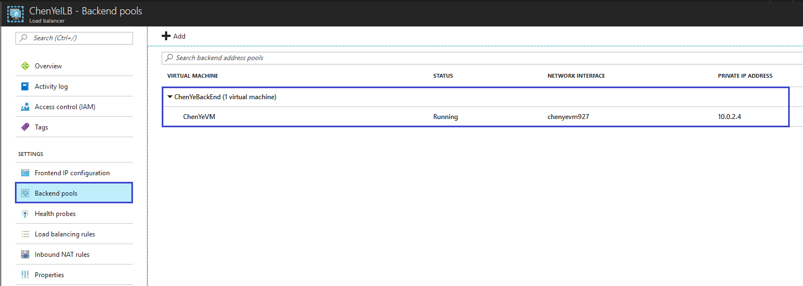

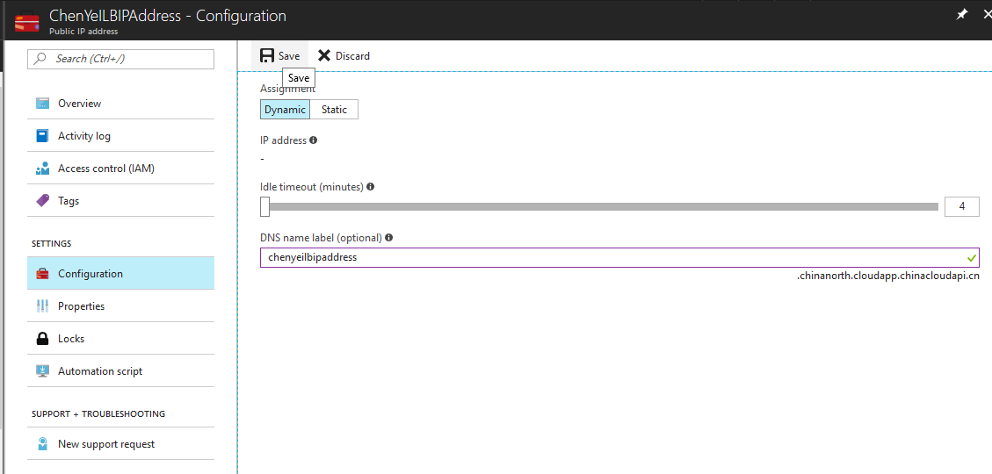

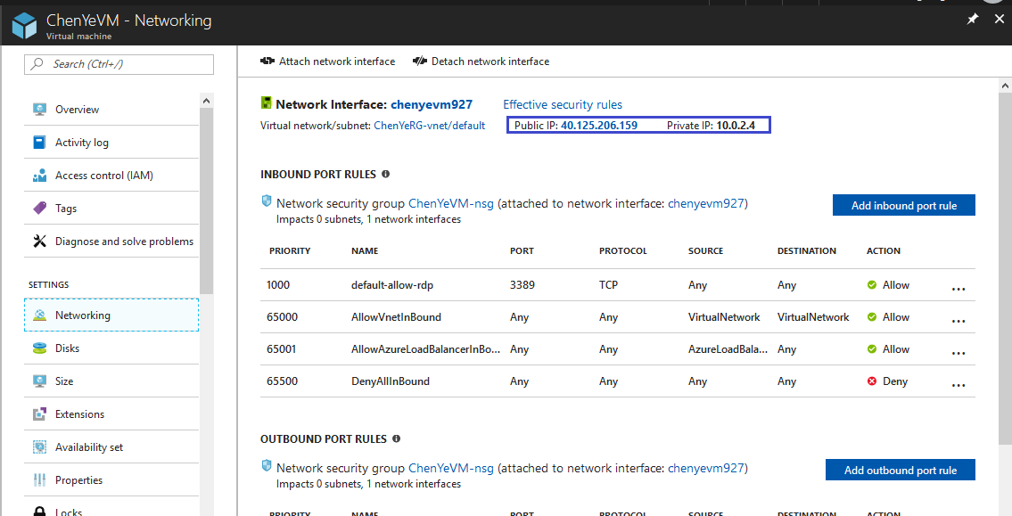

CLI command

$myResourceGroupLB="ChenYeRG"

az group create `

--name $myResourceGroupLB `

--location chinanorth

---------------------

az network public-ip create --resource-group $myResourceGroupLB --name myPublicIP

az network lb create `

--resource-group $myResourceGroupLB `

--name myLoadBalancer `

--public-ip-address myPublicIP `

--frontend-ip-name myFrontEndPool `

--backend-pool-name myBackEndPool

---------------------

az network lb probe create `

--resource-group $myResourceGroupLB `

--lb-name myLoadBalancer `

--name myHealthProbe `

--protocol tcp `

--port 80

---------------------

az network lb rule create `

--resource-group $myResourceGroupLB `

--lb-name myLoadBalancer `

--name myHTTPRule `

--protocol tcp `

--frontend-port 80 `

--backend-port 80 `

--frontend-ip-name myFrontEndPool `

--backend-pool-name myBackEndPool `

--probe-name myHealthProbe

---------------------

az network vnet create `

--resource-group $myResourceGroupLB `

--location chinanorth `

--name myVnet `

--subnet-name mySubnet

---------------------

az network nsg create `

--resource-group $myResourceGroupLB `

--name myNetworkSecurityGroup

---------------------

az network nsg rule create `

--resource-group $myResourceGroupLB `

--nsg-name myNetworkSecurityGroup `

--name myNetworkSecurityGroupRuleHTTP `

--protocol tcp `

--direction inbound `

--source-address-prefix '\*' `

--source-port-range '\*' `

--destination-address-prefix '\*' `

--destination-port-range 80 `

--access allow `

--priority 200

---------------------

for i in `seq 1 2`; do

az network nic create `

--resource-group $myResourceGroupLB `

--name myNic2 `

--vnet-name myVnet `

--subnet mySubnet `

--network-security-group myNetworkSecurityGroup `

--lb-name myLoadBalancer `

--lb-address-pools myBackEndPool

done

---------------------

az vm availability-set create `

--resource-group $myResourceGroupLB `

--name myAvailabilitySet

az vm create \

--resource-group $myResourceGroupILB \

--name myVM1 \

--availability-set myAvailabilitySet \

--nics myNic$i \

--image UbuntuLTS \

--generate-ssh-keys \

--custom-data cloud-init.txt