Cloud Computing Project Report
High Availability Flask Web Deployment on Google Cloud Platform
Department of Electrical and Computer Engineering
Western University

1. Introduction

1.1 Project Background
This project explores essential modern cloud computing concepts through a hands-on deployment of a containerized web application and a database backend on Google Cloud Platform (GCP). The project uses Google Kubernetes Engine (GKE) to manage application deployment, internal service discovery, external access, load balancing, and pod scheduling across development and production environments.
The revised implementation is based on a Python Flask web application connected to a MySQL database. The deployment emphasizes reproducibility by using Kubernetes YAML manifests and a ConfigMap-based database initialization process, allowing a third party to recreate the environment without manually entering SQL commands inside the database container.

1.2 Problem Definition
The main problem addressed by this project is how to implement a cloud-hosted web service that remains accessible when part of the application layer fails. The solution must also keep the database isolated from public access, allow external users to reach the web application, and provide clear documentation so that the system can be replicated from scratch.

1.3 Project Objectives
- Deploy a containerized Flask web application with a MySQL database backend on GKE.
- Create a development environment for simplified testing and a production environment with multiple worker nodes.
- Expose the web tier through a Kubernetes LoadBalancer service while keeping the MySQL database private through a ClusterIP service.
- Use Kubernetes pod scheduling and pod anti-affinity rules to improve application-layer high availability.
- Automate database initialization using a ConfigMap-mounted init.sql file instead of manual MySQL CLI commands.
- Provide a clear replication guide that matches the code repository and README.md instructions.

2. System Architecture and Design

2.1 Development Environment
The development environment uses a simplified two-tier architecture deployed on a single GKE worker node. The Flask application pod and the MySQL database pod run in the same cluster environment, but the database remains accessible only inside the cluster through an internal Kubernetes service.
External HTTP traffic reaches the Flask application through a Kubernetes Service of type LoadBalancer. The service listens on port 80 and routes traffic to the Flask application container. The Flask application then connects to MySQL using the internal service name mysql-service on port 3306. This design allows the web application to be publicly accessible while keeping the database isolated from the public internet.
The database initialization process is automated. The init.sql file is converted into a Kubernetes ConfigMap and mounted into the MySQL container initialization directory. As a result, the required database, table, and sample rows are created automatically when the MySQL pod starts.
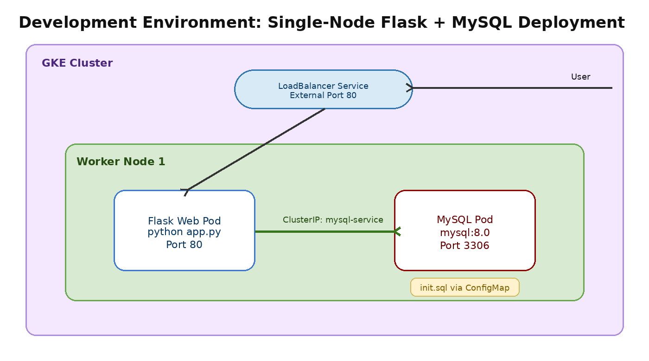
Figure 1. Development environment architecture using Flask, MySQL, LoadBalancer, and ConfigMap-based database initialization.

2.2 Production Environment
The production environment is designed for improved availability by distributing the application tier across multiple worker nodes. In this design, Node 1 and Node 2 host the Flask web application replicas, while Node 3 is dedicated to the MySQL database pod. Separating the application tier and data tier improves isolation and reduces the likelihood that a single node issue will affect the entire system.
The Flask application is deployed with two replicas. Kubernetes pod anti-affinity is used with the kubernetes.io/hostname topology key so that the two application pods are scheduled on different nodes whenever possible. This reduces the risk of both web replicas being lost due to a single-node failure.
The database pod is scheduled to the dedicated database node using node labels and node scheduling rules. The MySQL service remains a ClusterIP service, meaning that only workloads inside the Kubernetes cluster can access the database. The external user only communicates with the Flask application through the LoadBalancer service.
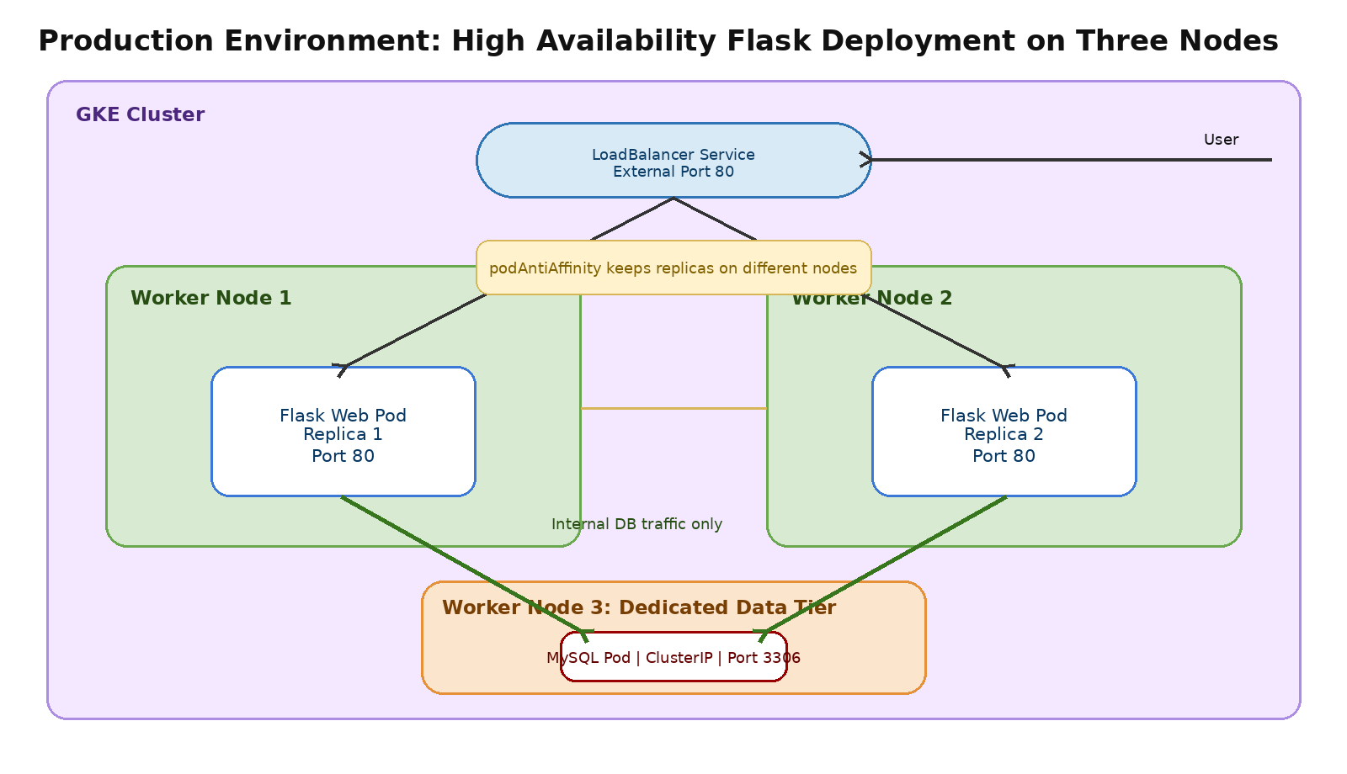
Figure 2. Production architecture with two Flask web replicas, a dedicated MySQL node, pod anti-affinity, and external load balancing.

3. Implementation

3.1 Application Design
The web application is implemented using Flask. It starts with python app.py and listens on 0.0.0.0 so that the container can receive traffic from Kubernetes. The application connects to the MySQL backend, retrieves item records, and renders them as a simple HTML table in the browser.
The application is intentionally lightweight because the focus of the project is cloud deployment, service connectivity, high availability, and reproducibility rather than complex business logic. The main functional requirement is that the web tier successfully reads data from the database tier and returns the result through the external LoadBalancer IP.

3.2 Docker Image and Application Packaging
The Flask application is containerized using a Dockerfile stored in the app directory. The Docker image contains the application source code and Python dependencies listed in requirements.txt. The image is built locally and pushed to Google Container Registry using the project ID configured in the GCP environment.
export PROJECT_ID="your-gcp-project-id"
docker build -t gcr.io/$PROJECT_ID/flask-mysql-app:v1 ./app
docker push gcr.io/$PROJECT_ID/flask-mysql-app:v1
After pushing the image, the image field in the Kubernetes deployment YAML must be updated to reference the correct project ID and image tag.

3.3 Kubernetes Configuration
The Kubernetes configuration separates the application tier and the database tier. The Flask web application is deployed as a Kubernetes Deployment, while the MySQL database is deployed as a separate Kubernetes Deployment. Services are used to control communication between components.
- Flask web deployment: runs the containerized Python Flask application and exposes container port 80.
- Web LoadBalancer service: exposes the application externally on HTTP port 80.
- MySQL deployment: runs the mysql:8.0 container and stores the project data.
- MySQL ClusterIP service: provides internal-only database access on port 3306.
- podAntiAffinity: helps distribute Flask replicas across different worker nodes in production.
- Node labels and node scheduling: place web replicas on web nodes and the database pod on the dedicated database node.

3.4 Automated Database Initialization with ConfigMap
A key improvement in this revised implementation is the use of a ConfigMap to automate database initialization. Instead of entering the MySQL CLI manually and pasting SQL commands, the SQL initialization file is created once in the repository and mounted into the database container.
kubectl create configmap mysql-init-script --from-file=./database/init.sql
The MySQL Docker image automatically executes SQL files placed in the /docker-entrypoint-initdb.d/ directory during the first initialization of the database container. This makes the deployment more repeatable and reduces the risk of human error during replication.

3.5 GCP Services Used
- Google Kubernetes Engine (GKE): used as the container orchestration platform for the Flask and MySQL workloads.
- Google Cloud Load Balancing: provisioned automatically through the Kubernetes LoadBalancer service.
- Google Container Registry: stores the custom Flask Docker image so that GKE can pull and run it.
- Compute Engine worker nodes: provide the infrastructure for running the Kubernetes pods.

4. Results and Evaluation

4.1 Functional Results
The functional test verifies that the Flask application can be reached through the external LoadBalancer IP and that it can retrieve records from the MySQL backend. After deployment, the external service can be checked using the following command:
kubectl get services
After locating the external IP address of the Flask LoadBalancer service, the application can be accessed in a browser or tested through curl:
curl http://<EXTERNAL-IP>/
The expected result is an HTML page displaying the database records initialized from init.sql. The sample records used by the project are shown below.
ID | Name | Description
1 | Item A | First sample record
2 | Item B | Second sample record
3 | Item C | Third sample record

4.2 High Availability Results
High availability is evaluated by deleting one of the running Flask application pods while the service remains exposed through the LoadBalancer. Before injecting a failure, the pod placement should be checked with the following command:
kubectl get pods -o wide
In the production environment, the output should show two Flask application pods running on different worker nodes. A failure can then be injected by deleting one of the web pods:
kubectl delete pod <web-pod-name>
After the pod is deleted, the application should remain accessible through the same external IP address because the LoadBalancer can continue routing traffic to the remaining healthy Flask pod. Kubernetes then creates a replacement pod to restore the desired number of replicas.

4.3 Load Balancing Verification
Load balancing is verified by confirming that the LoadBalancer service has multiple healthy backend endpoints corresponding to the Flask web replicas. The following commands can be used to inspect service routing and pod distribution:
kubectl get services
kubectl get endpoints
kubectl get pods -o wide
When the service selector matches both Flask application pods, Kubernetes provides multiple backend endpoints for the LoadBalancer service. This confirms that traffic is not tied to a single pod and can be distributed across the available application replicas.

4.4 Reproducibility Evaluation
The revised deployment process improves reproducibility because all major configuration steps are documented and represented as version-controlled files. The application source code, Dockerfile, requirements.txt, init.sql, and Kubernetes YAML manifests work together to allow a third party to recreate the environment without manually configuring the database through the MySQL CLI.

5. Conclusion

5.1 Summary of Achievements
- Successfully deployed a Flask web application with a MySQL database backend on GKE.
- Created a development environment for testing and a production environment with three worker nodes.
- Exposed the application through a Kubernetes LoadBalancer service while keeping the database private through a ClusterIP service.
- Improved high availability by deploying multiple Flask replicas and using pod anti-affinity to distribute them across worker nodes.
- Automated database initialization through a Kubernetes ConfigMap and init.sql file.
- Provided a replication guide aligned with the repository structure and README.md commands.

5.2 Lessons Learned
- Kubernetes services provide a clean separation between external web access and internal database communication.
- Pod anti-affinity and node labels are important for achieving meaningful high availability instead of simply increasing the replica count.
- ConfigMap-based database initialization makes the deployment workflow easier to reproduce and less dependent on manual terminal steps.
- A consistent report, README, and codebase are essential because small mismatches in framework names, ports, or deployment steps can cause replication failures.

5.3 Future Improvements
- Move database credentials from plain environment variables into Kubernetes Secrets.
- Replace the containerized MySQL pod with Cloud SQL for better production-grade database management.
- Add persistent storage for MySQL using PersistentVolumeClaims.
- Add horizontal pod autoscaling for the Flask application based on CPU or request load.
- Use HTTPS with an Ingress controller and managed TLS certificates.
- Add a CI/CD pipeline so that code changes automatically build, push, and deploy new container images.

6. Replication Guide

6.1 Development Environment

Phase 1 - Configure the Project Environment
- Enable the required GCP services:
gcloud services enable container.googleapis.com compute.googleapis.com
- Create a one-node GKE cluster for development testing:
gcloud container clusters create cloud-project-cluster --num-nodes=1 --zone=us-central1-a
- Configure kubectl to connect to the cluster:
gcloud container clusters get-credentials cloud-project-cluster --zone=us-central1-a

Phase 2 - Build and Deploy the Project Code
- Enter the project folder:
cd cloud-project
- Build and push the Flask Docker image:
export PROJECT_ID="your-gcp-project-id"
docker build -t gcr.io/$PROJECT_ID/flask-mysql-app:v1 ./app
docker push gcr.io/$PROJECT_ID/flask-mysql-app:v1
- Update the image field in the YAML files so that it points to your project image:
image: gcr.io/your-gcp-project-id/flask-mysql-app:v1
- Create the database initialization ConfigMap:
kubectl create configmap mysql-init-script --from-file=./database/init.sql
- Apply the development deployment YAML:
kubectl apply -f ./k8s-dev/dev-deployment.yaml

Phase 3 - Verify the Development Deployment
kubectl get pods -o wide
kubectl get services
curl http://<EXTERNAL-IP>/
The application should display the sample records from the MySQL database.

6.2 Production Environment

Phase 1 - Configure the Project Environment
- Create a three-node GKE cluster for the production environment:
gcloud container clusters create cloud-project-prod-cluster --num-nodes=3 --zone=us-central1-a
- Configure kubectl to connect to the production cluster:
gcloud container clusters get-credentials cloud-project-prod-cluster --zone=us-central1-a
- List the node names:
kubectl get nodes
- Label the nodes before applying the production YAML files. This step is required because the production manifests use node scheduling rules to separate the web tier and database tier:
kubectl label nodes <node-1-name> env=web-node-1
kubectl label nodes <node-2-name> env=web-node-2
kubectl label nodes <node-3-name> env=db-node
- Verify that the labels were applied correctly:
kubectl get nodes --show-labels

Phase 2 - Build and Deploy the Production Resources
- Build and push the Flask Docker image if it has not already been pushed:
export PROJECT_ID="your-gcp-project-id"
docker build -t gcr.io/$PROJECT_ID/flask-mysql-app:v1 ./app
docker push gcr.io/$PROJECT_ID/flask-mysql-app:v1
- Create the database initialization ConfigMap:
kubectl create configmap mysql-init-script --from-file=./database/init.sql
- Apply the production deployment and service YAML files:
kubectl apply -f ./k8s-prod/prod-deployment.yaml
kubectl apply -f ./k8s-prod/prod-services.yaml

Phase 3 - Verify the Production Deployment
After deployment, verify that the pods are running and distributed across the expected nodes:
kubectl get pods -o wide
Then locate the external IP address of the LoadBalancer service:
kubectl get services
Open the application in a browser or use curl:
curl http://<EXTERNAL-IP>/
To test high availability, delete one Flask web pod and confirm that the application remains accessible:
kubectl delete pod <web-pod-name>
kubectl get pods -o wide
curl http://<EXTERNAL-IP>/

Appendix A: Consistency Fixes Applied in This Revised Report
- Replaced FastAPI references with Flask to match the application code and README.md.
- Replaced uvicorn startup references with python app.py.
- Updated port descriptions so that the Flask application and LoadBalancer use HTTP port 80 consistently.
- Removed manual MySQL CLI database initialization steps and replaced them with ConfigMap-based init.sql initialization.
- Added the missing production node-labeling commands to prevent pod scheduling failures.
- Updated the replication guide to use the same repository paths as the README.md: app/, database/, k8s-dev/, and k8s-prod/.
- Removed the future-improvement item suggesting database initialization automation because this revised version already implements it.

