PHP + MySQL
Displaying a Name from a Database

1. Introduction
This documentation explains how to create a simple PHP application that connects to a MySQL/MariaDB database and displays a name stored inside a database table.
The technologies used are:
- PHP — processes the information
- MySQL/MariaDB — stores the student information
- HTML — displays the information on the webpage
- XAMPP — provides Apache and MariaDB/MySQL locally
- VS Code — used to write the PHP code
The final result will look similar to:


2. Start XAMPP
Before doing anything with PHP and MySQL, start XAMPP.
Open XAMPP Control Panel and start:
Apache - START
MySQL- START
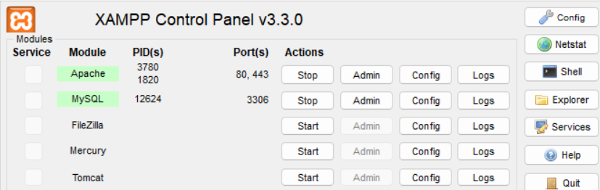

3. Create the Project Folder
Go to your XAMPP htdocs folder:

Create a folder:

Inside the folder, create:
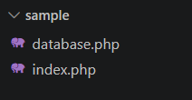

4. Create the Database
Open phpMyAdmin by going to:
http://localhost/phpmyadmin
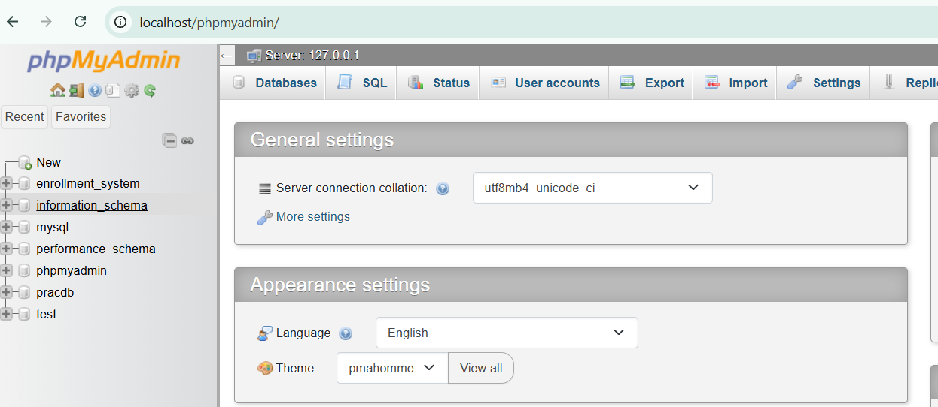
Create a database by clicking the “New” then this will appear:
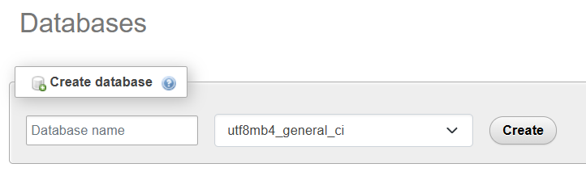
5. Create the Name Table
Create a table called name or use the SQL below:

CREATE TABLE names (
id INT AUTO_INCREMENT PRIMARY KEY,
first_name VARCHAR(100),
middle_initial VARCHAR(10),
last_name VARCHAR(100),
);

The table will contain:
Column | Purpose
id | Unique ID for each name
first_name | Your first name
middle_initial | Yourmiddle initial
last_name | Your last name

6. Understanding AUTO_INCREMENT
The id column uses:
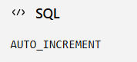
This means the database automatically generates the ID.
For example:
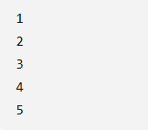
You don't have to manually enter those numbers.

The PRIMARY KEY means every name has a unique ID.
So our table might look like:
id | first_name | middle_initial | last_name
1 | John Lloyd | O | Paez
2 | Jeffrey | T | Ponce
3 | John Michael | E | Nataa
4 | Aldren | N | Ontolan

7. Adding Names Data
Now we need some names.
Use this SQL:
INSERT INTO names
(first_name, middle_initial, last_name)
VALUES
('John Lloyd', 'B', 'Paez');
You can add another:
INSERT INTO names
(first_name, middle_initial, last_name)
VALUES
('Jeffrey', 'T', 'Ponce');
And anoher:
INSERT INTO names
(first_name, middle_initial, last_name)
VALUES
('John Michael', 'B', 'Nataa');

The database will automatically assign the IDs.
8. Understanding SQL Commands
You have now encountered several important SQL commands.
SELECT - Gets information:
SELECT * FROM names;
Meaning:
"Give me everything from names."

WHERE - Filters the information:
SELECT * FROM names
WHERE id = 1;
Meaning:
"Give me only the name whose ID is 1."
This is very important when you don't want to display every name.

INSERT - Adds information:
INSERT INTO names (first_name, middle_initial, last_name)
VALUES (‘John Lloyd’,’O’,’Paez’);
Meaning:
"Put this new information into my table."

ALTER TABLE - Changes the structure of an existing table:
ALTER TABLE table_name
ADD COLUMN column_name column_type;

9. Create the Database Connection
Now open:

Put this inside:
<?php

$servername = "localhost";
$username = "root";
$password = "";
$dbname = "sampledb";

$conn = new mysqli(
$servername,
$username,
$password,
$dbname
);

if ($conn->connect_error) {
die("Connection failed: " . $conn->connect_error);
}

?>

What does this do?
These variables contain your database information:
$servername = "localhost";
$username = "root";
$password = "";
$dbname = "sampledb";

Then:
$conn = new mysqli(...);
creates the connection.
Think of $conn as a telephone connecting PHP to your database.
PHP
│
│ $conn
↓
MariaDB/MySQL
│
↓
sampledb
│
↓
names

10. Connect index.php to the Database
At the top of index.php:
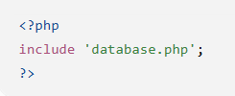
This means:
"PHP, go get the database connection from database.php."

11. Get One Name
Now we can retrieve a specific name.
For example, name ID 1:
$sql = "SELECT * FROM names WHERE id = 1";
$result = $conn->query($sql);
The SQL:
SELECT * FROM names WHERE id = 1
means:
"Find the name in table names whose ID is 1."

14. Get the Information from the Result
This is an important step.
After:
$result = $conn->query($sql);
we need:
$row = $result->fetch_assoc();
Think of it this way:
$result
↓
contains the database result
↓
fetch_assoc()
↓
gets the name’s row
↓
$row
Now $row contains something like:
$row
├── id → 1
├── first_name → John Lloyd
├── middle_initial → O
├── last_name → Paez
12. Display Your Name
Now we can access individual columns:
$row['first_name']
gets:
John Lloyd
This:
$row['middle_initial']
gets:
O
And:
$row['last_name']
Gets:
Paez
To combine them:
echo $row['first_name'] . " "
. $row['middle_initial'] . " "
. $row['last_name'];
The “.” means:
"Join these pieces together."

13. Complete index.php
Here is the complete version:
<?php
include 'database.php';
$sql = "SELECT * FROM names WHERE id = 1";
$result = $conn->query($sql);
$row = $result->fetch_assoc();
?>

<!DOCTYPE html>
<html lang="en">

<head>
<meta charset="UTF-8">

<meta name="viewport"
content="width=device-width, initial-scale=1.0">

<title>Name Display</title>
</head>

<body>

<h1>
MY NAME IS
<?php
echo $row['first_name'] . " "
. $row['middle_initial'] . " "
. $row['last_name'];
?>
</h1>

</body>

</html>
14. Displaying All Names vs. One Name
All names - SQL:
SELECT * FROM names;
Result:
John Lloyd Paez
Jeffrey Ponce
John Michael Nataa
Aldren Ontolan

Usually you'd use a loop:
while ($row = $result->fetch_assoc()) {
// display name
}

One name:
SELECT * FROM names
WHERE id = 1;
Then:
$row = $result->fetch_assoc();
Result:
John Lloyd B Paez

15. Displaying the Data as an HTML Table
If you want to display the name's information in a table:
<table>

<tr>
<th>ID</th>
<th>First Name</th>
<th>Middle Initial</th>
<th>Last Name</th>
</tr>

<tr>
<td><?php echo $row['id']; ?></td>
<td><?php echo $row['first_name']; ?></td>
<td><?php echo $row['middle_initial']; ?></td>
<td><?php echo $row['last_name']; ?></td>
</tr>

</table>
You can add CSS:
table {
border-collapse: collapse;
}

th, td {
border: 1px solid black;
padding: 10px;
}

th {
background-color: blue;
color: white;
}
This gives you an Excel-like table.
16. Testing the Website
Because you're using XAMPP, don't open the PHP file by double-clicking it.
Instead, make sure Apache is running and go to:
http://localhost/sample/
Your browser will execute the PHP code.
You should see:

17. Important PHP + MySQL Pattern to Remember
As you're learning PHP, memorize this basic pattern:
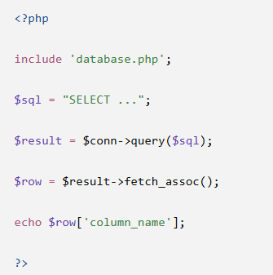
In simple words:
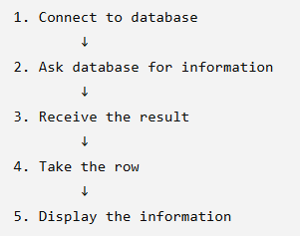
That's the foundation of a huge number of PHP/MySQL applications.

Credits to JDEV

