EARTHQUAKE PREDICTION MODEL USING PYTHON

It is well known that if a disaster has happened in a region, it is likely to happen there again. Some regions really have frequent earthquakes, but this is just a comparative quantity compared to other regions. So, predicting the earthquake with Date and Time, Latitude and Longitude from previous data is not a trend which follows like other things, it is natural occuring.

Import the necessary libraries required for buidling the model and data analysis of the earthquakes.

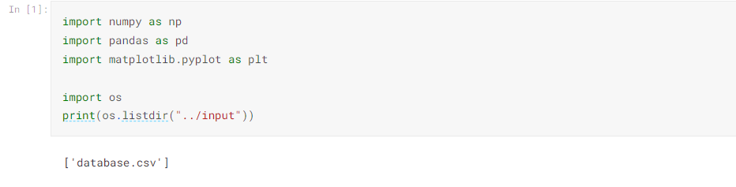

Read the data from csv and also columns which are necessary for the model and the column which needs to be predicted.

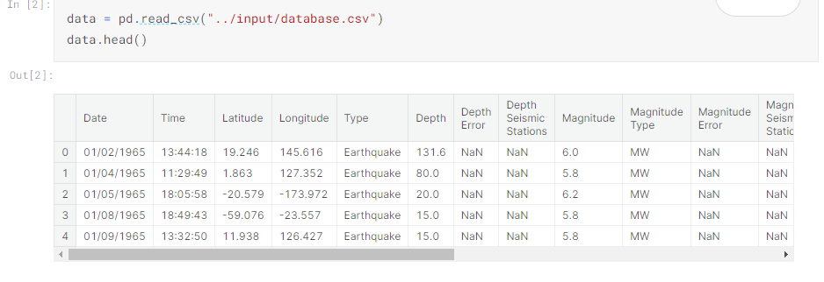

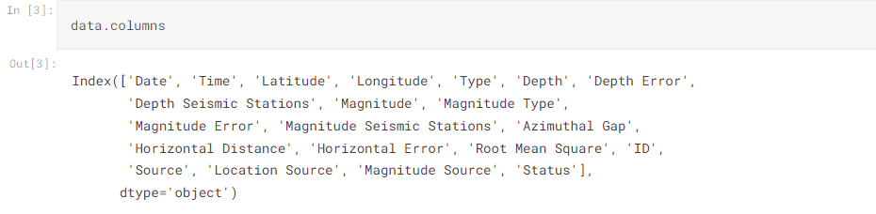 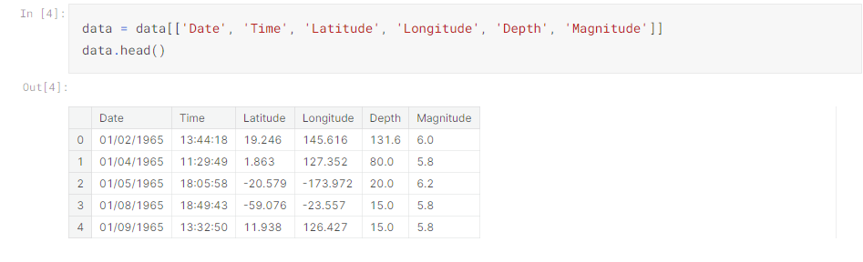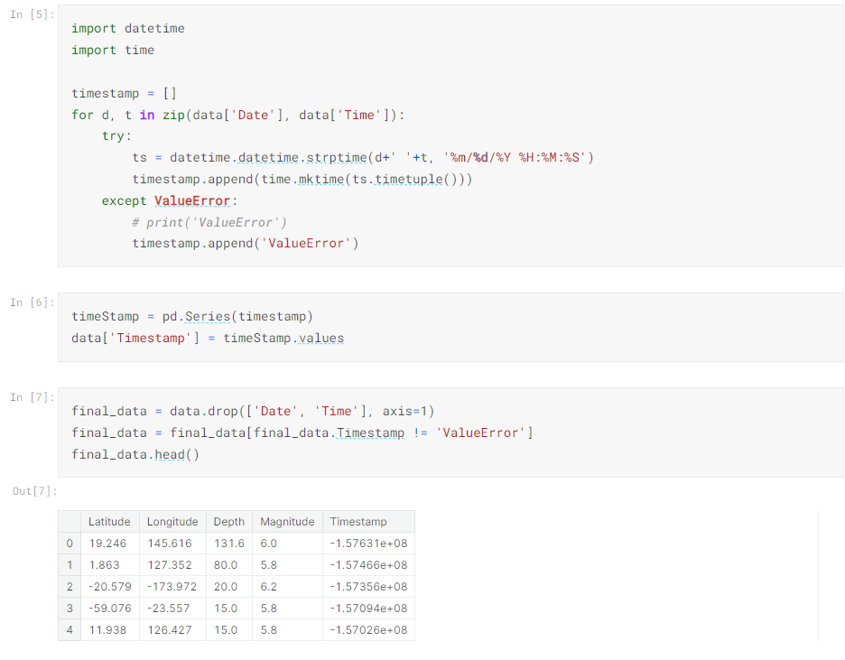

**Visualization**

Here, all the earthquakes from the database in visualized on to the world map which shows clear representation of the locations where frequency of the earthquake will be more.

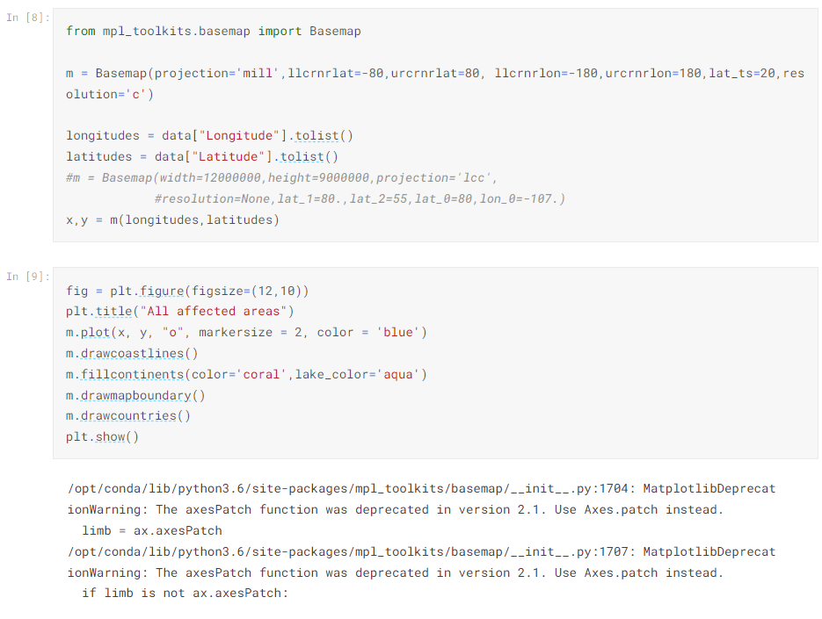

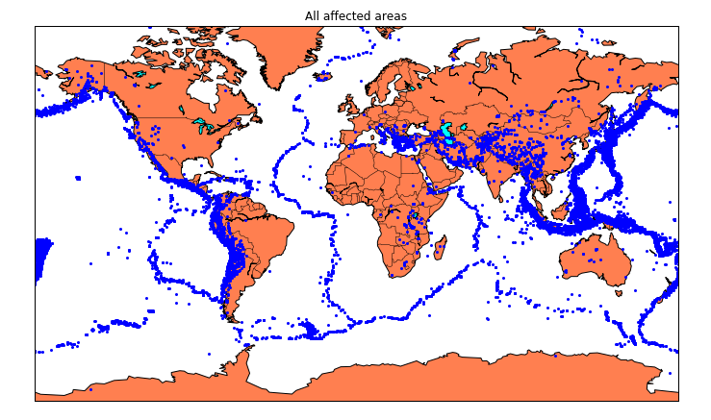

**Splitting the Data**

Firstly, split the data into Xs and ys which are input to the model and output of the model respectively. Here, inputs are TImestamp, Latitude and Longitude and outputs are Magnitude and Depth. Split the Xs and ys into train and test with validation. Training dataset contains 80% and Test dataset contains 20%.

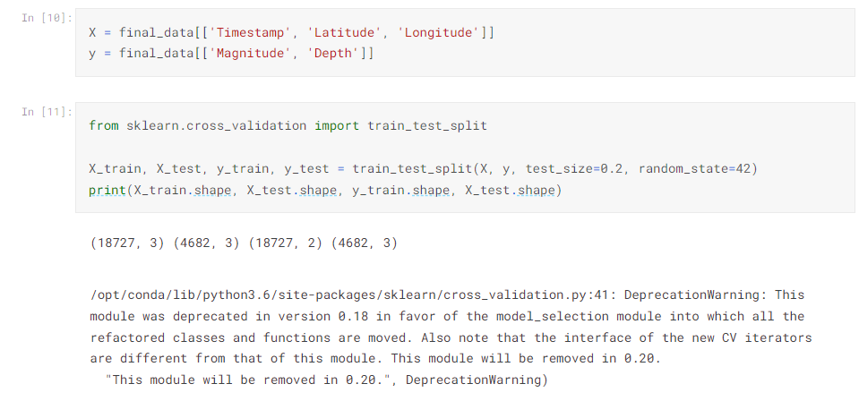

Here, we used the RandomForestRegressor model to predict the outputs, we see the strange prediction from this with score above 80% which can be assumed to be best fit but not due to its predicted values.

