ASSIGNMENT 4

Johnatan Quintero Vasquez

2023-07-16

# Markdown Basics

## Favorite Foods

1. Pizza
2. Ramen
3. Steak

## Images

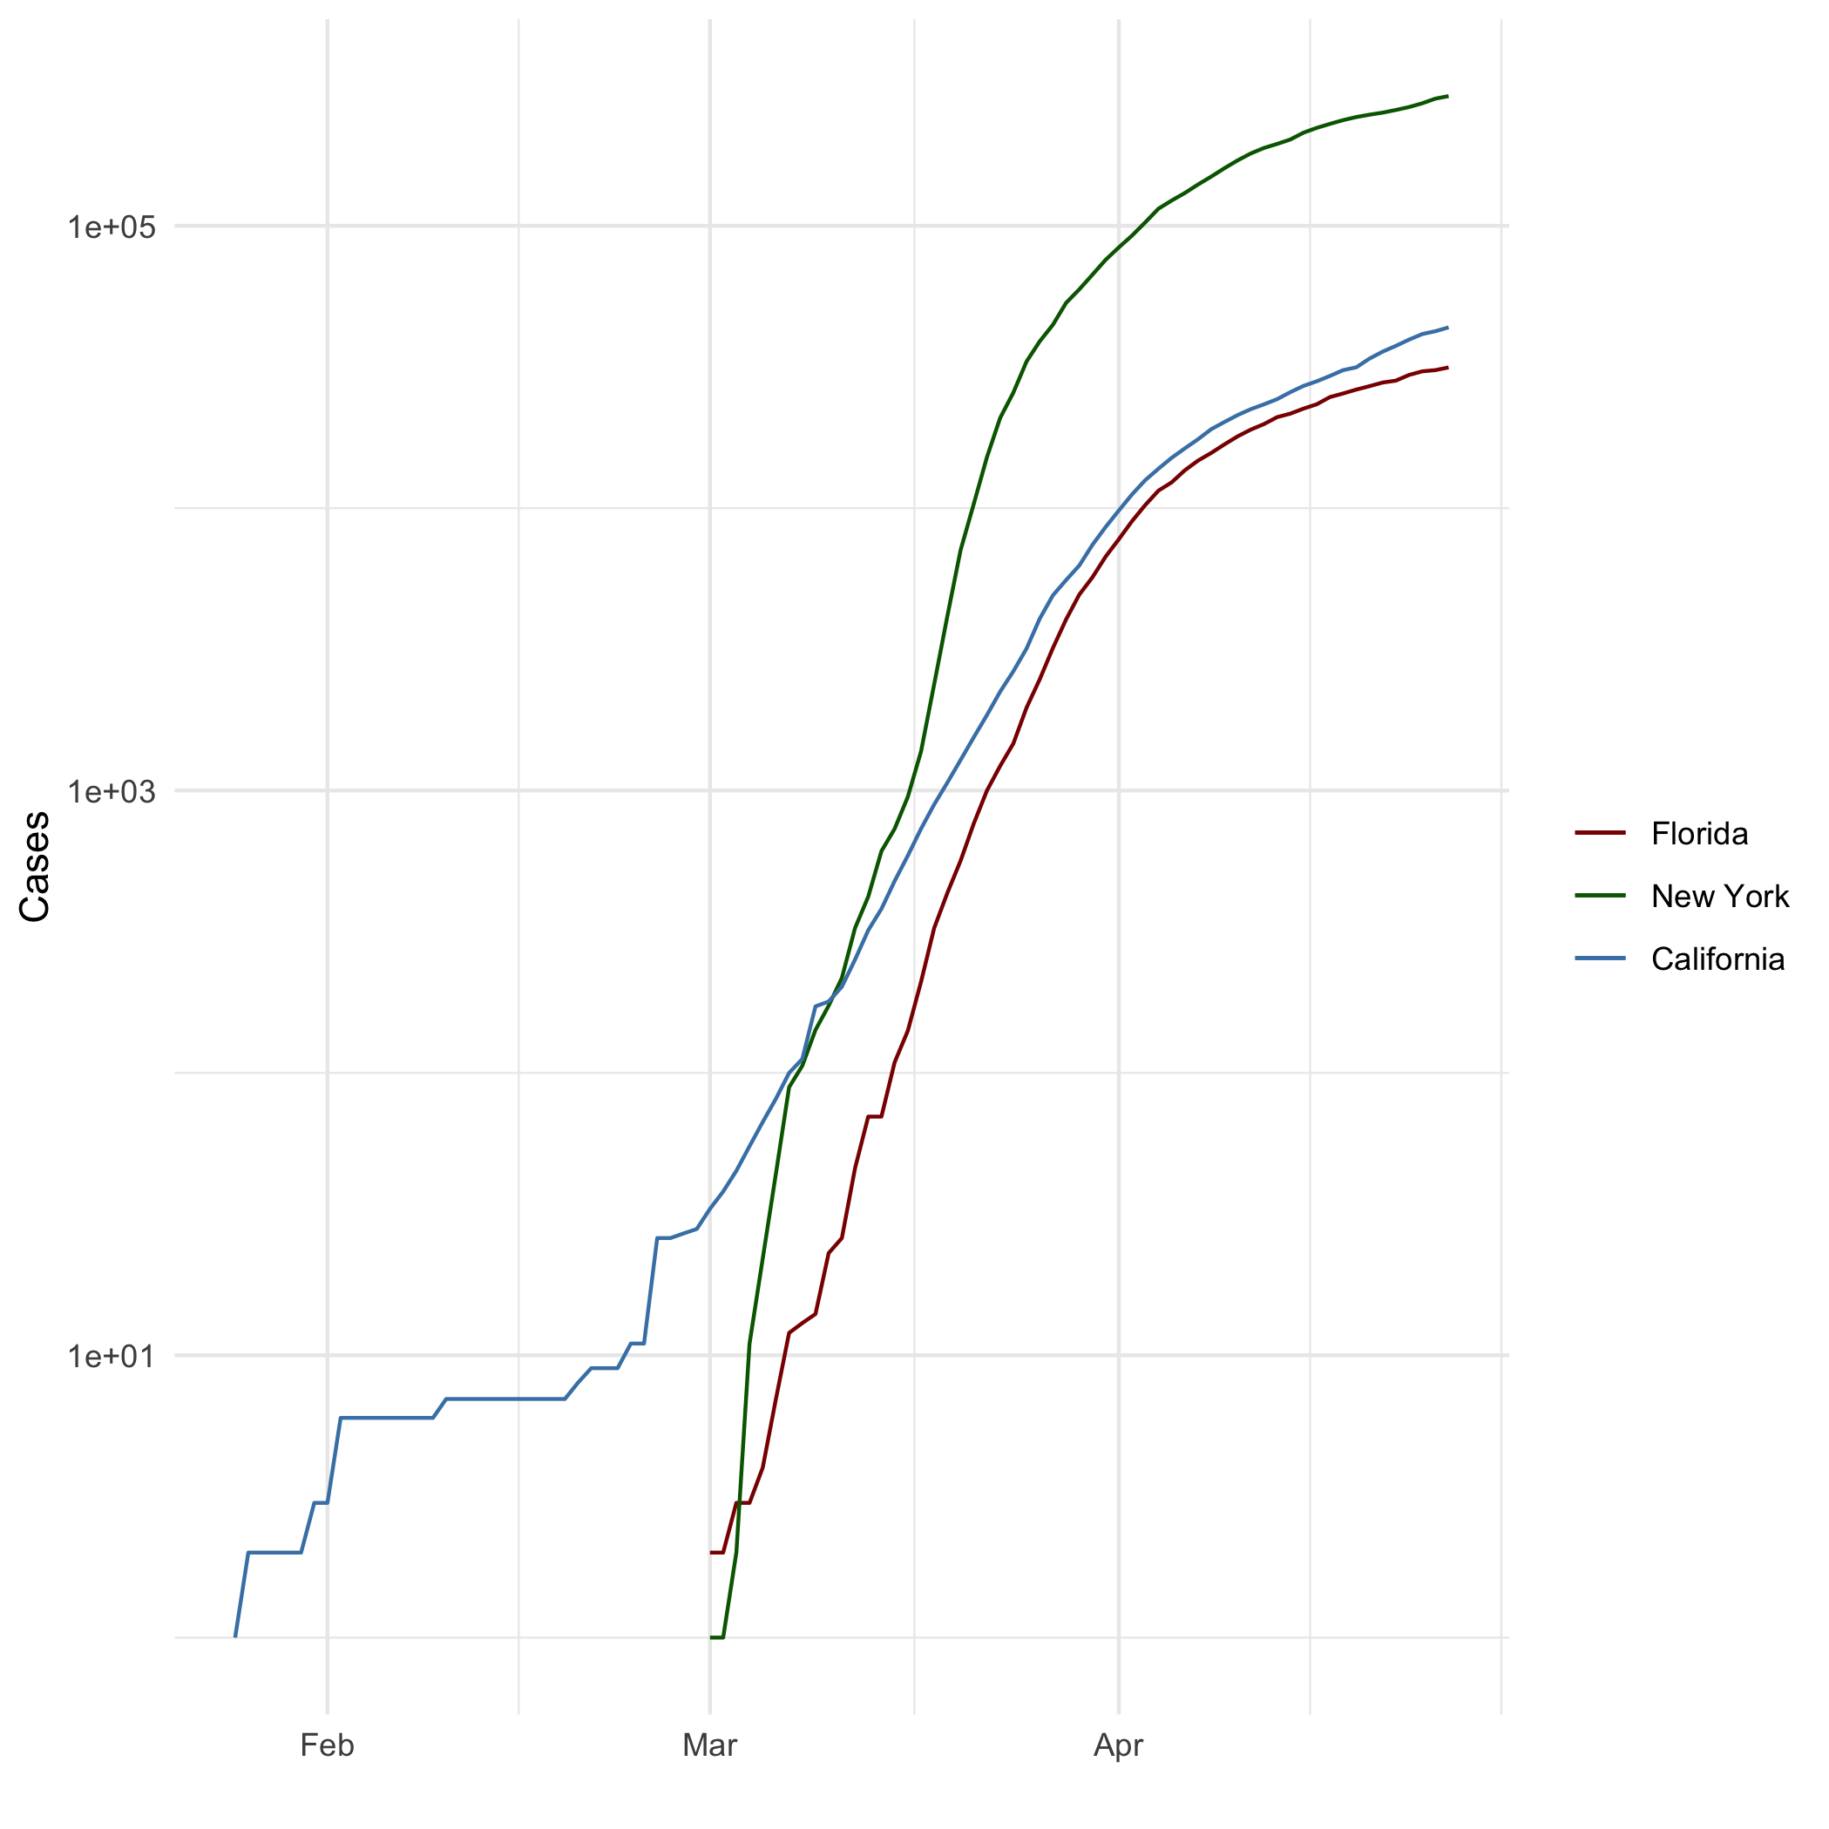

All Cases (Log Plot)

## Add a Quote

Milagro es la magia y la fuerza al creer. Andres Gimenez.

## Add an Equation

$x=\frac{−b±\sqrt[2]{b^{2}−4ac}}{2a}$

## Add a Footnote

[1]This is a footnote

## Add Citations

* (Lander 2014)R for Everyone
* (Field, Miles, and Field 2012)Discovering Statistics Using R

# Inline Code

library(ggplot2)

## Warning: package 'ggplot2' was built under R version 4.3.1

theme_set(theme_minimal())  
  
setwd("C:/Users/21428899/OneDrive-Bellevue University/Documents/GitHub/dsc520")  
  
heights_df <- read.csv("data/r4ds/heights.csv")  
  
covid_df <- read.csv("data/nytimes/covid-19-data/us-states.csv")  
  
california_df <- covid_df[ which( covid_df$state == "California"), ]  
ny_df <- covid_df[ which( covid_df$state == "New York"), ]  
florida_df <- covid_df[ which( covid_df$state == "Florida"), ]  
  
include=TRUE

## NY Times COVID-19 Data

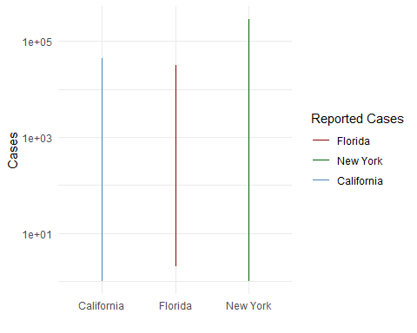 

## R4DS Height vs Earnings

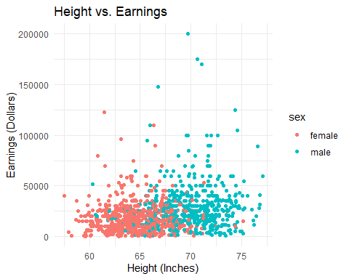

# Tables

## Knitr Table with Kable

One Ring to Rule Them All

| name | race | in_fellowship | ring_bearer | age |
| --- | --- | --- | --- | --- |
| Aragon | Men | TRUE | FALSE | 88 |
| Bilbo | Hobbit | FALSE | TRUE | 129 |
| Frodo | Hobbit | TRUE | TRUE | 51 |
| Galadriel | Elf | FALSE | FALSE | 7000 |
| Sam | Hobbit | TRUE | TRUE | 36 |
| Gandalf | Maia | TRUE | TRUE | 2019 |
| Legolas | Elf | TRUE | FALSE | 2931 |
| Sauron | Maia | FALSE | TRUE | 7052 |
| Gollum | Hobbit | FALSE | TRUE | 589 |

## Pandoc Table

| Name | Race | In Fellowship? | Is Ring Bearer? | Age |
| --- | --- | --- | --- | --- |
| Aragon | Men | Yes | No | 88 |
| Bilbo | Hobbit | No | Yes | 129 |
| Frodo | Hobbit | Yes | Yes | 51 |
| Sam | Hobbit | Yes | Yes | 36 |
| Sauron | Maia | No | Yes | 7052 |

# References

[PDF Quintero Vasquez Johnatan assignment04](%22C:\Users\21428899\OneDrive-Bellevue%20University\Documents\GitHub\dsc520\assignments\assignment04\assignment_04_Quintero_Vasquez_Johnatan.pdf%22)

[WORD Quintero Vasquez Johnatan assignment04](%22C:\Users\21428899\OneDrive-Bellevue%20University\Documents\GitHub\dsc520\assignments\assignment04\assignment_04_Quintero_Vasquez_Johnatan.docx%22)

Field, A., J. Miles, and Z. Field. 2012. *Discovering Statistics Using r*. SAGE Publications. <https://books.google.com/books?id=wd2K2zC3swIC>.

Lander, J. P. 2014. *R for Everyone: Advanced Analytics and Graphics*. Addison-Wesley Data and Analytics Series. Addison-Wesley. <https://books.google.com/books?id=3eBVAgAAQBAJ>.

1. This is a footnote.