

MOORING EQUIPMENT/DECK MOORING

DR. CARLOS S. LANTING COLLEGE



March 21, 2023

MARCIAL, JUSTINE R.

1.2 BRAVO

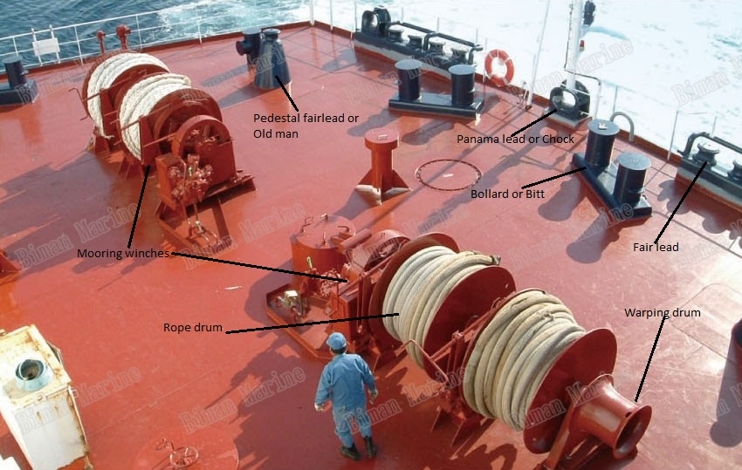PEDESTAL FAIRLEAD/ OLDMAN

-are commonly found on modern-day ships to guide mooring lines between the chock and the winch

MOORING WINCHES

-secure the shipboard end of mooring lines, provide for adjustment of the mooring line length and compensate for changes in draft and tide.

ROPE DRUM

-Description. The Rope Drum block represents a power transmission system where a rope is tightly wound around a cylindrical drum at a sufficient tension level to prevent slipping. You can configure the rope so that the ends point in the same or opposite directions.

WARPING DRUM

-The warping drum intended for installation on ocean-going ships serves for veering in a capron rope. It also can be used as a winch for hoisting and lowering a cargo up to 500 kg in mass by means of a steel rope to a height of 20 m.

FAIRLEAD

-A fairlead is a device to guide a line, rope or cable around an object, out of the way or to stop it from moving laterally. Typically a fairlead will be a ring or hook.

BOLLARD/BITT

They are useful when high densities of mooring lines are present, this is a better choice for ship mooring and shifting. Single Bitt Bollard also known as “US Style Pillar Bollards” are particularly suitable for applications where tidal range variations are large and can handle steep mooring line angles.

PANAMALEAD OR CHOCK

- The Panama Canal was built to lower the distance, cost, and time it took for ships to carry cargo between the Atlantic and the Pacific Oceans. Before the canal, ships would have to go around the entire continent of South America.

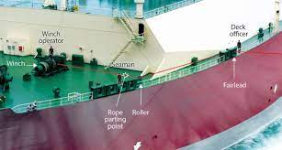

WINCH

- The primary function of a winch is to leverage that cable tension to pull a vehicle out of a difficult situation — whether it's stuck in mud, water, facing a steep incline, or unable to move under its own power. Single Bitt Bollards, often referred to as US Style Pillar bollards, are particularly suitable for applications where tidal range variations are large and can handle steep mooring line angles.

ROPE PARTING POINT

- A stopper knot is tied at the end of a rope to prevent the end from unraveling. It then functions like a whipping knot. A stopper knot is tied at the end of a rope to prevent the end from slipping through another knot, or passing back through a hole, block, or belay/rappel device. It then functions like a leash handle.

ROLLER

Made from galvanized steel, roller decks are designed to easily fit on top of Adam Equipment platforms. Unlike conventional rollers, when installed on bench and floor scale platforms, they allow parcels to be easily moved across them in two different orientations to accommodate front-to-back or side-to-side loading

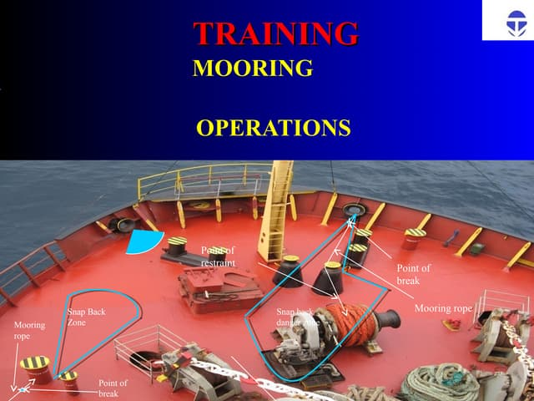MOORING ROPE

- Mooring rope is used to attach fittings on a vessel to fittings on a pier or harbour. There are three main types of mooring lines; chain mooring lines, wire mooring lines and synthetic fibre ropes. They are designed to be incredibly durable and strong to keep even the heaviest of vessels securely in place.

SNAP BACK DANGER

- They can be used in mooring, anchoring, tow lines and STS operations. Our RSB ropes: Increase operational safety.

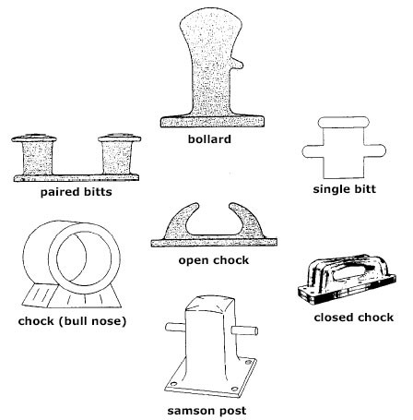

BOLLARD

- A bollard is a short post used to create a protective or architectural perimeter. When installed primarily as a visual guide, they guide traffic and mark boundaries. As architectural elements they come in a wide variety of shapes and styles to accentuate or visually stand out in their settings.

PAIRED BITTS

- Bitts are paired vertical wooden or metal posts mounted either aboard a ship or on a wharf, pier or quay. The posts are used to secure mooring lines, ropes, hawsers, or cables.

CHOCK OPEN AND CLOSE

- Open Chocks are primarily designed for guiding line or wire onto or around another deck fitting.

The Open Chock is made according to the standard of JIS F 2006-1976 and is a special model of the marine mooring chock used for small boats to lead the mooring rope from ship's inboard to outboard. It also can be applied for military and industrial ships, operating effectively throughout the world.

The closed chock is a type of ship's mooring and towing fitting installed on the shipside to lead the mooring and towing rope from the ship's inboard to outboard. The closed chocks are normally adopted for ships which use wire ropes.

SAMSON POST

-Quick Reference. In the old days when it was normal to cat anchors before they were let go or on weighing, a samson post was a post erected temporarily on deck to take a tackle with a sufficiently long lead for the whole crew to man the fall.

SINGLE BITT

- Single Bitt Bollards, often referred to as US Style Pillar bollards, are particularly suitable for applications where tidal range variations are large and can handle steep mooring line angles.