BUS ATTENDANCE SYSTEM THROUGH

FACIAL RECOGNITION BY

IMPLEMENTING AI INTEGRATION

*1JOHNSON C, 2KARTHICK M, 3SAKTHIVEL P, 4SASIKALA K, 5SANTHI A*

*1UG student, 2UG student, 3UG student*

*Department of Information Technology,*

*4Professor, Department of Information Technology*

*5Assistant Professor, Department of Information Technology*

*R P Sarathy Institute of Technology, Salem, Tamil Nadu.*

# *Abstract:* The Bus Attendance System through facial recognition by implementing AI integration a cutting-edge solution designed to streamline and enhance the attendance tracking process for students utilizing college transportation services. This innovative system leverages facial recognition technology and barcode scanning in conjunction with a comprehensive student database to automate attendance recording. This Bus Attendance System not only enhances the efficiency of attendance tracking but also ensures security and transparency in student transportation. By AI technologies, it minimizes manual data entry errors and provides a seamless experience for both students and parents. the system offers valuable insights and reports for administrative purposes, contributing to overall campus safety and accountability. Additionally, the system also sends real-time notifications to parents' mobile numbers, informing them when their child enters and exits the college bus, ensuring peace of mind and safety for both students and parents.

**Keywords:** Facial Recognition, barcode scanning, AI and cutting-edge technology, real-time notifications to parents.

1. **INTRODUCTION**

In an era marked by rapid technological advancement and a growing emphasis on safety and efficiency, the traditional methods of tracking student attendance have become increasingly outdated and cumbersome. This project, titled "Bus Attendance System through Facial Recognition by Implementing AI Tools," presents a cutting-edge solution to this age-old challenge within educational institutions.

The primary objective of this project is to revolutionize the way student attendance is managed on college buses by harnessing the power of artificial intelligence (AI). Through the seamless integration of facial recognition technology and barcode scanning, this innovative system ensures that students are accurately identified, recorded, and accounted for during their daily commutes.

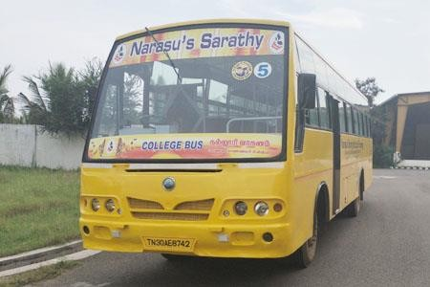 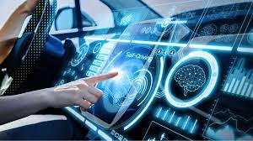

**Fig 1.1: College BUS Fig 1.2: AI Technology**

The key components of this system involve capturing a student's facial image and scanning their unique barcode (student ID). This data is then meticulously compared with an uploaded student database, allowing for precise identification and validation. Once this comparison is made, the student's attendance is seamlessly marked in the college's administrative system, recording essential details such as register number, name, department, year, date, and time.

One of the standout features of this system is its commitment to ensuring parental peace of mind. Whenever a student boards or disembarks from a college bus, an instant notification is sent to their parent's mobile number. This real-time communication fosters transparency and safety, enhancing the overall student experience.

Throughout this project, we will delve into the methodologies that underpin this sophisticated system. These methodologies encompass data collection and preparation, the development of a robust facial recognition model, barcode scanning implementation, secure database integration, attendance marking procedures, and the establishment of an effective notification system. Additionally, a user-friendly interface and administrative panel will be crafted to facilitate easy system operation and management.

As we embark on this journey to re-imagine student attendance tracking, our project will prioritize security and privacy, ensuring that sensitive student information remains protected and that the system complies with relevant data protection regulations.

Rigorous testing, comprehensive documentation, and ongoing support will be cornerstones of our project, ensuring that it not only meets but exceeds expectations. With the fusion of AI, cutting-edge technology, and a commitment to efficiency and safety, this Bus Attendance System stands to reshape the landscape of student attendance tracking on college buses, ushering in an era of innovation and effectiveness in the realm of educational transportation.

1. **LITERATURE REVIEW**

The literature review reveals a growing consensus on the limitations of traditional manual methods for tracking student attendance in educational institutions. Studies emphasize the prevalence of inaccuracies and inefficiencies in paper-based sign-in sheets and outdated ID card swiping systems, necessitating a paradigm shift towards automated and technologically advanced solutions.

Recent research underscores the increasing adoption of facial recognition technology and AI tools in attendance management systems. Facial recognition has shown promise in providing a secure and efficient means of student identification, while AI integration offers opportunities for real-time processing, adaptability, and enhanced system performance.

The literature consistently highlights the potential of such innovations to not only streamline attendance tracking but also contribute to heightened safety measures and parental engagement in the educational transportation context. Overall, the literature underscores the urgency and significance of incorporating advanced technologies to meet the evolving needs of modern educational systems.

1. **EXISTING SYSTEM**

In the existing system, student attendance on college buses is primarily managed using manual methods, such as paper-based sign-in sheets or ID card swiping systems. These traditional approaches pose several challenges in terms of accuracy, efficiency, and security. Manual sign-in sheets are prone to errors, such as illegible handwriting and the possibility of proxy attendance. On the other hand, ID card swiping systems may lack the robustness needed for comprehensive attendance tracking, as they often rely on outdated technology and can be easily manipulated.

Furthermore, the absence of real-time communication with parents leaves a gap in ensuring student safety during their commutes. Parents are often left uninformed about their child's whereabouts, which can cause anxiety and concerns about their safety. The lack of integration with modern technologies, such as facial recognition and AI tools, contributes to the limitations of the existing system in adapting to the evolving needs of educational institutions.

The current manual processes also demand significant administrative effort, leading to delays in recording and processing attendance data. This can result in inefficiencies and hinder the ability of educational institutions to promptly address attendance-related matters.

In the face of these challenges, the need for a more advanced and automated system becomes evident to streamline the attendance tracking process, enhance accuracy, and ensure a secure and transparent mechanism for both educational institutions and parents.

# PROPOSED SYSTEM

The cornerstone of our Bus Attendance System lies in its smart data processing capabilities, which leverage artificial intelligence (AI) to ensure accuracy, efficiency, and a seamless user experience.

**Facial Recognition Model Development:** To train a robust facial recognition model, a diverse dataset of facial images representing students in various lighting conditions and facial expressions will be collected and meticulously prepared.

**Deep Learning Implementation:** Cutting-edge deep learning techniques, such as Convolutional Neural Networks (CNNs), will be employed to develop a facial recognition model capable of accurately identifying and verifying students in real-time.

**Barcode Scanning Implementation:** The system will seamlessly integrate barcode scanning with facial recognition, providing an additional layer of verification. Student ID barcodes will be scanned to enhance the accuracy and reliability of the attendance tracking process.

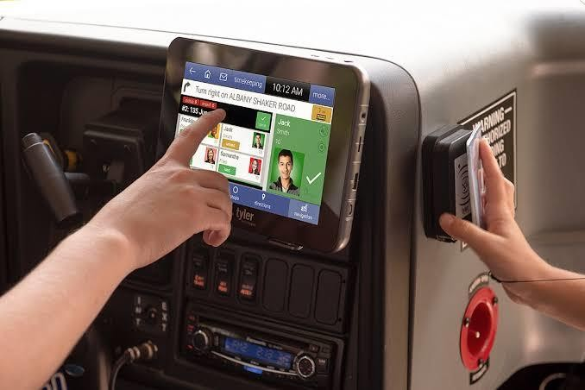

# Fig 1.3: ID Sensor

**Secure Database Integration:** A secure, centralized database will be implemented to store student information, ensuring quick and reliable access during attendance verification. This database will adhere to stringent security measures to safeguard sensitive student data.

**Real-time Data Synchronization:** The system will feature real-time data synchronization capabilities, ensuring that any updates or changes in the student database reflect instantaneously in the attendance tracking process.

**Attendance Marking Procedures:** Once the facial recognition and barcode scanning processes are complete, the system will automatically mark attendance in the college's administrative system. This includes essential details such as register number, name, department, year, date, and time, providing a comprehensive record.

**Real-time Notification System:** A real-time notification system will be implemented to send instant notifications to parents' mobile numbers whenever their child boards or disembarks from the college bus. This fosters transparency and ensures parents are promptly informed about their child's movements.

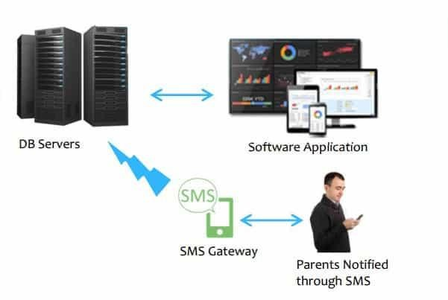

# Fig 1.4:Real-time Notification

**User-friendly Interface and Administrative Panel:** Intuitive User Interface: An intuitive and user-friendly interface will be developed for easy system operation. This includes a graphical interface for bus drivers and an administrative panel for system management, allowing authorized personnel to monitor and oversee the system's functionality.

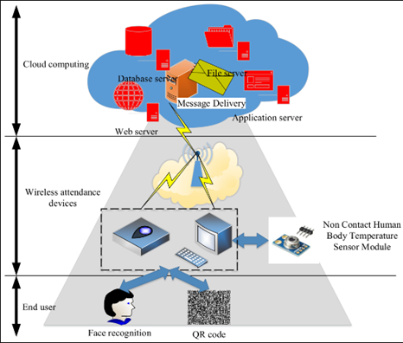

**Fig 1.5:Secure servers**

**Security and Privacy Measures:** Compliance with Data Protection Regulations: The system will be designed and implemented in compliance with relevant data protection regulations to ensure the privacy and security of sensitive student information as depicted in figure 1.5.

**Encryption and Access Control:** Robust encryption and access control mechanisms will be implemented to safeguard data integrity and restrict unauthorized access to the system.

# METHODOLOGY

**Facial Recognition**: The system utilizes Facial Recognition technology to scan the faces of students boarding and exiting the college bus. This enables accurate identification and eliminates the need for manual attendance marking.

**Barcode Scanning**: In addition to facial recognition, the system also scans the student's ID barcode. This dual identification process ensures a robust and error- free attendance record.

**Student Database**: An uploaded student database serves as the reference for comparison during the identification process. The system cross-references the scanned data with this database to ensure the student's identity.

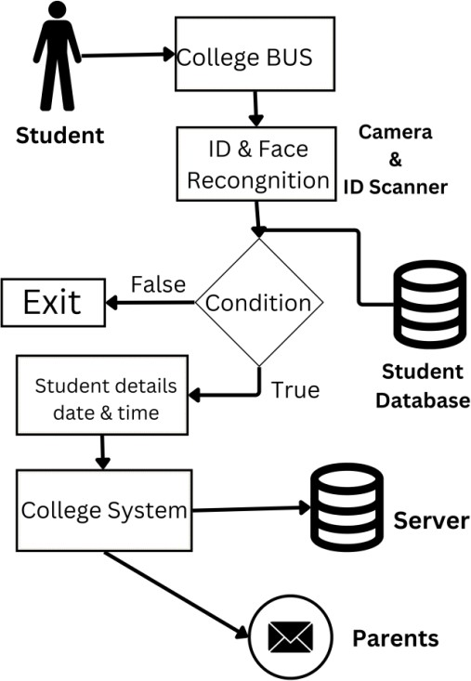**Attendance Marking**: Upon successful verification, the student's attendance is marked in the college system. This includes registering the student's roll number, name, department, year, date, and time of boarding or exiting the bus.

**Fig 1.6:Block Diagram**

**Parent Notification**: To enhance parent communication and safety, the system sends a notification to the registered mobile number of the student's parents whenever the student boards or exits the college bus.

This real-time notification feature ensures that parents are informed about their child's whereabouts and ensures peace of mind.

1. **CONCLUSION**

Provides comprehensive solution for colleges to streamline attendance. Helps in tracking, enhance security, and improve parent communication.

Improves operational efficiency, reduce manual effort, and provide an additional layer of safety for students.

1. **FUTURE ENHANCEMENT**

**Smart Predictive Analytics:** Incorporating predictive analytics can enable the system to anticipate and mitigate potential issues. By analyzing historical data, traffic patterns, and external factors, the system can provide predictive insights, optimizing bus routes and schedules for better efficiency.

**Biometric Multi-Modal Integration:** Enhancing the system's security and reliability by integrating additional biometric modalities, such as fingerprint or iris recognition, alongside facial recognition.

This multi-modal approach would add an extra layer of verification, reducing the likelihood of false positives and further securing attendance tracking.

**Energy-Efficient Hardware:** Exploring energy-efficient hardware options for the system's cameras and processors. This not only aligns with sustainability goals but also ensures prolonged system operation, especially in scenarios where buses may not have continuous access to power.

**Blockchain for Data Integrity:** Implementing blockchain technology to enhance the security and integrity of attendance records. By creating a decentralized and tamper-resistant ledger, the system can provide an immutable record of student attendance, instilling greater trust in the accuracy and reliability of the data.

**Integration with Student Performance Data:** Extending the system's capabilities to integrate with student performance data. This would allow for a holistic view of a student's academic journey, providing valuable insights into the correlation between attendance and academic achievement.

1. **REFERENCE**
2. M.M. Mansor (2009),” RFID based attendance system”, published in IEEE.
3. R. Santhana Krishnan (2021),"Secured College Bus Management System using IoT for Covid-19 Pandemic Situation", published in IEEE.
4. Mayank Srivastava (2020),"Real Time Attendance System Using Face Recognition Technique", published in IEEE.
5. DalalAljohar (2021),"Smart School Bus Tracking: Requirements and Design of an IoT based School Bus Tracking System", published in IEEE.
6. Aditi Purohit, Kumar Gaurav, Chetan Bhati, Atul Oak(2017) “Smart attendance” International conference of Electronics, Communication and Aerospace Technology (ICECA) 1, 415-419, 2017.
7. AsriNuhi, AgonMemeti, Florinda Imeri, BetimCico “Smart attendance system using qr code” 2020 9th Mediterranean Conference on Embedded Computing (MECO), 1-4.
8. Aafiya Hanafi, Sana Pathan, Shraddha Malik, RuhisanaAli(2017), “RFID-based System for School Children Transportation Safety Enhancement with Attendance System” AkbarNagani International Research Journal of Engineering and Technology (IRJET) 4 (03), 1704-1707.
9. Ciya James, David Nettikadan (2019) “Student monitoring system for school bus using facial recognition” 3rd International Conference on Trends in Electronics and Informatics (ICOEI), 659-663, 2019.
10. Kunal Ugale, Kuldip Lohare, RushikeshJaid, Amrita Ttuteja (2023) “Modern Face Recognition Attendance System Using Open CV” 2nd International Conference for Innovation in Technology (INOCON), 1-3.
11. Mayank Srivastava, Amit Kumar, Aditya Dixit, Aman Kumar “Real time attendance system using face recognition technique”.
12. Kunal Ugale, Kuldip Lohare, RushikeshJaid, Amrita Ttuteja “Modern Face Recognition Attendance System Using Open CV”.
13. Prajakta Bagul, Darshan Khedkar, Vaibhav Jagtap INTERNATIONAL JOURNAL 6 (2), (2021) “ATTENDANCE MONITORING SYSTEM WITH FACE RECOGNIZATION USING IOT”.
14. Vaithiyanathan Dhandapani, Swathi Majji, Kishore Udata, M Manigandan “Implementation of attendance management system based on text and face recognition” Advances in Energy Technology: Select Proceedings of EMSME 2020, 55-68, 2022.