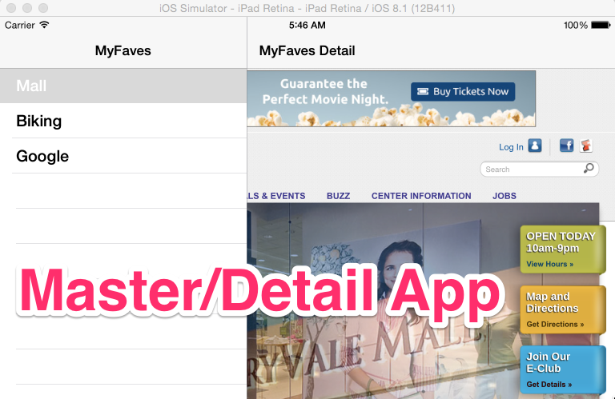

A Master/Detail App is great for apps that need a menu/display functionality. In addition, apps where menu’s grow and shrink.

1. Create a new project
   1. File > New Project
   2. Select “Master / Detail Application” > Next
   3. Fill in options screen > Next
   4. 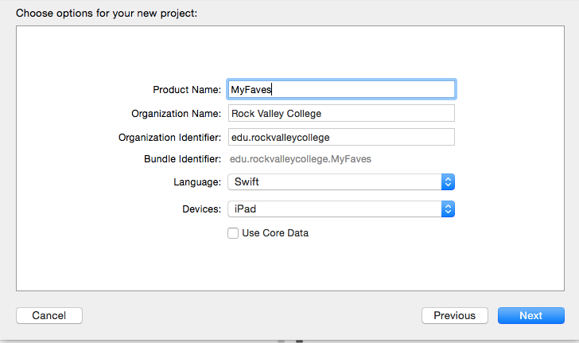
   5. Select “Desktop” (You can move later) > Create
2. UnCheck Upside Down  
   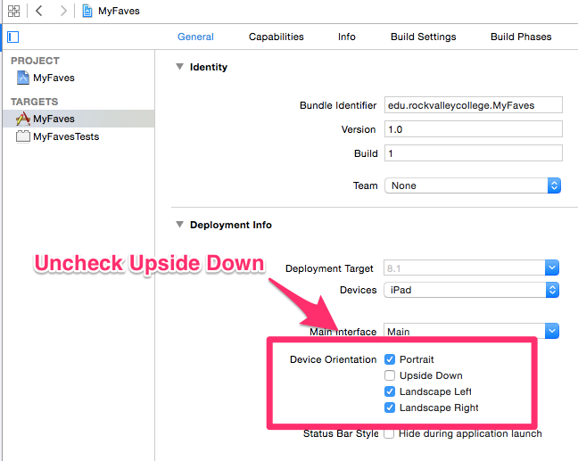
3. Edit Detail View  
   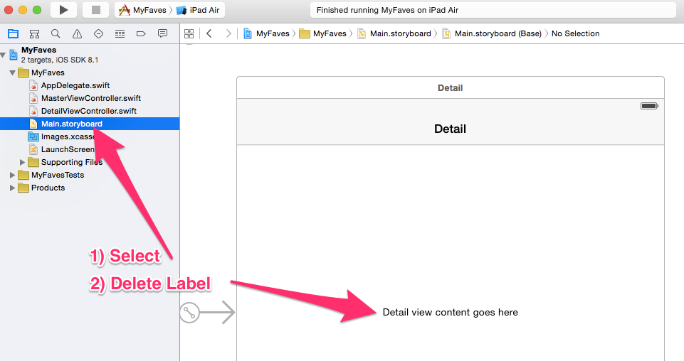
4. Add UIWebView to DetailViewController  
   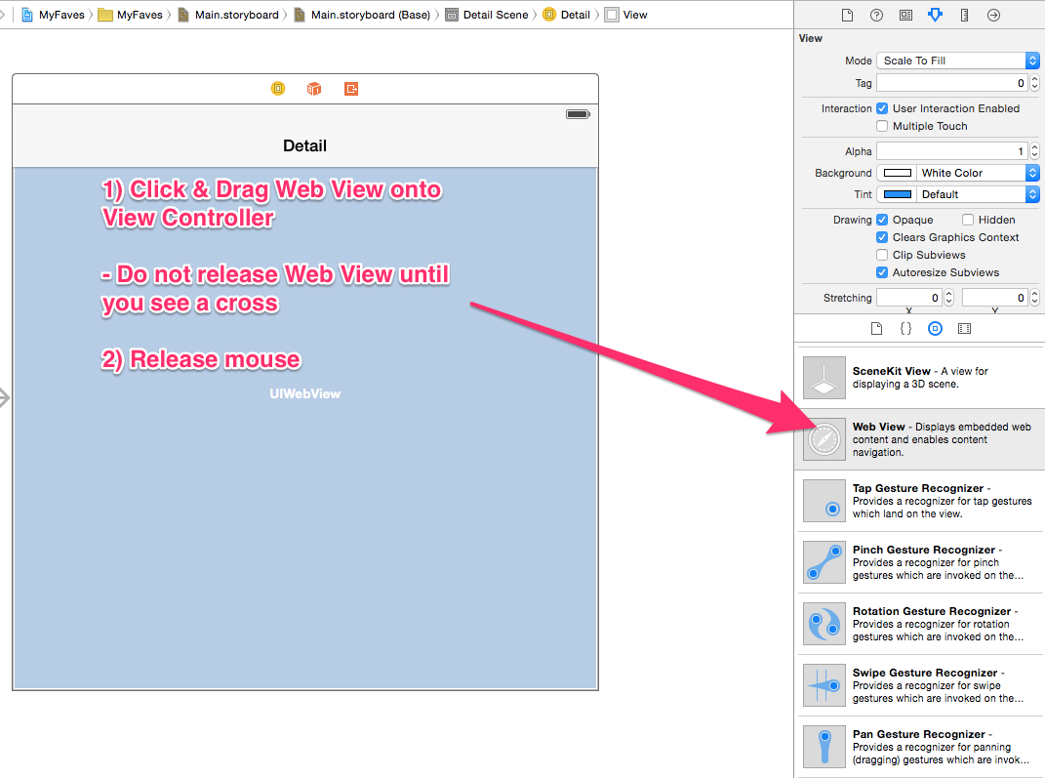
5. Add Constraints to UIWebView
   1. Select UIWebView by clicking ONCE with mouse
   2. Select “Resolve Auto Layout Issues”   
      Macintosh HD:private:var:folders:cx:s8bj0g1s2ddbsnh5kg217v8m0000gq:T:DMD5A8E269B-41A8-4458-9E54-B61865B48A0D:Cursor_and_Main_storyboard_—_Edited.png
   3. Under “Selected View” Choose & Select “Reset to Suggested Constraints”
6. Add Outlet for UIWebView
   1. Select UIWebView by clicking ONCE with mouse
   2. Select “Assistant Editor”

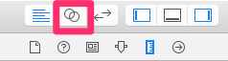

* 1. [CNTRL] + Drag UIWEBVIEW to DetailViewController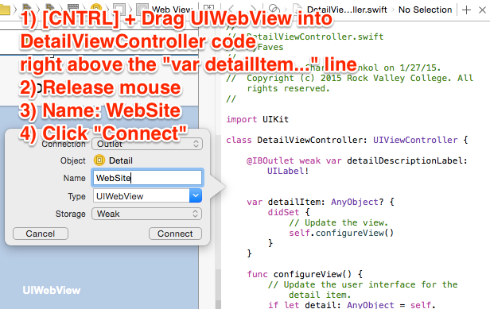
  2. Select the “Standard Editor” again  
     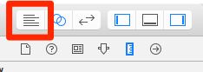

1. Edit the “MasterViewController.swift” file
   1. Select “MasterController.swift file under Project Navigator  
      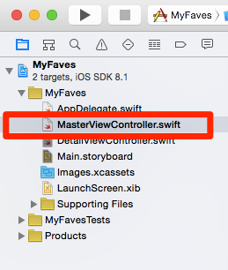
   2. See MasterViewController.swift: <https://github.com/ioscourse/MyFaves-Swift/blob/master/MyFaves%20Swift/MasterViewController.swift>
   3. Edit Code (Read and Complete 10 Steps in Comments)
2. Edit “DetailViewController.swift” file
   1. Select DetailViewController.swift file under Project Navigator
   2. See DetailViewController.swift: <https://github.com/ioscourse/MyFaves-Swift/blob/master/MyFaves%20Swift/DetailViewController.swift>
   3. Edit Code (Read and Complete 2 Steps in Comments)
3. Rename Titles for Master/Detail Views
   1. Select Main.StoryBoard
   2. Select Detail View & Rename “Detail” to “MyFaves Detail”  
      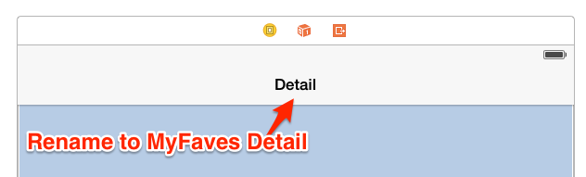
   3. Select Master Detail View & Rename “Master” to “MyFaves”  
      