
Intelligent Question Answering System for University Policy Documents
SUBMITTED BY:
OBIORA ORAKWUE
20221870
SUBMITTED TO:
DEPARTMENT OF COMPUTER SCIENCE,
FACULTY OF COMPUTING,
NILE UNIVERSITY OF NIGERIA

IN PARTIAL FULFILMENT FOR THE AWARD OF BACHELOR OF COMPUTER SCIENCE (B.Sc.) DEGREE IN COMPUTER SCIENCE IN THE FACULTY OF COMPUTING

SUPERVISOR: PROF. NOAH AKANDE

ABSTRACT 3
Chapter 1 – Introduction 5
1.0 Introduction 5
1.1 Backgroung of Study 5
1.2 Problem Statment and Research Questions 6
1.2.1 Problem Statement 6
1.3 Significance of Study 8
1.4 Aim and Objectives of Study 8
1.4.1 Study Aim 8
1.4.2 Objectives 9
1.5 Scope and Limitaion of Study 9
1.5.1 Scope of Study 9
1.5.2 Limitations of Study 9
B. Data-Related Limitations 10
C. Operational and Social Limitations 10
1.6 Oragnization of Stusy 10
Chapter 2 – Literature Review 13
2.1 Concept of Artificial Intelligence 13
2.2 Natural Language Processing 13
2.3 Evolution of Question Answering Systems 14
2.4 Transformer Architecture 14
2.5 Bidirectional Encoder Representations from Transformers (BERT) 15
2.6 DistilBERT and Model Optimization 15
2.7 Extractive Question Answering 15
2.8 Document-Based Question Answering Systems 16
2.9 Limitations of the Existing System 16
2.10 Related Works 16
2.11 Summary of Literature Review 21
Chapter 3 23
System Analysis And Design 23
3.0 Introduction 23
3.1 System Analysis 23
3.1.1 Analysis of Existing system 23
3.1.2 Justification for New system 24
3.1.3 Description of New system 24
3.2 Design of Proposed System 24
3.2.1 Data Model 24
3.2.2 Functional Requirements 25
3.2.2.1 Use Case Diagram 26
Figure 3.2.2.1: Use Case Diagram 26
Figure 3.2.2.2: Level 0 Data Flow Diagram 27
Figure 3.2.2.3 Level 1: Data Flow Diagram 28
Figure 3.2.2.4 Use Case Diagram 28
3.2.4 Software Structure 32
3.2.5 Workflow of Use Cases 32
3.3 Data Collection 34

ABSTRACT
This project focuses on the design and implementation of a transformer based Question Answering System for university policy documents. The system allows users to ask questions in natural language and receive accurate answers extracted directly from official university documents such as student handbooks and academic regulations.
The proposed solution applies Natural Language Processing(NLP) techniques and makes use of a fine tuned DistilBERT transformer model to perform extractive question answering by identifying relevant answer spans within the document text. To improve performance and efficiency, the policy documents are first preprocessed, segmented into smaller chunks, and indexed for easier retrieval
The system also provides a simple and user friendly interface that helps students and staff access important policy related information quickly without manually searching through long documents. Overall, this project highlights the effectiveness of transformer based Al models in improving accessibility, accuracy and efficiency in academic information systems

Chapter One – Introduction

Introduction

This chapter introduces the project titled “Design and Implementation of an Intelligent Question Answering System for University Policy Documents.” It presents the background of the study, explains the problem that motivated the research, and outlines the research questions. It also clearly states the aim and objectives of the project, defines the scope and limitations, and provides an overview of how the entire report is organized. These sections collectively create a strong foundation for understanding the direction and purpose of the research.

Background of Study

University environments are governed by a wide range of official documents that define academic rules, administrative procedures, and institutional policies. These documents include student handbooks, academic regulations, departmental guidelines, examination policies, and codes of conduct. They are designed to ensure consistency, transparency, and fairness in the management of academic and administrative activities. For students in particular, these documents serve as primary sources of information for understanding their rights, responsibilities, and academic requirements.
Despite their importance, accessing relevant information from university policy documents is often challenging. Many of these documents are lengthy, spanning dozens or even hundreds of pages, and are written in formal language that may not be easily understood by all users. Students who need quick answers to specific questions such as deadlines for course registration, rules governing examinations, or requirements for graduation often find it difficult to locate the
relevant sections efficiently. As a result, users may spend significant time searching through documents or rely on informal sources that may provide inaccurate information.
With the advancement of Artificial Intelligence (AI) and Natural Language Processing(NLP), it has become possible to improve how people interact with large text documents. NLP allows computers to understand and interpret human language, making it possible to build systems that respond intelligently to user questions. One key application of NLP is Question Answering (QA) systems, which enables users to ask questions naturally and receive direct answers extracted from a document or database
Recent progress in deep learning has strengthened modern QA systems, especially with transformers based models such as BERT and its variants. DistilBERT is a lighter and faster version of BERT that retains most of its accuracy while requiring fewer computational resources. Because of this balance, DistilBERT is suitable for real world academic systems where performance and speed are important. This project therefore applies transformer based NLP techniques to university policy documents to improve access to institutional information and reduce stress of manual searching

Problem Statement and Research Questions

Problem Statement
Although university policy documents are readily available, they are not always user-friendly in terms of information retrieval. Students and staff often experience difficulty locating specific answers within large and unstructured documents. Manual reading is time-consuming, while basic keyword search tools frequently return irrelevant results or fail to capture the intent behind a user’s query. This situation can lead to confusion, misinterpretation of policies, and, in some cases, failure to comply with important academic requirements.
The lack of an intelligent system capable of understanding natural-language queries means that users often depend on administrative offices for clarification. This dependency increases the workload of administrative staff and slows down communication within the institution. Furthermore, inconsistent responses from different sources may result in misinformation. These challenges highlight the need for a system that can automatically retrieve accurate, context-aware answers directly from official policy documents.
1.2.2 Research Questions
This study seeks to answer the following questions:
      - How can transformer-based NLP models be applied to extract accurate answers from university policy documents?
      - To what extent can a fine-tuned DistilBERT model improve the accuracy of document- based question answering compared to keyword-based search methods?
      - How effective is an AI-powered Question Answering System in improving information accessibility for students and staff?
      - What challenges arise when applying transformer models to long and unstructured policy documents, and how can they be mitigated?

Significance of Study
This study is important because it demonstrates how modern AI can be used to solve a practical issue in a university environment. By providing a system that enables direct interaction with policy documents through natural-language questions, the project improves information accessibility for students and staff. It also reduces the dependence on administrative personnel for routine inquiries, thereby improving institutional efficiency.
From a technical perspective, the project contributes to the practical application of transformer- based models in document-based information retrieval. It also serves as a reference for future research and development of AI-driven systems within educational institutions, particularly in developing countries where access to information is a recurring challenge.

Aim and Objectives of the Study
This section presents the general aim of the study and outlines the specific objectives required to achieve the stated aim.

Study Aim
The aim of this project is to design and implement an AI-powered Question Answering System that uses transformer-based natural language processing techniques to provide accurate and context-aware answers to questions posed on university policy documents.

1.4.2 Objectives
To achieve the stated aim, the study is guided by the following objectives:
      - To examine existing question answering systems and natural language processing techniques
      - To preprocess and structure university policy documents for effective use in a machine learning-based system
      - To fine-tune a DistilBERT transformer model for extractive question answering
      - To design and implement a system that accepts natural-language queries and retrieves relevant answers
      - To evaluate the system’s performance in terms of accuracy, relevance, and
usability

Scope and Limitation of the Study
This section defines the boundaries of the study by clearly outlining what the project covers and identifying the constraints encountered during its development. Separating the scope from the limitations helps to clarify the extent of the research and provides context for interpreting the system’s results.

Scope of the Study
The scope of this project is limited to the development of an extractive Question Answering System applied to English-language university policy documents. The system focuses on documents such as student handbooks and academic regulations and is designed to retrieve answers directly from these sources. The study emphasizes the use of transformer-based models, particularly DistilBERT, within an academic environment and does not incorporate external knowledge bases or internet search engines.

Limitations of the Study
Despite the effectiveness of the proposed system, the study is subject to certain limitations, which are grouped into technical, data-related, and operational limitations.

- Technical Limitations

The system relies on transformer-based models, which impose constraints on input length due to fixed token limits. As a result, lengthy university policy documents must be segmented into smaller text chunks before processing, which may occasionally affect the preservation of full contextual meaning. In addition, although DistilBERT offers improved computational efficiency compared to larger transformer models, its reduced size may lead to slight performance of trade offs in complex question-answering scenarios.
The system also operates as an extractive Question Answering model, meaning it can only return answers that explicitly exist within the source documents. It cannot generate new explanations or infer information beyond the available text. Furthermore, the performance of the system may vary depending on hardware limitations, particularly when deployed on machines with limited processing power.

B. Data-Related Limitations
The accuracy and reliability of the system are highly dependent on the quality, structure, and completeness of the university policy documents used. Documents containing ambiguous language, outdated policies, or inconsistent formatting may negatively impact answer precision. Additionally, the study is limited to English-language documents, which restricts usability for users who may prefer or require other languages.

C. Operational and Social Limitations
From an operational perspective, the system’s adoption depends on user familiarity and trust in AI-based solutions. Some users may prefer traditional methods of information retrieval or may be hesitant to rely on automated systems for official policy interpretation. There is also the possibility of users misinterpreting extracted answers without consulting the full policy context, which could lead to misunderstanding if not properly guided.
Institutional acceptance and integration into existing university systems may also present challenges, as policy updates require consistent document maintenance to ensure that the system remains accurate and up to date.

Organization of the Study
This project report is organized into five chapters. Chapter One presents the introduction to the study, outlining the background, problem statement, research questions, aim and objectives, scope, limitations, and definition of key operational terms. Chapter Two reviews existing literature related to question answering systems, natural language processing techniques, and transformer-based models relevant to the study. Chapter Three focuses on the analysis and design of the proposed system, including system architecture and design considerations. Chapter Four discusses the implementation of the system, testing procedures, and evaluation of results. Finally, Chapter Five concludes the study by summarizing the findings and providing recommendations for future research and system improvements.
Artificial Intelligence (AI): The branch of computer science concerned with the development of systems capable of performing tasks that typically require human intelligence, such as learning, reasoning, and decision-making.
Natural Language Processing (NLP): A subfield of artificial intelligence that focuses on enabling computers to understand, interpret, and process human language in a meaningful and context- aware manner.
Question Answering System: A software system designed to automatically provide direct and relevant answers to user questions expressed in natural language by analyzing a given data source.
Transformer Model: A deep learning architecture that utilizes self-attention mechanisms to model contextual relationships within text data, enabling improved language understanding.
DistilBERT: A compressed transformer-based language model derived from BERT, optimized to retain high performance while reducing computational complexity and inference time.
Extractive Question Answering: A question answering approach in which answers are selected directly from the source document rather than being generated or inferred beyond the available text.
University Policy Documents: Official institutional documents such as student handbooks, academic regulations, and departmental guidelines that define rules, procedures, and policies within the university.

Chapter Two – Literature Review

2.1 Concept of Artificial Intelligence
Artificial Intelligence (AI) refers to the development of computer systems that can perform tasks that normally require human intelligence, such as learning, reasoning, decision making and pattern recognition. Over the years, AI has evolved significantly from early rule based expert systems to modern data driven machine learning approaches that can adapt and improve based on experience and new information.
In academic environments, AI has increasingly been applied to tasks such as automated grading, intelligent tutoring systems, recommendation engines, and information retrieval [14]. These applications aim to improve efficiency and enhance user experience. The present study applies AI to the problem of accessing university policy documents, an area where accurate and timely information is critical for effective decision-making by students and staff.

2.2 Natural Language Processing
Natural Language Processing (NLP) is a subfield of AI that focuses on enabling computers to understand, interpret, and process human language in a meaningful way. NLP combines concepts from linguistics, computer science and machine learning to analyze text and extract useful meaning from it. Early NLP systems relied mainly on handcrafted rules and grammar based methods, but these approaches were difficult to scale and often failed when language became complex or unpredictable. In contrast modern NLP approaches leverage statistical models and neural networks to learn language representations from large datasets. Key NLP tasks include tokenization, part of speech tagging, named entity recognition and semantic understanding. These tasks allow systems to move beyond surface-level keyword matching toward deeper language understanding, which is essential for effective question answering.

2.3 Evolution of Question Answering Systems
Question Answering (QA) systems have undergone significant transformation over time. Early QA systems were mostly ruled based and domain-specific, requiring extensive manual effort to define question patterns and expected answers [16]. While these systems performed adequately in constrained environments, they struggled with language variability and complex sentence structures.
The introduction of machine learning techniques marked a major shift in QA system development. Statistical models enabled systems to learn from data rather than relying solely on predefined rules [17]. However, these approaches still faced limitations in capturing long-range dependencies and contextual meaning within text.
These limitations encouraged the development of transformer models, which became the foundation for modern QA systems due to their strong performance in understanding context and meaning.

2.4 Transformer Architecture
The transformer architecture represents a significant advancement in Natural Language Processing. Unlike traditional sequence models, transformers rely on self-attention mechanisms to capture relationships between words in a sentence regardless of their position [19]. This allows the model to understand context more effectively and process text in parallel, leading to improved efficiency.
Self-attention enables the model to weigh the importance of each word relative to others when generating representations [19]. This mechanism is particularly beneficial for question answering tasks, where understanding the relationship between a question and a passage is crucial. Transformers have become the foundation for many state-of-the-art NLP models, including BERT and its variants.

2.5 Bidirectional Encoder Representations from Transformers (BERT)
BERT is a transformer-based model designed to learn deep bidirectional representations of text. Unlike earlier models that processed text in a unidirectional manner, BERT considers both left and right context simultaneously [2]. This bidirectional understanding allows the model to capture nuanced meanings and improve performance on a wide range of NLP tasks.
BERT is pre-trained on large corpora using tasks such as masked language modeling and next sentence prediction [2]. It can then be fine-tuned on specific tasks, including question answering, using relatively small domain-specific datasets. Despite its effectiveness, BERT’s large size and computational requirements present challenges for deployment in resource-constrained environments.

2.6 DistilBERT and Model Optimization
DistilBERT is a distilled version of BERT designed to reduce model size while retaining most of its performance [6]. Through a knowledge distillation process, DistilBERT learns to mimic the behavior of the larger BERT model using fewer parameters [6]. This results in faster inference times and reduced memory consumption.
In document-based question-answering systems, efficiency is a critical consideration, particularly when processing multiple user queries. DistilBERT offers a practical balance between accuracy and performance, making it suitable for deployment in academic systems where computational resources may be limited [6]. This study adopts DistilBERT to ensure scalability and responsiveness without significant loss in answer quality.

2.7 Extractive Question Answering
Extractive Question Answering involves selecting answer spans directly from a given text rather than generating new responses [5]. This approach ensures that answers remain grounded in the source document, which is especially important when dealing with official policy materials [5]. Extractive QA systems identify the most relevant section of text that addresses the user’s question.
In the context of university policy documents, extractive QA provides transparency and reliability, as users can trust that responses are drawn from verified institutional sources [5]. This characteristic makes extractive QA particularly suitable for administrative and academic applications.

2.8 Document-Based Question Answering Systems
Document-based QA systems focus on answering questions using specific documents rather than open-domain knowledge bases [1]. These systems typically involve document preprocessing, passage segmentation, and relevance ranking before applying a QA model [1]. Challenges in document-based QA include handling long documents, maintaining contextual coherence, and ensuring accurate extraction of answers.
University policy documents often contain complex language and cross-referenced sections, making them challenging for traditional retrieval systems. Transformer-based QA models address these challenges by leveraging contextual embeddings to understand semantic relationships within text [20]. This capability makes transformer-based systems particularly suitable for institutional knowledge access platforms.

2.9 Limitations of the Existing System
The current approach has several limitations. First, keyword-based search tools do not understand the intent behind a user’s question, making it difficult to retrieve accurate answers unless exact wording is used. Second, manual document searching is time-consuming and inefficient,
especially when users are under time constraints. Third, there is no centralized intelligent system that provides direct answers, leading to repeated inquiries and delays in information dissemination. These limitations demonstrate that the existing system does not adequately support efficient and reliable access to university policy information.

2.10 Related Works

Several studies have explored the use of AI and NLP for question answering. Researchers have demonstrated that transformer-based models outperform traditional methods in both accuracy and robustness. Studies focusing on domain-specific QA systems report improved performance when models are fine-tuned on relevant datasets.
However, most existing works focus on domains such as healthcare, legal texts, and customer support. Limited research has been conducted on applying transformer-based QA systems to university policy documents. This gap highlights the relevance and originality of the present study. Below are some related works to this system.

1. Survey of Question Answering Systems
Hirschman and Gaizauskas (2001) conducted an early and influential survey of question-answering (QA) systems, examining the evolution from simple keyword-based search to natural-language-driven interfaces. The study categorized QA systems into information retrieval-based, rule-based, and natural language processing-driven approaches. The authors emphasized that early QA systems struggled with understanding semantic intent and often failed to deliver precise answers. This work laid the conceptual foundation for later machine learning-based QA systems by highlighting the importance of linguistic processing and semantic interpretation. However, the study did not address deep learning approaches, which limits its applicability to modern AI-based QA systems.

3. Deep Learning for Question Answering over Knowledge Bases
Yih et al. (2015) explored the application of deep learning techniques to question answering over structured knowledge bases. Their research demonstrated how neural networks can map natural language questions to structured queries, enabling more accurate retrieval of relevant information. While their focus was on structured data rather than unstructured documents, the study highlighted the importance of semantic representation and embedding techniques. This work is relevant to document-based QA systems because it underscores the role of deep learning in understanding meaning beyond surface-level keywords. However, its reliance on structured knowledge bases limits its direct applicability to document-based policy QA systems.

3. Transformer Architecture in Natural Language Processing
Vaswani et al. (2017) introduced the transformer architecture in their landmark paper Attention Is All You Need. The authors proposed a model based entirely on self-attention mechanisms, eliminating the need for recurrent or convolutional neural networks. This architecture significantly improved performance across various natural language processing tasks, including translation, summarization, and question answering. The transformer’s ability to model long-range dependencies and contextual relationships made it particularly suitable for document comprehension. This work forms the foundation of modern QA systems, including BERT, RoBERTa, and DistilBERT. A limitation of the original transformer model is its high computational cost, which later models attempted to reduce.

4. BERT for Extractive Question Answering
Devlin et al. (2019) introduced BERT (Bidirectional Encoder Representations from Transformers), a pre-trained language model that achieved state-of-the-art results on multiple NLP benchmarks, including the Stanford Question Answering Dataset (SQuAD). The authors demonstrated that BERT’s bidirectional training approach allows the model to better understand context within a sentence. In extractive QA tasks, BERT identifies the start and end positions of answers within a given passage. This approach directly supports document-based QA systems where answers must be extracted from policy documents. However, BERT’s large size and computational demands can limit its deployment in resource-constrained environments.

5. DistilBERT: Lightweight Transformer for QA
Sanh et al. (2019) proposed DistilBERT, a compressed version of BERT designed to retain most of its language understanding capabilities while significantly reducing model size and inference time. Their study showed that DistilBERT maintains approximately 97% of BERT’s performance while being 40% smaller and 60% faster. This makes DistilBERT highly suitable for real-time applications such as web-based QA systems. The authors evaluated the model on multiple benchmarks, including QA tasks, demonstrating its practical effectiveness. However, the model may underperform larger models in highly complex linguistic scenarios.
6. Document-Level Question Answering Systems
Chen et al. (2017) proposed a document-level QA framework that integrates information retrieval and reading comprehension modules. Their system retrieves relevant passages from large document collections and then applies a neural reader to extract precise answers. This two-stage architecture is particularly effective for long documents, such as policy manuals or handbooks. The study highlights the importance of passage selection as a precursor to accurate answer extraction. However, system performance depends heavily on the quality of the retrieval stage, and errors at this stage can propagate to the final answer.

7. Generative vs. Extractive QA Models
Lewis et al. (2020) compared generative and extractive QA models, highlighting the strengths and weaknesses of each approach. Generative models, such as T5 and BART, generate answers in natural language, while extractive models select answer spans directly from the source text. The authors found that extractive models generally perform better in domains where factual accuracy and textual grounding are essential, such as legal and policy documents. This supports the choice of an extractive QA approach for university policy systems. However, extractive models are limited to the phrasing used in the source document, which may affect readability in some cases.

8. QA Systems for Domain-Specific Documents
Zhang et al. (2021) examined the application of QA systems in domain-specific environments, particularly legal and regulatory documents. Their study demonstrated that fine-tuning transformer models on domain-specific datasets significantly improves performance compared to general-purpose QA models. This finding is directly relevant to university policy documents, which contain specialized terminology and institutional language. The study highlights the importance of domain adaptation. However, the creation of labeled domain-specific datasets remains a major challenge due to the cost and time required for annotation.

9. QA from Unstructured Textual Documents
Rajpurkar et al. (2016) introduced the Stanford Question Answering Dataset (SQuAD), which became a benchmark for evaluating extractive QA systems. Their work emphasized the importance of reading comprehension rather than simple retrieval, as systems must understand context to identify correct answers. The dataset facilitated the development of robust QA models by providing large-scale annotated data. While the dataset significantly advanced QA research, its focus on short Wikipedia passages limits its representativeness for long institutional documents such as policy manuals.
10. Challenges in Long-Document Question Answering
Caciularu et al. (2019) investigated the challenges of applying QA models to long documents, particularly those exceeding transformer input limits. The authors proposed document chunking and hierarchical attention mechanisms to manage long contexts. Their findings highlight the importance of text segmentation and context management when working with long policy documents. Although their approach improved performance, it introduced additional complexity in system design and increased processing time.
11. Evaluation Metrics for Question Answering Systems
Voorhees and Tice (2000) discussed evaluation methodologies for QA systems. Their work established standard evaluation frameworks that are still widely used in modern QA research. These metrics enable objective comparison of system performance and guide model optimization. However, traditional metrics may not fully capture user satisfaction or contextual relevance, especially in real-world applications such as university policy interpretation.
12. Practical Implementation of Document-Based QA Systems
Li et al. (2022) presented a practical implementation of a document-based QA system deployed in an organizational environment. The system integrated PDF parsing, text chunking, vector embeddings, and transformer-based QA models to deliver real-time answers to user queries. Their study demonstrated that combining document preprocessing with AI inference improves system accuracy and usability. This work closely aligns with the proposed system, as it addresses both technical and user-experience challenges. However, the study noted scalability limitations when processing extremely large document repositories.

2.11 Sumaarry of Literature Review
The reviewed literature shows a clear evolution from early keyword-based QA systems to modern transformer-based extractive models capable of understanding complex natural language queries. Transformer architectures, particularly BERT and DistilBERT, have significantly improved answer accuracy and contextual understanding. Document-level QA systems and domain-specific adaptations have further enhanced applicability in specialized fields such as legal, regulatory, and institutional documentation. However, challenges remain in managing long documents, ensuring domain adaptation, and maintaining system efficiency. These gaps support the need for the proposed system in this project, which aims to provide a user friendly and reliable way for students and staff to retrieve accurate policy information directly from official university documents.

Title of Paper | Author(s) | Year Published | Methodology | Focus | Limitations
Survey of Question Answering Systems | Hirschman & Gaizauskas | 2001 | Analytical survey of QA techniques | Evolution of QA systems | Does not address deep learning approaches
Deep Learning for QA over Knowledge Bases | Yih, He & Meek | 2015 | Neural network modeling | Semantic understanding in QA | Focuses on structured data, not documents
Neural QA over Long Documents | Chen et al. | 2017 | Two-stage retrieval and reading model | Document-level QA | Performance depends on retrieval accuracy
Generative vs. Extractive QA Models | Lewis et al. | 2020 | Comparative evaluation | Strengths of QA architectures | Generative models may hallucinate content
Domain-Specific QA Systems | Zhang et al. | 2021 | Fine-tuning transformers on domain data | Specialized QA for legal/regulatory texts | Requires costly labeled datasets
SQuAD: Reading Comprehension Dataset | Rajpurkar et al. | 2016 | Dataset construction and evaluation | Benchmarking extractive QA | Limited to short Wikipedia passages
Long Document QA Challenges | Caciularu et al. | 2019 | Chunking and hierarchical modeling | Handling long textual contexts | Increased system complexity
Evaluation of QA Systems | Voorhees & Tice | 2000 | Metric-based system evaluation | QA system performance measurement | Does not measure user satisfaction
Practical Deployment of Document QA | Li et al. | 2022 | System implementation and testing | Real-world document-based QA | Scalability challenges

CHAPTER 3

SYSTEM ANALYSIS AND DESIGN

Introduction
This chapter focuses on the analysis and design of the proposed system for answering questions from university policy documents. It begins by examining the existing method of accessing policy information and identifies the challenges users face. It then explains why there is a need for a new and more intelligent solution
The chapter also presents the design of the proposed system, including the data model, functional requirements, system architecture, software structure, and workflow for key system operations. Finally, it discusses the data collection process that supports the AI components of the system.

System Analysis
System analysis involves studying the current operating method to identify weaknesses and determine how a new system can address them more effectively. In the context of this project, system analysis focuses on how students and staff currently access university policy documents and the challenges associated with this approach.

Analysis of Existing System
The current approach for accessing university policy information relies largely on manual document consultation and basic keyword-based search functions. Policy documents are typically provided in PDF or printed formats, requiring users to read through large volumes of text to locate specific information. In some cases, users rely on document search features that return results based solely on keyword matching rather than contextual understanding.
This approach places a significant cognitive and time burden on users, particularly students who may not be familiar with the structure or terminology used in official policy documents. As a result, users may overlook important information or misinterpret policies. In many situations, students resort to asking peers or administrative staff for clarification, which introduces inconsistency and increases administrative workload.

Justification for the New System
The limitations of manual searching and keyword based tools justify the need for an intelligent question answering system. By using transformer based NLP models, the proposed system will understand questions written in natural language and extract correct answers directly from policy documents
Additionally, the use of a machine learning-based system ensures scalability and adaptability, as the system can be updated with new documents without redesigning the entire solution.

Description of New System
The proposed system is an AI powered document based Question Answering System designed specifically for university policy documents through a simple interface, and the system processes both the question and the relevant policy text using a fine tuned DistilBERT transformer model. The model identifies the most relevant answer span from the document and returns it to be user in a clear and direct format.
Unlike traditional search systems, the proposed solution focuses on contextual understanding rather than keyword matching, ensuring that answers are accurate and grounded in official documents.

Design of Proposed System
System design defines how the proposed system will work and how its components will interact. The design of this system emphasizes modularity, scalability, and clarity to ensure ease of maintenance and future enhancement.

Data Model
The data model defines how information is stored and managed within the system. The system stores policy documents, extracted text segments, and user query logs. Each document is uniquely identified and linked to its corresponding text passages.
The database structure is designed in Third Normal Form (3NF) to reduce redundancy and ensure consistency. Document tables store metadata such as title and upload date, while passage tables store segmented text used for question answering. This structured approach supports efficient retrieval and processing of document content.
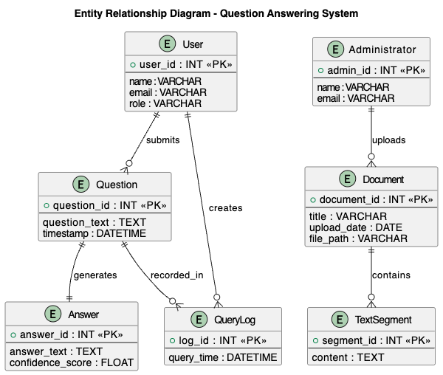
Figure 3.2.1 Data Model

Functional Requirements
Functional requirements describe what the system must do from the user’s perspective. The system must allow administrators to upload and manage policy documents, while users should be able to ask questions and receive accurate answers. The system must also support preprocess documents, segment long texts, and apply the transformer-based model to extract relevant answers.

Use Case Diagram
The Use Case Diagram shows how users interact with the system and outlines the key actions they can perform.
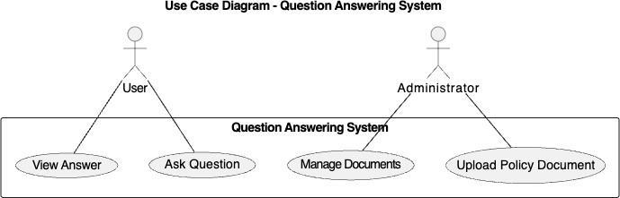

Figure 3.2.2.1: Use Case Diagram

3.2.2.2 Levl 0 Data Flow Diagram
The Level 0 Data Flow Diagram represents the system as a single process and focuses mainly on how external entities interact with the system. It shows the type of data that enters and exits the system without describing internal processes. It basically answers the question “Who interacts with the system and what data goes in and out?”.
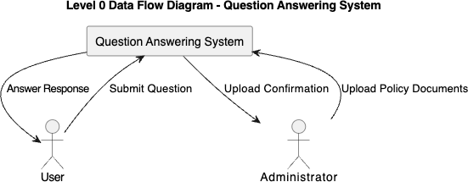

Figure 3.2.2.2: Level 0 Data Flow Diagram

      - Level 1 Data Flow Diagram

The Level 1 Data Flow Diagram expands the Level 0 diagram and breaks the system into internal processes. It shows how data flows inside the system, including documents processing, retrieval, and answer generation. It also includes data stores used to manage document content and queries. This answers the question “How does the system actually process the data?”
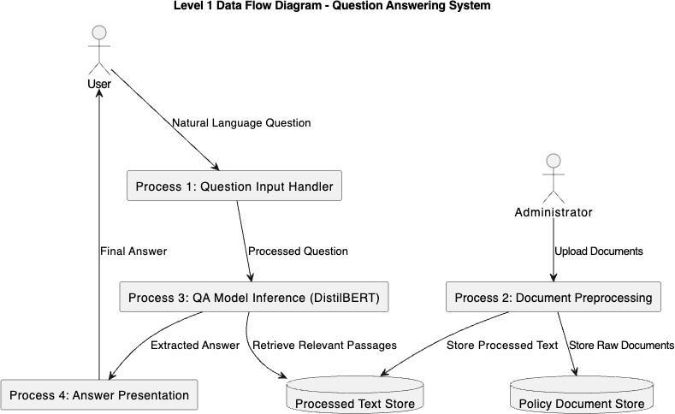

Figure 3.2.2.3 Level 1: Data Flow Diagram

      - Use Case Diagram

Below is the Use Case Diagram for the system. This diagram shows who can use the system and what actions they can perform. It focuses on user interaction, not data flow and not internal processing


Figure 3.2.2.4 Use Case Diagram

      - Database Model

The Database Model describes how the system stores information in tables and defines the keys entities and relationships. It ensures that stored data remains consistent and support efficient retrieval during questions answering.
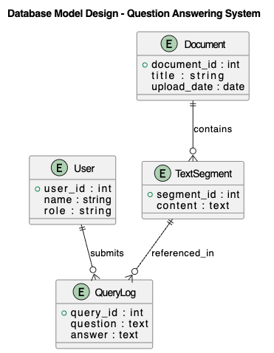
Figure 3.2.2.4 Database Model
3.2.2.6 Sequence Diagram

The Sequence Diagram explains how the system components interact step by step when a user submits a question. The process begins when the user enters a natural language query through the interface. This question is transmitted to the backend server, which acts as the central coordinator of system operations. The backend retrieves relevant policy document passages from the policy document store and forwards both the user’s question and the retrieved text to the Question Answering Engine powered by the DistilBERT model. The QA engine processes the input and extracts the most relevant answer span from the document text. This extracted answer is then returned to the backend server, which sends the final response to the user interface for display. The sequence diagram clearly demonstrates the step-by-step flow of operations and highlights how system components collaborate to deliver accurate answers in real time.
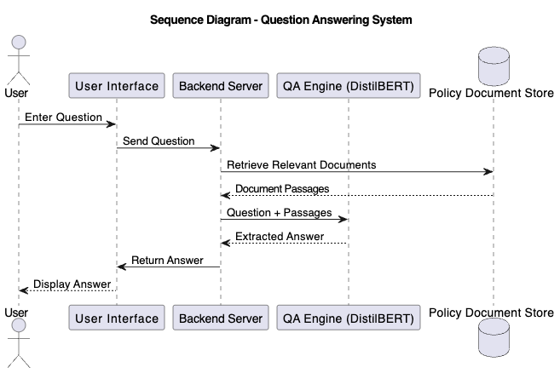Figure 3.2.2.6 Sequence Diagram
3.2.2.8 Class Diagram
The Class Diagram represents the internal software structure of the system and identifies key classes, their attributes, and their relationship . Classes such as User and Administrator represent system actors, while Document, Text Segment, Question, and Answer represent core data objects. The QASystem class coordinates question processing and answer retrieval. Relationships between classes illustrate how users submit questions, administrators upload documents, documents are segmented into text passages, and answers are generated from questions. This diagram provides a clear blueprint for system implementation and ensures that the software de3sign aligns with the expected system behaviour.
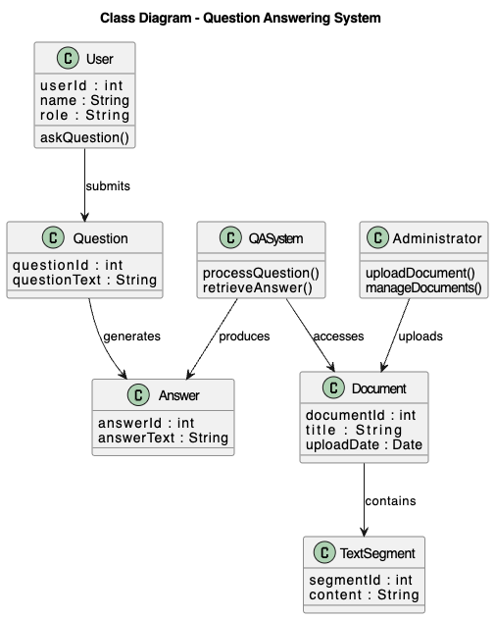
Figure 3.2.2.9 Class Daigram

    - System Architecture

The system is designed using a client server architecture. The client side provides a user friendly interface for entering questions and viewing answers. The server layer handles document management, preprocessing, and interaction with the AI model. The inference engine hosts the DistilBERT model responsible for extracting answers.
This layered architecture promotes separation of concerns, improves system reliability, and allows individual components to be updated independently. A Deployment Diagram illustrates how the system components are distributed across hardware and software environments.

Software Structure

The software is organized into modular components to make development band maintenance easier. These components include document processing modules, query handling modules, model inference modules, and user interface handlers. This modular structure simplifies debugging, testing, and future expansion of the system.
The relationships among these components are represented using a Class Diagram, which shows how different classes interact within the system.

Workflow of Use Cases

The system workflow explains what happens when a user interacts with the system. When a question is submitted, the system retrieves relevant document passages, processes the input using the QA model, and extracts the answer to the user.
This process is illustrated using an Activity Diagram, which provides a clear view of system behavior from start to finish.
3.3 Functional and Non-Functional Requirements
3.3.1 Functional Requirements
The functional requirements outline the key services the system must provide to achieve its objectives:
- The system allow users to input natural language questions through a web interface.
- The system shall process uploaded university policy documents and extract their textual content for analysis.
- The system shall tokenize, preprocess, and convert both user queries and document content into model-compatible formats.
- The system shall apply a transformer-based question answering model to identify relevant answer spans from the document corpus.
- The system shall return the most relevant answer along with the corresponding source context from the policy document.
- The system shall support document management, including uploading, updating, and removing policy documents from the knowledge base.
- The system shall maintain a history of user queries and system responses for monitoring, evaluation, and future improvement.
3.3.2 Non-Functional Requirements
Non-functional requirements describe system quality attributes such as performance, security and usability.
- The system provide responses within an acceptable time frame, with an average response latency of no more than a few seconds per query.
- The system shall ensure data privacy and security by restricting unauthorized access to stored documents and user interactions.
- The system shall maintain high accuracy and reliability, producing consistent and correct answers across different question types.
- The system shall be scalable to support more documents and users without major performance loss.
- The system shall be easy to use for users with different technical skills levels

- The system shall be modular and maintainable for easy future updates, debugging, and model improvements.
- The system shall work across modern web browsers and devices.

Data Collection

Data collection is a vital part of this project due to its reliance on artificial intelligence techniques. The dataset used consists of official university policy documents such as student handbooks and academic regulations. These documents are collected in digital format and converted into machine-readable text.
Before use, the documents undergo preprocessing steps including text extraction, cleaning, and segmentation to ensure compatibility with transformer-based models. This preparation improves model performance and ensures accurate extraction of answers.
REFERENCES
- Chen, D., Fisch, A., Weston, J., & Bordes, A. (2017). Reading Wikipedia to answer open-domain questions. Proceedings of the 55th Annual Meeting of the Association for Computational Linguistics (ACL), 1870–1879.
- Huang, K., & Zeng, X. (2020). Automated document-based question answering systems: Techniques and applications. Journal of Artificial Intelligence Research, 67, 123–145.
- McDonald, T., Tsan, B., Saini, A., Ordonez, J., Gutierrez, L., Nguyen, P., Mason, B., & Ng, B. (2022). Detect, retrieve, comprehend: A flexible framework for zero-shot document-level question answering. Advances in Document Information Systems.
- Rajpurkar, P., Zhang, J., Lopyrev, K., & Liang, P. (2016). SQuAD: 100,000+ questions for machine comprehension of text. arXiv Preprint.
- Wasi Uddin Ahmad, J. Chi, Y. Tian, & K.-W. Chang. (2020). PolicyQA: A reading comprehension dataset for privacy policies. Document QA Research.
- Athira, P. M., Sreeja, M., & Reghu Raj, P. C. (2013). Architecture of an ontology-based domain-specific natural language question answering system. International Conference on Natural Language Processing Systems.
- Alqifari, R. (2019). Question answering systems: Approaches and challenges. Proceedings of the Student Research Workshop Associated with RANLP.
- Sakil Ansari, R., Raut, R., & Shah, B. K. (2023). A review of question answering systems: Approaches, challenges, and applications. International Journal of Computer.
- Saad-Falcon, J., Barrow, J., Siu, A., Nenkova, A., Yoon, D. S., Rossi, R. A., & Dernoncourt, F. (2023). PDFTriage: Question answering over long, structured documents. Document QA Systems Research.
- Russell, S. J., & Norvig, P. (2021). Artificial intelligence: A modern approach (4th ed.). Pearson.
- Nilsson, N. J. (2014). The quest for artificial intelligence. Cambridge University Press.
- Holmes, W., Bialik, M., & Fadel, C. (2019). Artificial intelligence in education. Center for Curriculum Redesign.
- Jurafsky, D., & Martin, J. H. (2023). Speech and language processing (3rd ed.). Draft manuscript.
- Hirschman, L., & Gaizauskas, R. (2001). Natural language question answering: The view from here. Natural Language Engineering, 7(4), 275–300.
- Prager, J. (2006). Open-domain question-answering. Foundations and Trends in Information Retrieval, 1(2), 91–231.
- Hochreiter, S., & Schmidhuber, J. (1997). Long short-term memory. Neural Computation, 9(8), 1735–1780.
- Yang, Z., Dai, Z., Yang, Y., Carbonell, J., Salakhutdinov, R., & Le, Q. V. (2019). XLNet: Generalized autoregressive pretraining for language understanding. Advances in Neural Information Processing Systems, 32, 5753–5763.

