**SpectraSpectre Application Quick Start**

*SpectraSpectre is an implementation of the Python package MassQL for rapid querying of mass spectrometry data*

**Easy setup, recommended for first time use**

1. Extract SpectraSpectre.7z to your C:

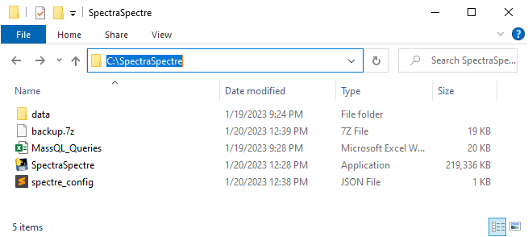

1. Place one **mzML format** data file into data>DataMZML directory

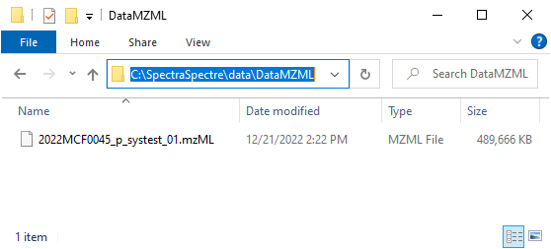

1. In SpectraSpectre directory, open “MassQL_Queries” file
2. Add/modify queries, save and close.
   1. ion_mode column:
      1. Use value of ‘1’ to indicate positive mode
      2. Use value of ‘0’ to indicate negative mode
3. In SpectraSpectre directory, open “spectre_config.json” file in a text editor
4. Verify the contents look as in this image:

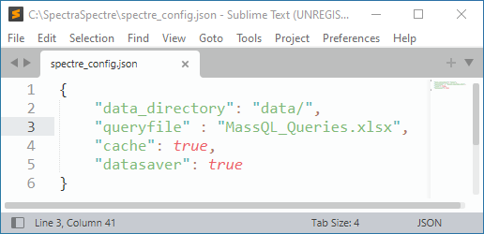

1. Double click “SpectraSpectre” file to run application
2. A blank console window should open (be patient). If everything is configured correctly, you should see an output that looks like this:

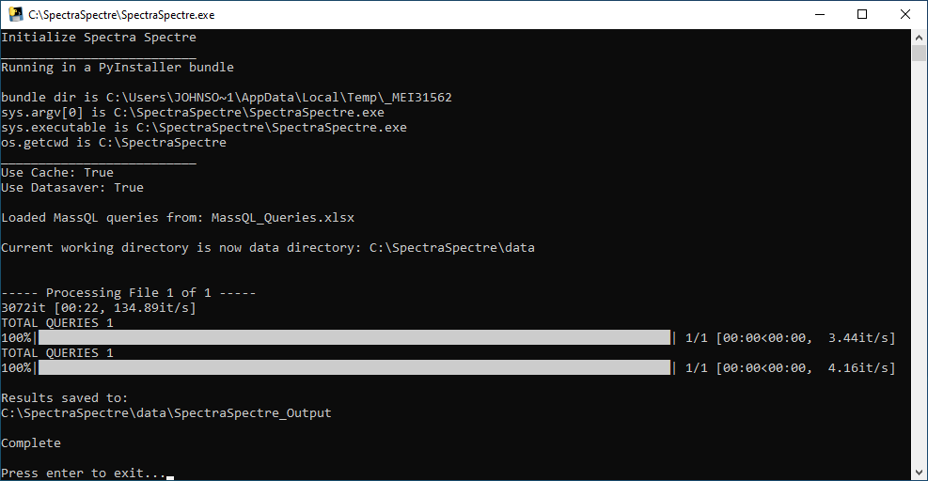

In my configuration, I ran two queries on one file. The output is saved within the data directory. Using the settings in this Easy setup, that directory is C:/SpectraSpectre/data/SpectraSpectre_Output

That directory should contain timestamped directories. The most recent (or only) directory should contain two files. One is an excel spreadsheet of the peak areas for each query applied to each file. The second file is a PDF with images showing the result of each query.

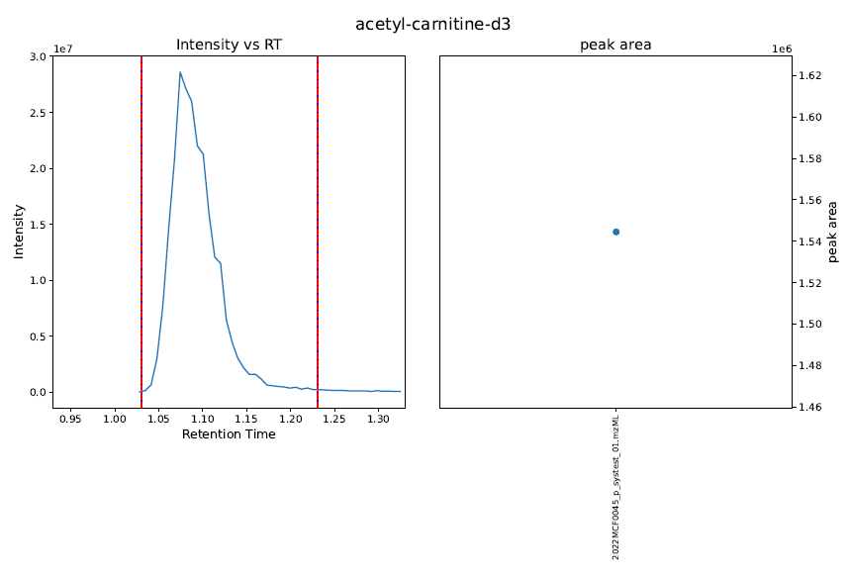

**Custom Setup**

Use this setup if either of the following apply:

* You wish to query data stored outside of the SpectraSpectre directory
* You want to specify a different path/name of your MassQL query file

1. It is recommended to first test the Easy setup above and make sure that works before proceeding with custom setup
2. Setup your data directory to follow the same schema as in the Easy setup. Your data directory is the root directory that must contain a directory titled “DataMZML” where your mzML format data is stored.

For example, if you have raw format data stored in “C:/MSData/”

You may choose to create a “DataMZML” directory within that directory to store your mzML format data “C:/MSData/DataMZML”

In this scenario, your data directory is “C:/MSData/”

1. Your query file may also be located anywhere on your PC
2. In SpectraSpectre directory, open “spectre_config.json” file in a text editor
3. Populate the “data_directory” and “queryfile” fields with the absolute paths to the corresponding directory and file

Example:

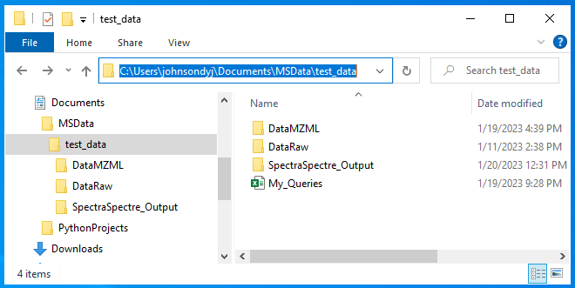

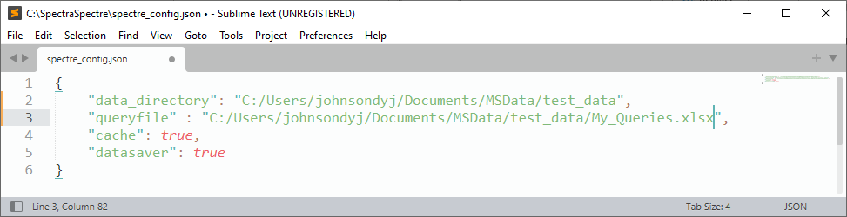

1. Save and close the “spectre_config” file. This file should always be kept in the SpectraSpectre directory
2. Double click the SpectraSpectre.exe file to start the application