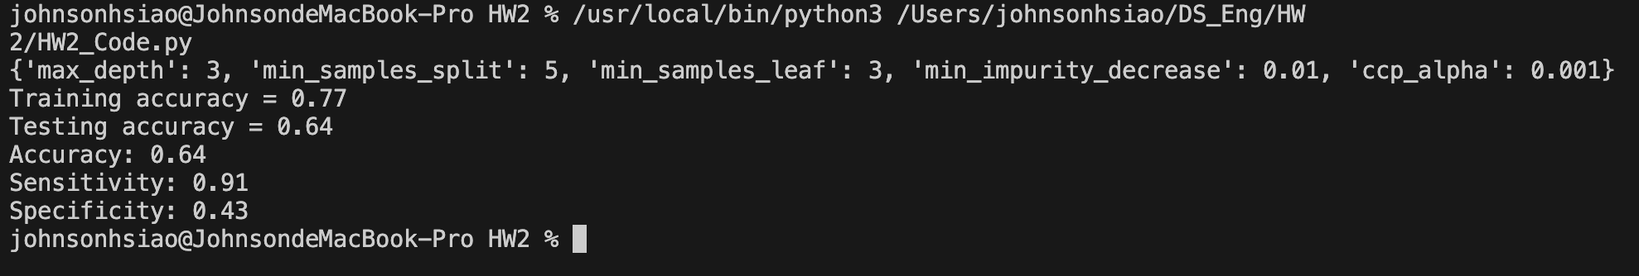

Three rules of the Tree.

# 1. If BMI ≤ 29.35 and Age ≤ 49.5, then No Diabetes

# The samples that satisfy this condition have a Gini index of 0.077, with 25 samples classified as No Diabetes (value = [24, 1]).

# 2. If BMI > 29.35 and Glucose ≤ 146.5, then No Diabetes

# The samples that satisfy this condition have a Gini index of 0.437, with 59 samples and a majority classified as Diabetes (value = [19, 40]).

# 3. If BMI > 29.35, Glucose > 146.5, and BMI ≤ 31.35, then Diabetes

# The samples that satisfy this condition have a Gini index of 0.495, with 40 samples split between No Diabetes and Diabetes (value = [18, 22]).

