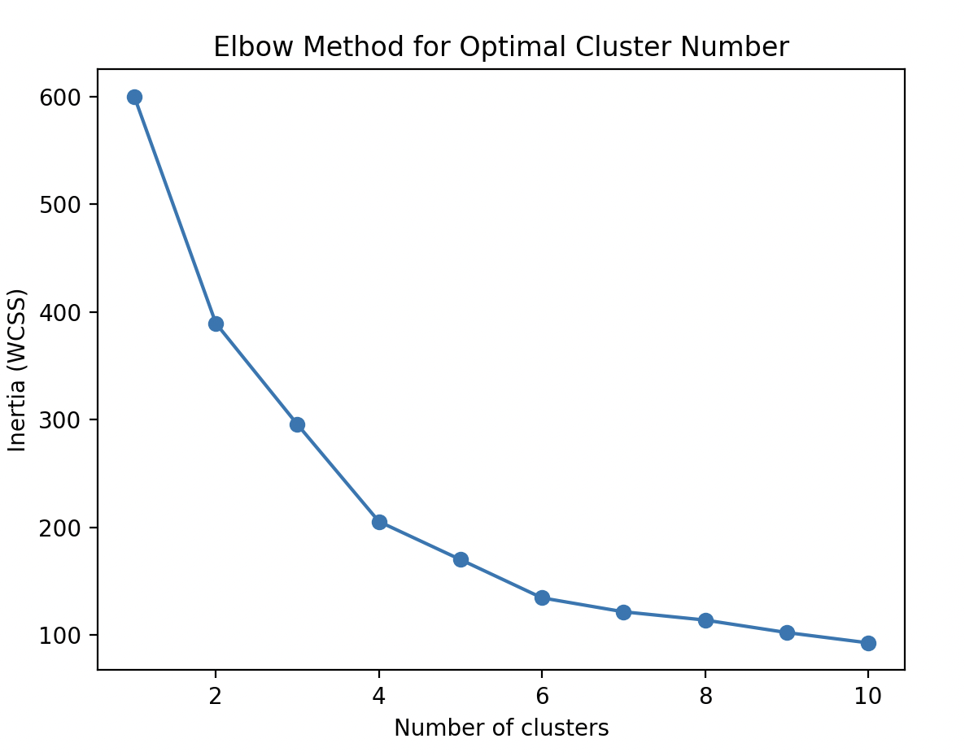

So we choose the cluster = 4;

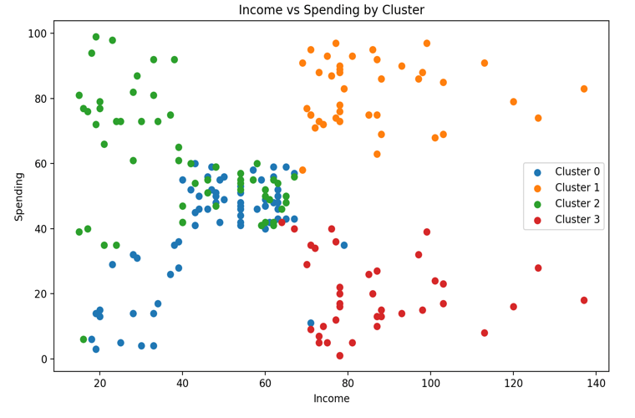Clusetr0 : Low Earners, Moderate Spenders(people who just lived alone)

Clusetr1 : High Earners, High Spenders(Maybe a high-class family)

Clusetr2 : Low Earners, High Spenders (Some of teenagers)

Clusetr3 : Moderate Earners, Low Spenders(Normal Family)

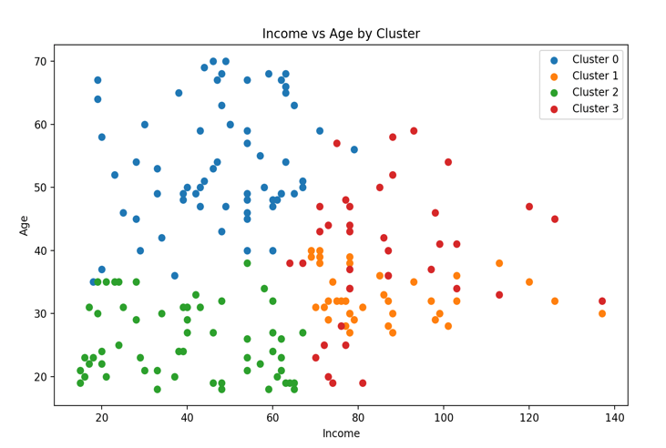

Clusetr0 : Older, Low Earners

(Part of elders in countryside)

Clusetr1 : Middle-Aged, High Earner(Engineer or hign-level employee)

Clusetr0 : Younger, Low Earners(student)

Clusetr0 : Middle-Aged, Moderate Earners(normal people)