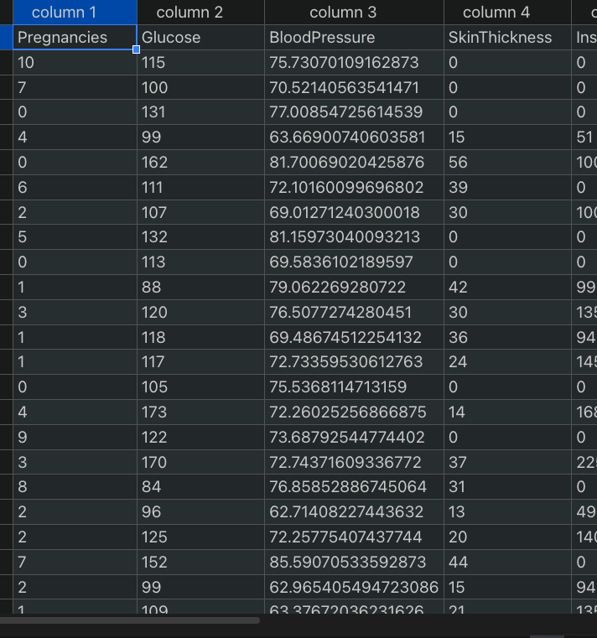

This columns is a predicted blood pressure and I also attached a csv file.

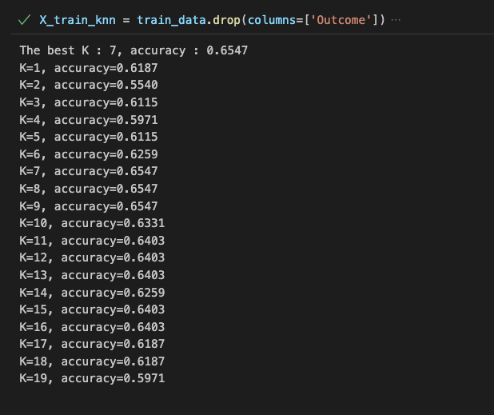

This are all iterations of KNN from 1 to 19, and the final answer is 7.