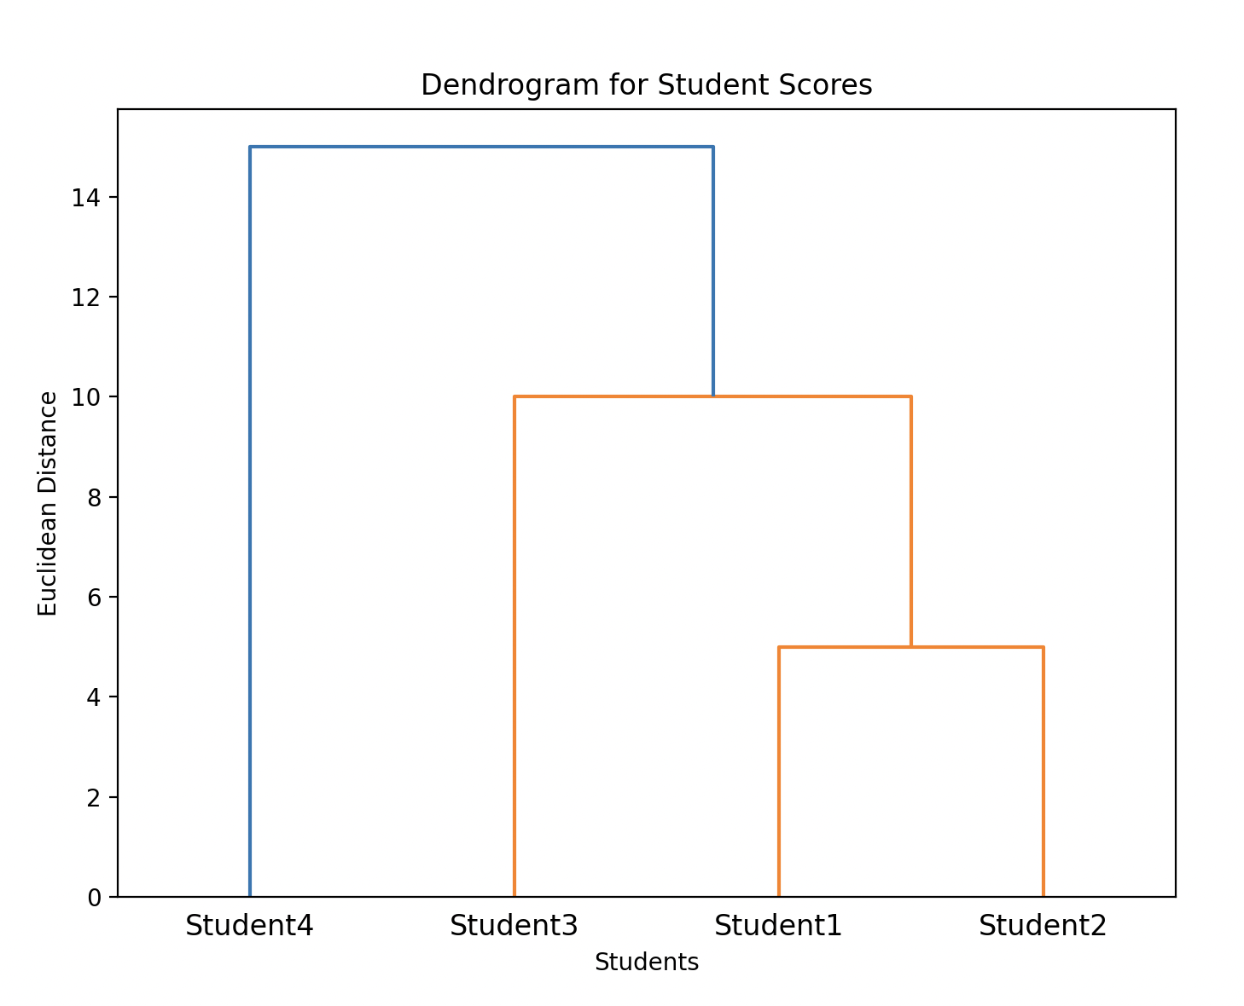

We compute the distances between every pair of students:

* d(Student1, Student2)= $\sqrt{{(75-80)}^{2}}$ = 5
* d(Student1, Student3)= $\sqrt{{(75-65)}^{2}}$ = 10
* d(Student1, Student4)= $\sqrt{{(75-95)}^{2}}$ = 20
* d(Student2, Student3) = $\sqrt{{(80-65)}^{2}}$ = 15
* d(Student2, Student4) = $\sqrt{{(80-95)}^{2}}$ = 15
* d(Student3, Student4) = $\sqrt{{(65-95)}^{2}}$ = 30

The closest pair of students is **Student1** and **Student2** with a distance of **5**.

We **merge** **Student1** and **Student2** into a single cluster.

**Recompute Distances**

Now that **Student1** and **Student2** are in a cluster, we compute the new distances using single linkage (i.e., the minimum distance between points from different clusters):

* Cluster {Student1, Student2} to **Student3**:   
  The distance is the minimum of d(Student1, Student3) = 10   
  and d(Student2, Student3)=15   
  So, the new distance is **10**.
* Cluster {Student1, Student2} to **Student4**:   
  The distance is the minimum of d(Student1, Student4)=20  
  and d(Student2, Student4)=15  
  So, the new distance is **15**.

**Identify Next Closest Pair**

The **next closest** pair is the cluster {Student1, Student2} and **Student3**, with a distance of **10**.

We **merge** the cluster {Student1, Student2} and **Student3** into a new cluster {Student1, Student2, Student3}.

Now, we compute the distances between the new cluster and **Student4**:

* Cluster {Student1, Student2, Student3} to **Student4**:   
  The distance is the minimum of   
  d(Student1, Student4)=20,   
  d(Student2, Student4)=15,   
  and d(Student3, Student4)=30.   
  So, the new distance is **15**.

The **final merge** is between the cluster {Student1, Student2, Student3} and **Student4** with a distance of **15**.

**Final Cluster**

The final clustering results in one single cluster: {Student1, Student2, Student3, Student4}.