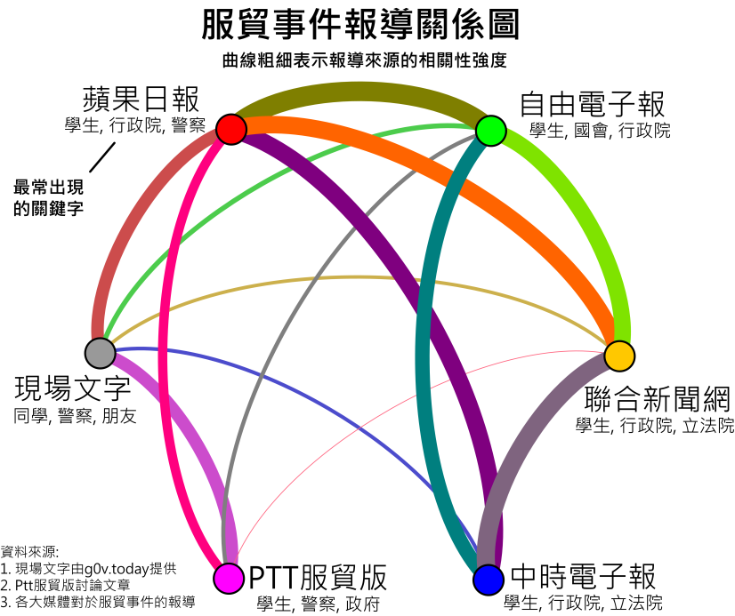

新聞詞頻(節錄)

|  |  |  |  |  |  |  |  |  |  |  |  |  |  |  |  |
| --- | --- | --- | --- | --- | --- | --- | --- | --- | --- | --- | --- | --- | --- | --- | --- |
|  | Live | PTT | 蘋果 | 中時 | 中央社 | 東森 | 自由 | 新頭殼 | NowNews | 聯合 | TVBS | 中廣 | 台視 | 華視 | 民視 |
| 同學 | 831 | 323 | 90 | 33 | 0 | 28 | 37 | 16 | 10 | 23 | 37 | 0 | 0 | 12 | 15 |
| 服貿 | 820 | 3602 | 722 | 484 | 287 | 348 | 663 | 78 | 143 | 628 | 191 | 86 | 41 | 116 | 173 |
| 警察 | 712 | 3902 | 368 | 89 | 46 | 103 | 253 | 31 | 32 | 132 | 70 | 11 | 6 | 16 | 30 |
| 學生 | 600 | 4128 | 1177 | 696 | 337 | 399 | 1256 | 215 | 274 | 864 | 291 | 94 | 69 | 113 | 230 |
| 行政院 | 559 | 2046 | 382 | 285 | 106 | 255 | 318 | 95 | 137 | 250 | 104 | 23 | 24 | 43 | 91 |
| 政府 | 529 | 2073 | 247 | 142 | 85 | 115 | 205 | 50 | 56 | 154 | 30 | 24 | 7 | 18 | 39 |
| 老師 | 348 | 347 | 70 | 34 | 5 | 17 | 37 | 11 | 3 | 46 | 13 | 4 | 0 | 7 | 5 |
| 律師 | 332 | 138 | 29 | 11 | 5 | 24 | 26 | 6 | 13 | 9 | 7 | 0 | 3 | 0 | 4 |
| 立法院 | 328 | 1552 | 224 | 167 | 158 | 110 | 159 | 49 | 103 | 209 | 75 | 30 | 14 | 30 | 42 |
| 國家 | 328 | 1172 | 165 | 79 | 55 | 61 | 117 | 21 | 25 | 99 | 13 | 4 | 0 | 8 | 14 |

相似度矩陣 (C22)

|  |  |  |  |  |  |  |  |  |  |  |  |  |  |  |  |
| --- | --- | --- | --- | --- | --- | --- | --- | --- | --- | --- | --- | --- | --- | --- | --- |
|  | 1 | 2 | 3 | 4 | 5 | 6 | 7 | 8 | 9 | 10 | 11 | 12 | 13 | 14 | 15 |
| 1 | 1.000 | 0.840 | 0.754 | 0.685 | 0.629 | 0.747 | 0.625 | 0.660 | 0.627 | 0.671 | 0.680 | 0.565 | 0.424 | 0.587 | 0.604 |
| 2 | 0.840 | 1.000 | 0.863 | 0.785 | 0.697 | 0.838 | 0.717 | 0.717 | 0.705 | 0.766 | 0.768 | 0.631 | 0.483 | 0.652 | 0.672 |
| 3 | 0.754 | 0.863 | 1.000 | 0.926 | 0.843 | 0.937 | 0.907 | 0.908 | 0.884 | 0.928 | 0.928 | 0.813 | 0.700 | 0.787 | 0.874 |
| 4 | 0.685 | 0.785 | 0.926 | 1.000 | 0.842 | 0.906 | 0.863 | 0.872 | 0.864 | 0.905 | 0.895 | 0.818 | 0.705 | 0.785 | 0.856 |
| 5 | 0.629 | 0.697 | 0.843 | 0.842 | 1.000 | 0.834 | 0.807 | 0.822 | 0.857 | 0.912 | 0.820 | 0.848 | 0.687 | 0.736 | 0.787 |
| 6 | 0.747 | 0.838 | 0.937 | 0.906 | 0.834 | 1.000 | 0.865 | 0.864 | 0.912 | 0.909 | 0.910 | 0.790 | 0.669 | 0.783 | 0.858 |
| 7 | 0.625 | 0.717 | 0.907 | 0.863 | 0.807 | 0.865 | 1.000 | 0.895 | 0.890 | 0.911 | 0.890 | 0.817 | 0.773 | 0.747 | 0.908 |
| 8 | 0.660 | 0.717 | 0.908 | 0.872 | 0.822 | 0.864 | 0.895 | 1.000 | 0.898 | 0.885 | 0.876 | 0.814 | 0.751 | 0.724 | 0.874 |
| 9 | 0.627 | 0.705 | 0.884 | 0.864 | 0.857 | 0.912 | 0.890 | 0.898 | 1.000 | 0.910 | 0.891 | 0.816 | 0.742 | 0.744 | 0.872 |
| 10 | 0.671 | 0.766 | 0.928 | 0.905 | 0.912 | 0.909 | 0.911 | 0.885 | 0.910 | 1.000 | 0.897 | 0.847 | 0.734 | 0.791 | 0.873 |
| 11 | 0.680 | 0.768 | 0.928 | 0.895 | 0.820 | 0.910 | 0.890 | 0.876 | 0.891 | 0.897 | 1.000 | 0.847 | 0.764 | 0.779 | 0.909 |
| 12 | 0.565 | 0.631 | 0.813 | 0.818 | 0.848 | 0.790 | 0.817 | 0.814 | 0.816 | 0.847 | 0.847 | 1.000 | 0.793 | 0.748 | 0.866 |
| 13 | 0.424 | 0.483 | 0.700 | 0.705 | 0.687 | 0.669 | 0.773 | 0.751 | 0.742 | 0.734 | 0.764 | 0.793 | 1.000 | 0.639 | 0.847 |
| 14 | 0.587 | 0.652 | 0.787 | 0.785 | 0.736 | 0.783 | 0.747 | 0.724 | 0.744 | 0.791 | 0.779 | 0.748 | 0.639 | 1.000 | 0.772 |
| 15 | 0.604 | 0.672 | 0.874 | 0.856 | 0.787 | 0.858 | 0.908 | 0.874 | 0.872 | 0.873 | 0.909 | 0.866 | 0.847 | 0.772 | 1.000 |