Measurement Protocol
Measurement Object | Utah_EVS_0520

Project | HASB+HAFB Rev08_GCF_PTCRB Release 17 (2023-03) TS 26.131/132 (Handset) Super/Fullband
Report Generation Date | 5/22/2025 10:29 AM
Responsible Person | tinno
Status Overview
SMD | Status | Single Value Description | Single  Value | Object
9.10.0 Overall Delay in RCV Dir. HASB | Done | Delay (Cross) [ms] | 131.3 | Utah_EVS_0520
9.10.0 DUT Delay RCV LTE/NR Setup HASB | Done | Calculated Value [ms] | 71.11 | Utah_EVS_0520
9.10.0 Overall Delay in SND Dir. HASB | Done | Delay (Cross) [ms] | 257.6 | Utah_EVS_0520
9.10.0 DUT Delay SND LTE/NR Setup HASB | Done | Calculated Value [ms] | 35.58 | Utah_EVS_0520
9.10.0 Check DUT Delay SND + RCV HASB | Ok | Calculated Value [ms] | 106.69 | Utah_EVS_0520
9.2.2.2 Loudness Rating RCV (RLR) Speech MAX HASB | Ok | RLR [dB] | -11.22 | Utah_EVS_0520
9.2.2.2 Loudness Rating RCV (RLR) Speech MAX-1 HASB | Done | RLR [dB] | -8.22 | Utah_EVS_0520
9.2.2.2 Loudness Rating RCV (RLR) Speech MAX-2 HASB | Done | RLR [dB] | -5.28 | Utah_EVS_0520
9.2.2.2 Loudness Rating RCV (RLR) Speech MAX-3 HASB | Done | RLR [dB] | -2.45 | Utah_EVS_0520
9.2.2.2 Loudness Rating RCV (RLR) Speech MAX-4(NOM)HASB | Ok | RLR [dB] | 0.74 | Utah_EVS_0520
9.2.2.2 Loudness Rating RCV (RLR) Speech MAX-5 HASB | Done | RLR [dB] | 3.72 | Utah_EVS_0520
9.2.2.2 Loudness Rating RCV (RLR) Speech MAX-6 HASB | Done | RLR [dB] | 6.71 | Utah_EVS_0520
9.2.2.2 Loudness Rating RCV (RLR) Speech MAX-7(MIN)HASB | Ok | RLR [dB] | 9.71 | Utah_EVS_0520
9.5.1 Sidetone Electr. Enabled MAX VOL HASB | Ok | STMR (unsealed) [dB] | 16.98 | Utah_EVS_0520
9.5.1 Sidetone Electr. Enabled NOM VOL HASB | Ok | STMR (unsealed) [dB] | 16.98 | Utah_EVS_0520
9.5.1 Sidetone Electr. Enabled MIN VOL HASB | Ok | STMR (unsealed) [dB] | 16.98 | Utah_EVS_0520
9.5.4 Sidetone delay, Volume NOM HASB | Done | Delay (Cross) [ms] | 2.2 | Utah_EVS_0520
9.3.2 Idle channel noise RCV MAX Volume, #1 HASB | Done | Level [dB[Pa]] | -66.84 | Utah_EVS_0520
9.3.2 Idle channel noise RCV MAX Volume, #2 HASB | Done | Level [dB[Pa]] | -67.37 | Utah_EVS_0520
9.3.2 Idle channel noise RCV MAX Volume, #3 HASB | Done | Level [dB[Pa]] | -67.87 | Utah_EVS_0520
9.3.2 Idle channel noise RCV AVG max. Volume, HASB | Ok | Calculated Value [dBPa(A)] | -67.34 | Utah_EVS_0520
9.3.2 Idle channel noise RCV NOM Volume, #1 HASB | Done | Level [dB[Pa]] | -68.13 | Utah_EVS_0520
9.3.2 Idle channel noise RCV NOM Volume, #2 HASB | Done | Level [dB[Pa]] | -66.72 | Utah_EVS_0520
9.3.2 Idle channel noise RCV NOM Volume, #3 HASB | Done | Level [dB[Pa]] | -67.41 | Utah_EVS_0520
9.3.2 Idle channel noise RCV AVG nom. Volume, HASB | Ok | Calculated Value [dBPa(A)] | -67.38 | Utah_EVS_0520
9.3.2 Single Frequency Disturbances RCV HASB | Ok | Min. dist. to tolerance scheme [dB], 673.8 Hz | 15.30 | Utah_EVS_0520
9.3.2 Single Frequency Disturbances RCV HASB | Ok | Min. dist. to tolerance scheme [dB], 668.0 Hz | 16.95 | Utah_EVS_0520
9.3.2 Single Frequency Disturbances RCV HASB | Ok | Min. dist. to tolerance scheme [dB], 1300.8 Hz | 23.42 | Utah_EVS_0520
9.3.2 Average Single Frequency Disturbances RCV HASB | Ok | Min. dist. to tolerance scheme [Pa], 668.0 Hz | 17.83 | Utah_EVS_0520
9.4.2 Sensitivity frequency char. RCV 1/3oct HASB MAX | Ok | Min. dist. to tolerance scheme [dB], 3150.0 Hz | 3.30 | Utah_EVS_0520
9.4.2 Sensitivity frequency char. RCV 1/3oct HASB NOM | Done | Min. dist. to tolerance scheme [dB], 3150.0 Hz | 3.37 | Utah_EVS_0520
9.4.2 Sensitivity frequency char. RCV 1/12oct HASB MAX | Ok | Min. dist. to tolerance scheme [dB], 3245.6 Hz | 3.96 | Utah_EVS_0520
9.4.2 Sensitivity frequency char. RCV 1/12oct HASB NOM | Ok | Min. dist. to tolerance scheme [dB], 2571.8 Hz | 3.86 | Utah_EVS_0520
9.8.2 Distortion Level RCV 1020 Hz #1 HASB MAX | Ok | Distortion [dB], 0.0 dB | 50.81 | Utah_EVS_0520
9.8.2b Distortion Level RCV 1020 Hz #2 HASB MAX | Ok | Distortion [dB], 0.0 dB | 50.10 | Utah_EVS_0520
9.8.2c Distortion Level RCV 1020 Hz #3 HASB MAX | Ok | Distortion [dB], 0.0 dB | 50.12 | Utah_EVS_0520
9.8.2 Distortion Level RCV 1020 Hz activation Average HASB MAX | Ok |  |  | Utah_EVS_0520
9.4.2 Sensitivity frequency char. RCV 1/3oct HASB MIN | Ok | Min. dist. to tolerance scheme [dB], 3150.0 Hz | 3.15 | Utah_EVS_0520
9.8.2 Distortion Level RCV 1020 Hz #1 HASB NOM | Ok | Distortion [dB], 0.0 dB | 53.21 | Utah_EVS_0520
9.8.2b Distortion Level RCV 1020 Hz #2 HASB NOM | Ok | Distortion [dB], 0.0 dB | 52.99 | Utah_EVS_0520
9.8.2c Distortion Level RCV 1020 Hz #3 HASB NOM | Ok | Distortion [dB], 0.0 dB | 53.26 | Utah_EVS_0520
9.8.2 Distortion Level RCV 1020 Hz activation Average HASB NOM | Ok |  |  | Utah_EVS_0520
9.8.2 Distortion Freq. RCV -16 dBm0, #1 HASB MAX | Ok | Distortion [dB], 315.0 Hz | 43.05 | Utah_EVS_0520
9.8.2 Distortion Freq. RCV -16 dBm0, #2 HASB MAX | Ok | Distortion [dB], 315.0 Hz | 42.65 | Utah_EVS_0520
9.8.2 Distortion Freq. RCV -16 dBm0, #3 HASB MAX | Ok | Distortion [dB], 315.0 Hz | 42.65 | Utah_EVS_0520
9.8.2 Distortion Freq. RCV -16 dBm0 activation Average HASB MAX | Ok |  |  | Utah_EVS_0520
9.8.2 Distortion Freq. RCV -16 dBm0, #1 HASB NOM | Ok | Distortion [dB], 315.0 Hz | 50.56 | Utah_EVS_0520
9.8.2 Distortion Freq. RCV -16 dBm0, #2 HASB NOM | Ok | Distortion [dB], 315.0 Hz | 50.46 | Utah_EVS_0520
9.8.2 Distortion Freq. RCV -16 dBm0, #3 HASB NOM | Ok | Distortion [dB], 315.0 Hz | 50.25 | Utah_EVS_0520
9.8.2 Distortion Freq. RCV -16 dBm0 activation Average HASB NOM | Ok |  |  | Utah_EVS_0520
P.863 AC RCV Handset SWB 13.2k MAX | Ok | MOS-LQO (Average) | 4.08 | Utah_EVS_0520
P.863 AC RCV Handset SWB 13.2k NOM | Ok | MOS-LQO (Average) | 4.01 | Utah_EVS_0520
P.863 AC RCV Handset SWB 13.2k MIN | Ok | MOS-LQO (Average) | 4.00 | Utah_EVS_0520
9.2.2.1 Loudness Rating SND (SLR) P.501 HASB | Ok | SLR [dB] | 6.79 | Utah_EVS_0520
SND Robustness with noise(gausswhite 82dB) HASB ECRP | Ok | SLR [dB] | 7.98 | Utah_EVS_0520
SND Robustness with noise(gausswhite 82dB) HASB 20UP | Ok | SLR [dB] | 8.14 | Utah_EVS_0520
SND Robustness with noise(gausswhite 82dB) HASB 25DOWN | Ok | SLR [dB] | 8.26 | Utah_EVS_0520
SND Robustness with noise(gausswhite 82dB) HASB 10OUT | Ok | SLR [dB] | 8.10 | Utah_EVS_0520
9.3.1 Idle channel noise SND, #1 HASB | Done | Level [dBm0] | -88.69 | Utah_EVS_0520
9.3.1 Idle channel noise SND, #2 HASB | Done | Level [dBm0] | -86.86 | Utah_EVS_0520
9.3.1 Idle channel noise SND, #3 HASB | Done | Level [dBm0] | -88.12 | Utah_EVS_0520
9.3.1 Idle channel noise SND, AVG HASB | Ok | Calculated Value [dBm0(A)] | -87.82 | Utah_EVS_0520
9.3.1 Single Freq. Distur. SND #1 HASB Perf. objective | Ok | Min. dist. to tolerance scheme [dB], 8015.6 Hz | 26.82 | Utah_EVS_0520
9.3.1 Single Freq. Distur. SND #2 HASB Perf. objective | Ok | Min. dist. to tolerance scheme [dB], 7992.2 Hz | 21.93 | Utah_EVS_0520
9.3.1 Single Freq. Distur. SND #3 HASB Perf. objective | Ok | Min. dist. to tolerance scheme [dB], 8009.8 Hz | 26.15 | Utah_EVS_0520
9.3.1 AVG Single Freq. Dist. SND HASB Perf. objective | Ok | Min. dist. to tolerance scheme [V], 7992.2 Hz | 25.16 | Utah_EVS_0520
9.4.1 Sensitivity frequency SND Speech 1/3oct MAN HASB | Ok | Min. dist. to tolerance scheme [dB], 2500.0 Hz | 1.07 | Utah_EVS_0520
9.4.1 Sensitivity frequency SND MAND 1/12oct HASB | Ok | Min. dist. to tolerance scheme [dB], 2432.3 Hz | 2.11 | Utah_EVS_0520
9.7.3 Acoustic echo control Compr. Speech MAX VOL HASB | Ok | Echo Loss [dB] | 77.68 | Utah_EVS_0520
9.7.3 Acoustic echo control Compr. Speech MIN VOL HASB | Ok | Echo Loss [dB] | 77.71 | Utah_EVS_0520
9.7.3 Acoustic echo control Compr. Speech NOM VOL HASB | Ok | Echo Loss [dB] | 81.24 | Utah_EVS_0520
9.8.1 Distortion SND 1020 Hz, activation, #1 HASB | Ok | Distortion [dB], 5.0 dB | 51.50 | Utah_EVS_0520
9.8.1 Distortion SND 1020 Hz, activation, #2 HASB | Ok | Distortion [dB], 5.0 dB | 43.70 | Utah_EVS_0520
9.8.1 Distortion SND 1020 Hz, activation, #3 HASB | Ok | Distortion [dB], 5.0 dB | 52.98 | Utah_EVS_0520
9.8.1 Distortion SND 1020 Hz activation Average HASB | Ok |  |  | Utah_EVS_0520
9.8.1 Distortion SND, activation, -4.7 dBPa, #1 HASB | Ok | Distortion [dB], 315.0 Hz | 35.70 | Utah_EVS_0520
9.8.1 Distortion SND, activation, -4.7 dBPa, #2 HASB | Ok | Distortion [dB], 315.0 Hz | 37.12 | Utah_EVS_0520
9.8.1 Distortion SND, activation, -4.7 dBPa, #3 HASB | Ok | Distortion [dB], 315.0 Hz | 35.62 | Utah_EVS_0520
9.8.1 Distortion SND -4.7 dBPa activation Average HASB | Ok |  |  | Utah_EVS_0520
9.6 Stability loss, check 100 Hz- 16000 Hz, MAX HASB | Ok | Min. dist. to tolerance scheme [dB], 785.2 Hz | 67.03 | Utah_EVS_0520
9.11 Record Echo Control Charact. Speech DT SND HASB | Done | DT Class A1 [%] | 100.00 | Utah_EVS_0520
9.11 Echo Control Chara. Speech short DT SND 1o2 HASB | Ok | DT Class A1 [%] | 100.00 | Utah_EVS_0520
9.11 Echo Control Chara. Speech long DT SND 2o2 HASB | Ok | DT Class A1 [%] | 99.74 | Utah_EVS_0520
P.863 AC SND Handset SWB 13.2K | Ok | MOS-LQO (Average) | 4.06 | Utah_EVS_0520
BGN Connection Wizard | Ok |  |  | Utah_EVS_0520
Prep: Measure Correction Factor for 3Quest SWB/FB | Done | Corrected Speech Level [dB[SPL]] | -1.55 | Utah_EVS_0520
9.12.1 Quality in ambient noise, Pub | Done | G-MOS (Average) | 3.39 | Utah_EVS_0520
9.12.1 Quality in ambient noise, Road | Done | G-MOS (Average) | 3.40 | Utah_EVS_0520
9.12.1 Quality in ambient noise, Crossroad | Done | G-MOS (Average) | 3.71 | Utah_EVS_0520
9.12.1 Quality in ambient noise, Train Station | Done | G-MOS (Average) | 3.71 | Utah_EVS_0520
9.12.1 Quality in ambient noise, Fullsize Car 130 km/h | Done | G-MOS (Average) | 3.59 | Utah_EVS_0520
9.12.1 Quality in ambient noise, Cafeteria | Done | G-MOS (Average) | 3.35 | Utah_EVS_0520
9.12.1 Quality in ambient noise, Mensa | Done | G-MOS (Average) | 3.73 | Utah_EVS_0520
9.12.1 Quality in ambient noise, Callcenter | Done | G-MOS (Average) | 3.94 | Utah_EVS_0520
9.12.1 Quality in the Presence of Ambient Noise AVG | Done |  |  | Utah_EVS_0520
9.12.1 Average N-MOS (Noise) HASB | Ok | Calculated Value [MOS] | 3.92 | Utah_EVS_0520
9.12.1 Average S-MOS (Speech) HASB | Ok | Calculated Value [MOS] | 3.97 | Utah_EVS_0520
9.12.1 Average G-MOS (Speech) HASB | Not Ok | Calculated Value [MOS] | 3.60 | Utah_EVS_0520
9.2.2.3 RLR max. with BGN - BGN only Rec. #1 HASB | Done |  |  | Utah_EVS_0520
9.2.2.3 RLR max. with BGN - Speech + BGN Rec. #2 HASB | Done |  |  | Utah_EVS_0520
9.2.2.3 RLR max. with BGN #3 HASB | Ok | RLR [dB] | -11.20 | Utah_EVS_0520

9.10.0 Overall Delay in RCV Dir. HASB 10
9.10.0 DUT Delay RCV LTE/NR Setup HASB 13
9.10.0 Overall Delay in SND Dir. HASB 14
9.10.0 DUT Delay SND LTE/NR Setup HASB 17
9.10.0 Check DUT Delay SND + RCV HASB 18
9.2.2.2 Loudness Rating RCV (RLR) Speech MAX HASB 19
9.2.2.2 Loudness Rating RCV (RLR) Speech MAX-1 HASB 22
9.2.2.2 Loudness Rating RCV (RLR) Speech MAX-2 HASB 25
9.2.2.2 Loudness Rating RCV (RLR) Speech MAX-3 HASB 28
9.2.2.2 Loudness Rating RCV (RLR) Speech MAX-4(NOM)HASB 30
9.2.2.2 Loudness Rating RCV (RLR) Speech MAX-5 HASB 33
9.2.2.2 Loudness Rating RCV (RLR) Speech MAX-6 HASB 36
9.2.2.2 Loudness Rating RCV (RLR) Speech MAX-7(MIN)HASB 39
9.5.1 Sidetone Electr. Enabled MAX VOL HASB 42
9.5.1 Sidetone Electr. Enabled NOM VOL HASB 45
9.5.1 Sidetone Electr. Enabled MIN VOL HASB 48
9.5.4 Sidetone delay, Volume NOM HASB 51
9.3.2 Idle channel noise RCV MAX Volume, #1 HASB 54
9.3.2 Idle channel noise RCV MAX Volume, #2 HASB 57
9.3.2 Idle channel noise RCV MAX Volume, #3 HASB 59
9.3.2 Idle channel noise RCV AVG max. Volume, HASB 61
9.3.2 Idle channel noise RCV NOM Volume, #1 HASB 62
9.3.2 Idle channel noise RCV NOM Volume, #2 HASB 65
9.3.2 Idle channel noise RCV NOM Volume, #3 HASB 67
9.3.2 Idle channel noise RCV AVG nom. Volume, HASB 69
9.3.2 Single Frequency Disturbances RCV HASB 70
9.3.2 Single Frequency Disturbances RCV HASB 72
9.3.2 Single Frequency Disturbances RCV HASB 74
9.3.2 Average Single Frequency Disturbances RCV HASB 76
9.4.2 Sensitivity frequency char. RCV 1/3oct HASB MAX 77
9.4.2 Sensitivity frequency char. RCV 1/3oct HASB NOM 80
9.4.2 Sensitivity frequency char. RCV 1/12oct HASB MAX 83
9.4.2 Sensitivity frequency char. RCV 1/12oct HASB NOM 85
9.8.2 Distortion Level RCV 1020 Hz #1 HASB MAX 87
9.8.2b Distortion Level RCV 1020 Hz #2 HASB MAX 90
9.8.2c Distortion Level RCV 1020 Hz #3 HASB MAX 93
9.8.2 Distortion Level RCV 1020 Hz activation Average HASB MAX 96
9.4.2 Sensitivity frequency char. RCV 1/3oct HASB MIN 97
9.8.2 Distortion Level RCV 1020 Hz #1 HASB NOM 100
9.8.2b Distortion Level RCV 1020 Hz #2 HASB NOM 103
9.8.2c Distortion Level RCV 1020 Hz #3 HASB NOM 106
9.8.2 Distortion Level RCV 1020 Hz activation Average HASB NOM 109
9.8.2 Distortion Freq. RCV -16 dBm0, #1 HASB MAX 110
9.8.2 Distortion Freq. RCV -16 dBm0, #2 HASB MAX 113
9.8.2 Distortion Freq. RCV -16 dBm0, #3 HASB MAX 116
9.8.2 Distortion Freq. RCV -16 dBm0 activation Average HASB MAX 119
9.8.2 Distortion Freq. RCV -16 dBm0, #1 HASB NOM 120
9.8.2 Distortion Freq. RCV -16 dBm0, #2 HASB NOM 123
9.8.2 Distortion Freq. RCV -16 dBm0, #3 HASB NOM 126
9.8.2 Distortion Freq. RCV -16 dBm0 activation Average HASB NOM 129
P.863 AC RCV Handset SWB 13.2k MAX 130
P.863 AC RCV Handset SWB 13.2k NOM 133
P.863 AC RCV Handset SWB 13.2k MIN 136
9.2.2.1 Loudness Rating SND (SLR) P.501 HASB 139
SND Robustness with noise(gausswhite 82dB) HASB ECRP 142
SND Robustness with noise(gausswhite 82dB) HASB 20UP 145
SND Robustness with noise(gausswhite 82dB) HASB 25DOWN 148
SND Robustness with noise(gausswhite 82dB) HASB 10OUT 151
9.3.1 Idle channel noise SND, #1 HASB 154
9.3.1 Idle channel noise SND, #2 HASB 157
9.3.1 Idle channel noise SND, #3 HASB 158
9.3.1 Idle channel noise SND, AVG HASB 159
9.3.1 Single Freq. Distur. SND #1 HASB Perf. objective 160
9.3.1 Single Freq. Distur. SND #2 HASB Perf. objective 162
9.3.1 Single Freq. Distur. SND #3 HASB Perf. objective 164
9.3.1 AVG Single Freq. Dist. SND HASB Perf. objective 166
9.4.1 Sensitivity frequency SND Speech 1/3oct MAN HASB 167
9.4.1 Sensitivity frequency SND MAND 1/12oct HASB 170
9.7.3 Acoustic echo control Compr. Speech MAX VOL HASB 172
9.7.3 Acoustic echo control Compr. Speech MIN VOL HASB 175
9.7.3 Acoustic echo control Compr. Speech NOM VOL HASB 178
9.8.1 Distortion SND 1020 Hz, activation, #1 HASB 181
9.8.1 Distortion SND 1020 Hz, activation, #2 HASB 184
9.8.1 Distortion SND 1020 Hz, activation, #3 HASB 187
9.8.1 Distortion SND 1020 Hz activation Average HASB 190
9.8.1 Distortion SND, activation, -4.7 dBPa, #1 HASB 191
9.8.1 Distortion SND, activation, -4.7 dBPa, #2 HASB 194
9.8.1 Distortion SND, activation, -4.7 dBPa, #3 HASB 197
9.8.1 Distortion SND -4.7 dBPa activation Average HASB 200
9.6 Stability loss, check 100 Hz- 16000 Hz, MAX HASB 201
9.11 Record Echo Control Charact. Speech DT SND HASB 203
9.11 Echo Control Chara. Speech short DT SND 1o2 HASB 206
9.11 Echo Control Chara. Speech long DT SND 2o2 HASB 208
P.863 AC SND Handset SWB 13.2K 210
BGN Connection Wizard 213
Prep: Measure Correction Factor for 3Quest SWB/FB 214
9.12.1 Quality in ambient noise, Pub 216
9.12.1 Quality in ambient noise, Road 223
9.12.1 Quality in ambient noise, Crossroad 230
9.12.1 Quality in ambient noise, Train Station 237
9.12.1 Quality in ambient noise, Fullsize Car 130 km/h 244
9.12.1 Quality in ambient noise, Cafeteria 251
9.12.1 Quality in ambient noise, Mensa 258
9.12.1 Quality in ambient noise, Callcenter 265
9.12.1 Quality in the Presence of Ambient Noise AVG 272
9.12.1 Average N-MOS (Noise) HASB 273
9.12.1 Average S-MOS (Speech) HASB 274
9.12.1 Average G-MOS (Speech) HASB 275
9.2.2.3 RLR max. with BGN - BGN only Rec. #1 HASB 276
9.2.2.3 RLR max. with BGN - Speech + BGN Rec. #2 HASB 279
9.2.2.3 RLR max. with BGN #3 HASB 282

9.10.0 Overall Delay in RCV Dir. HASB
Handset Measurements Superwideband and Fullband \ Handset Measurements SuperWideband (HASB) \ Preparation Handset Measurements SuperWideband (HASB) \ Syncronization Delay Superwideband (HASB)
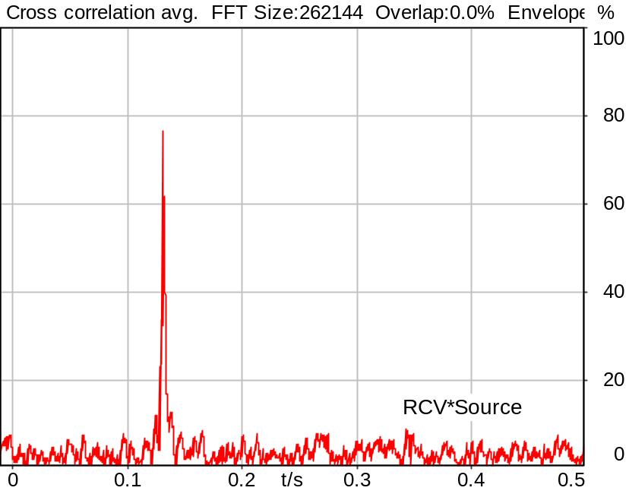

Channel | Delay
RCV*Source | 131.3 ms

5/20/2025 11:13 AM ACQUA 6.0.200
Unmodified HEAD acoustics Measurement Descriptor

Meas. Setting DRP-off

Underlying Standard: 3GPP TS 26.131 V17.3.0 and 3GPP TS 26.132 V17.2.0
Database Version: 60_UG_TS26131_32_SWB_FB_Rev08_GCF_PTCRB

Source: sp4x3_cs1b_16_nb.dat
Level adjustment Channel 1 Gain -90.00 dB
NARROWBAND Real Speech (ITU-T 12 sentences) plus Composite Source Signal Burst at Channel 2
Pause 0.5 s +
Superwideband Real Speech (3x male speech, 3x female speech, 3x male speech, 3x female speech) +
Pause 0.5 s +
CSS Burst (voiced signal + pseudo noise (32k-FFT)) +
Pause till end of file

Bandlimited 100Hz - 4000Hz (IIR Butterworth Filters, 4th Order, 24dB/oct)
Signal level (ch2): -16dBm0 active speech level
Signal Length: 38s

For license information refer to the files >LICENSE_psytechnics.txt< and >LICENSE_nokia.txt<,
see Preparation of Test Setup - Info: Test Signals.

Calibration
SND (1) 0.00 dB (Radio Tester 1 (CMW500))
RCV (2) 1.06 dB 4/29/2025 (HATS 7 (B&K 5128))
Output ch. 1 0.00 dB
Output ch. 2 0.00 dB (Radio Tester 1 (CMW500))

Output Equalization/Filter
Mouth Eq. Ch.1 HATS 7 (B&K 5128) (5/28/2024 5:25 PM)

Analysis
Analyse Channel 2
Range start 35500.00 ms Range length 2000.00 ms
Frequency base Transformation
FFT size 262144 Overlap 0 %
Window function Hann Smooth Off
Reference channel Channel 1
Valid range start -2457.58 ms Valid range end 2457.60 ms

Input Filters
DF Avg. Channel 2

Special Features
Show source signal Source ch.2 Store to variable D_RCV_EQ_HASB

Hardware Config Settings
Used Setting HA&HE_5128_volte

labCORE Settings
labCORE Serial 77000280 Nickname
Firmware 3.7.5 Sync Source Internal
Clock Pitch 0.00 ppm
----------
labCORE Routing
Out Channel 1 -> Analog Out 1 -> ExternalAmplifier In -> HATS 7 (B&K 5128) Speaker
Out Channel 2 -> VoIP 2
Out Channel 2 -> VoIP 1 -> Radio Tester 1 (CMW500) RF In/Out
In Channel 1 <- VoIP In/Out 1 <- Radio Tester 1 (CMW500) RF In/Out
In Channel 2 <- BEQ Filter 1 R <- ICP Amp. (Slot 7) In 2 <- HATS 7 (B&K 5128) Mic. Right
----------
Analog Out Mainboard Settings (Analog Out)
Range Ch. 1 0.00 dB Range Ch. 2 0.00 dB
----------
ICP Settings (ICP Amp. (Slot 7))
Channel In 1 Settings
Range 132 dB[SPL] @ 50 mV/Pa Highpass 20Hz
Supply Voltage On
Channel In 2 Settings
Range 132 dB[SPL] @ 50 mV/Pa Highpass 20Hz
Supply Voltage On
Channel In 3 Settings
Range 132 dB[SPL] @ 50 mV/Pa Highpass 20Hz
Supply Voltage Off
Channel In 4 Settings
Range 132 dB[SPL] @ 50 mV/Pa Highpass 20Hz
Supply Voltage Off
----------
VoIP Settings (VoIP)
RTP Connection Streaming SIP Connection Unavailable
SIP Reg. State Unregistered Jitterbuffer Length 100
Jitter Buffer Reset On Playback Enabled Codec EVS/16000/1
Packet Length 20 Encoder Parameter ;evs-mode-switch=0;max-red=0;br=13.2;bw=swb;ch-aw-recv=-1
FMTP Parameter ;evs-mode-switch=0;bw=swb;br=13.2;ch-aw-recv=-1;max-red=220
Impairment Mode Off Impairment Type Off
----------
BEQ Settings (BEQ Filter 1)
Block mode Bypass
----------
Artificial Head Settings (HATS 7 (B&K 5128))
Ser. Nr. BK_3408387 Pinna Type Type 4.3

HIB Settings
HIB Name 60020101 Serial 60020101
HIB Mode Mobile Measurement Impedance 32 Ohm
Gain out 1 -40.00 dB Gain out 2 0.00 dB
Gain in 1 0.00 dB Gain in 2 0.00 dB
Mic 1 Power Supply Off Mic 2 Power Supply Off

9.10.0 DUT Delay RCV LTE/NR Setup HASB
Handset Measurements Superwideband and Fullband \ Handset Measurements SuperWideband (HASB) \ Preparation Handset Measurements SuperWideband (HASB) \ Syncronization Delay Superwideband (HASB)
Correction
D_RCV_EQ_HASB | 131.300 ms | 5/20/2025 | Measured | 9.10.0 Overall Delay in RCV Dir. HASB
D_RCV_COREIP | 59.729 ms | 5/20/2025 | User defined
D_RCV_NETWORK | 0.000 ms | 5/20/2025 | User defined
D_RAN_AD | 0.460 ms | 5/20/2025 | User defined
D_RCV_EQ_HASB- D_RCV_COREIP - D_RCV_NETWORK - D_RAN_AD

Calculated Value: 71.11 ms

5/20/2025 11:13 AM ACQUA 6.0.200

Underlying Standard: 3GPP TS 26.131 V17.3.0 and 3GPP TS 26.132 V17.2.0
Database Version: 60_UG_TS26131_32_SWB_FB_Rev08_GCF_PTCRB

9.10.0 Overall Delay in SND Dir. HASB
Handset Measurements Superwideband and Fullband \ Handset Measurements SuperWideband (HASB) \ Preparation Handset Measurements SuperWideband (HASB) \ Syncronization Delay Superwideband (HASB)
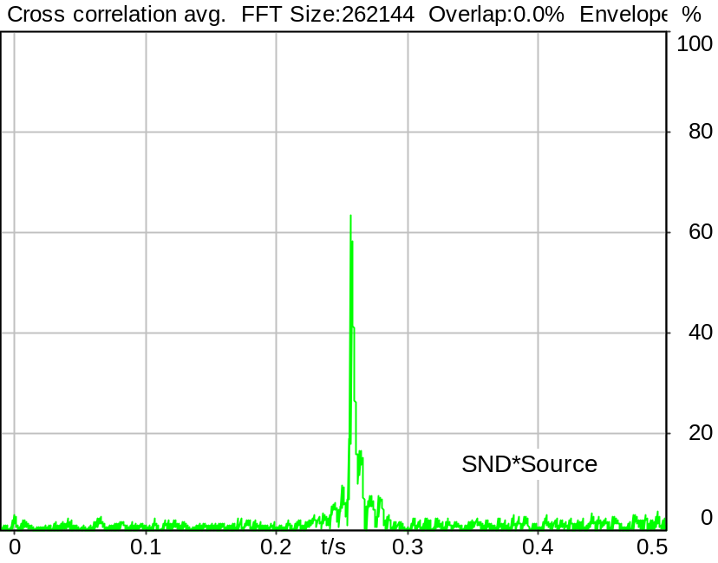

Channel | Delay
SND*Source | 257.6 ms

5/20/2025 11:13 AM ACQUA 6.0.200
Unmodified HEAD acoustics Measurement Descriptor

Meas. Setting DRP-off

Underlying Standard: 3GPP TS 26.131 V17.3.0 and 3GPP TS 26.132 V17.2.0
Database Version: 60_UG_TS26131_32_SWB_FB_Rev08_GCF_PTCRB

Source: cssfb1b_32k.dat
Level adjustment Channel 1 Gain 10.00 dB
CSSfb1b_32k.dat

CS-signal with special 32k-FFT PN periodicity.

FULLBAND Composite Source Signal SND P.501 (1 bursts) at Channel 1
Pause 0.5 s +
voiced signal + 100 to 20000 Hz 32K-FFT pseudo noise 0.7 s + Pause 0.101 s +
Pause till end of file

Signal level (ch1): -14.7 dBV from 1s to 1.35s for 32K- FFT, Rectangle window,
0 % overlap in frequency range of 100 to 20000 Hz

Calibration
SND (1) 0.00 dB (Radio Tester 1 (CMW500))
RCV (2) 1.06 dB 4/29/2025 (HATS 7 (B&K 5128))
Output ch. 1 0.00 dB
Output ch. 2 0.00 dB (Radio Tester 1 (CMW500))

Output Equalization/Filter
Mouth Eq. Ch.1 HATS 7 (B&K 5128) (5/28/2024 5:25 PM)

Analysis
Analyse Channel 1
Range start 300.00 ms Range length 2000.00 ms
Frequency base Transformation
FFT size 262144 Overlap 0 %
Window function Hann Smooth Off
Reference channel Channel 2
Valid range start -2457.58 ms Valid range end 2457.60 ms

Special Features
Show source signal Source ch.1 Store to variable D_SND_EQ_HASB

Hardware Config Settings
Used Setting HA&HE_5128_volte

labCORE Settings
labCORE Serial 77000280 Nickname
Firmware 3.7.5 Sync Source Internal
Clock Pitch 0.00 ppm
----------
labCORE Routing
Out Channel 1 -> Analog Out 1 -> ExternalAmplifier In -> HATS 7 (B&K 5128) Speaker
Out Channel 2 -> VoIP 2
Out Channel 2 -> VoIP 1 -> Radio Tester 1 (CMW500) RF In/Out
In Channel 1 <- VoIP In/Out 1 <- Radio Tester 1 (CMW500) RF In/Out
In Channel 2 <- BEQ Filter 1 R <- ICP Amp. (Slot 7) In 2 <- HATS 7 (B&K 5128) Mic. Right
----------
Analog Out Mainboard Settings (Analog Out)
Range Ch. 1 0.00 dB Range Ch. 2 0.00 dB
----------
ICP Settings (ICP Amp. (Slot 7))
Channel In 1 Settings
Range 132 dB[SPL] @ 50 mV/Pa Highpass 20Hz
Supply Voltage On
Channel In 2 Settings
Range 132 dB[SPL] @ 50 mV/Pa Highpass 20Hz
Supply Voltage On
Channel In 3 Settings
Range 132 dB[SPL] @ 50 mV/Pa Highpass 20Hz
Supply Voltage Off
Channel In 4 Settings
Range 132 dB[SPL] @ 50 mV/Pa Highpass 20Hz
Supply Voltage Off
----------
VoIP Settings (VoIP)
RTP Connection Streaming SIP Connection Unavailable
SIP Reg. State Unregistered Jitterbuffer Length 100
Jitter Buffer Reset On Playback Enabled Codec EVS/16000/1
Packet Length 20 Encoder Parameter ;evs-mode-switch=0;max-red=0;br=13.2;bw=swb;ch-aw-recv=-1
FMTP Parameter ;evs-mode-switch=0;bw=swb;br=13.2;ch-aw-recv=-1;max-red=220
Impairment Mode Off Impairment Type Off
----------
BEQ Settings (BEQ Filter 1)
Block mode Bypass
----------
Artificial Head Settings (HATS 7 (B&K 5128))
Ser. Nr. BK_3408387 Pinna Type Type 4.3

HIB Settings
HIB Name 60020101 Serial 60020101
HIB Mode Mobile Measurement Impedance 32 Ohm
Gain out 1 -40.00 dB Gain out 2 0.00 dB
Gain in 1 0.00 dB Gain in 2 0.00 dB
Mic 1 Power Supply Off Mic 2 Power Supply Off

9.10.0 DUT Delay SND LTE/NR Setup HASB
Handset Measurements Superwideband and Fullband \ Handset Measurements SuperWideband (HASB) \ Preparation Handset Measurements SuperWideband (HASB) \ Syncronization Delay Superwideband (HASB)
Correction
D_SND_EQ_HASB | 257.600 ms | 5/20/2025 | Measured | 9.10.0 Overall Delay in SND Dir. HASB
D_SND_COREIP | 212.354 ms | 5/20/2025 | User defined
D_SND_NETWORK | 9.000 ms | 5/20/2025 | User defined
D_RAN_DA | 0.670 ms | 5/20/2025 | User defined
max_uncertainty | 0.000 | 5/20/2025 | User defined
D_SND_EQ_HASB- D_SND_COREIP - D_SND_NETWORK - D_RAN_DA - max_uncertainty

Calculated Value: 35.58 ms

5/20/2025 11:14 AM ACQUA 6.0.200

Underlying Standard: 3GPP TS 26.131 V17.3.0 and 3GPP TS 26.132 V17.2.0
Database Version: 60_UG_TS26131_32_SWB_FB_Rev08_GCF_PTCRB

9.10.0 Check DUT Delay SND + RCV HASB
Handset Measurements Superwideband and Fullband \ Handset Measurements SuperWideband (HASB) \ Preparation Handset Measurements SuperWideband (HASB) \ Syncronization Delay Superwideband (HASB)
Correction
D_SND_DUT_HASB | 35.580 ms | 5/20/2025 | Measured | 9.10.0 DUT Delay SND LTE/NR Setup HASB
D_RCV_DUT_HASB | 71.110 ms | 5/20/2025 | Measured | 9.10.0 DUT Delay RCV LTE/NR Setup HASB
D_SND_DUT_HASB+ D_RCV_DUT_HASB

Calculated Value: 106.69 ms Ok

Ok
5/20/2025 11:14 AM ACQUA 6.0.200

Limits
 | upper
Run 1 | 190.00 ms

Underlying Standard: 3GPP TS 26.131 V17.3.0 and 3GPP TS 26.132 V17.2.0
Database Version: 60_UG_TS26131_32_SWB_FB_Rev08_GCF_PTCRB

9.2.2.2 Loudness Rating RCV (RLR) Speech MAX HASB
Handset Measurements Superwideband and Fullband \ Handset Measurements SuperWideband (HASB) \ Connections with Handset Receiving Direction (HASB) \ Receiving Dir. DRP/ERP >ON< Correction LIN EQ
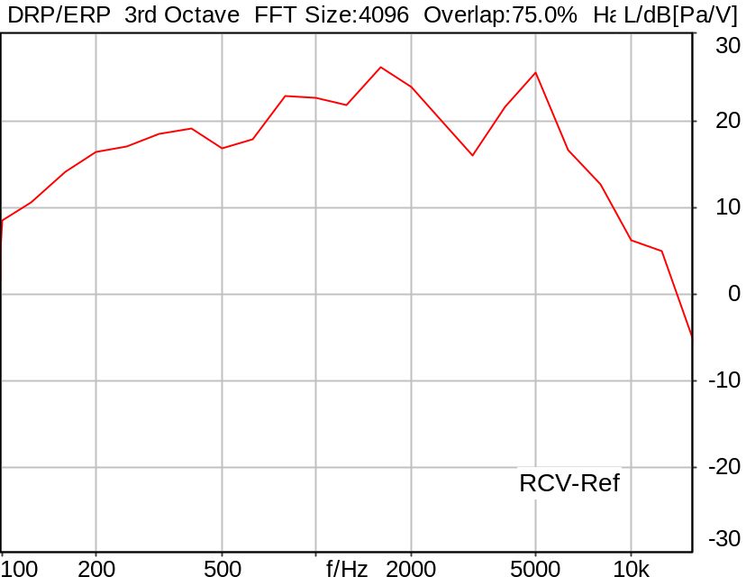

RLR: -11.22 dB Ok

Ok
5/20/2025 11:15 AM ACQUA 6.0.200

Limits
 | lower | upper
Run 1 | -13.00 dB | -10.00 dB

Meas. Setting DRP-off

Underlying Standard: 3GPP TS 26.131 V17.3.0 and 3GPP TS 26.132 V17.2.0
Database Version: 60_UG_TS26131_32_SWB_FB_Rev08_GCF_PTCRB

Source: spst4x3_sb_r16.dat
SUPERWIDEBAND Real Speech (ITU-T 12 sentences) at Channel 2
Pause 0.5 s +
Superwideband Real Speech (3x male speech, 3x female speech, 3x male speech, 3x female speech) +
Pause till end of file
Bandlimited 50-16000Hz
Signal level (ch2): -16dBm0 active speech level
Signal Length: 35.4s

For license information refer to the files >LICENSE_psytechnics.txt< and >LICENSE_nokia.txt<,
see Preparation of Test Setup - Info: Test Signals.

Calibration
RCV (2) 1.06 dB 4/29/2025 (HATS 7 (B&K 5128))
Output ch. 1 0.00 dB
Output ch. 2 0.00 dB (Radio Tester 1 (CMW500))

Output Equalization/Filter
Mouth Eq. Ch.1 HATS 7 (B&K 5128) (5/28/2024 5:25 PM)

Analysis
Analyse Channel 2
Range start 400.00 ms Range length 34650.00 ms
DRP/ERP Ch.2 P.57 (4.3/4.4)
Frequency base 3rd octave DIN Row Row B
Method FFT
FFT size 4096 Overlap 75 %
Window function Hann
Reference file r9222_rlr_hasb.fft
LR kind RLR Method ITU-T P.79
Bands for LR calc. 1..20
Leakage correction No

Special Features
Compensate delay 131.3000 ms (D_SCRIPT, Original Delay Variable stored to D_SCRIPT: D_RCV_EQ_HASB)

Hardware Config Settings
Used Setting HA&HE_5128_volte

labCORE Settings
labCORE Serial 77000280 Nickname
Firmware 3.7.5 Sync Source Internal
Clock Pitch 0.00 ppm
----------
labCORE Routing
Out Channel 1 -> Analog Out 1 -> ExternalAmplifier In -> HATS 7 (B&K 5128) Speaker
Out Channel 2 -> VoIP 2
Out Channel 2 -> VoIP 1 -> Radio Tester 1 (CMW500) RF In/Out
In Channel 1 <- VoIP In/Out 1 <- Radio Tester 1 (CMW500) RF In/Out
In Channel 2 <- BEQ Filter 1 R <- ICP Amp. (Slot 7) In 2 <- HATS 7 (B&K 5128) Mic. Right
----------
Analog Out Mainboard Settings (Analog Out)
Range Ch. 1 0.00 dB Range Ch. 2 0.00 dB
----------
ICP Settings (ICP Amp. (Slot 7))
Channel In 1 Settings
Range 132 dB[SPL] @ 50 mV/Pa Highpass 20Hz
Supply Voltage On
Channel In 2 Settings
Range 132 dB[SPL] @ 50 mV/Pa Highpass 20Hz
Supply Voltage On
Channel In 3 Settings
Range 132 dB[SPL] @ 50 mV/Pa Highpass 20Hz
Supply Voltage Off
Channel In 4 Settings
Range 132 dB[SPL] @ 50 mV/Pa Highpass 20Hz
Supply Voltage Off
----------
VoIP Settings (VoIP)
RTP Connection Streaming SIP Connection Unavailable
SIP Reg. State Unregistered Jitterbuffer Length 100
Jitter Buffer Reset On Playback Enabled Codec EVS/16000/1
Packet Length 20 Encoder Parameter ;evs-mode-switch=0;max-red=0;br=13.2;bw=swb;ch-aw-recv=-1
FMTP Parameter ;evs-mode-switch=0;bw=swb;br=13.2;ch-aw-recv=-1;max-red=220
Impairment Mode Off Impairment Type Off
----------
BEQ Settings (BEQ Filter 1)
Block mode Bypass
----------
Artificial Head Settings (HATS 7 (B&K 5128))
Ser. Nr. BK_3408387 Pinna Type Type 4.3

HIB Settings
HIB Name 60020101 Serial 60020101
HIB Mode Mobile Measurement Impedance 32 Ohm
Gain out 1 -40.00 dB Gain out 2 0.00 dB
Gain in 1 0.00 dB Gain in 2 0.00 dB
Mic 1 Power Supply Off Mic 2 Power Supply Off

9.2.2.2 Loudness Rating RCV (RLR) Speech MAX-1 HASB
Handset Measurements Superwideband and Fullband \ Handset Measurements SuperWideband (HASB) \ Connections with Handset Receiving Direction (HASB) \ Receiving Dir. DRP/ERP >ON< Correction LIN EQ
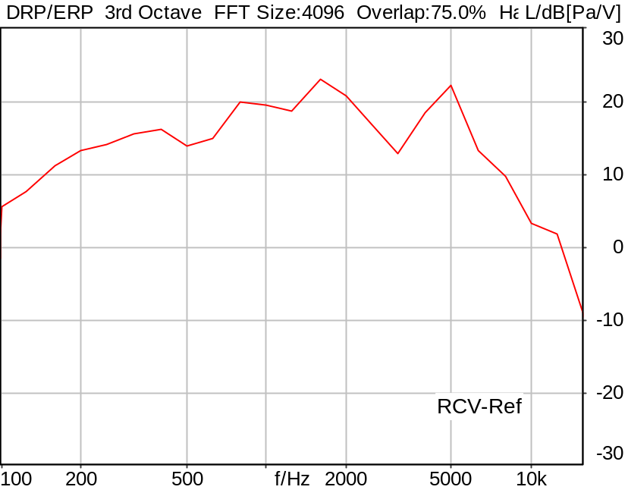

RLR: -8.22 dB

5/20/2025 11:16 AM ACQUA 6.0.200

Meas. Setting DRP-off

Underlying Standard: 3GPP TS 26.131 V17.3.0 and 3GPP TS 26.132 V17.2.0
Database Version: 60_UG_TS26131_32_SWB_FB_Rev08_GCF_PTCRB

Source: spst4x3_sb_r16.dat
SUPERWIDEBAND Real Speech (ITU-T 12 sentences) at Channel 2
Pause 0.5 s +
Superwideband Real Speech (3x male speech, 3x female speech, 3x male speech, 3x female speech) +
Pause till end of file
Bandlimited 50-16000Hz
Signal level (ch2): -16dBm0 active speech level
Signal Length: 35.4s

For license information refer to the files >LICENSE_psytechnics.txt< and >LICENSE_nokia.txt<,
see Preparation of Test Setup - Info: Test Signals.

Calibration
RCV (2) 1.06 dB 4/29/2025 (HATS 7 (B&K 5128))
Output ch. 1 0.00 dB
Output ch. 2 0.00 dB (Radio Tester 1 (CMW500))

Output Equalization/Filter
Mouth Eq. Ch.1 HATS 7 (B&K 5128) (5/28/2024 5:25 PM)

Analysis
Analyse Channel 2
Range start 400.00 ms Range length 34650.00 ms
DRP/ERP Ch.2 P.57 (4.3/4.4)
Frequency base 3rd octave DIN Row Row B
Method FFT
FFT size 4096 Overlap 75 %
Window function Hann
Reference file r9222_rlr_hasb.fft
LR kind RLR Method ITU-T P.79
Bands for LR calc. 1..20
Leakage correction No

Special Features
Compensate delay 131.3000 ms (D_SCRIPT, Original Delay Variable stored to D_SCRIPT: D_RCV_EQ_HASB)

Hardware Config Settings
Used Setting HA&HE_5128_volte

labCORE Settings
labCORE Serial 77000280 Nickname
Firmware 3.7.5 Sync Source Internal
Clock Pitch 0.00 ppm
----------
labCORE Routing
Out Channel 1 -> Analog Out 1 -> ExternalAmplifier In -> HATS 7 (B&K 5128) Speaker
Out Channel 2 -> VoIP 2
Out Channel 2 -> VoIP 1 -> Radio Tester 1 (CMW500) RF In/Out
In Channel 1 <- VoIP In/Out 1 <- Radio Tester 1 (CMW500) RF In/Out
In Channel 2 <- BEQ Filter 1 R <- ICP Amp. (Slot 7) In 2 <- HATS 7 (B&K 5128) Mic. Right
----------
Analog Out Mainboard Settings (Analog Out)
Range Ch. 1 0.00 dB Range Ch. 2 0.00 dB
----------
ICP Settings (ICP Amp. (Slot 7))
Channel In 1 Settings
Range 132 dB[SPL] @ 50 mV/Pa Highpass 20Hz
Supply Voltage On
Channel In 2 Settings
Range 132 dB[SPL] @ 50 mV/Pa Highpass 20Hz
Supply Voltage On
Channel In 3 Settings
Range 132 dB[SPL] @ 50 mV/Pa Highpass 20Hz
Supply Voltage Off
Channel In 4 Settings
Range 132 dB[SPL] @ 50 mV/Pa Highpass 20Hz
Supply Voltage Off
----------
VoIP Settings (VoIP)
RTP Connection Streaming SIP Connection Unavailable
SIP Reg. State Unregistered Jitterbuffer Length 100
Jitter Buffer Reset On Playback Enabled Codec EVS/16000/1
Packet Length 20 Encoder Parameter ;evs-mode-switch=0;max-red=0;br=13.2;bw=swb;ch-aw-recv=-1
FMTP Parameter ;evs-mode-switch=0;bw=swb;br=13.2;ch-aw-recv=-1;max-red=220
Impairment Mode Off Impairment Type Off
----------
BEQ Settings (BEQ Filter 1)
Block mode Bypass
----------
Artificial Head Settings (HATS 7 (B&K 5128))
Ser. Nr. BK_3408387 Pinna Type Type 4.3

HIB Settings
HIB Name 60020101 Serial 60020101
HIB Mode Mobile Measurement Impedance 32 Ohm
Gain out 1 -40.00 dB Gain out 2 0.00 dB
Gain in 1 0.00 dB Gain in 2 0.00 dB
Mic 1 Power Supply Off Mic 2 Power Supply Off

9.2.2.2 Loudness Rating RCV (RLR) Speech MAX-2 HASB
Handset Measurements Superwideband and Fullband \ Handset Measurements SuperWideband (HASB) \ Connections with Handset Receiving Direction (HASB) \ Receiving Dir. DRP/ERP >ON< Correction LIN EQ
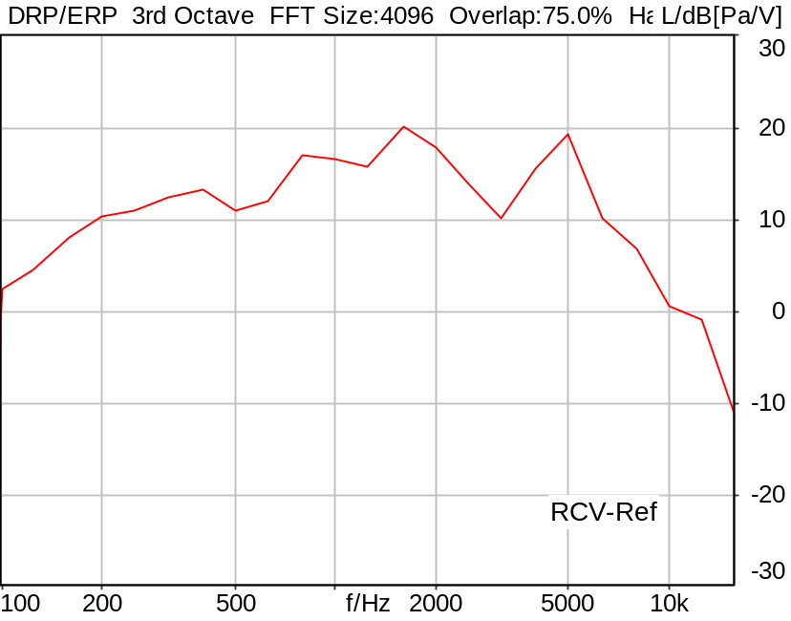

RLR: -5.28 dB

5/20/2025 11:17 AM ACQUA 6.0.200

Meas. Setting DRP-off

Underlying Standard: 3GPP TS 26.131 V17.3.0 and 3GPP TS 26.132 V17.2.0
Database Version: 60_UG_TS26131_32_SWB_FB_Rev08_GCF_PTCRB

Source: spst4x3_sb_r16.dat
SUPERWIDEBAND Real Speech (ITU-T 12 sentences) at Channel 2
Pause 0.5 s +
Superwideband Real Speech (3x male speech, 3x female speech, 3x male speech, 3x female speech) +
Pause till end of file
Bandlimited 50-16000Hz
Signal level (ch2): -16dBm0 active speech level
Signal Length: 35.4s

For license information refer to the files >LICENSE_psytechnics.txt< and >LICENSE_nokia.txt<,
see Preparation of Test Setup - Info: Test Signals.

Calibration
RCV (2) 1.06 dB 4/29/2025 (HATS 7 (B&K 5128))
Output ch. 1 0.00 dB
Output ch. 2 0.00 dB (Radio Tester 1 (CMW500))

Output Equalization/Filter
Mouth Eq. Ch.1 HATS 7 (B&K 5128) (5/28/2024 5:25 PM)

Analysis
Analyse Channel 2
Range start 400.00 ms Range length 34650.00 ms
DRP/ERP Ch.2 P.57 (4.3/4.4)
Frequency base 3rd octave DIN Row Row B
Method FFT
FFT size 4096 Overlap 75 %
Window function Hann
Reference file r9222_rlr_hasb.fft
LR kind RLR Method ITU-T P.79
Bands for LR calc. 1..20
Leakage correction No

Special Features
Compensate delay 131.3000 ms (D_SCRIPT, Original Delay Variable stored to D_SCRIPT: D_RCV_EQ_HASB)

Hardware Config Settings
Used Setting HA&HE_5128_volte

labCORE Settings
labCORE Serial 77000280 Nickname
Firmware 3.7.5 Sync Source Internal
Clock Pitch 0.00 ppm
----------
labCORE Routing
Out Channel 1 -> Analog Out 1 -> ExternalAmplifier In -> HATS 7 (B&K 5128) Speaker
Out Channel 2 -> VoIP 2
Out Channel 2 -> VoIP 1 -> Radio Tester 1 (CMW500) RF In/Out
In Channel 1 <- VoIP In/Out 1 <- Radio Tester 1 (CMW500) RF In/Out
In Channel 2 <- BEQ Filter 1 R <- ICP Amp. (Slot 7) In 2 <- HATS 7 (B&K 5128) Mic. Right
----------
Analog Out Mainboard Settings (Analog Out)
Range Ch. 1 0.00 dB Range Ch. 2 0.00 dB
----------
ICP Settings (ICP Amp. (Slot 7))
Channel In 1 Settings
Range 132 dB[SPL] @ 50 mV/Pa Highpass 20Hz
Supply Voltage On
Channel In 2 Settings
Range 132 dB[SPL] @ 50 mV/Pa Highpass 20Hz
Supply Voltage On
Channel In 3 Settings
Range 132 dB[SPL] @ 50 mV/Pa Highpass 20Hz
Supply Voltage Off
Channel In 4 Settings
Range 132 dB[SPL] @ 50 mV/Pa Highpass 20Hz
Supply Voltage Off
----------
VoIP Settings (VoIP)
RTP Connection Streaming SIP Connection Unavailable
SIP Reg. State Unregistered Jitterbuffer Length 100
Jitter Buffer Reset On Playback Enabled Codec EVS/16000/1
Packet Length 20 Encoder Parameter ;evs-mode-switch=0;max-red=0;br=13.2;bw=swb;ch-aw-recv=-1
FMTP Parameter ;evs-mode-switch=0;bw=swb;br=13.2;ch-aw-recv=-1;max-red=220
Impairment Mode Off Impairment Type Off
----------
BEQ Settings (BEQ Filter 1)
Block mode Bypass
----------
Artificial Head Settings (HATS 7 (B&K 5128))
Ser. Nr. BK_3408387 Pinna Type Type 4.3

HIB Settings
HIB Name 60020101 Serial 60020101
HIB Mode Mobile Measurement Impedance 32 Ohm
Gain out 1 -40.00 dB Gain out 2 0.00 dB
Gain in 1 0.00 dB Gain in 2 0.00 dB
Mic 1 Power Supply Off Mic 2 Power Supply Off

9.2.2.2 Loudness Rating RCV (RLR) Speech MAX-3 HASB
Handset Measurements Superwideband and Fullband \ Handset Measurements SuperWideband (HASB) \ Connections with Handset Receiving Direction (HASB) \ Receiving Dir. DRP/ERP >ON< Correction LIN EQ
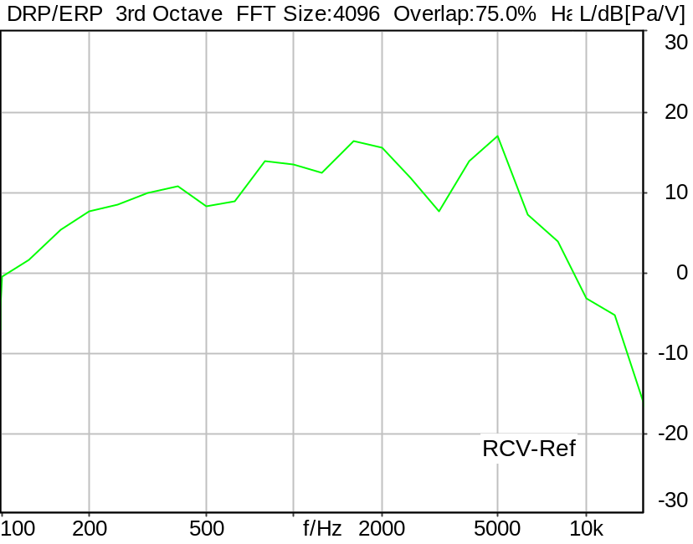

RLR: -2.45 dB

5/21/2025 10:50 PM ACQUA 6.0.200

Meas. Setting DRP-off

Underlying Standard: 3GPP TS 26.131 V17.3.0 and 3GPP TS 26.132 V17.2.0
Database Version: 60_UG_TS26131_32_SWB_FB_Rev08_GCF_PTCRB

Source: spst4x3_sb_r16.dat
SUPERWIDEBAND Real Speech (ITU-T 12 sentences) at Channel 2
Pause 0.5 s +
Superwideband Real Speech (3x male speech, 3x female speech, 3x male speech, 3x female speech) +
Pause till end of file
Bandlimited 50-16000Hz
Signal level (ch2): -16dBm0 active speech level
Signal Length: 35.4s

For license information refer to the files >LICENSE_psytechnics.txt< and >LICENSE_nokia.txt<,
see Preparation of Test Setup - Info: Test Signals.

Calibration
RCV (2) 1.06 dB 4/29/2025 (HATS 7 (B&K 5128))
Output ch. 1 0.00 dB
Output ch. 2 0.00 dB (Radio Tester 1 (CMW500))

Output Equalization/Filter
Mouth Eq. Ch.1 HATS 7 (B&K 5128) (5/28/2024 5:25 PM)

Analysis
Analyse Channel 2
Range start 400.00 ms Range length 34650.00 ms
DRP/ERP Ch.2 P.57 (4.3/4.4)
Frequency base 3rd octave DIN Row Row B
Method FFT
FFT size 4096 Overlap 75 %
Window function Hann
Reference file r9222_rlr_hasb.fft
LR kind RLR Method ITU-T P.79
Bands for LR calc. 1..20
Leakage correction No

Special Features
Compensate delay 123.3000 ms (D_SCRIPT, Original Delay Variable stored to D_SCRIPT: D_RCV_EQ_HASB)

Hardware Config Settings
Used Setting HA&HE_5128_volte

labCORE Settings
labCORE Serial 77000280 Nickname
Firmware 3.7.5 Sync Source Internal
Clock Pitch 0.00 ppm
----------
labCORE Routing
Out Channel 1 -> Analog Out 1 -> ExternalAmplifier In -> HATS 7 (B&K 5128) Speaker
Out Channel 2 -> VoIP 2
Out Channel 2 -> VoIP 1 -> Radio Tester 1 (CMW500) RF In/Out
In Channel 1 <- VoIP In/Out 1 <- Radio Tester 1 (CMW500) RF In/Out
In Channel 2 <- BEQ Filter 1 R <- ICP Amp. (Slot 7) In 2 <- HATS 7 (B&K 5128) Mic. Right
----------
Analog Out Mainboard Settings (Analog Out)
Range Ch. 1 0.00 dB Range Ch. 2 0.00 dB
----------
ICP Settings (ICP Amp. (Slot 7))
Channel In 1 Settings
Range 132 dB[SPL] @ 50 mV/Pa Highpass 20Hz
Supply Voltage On
Channel In 2 Settings
Range 132 dB[SPL] @ 50 mV/Pa Highpass 20Hz
Supply Voltage On
Channel In 3 Settings
Range 132 dB[SPL] @ 50 mV/Pa Highpass 20Hz
Supply Voltage Off
Channel In 4 Settings
Range 132 dB[SPL] @ 50 mV/Pa Highpass 20Hz
Supply Voltage Off
----------
VoIP Settings (VoIP)
RTP Connection Streaming SIP Connection Unavailable
SIP Reg. State Unregistered Jitterbuffer Length 140
Jitter Buffer Reset On Playback Enabled Codec EVS/16000/1
Packet Length 20 Encoder Parameter ;evs-mode-switch=0;max-red=0;br=13.2;bw=swb;ch-aw-recv=-1
FMTP Parameter ;evs-mode-switch=0;bw=swb;br=13.2;ch-aw-recv=-1;max-red=220
Impairment Mode Off Impairment Type Off
----------
BEQ Settings (BEQ Filter 1)
Block mode Bypass
----------
Artificial Head Settings (HATS 7 (B&K 5128))
Ser. Nr. BK_3408387 Pinna Type Type 4.3

9.2.2.2 Loudness Rating RCV (RLR) Speech MAX-4(NOM)HASB
Handset Measurements Superwideband and Fullband \ Handset Measurements SuperWideband (HASB) \ Connections with Handset Receiving Direction (HASB) \ Receiving Dir. DRP/ERP >ON< Correction LIN EQ
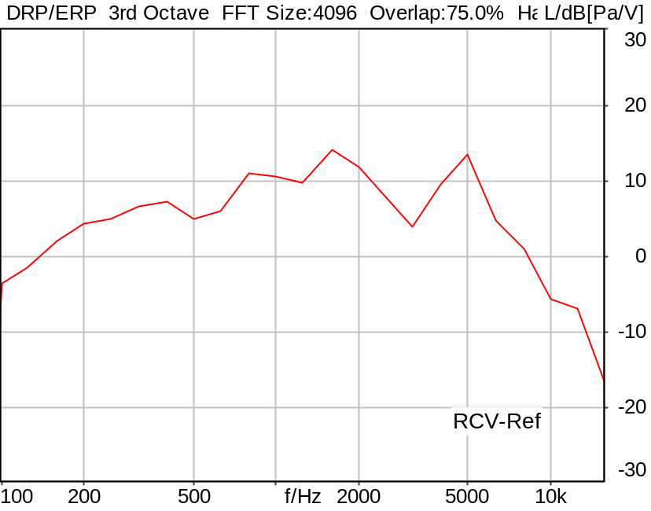

RLR: 0.74 dB Ok

Ok
5/20/2025 11:19 AM ACQUA 6.0.200

Limits
 | lower | upper
Run 1 | -1.00 dB | 5.00 dB

Meas. Setting DRP-off

Underlying Standard: 3GPP TS 26.131 V17.3.0 and 3GPP TS 26.132 V17.2.0
Database Version: 60_UG_TS26131_32_SWB_FB_Rev08_GCF_PTCRB

Source: spst4x3_sb_r16.dat
SUPERWIDEBAND Real Speech (ITU-T 12 sentences) at Channel 2
Pause 0.5 s +
Superwideband Real Speech (3x male speech, 3x female speech, 3x male speech, 3x female speech) +
Pause till end of file
Bandlimited 50-16000Hz
Signal level (ch2): -16dBm0 active speech level
Signal Length: 35.4s

For license information refer to the files >LICENSE_psytechnics.txt< and >LICENSE_nokia.txt<,
see Preparation of Test Setup - Info: Test Signals.

Calibration
RCV (2) 1.06 dB 4/29/2025 (HATS 7 (B&K 5128))
Output ch. 1 0.00 dB
Output ch. 2 0.00 dB (Radio Tester 1 (CMW500))

Output Equalization/Filter
Mouth Eq. Ch.1 HATS 7 (B&K 5128) (5/28/2024 5:25 PM)

Analysis
Analyse Channel 2
Range start 400.00 ms Range length 34650.00 ms
DRP/ERP Ch.2 P.57 (4.3/4.4)
Frequency base 3rd octave DIN Row Row B
Method FFT
FFT size 4096 Overlap 75 %
Window function Hann
Reference file ref_rlr_nom_hasb.fft
LR kind RLR Method ITU-T P.79
Bands for LR calc. 1..20
Leakage correction No

Special Features
Compensate delay 131.3000 ms (D_SCRIPT, Original Delay Variable stored to D_SCRIPT: D_RCV_EQ_HASB)

Hardware Config Settings
Used Setting HA&HE_5128_volte

labCORE Settings
labCORE Serial 77000280 Nickname
Firmware 3.7.5 Sync Source Internal
Clock Pitch 0.00 ppm
----------
labCORE Routing
Out Channel 1 -> Analog Out 1 -> ExternalAmplifier In -> HATS 7 (B&K 5128) Speaker
Out Channel 2 -> VoIP 2
Out Channel 2 -> VoIP 1 -> Radio Tester 1 (CMW500) RF In/Out
In Channel 1 <- VoIP In/Out 1 <- Radio Tester 1 (CMW500) RF In/Out
In Channel 2 <- BEQ Filter 1 R <- ICP Amp. (Slot 7) In 2 <- HATS 7 (B&K 5128) Mic. Right
----------
Analog Out Mainboard Settings (Analog Out)
Range Ch. 1 0.00 dB Range Ch. 2 0.00 dB
----------
ICP Settings (ICP Amp. (Slot 7))
Channel In 1 Settings
Range 132 dB[SPL] @ 50 mV/Pa Highpass 20Hz
Supply Voltage On
Channel In 2 Settings
Range 132 dB[SPL] @ 50 mV/Pa Highpass 20Hz
Supply Voltage On
Channel In 3 Settings
Range 132 dB[SPL] @ 50 mV/Pa Highpass 20Hz
Supply Voltage Off
Channel In 4 Settings
Range 132 dB[SPL] @ 50 mV/Pa Highpass 20Hz
Supply Voltage Off
----------
VoIP Settings (VoIP)
RTP Connection Streaming SIP Connection Unavailable
SIP Reg. State Unregistered Jitterbuffer Length 100
Jitter Buffer Reset On Playback Enabled Codec EVS/16000/1
Packet Length 20 Encoder Parameter ;evs-mode-switch=0;max-red=0;br=13.2;bw=swb;ch-aw-recv=-1
FMTP Parameter ;evs-mode-switch=0;bw=swb;br=13.2;ch-aw-recv=-1;max-red=220
Impairment Mode Off Impairment Type Off
----------
BEQ Settings (BEQ Filter 1)
Block mode Bypass
----------
Artificial Head Settings (HATS 7 (B&K 5128))
Ser. Nr. BK_3408387 Pinna Type Type 4.3

HIB Settings
HIB Name 60020101 Serial 60020101
HIB Mode Mobile Measurement Impedance 32 Ohm
Gain out 1 -40.00 dB Gain out 2 0.00 dB
Gain in 1 0.00 dB Gain in 2 0.00 dB
Mic 1 Power Supply Off Mic 2 Power Supply Off

9.2.2.2 Loudness Rating RCV (RLR) Speech MAX-5 HASB
Handset Measurements Superwideband and Fullband \ Handset Measurements SuperWideband (HASB) \ Connections with Handset Receiving Direction (HASB) \ Receiving Dir. DRP/ERP >ON< Correction LIN EQ
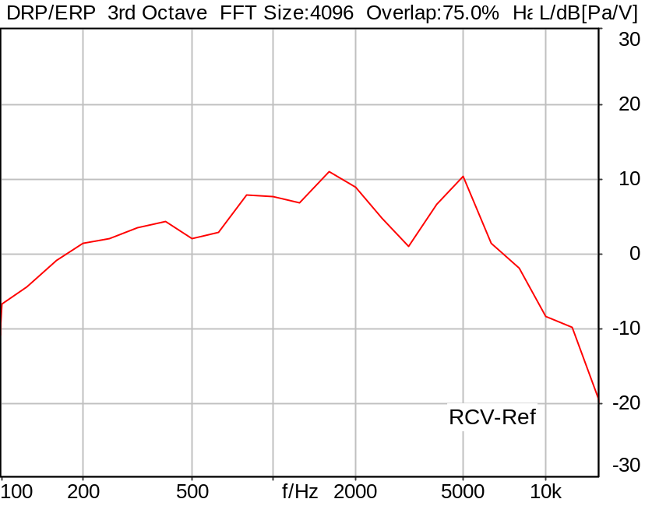

RLR: 3.72 dB

5/20/2025 11:20 AM ACQUA 6.0.200

Meas. Setting DRP-off

Underlying Standard: 3GPP TS 26.131 V17.3.0 and 3GPP TS 26.132 V17.2.0
Database Version: 60_UG_TS26131_32_SWB_FB_Rev08_GCF_PTCRB

Source: spst4x3_sb_r16.dat
SUPERWIDEBAND Real Speech (ITU-T 12 sentences) at Channel 2
Pause 0.5 s +
Superwideband Real Speech (3x male speech, 3x female speech, 3x male speech, 3x female speech) +
Pause till end of file
Bandlimited 50-16000Hz
Signal level (ch2): -16dBm0 active speech level
Signal Length: 35.4s

For license information refer to the files >LICENSE_psytechnics.txt< and >LICENSE_nokia.txt<,
see Preparation of Test Setup - Info: Test Signals.

Calibration
RCV (2) 1.06 dB 4/29/2025 (HATS 7 (B&K 5128))
Output ch. 1 0.00 dB
Output ch. 2 0.00 dB (Radio Tester 1 (CMW500))

Output Equalization/Filter
Mouth Eq. Ch.1 HATS 7 (B&K 5128) (5/28/2024 5:25 PM)

Analysis
Analyse Channel 2
Range start 400.00 ms Range length 34650.00 ms
DRP/ERP Ch.2 P.57 (4.3/4.4)
Frequency base 3rd octave DIN Row Row B
Method FFT
FFT size 4096 Overlap 75 %
Window function Hann
Reference file ref_rlr_nom_hasb.fft
LR kind RLR Method ITU-T P.79
Bands for LR calc. 1..20
Leakage correction No

Special Features
Compensate delay 131.3000 ms (D_SCRIPT, Original Delay Variable stored to D_SCRIPT: D_RCV_EQ_HASB)

Hardware Config Settings
Used Setting HA&HE_5128_volte

labCORE Settings
labCORE Serial 77000280 Nickname
Firmware 3.7.5 Sync Source Internal
Clock Pitch 0.00 ppm
----------
labCORE Routing
Out Channel 1 -> Analog Out 1 -> ExternalAmplifier In -> HATS 7 (B&K 5128) Speaker
Out Channel 2 -> VoIP 2
Out Channel 2 -> VoIP 1 -> Radio Tester 1 (CMW500) RF In/Out
In Channel 1 <- VoIP In/Out 1 <- Radio Tester 1 (CMW500) RF In/Out
In Channel 2 <- BEQ Filter 1 R <- ICP Amp. (Slot 7) In 2 <- HATS 7 (B&K 5128) Mic. Right
----------
Analog Out Mainboard Settings (Analog Out)
Range Ch. 1 0.00 dB Range Ch. 2 0.00 dB
----------
ICP Settings (ICP Amp. (Slot 7))
Channel In 1 Settings
Range 132 dB[SPL] @ 50 mV/Pa Highpass 20Hz
Supply Voltage On
Channel In 2 Settings
Range 132 dB[SPL] @ 50 mV/Pa Highpass 20Hz
Supply Voltage On
Channel In 3 Settings
Range 132 dB[SPL] @ 50 mV/Pa Highpass 20Hz
Supply Voltage Off
Channel In 4 Settings
Range 132 dB[SPL] @ 50 mV/Pa Highpass 20Hz
Supply Voltage Off
----------
VoIP Settings (VoIP)
RTP Connection Streaming SIP Connection Unavailable
SIP Reg. State Unregistered Jitterbuffer Length 100
Jitter Buffer Reset On Playback Enabled Codec EVS/16000/1
Packet Length 20 Encoder Parameter ;evs-mode-switch=0;max-red=0;br=13.2;bw=swb;ch-aw-recv=-1
FMTP Parameter ;evs-mode-switch=0;bw=swb;br=13.2;ch-aw-recv=-1;max-red=220
Impairment Mode Off Impairment Type Off
----------
BEQ Settings (BEQ Filter 1)
Block mode Bypass
----------
Artificial Head Settings (HATS 7 (B&K 5128))
Ser. Nr. BK_3408387 Pinna Type Type 4.3

HIB Settings
HIB Name 60020101 Serial 60020101
HIB Mode Mobile Measurement Impedance 32 Ohm
Gain out 1 -40.00 dB Gain out 2 0.00 dB
Gain in 1 0.00 dB Gain in 2 0.00 dB
Mic 1 Power Supply Off Mic 2 Power Supply Off

9.2.2.2 Loudness Rating RCV (RLR) Speech MAX-6 HASB
Handset Measurements Superwideband and Fullband \ Handset Measurements SuperWideband (HASB) \ Connections with Handset Receiving Direction (HASB) \ Receiving Dir. DRP/ERP >ON< Correction LIN EQ
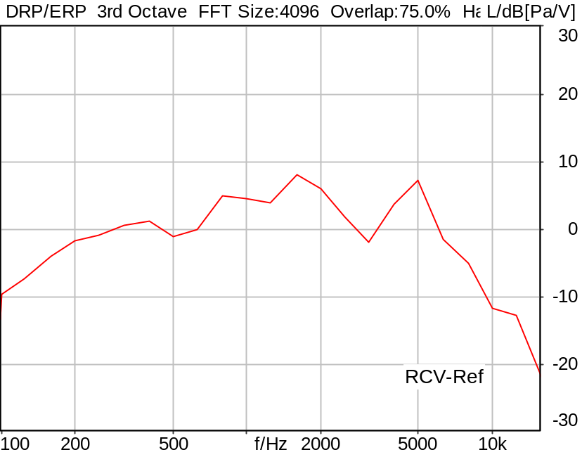

RLR: 6.71 dB

5/20/2025 11:21 AM ACQUA 6.0.200

Meas. Setting DRP-off

Underlying Standard: 3GPP TS 26.131 V17.3.0 and 3GPP TS 26.132 V17.2.0
Database Version: 60_UG_TS26131_32_SWB_FB_Rev08_GCF_PTCRB

Source: spst4x3_sb_r16.dat
SUPERWIDEBAND Real Speech (ITU-T 12 sentences) at Channel 2
Pause 0.5 s +
Superwideband Real Speech (3x male speech, 3x female speech, 3x male speech, 3x female speech) +
Pause till end of file
Bandlimited 50-16000Hz
Signal level (ch2): -16dBm0 active speech level
Signal Length: 35.4s

For license information refer to the files >LICENSE_psytechnics.txt< and >LICENSE_nokia.txt<,
see Preparation of Test Setup - Info: Test Signals.

Calibration
RCV (2) 1.06 dB 4/29/2025 (HATS 7 (B&K 5128))
Output ch. 1 0.00 dB
Output ch. 2 0.00 dB (Radio Tester 1 (CMW500))

Output Equalization/Filter
Mouth Eq. Ch.1 HATS 7 (B&K 5128) (5/28/2024 5:25 PM)

Analysis
Analyse Channel 2
Range start 400.00 ms Range length 34650.00 ms
DRP/ERP Ch.2 P.57 (4.3/4.4)
Frequency base 3rd octave DIN Row Row B
Method FFT
FFT size 4096 Overlap 75 %
Window function Hann
Reference file ref_rlr_nom_hasb.fft
LR kind RLR Method ITU-T P.79
Bands for LR calc. 1..20
Leakage correction No

Special Features
Compensate delay 131.3000 ms (D_SCRIPT, Original Delay Variable stored to D_SCRIPT: D_RCV_EQ_HASB)

Hardware Config Settings
Used Setting HA&HE_5128_volte

labCORE Settings
labCORE Serial 77000280 Nickname
Firmware 3.7.5 Sync Source Internal
Clock Pitch 0.00 ppm
----------
labCORE Routing
Out Channel 1 -> Analog Out 1 -> ExternalAmplifier In -> HATS 7 (B&K 5128) Speaker
Out Channel 2 -> VoIP 2
Out Channel 2 -> VoIP 1 -> Radio Tester 1 (CMW500) RF In/Out
In Channel 1 <- VoIP In/Out 1 <- Radio Tester 1 (CMW500) RF In/Out
In Channel 2 <- BEQ Filter 1 R <- ICP Amp. (Slot 7) In 2 <- HATS 7 (B&K 5128) Mic. Right
----------
Analog Out Mainboard Settings (Analog Out)
Range Ch. 1 0.00 dB Range Ch. 2 0.00 dB
----------
ICP Settings (ICP Amp. (Slot 7))
Channel In 1 Settings
Range 132 dB[SPL] @ 50 mV/Pa Highpass 20Hz
Supply Voltage On
Channel In 2 Settings
Range 132 dB[SPL] @ 50 mV/Pa Highpass 20Hz
Supply Voltage On
Channel In 3 Settings
Range 132 dB[SPL] @ 50 mV/Pa Highpass 20Hz
Supply Voltage Off
Channel In 4 Settings
Range 132 dB[SPL] @ 50 mV/Pa Highpass 20Hz
Supply Voltage Off
----------
VoIP Settings (VoIP)
RTP Connection Streaming SIP Connection Unavailable
SIP Reg. State Unregistered Jitterbuffer Length 100
Jitter Buffer Reset On Playback Enabled Codec EVS/16000/1
Packet Length 20 Encoder Parameter ;evs-mode-switch=0;max-red=0;br=13.2;bw=swb;ch-aw-recv=-1
FMTP Parameter ;evs-mode-switch=0;bw=swb;br=13.2;ch-aw-recv=-1;max-red=220
Impairment Mode Off Impairment Type Off
----------
BEQ Settings (BEQ Filter 1)
Block mode Bypass
----------
Artificial Head Settings (HATS 7 (B&K 5128))
Ser. Nr. BK_3408387 Pinna Type Type 4.3

HIB Settings
HIB Name 60020101 Serial 60020101
HIB Mode Mobile Measurement Impedance 32 Ohm
Gain out 1 -40.00 dB Gain out 2 0.00 dB
Gain in 1 0.00 dB Gain in 2 0.00 dB
Mic 1 Power Supply Off Mic 2 Power Supply Off

9.2.2.2 Loudness Rating RCV (RLR) Speech MAX-7(MIN)HASB
Handset Measurements Superwideband and Fullband \ Handset Measurements SuperWideband (HASB) \ Connections with Handset Receiving Direction (HASB) \ Receiving Dir. DRP/ERP >ON< Correction LIN EQ
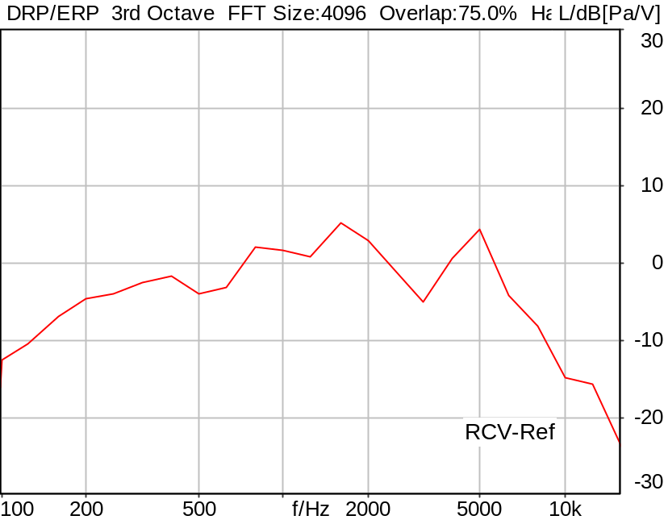

RLR: 9.71 dB Ok

Ok
5/20/2025 11:21 AM ACQUA 6.0.200

Limits
 | lower | upper
Run 1 | 8.00 dB | 18.00 dB

Meas. Setting DRP-off

Underlying Standard: 3GPP TS 26.131 V17.3.0 and 3GPP TS 26.132 V17.2.0
Database Version: 60_UG_TS26131_32_SWB_FB_Rev08_GCF_PTCRB

Source: spst4x3_sb_r16.dat
SUPERWIDEBAND Real Speech (ITU-T 12 sentences) at Channel 2
Pause 0.5 s +
Superwideband Real Speech (3x male speech, 3x female speech, 3x male speech, 3x female speech) +
Pause till end of file
Bandlimited 50-16000Hz
Signal level (ch2): -16dBm0 active speech level
Signal Length: 35.4s

For license information refer to the files >LICENSE_psytechnics.txt< and >LICENSE_nokia.txt<,
see Preparation of Test Setup - Info: Test Signals.

Calibration
RCV (2) 1.06 dB 4/29/2025 (HATS 7 (B&K 5128))
Output ch. 1 0.00 dB
Output ch. 2 0.00 dB (Radio Tester 1 (CMW500))

Output Equalization/Filter
Mouth Eq. Ch.1 HATS 7 (B&K 5128) (5/28/2024 5:25 PM)

Analysis
Analyse Channel 2
Range start 400.00 ms Range length 34650.00 ms
DRP/ERP Ch.2 P.57 (4.3/4.4)
Frequency base 3rd octave DIN Row Row B
Method FFT
FFT size 4096 Overlap 75 %
Window function Hann
Reference file r_rlr_min_hasb.fft
LR kind RLR Method ITU-T P.79
Bands for LR calc. 1..20
Leakage correction No

Special Features
Compensate delay 131.3000 ms (D_SCRIPT, Original Delay Variable stored to D_SCRIPT: D_RCV_EQ_HASB)

Hardware Config Settings
Used Setting HA&HE_5128_volte

labCORE Settings
labCORE Serial 77000280 Nickname
Firmware 3.7.5 Sync Source Internal
Clock Pitch 0.00 ppm
----------
labCORE Routing
Out Channel 1 -> Analog Out 1 -> ExternalAmplifier In -> HATS 7 (B&K 5128) Speaker
Out Channel 2 -> VoIP 2
Out Channel 2 -> VoIP 1 -> Radio Tester 1 (CMW500) RF In/Out
In Channel 1 <- VoIP In/Out 1 <- Radio Tester 1 (CMW500) RF In/Out
In Channel 2 <- BEQ Filter 1 R <- ICP Amp. (Slot 7) In 2 <- HATS 7 (B&K 5128) Mic. Right
----------
Analog Out Mainboard Settings (Analog Out)
Range Ch. 1 0.00 dB Range Ch. 2 0.00 dB
----------
ICP Settings (ICP Amp. (Slot 7))
Channel In 1 Settings
Range 132 dB[SPL] @ 50 mV/Pa Highpass 20Hz
Supply Voltage On
Channel In 2 Settings
Range 132 dB[SPL] @ 50 mV/Pa Highpass 20Hz
Supply Voltage On
Channel In 3 Settings
Range 132 dB[SPL] @ 50 mV/Pa Highpass 20Hz
Supply Voltage Off
Channel In 4 Settings
Range 132 dB[SPL] @ 50 mV/Pa Highpass 20Hz
Supply Voltage Off
----------
VoIP Settings (VoIP)
RTP Connection Streaming SIP Connection Unavailable
SIP Reg. State Unregistered Jitterbuffer Length 100
Jitter Buffer Reset On Playback Enabled Codec EVS/16000/1
Packet Length 20 Encoder Parameter ;evs-mode-switch=0;max-red=0;br=13.2;bw=swb;ch-aw-recv=-1
FMTP Parameter ;evs-mode-switch=0;bw=swb;br=13.2;ch-aw-recv=-1;max-red=220
Impairment Mode Off Impairment Type Off
----------
BEQ Settings (BEQ Filter 1)
Block mode Bypass
----------
Artificial Head Settings (HATS 7 (B&K 5128))
Ser. Nr. BK_3408387 Pinna Type Type 4.3

HIB Settings
HIB Name 60020101 Serial 60020101
HIB Mode Mobile Measurement Impedance 32 Ohm
Gain out 1 -40.00 dB Gain out 2 0.00 dB
Gain in 1 0.00 dB Gain in 2 0.00 dB
Mic 1 Power Supply Off Mic 2 Power Supply Off

9.5.1 Sidetone Electr. Enabled MAX VOL HASB
Handset Measurements Superwideband and Fullband \ Handset Measurements SuperWideband (HASB) \ Connections with Handset Receiving Direction (HASB) \ Receiving Dir. DRP/ERP >ON< Correction LIN EQ
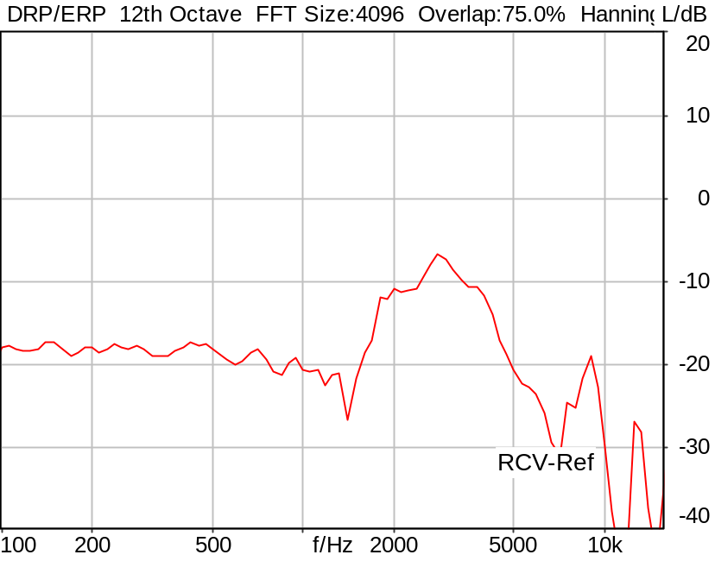

STMR (unsealed): 16.98 dB Ok

Ok
5/20/2025 11:22 AM ACQUA 6.0.200

Limits
 | lower | upper
Run 1 | 10.00 dB | 23.00 dB

Meas. Setting DRP-off

Underlying Standard: 3GPP TS 26.131 V17.3.0 and 3GPP TS 26.132 V17.2.0
Database Version: 60_UG_TS26131_32_SWB_FB_Rev08_GCF_PTCRB

Source: spst4x3_fb_s147.dat
Level adjustment Channel 2 Gain -90.00 dB
Level adjustment Channel 1 Gain 10.00 dB
FULLBAND Real Speech Single Talk (ITU-T SG 12 sentences) at Channel 1
(3x male speech, 3x female speech, 3x male speech, 3x female speech)
A silence period of 0.5 s is inserted between each sentence as well as at the
beginning and end of the sequence.
Signal level (ch1): -14.7 dBV active speech level, overall duration 35.5 s.

For license information refer to the files >LICENSE_psytechnics.txt< and
>LICENSE_nokia.txt<, see Preparation of Test Setup - Info: Test Signals

Calibration
RCV (2) 1.06 dB 4/29/2025 (HATS 7 (B&K 5128))
Output ch. 1 0.00 dB
Output ch. 2 0.00 dB (Radio Tester 1 (CMW500))

Output Equalization/Filter
Mouth Eq. Ch.1 HATS 7 (B&K 5128) (5/28/2024 5:25 PM)

Analysis
Analyse Channel 2
Range start 400.00 ms Range length 34680.00 ms
DRP/ERP Ch.2 P.57 (4.3/4.4)
Frequency base 12th octave DIN Row Row B
Method FFT
FFT size 4096 Overlap 75 %
Window function Hann
Reference file r_sidetone_hasb.fft
Sidetone kind STMR Method ITU-T P.79
Bands for LR calc. 1..20
Coupling Unsealed Leakage correction No

Hardware Config Settings
Used Setting HA&HE_5128_volte

labCORE Settings
labCORE Serial 77000280 Nickname
Firmware 3.7.5 Sync Source Internal
Clock Pitch 0.00 ppm
----------
labCORE Routing
Out Channel 1 -> Analog Out 1 -> ExternalAmplifier In -> HATS 7 (B&K 5128) Speaker
Out Channel 2 -> VoIP 2
Out Channel 2 -> VoIP 1 -> Radio Tester 1 (CMW500) RF In/Out
In Channel 1 <- VoIP In/Out 1 <- Radio Tester 1 (CMW500) RF In/Out
In Channel 2 <- BEQ Filter 1 R <- ICP Amp. (Slot 7) In 2 <- HATS 7 (B&K 5128) Mic. Right
----------
Analog Out Mainboard Settings (Analog Out)
Range Ch. 1 0.00 dB Range Ch. 2 0.00 dB
----------
ICP Settings (ICP Amp. (Slot 7))
Channel In 1 Settings
Range 132 dB[SPL] @ 50 mV/Pa Highpass 20Hz
Supply Voltage On
Channel In 2 Settings
Range 132 dB[SPL] @ 50 mV/Pa Highpass 20Hz
Supply Voltage On
Channel In 3 Settings
Range 132 dB[SPL] @ 50 mV/Pa Highpass 20Hz
Supply Voltage Off
Channel In 4 Settings
Range 132 dB[SPL] @ 50 mV/Pa Highpass 20Hz
Supply Voltage Off
----------
VoIP Settings (VoIP)
RTP Connection Streaming SIP Connection Unavailable
SIP Reg. State Unregistered Jitterbuffer Length 100
Jitter Buffer Reset On Playback Enabled Codec EVS/16000/1
Packet Length 20 Encoder Parameter ;evs-mode-switch=0;max-red=0;br=13.2;bw=swb;ch-aw-recv=-1
FMTP Parameter ;evs-mode-switch=0;bw=swb;br=13.2;ch-aw-recv=-1;max-red=220
Impairment Mode Off Impairment Type Off
----------
BEQ Settings (BEQ Filter 1)
Block mode Bypass
----------
Artificial Head Settings (HATS 7 (B&K 5128))
Ser. Nr. BK_3408387 Pinna Type Type 4.3

HIB Settings
HIB Name 60020101 Serial 60020101
HIB Mode Mobile Measurement Impedance 32 Ohm
Gain out 1 -40.00 dB Gain out 2 0.00 dB
Gain in 1 0.00 dB Gain in 2 0.00 dB
Mic 1 Power Supply Off Mic 2 Power Supply Off

9.5.1 Sidetone Electr. Enabled NOM VOL HASB
Handset Measurements Superwideband and Fullband \ Handset Measurements SuperWideband (HASB) \ Connections with Handset Receiving Direction (HASB) \ Receiving Dir. DRP/ERP >ON< Correction LIN EQ
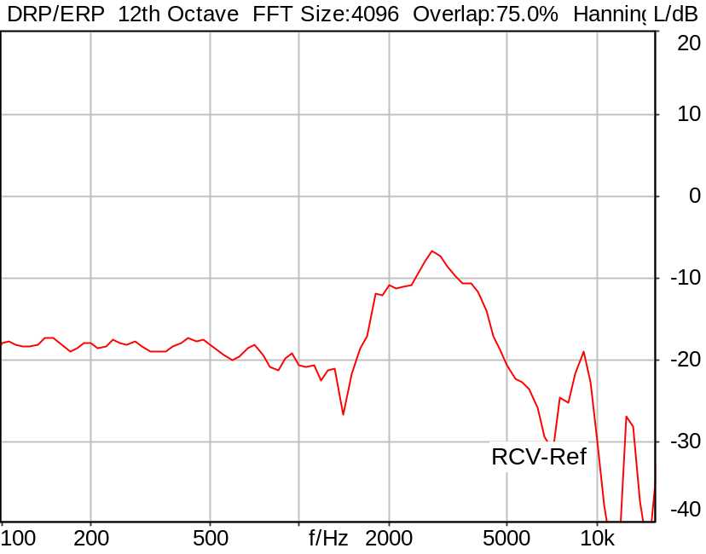

STMR (unsealed): 16.98 dB Ok

Ok
5/20/2025 11:23 AM ACQUA 6.0.200

Limits
 | lower | upper
Run 1 | 15.00 dB | 23.00 dB

Meas. Setting DRP-off

Underlying Standard: 3GPP TS 26.131 V17.3.0 and 3GPP TS 26.132 V17.2.0
Database Version: 60_UG_TS26131_32_SWB_FB_Rev08_GCF_PTCRB

Source: spst4x3_fb_s147.dat
Level adjustment Channel 2 Gain -90.00 dB
Level adjustment Channel 1 Gain 10.00 dB
FULLBAND Real Speech Single Talk (ITU-T SG 12 sentences) at Channel 1
(3x male speech, 3x female speech, 3x male speech, 3x female speech)
A silence period of 0.5 s is inserted between each sentence as well as at the
beginning and end of the sequence.
Signal level (ch1): -14.7 dBV active speech level, overall duration 35.5 s.

For license information refer to the files >LICENSE_psytechnics.txt< and
>LICENSE_nokia.txt<, see Preparation of Test Setup - Info: Test Signals

Calibration
RCV (2) 1.06 dB 4/29/2025 (HATS 7 (B&K 5128))
Output ch. 1 0.00 dB
Output ch. 2 0.00 dB (Radio Tester 1 (CMW500))

Output Equalization/Filter
Mouth Eq. Ch.1 HATS 7 (B&K 5128) (5/28/2024 5:25 PM)

Analysis
Analyse Channel 2
Range start 400.00 ms Range length 34680.00 ms
DRP/ERP Ch.2 P.57 (4.3/4.4)
Frequency base 12th octave DIN Row Row B
Method FFT
FFT size 4096 Overlap 75 %
Window function Hann
Reference file re_sidetone_nom_hasb.fft
Sidetone kind STMR Method ITU-T P.79
Bands for LR calc. 1..20
Coupling Unsealed Leakage correction No

Special Features
Store to variable STMR_HASB

Hardware Config Settings
Used Setting HA&HE_5128_volte

labCORE Settings
labCORE Serial 77000280 Nickname
Firmware 3.7.5 Sync Source Internal
Clock Pitch 0.00 ppm
----------
labCORE Routing
Out Channel 1 -> Analog Out 1 -> ExternalAmplifier In -> HATS 7 (B&K 5128) Speaker
Out Channel 2 -> VoIP 2
Out Channel 2 -> VoIP 1 -> Radio Tester 1 (CMW500) RF In/Out
In Channel 1 <- VoIP In/Out 1 <- Radio Tester 1 (CMW500) RF In/Out
In Channel 2 <- BEQ Filter 1 R <- ICP Amp. (Slot 7) In 2 <- HATS 7 (B&K 5128) Mic. Right
----------
Analog Out Mainboard Settings (Analog Out)
Range Ch. 1 0.00 dB Range Ch. 2 0.00 dB
----------
ICP Settings (ICP Amp. (Slot 7))
Channel In 1 Settings
Range 132 dB[SPL] @ 50 mV/Pa Highpass 20Hz
Supply Voltage On
Channel In 2 Settings
Range 132 dB[SPL] @ 50 mV/Pa Highpass 20Hz
Supply Voltage On
Channel In 3 Settings
Range 132 dB[SPL] @ 50 mV/Pa Highpass 20Hz
Supply Voltage Off
Channel In 4 Settings
Range 132 dB[SPL] @ 50 mV/Pa Highpass 20Hz
Supply Voltage Off
----------
VoIP Settings (VoIP)
RTP Connection Streaming SIP Connection Unavailable
SIP Reg. State Unregistered Jitterbuffer Length 100
Jitter Buffer Reset On Playback Enabled Codec EVS/16000/1
Packet Length 20 Encoder Parameter ;evs-mode-switch=0;max-red=0;br=13.2;bw=swb;ch-aw-recv=-1
FMTP Parameter ;evs-mode-switch=0;bw=swb;br=13.2;ch-aw-recv=-1;max-red=220
Impairment Mode Off Impairment Type Off
----------
BEQ Settings (BEQ Filter 1)
Block mode Bypass
----------
Artificial Head Settings (HATS 7 (B&K 5128))
Ser. Nr. BK_3408387 Pinna Type Type 4.3

HIB Settings
HIB Name 60020101 Serial 60020101
HIB Mode Mobile Measurement Impedance 32 Ohm
Gain out 1 -40.00 dB Gain out 2 0.00 dB
Gain in 1 0.00 dB Gain in 2 0.00 dB
Mic 1 Power Supply Off Mic 2 Power Supply Off

9.5.1 Sidetone Electr. Enabled MIN VOL HASB
Handset Measurements Superwideband and Fullband \ Handset Measurements SuperWideband (HASB) \ Connections with Handset Receiving Direction (HASB) \ Receiving Dir. DRP/ERP >ON< Correction LIN EQ
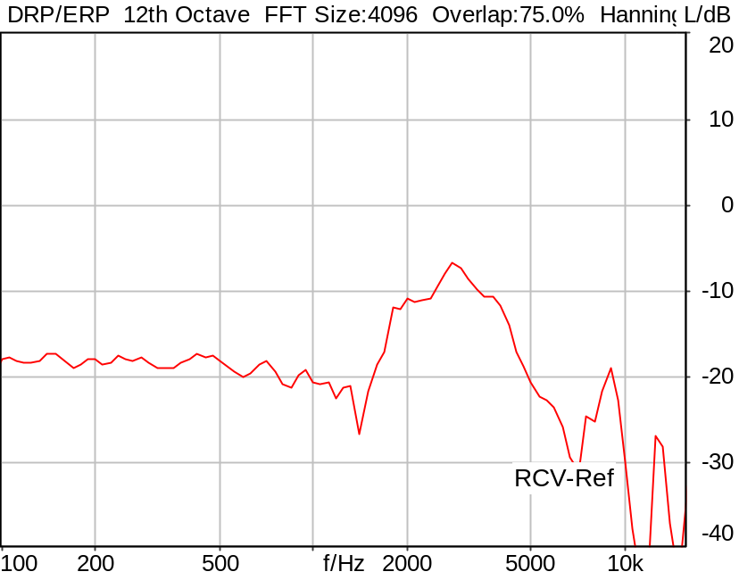

STMR (unsealed): 16.98 dB Ok

Ok
5/20/2025 11:24 AM ACQUA 6.0.200

Limits
 | lower | upper
Run 1 | 10.00 dB | 23.00 dB

Meas. Setting DRP-off

Underlying Standard: 3GPP TS 26.131 V17.3.0 and 3GPP TS 26.132 V17.2.0
Database Version: 60_UG_TS26131_32_SWB_FB_Rev08_GCF_PTCRB

Source: spst4x3_fb_s147.dat
Level adjustment Channel 2 Gain -90.00 dB
Level adjustment Channel 1 Gain 10.00 dB
FULLBAND Real Speech Single Talk (ITU-T SG 12 sentences) at Channel 1
(3x male speech, 3x female speech, 3x male speech, 3x female speech)
A silence period of 0.5 s is inserted between each sentence as well as at the
beginning and end of the sequence.
Signal level (ch1): -14.7 dBV active speech level, overall duration 35.5 s.

For license information refer to the files >LICENSE_psytechnics.txt< and
>LICENSE_nokia.txt<, see Preparation of Test Setup - Info: Test Signals

Calibration
RCV (2) 1.06 dB 4/29/2025 (HATS 7 (B&K 5128))
Output ch. 1 0.00 dB
Output ch. 2 0.00 dB (Radio Tester 1 (CMW500))

Output Equalization/Filter
Mouth Eq. Ch.1 HATS 7 (B&K 5128) (5/28/2024 5:25 PM)

Analysis
Analyse Channel 2
Range start 400.00 ms Range length 34680.00 ms
DRP/ERP Ch.2 P.57 (4.3/4.4)
Frequency base 12th octave DIN Row Row B
Method FFT
FFT size 4096 Overlap 75 %
Window function Hann
Reference file re_sidetone_nom_hasb.fft
Sidetone kind STMR Method ITU-T P.79
Bands for LR calc. 1..20
Coupling Unsealed Leakage correction No

Hardware Config Settings
Used Setting HA&HE_5128_volte

labCORE Settings
labCORE Serial 77000280 Nickname
Firmware 3.7.5 Sync Source Internal
Clock Pitch 0.00 ppm
----------
labCORE Routing
Out Channel 1 -> Analog Out 1 -> ExternalAmplifier In -> HATS 7 (B&K 5128) Speaker
Out Channel 2 -> VoIP 2
Out Channel 2 -> VoIP 1 -> Radio Tester 1 (CMW500) RF In/Out
In Channel 1 <- VoIP In/Out 1 <- Radio Tester 1 (CMW500) RF In/Out
In Channel 2 <- BEQ Filter 1 R <- ICP Amp. (Slot 7) In 2 <- HATS 7 (B&K 5128) Mic. Right
----------
Analog Out Mainboard Settings (Analog Out)
Range Ch. 1 0.00 dB Range Ch. 2 0.00 dB
----------
ICP Settings (ICP Amp. (Slot 7))
Channel In 1 Settings
Range 132 dB[SPL] @ 50 mV/Pa Highpass 20Hz
Supply Voltage On
Channel In 2 Settings
Range 132 dB[SPL] @ 50 mV/Pa Highpass 20Hz
Supply Voltage On
Channel In 3 Settings
Range 132 dB[SPL] @ 50 mV/Pa Highpass 20Hz
Supply Voltage Off
Channel In 4 Settings
Range 132 dB[SPL] @ 50 mV/Pa Highpass 20Hz
Supply Voltage Off
----------
VoIP Settings (VoIP)
RTP Connection Streaming SIP Connection Unavailable
SIP Reg. State Unregistered Jitterbuffer Length 100
Jitter Buffer Reset On Playback Enabled Codec EVS/16000/1
Packet Length 20 Encoder Parameter ;evs-mode-switch=0;max-red=0;br=13.2;bw=swb;ch-aw-recv=-1
FMTP Parameter ;evs-mode-switch=0;bw=swb;br=13.2;ch-aw-recv=-1;max-red=220
Impairment Mode Off Impairment Type Off
----------
BEQ Settings (BEQ Filter 1)
Block mode Bypass
----------
Artificial Head Settings (HATS 7 (B&K 5128))
Ser. Nr. BK_3408387 Pinna Type Type 4.3

HIB Settings
HIB Name 60020101 Serial 60020101
HIB Mode Mobile Measurement Impedance 32 Ohm
Gain out 1 -40.00 dB Gain out 2 0.00 dB
Gain in 1 0.00 dB Gain in 2 0.00 dB
Mic 1 Power Supply Off Mic 2 Power Supply Off

9.5.4 Sidetone delay, Volume NOM HASB
Handset Measurements Superwideband and Fullband \ Handset Measurements SuperWideband (HASB) \ Connections with Handset Receiving Direction (HASB) \ Receiving Dir. DRP/ERP >OFF< DF AVG via SMD LIN EQ
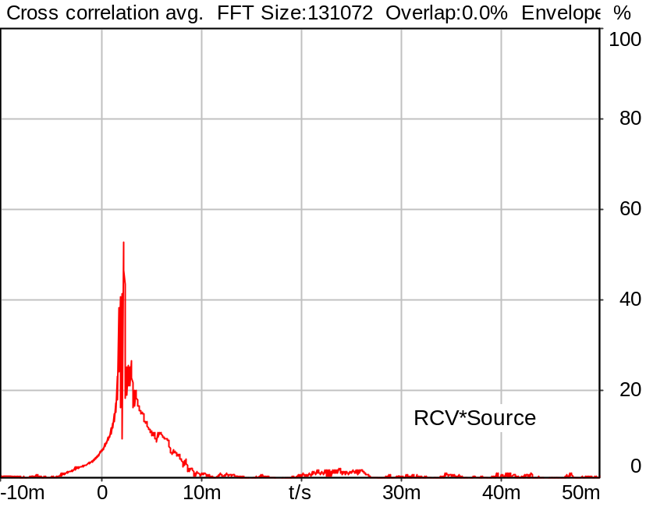

Channel | Delay
RCV*Source | 2.2 ms

5/20/2025 11:24 AM ACQUA 6.0.200
Unmodified HEAD acoustics Measurement Descriptor

Meas. Setting DRP-off

Underlying Standard: 3GPP TS 26.131 V17.3.0 and 3GPP TS 26.132 V17.2.0
Database Version: 60_UG_TS26131_32_SWB_FB_Rev08_GCF_PTCRB

Source: cssfb1b_4k.dat
Level adjustment Channel 2 Gain -90.00 dB
Level adjustment Channel 1 Gain 10.00 dB
CSSfb1b_4k.dat

CS-signal with special 4k-FFT PN periodicity.

FULLBAND Composite Source Signal SND P.501 (1 bursts) at Channel 1
Pause 0.5 s +
voiced signal + 100 to 20000 Hz pseudo noise 0.2 s + Pause 0.101 s +
Pause till end of file

Signal level (ch1): -14.7 dBV from 0.5s to 0.85 s for 4K- FFT, Rectangle window,
0 % overlap in frequency range of 100 to 20000 Hz

Calibration
SND (1) 0.00 dB (Radio Tester 1 (CMW500))
RCV (2) 1.06 dB 4/29/2025 (HATS 7 (B&K 5128))
Output ch. 1 0.00 dB
Output ch. 2 0.00 dB (Radio Tester 1 (CMW500))

Output Equalization/Filter
Mouth Eq. Ch.1 HATS 7 (B&K 5128) (5/28/2024 5:25 PM)

Analysis
Analyse Channel 2
Range start 550.00 ms Range length 170.67 ms
Frequency base Transformation
FFT size 131072 Overlap 0 %
Window function Hann Smooth Off
Reference channel Channel 1
Valid range start -1228.79 ms Valid range end 1228.81 ms

Special Features
Show source signal Source ch.1

Hardware Config Settings
Used Setting HA&HE_5128_volte

labCORE Settings
labCORE Serial 77000280 Nickname
Firmware 3.7.5 Sync Source Internal
Clock Pitch 0.00 ppm
----------
labCORE Routing
Out Channel 1 -> Analog Out 1 -> ExternalAmplifier In -> HATS 7 (B&K 5128) Speaker
Out Channel 2 -> VoIP 2
Out Channel 2 -> VoIP 1 -> Radio Tester 1 (CMW500) RF In/Out
In Channel 1 <- VoIP In/Out 1 <- Radio Tester 1 (CMW500) RF In/Out
In Channel 2 <- BEQ Filter 1 R <- ICP Amp. (Slot 7) In 2 <- HATS 7 (B&K 5128) Mic. Right
----------
Analog Out Mainboard Settings (Analog Out)
Range Ch. 1 0.00 dB Range Ch. 2 0.00 dB
----------
ICP Settings (ICP Amp. (Slot 7))
Channel In 1 Settings
Range 132 dB[SPL] @ 50 mV/Pa Highpass 20Hz
Supply Voltage On
Channel In 2 Settings
Range 132 dB[SPL] @ 50 mV/Pa Highpass 20Hz
Supply Voltage On
Channel In 3 Settings
Range 132 dB[SPL] @ 50 mV/Pa Highpass 20Hz
Supply Voltage Off
Channel In 4 Settings
Range 132 dB[SPL] @ 50 mV/Pa Highpass 20Hz
Supply Voltage Off
----------
VoIP Settings (VoIP)
RTP Connection Streaming SIP Connection Unavailable
SIP Reg. State Unregistered Jitterbuffer Length 100
Jitter Buffer Reset On Playback Enabled Codec EVS/16000/1
Packet Length 20 Encoder Parameter ;evs-mode-switch=0;max-red=0;br=13.2;bw=swb;ch-aw-recv=-1
FMTP Parameter ;evs-mode-switch=0;bw=swb;br=13.2;ch-aw-recv=-1;max-red=220
Impairment Mode Off Impairment Type Off
----------
BEQ Settings (BEQ Filter 1)
Block mode Bypass
----------
Artificial Head Settings (HATS 7 (B&K 5128))
Ser. Nr. BK_3408387 Pinna Type Type 4.3

HIB Settings
HIB Name 60020101 Serial 60020101
HIB Mode Mobile Measurement Impedance 32 Ohm
Gain out 1 -40.00 dB Gain out 2 0.00 dB
Gain in 1 0.00 dB Gain in 2 0.00 dB
Mic 1 Power Supply Off Mic 2 Power Supply Off

9.3.2 Idle channel noise RCV MAX Volume, #1 HASB
Handset Measurements Superwideband and Fullband \ Handset Measurements SuperWideband (HASB) \ Connections with Handset Receiving Direction (HASB) \ Receiving Dir. DRP/ERP >OFF< DF AVG via SMD LIN EQ
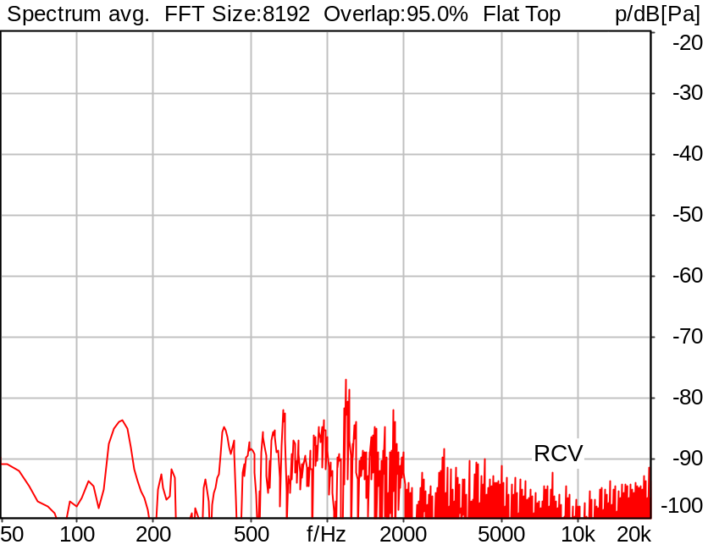

Channel | Noise level
RCV | -66.84 dB[Pa]

5/20/2025 11:25 AM ACQUA 6.0.200
Unmodified HEAD acoustics Measurement Descriptor

Meas. Setting DRP-off

Underlying Standard: 3GPP TS 26.131 V17.3.0 and 3GPP TS 26.132 V17.2.0
Database Version: 60_UG_TS26131_32_SWB_FB_Rev08_GCF_PTCRB

Source: csssb4b_r16_p.dat
FULLBAND Composite Source Signal RCV P.501 (4 bursts) at Channel 2
4x times (Pause 0.5 s + voiced signal + 16000 Hz band limited pseudo noise 0.2 s +Pause 0.200 s)
+ Pause till end of file
voiced signal 0.0486 s (as activation) +
Signal level (ch2): -16 dBm0 from 0.5s to 1.2s for 2048 FFT, Rectangle window,
0 % overlap in frequency range of 100 to 16000 Hz

Calibration
RCV (2) 1.06 dB 4/29/2025 (HATS 7 (B&K 5128))
Output ch. 1 0.00 dB
Output ch. 2 0.00 dB (Radio Tester 1 (CMW500))

Output Equalization/Filter
Mouth Eq. Ch.1 HATS 7 (B&K 5128) (5/28/2024 5:25 PM)

Analysis
Analyse Channel 2
Range start 763.00 ms Range length 170.67 ms
Frequency base Transformation
FFT size 8192 Overlap 95 %
Window function Flat Top Smooth Off
Analysis bandwidth octave

Input Filters
FIR Filter Channel 2 Filename a-filter.hdf
DF Avg. Channels 1,2

Special Features
Compensate delay 131.3000 ms (D_SCRIPT, Original Delay Variable stored to D_SCRIPT: D_RCV_EQ_HASB)
Store to file idlenoise_max_hasb.dat Store to variable IdlNoiRcv_Amax_Hasb

Hardware Config Settings
Used Setting HA&HE_5128_volte

labCORE Settings
labCORE Serial 77000280 Nickname
Firmware 3.7.5 Sync Source Internal
Clock Pitch 0.00 ppm
----------
labCORE Routing
Out Channel 1 -> Analog Out 1 -> ExternalAmplifier In -> HATS 7 (B&K 5128) Speaker
Out Channel 2 -> VoIP 2
Out Channel 2 -> VoIP 1 -> Radio Tester 1 (CMW500) RF In/Out
In Channel 1 <- VoIP In/Out 1 <- Radio Tester 1 (CMW500) RF In/Out
In Channel 2 <- BEQ Filter 1 R <- ICP Amp. (Slot 7) In 2 <- HATS 7 (B&K 5128) Mic. Right
----------
Analog Out Mainboard Settings (Analog Out)
Range Ch. 1 0.00 dB Range Ch. 2 0.00 dB
----------
ICP Settings (ICP Amp. (Slot 7))
Channel In 1 Settings
Range 132 dB[SPL] @ 50 mV/Pa Highpass 20Hz
Supply Voltage On
Channel In 2 Settings
Range 132 dB[SPL] @ 50 mV/Pa Highpass 20Hz
Supply Voltage On
Channel In 3 Settings
Range 132 dB[SPL] @ 50 mV/Pa Highpass 20Hz
Supply Voltage Off
Channel In 4 Settings
Range 132 dB[SPL] @ 50 mV/Pa Highpass 20Hz
Supply Voltage Off
----------
VoIP Settings (VoIP)
RTP Connection Streaming SIP Connection Unavailable
SIP Reg. State Unregistered Jitterbuffer Length 100
Jitter Buffer Reset On Playback Enabled Codec EVS/16000/1
Packet Length 20 Encoder Parameter ;evs-mode-switch=0;max-red=0;br=13.2;bw=swb;ch-aw-recv=-1
FMTP Parameter ;evs-mode-switch=0;bw=swb;br=13.2;ch-aw-recv=-1;max-red=220
Impairment Mode Off Impairment Type Off
----------
BEQ Settings (BEQ Filter 1)
Block mode Bypass
----------
Artificial Head Settings (HATS 7 (B&K 5128))
Ser. Nr. BK_3408387 Pinna Type Type 4.3

HIB Settings
HIB Name 60020101 Serial 60020101
HIB Mode Mobile Measurement Impedance 32 Ohm
Gain out 1 -40.00 dB Gain out 2 0.00 dB
Gain in 1 0.00 dB Gain in 2 0.00 dB
Mic 1 Power Supply Off Mic 2 Power Supply Off

9.3.2 Idle channel noise RCV MAX Volume, #2 HASB
Handset Measurements Superwideband and Fullband \ Handset Measurements SuperWideband (HASB) \ Connections with Handset Receiving Direction (HASB) \ Receiving Dir. DRP/ERP >OFF< DF AVG via SMD LIN EQ
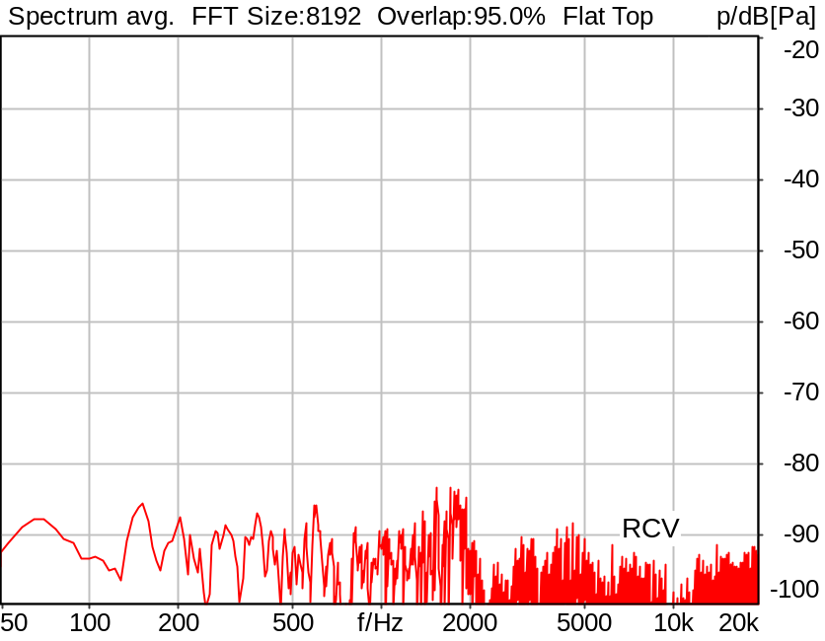

Channel | Noise level
RCV | -67.37 dB[Pa]

5/20/2025 11:26 AM ACQUA 6.0.200
Unmodified HEAD acoustics Measurement Descriptor

Meas. Setting DRP-off

Underlying Standard: 3GPP TS 26.131 V17.3.0 and 3GPP TS 26.132 V17.2.0
Database Version: 60_UG_TS26131_32_SWB_FB_Rev08_GCF_PTCRB

Analysed: idlenoise_max_hasb.dat
9.3.2 Idle channel noise RCV MAX Volume, #1 HASB

Analysis
Analyse Channel 2
Range start 1213.00 ms Range length 170.67 ms
Frequency base Transformation
FFT size 8192 Overlap 95 %
Window function Flat Top Smooth Off
Analysis bandwidth octave

Input Filters
DF Avg. Channels 1,2

Special Features
Store to variable IdlNoiRcv_Bmax_Hasb

9.3.2 Idle channel noise RCV MAX Volume, #3 HASB
Handset Measurements Superwideband and Fullband \ Handset Measurements SuperWideband (HASB) \ Connections with Handset Receiving Direction (HASB) \ Receiving Dir. DRP/ERP >OFF< DF AVG via SMD LIN EQ
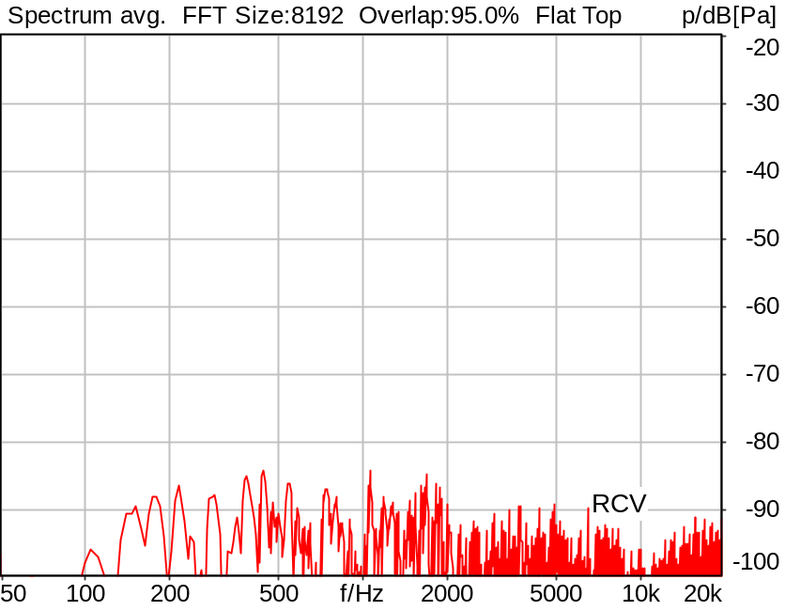

Channel | Noise level
RCV | -67.87 dB[Pa]

5/20/2025 11:26 AM ACQUA 6.0.200
Unmodified HEAD acoustics Measurement Descriptor

Meas. Setting DRP-off

Underlying Standard: 3GPP TS 26.131 V17.3.0 and 3GPP TS 26.132 V17.2.0
Database Version: 60_UG_TS26131_32_SWB_FB_Rev08_GCF_PTCRB

Analysed: idlenoise_max_hasb.dat
9.3.2 Idle channel noise RCV MAX Volume, #1 HASB

Analysis
Analyse Channel 2
Range start 1663.00 ms Range length 170.67 ms
Frequency base Transformation
FFT size 8192 Overlap 95 %
Window function Flat Top Smooth Off
Analysis bandwidth octave

Input Filters
DF Avg. Channels 1,2

Special Features
Store to variable IdlNoiRcv_Cmax_Hasb

9.3.2 Idle channel noise RCV AVG max. Volume, HASB
Handset Measurements Superwideband and Fullband \ Handset Measurements SuperWideband (HASB) \ Connections with Handset Receiving Direction (HASB) \ Receiving Dir. DRP/ERP >OFF< DF AVG via SMD LIN EQ
Correction
IdlNoiRcv_Amax_Hasb | -66.840 dB[Pa] | 5/20/2025 | Measured | 9.3.2 Idle channel noise RCV MAX Volume, #1 HASB
IdlNoiRcv_Bmax_Hasb | -67.370 dB[Pa] | 5/20/2025 | Measured | 9.3.2 Idle channel noise RCV MAX Volume, #2 HASB
IdlNoiRcv_Cmax_Hasb | -67.870 dB[Pa] | 5/20/2025 | Measured | 9.3.2 Idle channel noise RCV MAX Volume, #3 HASB
10*log((10^(IdlNoiRcv_Amax_Hasb/10) + 10^(IdlNoiRcv_Bmax_Hasb/10) + 10^(IdlNoiRcv_Cmax_Hasb/10)) / 3)

Calculated Value: -67.34 dBPa(A) Ok

Ok
5/20/2025 11:26 AM ACQUA 6.0.200
Unmodified HEAD acoustics Measurement Descriptor

Limits
 | upper
Run 1 | -54.00 dBPa(A)

Underlying Standard: 3GPP TS 26.131 V17.3.0 and 3GPP TS 26.132 V17.2.0
Database Version: 60_UG_TS26131_32_SWB_FB_Rev08_GCF_PTCRB

9.3.2 Idle channel noise RCV NOM Volume, #1 HASB
Handset Measurements Superwideband and Fullband \ Handset Measurements SuperWideband (HASB) \ Connections with Handset Receiving Direction (HASB) \ Receiving Dir. DRP/ERP >OFF< DF AVG via SMD LIN EQ
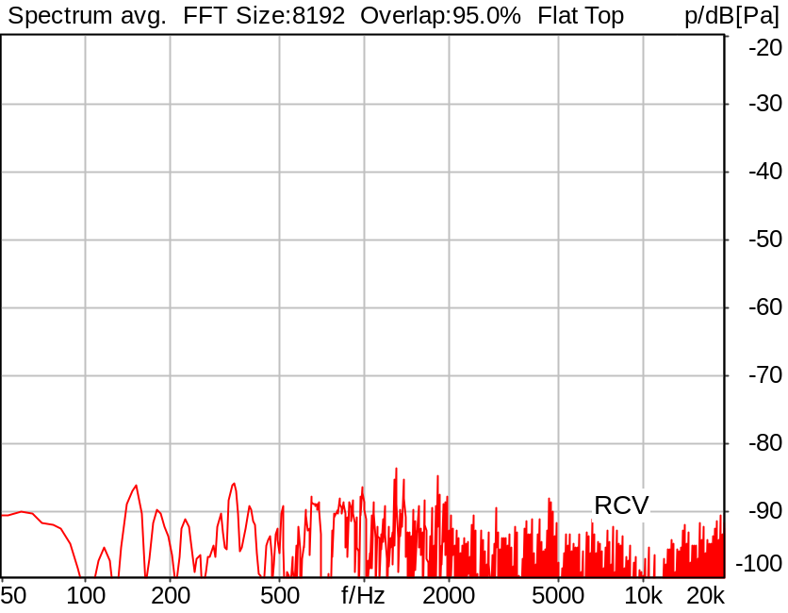

Channel | Noise level
RCV | -68.13 dB[Pa]

5/20/2025 11:26 AM ACQUA 6.0.200
Unmodified HEAD acoustics Measurement Descriptor

Meas. Setting DRP-off

Underlying Standard: 3GPP TS 26.131 V17.3.0 and 3GPP TS 26.132 V17.2.0
Database Version: 60_UG_TS26131_32_SWB_FB_Rev08_GCF_PTCRB

Source: csssb4b_r16_p.dat
FULLBAND Composite Source Signal RCV P.501 (4 bursts) at Channel 2
4x times (Pause 0.5 s + voiced signal + 16000 Hz band limited pseudo noise 0.2 s +Pause 0.200 s)
+ Pause till end of file
voiced signal 0.0486 s (as activation) +
Signal level (ch2): -16 dBm0 from 0.5s to 1.2s for 2048 FFT, Rectangle window,
0 % overlap in frequency range of 100 to 16000 Hz

Calibration
RCV (2) 1.06 dB 4/29/2025 (HATS 7 (B&K 5128))
Output ch. 1 0.00 dB
Output ch. 2 0.00 dB (Radio Tester 1 (CMW500))

Output Equalization/Filter
Mouth Eq. Ch.1 HATS 7 (B&K 5128) (5/28/2024 5:25 PM)

Analysis
Analyse Channel 2
Range start 763.00 ms Range length 170.67 ms
Frequency base Transformation
FFT size 8192 Overlap 95 %
Window function Flat Top Smooth Off
Analysis bandwidth octave

Input Filters
FIR Filter Channel 2 Filename a-filter.hdf
DF Avg. Channels 1,2

Special Features
Compensate delay 131.3000 ms (D_SCRIPT, Original Delay Variable stored to D_SCRIPT: D_RCV_EQ_HASB)
Store to file idlenoise_nom_hasb.dat Store to variable IdlNoiRcv_Anom_Hasb

Hardware Config Settings
Used Setting HA&HE_5128_volte

labCORE Settings
labCORE Serial 77000280 Nickname
Firmware 3.7.5 Sync Source Internal
Clock Pitch 0.00 ppm
----------
labCORE Routing
Out Channel 1 -> Analog Out 1 -> ExternalAmplifier In -> HATS 7 (B&K 5128) Speaker
Out Channel 2 -> VoIP 2
Out Channel 2 -> VoIP 1 -> Radio Tester 1 (CMW500) RF In/Out
In Channel 1 <- VoIP In/Out 1 <- Radio Tester 1 (CMW500) RF In/Out
In Channel 2 <- BEQ Filter 1 R <- ICP Amp. (Slot 7) In 2 <- HATS 7 (B&K 5128) Mic. Right
----------
Analog Out Mainboard Settings (Analog Out)
Range Ch. 1 0.00 dB Range Ch. 2 0.00 dB
----------
ICP Settings (ICP Amp. (Slot 7))
Channel In 1 Settings
Range 132 dB[SPL] @ 50 mV/Pa Highpass 20Hz
Supply Voltage On
Channel In 2 Settings
Range 132 dB[SPL] @ 50 mV/Pa Highpass 20Hz
Supply Voltage On
Channel In 3 Settings
Range 132 dB[SPL] @ 50 mV/Pa Highpass 20Hz
Supply Voltage Off
Channel In 4 Settings
Range 132 dB[SPL] @ 50 mV/Pa Highpass 20Hz
Supply Voltage Off
----------
VoIP Settings (VoIP)
RTP Connection Streaming SIP Connection Unavailable
SIP Reg. State Unregistered Jitterbuffer Length 100
Jitter Buffer Reset On Playback Enabled Codec EVS/16000/1
Packet Length 20 Encoder Parameter ;evs-mode-switch=0;max-red=0;br=13.2;bw=swb;ch-aw-recv=-1
FMTP Parameter ;evs-mode-switch=0;bw=swb;br=13.2;ch-aw-recv=-1;max-red=220
Impairment Mode Off Impairment Type Off
----------
BEQ Settings (BEQ Filter 1)
Block mode Bypass
----------
Artificial Head Settings (HATS 7 (B&K 5128))
Ser. Nr. BK_3408387 Pinna Type Type 4.3

HIB Settings
HIB Name 60020101 Serial 60020101
HIB Mode Mobile Measurement Impedance 32 Ohm
Gain out 1 -40.00 dB Gain out 2 0.00 dB
Gain in 1 0.00 dB Gain in 2 0.00 dB
Mic 1 Power Supply Off Mic 2 Power Supply Off

9.3.2 Idle channel noise RCV NOM Volume, #2 HASB
Handset Measurements Superwideband and Fullband \ Handset Measurements SuperWideband (HASB) \ Connections with Handset Receiving Direction (HASB) \ Receiving Dir. DRP/ERP >OFF< DF AVG via SMD LIN EQ
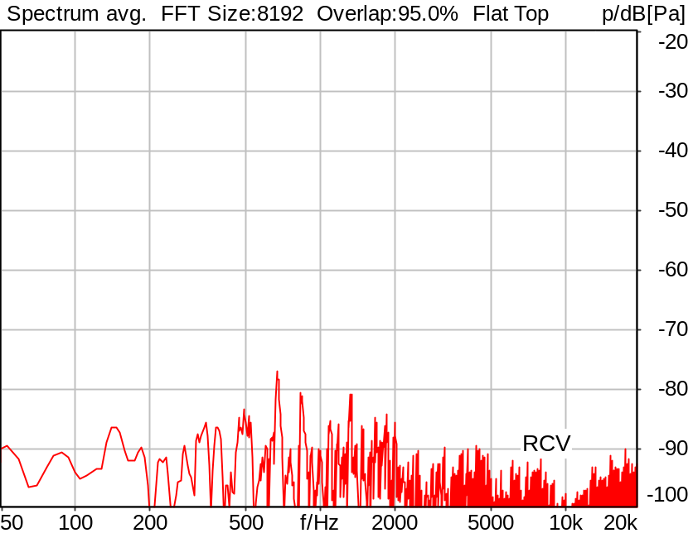

Channel | Noise level
RCV | -66.72 dB[Pa]

5/20/2025 11:26 AM ACQUA 6.0.200
Unmodified HEAD acoustics Measurement Descriptor

Meas. Setting DRP-off

Underlying Standard: 3GPP TS 26.131 V17.3.0 and 3GPP TS 26.132 V17.2.0
Database Version: 60_UG_TS26131_32_SWB_FB_Rev08_GCF_PTCRB

Analysed: idlenoise_nom_hasb.dat
9.3.2 Idle channel noise RCV NOM Volume, #1 HASB

Analysis
Analyse Channel 2
Range start 1213.00 ms Range length 170.67 ms
Frequency base Transformation
FFT size 8192 Overlap 95 %
Window function Flat Top Smooth Off
Analysis bandwidth octave

Input Filters
DF Avg. Channels 1,2

Special Features
Store to variable IdlNoiRcv_Bnom_Hasb

9.3.2 Idle channel noise RCV NOM Volume, #3 HASB
Handset Measurements Superwideband and Fullband \ Handset Measurements SuperWideband (HASB) \ Connections with Handset Receiving Direction (HASB) \ Receiving Dir. DRP/ERP >OFF< DF AVG via SMD LIN EQ
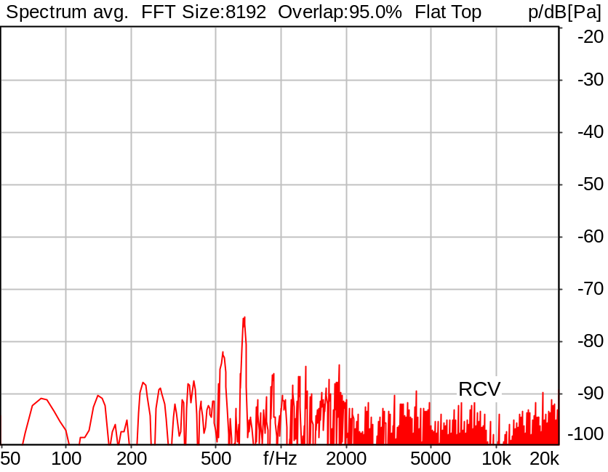

Channel | Noise level
RCV | -67.41 dB[Pa]

5/20/2025 11:26 AM ACQUA 6.0.200
Unmodified HEAD acoustics Measurement Descriptor

Meas. Setting DRP-off

Underlying Standard: 3GPP TS 26.131 V17.3.0 and 3GPP TS 26.132 V17.2.0
Database Version: 60_UG_TS26131_32_SWB_FB_Rev08_GCF_PTCRB

Analysed: idlenoise_nom_hasb.dat
9.3.2 Idle channel noise RCV NOM Volume, #1 HASB

Analysis
Analyse Channel 2
Range start 1663.00 ms Range length 170.67 ms
Frequency base Transformation
FFT size 8192 Overlap 95 %
Window function Flat Top Smooth Off
Analysis bandwidth octave

Input Filters
DF Avg. Channels 1,2

Special Features
Store to variable IdlNoiRcv_Cnom_Hasb

9.3.2 Idle channel noise RCV AVG nom. Volume, HASB
Handset Measurements Superwideband and Fullband \ Handset Measurements SuperWideband (HASB) \ Connections with Handset Receiving Direction (HASB) \ Receiving Dir. DRP/ERP >OFF< DF AVG via SMD LIN EQ
Correction
IdlNoiRcv_Anom_Hasb | -68.130 dB[Pa] | 5/20/2025 | Measured | 9.3.2 Idle channel noise RCV NOM Volume, #1 HASB
IdlNoiRcv_Bnom_Hasb | -66.720 dB[Pa] | 5/20/2025 | Measured | 9.3.2 Idle channel noise RCV NOM Volume, #2 HASB
IdlNoiRcv_Cnom_Hasb | -67.410 dB[Pa] | 5/20/2025 | Measured | 9.3.2 Idle channel noise RCV NOM Volume, #3 HASB
10*log((10^(IdlNoiRcv_Anom_Hasb/10) + 10^(IdlNoiRcv_Bnom_Hasb/10) + 10^(IdlNoiRcv_Cnom_Hasb/10)) / 3)

Calculated Value: -67.38 dBPa(A) Ok

Ok
5/20/2025 11:26 AM ACQUA 6.0.200
Unmodified HEAD acoustics Measurement Descriptor

Limits
 | upper
Run 1 | -57.00 dBPa(A)

Underlying Standard: 3GPP TS 26.131 V17.3.0 and 3GPP TS 26.132 V17.2.0
Database Version: 60_UG_TS26131_32_SWB_FB_Rev08_GCF_PTCRB

9.3.2 Single Frequency Disturbances RCV HASB
Handset Measurements Superwideband and Fullband \ Handset Measurements SuperWideband (HASB) \ Connections with Handset Receiving Direction (HASB) \ Receiving Dir. DRP/ERP >OFF< DF AVG via SMD LIN EQ
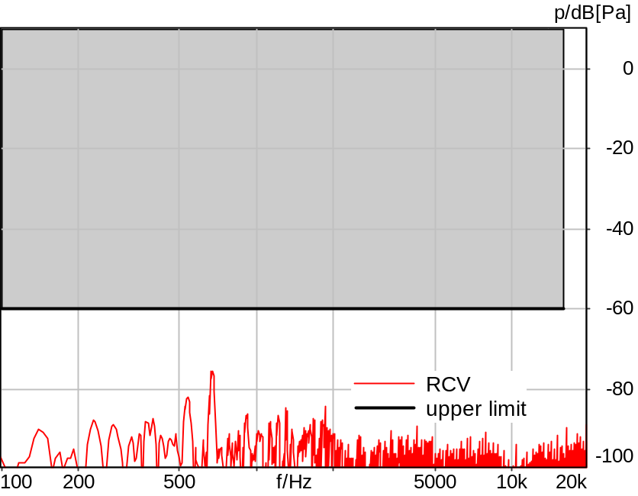

Absolute minimal distance
15.30 dB at 673.8 Hz Ok

Ok
5/20/2025 11:26 AM ACQUA 6.0.200
Unmodified HEAD acoustics Measurement Descriptor

Limits
 | lower
Run 1 | Fit into tolerance

Meas. Setting DRP-off

Underlying Standard: 3GPP TS 26.131 V17.3.0 and 3GPP TS 26.132 V17.2.0
Database Version: 60_UG_TS26131_32_SWB_FB_Rev08_GCF_PTCRB

Analysed: idlenoise_nom_hasb.dat
9.3.2 Idle channel noise RCV NOM Volume, #1 HASB

Analysis
Analyse Channel 2
Range start 1663.00 ms Range length 170.67 ms
Frequency base Transformation
FFT size 8192 Overlap 95 %
Window function Flat Top Smooth Off
Tol. scheme file sfi_rcv_hasb.tol Min. freq. for tol. 100.0 Hz
Auto adjust No Max. freq. for tol. 16000.0 Hz

Special Features
Store to file sfi_rcv_m_hasb.fft

9.3.2 Single Frequency Disturbances RCV HASB
Handset Measurements Superwideband and Fullband \ Handset Measurements SuperWideband (HASB) \ Connections with Handset Receiving Direction (HASB) \ Receiving Dir. DRP/ERP >OFF< DF AVG via SMD LIN EQ
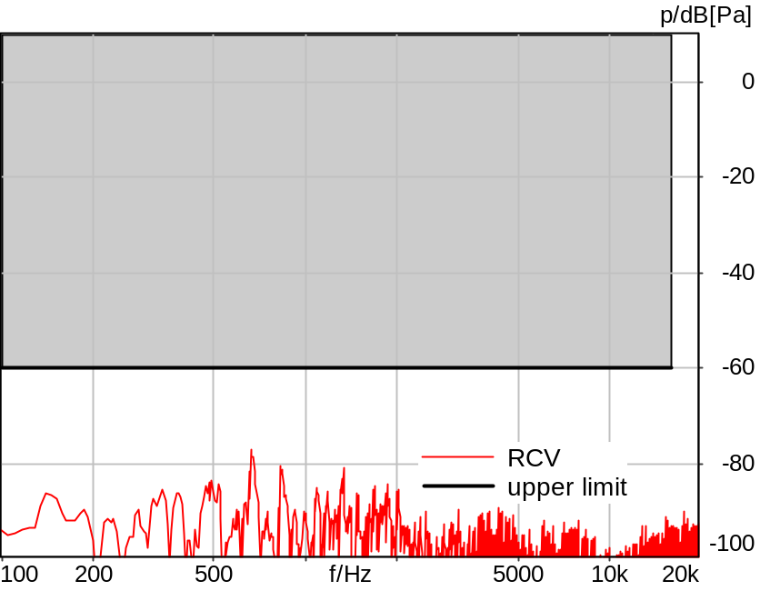

Absolute minimal distance
16.95 dB at 668.0 Hz Ok

Ok
5/20/2025 11:27 AM ACQUA 6.0.200
Unmodified HEAD acoustics Measurement Descriptor

Limits
 | lower
Run 1 | Fit into tolerance

Meas. Setting DRP-off

Underlying Standard: 3GPP TS 26.131 V17.3.0 and 3GPP TS 26.132 V17.2.0
Database Version: 60_UG_TS26131_32_SWB_FB_Rev08_GCF_PTCRB

Analysed: idlenoise_nom_hasb.dat
9.3.2 Idle channel noise RCV NOM Volume, #1 HASB

Analysis
Analyse Channel 2
Range start 1213.00 ms Range length 170.67 ms
Frequency base Transformation
FFT size 8192 Overlap 95 %
Window function Flat Top Smooth Off
Tol. scheme file sfi_rcv_hasb.tol Min. freq. for tol. 100.0 Hz
Auto adjust No Max. freq. for tol. 16000.0 Hz

Special Features
Store to file sfi_rcv_l_hasb.fft

9.3.2 Single Frequency Disturbances RCV HASB
Handset Measurements Superwideband and Fullband \ Handset Measurements SuperWideband (HASB) \ Connections with Handset Receiving Direction (HASB) \ Receiving Dir. DRP/ERP >OFF< DF AVG via SMD LIN EQ
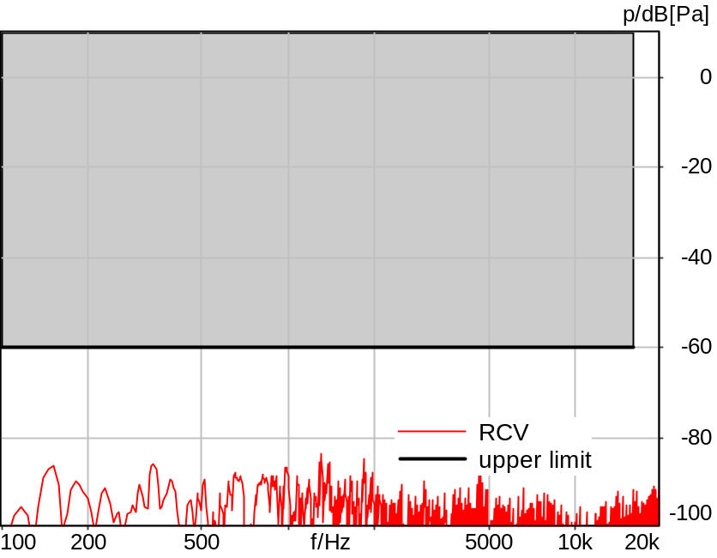

Absolute minimal distance
23.42 dB at 1300.8 Hz Ok

Ok
5/20/2025 11:27 AM ACQUA 6.0.200
Unmodified HEAD acoustics Measurement Descriptor

Limits
 | lower
Run 1 | Fit into tolerance

Meas. Setting DRP-off

Underlying Standard: 3GPP TS 26.131 V17.3.0 and 3GPP TS 26.132 V17.2.0
Database Version: 60_UG_TS26131_32_SWB_FB_Rev08_GCF_PTCRB

Analysed: idlenoise_nom_hasb.dat
9.3.2 Idle channel noise RCV NOM Volume, #1 HASB

Analysis
Analyse Channel 2
Range start 763.00 ms Range length 170.67 ms
Frequency base Transformation
FFT size 8192 Overlap 95 %
Window function Flat Top Smooth Off
Tol. scheme file sfi_rcv_hasb.tol Min. freq. for tol. 100.0 Hz
Auto adjust No Max. freq. for tol. 16000.0 Hz

Special Features
Store to file sfi_rcv_k_hasb.fft

9.3.2 Average Single Frequency Disturbances RCV HASB
Handset Measurements Superwideband and Fullband \ Handset Measurements SuperWideband (HASB) \ Connections with Handset Receiving Direction (HASB) \ Receiving Dir. DRP/ERP >OFF< DF AVG via SMD LIN EQ
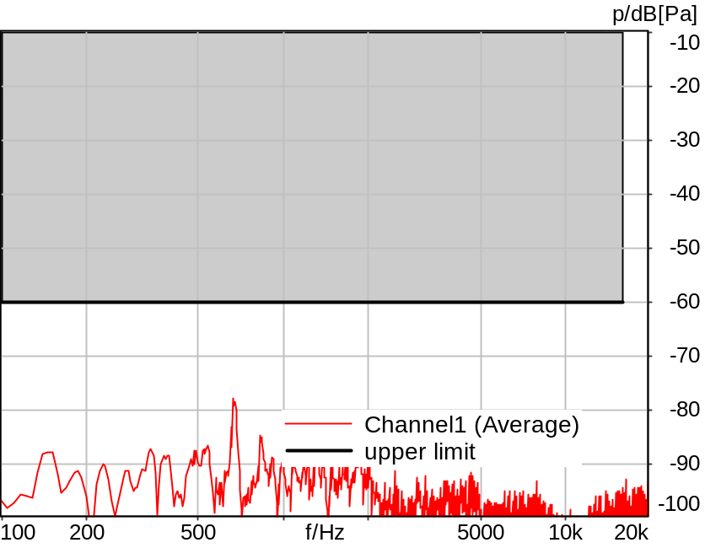

Absolute minimal distance
17.83 dB at 668.0 Hz Ok

Ok
5/20/2025 11:27 AM ACQUA 6.0.200
Unmodified HEAD acoustics Measurement Descriptor

Limits
 | lower
Run 1 | Fit into tolerance

Underlying Standard: 3GPP TS 26.131 V17.3.0 and 3GPP TS 26.132 V17.2.0
Database Version: 60_UG_TS26131_32_SWB_FB_Rev08_GCF_PTCRB

9.4.2 Sensitivity frequency char. RCV 1/3oct HASB MAX
Handset Measurements Superwideband and Fullband \ Handset Measurements SuperWideband (HASB) \ Connections with Handset Receiving Direction (HASB) \ Receiving Dir. DRP/ERP >OFF< DF AVG via SMD LIN EQ
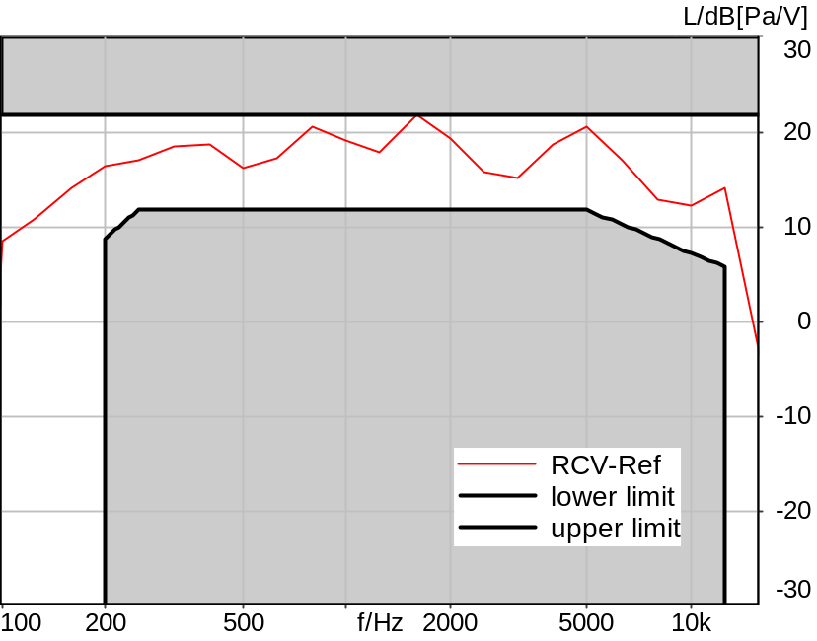

Absolute minimal distance
3.30 dB at 3150.0 Hz Ok

Ok
5/20/2025 11:27 AM ACQUA 6.0.200

Limits
 | lower
Run 1 | 1.00 dB

Meas. Setting DRP-off

Underlying Standard: 3GPP TS 26.131 V17.3.0 and 3GPP TS 26.132 V17.2.0
Database Version: 60_UG_TS26131_32_SWB_FB_Rev08_GCF_PTCRB

Source: spst4x3_sb_r16.dat
SUPERWIDEBAND Real Speech (ITU-T 12 sentences) at Channel 2
Pause 0.5 s +
Superwideband Real Speech (3x male speech, 3x female speech, 3x male speech, 3x female speech) +
Pause till end of file
Bandlimited 50-16000Hz
Signal level (ch2): -16dBm0 active speech level
Signal Length: 35.4s

For license information refer to the files >LICENSE_psytechnics.txt< and >LICENSE_nokia.txt<,
see Preparation of Test Setup - Info: Test Signals.

Calibration
RCV (2) 1.06 dB 4/29/2025 (HATS 7 (B&K 5128))
Output ch. 1 0.00 dB
Output ch. 2 0.00 dB (Radio Tester 1 (CMW500))

Output Equalization/Filter
Mouth Eq. Ch.1 HATS 7 (B&K 5128) (5/28/2024 5:25 PM)

Analysis
Analyse Channel 2
Range start 400.00 ms Range length 34680.00 ms
Frequency base 3rd octave DIN Row Row B
Method FFT
FFT size 4096 Overlap 75 %
Window function Hann
Reference file re_frq_rcv_hasb.fft
Tol. scheme file 942_rcv_frq_rsp_hasb_man.tol Min. freq. for tol. 100.0 Hz
Auto adjust To upper scheme Max. freq. for tol. 16000.0 Hz

Input Filters
DF Avg. Channels 1,2

Special Features
Compensate delay 131.3000 ms (D_SCRIPT, Original Delay Variable stored to D_SCRIPT: D_RCV_EQ_HASB)
Store to file frq_resp_rcv_hasb.dat

Hardware Config Settings
Used Setting HA&HE_5128_volte

labCORE Settings
labCORE Serial 77000280 Nickname
Firmware 3.7.5 Sync Source Internal
Clock Pitch 0.00 ppm
----------
labCORE Routing
Out Channel 1 -> Analog Out 1 -> ExternalAmplifier In -> HATS 7 (B&K 5128) Speaker
Out Channel 2 -> VoIP 2
Out Channel 2 -> VoIP 1 -> Radio Tester 1 (CMW500) RF In/Out
In Channel 1 <- VoIP In/Out 1 <- Radio Tester 1 (CMW500) RF In/Out
In Channel 2 <- BEQ Filter 1 R <- ICP Amp. (Slot 7) In 2 <- HATS 7 (B&K 5128) Mic. Right
----------
Analog Out Mainboard Settings (Analog Out)
Range Ch. 1 0.00 dB Range Ch. 2 0.00 dB
----------
ICP Settings (ICP Amp. (Slot 7))
Channel In 1 Settings
Range 132 dB[SPL] @ 50 mV/Pa Highpass 20Hz
Supply Voltage On
Channel In 2 Settings
Range 132 dB[SPL] @ 50 mV/Pa Highpass 20Hz
Supply Voltage On
Channel In 3 Settings
Range 132 dB[SPL] @ 50 mV/Pa Highpass 20Hz
Supply Voltage Off
Channel In 4 Settings
Range 132 dB[SPL] @ 50 mV/Pa Highpass 20Hz
Supply Voltage Off
----------
VoIP Settings (VoIP)
RTP Connection Streaming SIP Connection Unavailable
SIP Reg. State Unregistered Jitterbuffer Length 100
Jitter Buffer Reset On Playback Enabled Codec EVS/16000/1
Packet Length 20 Encoder Parameter ;evs-mode-switch=0;max-red=0;br=13.2;bw=swb;ch-aw-recv=-1
FMTP Parameter ;evs-mode-switch=0;bw=swb;br=13.2;ch-aw-recv=-1;max-red=220
Impairment Mode Off Impairment Type Off
----------
BEQ Settings (BEQ Filter 1)
Block mode Bypass
----------
Artificial Head Settings (HATS 7 (B&K 5128))
Ser. Nr. BK_3408387 Pinna Type Type 4.3

HIB Settings
HIB Name 60020101 Serial 60020101
HIB Mode Mobile Measurement Impedance 32 Ohm
Gain out 1 -40.00 dB Gain out 2 0.00 dB
Gain in 1 0.00 dB Gain in 2 0.00 dB
Mic 1 Power Supply Off Mic 2 Power Supply Off

9.4.2 Sensitivity frequency char. RCV 1/3oct HASB NOM
Handset Measurements Superwideband and Fullband \ Handset Measurements SuperWideband (HASB) \ Connections with Handset Receiving Direction (HASB) \ Receiving Dir. DRP/ERP >OFF< DF AVG via SMD LIN EQ
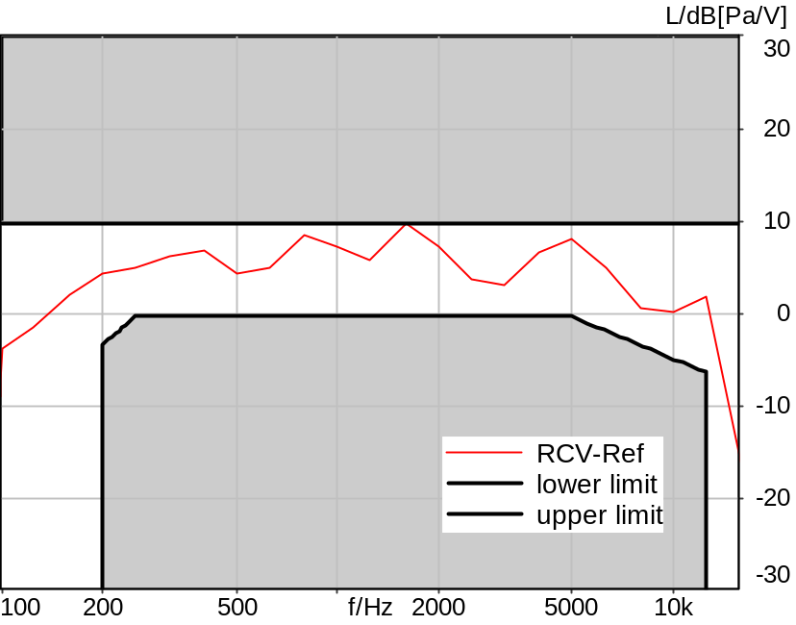

Absolute minimal distance
3.37 dB at 3150.0 Hz

5/20/2025 11:29 AM ACQUA 6.0.200

Meas. Setting DRP-off

Underlying Standard: 3GPP TS 26.131 V17.3.0 and 3GPP TS 26.132 V17.2.0
Database Version: 60_UG_TS26131_32_SWB_FB_Rev08_GCF_PTCRB

Source: spst4x3_sb_r16.dat
SUPERWIDEBAND Real Speech (ITU-T 12 sentences) at Channel 2
Pause 0.5 s +
Superwideband Real Speech (3x male speech, 3x female speech, 3x male speech, 3x female speech) +
Pause till end of file
Bandlimited 50-16000Hz
Signal level (ch2): -16dBm0 active speech level
Signal Length: 35.4s

For license information refer to the files >LICENSE_psytechnics.txt< and >LICENSE_nokia.txt<,
see Preparation of Test Setup - Info: Test Signals.

Calibration
RCV (2) 1.06 dB 4/29/2025 (HATS 7 (B&K 5128))
Output ch. 1 0.00 dB
Output ch. 2 0.00 dB (Radio Tester 1 (CMW500))

Output Equalization/Filter
Mouth Eq. Ch.1 HATS 7 (B&K 5128) (5/28/2024 5:25 PM)

Analysis
Analyse Channel 2
Range start 400.00 ms Range length 34680.00 ms
Frequency base 3rd octave DIN Row Row B
Method FFT
FFT size 4096 Overlap 75 %
Window function Hann
Reference file re_frq_rcv_hasb.fft
Tol. scheme file 942_rcv_frq_rsp_hasb_man.tol Min. freq. for tol. 100.0 Hz
Auto adjust To upper scheme Max. freq. for tol. 16000.0 Hz

Input Filters
DF Avg. Channels 1,2

Special Features
Compensate delay 131.3000 ms (D_SCRIPT, Original Delay Variable stored to D_SCRIPT: D_RCV_EQ_HASB)
Store to file frq_resp_rcv_hasb_nom.dat

Hardware Config Settings
Used Setting HA&HE_5128_volte

labCORE Settings
labCORE Serial 77000280 Nickname
Firmware 3.7.5 Sync Source Internal
Clock Pitch 0.00 ppm
----------
labCORE Routing
Out Channel 1 -> Analog Out 1 -> ExternalAmplifier In -> HATS 7 (B&K 5128) Speaker
Out Channel 2 -> VoIP 2
Out Channel 2 -> VoIP 1 -> Radio Tester 1 (CMW500) RF In/Out
In Channel 1 <- VoIP In/Out 1 <- Radio Tester 1 (CMW500) RF In/Out
In Channel 2 <- BEQ Filter 1 R <- ICP Amp. (Slot 7) In 2 <- HATS 7 (B&K 5128) Mic. Right
----------
Analog Out Mainboard Settings (Analog Out)
Range Ch. 1 0.00 dB Range Ch. 2 0.00 dB
----------
ICP Settings (ICP Amp. (Slot 7))
Channel In 1 Settings
Range 132 dB[SPL] @ 50 mV/Pa Highpass 20Hz
Supply Voltage On
Channel In 2 Settings
Range 132 dB[SPL] @ 50 mV/Pa Highpass 20Hz
Supply Voltage On
Channel In 3 Settings
Range 132 dB[SPL] @ 50 mV/Pa Highpass 20Hz
Supply Voltage Off
Channel In 4 Settings
Range 132 dB[SPL] @ 50 mV/Pa Highpass 20Hz
Supply Voltage Off
----------
VoIP Settings (VoIP)
RTP Connection Streaming SIP Connection Unavailable
SIP Reg. State Unregistered Jitterbuffer Length 100
Jitter Buffer Reset On Playback Enabled Codec EVS/16000/1
Packet Length 20 Encoder Parameter ;evs-mode-switch=0;max-red=0;br=13.2;bw=swb;ch-aw-recv=-1
FMTP Parameter ;evs-mode-switch=0;bw=swb;br=13.2;ch-aw-recv=-1;max-red=220
Impairment Mode Off Impairment Type Off
----------
BEQ Settings (BEQ Filter 1)
Block mode Bypass
----------
Artificial Head Settings (HATS 7 (B&K 5128))
Ser. Nr. BK_3408387 Pinna Type Type 4.3

HIB Settings
HIB Name 60020101 Serial 60020101
HIB Mode Mobile Measurement Impedance 32 Ohm
Gain out 1 -40.00 dB Gain out 2 0.00 dB
Gain in 1 0.00 dB Gain in 2 0.00 dB
Mic 1 Power Supply Off Mic 2 Power Supply Off

9.4.2 Sensitivity frequency char. RCV 1/12oct HASB MAX
Handset Measurements Superwideband and Fullband \ Handset Measurements SuperWideband (HASB) \ Connections with Handset Receiving Direction (HASB) \ Receiving Dir. DRP/ERP >OFF< DF AVG via SMD LIN EQ
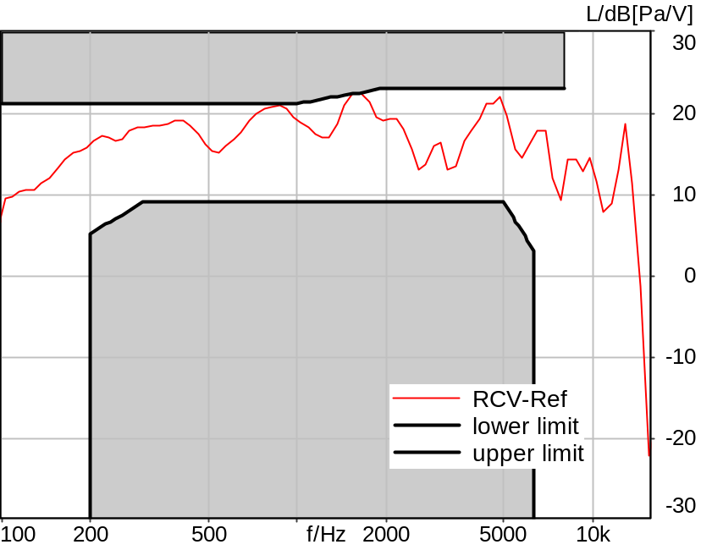

Absolute minimal distance
3.96 dB at 3245.6 Hz Ok

Ok
5/20/2025 11:28 AM ACQUA 6.0.200

Limits
 | lower
Run 1 | 2.00 dB

Meas. Setting DRP-off

Underlying Standard: 3GPP TS 26.131 V17.3.0 and 3GPP TS 26.132 V17.2.0
Database Version: 60_UG_TS26131_32_SWB_FB_Rev08_GCF_PTCRB

Analysed: frq_resp_rcv_hasb.dat
9.4.2 Sensitivity frequency char. RCV 1/3oct HASB MAX

Analysis
Analyse Channel 2
Range start 400.00 ms Range length 34680.00 ms
Frequency base 12th octave DIN Row Row A
Method FFT
FFT size 4096 Overlap 75 %
Window function Hann
Reference file re_frq_rcv_hasb_12th.fft
Tol. scheme file 842_10rfr_hawb.tol Min. freq. for tol. 100.0 Hz
Auto adjust To upper scheme Max. freq. for tol. 8000.0 Hz

Input Filters
DF Avg. Channels 1,2

9.4.2 Sensitivity frequency char. RCV 1/12oct HASB NOM
Handset Measurements Superwideband and Fullband \ Handset Measurements SuperWideband (HASB) \ Connections with Handset Receiving Direction (HASB) \ Receiving Dir. DRP/ERP >OFF< DF AVG via SMD LIN EQ
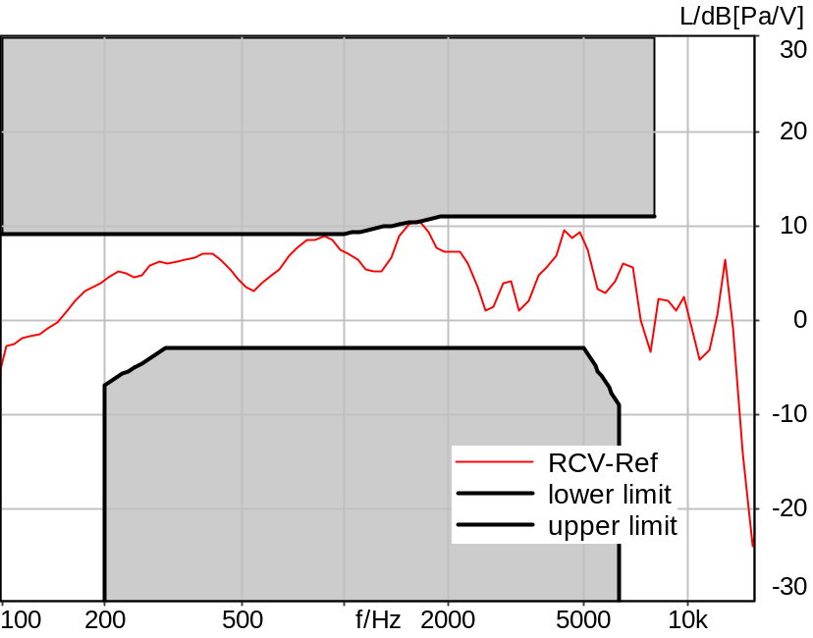

Absolute minimal distance
3.86 dB at 2571.8 Hz Ok

Ok
5/20/2025 11:29 AM ACQUA 6.0.200

Limits
 | lower
Run 1 | 2.00 dB

Meas. Setting DRP-off

Underlying Standard: 3GPP TS 26.131 V17.3.0 and 3GPP TS 26.132 V17.2.0
Database Version: 60_UG_TS26131_32_SWB_FB_Rev08_GCF_PTCRB

Analysed: frq_resp_rcv_hasb_nom.dat
9.4.2 Sensitivity frequency char. RCV 1/3oct HASB NOM

Analysis
Analyse Channel 2
Range start 400.00 ms Range length 34680.00 ms
Frequency base 12th octave DIN Row Row A
Method FFT
FFT size 4096 Overlap 75 %
Window function Hann
Reference file re_frq_rcv_hasb_12th.fft
Tol. scheme file 842_10rfr_hawb.tol Min. freq. for tol. 100.0 Hz
Auto adjust To upper scheme Max. freq. for tol. 8000.0 Hz

Input Filters
DF Avg. Channels 1,2

9.8.2 Distortion Level RCV 1020 Hz #1 HASB MAX
Handset Measurements Superwideband and Fullband \ Handset Measurements SuperWideband (HASB) \ Connections with Handset Receiving Direction (HASB) \ Receiving Dir. DRP/ERP >OFF< DF AVG via SMD LIN EQ \ 9.8.2 Distortion Receiving, activation HASB MAX
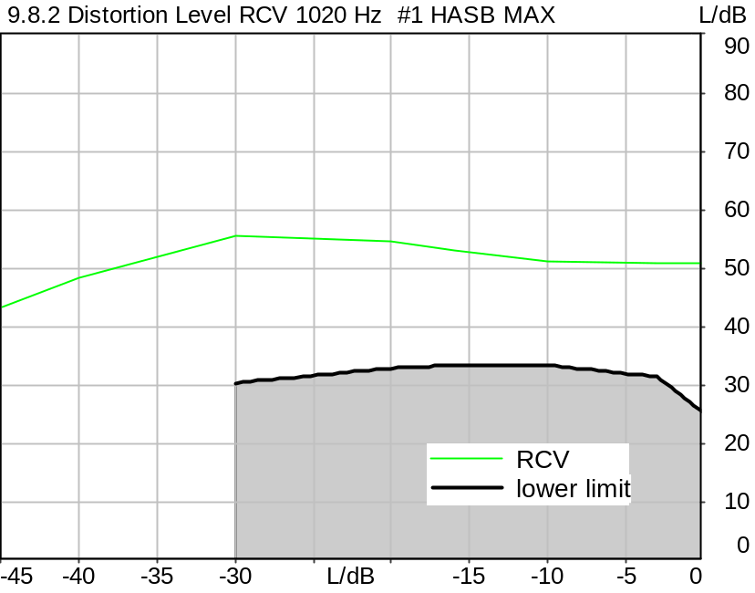

Distortion
Gain | RCV
0.0 dB | 50.81 dB (0.29%), 1019.5 Hz | Ok
-3.0 dB | 50.99 dB (0.28%), 1019.5 Hz | Ok
-10.0 dB | 51.18 dB (0.28%), 1019.5 Hz | Ok
-16.0 dB | 53.03 dB (0.22%), 1019.5 Hz | Ok
-20.0 dB | 54.65 dB (0.19%), 1019.5 Hz | Ok
-30.0 dB | 55.44 dB (0.17%), 1019.5 Hz | Ok
-40.0 dB | 48.34 dB (0.38%), 1019.5 Hz
-45.0 dB | 43.54 dB (0.66%), 1019.5 Hz

Ok
5/20/2025 11:31 AM ACQUA 6.0.200

Limits
 | lower
Run 1 | 25.50 dB
Run 2 | 31.50 dB
Run 3 | 33.50 dB
Run 4 | 33.50 dB
Run 5 | 33.00 dB
Run 6 | 30.50 dB

Meas. Setting DRP-off

Underlying Standard: 3GPP TS 26.131 V17.3.0 and 3GPP TS 26.132 V17.2.0
Database Version: 60_UG_TS26131_32_SWB_FB_Rev08_GCF_PTCRB

Source: csssb2b_r0_1020_1s.dat
SUPERWIDEBAND Composite Source Signal RCV P.501 (2 bursts) at Channel 2
Pause 0.5 s +
voiced signal + 16000 Hz band limited pseudo noise 0.2 s
Pause 0.101 s +
voiced signal + 16000 Hz band limited pseudo noise 0.2 s
Pause 0.101 s +
voiced signal 0.0486 s (as activation) +
sine-wave signal 1020 Hz, 0 dBm0, 0.36 s +
Pause 0.101 s +
Pause till end of file
Signal level (ch2): 0 dBm0 from 0.5s to 1.2s for 2048 FFT, Rectangle window,
0 % overlap in frequency range of 100 to 16000 Hz

Calibration
RCV (2) 1.06 dB 4/29/2025 (HATS 7 (B&K 5128))
Output ch. 1 0.00 dB
Output ch. 2 0.00 dB (Radio Tester 1 (CMW500))

Output Equalization/Filter
Mouth Eq. Ch.1 HATS 7 (B&K 5128) (5/28/2024 5:25 PM)

Analysis
Analyse Channel 2
Range start 1300.00 ms Range length 170.67 ms
Frequency base Transformation
FFT size 4096 Overlap 75 %
Window function Hann Smooth Off
Distortion Total dist. dB weighting psophometric
Freq. range min. 100.0 Hz Freq. range max. 6000.0 Hz
O.132 corr. factor No

Input Filters
DF Avg. Channels 1,2

Special Features
Compensate delay 131.3000 ms (D_SCRIPT, Original Delay Variable stored to D_SCRIPT: D_RCV_EQ_HASB)
Store to variable D1k_RCV_HASB_Act_a

Hardware Config Settings
Used Setting HA&HE_5128_volte

labCORE Settings
labCORE Serial 77000280 Nickname
Firmware 3.7.5 Sync Source Internal
Clock Pitch 0.00 ppm
----------
labCORE Routing
Out Channel 1 -> Analog Out 1 -> ExternalAmplifier In -> HATS 7 (B&K 5128) Speaker
Out Channel 2 -> VoIP 2
Out Channel 2 -> VoIP 1 -> Radio Tester 1 (CMW500) RF In/Out
In Channel 1 <- VoIP In/Out 1 <- Radio Tester 1 (CMW500) RF In/Out
In Channel 2 <- BEQ Filter 1 R <- ICP Amp. (Slot 7) In 2 <- HATS 7 (B&K 5128) Mic. Right
----------
Analog Out Mainboard Settings (Analog Out)
Range Ch. 1 0.00 dB Range Ch. 2 0.00 dB
----------
ICP Settings (ICP Amp. (Slot 7))
Channel In 1 Settings
Range 132 dB[SPL] @ 50 mV/Pa Highpass 20Hz
Supply Voltage On
Channel In 2 Settings
Range 132 dB[SPL] @ 50 mV/Pa Highpass 20Hz
Supply Voltage On
Channel In 3 Settings
Range 132 dB[SPL] @ 50 mV/Pa Highpass 20Hz
Supply Voltage Off
Channel In 4 Settings
Range 132 dB[SPL] @ 50 mV/Pa Highpass 20Hz
Supply Voltage Off
----------
VoIP Settings (VoIP)
RTP Connection Streaming SIP Connection Unavailable
SIP Reg. State Unregistered Jitterbuffer Length 100
Jitter Buffer Reset On Playback Enabled Codec EVS/16000/1
Packet Length 20 Encoder Parameter ;evs-mode-switch=0;max-red=0;br=13.2;bw=swb;ch-aw-recv=-1
FMTP Parameter ;evs-mode-switch=0;bw=swb;br=13.2;ch-aw-recv=-1;max-red=220
Impairment Mode Off Impairment Type Off
----------
BEQ Settings (BEQ Filter 1)
Block mode Bypass
----------
Artificial Head Settings (HATS 7 (B&K 5128))
Ser. Nr. BK_3408387 Pinna Type Type 4.3

HIB Settings
HIB Name 60020101 Serial 60020101
HIB Mode Mobile Measurement Impedance 32 Ohm
Gain out 1 -40.00 dB Gain out 2 0.00 dB
Gain in 1 0.00 dB Gain in 2 0.00 dB
Mic 1 Power Supply Off Mic 2 Power Supply Off

9.8.2b Distortion Level RCV 1020 Hz #2 HASB MAX
Handset Measurements Superwideband and Fullband \ Handset Measurements SuperWideband (HASB) \ Connections with Handset Receiving Direction (HASB) \ Receiving Dir. DRP/ERP >OFF< DF AVG via SMD LIN EQ \ 9.8.2 Distortion Receiving, activation HASB MAX
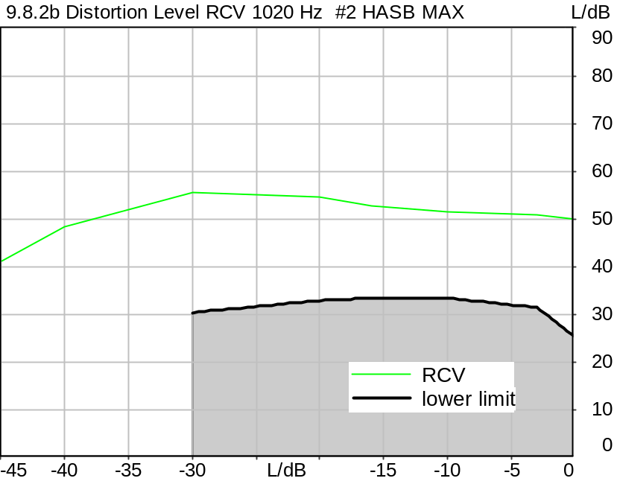

Distortion
Gain | RCV
0.0 dB | 50.10 dB (0.31%), 1019.5 Hz | Ok
-3.0 dB | 50.76 dB (0.29%), 1019.5 Hz | Ok
-10.0 dB | 51.52 dB (0.27%), 1019.5 Hz | Ok
-16.0 dB | 52.78 dB (0.23%), 1019.5 Hz | Ok
-20.0 dB | 54.61 dB (0.19%), 1019.5 Hz | Ok
-30.0 dB | 55.73 dB (0.16%), 1019.5 Hz | Ok
-40.0 dB | 48.49 dB (0.38%), 1019.5 Hz
-45.0 dB | 41.19 dB (0.87%), 1019.5 Hz

Ok
5/20/2025 11:32 AM ACQUA 6.0.200

Limits
 | lower
Run 1 | 25.50 dB
Run 2 | 31.50 dB
Run 3 | 33.50 dB
Run 4 | 33.50 dB
Run 5 | 33.00 dB
Run 6 | 30.50 dB

Meas. Setting DRP-off

Underlying Standard: 3GPP TS 26.131 V17.3.0 and 3GPP TS 26.132 V17.2.0
Database Version: 60_UG_TS26131_32_SWB_FB_Rev08_GCF_PTCRB

Source: csssb2b_r0_1020_1s.dat
SUPERWIDEBAND Composite Source Signal RCV P.501 (2 bursts) at Channel 2
Pause 0.5 s +
voiced signal + 16000 Hz band limited pseudo noise 0.2 s
Pause 0.101 s +
voiced signal + 16000 Hz band limited pseudo noise 0.2 s
Pause 0.101 s +
voiced signal 0.0486 s (as activation) +
sine-wave signal 1020 Hz, 0 dBm0, 0.36 s +
Pause 0.101 s +
Pause till end of file
Signal level (ch2): 0 dBm0 from 0.5s to 1.2s for 2048 FFT, Rectangle window,
0 % overlap in frequency range of 100 to 16000 Hz

Calibration
RCV (2) 1.06 dB 4/29/2025 (HATS 7 (B&K 5128))
Output ch. 1 0.00 dB
Output ch. 2 0.00 dB (Radio Tester 1 (CMW500))

Output Equalization/Filter
Mouth Eq. Ch.1 HATS 7 (B&K 5128) (5/28/2024 5:25 PM)

Analysis
Analyse Channel 2
Range start 1300.00 ms Range length 170.67 ms
Frequency base Transformation
FFT size 4096 Overlap 75 %
Window function Hann Smooth Off
Distortion Total dist. dB weighting psophometric
Freq. range min. 100.0 Hz Freq. range max. 6000.0 Hz
O.132 corr. factor No

Input Filters
DF Avg. Channels 1,2

Special Features
Compensate delay 131.3000 ms (D_SCRIPT, Original Delay Variable stored to D_SCRIPT: D_RCV_EQ_HASB)
Store to variable D1k_RCV_HASB_Act_b

Hardware Config Settings
Used Setting HA&HE_5128_volte

labCORE Settings
labCORE Serial 77000280 Nickname
Firmware 3.7.5 Sync Source Internal
Clock Pitch 0.00 ppm
----------
labCORE Routing
Out Channel 1 -> Analog Out 1 -> ExternalAmplifier In -> HATS 7 (B&K 5128) Speaker
Out Channel 2 -> VoIP 2
Out Channel 2 -> VoIP 1 -> Radio Tester 1 (CMW500) RF In/Out
In Channel 1 <- VoIP In/Out 1 <- Radio Tester 1 (CMW500) RF In/Out
In Channel 2 <- BEQ Filter 1 R <- ICP Amp. (Slot 7) In 2 <- HATS 7 (B&K 5128) Mic. Right
----------
Analog Out Mainboard Settings (Analog Out)
Range Ch. 1 0.00 dB Range Ch. 2 0.00 dB
----------
ICP Settings (ICP Amp. (Slot 7))
Channel In 1 Settings
Range 132 dB[SPL] @ 50 mV/Pa Highpass 20Hz
Supply Voltage On
Channel In 2 Settings
Range 132 dB[SPL] @ 50 mV/Pa Highpass 20Hz
Supply Voltage On
Channel In 3 Settings
Range 132 dB[SPL] @ 50 mV/Pa Highpass 20Hz
Supply Voltage Off
Channel In 4 Settings
Range 132 dB[SPL] @ 50 mV/Pa Highpass 20Hz
Supply Voltage Off
----------
VoIP Settings (VoIP)
RTP Connection Streaming SIP Connection Unavailable
SIP Reg. State Unregistered Jitterbuffer Length 100
Jitter Buffer Reset On Playback Enabled Codec EVS/16000/1
Packet Length 20 Encoder Parameter ;evs-mode-switch=0;max-red=0;br=13.2;bw=swb;ch-aw-recv=-1
FMTP Parameter ;evs-mode-switch=0;bw=swb;br=13.2;ch-aw-recv=-1;max-red=220
Impairment Mode Off Impairment Type Off
----------
BEQ Settings (BEQ Filter 1)
Block mode Bypass
----------
Artificial Head Settings (HATS 7 (B&K 5128))
Ser. Nr. BK_3408387 Pinna Type Type 4.3

HIB Settings
HIB Name 60020101 Serial 60020101
HIB Mode Mobile Measurement Impedance 32 Ohm
Gain out 1 -40.00 dB Gain out 2 0.00 dB
Gain in 1 0.00 dB Gain in 2 0.00 dB
Mic 1 Power Supply Off Mic 2 Power Supply Off

9.8.2c Distortion Level RCV 1020 Hz #3 HASB MAX
Handset Measurements Superwideband and Fullband \ Handset Measurements SuperWideband (HASB) \ Connections with Handset Receiving Direction (HASB) \ Receiving Dir. DRP/ERP >OFF< DF AVG via SMD LIN EQ \ 9.8.2 Distortion Receiving, activation HASB MAX
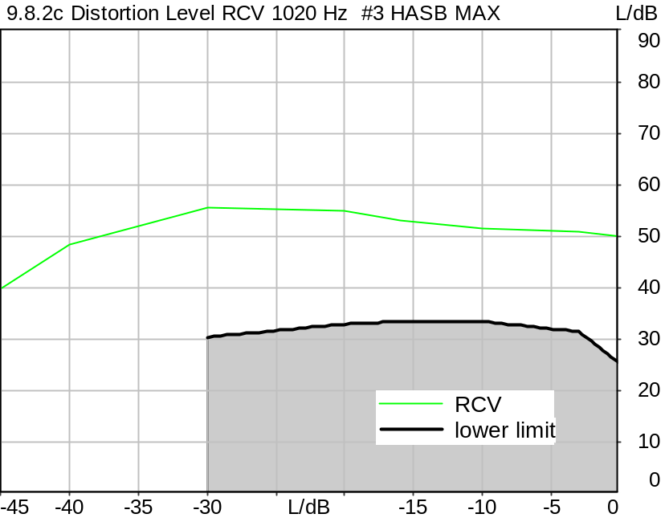

Distortion
Gain | RCV
0.0 dB | 50.12 dB (0.31%), 1019.5 Hz | Ok
-3.0 dB | 50.77 dB (0.29%), 1019.5 Hz | Ok
-10.0 dB | 51.54 dB (0.26%), 1019.5 Hz | Ok
-16.0 dB | 52.97 dB (0.22%), 1019.5 Hz | Ok
-20.0 dB | 54.83 dB (0.18%), 1019.5 Hz | Ok
-30.0 dB | 55.66 dB (0.16%), 1019.5 Hz | Ok
-40.0 dB | 48.35 dB (0.38%), 1019.5 Hz
-45.0 dB | 40.16 dB (0.98%), 1019.5 Hz

Ok
5/20/2025 11:33 AM ACQUA 6.0.200

Limits
 | lower
Run 1 | 25.50 dB
Run 2 | 31.50 dB
Run 3 | 33.50 dB
Run 4 | 33.50 dB
Run 5 | 33.00 dB
Run 6 | 30.50 dB

Meas. Setting DRP-off

Underlying Standard: 3GPP TS 26.131 V17.3.0 and 3GPP TS 26.132 V17.2.0
Database Version: 60_UG_TS26131_32_SWB_FB_Rev08_GCF_PTCRB

Source: csssb2b_r0_1020_1s.dat
SUPERWIDEBAND Composite Source Signal RCV P.501 (2 bursts) at Channel 2
Pause 0.5 s +
voiced signal + 16000 Hz band limited pseudo noise 0.2 s
Pause 0.101 s +
voiced signal + 16000 Hz band limited pseudo noise 0.2 s
Pause 0.101 s +
voiced signal 0.0486 s (as activation) +
sine-wave signal 1020 Hz, 0 dBm0, 0.36 s +
Pause 0.101 s +
Pause till end of file
Signal level (ch2): 0 dBm0 from 0.5s to 1.2s for 2048 FFT, Rectangle window,
0 % overlap in frequency range of 100 to 16000 Hz

Calibration
RCV (2) 1.06 dB 4/29/2025 (HATS 7 (B&K 5128))
Output ch. 1 0.00 dB
Output ch. 2 0.00 dB (Radio Tester 1 (CMW500))

Output Equalization/Filter
Mouth Eq. Ch.1 HATS 7 (B&K 5128) (5/28/2024 5:25 PM)

Analysis
Analyse Channel 2
Range start 1300.00 ms Range length 170.67 ms
Frequency base Transformation
FFT size 4096 Overlap 75 %
Window function Hann Smooth Off
Distortion Total dist. dB weighting psophometric
Freq. range min. 100.0 Hz Freq. range max. 6000.0 Hz
O.132 corr. factor No

Input Filters
DF Avg. Channels 1,2

Special Features
Compensate delay 131.3000 ms (D_SCRIPT, Original Delay Variable stored to D_SCRIPT: D_RCV_EQ_HASB)
Store to variable D1k_RCV_HASB_Act_c

Hardware Config Settings
Used Setting HA&HE_5128_volte

labCORE Settings
labCORE Serial 77000280 Nickname
Firmware 3.7.5 Sync Source Internal
Clock Pitch 0.00 ppm
----------
labCORE Routing
Out Channel 1 -> Analog Out 1 -> ExternalAmplifier In -> HATS 7 (B&K 5128) Speaker
Out Channel 2 -> VoIP 2
Out Channel 2 -> VoIP 1 -> Radio Tester 1 (CMW500) RF In/Out
In Channel 1 <- VoIP In/Out 1 <- Radio Tester 1 (CMW500) RF In/Out
In Channel 2 <- BEQ Filter 1 R <- ICP Amp. (Slot 7) In 2 <- HATS 7 (B&K 5128) Mic. Right
----------
Analog Out Mainboard Settings (Analog Out)
Range Ch. 1 0.00 dB Range Ch. 2 0.00 dB
----------
ICP Settings (ICP Amp. (Slot 7))
Channel In 1 Settings
Range 132 dB[SPL] @ 50 mV/Pa Highpass 20Hz
Supply Voltage On
Channel In 2 Settings
Range 132 dB[SPL] @ 50 mV/Pa Highpass 20Hz
Supply Voltage On
Channel In 3 Settings
Range 132 dB[SPL] @ 50 mV/Pa Highpass 20Hz
Supply Voltage Off
Channel In 4 Settings
Range 132 dB[SPL] @ 50 mV/Pa Highpass 20Hz
Supply Voltage Off
----------
VoIP Settings (VoIP)
RTP Connection Streaming SIP Connection Unavailable
SIP Reg. State Unregistered Jitterbuffer Length 100
Jitter Buffer Reset On Playback Enabled Codec EVS/16000/1
Packet Length 20 Encoder Parameter ;evs-mode-switch=0;max-red=0;br=13.2;bw=swb;ch-aw-recv=-1
FMTP Parameter ;evs-mode-switch=0;bw=swb;br=13.2;ch-aw-recv=-1;max-red=220
Impairment Mode Off Impairment Type Off
----------
BEQ Settings (BEQ Filter 1)
Block mode Bypass
----------
Artificial Head Settings (HATS 7 (B&K 5128))
Ser. Nr. BK_3408387 Pinna Type Type 4.3

HIB Settings
HIB Name 60020101 Serial 60020101
HIB Mode Mobile Measurement Impedance 32 Ohm
Gain out 1 -40.00 dB Gain out 2 0.00 dB
Gain in 1 0.00 dB Gain in 2 0.00 dB
Mic 1 Power Supply Off Mic 2 Power Supply Off

9.8.2 Distortion Level RCV 1020 Hz activation Average HASB MAX
Handset Measurements Superwideband and Fullband \ Handset Measurements SuperWideband (HASB) \ Connections with Handset Receiving Direction (HASB) \ Receiving Dir. DRP/ERP >OFF< DF AVG via SMD LIN EQ \ 9.8.2 Distortion Receiving, activation HASB MAX
Freq. (Hz) | Level (dBm0) | SDR [dB] | Req. [dB] | Status
1020 | 0.0 | 50.3 | 25.5 | Ok
1020 | -3.0 | 50.8 | 31.5 | Ok
1020 | -10.0 | 51.4 | 33.5 | Ok
1020 | -16.0 | 52.9 | 33.5 | Ok
1020 | -20.0 | 54.7 | 33.0 | Ok
1020 | -30.0 | 55.6 | 30.5 | Ok
1020 | -40.0 | 48.4 | 22.5 | Ok
1020 | -45.0 | 41.7 | 17.5 | Ok

5/20/2025 11:33 AM ACQUA

9.4.2 Sensitivity frequency char. RCV 1/3oct HASB MIN
Handset Measurements Superwideband and Fullband \ Handset Measurements SuperWideband (HASB) \ Connections with Handset Receiving Direction (HASB) \ Receiving Dir. DRP/ERP >OFF< DF AVG via SMD LIN EQ
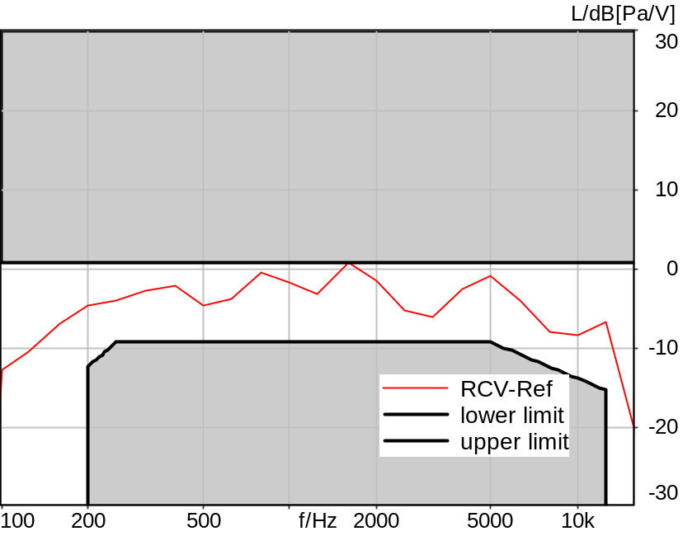

Absolute minimal distance
3.15 dB at 3150.0 Hz Ok

Ok
5/20/2025 11:30 AM ACQUA 6.0.200

Limits
 | lower
Run 1 | 2.00 dB

Meas. Setting DRP-off

Underlying Standard: 3GPP TS 26.131 V17.3.0 and 3GPP TS 26.132 V17.2.0
Database Version: 60_UG_TS26131_32_SWB_FB_Rev08_GCF_PTCRB

Source: spst4x3_sb_r16.dat
SUPERWIDEBAND Real Speech (ITU-T 12 sentences) at Channel 2
Pause 0.5 s +
Superwideband Real Speech (3x male speech, 3x female speech, 3x male speech, 3x female speech) +
Pause till end of file
Bandlimited 50-16000Hz
Signal level (ch2): -16dBm0 active speech level
Signal Length: 35.4s

For license information refer to the files >LICENSE_psytechnics.txt< and >LICENSE_nokia.txt<,
see Preparation of Test Setup - Info: Test Signals.

Calibration
RCV (2) 1.06 dB 4/29/2025 (HATS 7 (B&K 5128))
Output ch. 1 0.00 dB
Output ch. 2 0.00 dB (Radio Tester 1 (CMW500))

Output Equalization/Filter
Mouth Eq. Ch.1 HATS 7 (B&K 5128) (5/28/2024 5:25 PM)

Analysis
Analyse Channel 2
Range start 400.00 ms Range length 34680.00 ms
Frequency base 3rd octave DIN Row Row B
Method FFT
FFT size 4096 Overlap 75 %
Window function Hann
Reference file re_frq_rcv_hasb.fft
Tol. scheme file 942_rcv_frq_rsp_hasb_man.tol Min. freq. for tol. 100.0 Hz
Auto adjust To upper scheme Max. freq. for tol. 16000.0 Hz

Input Filters
DF Avg. Channels 1,2

Special Features
Compensate delay 131.3000 ms (D_SCRIPT, Original Delay Variable stored to D_SCRIPT: D_RCV_EQ_HASB)
Store to file frq_resp_rcv_hasb.dat

Hardware Config Settings
Used Setting HA&HE_5128_volte

labCORE Settings
labCORE Serial 77000280 Nickname
Firmware 3.7.5 Sync Source Internal
Clock Pitch 0.00 ppm
----------
labCORE Routing
Out Channel 1 -> Analog Out 1 -> ExternalAmplifier In -> HATS 7 (B&K 5128) Speaker
Out Channel 2 -> VoIP 2
Out Channel 2 -> VoIP 1 -> Radio Tester 1 (CMW500) RF In/Out
In Channel 1 <- VoIP In/Out 1 <- Radio Tester 1 (CMW500) RF In/Out
In Channel 2 <- BEQ Filter 1 R <- ICP Amp. (Slot 7) In 2 <- HATS 7 (B&K 5128) Mic. Right
----------
Analog Out Mainboard Settings (Analog Out)
Range Ch. 1 0.00 dB Range Ch. 2 0.00 dB
----------
ICP Settings (ICP Amp. (Slot 7))
Channel In 1 Settings
Range 132 dB[SPL] @ 50 mV/Pa Highpass 20Hz
Supply Voltage On
Channel In 2 Settings
Range 132 dB[SPL] @ 50 mV/Pa Highpass 20Hz
Supply Voltage On
Channel In 3 Settings
Range 132 dB[SPL] @ 50 mV/Pa Highpass 20Hz
Supply Voltage Off
Channel In 4 Settings
Range 132 dB[SPL] @ 50 mV/Pa Highpass 20Hz
Supply Voltage Off
----------
VoIP Settings (VoIP)
RTP Connection Streaming SIP Connection Unavailable
SIP Reg. State Unregistered Jitterbuffer Length 100
Jitter Buffer Reset On Playback Enabled Codec EVS/16000/1
Packet Length 20 Encoder Parameter ;evs-mode-switch=0;max-red=0;br=13.2;bw=swb;ch-aw-recv=-1
FMTP Parameter ;evs-mode-switch=0;bw=swb;br=13.2;ch-aw-recv=-1;max-red=220
Impairment Mode Off Impairment Type Off
----------
BEQ Settings (BEQ Filter 1)
Block mode Bypass
----------
Artificial Head Settings (HATS 7 (B&K 5128))
Ser. Nr. BK_3408387 Pinna Type Type 4.3

HIB Settings
HIB Name 60020101 Serial 60020101
HIB Mode Mobile Measurement Impedance 32 Ohm
Gain out 1 -40.00 dB Gain out 2 0.00 dB
Gain in 1 0.00 dB Gain in 2 0.00 dB
Mic 1 Power Supply Off Mic 2 Power Supply Off

9.8.2 Distortion Level RCV 1020 Hz #1 HASB NOM
Handset Measurements Superwideband and Fullband \ Handset Measurements SuperWideband (HASB) \ Connections with Handset Receiving Direction (HASB) \ Receiving Dir. DRP/ERP >OFF< DF AVG via SMD LIN EQ \ 9.8.2 Distortion Receiving, activation HASB NOM
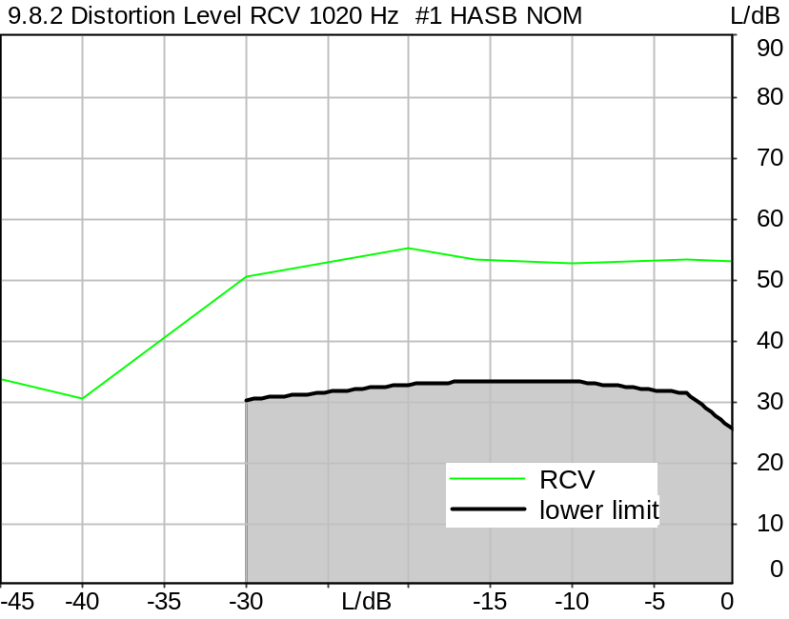

Distortion
Gain | RCV
0.0 dB | 53.21 dB (0.22%), 1019.5 Hz | Ok
-3.0 dB | 53.38 dB (0.21%), 1019.5 Hz | Ok
-10.0 dB | 52.65 dB (0.23%), 1019.5 Hz | Ok
-16.0 dB | 53.34 dB (0.22%), 1019.5 Hz | Ok
-20.0 dB | 55.21 dB (0.17%), 1019.5 Hz | Ok
-30.0 dB | 50.74 dB (0.29%), 1019.5 Hz | Ok
-40.0 dB | 30.70 dB (2.92%), 1019.5 Hz
-45.0 dB | 33.73 dB (2.06%), 1019.5 Hz

Ok
5/20/2025 11:34 AM ACQUA 6.0.200

Limits
 | lower
Run 1 | 25.50 dB
Run 2 | 31.50 dB
Run 3 | 33.50 dB
Run 4 | 33.50 dB
Run 5 | 33.00 dB
Run 6 | 30.50 dB

Meas. Setting DRP-off

Underlying Standard: 3GPP TS 26.131 V17.3.0 and 3GPP TS 26.132 V17.2.0
Database Version: 60_UG_TS26131_32_SWB_FB_Rev08_GCF_PTCRB

Source: csssb2b_r0_1020_1s.dat
SUPERWIDEBAND Composite Source Signal RCV P.501 (2 bursts) at Channel 2
Pause 0.5 s +
voiced signal + 16000 Hz band limited pseudo noise 0.2 s
Pause 0.101 s +
voiced signal + 16000 Hz band limited pseudo noise 0.2 s
Pause 0.101 s +
voiced signal 0.0486 s (as activation) +
sine-wave signal 1020 Hz, 0 dBm0, 0.36 s +
Pause 0.101 s +
Pause till end of file
Signal level (ch2): 0 dBm0 from 0.5s to 1.2s for 2048 FFT, Rectangle window,
0 % overlap in frequency range of 100 to 16000 Hz

Calibration
RCV (2) 1.06 dB 4/29/2025 (HATS 7 (B&K 5128))
Output ch. 1 0.00 dB
Output ch. 2 0.00 dB (Radio Tester 1 (CMW500))

Output Equalization/Filter
Mouth Eq. Ch.1 HATS 7 (B&K 5128) (5/28/2024 5:25 PM)

Analysis
Analyse Channel 2
Range start 1300.00 ms Range length 170.67 ms
Frequency base Transformation
FFT size 4096 Overlap 75 %
Window function Hann Smooth Off
Distortion Total dist. dB weighting psophometric
Freq. range min. 100.0 Hz Freq. range max. 6000.0 Hz
O.132 corr. factor No

Input Filters
DF Avg. Channels 1,2

Special Features
Compensate delay 131.3000 ms (D_SCRIPT, Original Delay Variable stored to D_SCRIPT: D_RCV_EQ_HASB)
Store to variable D1k_RCV_HASB_Act_a

Hardware Config Settings
Used Setting HA&HE_5128_volte

labCORE Settings
labCORE Serial 77000280 Nickname
Firmware 3.7.5 Sync Source Internal
Clock Pitch 0.00 ppm
----------
labCORE Routing
Out Channel 1 -> Analog Out 1 -> ExternalAmplifier In -> HATS 7 (B&K 5128) Speaker
Out Channel 2 -> VoIP 2
Out Channel 2 -> VoIP 1 -> Radio Tester 1 (CMW500) RF In/Out
In Channel 1 <- VoIP In/Out 1 <- Radio Tester 1 (CMW500) RF In/Out
In Channel 2 <- BEQ Filter 1 R <- ICP Amp. (Slot 7) In 2 <- HATS 7 (B&K 5128) Mic. Right
----------
Analog Out Mainboard Settings (Analog Out)
Range Ch. 1 0.00 dB Range Ch. 2 0.00 dB
----------
ICP Settings (ICP Amp. (Slot 7))
Channel In 1 Settings
Range 132 dB[SPL] @ 50 mV/Pa Highpass 20Hz
Supply Voltage On
Channel In 2 Settings
Range 132 dB[SPL] @ 50 mV/Pa Highpass 20Hz
Supply Voltage On
Channel In 3 Settings
Range 132 dB[SPL] @ 50 mV/Pa Highpass 20Hz
Supply Voltage Off
Channel In 4 Settings
Range 132 dB[SPL] @ 50 mV/Pa Highpass 20Hz
Supply Voltage Off
----------
VoIP Settings (VoIP)
RTP Connection Streaming SIP Connection Unavailable
SIP Reg. State Unregistered Jitterbuffer Length 100
Jitter Buffer Reset On Playback Enabled Codec EVS/16000/1
Packet Length 20 Encoder Parameter ;evs-mode-switch=0;max-red=0;br=13.2;bw=swb;ch-aw-recv=-1
FMTP Parameter ;evs-mode-switch=0;bw=swb;br=13.2;ch-aw-recv=-1;max-red=220
Impairment Mode Off Impairment Type Off
----------
BEQ Settings (BEQ Filter 1)
Block mode Bypass
----------
Artificial Head Settings (HATS 7 (B&K 5128))
Ser. Nr. BK_3408387 Pinna Type Type 4.3

HIB Settings
HIB Name 60020101 Serial 60020101
HIB Mode Mobile Measurement Impedance 32 Ohm
Gain out 1 -40.00 dB Gain out 2 0.00 dB
Gain in 1 0.00 dB Gain in 2 0.00 dB
Mic 1 Power Supply Off Mic 2 Power Supply Off

9.8.2b Distortion Level RCV 1020 Hz #2 HASB NOM
Handset Measurements Superwideband and Fullband \ Handset Measurements SuperWideband (HASB) \ Connections with Handset Receiving Direction (HASB) \ Receiving Dir. DRP/ERP >OFF< DF AVG via SMD LIN EQ \ 9.8.2 Distortion Receiving, activation HASB NOM
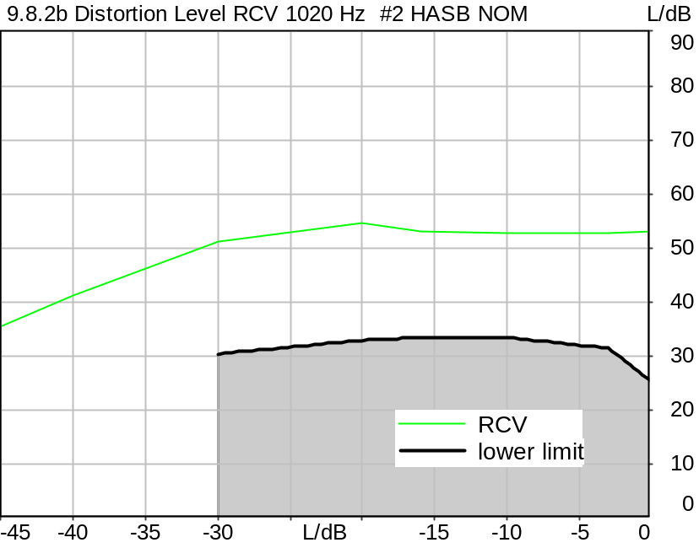

Distortion
Gain | RCV
0.0 dB | 52.99 dB (0.22%), 1019.5 Hz | Ok
-3.0 dB | 52.86 dB (0.23%), 1019.5 Hz | Ok
-10.0 dB | 52.69 dB (0.23%), 1019.5 Hz | Ok
-16.0 dB | 53.23 dB (0.22%), 1019.5 Hz | Ok
-20.0 dB | 54.57 dB (0.19%), 1019.5 Hz | Ok
-30.0 dB | 51.13 dB (0.28%), 1019.5 Hz | Ok
-40.0 dB | 41.32 dB (0.86%), 1019.5 Hz
-45.0 dB | 35.60 dB (1.66%), 1019.5 Hz

Ok
5/20/2025 11:35 AM ACQUA 6.0.200

Limits
 | lower
Run 1 | 25.50 dB
Run 2 | 31.50 dB
Run 3 | 33.50 dB
Run 4 | 33.50 dB
Run 5 | 33.00 dB
Run 6 | 30.50 dB

Meas. Setting DRP-off

Underlying Standard: 3GPP TS 26.131 V17.3.0 and 3GPP TS 26.132 V17.2.0
Database Version: 60_UG_TS26131_32_SWB_FB_Rev08_GCF_PTCRB

Source: csssb2b_r0_1020_1s.dat
SUPERWIDEBAND Composite Source Signal RCV P.501 (2 bursts) at Channel 2
Pause 0.5 s +
voiced signal + 16000 Hz band limited pseudo noise 0.2 s
Pause 0.101 s +
voiced signal + 16000 Hz band limited pseudo noise 0.2 s
Pause 0.101 s +
voiced signal 0.0486 s (as activation) +
sine-wave signal 1020 Hz, 0 dBm0, 0.36 s +
Pause 0.101 s +
Pause till end of file
Signal level (ch2): 0 dBm0 from 0.5s to 1.2s for 2048 FFT, Rectangle window,
0 % overlap in frequency range of 100 to 16000 Hz

Calibration
RCV (2) 1.06 dB 4/29/2025 (HATS 7 (B&K 5128))
Output ch. 1 0.00 dB
Output ch. 2 0.00 dB (Radio Tester 1 (CMW500))

Output Equalization/Filter
Mouth Eq. Ch.1 HATS 7 (B&K 5128) (5/28/2024 5:25 PM)

Analysis
Analyse Channel 2
Range start 1300.00 ms Range length 170.67 ms
Frequency base Transformation
FFT size 4096 Overlap 75 %
Window function Hann Smooth Off
Distortion Total dist. dB weighting psophometric
Freq. range min. 100.0 Hz Freq. range max. 6000.0 Hz
O.132 corr. factor No

Input Filters
DF Avg. Channels 1,2

Special Features
Compensate delay 131.3000 ms (D_SCRIPT, Original Delay Variable stored to D_SCRIPT: D_RCV_EQ_HASB)
Store to variable D1k_RCV_HASB_Act_b

Hardware Config Settings
Used Setting HA&HE_5128_volte

labCORE Settings
labCORE Serial 77000280 Nickname
Firmware 3.7.5 Sync Source Internal
Clock Pitch 0.00 ppm
----------
labCORE Routing
Out Channel 1 -> Analog Out 1 -> ExternalAmplifier In -> HATS 7 (B&K 5128) Speaker
Out Channel 2 -> VoIP 2
Out Channel 2 -> VoIP 1 -> Radio Tester 1 (CMW500) RF In/Out
In Channel 1 <- VoIP In/Out 1 <- Radio Tester 1 (CMW500) RF In/Out
In Channel 2 <- BEQ Filter 1 R <- ICP Amp. (Slot 7) In 2 <- HATS 7 (B&K 5128) Mic. Right
----------
Analog Out Mainboard Settings (Analog Out)
Range Ch. 1 0.00 dB Range Ch. 2 0.00 dB
----------
ICP Settings (ICP Amp. (Slot 7))
Channel In 1 Settings
Range 132 dB[SPL] @ 50 mV/Pa Highpass 20Hz
Supply Voltage On
Channel In 2 Settings
Range 132 dB[SPL] @ 50 mV/Pa Highpass 20Hz
Supply Voltage On
Channel In 3 Settings
Range 132 dB[SPL] @ 50 mV/Pa Highpass 20Hz
Supply Voltage Off
Channel In 4 Settings
Range 132 dB[SPL] @ 50 mV/Pa Highpass 20Hz
Supply Voltage Off
----------
VoIP Settings (VoIP)
RTP Connection Streaming SIP Connection Unavailable
SIP Reg. State Unregistered Jitterbuffer Length 100
Jitter Buffer Reset On Playback Enabled Codec EVS/16000/1
Packet Length 20 Encoder Parameter ;evs-mode-switch=0;max-red=0;br=13.2;bw=swb;ch-aw-recv=-1
FMTP Parameter ;evs-mode-switch=0;bw=swb;br=13.2;ch-aw-recv=-1;max-red=220
Impairment Mode Off Impairment Type Off
----------
BEQ Settings (BEQ Filter 1)
Block mode Bypass
----------
Artificial Head Settings (HATS 7 (B&K 5128))
Ser. Nr. BK_3408387 Pinna Type Type 4.3

HIB Settings
HIB Name 60020101 Serial 60020101
HIB Mode Mobile Measurement Impedance 32 Ohm
Gain out 1 -40.00 dB Gain out 2 0.00 dB
Gain in 1 0.00 dB Gain in 2 0.00 dB
Mic 1 Power Supply Off Mic 2 Power Supply Off

9.8.2c Distortion Level RCV 1020 Hz #3 HASB NOM
Handset Measurements Superwideband and Fullband \ Handset Measurements SuperWideband (HASB) \ Connections with Handset Receiving Direction (HASB) \ Receiving Dir. DRP/ERP >OFF< DF AVG via SMD LIN EQ \ 9.8.2 Distortion Receiving, activation HASB NOM
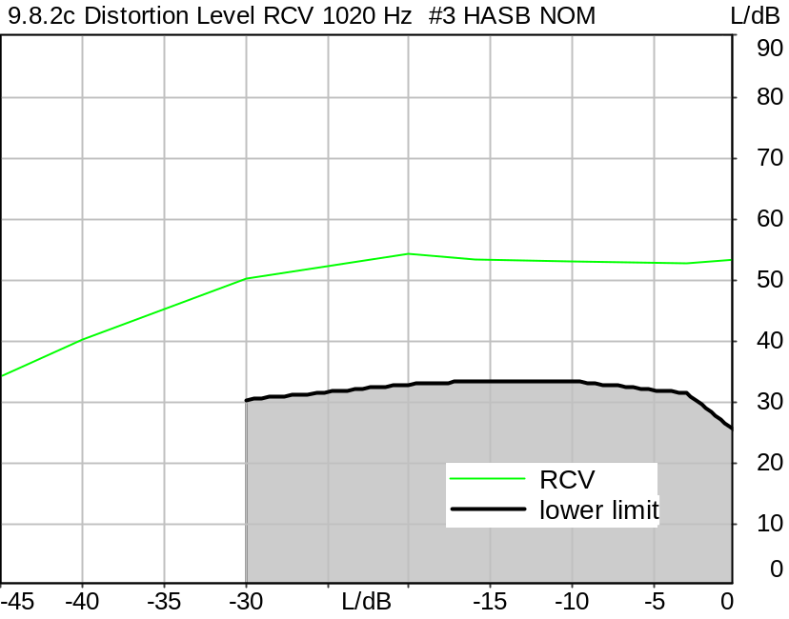

Distortion
Gain | RCV
0.0 dB | 53.26 dB (0.22%), 1019.5 Hz | Ok
-3.0 dB | 52.76 dB (0.23%), 1019.5 Hz | Ok
-10.0 dB | 53.13 dB (0.22%), 1019.5 Hz | Ok
-16.0 dB | 53.41 dB (0.21%), 1019.5 Hz | Ok
-20.0 dB | 54.46 dB (0.19%), 1019.5 Hz | Ok
-30.0 dB | 50.16 dB (0.31%), 1019.5 Hz | Ok
-40.0 dB | 40.32 dB (0.96%), 1019.5 Hz
-45.0 dB | 34.57 dB (1.87%), 1019.5 Hz

Ok
5/20/2025 11:37 AM ACQUA 6.0.200

Limits
 | lower
Run 1 | 25.50 dB
Run 2 | 31.50 dB
Run 3 | 33.50 dB
Run 4 | 33.50 dB
Run 5 | 33.00 dB
Run 6 | 30.50 dB

Meas. Setting DRP-off

Underlying Standard: 3GPP TS 26.131 V17.3.0 and 3GPP TS 26.132 V17.2.0
Database Version: 60_UG_TS26131_32_SWB_FB_Rev08_GCF_PTCRB

Source: csssb2b_r0_1020_1s.dat
SUPERWIDEBAND Composite Source Signal RCV P.501 (2 bursts) at Channel 2
Pause 0.5 s +
voiced signal + 16000 Hz band limited pseudo noise 0.2 s
Pause 0.101 s +
voiced signal + 16000 Hz band limited pseudo noise 0.2 s
Pause 0.101 s +
voiced signal 0.0486 s (as activation) +
sine-wave signal 1020 Hz, 0 dBm0, 0.36 s +
Pause 0.101 s +
Pause till end of file
Signal level (ch2): 0 dBm0 from 0.5s to 1.2s for 2048 FFT, Rectangle window,
0 % overlap in frequency range of 100 to 16000 Hz

Calibration
RCV (2) 1.06 dB 4/29/2025 (HATS 7 (B&K 5128))
Output ch. 1 0.00 dB
Output ch. 2 0.00 dB (Radio Tester 1 (CMW500))

Output Equalization/Filter
Mouth Eq. Ch.1 HATS 7 (B&K 5128) (5/28/2024 5:25 PM)

Analysis
Analyse Channel 2
Range start 1300.00 ms Range length 170.67 ms
Frequency base Transformation
FFT size 4096 Overlap 75 %
Window function Hann Smooth Off
Distortion Total dist. dB weighting psophometric
Freq. range min. 100.0 Hz Freq. range max. 6000.0 Hz
O.132 corr. factor No

Input Filters
DF Avg. Channels 1,2

Special Features
Compensate delay 131.3000 ms (D_SCRIPT, Original Delay Variable stored to D_SCRIPT: D_RCV_EQ_HASB)
Store to variable D1k_RCV_HASB_Act_c

Hardware Config Settings
Used Setting HA&HE_5128_volte

labCORE Settings
labCORE Serial 77000280 Nickname
Firmware 3.7.5 Sync Source Internal
Clock Pitch 0.00 ppm
----------
labCORE Routing
Out Channel 1 -> Analog Out 1 -> ExternalAmplifier In -> HATS 7 (B&K 5128) Speaker
Out Channel 2 -> VoIP 2
Out Channel 2 -> VoIP 1 -> Radio Tester 1 (CMW500) RF In/Out
In Channel 1 <- VoIP In/Out 1 <- Radio Tester 1 (CMW500) RF In/Out
In Channel 2 <- BEQ Filter 1 R <- ICP Amp. (Slot 7) In 2 <- HATS 7 (B&K 5128) Mic. Right
----------
Analog Out Mainboard Settings (Analog Out)
Range Ch. 1 0.00 dB Range Ch. 2 0.00 dB
----------
ICP Settings (ICP Amp. (Slot 7))
Channel In 1 Settings
Range 132 dB[SPL] @ 50 mV/Pa Highpass 20Hz
Supply Voltage On
Channel In 2 Settings
Range 132 dB[SPL] @ 50 mV/Pa Highpass 20Hz
Supply Voltage On
Channel In 3 Settings
Range 132 dB[SPL] @ 50 mV/Pa Highpass 20Hz
Supply Voltage Off
Channel In 4 Settings
Range 132 dB[SPL] @ 50 mV/Pa Highpass 20Hz
Supply Voltage Off
----------
VoIP Settings (VoIP)
RTP Connection Streaming SIP Connection Unavailable
SIP Reg. State Unregistered Jitterbuffer Length 100
Jitter Buffer Reset On Playback Enabled Codec EVS/16000/1
Packet Length 20 Encoder Parameter ;evs-mode-switch=0;max-red=0;br=13.2;bw=swb;ch-aw-recv=-1
FMTP Parameter ;evs-mode-switch=0;bw=swb;br=13.2;ch-aw-recv=-1;max-red=220
Impairment Mode Off Impairment Type Off
----------
BEQ Settings (BEQ Filter 1)
Block mode Bypass
----------
Artificial Head Settings (HATS 7 (B&K 5128))
Ser. Nr. BK_3408387 Pinna Type Type 4.3

HIB Settings
HIB Name 60020101 Serial 60020101
HIB Mode Mobile Measurement Impedance 32 Ohm
Gain out 1 -40.00 dB Gain out 2 0.00 dB
Gain in 1 0.00 dB Gain in 2 0.00 dB
Mic 1 Power Supply Off Mic 2 Power Supply Off

9.8.2 Distortion Level RCV 1020 Hz activation Average HASB NOM
Handset Measurements Superwideband and Fullband \ Handset Measurements SuperWideband (HASB) \ Connections with Handset Receiving Direction (HASB) \ Receiving Dir. DRP/ERP >OFF< DF AVG via SMD LIN EQ \ 9.8.2 Distortion Receiving, activation HASB NOM
Freq. (Hz) | Level (dBm0) | SDR [dB] | Req. [dB] | Status
1020 | 0.0 | 53.2 | 25.5 | Ok
1020 | -3.0 | 53.0 | 31.5 | Ok
1020 | -10.0 | 52.8 | 33.5 | Ok
1020 | -16.0 | 53.3 | 33.5 | Ok
1020 | -20.0 | 54.8 | 33.0 | Ok
1020 | -30.0 | 50.7 | 30.5 | Ok
1020 | -40.0 | 38.6 | 22.5 | Ok
1020 | -45.0 | 34.7 | 17.5 | Ok

5/20/2025 11:37 AM ACQUA

9.8.2 Distortion Freq. RCV -16 dBm0, #1 HASB MAX
Handset Measurements Superwideband and Fullband \ Handset Measurements SuperWideband (HASB) \ Connections with Handset Receiving Direction (HASB) \ Receiving Dir. DRP/ERP >OFF< DF AVG via SMD LIN EQ \ 9.8.2 Distortion Receiving, -16 dBm0, activation HASB MAX
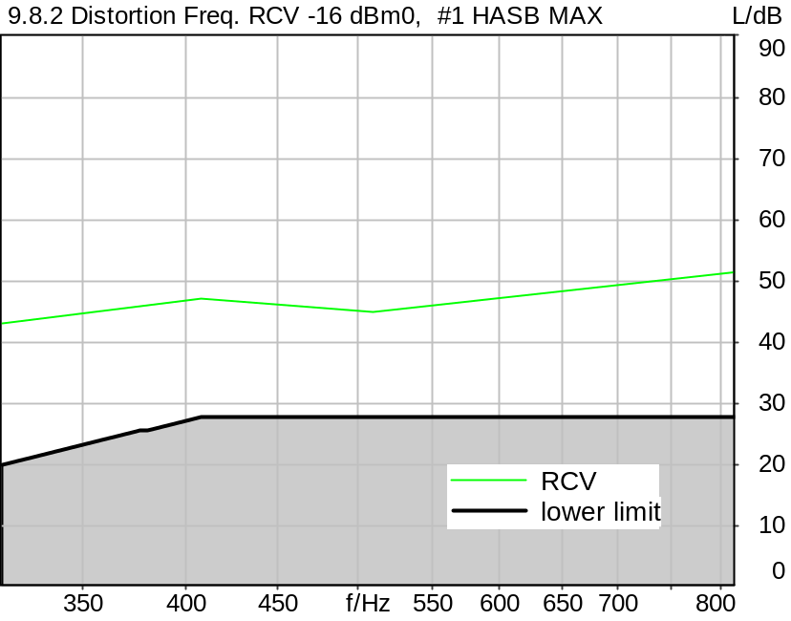

Distortion
Frequency | RCV
315.0 Hz | 43.05 dB (0.70%) | Ok
408.0 Hz | 47.06 dB (0.44%) | Ok
510.0 Hz | 44.91 dB (0.57%) | Ok
816.0 Hz | 51.53 dB (0.27%) | Ok

Ok
5/20/2025 11:33 AM ACQUA 6.0.200

Limits
 | lower
Run 1 | 20.00 dB
Run 2 | 28.00 dB
Run 3 | 28.00 dB
Run 4 | 28.00 dB

Meas. Setting DRP-off

Underlying Standard: 3GPP TS 26.131 V17.3.0 and 3GPP TS 26.132 V17.2.0
Database Version: 60_UG_TS26131_32_SWB_FB_Rev08_GCF_PTCRB

Source
Source level -2.20 dB
Activation file csssb2b_r0_act.dat

Calibration
RCV (2) 1.06 dB 4/29/2025 (HATS 7 (B&K 5128))
Output ch. 2 0.00 dB (Radio Tester 1 (CMW500))

Output Equalization/Filter
Mouth Eq. Ch.1 HATS 7 (B&K 5128) (5/28/2024 5:25 PM)

Analysis
Analyse Channel 2
Range start 20.00 ms Range length 170.67 ms
Frequency base Transformation
FFT size 4096 Overlap 75 %
Window function Hann Smooth Off
Distortion Total dist. dB weighting psophometric
Freq. range min. 100.0 Hz Freq. range max. 6000.0 Hz
O.132 corr. factor No

Input Filters
DF Avg. Channels 1,2

Special Features
Compensate delay 131.3000 ms (D_SCRIPT, Original Delay Variable stored to D_SCRIPT: D_RCV_EQ_HASB)
Store to variable D16_RCV_HASB_Act_a

Hardware Config Settings
Used Setting HA&HE_5128_volte

labCORE Settings
labCORE Serial 77000280 Nickname
Firmware 3.7.5 Sync Source Internal
Clock Pitch 0.00 ppm
----------
labCORE Routing
Out Channel 1 -> Analog Out 1 -> ExternalAmplifier In -> HATS 7 (B&K 5128) Speaker
Out Channel 2 -> VoIP 2
Out Channel 2 -> VoIP 1 -> Radio Tester 1 (CMW500) RF In/Out
In Channel 1 <- VoIP In/Out 1 <- Radio Tester 1 (CMW500) RF In/Out
In Channel 2 <- BEQ Filter 1 R <- ICP Amp. (Slot 7) In 2 <- HATS 7 (B&K 5128) Mic. Right
----------
Analog Out Mainboard Settings (Analog Out)
Range Ch. 1 0.00 dB Range Ch. 2 0.00 dB
----------
ICP Settings (ICP Amp. (Slot 7))
Channel In 1 Settings
Range 132 dB[SPL] @ 50 mV/Pa Highpass 20Hz
Supply Voltage On
Channel In 2 Settings
Range 132 dB[SPL] @ 50 mV/Pa Highpass 20Hz
Supply Voltage On
Channel In 3 Settings
Range 132 dB[SPL] @ 50 mV/Pa Highpass 20Hz
Supply Voltage Off
Channel In 4 Settings
Range 132 dB[SPL] @ 50 mV/Pa Highpass 20Hz
Supply Voltage Off
----------
VoIP Settings (VoIP)
RTP Connection Streaming SIP Connection Unavailable
SIP Reg. State Unregistered Jitterbuffer Length 100
Jitter Buffer Reset On Playback Enabled Codec EVS/16000/1
Packet Length 20 Encoder Parameter ;evs-mode-switch=0;max-red=0;br=13.2;bw=swb;ch-aw-recv=-1
FMTP Parameter ;evs-mode-switch=0;bw=swb;br=13.2;ch-aw-recv=-1;max-red=220
Impairment Mode Off Impairment Type Off
----------
BEQ Settings (BEQ Filter 1)
Block mode Bypass
----------
Artificial Head Settings (HATS 7 (B&K 5128))
Ser. Nr. BK_3408387 Pinna Type Type 4.3

HIB Settings
HIB Name 60020101 Serial 60020101
HIB Mode Mobile Measurement Impedance 32 Ohm
Gain out 1 -40.00 dB Gain out 2 0.00 dB
Gain in 1 0.00 dB Gain in 2 0.00 dB
Mic 1 Power Supply Off Mic 2 Power Supply Off

9.8.2 Distortion Freq. RCV -16 dBm0, #2 HASB MAX
Handset Measurements Superwideband and Fullband \ Handset Measurements SuperWideband (HASB) \ Connections with Handset Receiving Direction (HASB) \ Receiving Dir. DRP/ERP >OFF< DF AVG via SMD LIN EQ \ 9.8.2 Distortion Receiving, -16 dBm0, activation HASB MAX
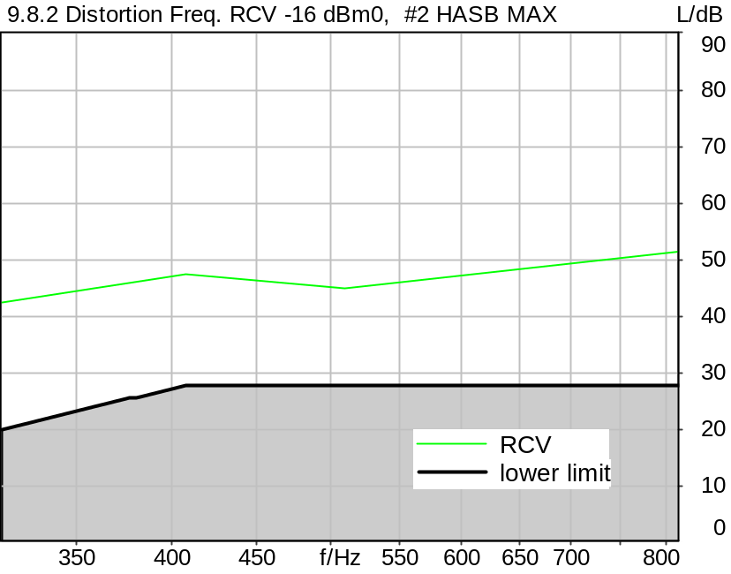

Distortion
Frequency | RCV
315.0 Hz | 42.65 dB (0.74%) | Ok
408.0 Hz | 47.48 dB (0.42%) | Ok
510.0 Hz | 44.91 dB (0.57%) | Ok
816.0 Hz | 51.52 dB (0.27%) | Ok

Ok
5/20/2025 11:33 AM ACQUA 6.0.200

Limits
 | lower
Run 1 | 20.00 dB
Run 2 | 28.00 dB
Run 3 | 28.00 dB
Run 4 | 28.00 dB

Meas. Setting DRP-off

Underlying Standard: 3GPP TS 26.131 V17.3.0 and 3GPP TS 26.132 V17.2.0
Database Version: 60_UG_TS26131_32_SWB_FB_Rev08_GCF_PTCRB

Source
Source level -2.20 dB
Activation file csssb2b_r0_act.dat

Calibration
RCV (2) 1.06 dB 4/29/2025 (HATS 7 (B&K 5128))
Output ch. 2 0.00 dB (Radio Tester 1 (CMW500))

Output Equalization/Filter
Mouth Eq. Ch.1 HATS 7 (B&K 5128) (5/28/2024 5:25 PM)

Analysis
Analyse Channel 2
Range start 20.00 ms Range length 170.67 ms
Frequency base Transformation
FFT size 4096 Overlap 75 %
Window function Hann Smooth Off
Distortion Total dist. dB weighting psophometric
Freq. range min. 100.0 Hz Freq. range max. 6000.0 Hz
O.132 corr. factor No

Input Filters
DF Avg. Channels 1,2

Special Features
Compensate delay 131.3000 ms (D_SCRIPT, Original Delay Variable stored to D_SCRIPT: D_RCV_EQ_HASB)
Store to variable D16_RCV_HASB_Act_b

Hardware Config Settings
Used Setting HA&HE_5128_volte

labCORE Settings
labCORE Serial 77000280 Nickname
Firmware 3.7.5 Sync Source Internal
Clock Pitch 0.00 ppm
----------
labCORE Routing
Out Channel 1 -> Analog Out 1 -> ExternalAmplifier In -> HATS 7 (B&K 5128) Speaker
Out Channel 2 -> VoIP 2
Out Channel 2 -> VoIP 1 -> Radio Tester 1 (CMW500) RF In/Out
In Channel 1 <- VoIP In/Out 1 <- Radio Tester 1 (CMW500) RF In/Out
In Channel 2 <- BEQ Filter 1 R <- ICP Amp. (Slot 7) In 2 <- HATS 7 (B&K 5128) Mic. Right
----------
Analog Out Mainboard Settings (Analog Out)
Range Ch. 1 0.00 dB Range Ch. 2 0.00 dB
----------
ICP Settings (ICP Amp. (Slot 7))
Channel In 1 Settings
Range 132 dB[SPL] @ 50 mV/Pa Highpass 20Hz
Supply Voltage On
Channel In 2 Settings
Range 132 dB[SPL] @ 50 mV/Pa Highpass 20Hz
Supply Voltage On
Channel In 3 Settings
Range 132 dB[SPL] @ 50 mV/Pa Highpass 20Hz
Supply Voltage Off
Channel In 4 Settings
Range 132 dB[SPL] @ 50 mV/Pa Highpass 20Hz
Supply Voltage Off
----------
VoIP Settings (VoIP)
RTP Connection Streaming SIP Connection Unavailable
SIP Reg. State Unregistered Jitterbuffer Length 100
Jitter Buffer Reset On Playback Enabled Codec EVS/16000/1
Packet Length 20 Encoder Parameter ;evs-mode-switch=0;max-red=0;br=13.2;bw=swb;ch-aw-recv=-1
FMTP Parameter ;evs-mode-switch=0;bw=swb;br=13.2;ch-aw-recv=-1;max-red=220
Impairment Mode Off Impairment Type Off
----------
BEQ Settings (BEQ Filter 1)
Block mode Bypass
----------
Artificial Head Settings (HATS 7 (B&K 5128))
Ser. Nr. BK_3408387 Pinna Type Type 4.3

HIB Settings
HIB Name 60020101 Serial 60020101
HIB Mode Mobile Measurement Impedance 32 Ohm
Gain out 1 -40.00 dB Gain out 2 0.00 dB
Gain in 1 0.00 dB Gain in 2 0.00 dB
Mic 1 Power Supply Off Mic 2 Power Supply Off

9.8.2 Distortion Freq. RCV -16 dBm0, #3 HASB MAX
Handset Measurements Superwideband and Fullband \ Handset Measurements SuperWideband (HASB) \ Connections with Handset Receiving Direction (HASB) \ Receiving Dir. DRP/ERP >OFF< DF AVG via SMD LIN EQ \ 9.8.2 Distortion Receiving, -16 dBm0, activation HASB MAX
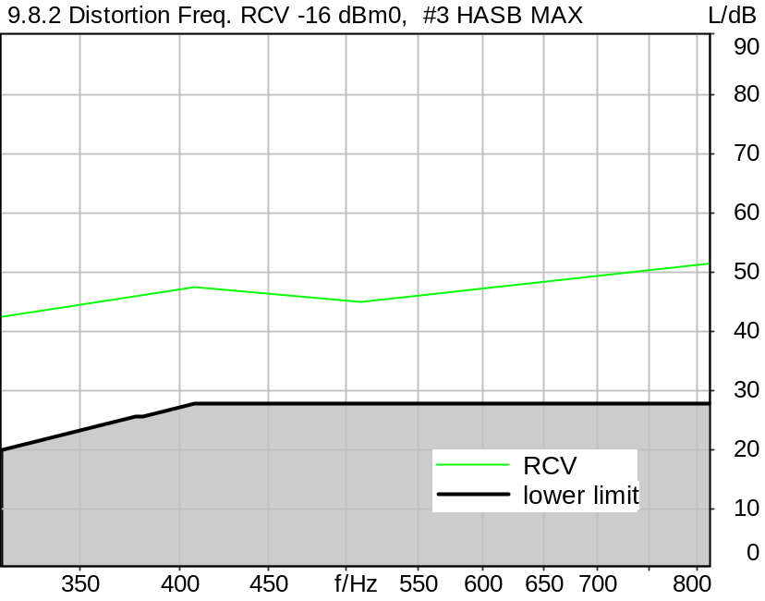

Distortion
Frequency | RCV
315.0 Hz | 42.65 dB (0.74%) | Ok
408.0 Hz | 47.53 dB (0.42%) | Ok
510.0 Hz | 44.88 dB (0.57%) | Ok
816.0 Hz | 51.53 dB (0.27%) | Ok

Ok
5/20/2025 11:33 AM ACQUA 6.0.200

Limits
 | lower
Run 1 | 20.00 dB
Run 2 | 28.00 dB
Run 3 | 28.00 dB
Run 4 | 28.00 dB

Meas. Setting DRP-off

Underlying Standard: 3GPP TS 26.131 V17.3.0 and 3GPP TS 26.132 V17.2.0
Database Version: 60_UG_TS26131_32_SWB_FB_Rev08_GCF_PTCRB

Source
Source level -2.20 dB
Activation file csssb2b_r0_act.dat

Calibration
RCV (2) 1.06 dB 4/29/2025 (HATS 7 (B&K 5128))
Output ch. 2 0.00 dB (Radio Tester 1 (CMW500))

Output Equalization/Filter
Mouth Eq. Ch.1 HATS 7 (B&K 5128) (5/28/2024 5:25 PM)

Analysis
Analyse Channel 2
Range start 20.00 ms Range length 170.67 ms
Frequency base Transformation
FFT size 4096 Overlap 75 %
Window function Hann Smooth Off
Distortion Total dist. dB weighting psophometric
Freq. range min. 100.0 Hz Freq. range max. 6000.0 Hz
O.132 corr. factor No

Input Filters
DF Avg. Channels 1,2

Special Features
Compensate delay 131.3000 ms (D_SCRIPT, Original Delay Variable stored to D_SCRIPT: D_RCV_EQ_HASB)
Store to variable D16_RCV_HASB_Act_c

Hardware Config Settings
Used Setting HA&HE_5128_volte

labCORE Settings
labCORE Serial 77000280 Nickname
Firmware 3.7.5 Sync Source Internal
Clock Pitch 0.00 ppm
----------
labCORE Routing
Out Channel 1 -> Analog Out 1 -> ExternalAmplifier In -> HATS 7 (B&K 5128) Speaker
Out Channel 2 -> VoIP 2
Out Channel 2 -> VoIP 1 -> Radio Tester 1 (CMW500) RF In/Out
In Channel 1 <- VoIP In/Out 1 <- Radio Tester 1 (CMW500) RF In/Out
In Channel 2 <- BEQ Filter 1 R <- ICP Amp. (Slot 7) In 2 <- HATS 7 (B&K 5128) Mic. Right
----------
Analog Out Mainboard Settings (Analog Out)
Range Ch. 1 0.00 dB Range Ch. 2 0.00 dB
----------
ICP Settings (ICP Amp. (Slot 7))
Channel In 1 Settings
Range 132 dB[SPL] @ 50 mV/Pa Highpass 20Hz
Supply Voltage On
Channel In 2 Settings
Range 132 dB[SPL] @ 50 mV/Pa Highpass 20Hz
Supply Voltage On
Channel In 3 Settings
Range 132 dB[SPL] @ 50 mV/Pa Highpass 20Hz
Supply Voltage Off
Channel In 4 Settings
Range 132 dB[SPL] @ 50 mV/Pa Highpass 20Hz
Supply Voltage Off
----------
VoIP Settings (VoIP)
RTP Connection Streaming SIP Connection Unavailable
SIP Reg. State Unregistered Jitterbuffer Length 100
Jitter Buffer Reset On Playback Enabled Codec EVS/16000/1
Packet Length 20 Encoder Parameter ;evs-mode-switch=0;max-red=0;br=13.2;bw=swb;ch-aw-recv=-1
FMTP Parameter ;evs-mode-switch=0;bw=swb;br=13.2;ch-aw-recv=-1;max-red=220
Impairment Mode Off Impairment Type Off
----------
BEQ Settings (BEQ Filter 1)
Block mode Bypass
----------
Artificial Head Settings (HATS 7 (B&K 5128))
Ser. Nr. BK_3408387 Pinna Type Type 4.3

HIB Settings
HIB Name 60020101 Serial 60020101
HIB Mode Mobile Measurement Impedance 32 Ohm
Gain out 1 -40.00 dB Gain out 2 0.00 dB
Gain in 1 0.00 dB Gain in 2 0.00 dB
Mic 1 Power Supply Off Mic 2 Power Supply Off

9.8.2 Distortion Freq. RCV -16 dBm0 activation Average HASB MAX
Handset Measurements Superwideband and Fullband \ Handset Measurements SuperWideband (HASB) \ Connections with Handset Receiving Direction (HASB) \ Receiving Dir. DRP/ERP >OFF< DF AVG via SMD LIN EQ \ 9.8.2 Distortion Receiving, -16 dBm0, activation HASB MAX
Freq. (Hz) | Level (dBm0) | SDR [dB] | Req. [dB] | Status
315 | -16.0 | 42.8 | 20.0 | Ok
408 | -16.0 | 47.4 | 28.0 | Ok
510 | -16.0 | 44.9 | 28.0 | Ok
816 | -16.0 | 51.5 | 28.0 | Ok

5/20/2025 11:33 AM ACQUA

9.8.2 Distortion Freq. RCV -16 dBm0, #1 HASB NOM
Handset Measurements Superwideband and Fullband \ Handset Measurements SuperWideband (HASB) \ Connections with Handset Receiving Direction (HASB) \ Receiving Dir. DRP/ERP >OFF< DF AVG via SMD LIN EQ \ 9.8.2 Distortion Receiving, -16 dBm0, activation HASB NOM
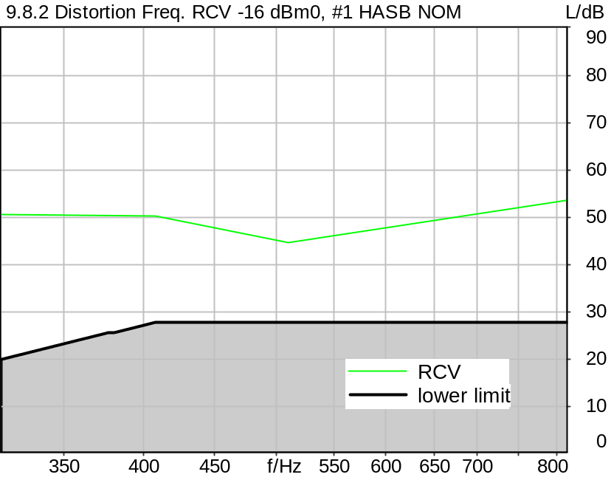

Distortion
Frequency | RCV
315.0 Hz | 50.56 dB (0.30%) | Ok
408.0 Hz | 50.41 dB (0.30%) | Ok
510.0 Hz | 44.76 dB (0.58%) | Ok
816.0 Hz | 53.85 dB (0.20%) | Ok

Ok
5/20/2025 11:37 AM ACQUA 6.0.200

Limits
 | lower
Run 1 | 20.00 dB
Run 2 | 28.00 dB
Run 3 | 28.00 dB
Run 4 | 28.00 dB

Meas. Setting DRP-off

Underlying Standard: 3GPP TS 26.131 V17.3.0 and 3GPP TS 26.132 V17.2.0
Database Version: 60_UG_TS26131_32_SWB_FB_Rev08_GCF_PTCRB

Source
Source level -2.20 dB
Activation file csssb2b_r0_act.dat

Calibration
RCV (2) 1.06 dB 4/29/2025 (HATS 7 (B&K 5128))
Output ch. 2 0.00 dB (Radio Tester 1 (CMW500))

Output Equalization/Filter
Mouth Eq. Ch.1 HATS 7 (B&K 5128) (5/28/2024 5:25 PM)

Analysis
Analyse Channel 2
Range start 20.00 ms Range length 170.67 ms
Frequency base Transformation
FFT size 4096 Overlap 75 %
Window function Hann Smooth Off
Distortion Total dist. dB weighting psophometric
Freq. range min. 100.0 Hz Freq. range max. 6000.0 Hz
O.132 corr. factor No

Input Filters
DF Avg. Channels 1,2

Special Features
Compensate delay 131.3000 ms (D_SCRIPT, Original Delay Variable stored to D_SCRIPT: D_RCV_EQ_HASB)
Store to variable D16_RCV_HASB_Act_a

Hardware Config Settings
Used Setting HA&HE_5128_volte

labCORE Settings
labCORE Serial 77000280 Nickname
Firmware 3.7.5 Sync Source Internal
Clock Pitch 0.00 ppm
----------
labCORE Routing
Out Channel 1 -> Analog Out 1 -> ExternalAmplifier In -> HATS 7 (B&K 5128) Speaker
Out Channel 2 -> VoIP 2
Out Channel 2 -> VoIP 1 -> Radio Tester 1 (CMW500) RF In/Out
In Channel 1 <- VoIP In/Out 1 <- Radio Tester 1 (CMW500) RF In/Out
In Channel 2 <- BEQ Filter 1 R <- ICP Amp. (Slot 7) In 2 <- HATS 7 (B&K 5128) Mic. Right
----------
Analog Out Mainboard Settings (Analog Out)
Range Ch. 1 0.00 dB Range Ch. 2 0.00 dB
----------
ICP Settings (ICP Amp. (Slot 7))
Channel In 1 Settings
Range 132 dB[SPL] @ 50 mV/Pa Highpass 20Hz
Supply Voltage On
Channel In 2 Settings
Range 132 dB[SPL] @ 50 mV/Pa Highpass 20Hz
Supply Voltage On
Channel In 3 Settings
Range 132 dB[SPL] @ 50 mV/Pa Highpass 20Hz
Supply Voltage Off
Channel In 4 Settings
Range 132 dB[SPL] @ 50 mV/Pa Highpass 20Hz
Supply Voltage Off
----------
VoIP Settings (VoIP)
RTP Connection Streaming SIP Connection Unavailable
SIP Reg. State Unregistered Jitterbuffer Length 100
Jitter Buffer Reset On Playback Enabled Codec EVS/16000/1
Packet Length 20 Encoder Parameter ;evs-mode-switch=0;max-red=0;br=13.2;bw=swb;ch-aw-recv=-1
FMTP Parameter ;evs-mode-switch=0;bw=swb;br=13.2;ch-aw-recv=-1;max-red=220
Impairment Mode Off Impairment Type Off
----------
BEQ Settings (BEQ Filter 1)
Block mode Bypass
----------
Artificial Head Settings (HATS 7 (B&K 5128))
Ser. Nr. BK_3408387 Pinna Type Type 4.3

HIB Settings
HIB Name 60020101 Serial 60020101
HIB Mode Mobile Measurement Impedance 32 Ohm
Gain out 1 -40.00 dB Gain out 2 0.00 dB
Gain in 1 0.00 dB Gain in 2 0.00 dB
Mic 1 Power Supply Off Mic 2 Power Supply Off

9.8.2 Distortion Freq. RCV -16 dBm0, #2 HASB NOM
Handset Measurements Superwideband and Fullband \ Handset Measurements SuperWideband (HASB) \ Connections with Handset Receiving Direction (HASB) \ Receiving Dir. DRP/ERP >OFF< DF AVG via SMD LIN EQ \ 9.8.2 Distortion Receiving, -16 dBm0, activation HASB NOM
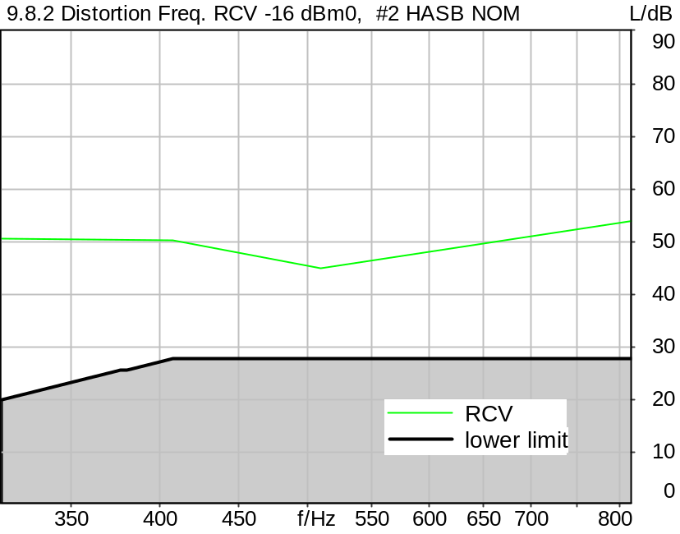

Distortion
Frequency | RCV
315.0 Hz | 50.46 dB (0.30%) | Ok
408.0 Hz | 50.34 dB (0.30%) | Ok
510.0 Hz | 44.89 dB (0.57%) | Ok
816.0 Hz | 53.90 dB (0.20%) | Ok

Ok
5/20/2025 11:37 AM ACQUA 6.0.200

Limits
 | lower
Run 1 | 20.00 dB
Run 2 | 28.00 dB
Run 3 | 28.00 dB
Run 4 | 28.00 dB

Meas. Setting DRP-off

Underlying Standard: 3GPP TS 26.131 V17.3.0 and 3GPP TS 26.132 V17.2.0
Database Version: 60_UG_TS26131_32_SWB_FB_Rev08_GCF_PTCRB

Source
Source level -2.20 dB
Activation file csssb2b_r0_act.dat

Calibration
RCV (2) 1.06 dB 4/29/2025 (HATS 7 (B&K 5128))
Output ch. 2 0.00 dB (Radio Tester 1 (CMW500))

Output Equalization/Filter
Mouth Eq. Ch.1 HATS 7 (B&K 5128) (5/28/2024 5:25 PM)

Analysis
Analyse Channel 2
Range start 20.00 ms Range length 170.67 ms
Frequency base Transformation
FFT size 4096 Overlap 75 %
Window function Hann Smooth Off
Distortion Total dist. dB weighting psophometric
Freq. range min. 100.0 Hz Freq. range max. 6000.0 Hz
O.132 corr. factor No

Input Filters
DF Avg. Channels 1,2

Special Features
Compensate delay 131.3000 ms (D_SCRIPT, Original Delay Variable stored to D_SCRIPT: D_RCV_EQ_HASB)
Store to variable D16_RCV_HASB_Act_b

Hardware Config Settings
Used Setting HA&HE_5128_volte

labCORE Settings
labCORE Serial 77000280 Nickname
Firmware 3.7.5 Sync Source Internal
Clock Pitch 0.00 ppm
----------
labCORE Routing
Out Channel 1 -> Analog Out 1 -> ExternalAmplifier In -> HATS 7 (B&K 5128) Speaker
Out Channel 2 -> VoIP 2
Out Channel 2 -> VoIP 1 -> Radio Tester 1 (CMW500) RF In/Out
In Channel 1 <- VoIP In/Out 1 <- Radio Tester 1 (CMW500) RF In/Out
In Channel 2 <- BEQ Filter 1 R <- ICP Amp. (Slot 7) In 2 <- HATS 7 (B&K 5128) Mic. Right
----------
Analog Out Mainboard Settings (Analog Out)
Range Ch. 1 0.00 dB Range Ch. 2 0.00 dB
----------
ICP Settings (ICP Amp. (Slot 7))
Channel In 1 Settings
Range 132 dB[SPL] @ 50 mV/Pa Highpass 20Hz
Supply Voltage On
Channel In 2 Settings
Range 132 dB[SPL] @ 50 mV/Pa Highpass 20Hz
Supply Voltage On
Channel In 3 Settings
Range 132 dB[SPL] @ 50 mV/Pa Highpass 20Hz
Supply Voltage Off
Channel In 4 Settings
Range 132 dB[SPL] @ 50 mV/Pa Highpass 20Hz
Supply Voltage Off
----------
VoIP Settings (VoIP)
RTP Connection Streaming SIP Connection Unavailable
SIP Reg. State Unregistered Jitterbuffer Length 100
Jitter Buffer Reset On Playback Enabled Codec EVS/16000/1
Packet Length 20 Encoder Parameter ;evs-mode-switch=0;max-red=0;br=13.2;bw=swb;ch-aw-recv=-1
FMTP Parameter ;evs-mode-switch=0;bw=swb;br=13.2;ch-aw-recv=-1;max-red=220
Impairment Mode Off Impairment Type Off
----------
BEQ Settings (BEQ Filter 1)
Block mode Bypass
----------
Artificial Head Settings (HATS 7 (B&K 5128))
Ser. Nr. BK_3408387 Pinna Type Type 4.3

HIB Settings
HIB Name 60020101 Serial 60020101
HIB Mode Mobile Measurement Impedance 32 Ohm
Gain out 1 -40.00 dB Gain out 2 0.00 dB
Gain in 1 0.00 dB Gain in 2 0.00 dB
Mic 1 Power Supply Off Mic 2 Power Supply Off

9.8.2 Distortion Freq. RCV -16 dBm0, #3 HASB NOM
Handset Measurements Superwideband and Fullband \ Handset Measurements SuperWideband (HASB) \ Connections with Handset Receiving Direction (HASB) \ Receiving Dir. DRP/ERP >OFF< DF AVG via SMD LIN EQ \ 9.8.2 Distortion Receiving, -16 dBm0, activation HASB NOM
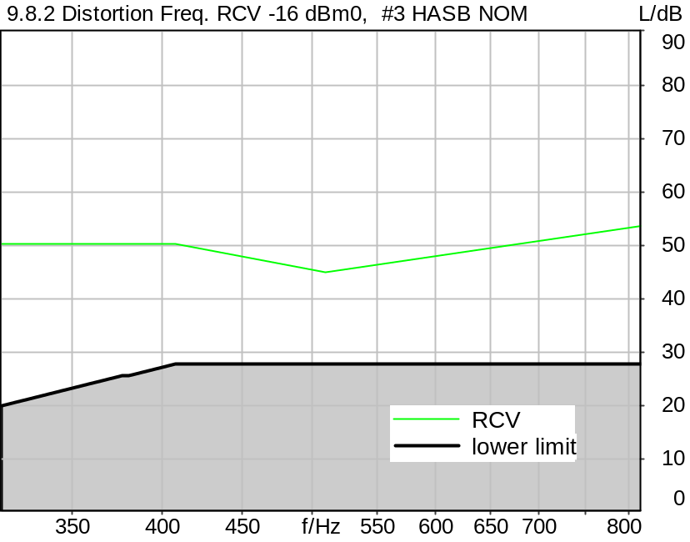

Distortion
Frequency | RCV
315.0 Hz | 50.25 dB (0.31%) | Ok
408.0 Hz | 50.44 dB (0.30%) | Ok
510.0 Hz | 44.86 dB (0.57%) | Ok
816.0 Hz | 53.79 dB (0.20%) | Ok

Ok
5/20/2025 11:38 AM ACQUA 6.0.200

Limits
 | lower
Run 1 | 20.00 dB
Run 2 | 28.00 dB
Run 3 | 28.00 dB
Run 4 | 28.00 dB

Meas. Setting DRP-off

Underlying Standard: 3GPP TS 26.131 V17.3.0 and 3GPP TS 26.132 V17.2.0
Database Version: 60_UG_TS26131_32_SWB_FB_Rev08_GCF_PTCRB

Source
Source level -2.20 dB
Activation file csssb2b_r0_act.dat

Calibration
RCV (2) 1.06 dB 4/29/2025 (HATS 7 (B&K 5128))
Output ch. 2 0.00 dB (Radio Tester 1 (CMW500))

Output Equalization/Filter
Mouth Eq. Ch.1 HATS 7 (B&K 5128) (5/28/2024 5:25 PM)

Analysis
Analyse Channel 2
Range start 20.00 ms Range length 170.67 ms
Frequency base Transformation
FFT size 4096 Overlap 75 %
Window function Hann Smooth Off
Distortion Total dist. dB weighting psophometric
Freq. range min. 100.0 Hz Freq. range max. 6000.0 Hz
O.132 corr. factor No

Input Filters
DF Avg. Channels 1,2

Special Features
Compensate delay 131.3000 ms (D_SCRIPT, Original Delay Variable stored to D_SCRIPT: D_RCV_EQ_HASB)
Store to variable D16_RCV_HASB_Act_c

Hardware Config Settings
Used Setting HA&HE_5128_volte

labCORE Settings
labCORE Serial 77000280 Nickname
Firmware 3.7.5 Sync Source Internal
Clock Pitch 0.00 ppm
----------
labCORE Routing
Out Channel 1 -> Analog Out 1 -> ExternalAmplifier In -> HATS 7 (B&K 5128) Speaker
Out Channel 2 -> VoIP 2
Out Channel 2 -> VoIP 1 -> Radio Tester 1 (CMW500) RF In/Out
In Channel 1 <- VoIP In/Out 1 <- Radio Tester 1 (CMW500) RF In/Out
In Channel 2 <- BEQ Filter 1 R <- ICP Amp. (Slot 7) In 2 <- HATS 7 (B&K 5128) Mic. Right
----------
Analog Out Mainboard Settings (Analog Out)
Range Ch. 1 0.00 dB Range Ch. 2 0.00 dB
----------
ICP Settings (ICP Amp. (Slot 7))
Channel In 1 Settings
Range 132 dB[SPL] @ 50 mV/Pa Highpass 20Hz
Supply Voltage On
Channel In 2 Settings
Range 132 dB[SPL] @ 50 mV/Pa Highpass 20Hz
Supply Voltage On
Channel In 3 Settings
Range 132 dB[SPL] @ 50 mV/Pa Highpass 20Hz
Supply Voltage Off
Channel In 4 Settings
Range 132 dB[SPL] @ 50 mV/Pa Highpass 20Hz
Supply Voltage Off
----------
VoIP Settings (VoIP)
RTP Connection Streaming SIP Connection Unavailable
SIP Reg. State Unregistered Jitterbuffer Length 100
Jitter Buffer Reset On Playback Enabled Codec EVS/16000/1
Packet Length 20 Encoder Parameter ;evs-mode-switch=0;max-red=0;br=13.2;bw=swb;ch-aw-recv=-1
FMTP Parameter ;evs-mode-switch=0;bw=swb;br=13.2;ch-aw-recv=-1;max-red=220
Impairment Mode Off Impairment Type Off
----------
BEQ Settings (BEQ Filter 1)
Block mode Bypass
----------
Artificial Head Settings (HATS 7 (B&K 5128))
Ser. Nr. BK_3408387 Pinna Type Type 4.3

HIB Settings
HIB Name 60020101 Serial 60020101
HIB Mode Mobile Measurement Impedance 32 Ohm
Gain out 1 -40.00 dB Gain out 2 0.00 dB
Gain in 1 0.00 dB Gain in 2 0.00 dB
Mic 1 Power Supply Off Mic 2 Power Supply Off

9.8.2 Distortion Freq. RCV -16 dBm0 activation Average HASB NOM
Handset Measurements Superwideband and Fullband \ Handset Measurements SuperWideband (HASB) \ Connections with Handset Receiving Direction (HASB) \ Receiving Dir. DRP/ERP >OFF< DF AVG via SMD LIN EQ \ 9.8.2 Distortion Receiving, -16 dBm0, activation HASB NOM
Freq. (Hz) | Level (dBm0) | SDR [dB] | Req. [dB] | Status
315 | -16.0 | 50.4 | 20.0 | Ok
408 | -16.0 | 50.4 | 28.0 | Ok
510 | -16.0 | 44.8 | 28.0 | Ok
816 | -16.0 | 53.8 | 28.0 | Ok

5/20/2025 11:38 AM ACQUA

P.863 AC RCV Handset SWB 13.2k MAX
Handset Measurements Superwideband and Fullband \ Handset Measurements SuperWideband (HASB)
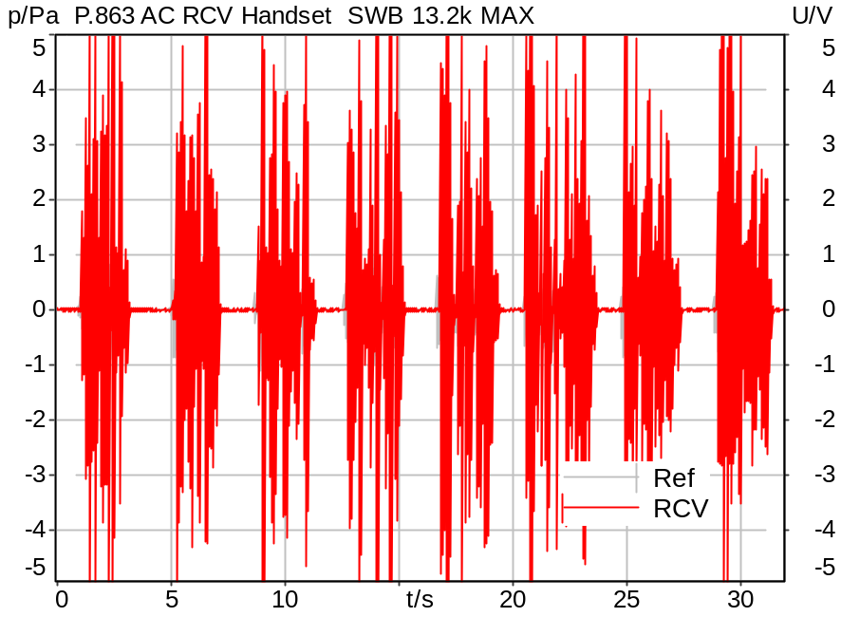

Time range: 0.0 .. 8.0 s
MOS-LQO | 3.74
Time range: 8.0 .. 16.0 s
MOS-LQO | 4.36
Time range: 16.0 .. 24.0 s
MOS-LQO | 4.25
Time range: 24.0 .. 32.0 s
MOS-LQO | 3.98

MOS-LQO (Average) 4.08 Ok

Ok
5/20/2025 11:39 AM ACQUA 6.0.200

Limits
 | lower | upper
Average | 3.70 | 4.80

Meas. Setting DRP-off

Underlying Standard: ACQUA Demo SMDs Rev06
Database Version: ACQUA Demo SMDs Rev06

Source: sp2s_be4x2_swb_sr182.dat
Level adjustment Channel 1 Gain -90.00 dB
SUPERWIDEBAND Real Speech Signals (British English P.501 (from Fullband), 2 sentences per speaker)
(2x male speaker 1, 2x male speaker 2, 2x female speaker 1, 2x female speaker 2).
Edited to fit 4s sequence, bandlimited 50 Hz - 14000 Hz.

Signal Level (Ch1&2): -18.2 dBV active speech level.

Calibration
RCV (2) 1.06 dB 4/29/2025 (HATS 7 (B&K 5128))
Output ch. 1 0.00 dB
Output ch. 2 0.00 dB (Radio Tester 1 (CMW500))

Output Equalization/Filter
Mouth Eq. Ch.1 HATS 7 (B&K 5128) (5/28/2024 5:25 PM)

Analysis
Analyse Channel 2
Range start 0.00 ms Range length 8000.00 ms
Number of seq. 4 Sequence length 8000.00 ms
Reference from Source file
Algorithm POLQA
Version 3.0 Mode Fullband
Fixed Speech Level Yes Accuracy Normal

Input Filters
DF Avg. Channels 1,2

Hardware Config Settings
Used Setting HA&HE_5128_volte

labCORE Settings
labCORE Serial 77000280 Nickname
Firmware 3.7.5 Sync Source Internal
Clock Pitch 0.00 ppm
----------
labCORE Routing
Out Channel 1 -> Analog Out 1 -> ExternalAmplifier In -> HATS 7 (B&K 5128) Speaker
Out Channel 2 -> VoIP 2
Out Channel 2 -> VoIP 1 -> Radio Tester 1 (CMW500) RF In/Out
In Channel 1 <- VoIP In/Out 1 <- Radio Tester 1 (CMW500) RF In/Out
In Channel 2 <- BEQ Filter 1 R <- ICP Amp. (Slot 7) In 2 <- HATS 7 (B&K 5128) Mic. Right
----------
Analog Out Mainboard Settings (Analog Out)
Range Ch. 1 0.00 dB Range Ch. 2 0.00 dB
----------
ICP Settings (ICP Amp. (Slot 7))
Channel In 1 Settings
Range 132 dB[SPL] @ 50 mV/Pa Highpass 20Hz
Supply Voltage On
Channel In 2 Settings
Range 132 dB[SPL] @ 50 mV/Pa Highpass 20Hz
Supply Voltage On
Channel In 3 Settings
Range 132 dB[SPL] @ 50 mV/Pa Highpass 20Hz
Supply Voltage Off
Channel In 4 Settings
Range 132 dB[SPL] @ 50 mV/Pa Highpass 20Hz
Supply Voltage Off
----------
VoIP Settings (VoIP)
RTP Connection Streaming SIP Connection Unavailable
SIP Reg. State Unregistered Jitterbuffer Length 100
Jitter Buffer Reset On Playback Enabled Codec EVS/16000/1
Packet Length 20 Encoder Parameter ;evs-mode-switch=0;max-red=0;br=13.2;bw=swb;ch-aw-recv=-1
FMTP Parameter ;evs-mode-switch=0;bw=swb;br=13.2;ch-aw-recv=-1;max-red=220
Impairment Mode Off Impairment Type Off
----------
BEQ Settings (BEQ Filter 1)
Block mode Bypass
----------
Artificial Head Settings (HATS 7 (B&K 5128))
Ser. Nr. BK_3408387 Pinna Type Type 4.3

HIB Settings
HIB Name 60020101 Serial 60020101
HIB Mode Mobile Measurement Impedance 32 Ohm
Gain out 1 -40.00 dB Gain out 2 0.00 dB
Gain in 1 0.00 dB Gain in 2 0.00 dB
Mic 1 Power Supply Off Mic 2 Power Supply Off

P.863 AC RCV Handset SWB 13.2k NOM
Handset Measurements Superwideband and Fullband \ Handset Measurements SuperWideband (HASB)
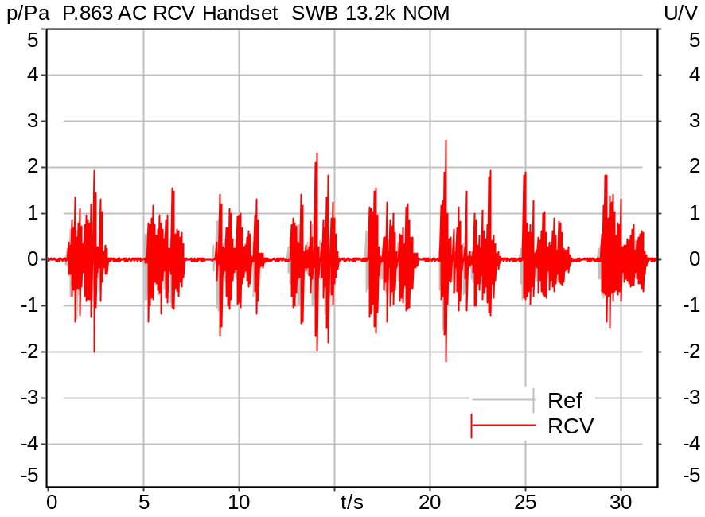

Time range: 0.0 .. 8.0 s
MOS-LQO | 3.55
Time range: 8.0 .. 16.0 s
MOS-LQO | 4.35
Time range: 16.0 .. 24.0 s
MOS-LQO | 4.22
Time range: 24.0 .. 32.0 s
MOS-LQO | 3.92

MOS-LQO (Average) 4.01 Ok

Ok
5/20/2025 11:40 AM ACQUA 6.0.200

Limits
 | lower | upper
Average | 3.70 | 4.80

Meas. Setting DRP-off

Underlying Standard: ACQUA Demo SMDs Rev06
Database Version: ACQUA Demo SMDs Rev06

Source: sp2s_be4x2_swb_sr182.dat
Level adjustment Channel 1 Gain -90.00 dB
SUPERWIDEBAND Real Speech Signals (British English P.501 (from Fullband), 2 sentences per speaker)
(2x male speaker 1, 2x male speaker 2, 2x female speaker 1, 2x female speaker 2).
Edited to fit 4s sequence, bandlimited 50 Hz - 14000 Hz.

Signal Level (Ch1&2): -18.2 dBV active speech level.

Calibration
RCV (2) 1.06 dB 4/29/2025 (HATS 7 (B&K 5128))
Output ch. 1 0.00 dB
Output ch. 2 0.00 dB (Radio Tester 1 (CMW500))

Output Equalization/Filter
Mouth Eq. Ch.1 HATS 7 (B&K 5128) (5/28/2024 5:25 PM)

Analysis
Analyse Channel 2
Range start 0.00 ms Range length 8000.00 ms
Number of seq. 4 Sequence length 8000.00 ms
Reference from Source file
Algorithm POLQA
Version 3.0 Mode Fullband
Fixed Speech Level Yes Accuracy Normal

Input Filters
DF Avg. Channels 1,2

Hardware Config Settings
Used Setting HA&HE_5128_volte

labCORE Settings
labCORE Serial 77000280 Nickname
Firmware 3.7.5 Sync Source Internal
Clock Pitch 0.00 ppm
----------
labCORE Routing
Out Channel 1 -> Analog Out 1 -> ExternalAmplifier In -> HATS 7 (B&K 5128) Speaker
Out Channel 2 -> VoIP 2
Out Channel 2 -> VoIP 1 -> Radio Tester 1 (CMW500) RF In/Out
In Channel 1 <- VoIP In/Out 1 <- Radio Tester 1 (CMW500) RF In/Out
In Channel 2 <- BEQ Filter 1 R <- ICP Amp. (Slot 7) In 2 <- HATS 7 (B&K 5128) Mic. Right
----------
Analog Out Mainboard Settings (Analog Out)
Range Ch. 1 0.00 dB Range Ch. 2 0.00 dB
----------
ICP Settings (ICP Amp. (Slot 7))
Channel In 1 Settings
Range 132 dB[SPL] @ 50 mV/Pa Highpass 20Hz
Supply Voltage On
Channel In 2 Settings
Range 132 dB[SPL] @ 50 mV/Pa Highpass 20Hz
Supply Voltage On
Channel In 3 Settings
Range 132 dB[SPL] @ 50 mV/Pa Highpass 20Hz
Supply Voltage Off
Channel In 4 Settings
Range 132 dB[SPL] @ 50 mV/Pa Highpass 20Hz
Supply Voltage Off
----------
VoIP Settings (VoIP)
RTP Connection Streaming SIP Connection Unavailable
SIP Reg. State Unregistered Jitterbuffer Length 100
Jitter Buffer Reset On Playback Enabled Codec EVS/16000/1
Packet Length 20 Encoder Parameter ;evs-mode-switch=0;max-red=0;br=13.2;bw=swb;ch-aw-recv=-1
FMTP Parameter ;evs-mode-switch=0;bw=swb;br=13.2;ch-aw-recv=-1;max-red=220
Impairment Mode Off Impairment Type Off
----------
BEQ Settings (BEQ Filter 1)
Block mode Bypass
----------
Artificial Head Settings (HATS 7 (B&K 5128))
Ser. Nr. BK_3408387 Pinna Type Type 4.3

HIB Settings
HIB Name 60020101 Serial 60020101
HIB Mode Mobile Measurement Impedance 32 Ohm
Gain out 1 -40.00 dB Gain out 2 0.00 dB
Gain in 1 0.00 dB Gain in 2 0.00 dB
Mic 1 Power Supply Off Mic 2 Power Supply Off

P.863 AC RCV Handset SWB 13.2k MIN
Handset Measurements Superwideband and Fullband \ Handset Measurements SuperWideband (HASB)
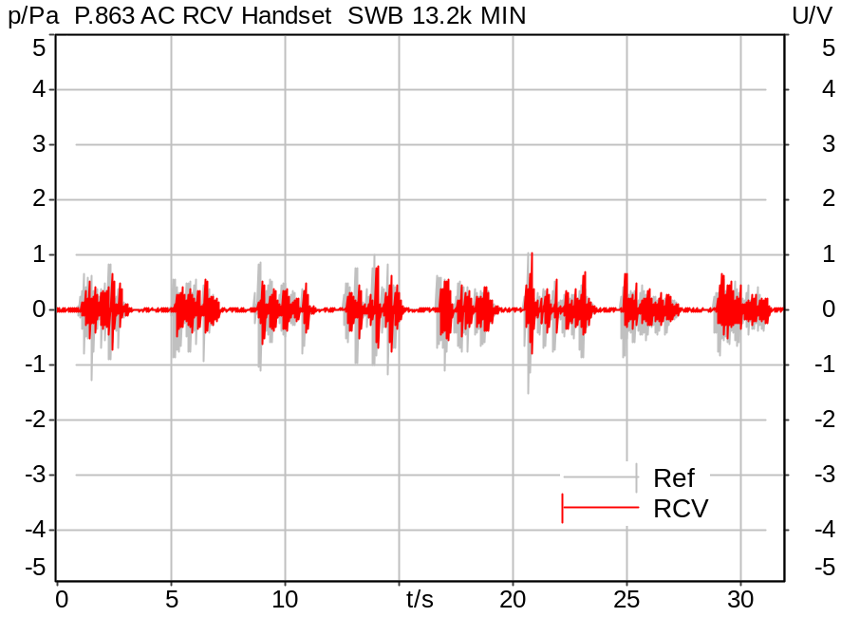

Time range: 0.0 .. 8.0 s
MOS-LQO | 3.67
Time range: 8.0 .. 16.0 s
MOS-LQO | 4.32
Time range: 16.0 .. 24.0 s
MOS-LQO | 4.16
Time range: 24.0 .. 32.0 s
MOS-LQO | 3.84

MOS-LQO (Average) 4.00 Ok

Ok
5/20/2025 11:42 AM ACQUA 6.0.200

Limits
 | lower | upper
Average | 3.70 | 4.80

Meas. Setting DRP-off

Underlying Standard: ACQUA Demo SMDs Rev06
Database Version: ACQUA Demo SMDs Rev06

Source: sp2s_be4x2_swb_sr182.dat
Level adjustment Channel 1 Gain -90.00 dB
SUPERWIDEBAND Real Speech Signals (British English P.501 (from Fullband), 2 sentences per speaker)
(2x male speaker 1, 2x male speaker 2, 2x female speaker 1, 2x female speaker 2).
Edited to fit 4s sequence, bandlimited 50 Hz - 14000 Hz.

Signal Level (Ch1&2): -18.2 dBV active speech level.

Calibration
RCV (2) 1.06 dB 4/29/2025 (HATS 7 (B&K 5128))
Output ch. 1 0.00 dB
Output ch. 2 0.00 dB (Radio Tester 1 (CMW500))

Output Equalization/Filter
Mouth Eq. Ch.1 HATS 7 (B&K 5128) (5/28/2024 5:25 PM)

Analysis
Analyse Channel 2
Range start 0.00 ms Range length 8000.00 ms
Number of seq. 4 Sequence length 8000.00 ms
Reference from Source file
Algorithm POLQA
Version 3.0 Mode Fullband
Fixed Speech Level Yes Accuracy Normal

Input Filters
DF Avg. Channels 1,2

Hardware Config Settings
Used Setting HA&HE_5128_volte

labCORE Settings
labCORE Serial 77000280 Nickname
Firmware 3.7.5 Sync Source Internal
Clock Pitch 0.00 ppm
----------
labCORE Routing
Out Channel 1 -> Analog Out 1 -> ExternalAmplifier In -> HATS 7 (B&K 5128) Speaker
Out Channel 2 -> VoIP 2
Out Channel 2 -> VoIP 1 -> Radio Tester 1 (CMW500) RF In/Out
In Channel 1 <- VoIP In/Out 1 <- Radio Tester 1 (CMW500) RF In/Out
In Channel 2 <- BEQ Filter 1 R <- ICP Amp. (Slot 7) In 2 <- HATS 7 (B&K 5128) Mic. Right
----------
Analog Out Mainboard Settings (Analog Out)
Range Ch. 1 0.00 dB Range Ch. 2 0.00 dB
----------
ICP Settings (ICP Amp. (Slot 7))
Channel In 1 Settings
Range 132 dB[SPL] @ 50 mV/Pa Highpass 20Hz
Supply Voltage On
Channel In 2 Settings
Range 132 dB[SPL] @ 50 mV/Pa Highpass 20Hz
Supply Voltage On
Channel In 3 Settings
Range 132 dB[SPL] @ 50 mV/Pa Highpass 20Hz
Supply Voltage Off
Channel In 4 Settings
Range 132 dB[SPL] @ 50 mV/Pa Highpass 20Hz
Supply Voltage Off
----------
VoIP Settings (VoIP)
RTP Connection Streaming SIP Connection Unavailable
SIP Reg. State Unregistered Jitterbuffer Length 100
Jitter Buffer Reset On Playback Enabled Codec EVS/16000/1
Packet Length 20 Encoder Parameter ;evs-mode-switch=0;max-red=0;br=13.2;bw=swb;ch-aw-recv=-1
FMTP Parameter ;evs-mode-switch=0;bw=swb;br=13.2;ch-aw-recv=-1;max-red=220
Impairment Mode Off Impairment Type Off
----------
BEQ Settings (BEQ Filter 1)
Block mode Bypass
----------
Artificial Head Settings (HATS 7 (B&K 5128))
Ser. Nr. BK_3408387 Pinna Type Type 4.3

HIB Settings
HIB Name 60020101 Serial 60020101
HIB Mode Mobile Measurement Impedance 32 Ohm
Gain out 1 -40.00 dB Gain out 2 0.00 dB
Gain in 1 0.00 dB Gain in 2 0.00 dB
Mic 1 Power Supply Off Mic 2 Power Supply Off

9.2.2.1 Loudness Rating SND (SLR) P.501 HASB
Handset Measurements Superwideband and Fullband \ Handset Measurements SuperWideband (HASB) \ Connections with Handset Sending Direction (HASB)
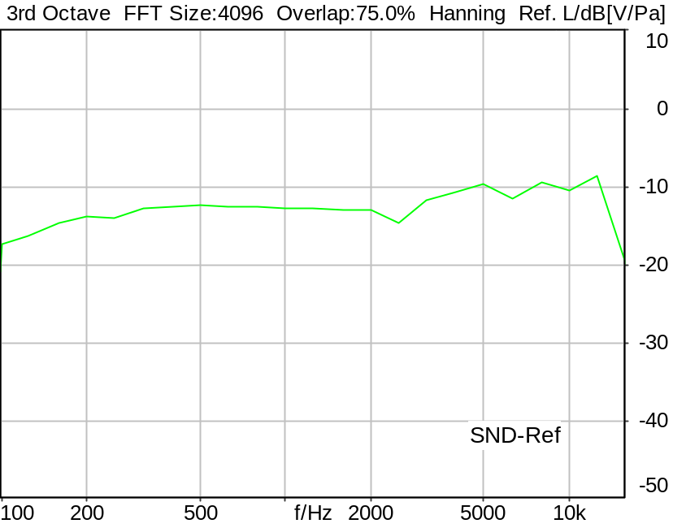

SLR: 6.79 dB Ok

Ok
5/20/2025 11:42 AM ACQUA 6.0.200
Unmodified HEAD acoustics Measurement Descriptor

Limits
 | lower | upper
Run 1 | 5.00 dB | 11.00 dB

Meas. Setting DRP-off

Underlying Standard: 3GPP TS 26.131 V17.3.0 and 3GPP TS 26.132 V17.2.0
Database Version: 60_UG_TS26131_32_SWB_FB_Rev08_GCF_PTCRB

Source: spst4x3_fb_s147.dat
Level adjustment Channel 2 Gain -90.00 dB
Level adjustment Channel 1 Gain 10.00 dB
FULLBAND Real Speech Single Talk (ITU-T SG 12 sentences) at Channel 1
(3x male speech, 3x female speech, 3x male speech, 3x female speech)
A silence period of 0.5 s is inserted between each sentence as well as at the
beginning and end of the sequence.
Signal level (ch1): -14.7 dBV active speech level, overall duration 35.5 s.

For license information refer to the files >LICENSE_psytechnics.txt< and
>LICENSE_nokia.txt<, see Preparation of Test Setup - Info: Test Signals

Calibration
SND (1) 0.00 dB (Radio Tester 1 (CMW500))
Output ch. 1 0.00 dB
Output ch. 2 0.00 dB (Radio Tester 1 (CMW500))

Output Equalization/Filter
Mouth Eq. Ch.1 HATS 7 (B&K 5128) (5/28/2024 5:25 PM)

Analysis
Analyse Channel 1
Range start 400.00 ms Range length 34680.00 ms
Frequency base 3rd octave DIN Row Row B
Method FFT
FFT size 4096 Overlap 75 %
Window function Hann
Reference file re_slr_snd_resp_hasb.fft
LR kind SLR Method ITU-T P.79
Bands for LR calc. 1..20

Special Features
Compensate delay 257.6000 ms (D_SCRIPT, Original Delay Variable stored to D_SCRIPT: D_SND_EQ_HASB)

Hardware Config Settings
Used Setting HA&HE_5128_volte

labCORE Settings
labCORE Serial 77000280 Nickname
Firmware 3.7.5 Sync Source Internal
Clock Pitch 0.00 ppm
----------
labCORE Routing
Out Channel 1 -> Analog Out 1 -> ExternalAmplifier In -> HATS 7 (B&K 5128) Speaker
Out Channel 2 -> VoIP 2
Out Channel 2 -> VoIP 1 -> Radio Tester 1 (CMW500) RF In/Out
In Channel 1 <- VoIP In/Out 1 <- Radio Tester 1 (CMW500) RF In/Out
In Channel 2 <- BEQ Filter 1 R <- ICP Amp. (Slot 7) In 2 <- HATS 7 (B&K 5128) Mic. Right
----------
Analog Out Mainboard Settings (Analog Out)
Range Ch. 1 0.00 dB Range Ch. 2 0.00 dB
----------
ICP Settings (ICP Amp. (Slot 7))
Channel In 1 Settings
Range 132 dB[SPL] @ 50 mV/Pa Highpass 20Hz
Supply Voltage On
Channel In 2 Settings
Range 132 dB[SPL] @ 50 mV/Pa Highpass 20Hz
Supply Voltage On
Channel In 3 Settings
Range 132 dB[SPL] @ 50 mV/Pa Highpass 20Hz
Supply Voltage Off
Channel In 4 Settings
Range 132 dB[SPL] @ 50 mV/Pa Highpass 20Hz
Supply Voltage Off
----------
VoIP Settings (VoIP)
RTP Connection Streaming SIP Connection Unavailable
SIP Reg. State Unregistered Jitterbuffer Length 100
Jitter Buffer Reset On Playback Enabled Codec EVS/16000/1
Packet Length 20 Encoder Parameter ;evs-mode-switch=0;max-red=0;br=13.2;bw=swb;ch-aw-recv=-1
FMTP Parameter ;evs-mode-switch=0;bw=swb;br=13.2;ch-aw-recv=-1;max-red=220
Impairment Mode Off Impairment Type Off
----------
BEQ Settings (BEQ Filter 1)
Block mode Bypass
----------
Artificial Head Settings (HATS 7 (B&K 5128))
Ser. Nr. BK_3408387 Pinna Type Type 4.3

HIB Settings
HIB Name 60020101 Serial 60020101
HIB Mode Mobile Measurement Impedance 32 Ohm
Gain out 1 -40.00 dB Gain out 2 0.00 dB
Gain in 1 0.00 dB Gain in 2 0.00 dB
Mic 1 Power Supply Off Mic 2 Power Supply Off

SND Robustness with noise(gausswhite 82dB) HASB ECRP
Handset Measurements Superwideband and Fullband \ Handset Measurements SuperWideband (HASB) \ Connections with Handset Sending Direction (HASB)
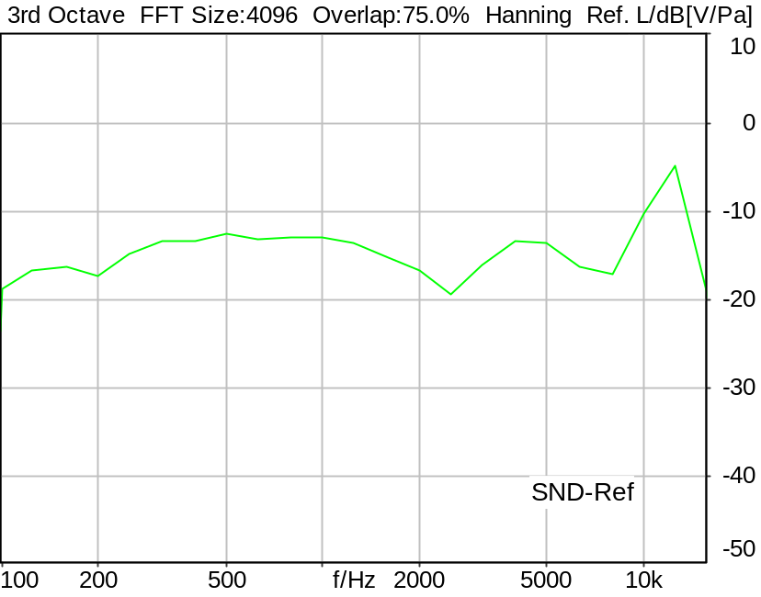

SLR: 7.98 dB Ok

Ok
5/21/2025 10:34 PM ACQUA 6.0.200

Limits
 | lower | upper
Run 1 | 5.00 dB | 17.00 dB

Meas. Setting DRP-off

Underlying Standard: 3GPP TS 26.131 V17.3.0 and 3GPP TS 26.132 V17.2.0
Database Version: 60_UG_TS26131_32_SWB_FB_Rev08_GCF_PTCRB

Source: spst4x3_fb_s147.dat
Level adjustment Channel 2 Gain -90.00 dB
Level adjustment Channel 1 Gain 10.00 dB
FULLBAND Real Speech Single Talk (ITU-T SG 12 sentences) at Channel 1
(3x male speech, 3x female speech, 3x male speech, 3x female speech)
A silence period of 0.5 s is inserted between each sentence as well as at the
beginning and end of the sequence.
Signal level (ch1): -14.7 dBV active speech level, overall duration 35.5 s.

For license information refer to the files >LICENSE_psytechnics.txt< and
>LICENSE_nokia.txt<, see Preparation of Test Setup - Info: Test Signals

Calibration
SND (1) 0.00 dB (Radio Tester 1 (CMW500))
Output ch. 1 0.00 dB
Output ch. 2 0.00 dB (Radio Tester 1 (CMW500))

Output Equalization/Filter
Mouth Eq. Ch.1 HATS 7 (B&K 5128) (5/28/2024 5:25 PM)

Analysis
Analyse Channel 1
Range start 400.00 ms Range length 34680.00 ms
Frequency base 3rd octave DIN Row Row B
Method FFT
FFT size 4096 Overlap 75 %
Window function Hann
Reference file re_slr_snd_resp_hasb.fft
LR kind SLR Method ITU-T P.79
Bands for LR calc. 1..20

Special Features
Compensate delay 303.0000 ms (D_SCRIPT, Original Delay Variable stored to D_SCRIPT: D_SND_EQ_HASB)

Hardware Config Settings
Used Setting HA&HE_5128_volte

labCORE Settings
labCORE Serial 77000280 Nickname
Firmware 3.7.5 Sync Source Internal
Clock Pitch 0.00 ppm
----------
labCORE Routing
Out Channel 1 -> Analog Out 1 -> ExternalAmplifier In -> HATS 7 (B&K 5128) Speaker
Out Channel 2 -> VoIP 2
Out Channel 2 -> VoIP 1 -> Radio Tester 1 (CMW500) RF In/Out
In Channel 1 <- VoIP In/Out 1 <- Radio Tester 1 (CMW500) RF In/Out
In Channel 2 <- BEQ Filter 1 R <- ICP Amp. (Slot 7) In 2 <- HATS 7 (B&K 5128) Mic. Right
----------
Analog Out Mainboard Settings (Analog Out)
Range Ch. 1 0.00 dB Range Ch. 2 0.00 dB
----------
ICP Settings (ICP Amp. (Slot 7))
Channel In 1 Settings
Range 132 dB[SPL] @ 50 mV/Pa Highpass 20Hz
Supply Voltage On
Channel In 2 Settings
Range 132 dB[SPL] @ 50 mV/Pa Highpass 20Hz
Supply Voltage On
Channel In 3 Settings
Range 132 dB[SPL] @ 50 mV/Pa Highpass 20Hz
Supply Voltage Off
Channel In 4 Settings
Range 132 dB[SPL] @ 50 mV/Pa Highpass 20Hz
Supply Voltage Off
----------
VoIP Settings (VoIP)
RTP Connection Streaming SIP Connection Unavailable
SIP Reg. State Unregistered Jitterbuffer Length 140
Jitter Buffer Reset On Playback Enabled Codec EVS/16000/1
Packet Length 20 Encoder Parameter ;evs-mode-switch=0;max-red=0;br=13.2;bw=swb;ch-aw-recv=-1
FMTP Parameter ;evs-mode-switch=0;bw=swb;br=13.2;ch-aw-recv=-1;max-red=220
Impairment Mode Off Impairment Type Off
----------
BEQ Settings (BEQ Filter 1)
Block mode Bypass
----------
Artificial Head Settings (HATS 7 (B&K 5128))
Ser. Nr. BK_3408387 Pinna Type Type 4.3

SND Robustness with noise(gausswhite 82dB) HASB 20UP
Handset Measurements Superwideband and Fullband \ Handset Measurements SuperWideband (HASB) \ Connections with Handset Sending Direction (HASB)
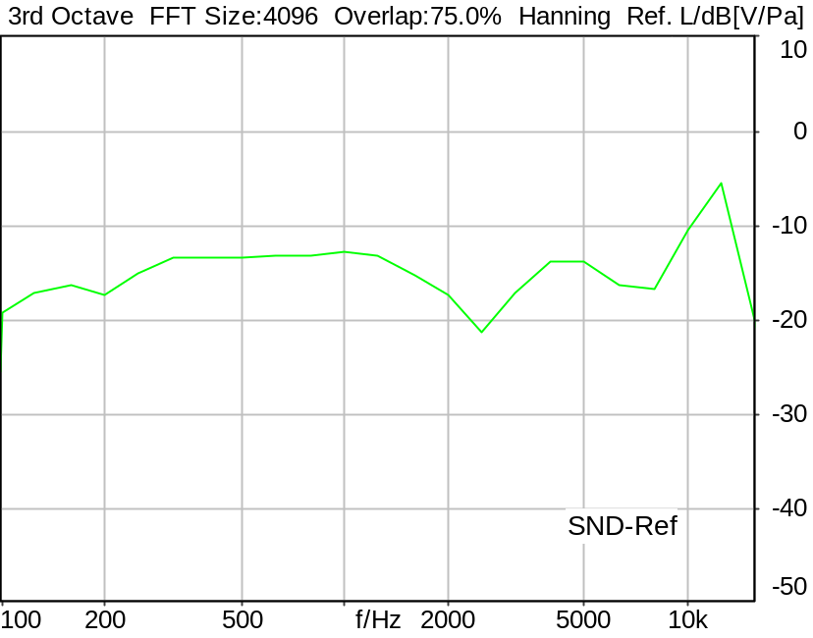

SLR: 8.14 dB Ok

Ok
5/21/2025 10:36 PM ACQUA 6.0.200

Limits
 | lower | upper
Run 1 | 5.00 dB | 17.00 dB

Meas. Setting DRP-off

Underlying Standard: 3GPP TS 26.131 V17.3.0 and 3GPP TS 26.132 V17.2.0
Database Version: 60_UG_TS26131_32_SWB_FB_Rev08_GCF_PTCRB

Source: spst4x3_fb_s147.dat
Level adjustment Channel 2 Gain -90.00 dB
Level adjustment Channel 1 Gain 10.00 dB
FULLBAND Real Speech Single Talk (ITU-T SG 12 sentences) at Channel 1
(3x male speech, 3x female speech, 3x male speech, 3x female speech)
A silence period of 0.5 s is inserted between each sentence as well as at the
beginning and end of the sequence.
Signal level (ch1): -14.7 dBV active speech level, overall duration 35.5 s.

For license information refer to the files >LICENSE_psytechnics.txt< and
>LICENSE_nokia.txt<, see Preparation of Test Setup - Info: Test Signals

Calibration
SND (1) 0.00 dB (Radio Tester 1 (CMW500))
Output ch. 1 0.00 dB
Output ch. 2 0.00 dB (Radio Tester 1 (CMW500))

Output Equalization/Filter
Mouth Eq. Ch.1 HATS 7 (B&K 5128) (5/28/2024 5:25 PM)

Analysis
Analyse Channel 1
Range start 400.00 ms Range length 34680.00 ms
Frequency base 3rd octave DIN Row Row B
Method FFT
FFT size 4096 Overlap 75 %
Window function Hann
Reference file re_slr_snd_resp_hasb.fft
LR kind SLR Method ITU-T P.79
Bands for LR calc. 1..20

Special Features
Compensate delay 303.0000 ms (D_SCRIPT, Original Delay Variable stored to D_SCRIPT: D_SND_EQ_HASB)

Hardware Config Settings
Used Setting HA&HE_5128_volte

labCORE Settings
labCORE Serial 77000280 Nickname
Firmware 3.7.5 Sync Source Internal
Clock Pitch 0.00 ppm
----------
labCORE Routing
Out Channel 1 -> Analog Out 1 -> ExternalAmplifier In -> HATS 7 (B&K 5128) Speaker
Out Channel 2 -> VoIP 2
Out Channel 2 -> VoIP 1 -> Radio Tester 1 (CMW500) RF In/Out
In Channel 1 <- VoIP In/Out 1 <- Radio Tester 1 (CMW500) RF In/Out
In Channel 2 <- BEQ Filter 1 R <- ICP Amp. (Slot 7) In 2 <- HATS 7 (B&K 5128) Mic. Right
----------
Analog Out Mainboard Settings (Analog Out)
Range Ch. 1 0.00 dB Range Ch. 2 0.00 dB
----------
ICP Settings (ICP Amp. (Slot 7))
Channel In 1 Settings
Range 132 dB[SPL] @ 50 mV/Pa Highpass 20Hz
Supply Voltage On
Channel In 2 Settings
Range 132 dB[SPL] @ 50 mV/Pa Highpass 20Hz
Supply Voltage On
Channel In 3 Settings
Range 132 dB[SPL] @ 50 mV/Pa Highpass 20Hz
Supply Voltage Off
Channel In 4 Settings
Range 132 dB[SPL] @ 50 mV/Pa Highpass 20Hz
Supply Voltage Off
----------
VoIP Settings (VoIP)
RTP Connection Streaming SIP Connection Unavailable
SIP Reg. State Unregistered Jitterbuffer Length 140
Jitter Buffer Reset On Playback Enabled Codec EVS/16000/1
Packet Length 20 Encoder Parameter ;evs-mode-switch=0;max-red=0;br=13.2;bw=swb;ch-aw-recv=-1
FMTP Parameter ;evs-mode-switch=0;bw=swb;br=13.2;ch-aw-recv=-1;max-red=220
Impairment Mode Off Impairment Type Off
----------
BEQ Settings (BEQ Filter 1)
Block mode Bypass
----------
Artificial Head Settings (HATS 7 (B&K 5128))
Ser. Nr. BK_3408387 Pinna Type Type 4.3

SND Robustness with noise(gausswhite 82dB) HASB 25DOWN
Handset Measurements Superwideband and Fullband \ Handset Measurements SuperWideband (HASB) \ Connections with Handset Sending Direction (HASB)
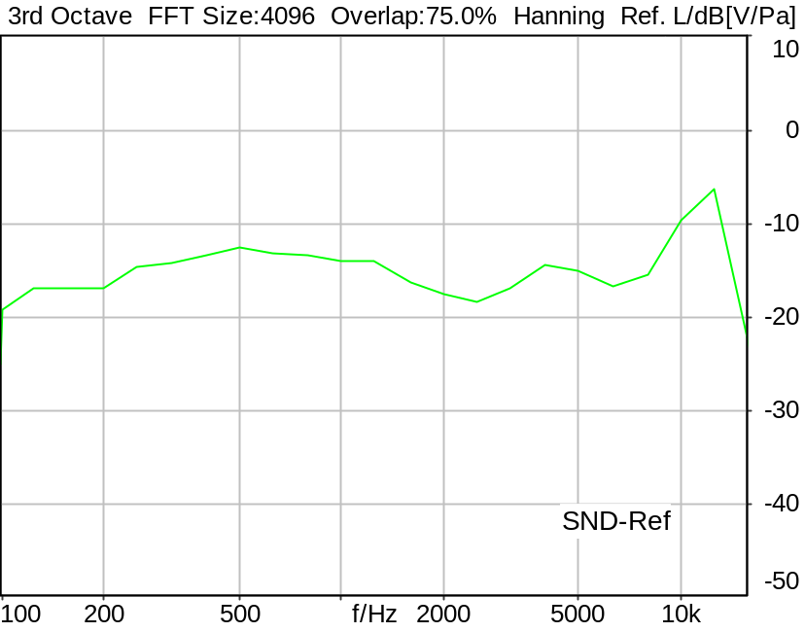

SLR: 8.26 dB Ok

Ok
5/21/2025 10:39 PM ACQUA 6.0.200

Limits
 | lower | upper
Run 1 | 5.00 dB | 17.00 dB

Meas. Setting DRP-off

Underlying Standard: 3GPP TS 26.131 V17.3.0 and 3GPP TS 26.132 V17.2.0
Database Version: 60_UG_TS26131_32_SWB_FB_Rev08_GCF_PTCRB

Source: spst4x3_fb_s147.dat
Level adjustment Channel 2 Gain -90.00 dB
Level adjustment Channel 1 Gain 10.00 dB
FULLBAND Real Speech Single Talk (ITU-T SG 12 sentences) at Channel 1
(3x male speech, 3x female speech, 3x male speech, 3x female speech)
A silence period of 0.5 s is inserted between each sentence as well as at the
beginning and end of the sequence.
Signal level (ch1): -14.7 dBV active speech level, overall duration 35.5 s.

For license information refer to the files >LICENSE_psytechnics.txt< and
>LICENSE_nokia.txt<, see Preparation of Test Setup - Info: Test Signals

Calibration
SND (1) 0.00 dB (Radio Tester 1 (CMW500))
Output ch. 1 0.00 dB
Output ch. 2 0.00 dB (Radio Tester 1 (CMW500))

Output Equalization/Filter
Mouth Eq. Ch.1 HATS 7 (B&K 5128) (5/28/2024 5:25 PM)

Analysis
Analyse Channel 1
Range start 400.00 ms Range length 34680.00 ms
Frequency base 3rd octave DIN Row Row B
Method FFT
FFT size 4096 Overlap 75 %
Window function Hann
Reference file re_slr_snd_resp_hasb.fft
LR kind SLR Method ITU-T P.79
Bands for LR calc. 1..20

Special Features
Compensate delay 303.0000 ms (D_SCRIPT, Original Delay Variable stored to D_SCRIPT: D_SND_EQ_HASB)

Hardware Config Settings
Used Setting HA&HE_5128_volte

labCORE Settings
labCORE Serial 77000280 Nickname
Firmware 3.7.5 Sync Source Internal
Clock Pitch 0.00 ppm
----------
labCORE Routing
Out Channel 1 -> Analog Out 1 -> ExternalAmplifier In -> HATS 7 (B&K 5128) Speaker
Out Channel 2 -> VoIP 2
Out Channel 2 -> VoIP 1 -> Radio Tester 1 (CMW500) RF In/Out
In Channel 1 <- VoIP In/Out 1 <- Radio Tester 1 (CMW500) RF In/Out
In Channel 2 <- BEQ Filter 1 R <- ICP Amp. (Slot 7) In 2 <- HATS 7 (B&K 5128) Mic. Right
----------
Analog Out Mainboard Settings (Analog Out)
Range Ch. 1 0.00 dB Range Ch. 2 0.00 dB
----------
ICP Settings (ICP Amp. (Slot 7))
Channel In 1 Settings
Range 132 dB[SPL] @ 50 mV/Pa Highpass 20Hz
Supply Voltage On
Channel In 2 Settings
Range 132 dB[SPL] @ 50 mV/Pa Highpass 20Hz
Supply Voltage On
Channel In 3 Settings
Range 132 dB[SPL] @ 50 mV/Pa Highpass 20Hz
Supply Voltage Off
Channel In 4 Settings
Range 132 dB[SPL] @ 50 mV/Pa Highpass 20Hz
Supply Voltage Off
----------
VoIP Settings (VoIP)
RTP Connection Streaming SIP Connection Unavailable
SIP Reg. State Unregistered Jitterbuffer Length 140
Jitter Buffer Reset On Playback Enabled Codec EVS/16000/1
Packet Length 20 Encoder Parameter ;evs-mode-switch=0;max-red=0;br=13.2;bw=swb;ch-aw-recv=-1
FMTP Parameter ;evs-mode-switch=0;bw=swb;br=13.2;ch-aw-recv=-1;max-red=220
Impairment Mode Off Impairment Type Off
----------
BEQ Settings (BEQ Filter 1)
Block mode Bypass
----------
Artificial Head Settings (HATS 7 (B&K 5128))
Ser. Nr. BK_3408387 Pinna Type Type 4.3

SND Robustness with noise(gausswhite 82dB) HASB 10OUT
Handset Measurements Superwideband and Fullband \ Handset Measurements SuperWideband (HASB) \ Connections with Handset Sending Direction (HASB)
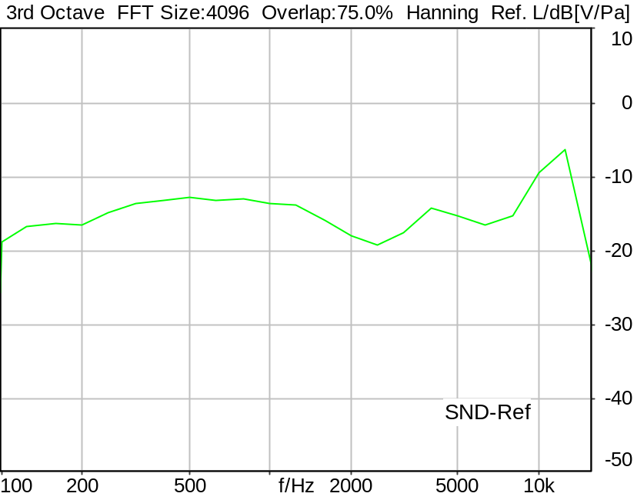

SLR: 8.10 dB Ok

Ok
5/21/2025 10:40 PM ACQUA 6.0.200

Limits
 | lower | upper
Run 1 | 5.00 dB | 17.00 dB

Meas. Setting DRP-off

Underlying Standard: 3GPP TS 26.131 V17.3.0 and 3GPP TS 26.132 V17.2.0
Database Version: 60_UG_TS26131_32_SWB_FB_Rev08_GCF_PTCRB

Source: spst4x3_fb_s147.dat
Level adjustment Channel 2 Gain -90.00 dB
Level adjustment Channel 1 Gain 10.00 dB
FULLBAND Real Speech Single Talk (ITU-T SG 12 sentences) at Channel 1
(3x male speech, 3x female speech, 3x male speech, 3x female speech)
A silence period of 0.5 s is inserted between each sentence as well as at the
beginning and end of the sequence.
Signal level (ch1): -14.7 dBV active speech level, overall duration 35.5 s.

For license information refer to the files >LICENSE_psytechnics.txt< and
>LICENSE_nokia.txt<, see Preparation of Test Setup - Info: Test Signals

Calibration
SND (1) 0.00 dB (Radio Tester 1 (CMW500))
Output ch. 1 0.00 dB
Output ch. 2 0.00 dB (Radio Tester 1 (CMW500))

Output Equalization/Filter
Mouth Eq. Ch.1 HATS 7 (B&K 5128) (5/28/2024 5:25 PM)

Analysis
Analyse Channel 1
Range start 400.00 ms Range length 34680.00 ms
Frequency base 3rd octave DIN Row Row B
Method FFT
FFT size 4096 Overlap 75 %
Window function Hann
Reference file re_slr_snd_resp_hasb.fft
LR kind SLR Method ITU-T P.79
Bands for LR calc. 1..20

Special Features
Compensate delay 303.0000 ms (D_SCRIPT, Original Delay Variable stored to D_SCRIPT: D_SND_EQ_HASB)

Hardware Config Settings
Used Setting HA&HE_5128_volte

labCORE Settings
labCORE Serial 77000280 Nickname
Firmware 3.7.5 Sync Source Internal
Clock Pitch 0.00 ppm
----------
labCORE Routing
Out Channel 1 -> Analog Out 1 -> ExternalAmplifier In -> HATS 7 (B&K 5128) Speaker
Out Channel 2 -> VoIP 2
Out Channel 2 -> VoIP 1 -> Radio Tester 1 (CMW500) RF In/Out
In Channel 1 <- VoIP In/Out 1 <- Radio Tester 1 (CMW500) RF In/Out
In Channel 2 <- BEQ Filter 1 R <- ICP Amp. (Slot 7) In 2 <- HATS 7 (B&K 5128) Mic. Right
----------
Analog Out Mainboard Settings (Analog Out)
Range Ch. 1 0.00 dB Range Ch. 2 0.00 dB
----------
ICP Settings (ICP Amp. (Slot 7))
Channel In 1 Settings
Range 132 dB[SPL] @ 50 mV/Pa Highpass 20Hz
Supply Voltage On
Channel In 2 Settings
Range 132 dB[SPL] @ 50 mV/Pa Highpass 20Hz
Supply Voltage On
Channel In 3 Settings
Range 132 dB[SPL] @ 50 mV/Pa Highpass 20Hz
Supply Voltage Off
Channel In 4 Settings
Range 132 dB[SPL] @ 50 mV/Pa Highpass 20Hz
Supply Voltage Off
----------
VoIP Settings (VoIP)
RTP Connection Streaming SIP Connection Unavailable
SIP Reg. State Unregistered Jitterbuffer Length 140
Jitter Buffer Reset On Playback Enabled Codec EVS/16000/1
Packet Length 20 Encoder Parameter ;evs-mode-switch=0;max-red=0;br=13.2;bw=swb;ch-aw-recv=-1
FMTP Parameter ;evs-mode-switch=0;bw=swb;br=13.2;ch-aw-recv=-1;max-red=220
Impairment Mode Off Impairment Type Off
----------
BEQ Settings (BEQ Filter 1)
Block mode Bypass
----------
Artificial Head Settings (HATS 7 (B&K 5128))
Ser. Nr. BK_3408387 Pinna Type Type 4.3

9.3.1 Idle channel noise SND, #1 HASB
Handset Measurements Superwideband and Fullband \ Handset Measurements SuperWideband (HASB) \ Connections with Handset Sending Direction (HASB)
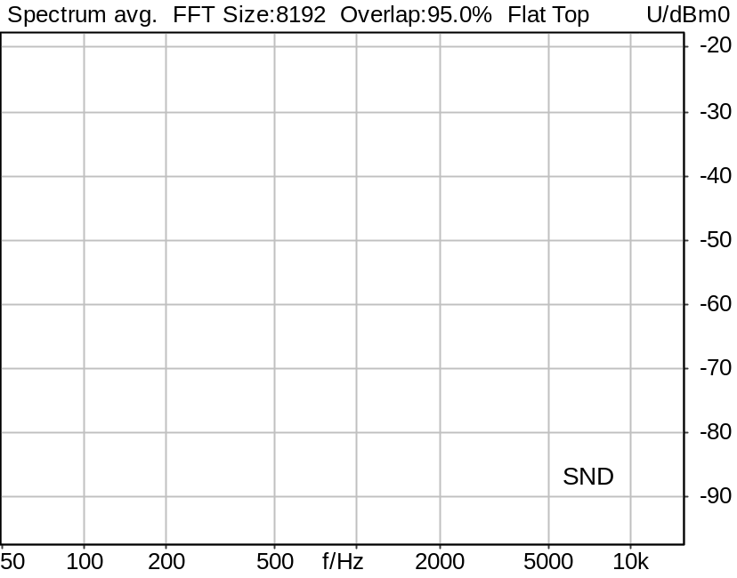

Channel | Noise level
SND | -88.69 dBm0

5/20/2025 11:43 AM ACQUA 6.0.200
Unmodified HEAD acoustics Measurement Descriptor

Meas. Setting DRP-off

Underlying Standard: 3GPP TS 26.131 V17.3.0 and 3GPP TS 26.132 V17.2.0
Database Version: 60_UG_TS26131_32_SWB_FB_Rev08_GCF_PTCRB

Source: cssfb4b_s147_p.dat
Level adjustment Channel 2 Gain -90.00 dB
Level adjustment Channel 1 Gain 10.00 dB
FULLBAND Composite Source Signal SND P.501 (4 bursts) at Channel 1
Pause 0.5 s +
4 times (voiced signal + 100 to 20000 Hz pseudo noise 0.2 s + Pause 0.201 s) +
additional Pause 1.899 s
Signal level (ch1): -15.5 dBV from 0.5s to 2.2s for 2048 FFT, Rectangle window,
0 % overlap in frequency range of 100 to 20000 Hz
Signal with three increased pause sequences (101 ms+100ms)

Calibration
SND (1) 0.00 dB (Radio Tester 1 (CMW500))
Output ch. 1 0.00 dB
Output ch. 2 0.00 dB (Radio Tester 1 (CMW500))

Output Equalization/Filter
Mouth Eq. Ch.1 HATS 7 (B&K 5128) (5/28/2024 5:25 PM)

Analysis
Analyse Channel 1
Range start 763.00 ms Range length 170.67 ms
Frequency base Transformation
FFT size 8192 Overlap 95 %
Window function Flat Top Smooth Off
Analysis bandwidth octave

Input Filters
FIR Filter Channel 1 Filename a-filter.hdf

Special Features
Compensate delay 257.6000 ms (D_SCRIPT, Original Delay Variable stored to D_SCRIPT: D_SND_EQ_HASB)
Store to file idnoi_snd_hasb.dat Store to variable IdlNoi_SND_A_Hasb

Hardware Config Settings
Used Setting HA&HE_5128_volte

labCORE Settings
labCORE Serial 77000280 Nickname
Firmware 3.7.5 Sync Source Internal
Clock Pitch 0.00 ppm
----------
labCORE Routing
Out Channel 1 -> Analog Out 1 -> ExternalAmplifier In -> HATS 7 (B&K 5128) Speaker
Out Channel 2 -> VoIP 2
Out Channel 2 -> VoIP 1 -> Radio Tester 1 (CMW500) RF In/Out
In Channel 1 <- VoIP In/Out 1 <- Radio Tester 1 (CMW500) RF In/Out
In Channel 2 <- BEQ Filter 1 R <- ICP Amp. (Slot 7) In 2 <- HATS 7 (B&K 5128) Mic. Right
----------
Analog Out Mainboard Settings (Analog Out)
Range Ch. 1 0.00 dB Range Ch. 2 0.00 dB
----------
ICP Settings (ICP Amp. (Slot 7))
Channel In 1 Settings
Range 132 dB[SPL] @ 50 mV/Pa Highpass 20Hz
Supply Voltage On
Channel In 2 Settings
Range 132 dB[SPL] @ 50 mV/Pa Highpass 20Hz
Supply Voltage On
Channel In 3 Settings
Range 132 dB[SPL] @ 50 mV/Pa Highpass 20Hz
Supply Voltage Off
Channel In 4 Settings
Range 132 dB[SPL] @ 50 mV/Pa Highpass 20Hz
Supply Voltage Off
----------
VoIP Settings (VoIP)
RTP Connection Streaming SIP Connection Unavailable
SIP Reg. State Unregistered Jitterbuffer Length 100
Jitter Buffer Reset On Playback Enabled Codec EVS/16000/1
Packet Length 20 Encoder Parameter ;evs-mode-switch=0;max-red=0;br=13.2;bw=swb;ch-aw-recv=-1
FMTP Parameter ;evs-mode-switch=0;bw=swb;br=13.2;ch-aw-recv=-1;max-red=220
Impairment Mode Off Impairment Type Off
----------
BEQ Settings (BEQ Filter 1)
Block mode Bypass
----------
Artificial Head Settings (HATS 7 (B&K 5128))
Ser. Nr. BK_3408387 Pinna Type Type 4.3

HIB Settings
HIB Name 60020101 Serial 60020101
HIB Mode Mobile Measurement Impedance 32 Ohm
Gain out 1 -40.00 dB Gain out 2 0.00 dB
Gain in 1 0.00 dB Gain in 2 0.00 dB
Mic 1 Power Supply Off Mic 2 Power Supply Off

9.3.1 Idle channel noise SND, #2 HASB
Handset Measurements Superwideband and Fullband \ Handset Measurements SuperWideband (HASB) \ Connections with Handset Sending Direction (HASB)
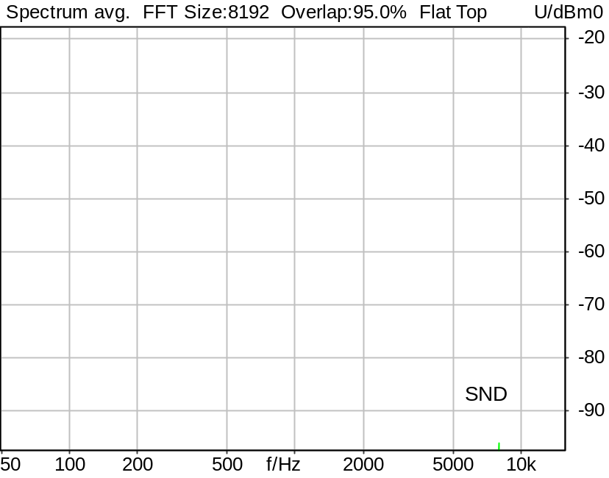

Channel | Noise level
SND | -86.86 dBm0

5/20/2025 11:43 AM ACQUA 6.0.200
Unmodified HEAD acoustics Measurement Descriptor

Meas. Setting DRP-off

Underlying Standard: 3GPP TS 26.131 V17.3.0 and 3GPP TS 26.132 V17.2.0
Database Version: 60_UG_TS26131_32_SWB_FB_Rev08_GCF_PTCRB

Analysed: idnoi_snd_hasb.dat
9.3.1 Idle channel noise SND, #1 HASB

Analysis
Analyse Channel 1
Range start 1213.00 ms Range length 170.67 ms
Frequency base Transformation
FFT size 8192 Overlap 95 %
Window function Flat Top Smooth Off
Analysis bandwidth octave

Special Features
Store to variable IdlNoi_SND_B_Hasb

9.3.1 Idle channel noise SND, #3 HASB
Handset Measurements Superwideband and Fullband \ Handset Measurements SuperWideband (HASB) \ Connections with Handset Sending Direction (HASB)

Channel | Noise level
SND | -88.12 dBm0

5/20/2025 11:43 AM ACQUA 6.0.200
Unmodified HEAD acoustics Measurement Descriptor

Meas. Setting DRP-off

Underlying Standard: 3GPP TS 26.131 V17.3.0 and 3GPP TS 26.132 V17.2.0
Database Version: 60_UG_TS26131_32_SWB_FB_Rev08_GCF_PTCRB

Analysed: idnoi_snd_hasb.dat
9.3.1 Idle channel noise SND, #1 HASB

Analysis
Analyse Channel 1
Range start 1663.00 ms Range length 170.67 ms
Frequency base Transformation
FFT size 8192 Overlap 95 %
Window function Flat Top Smooth Off
Analysis bandwidth octave

Special Features
Store to variable IdlNoi_SND_C_Hasb

9.3.1 Idle channel noise SND, AVG HASB
Handset Measurements Superwideband and Fullband \ Handset Measurements SuperWideband (HASB) \ Connections with Handset Sending Direction (HASB)
Correction
IdlNoi_SND_A_Hasb | -88.690 dBm0 | 5/20/2025 | Measured | 9.3.1 Idle channel noise SND, #1 HASB
IdlNoi_SND_B_Hasb | -86.860 dBm0 | 5/20/2025 | Measured | 9.3.1 Idle channel noise SND, #2 HASB
IdlNoi_SND_C_Hasb | -88.120 dBm0 | 5/20/2025 | Measured | 9.3.1 Idle channel noise SND, #3 HASB
10*log((10^(IdlNoi_SND_A_Hasb/10) + 10^(IdlNoi_SND_B_Hasb/10) + 10^(IdlNoi_SND_C_Hasb/10)) / 3)

Calculated Value: -87.82 dBm0(A) Ok

Ok
5/20/2025 11:43 AM ACQUA 6.0.200
Unmodified HEAD acoustics Measurement Descriptor

Limits
 | upper
Run 1 | -64.00 dBm0(A)

Underlying Standard: 3GPP TS 26.131 V17.3.0 and 3GPP TS 26.132 V17.2.0
Database Version: 60_UG_TS26131_32_SWB_FB_Rev08_GCF_PTCRB

9.3.1 Single Freq. Distur. SND #1 HASB Perf. objective
Handset Measurements Superwideband and Fullband \ Handset Measurements SuperWideband (HASB) \ Connections with Handset Sending Direction (HASB)
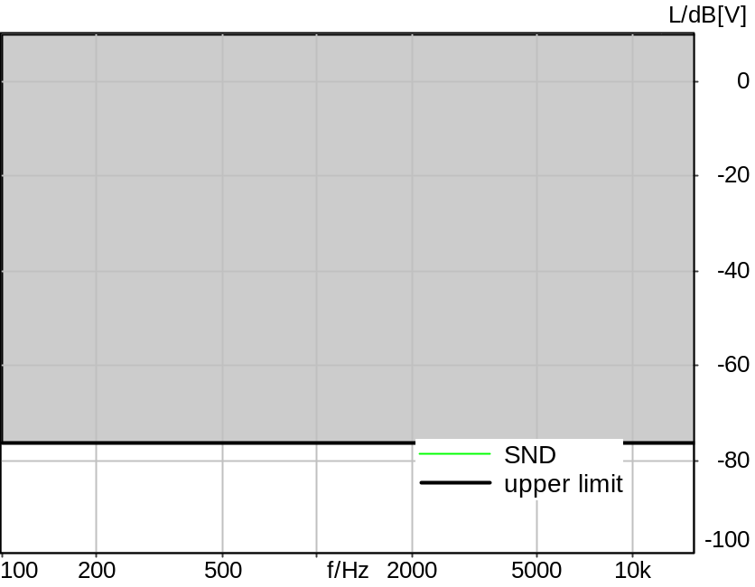

Absolute minimal distance
26.82 dB at 8015.6 Hz Ok

Ok
5/20/2025 11:44 AM ACQUA 6.0.200
Unmodified HEAD acoustics Measurement Descriptor

Limits
 | lower
Run 1 | Fit into tolerance

Meas. Setting DRP-off

Underlying Standard: 3GPP TS 26.131 V17.3.0 and 3GPP TS 26.132 V17.2.0
Database Version: 60_UG_TS26131_32_SWB_FB_Rev08_GCF_PTCRB

Analysed: idnoi_snd_hasb.dat
9.3.1 Idle channel noise SND, #1 HASB

Analysis
Analyse Channel 1
Range start 763.00 ms Range length 170.67 ms
Frequency base Transformation
FFT size 8192 Overlap 95 %
Window function Flat Top Smooth Off
Tol. scheme file sfi_snd_hasb.tol Min. freq. for tol. 100.0 Hz
Auto adjust No Max. freq. for tol. 16000.0 Hz

Special Features
Store to file sfi_snd_f_hasb.fft

9.3.1 Single Freq. Distur. SND #2 HASB Perf. objective
Handset Measurements Superwideband and Fullband \ Handset Measurements SuperWideband (HASB) \ Connections with Handset Sending Direction (HASB)
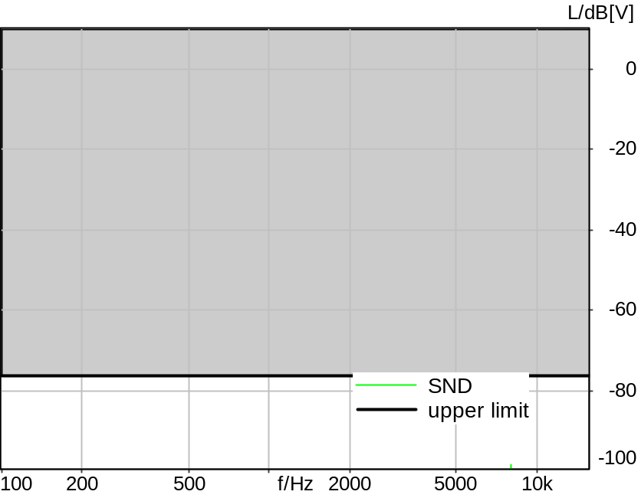

Absolute minimal distance
21.93 dB at 7992.2 Hz Ok

Ok
5/20/2025 11:44 AM ACQUA 6.0.200
Unmodified HEAD acoustics Measurement Descriptor

Limits
 | lower
Run 1 | Fit into tolerance

Meas. Setting DRP-off

Underlying Standard: 3GPP TS 26.131 V17.3.0 and 3GPP TS 26.132 V17.2.0
Database Version: 60_UG_TS26131_32_SWB_FB_Rev08_GCF_PTCRB

Analysed: idnoi_snd_hasb.dat
9.3.1 Idle channel noise SND, #1 HASB

Analysis
Analyse Channel 1
Range start 1213.00 ms Range length 170.67 ms
Frequency base Transformation
FFT size 8192 Overlap 95 %
Window function Flat Top Smooth Off
Tol. scheme file sfi_snd_hasb.tol Min. freq. for tol. 100.0 Hz
Auto adjust No Max. freq. for tol. 16000.0 Hz

Special Features
Store to file sfi_snd_g_hasb.fft

9.3.1 Single Freq. Distur. SND #3 HASB Perf. objective
Handset Measurements Superwideband and Fullband \ Handset Measurements SuperWideband (HASB) \ Connections with Handset Sending Direction (HASB)

Absolute minimal distance
26.15 dB at 8009.8 Hz Ok

Ok
5/20/2025 11:44 AM ACQUA 6.0.200
Unmodified HEAD acoustics Measurement Descriptor

Limits
 | lower
Run 1 | Fit into tolerance

Meas. Setting DRP-off

Underlying Standard: 3GPP TS 26.131 V17.3.0 and 3GPP TS 26.132 V17.2.0
Database Version: 60_UG_TS26131_32_SWB_FB_Rev08_GCF_PTCRB

Analysed: idnoi_snd_hasb.dat
9.3.1 Idle channel noise SND, #1 HASB

Analysis
Analyse Channel 1
Range start 1663.00 ms Range length 170.67 ms
Frequency base Transformation
FFT size 8192 Overlap 95 %
Window function Flat Top Smooth Off
Tol. scheme file sfi_snd_hasb.tol Min. freq. for tol. 100.0 Hz
Auto adjust No Max. freq. for tol. 16000.0 Hz

Special Features
Store to file sfi_snd_h_hasb.fft

9.3.1 AVG Single Freq. Dist. SND HASB Perf. objective
Handset Measurements Superwideband and Fullband \ Handset Measurements SuperWideband (HASB) \ Connections with Handset Sending Direction (HASB)
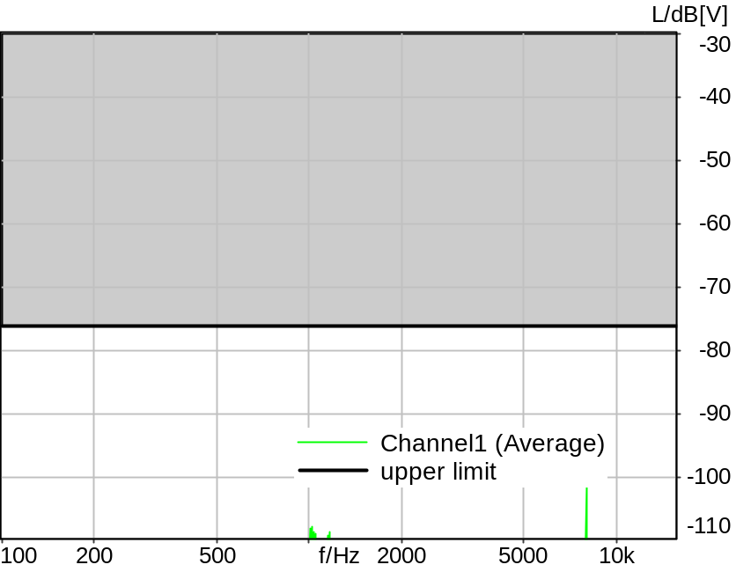

Absolute minimal distance
25.16 dB at 7992.2 Hz Ok

Ok
5/20/2025 11:44 AM ACQUA 6.0.200
Unmodified HEAD acoustics Measurement Descriptor

Limits
 | lower
Run 1 | Fit into tolerance

Underlying Standard: 3GPP TS 26.131 V17.3.0 and 3GPP TS 26.132 V17.2.0
Database Version: 60_UG_TS26131_32_SWB_FB_Rev08_GCF_PTCRB

9.4.1 Sensitivity frequency SND Speech 1/3oct MAN HASB
Handset Measurements Superwideband and Fullband \ Handset Measurements SuperWideband (HASB) \ Connections with Handset Sending Direction (HASB)
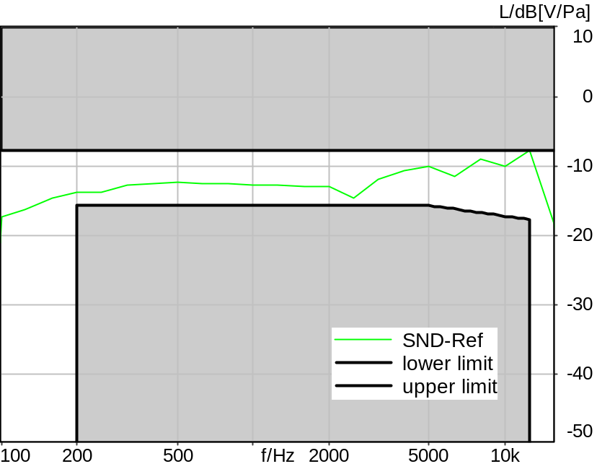

Absolute minimal distance
1.07 dB at 2500.0 Hz Ok

Ok
5/20/2025 11:45 AM ACQUA 6.0.200
Unmodified HEAD acoustics Measurement Descriptor

Limits
 | lower
Run 1 | Fit into tolerance

Meas. Setting DRP-off

Underlying Standard: 3GPP TS 26.131 V17.3.0 and 3GPP TS 26.132 V17.2.0
Database Version: 60_UG_TS26131_32_SWB_FB_Rev08_GCF_PTCRB

Source: spst4x3_fb_s147.dat
Level adjustment Channel 2 Gain -90.00 dB
Level adjustment Channel 1 Gain 10.00 dB
FULLBAND Real Speech Single Talk (ITU-T SG 12 sentences) at Channel 1
(3x male speech, 3x female speech, 3x male speech, 3x female speech)
A silence period of 0.5 s is inserted between each sentence as well as at the
beginning and end of the sequence.
Signal level (ch1): -14.7 dBV active speech level, overall duration 35.5 s.

For license information refer to the files >LICENSE_psytechnics.txt< and
>LICENSE_nokia.txt<, see Preparation of Test Setup - Info: Test Signals

Calibration
SND (1) 0.00 dB (Radio Tester 1 (CMW500))
Output ch. 1 0.00 dB
Output ch. 2 0.00 dB (Radio Tester 1 (CMW500))

Output Equalization/Filter
Mouth Eq. Ch.1 HATS 7 (B&K 5128) (5/28/2024 5:25 PM)

Analysis
Analyse Channel 1
Range start 400.00 ms Range length 34680.00 ms
Frequency base 3rd octave DIN Row Row B
Method FFT
FFT size 4096 Overlap 75 %
Window function Hann
Reference file re_slr_snd_resp_hasb.fft
Tol. scheme file 941_snd_frq_rsp_hasb_man.tol Min. freq. for tol. 100.0 Hz
Auto adjust To upper scheme Max. freq. for tol. 16000.0 Hz

Special Features
Compensate delay 257.6000 ms (D_SCRIPT, Original Delay Variable stored to D_SCRIPT: D_SND_EQ_HASB)
Store to file frq_resp_snd_hasb.dat

Hardware Config Settings
Used Setting HA&HE_5128_volte

labCORE Settings
labCORE Serial 77000280 Nickname
Firmware 3.7.5 Sync Source Internal
Clock Pitch 0.00 ppm
----------
labCORE Routing
Out Channel 1 -> Analog Out 1 -> ExternalAmplifier In -> HATS 7 (B&K 5128) Speaker
Out Channel 2 -> VoIP 2
Out Channel 2 -> VoIP 1 -> Radio Tester 1 (CMW500) RF In/Out
In Channel 1 <- VoIP In/Out 1 <- Radio Tester 1 (CMW500) RF In/Out
In Channel 2 <- BEQ Filter 1 R <- ICP Amp. (Slot 7) In 2 <- HATS 7 (B&K 5128) Mic. Right
----------
Analog Out Mainboard Settings (Analog Out)
Range Ch. 1 0.00 dB Range Ch. 2 0.00 dB
----------
ICP Settings (ICP Amp. (Slot 7))
Channel In 1 Settings
Range 132 dB[SPL] @ 50 mV/Pa Highpass 20Hz
Supply Voltage On
Channel In 2 Settings
Range 132 dB[SPL] @ 50 mV/Pa Highpass 20Hz
Supply Voltage On
Channel In 3 Settings
Range 132 dB[SPL] @ 50 mV/Pa Highpass 20Hz
Supply Voltage Off
Channel In 4 Settings
Range 132 dB[SPL] @ 50 mV/Pa Highpass 20Hz
Supply Voltage Off
----------
VoIP Settings (VoIP)
RTP Connection Streaming SIP Connection Unavailable
SIP Reg. State Unregistered Jitterbuffer Length 100
Jitter Buffer Reset On Playback Enabled Codec EVS/16000/1
Packet Length 20 Encoder Parameter ;evs-mode-switch=0;max-red=0;br=13.2;bw=swb;ch-aw-recv=-1
FMTP Parameter ;evs-mode-switch=0;bw=swb;br=13.2;ch-aw-recv=-1;max-red=220
Impairment Mode Off Impairment Type Off
----------
BEQ Settings (BEQ Filter 1)
Block mode Bypass
----------
Artificial Head Settings (HATS 7 (B&K 5128))
Ser. Nr. BK_3408387 Pinna Type Type 4.3

HIB Settings
HIB Name 60020101 Serial 60020101
HIB Mode Mobile Measurement Impedance 32 Ohm
Gain out 1 -40.00 dB Gain out 2 0.00 dB
Gain in 1 0.00 dB Gain in 2 0.00 dB
Mic 1 Power Supply Off Mic 2 Power Supply Off

9.4.1 Sensitivity frequency SND MAND 1/12oct HASB
Handset Measurements Superwideband and Fullband \ Handset Measurements SuperWideband (HASB) \ Connections with Handset Sending Direction (HASB)
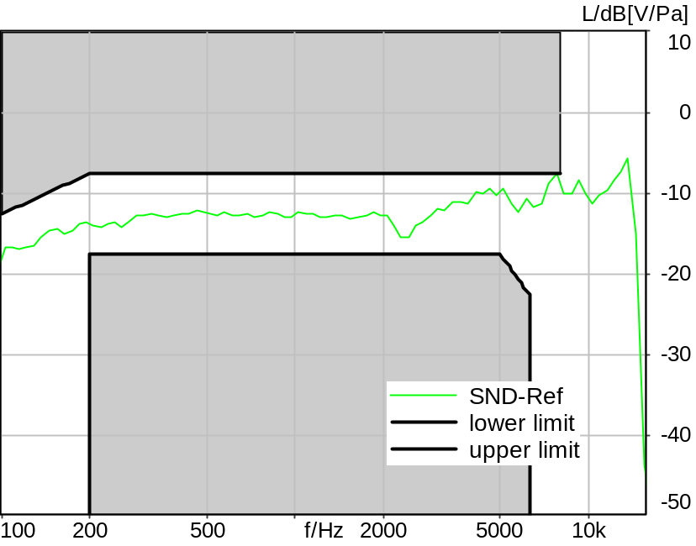

Absolute minimal distance
2.11 dB at 2432.3 Hz Ok

Ok
5/20/2025 11:45 AM ACQUA 6.0.200

Limits
 | lower
Run 1 | 2.00 dB

Meas. Setting DRP-off

Underlying Standard: 3GPP TS 26.131 V17.3.0 and 3GPP TS 26.132 V17.2.0
Database Version: 60_UG_TS26131_32_SWB_FB_Rev08_GCF_PTCRB

Analysed: frq_resp_snd_hasb.dat
9.4.1 Sensitivity frequency SND Speech 1/3oct MAN HASB

Analysis
Analyse Channel 1
Range start 400.00 ms Range length 34680.00 ms
Frequency base 12th octave DIN Row Row A
Method FFT
FFT size 4096 Overlap 75 %
Window function Hann
Reference file re_slr_snd_resp_hasb_12th.fft
Tol. scheme file 841_10sfr_hawb.tol Min. freq. for tol. 100.0 Hz
Auto adjust To upper scheme Max. freq. for tol. 8000.0 Hz

9.7.3 Acoustic echo control Compr. Speech MAX VOL HASB
Handset Measurements Superwideband and Fullband \ Handset Measurements SuperWideband (HASB) \ Connections with Handset Sending Direction (HASB)
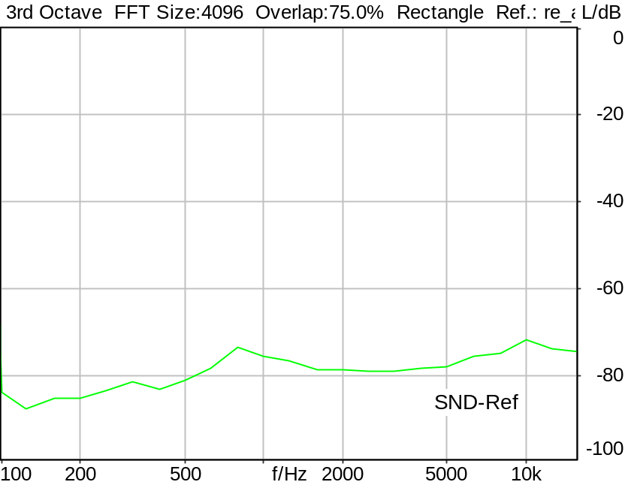

Echo Loss: 77.68 dB Ok

Ok
5/20/2025 11:47 AM ACQUA 6.0.200

Limits
 | lower
Run 1 | 46.00 dB

Meas. Setting DRP-off

Underlying Standard: 3GPP TS 26.131 V17.3.0 and 3GPP TS 26.132 V17.2.0
Database Version: 60_UG_TS26131_32_SWB_FB_Rev08_GCF_PTCRB

Source: spco4x3_sb_r16.dat
Level adjustment Channel 1 Gain -90.00 dB
Level adjustment Channel 2 Gain 6.00 dB
SUPERWIDEBAND Compressed Real Speech (ITU-T 12 sentences) at Channel 2
Pause 0.5 s +
Superwideband Compressed Real Speech (3x male speech, 3x female speech, 3x male speech, 3x female speech) +
Pause till end of file
Bandlimited 50-16000Hz
Signal level (ch2): -16dBm0 active speech level
Signal Length: 35.4s

For license information refer to the files >LICENSE_psytechnics.txt< and >LICENSE_nokia.txt<,
see Preparation of Test Setup - Info: Test Signals.

Calibration
SND (1) 0.00 dB (Radio Tester 1 (CMW500))
Output ch. 1 0.00 dB
Output ch. 2 0.00 dB (Radio Tester 1 (CMW500))

Output Equalization/Filter
Mouth Eq. Ch.1 HATS 7 (B&K 5128) (5/28/2024 5:25 PM)

Analysis
Direction Out 2 -> In 1 Calculate Echo loss (300..6700 Hz)
Analyse Channel 1
Range start 16900.00 ms Range length 18100.00 ms
Frequency base 3rd octave DIN Row Row B
Method FFT
FFT size 4096 Overlap 75 %
Window function Rectangle
Reference file re_ac_echo_hasb.fft

Hardware Config Settings
Used Setting HA&HE_5128_volte

labCORE Settings
labCORE Serial 77000280 Nickname
Firmware 3.7.5 Sync Source Internal
Clock Pitch 0.00 ppm
----------
labCORE Routing
Out Channel 1 -> Analog Out 1 -> ExternalAmplifier In -> HATS 7 (B&K 5128) Speaker
Out Channel 2 -> VoIP 2
Out Channel 2 -> VoIP 1 -> Radio Tester 1 (CMW500) RF In/Out
In Channel 1 <- VoIP In/Out 1 <- Radio Tester 1 (CMW500) RF In/Out
In Channel 2 <- BEQ Filter 1 R <- ICP Amp. (Slot 7) In 2 <- HATS 7 (B&K 5128) Mic. Right
----------
Analog Out Mainboard Settings (Analog Out)
Range Ch. 1 0.00 dB Range Ch. 2 0.00 dB
----------
ICP Settings (ICP Amp. (Slot 7))
Channel In 1 Settings
Range 132 dB[SPL] @ 50 mV/Pa Highpass 20Hz
Supply Voltage On
Channel In 2 Settings
Range 132 dB[SPL] @ 50 mV/Pa Highpass 20Hz
Supply Voltage On
Channel In 3 Settings
Range 132 dB[SPL] @ 50 mV/Pa Highpass 20Hz
Supply Voltage Off
Channel In 4 Settings
Range 132 dB[SPL] @ 50 mV/Pa Highpass 20Hz
Supply Voltage Off
----------
VoIP Settings (VoIP)
RTP Connection Streaming SIP Connection Unavailable
SIP Reg. State Unregistered Jitterbuffer Length 100
Jitter Buffer Reset On Playback Enabled Codec EVS/16000/1
Packet Length 20 Encoder Parameter ;evs-mode-switch=0;max-red=0;br=13.2;bw=swb;ch-aw-recv=-1
FMTP Parameter ;evs-mode-switch=0;bw=swb;br=13.2;ch-aw-recv=-1;max-red=220
Impairment Mode Off Impairment Type Off
----------
BEQ Settings (BEQ Filter 1)
Block mode Bypass
----------
Artificial Head Settings (HATS 7 (B&K 5128))
Ser. Nr. BK_3408387 Pinna Type Type 4.3

HIB Settings
HIB Name 60020101 Serial 60020101
HIB Mode Mobile Measurement Impedance 32 Ohm
Gain out 1 -40.00 dB Gain out 2 0.00 dB
Gain in 1 0.00 dB Gain in 2 0.00 dB
Mic 1 Power Supply Off Mic 2 Power Supply Off

9.7.3 Acoustic echo control Compr. Speech MIN VOL HASB
Handset Measurements Superwideband and Fullband \ Handset Measurements SuperWideband (HASB) \ Connections with Handset Sending Direction (HASB)
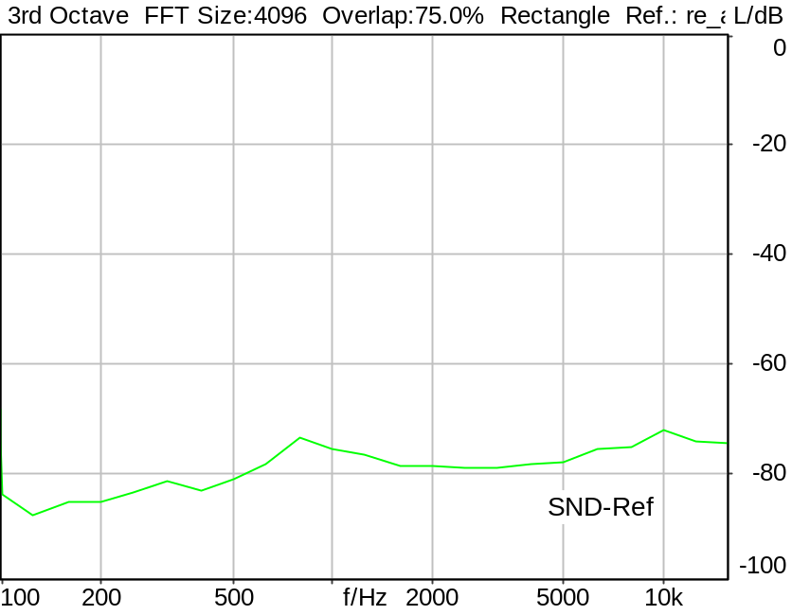

Echo Loss: 77.71 dB Ok

Ok
5/20/2025 11:48 AM ACQUA 6.0.200

Limits
 | lower
Run 1 | 46.00 dB

Meas. Setting DRP-off

Underlying Standard: 3GPP TS 26.131 V17.3.0 and 3GPP TS 26.132 V17.2.0
Database Version: 60_UG_TS26131_32_SWB_FB_Rev08_GCF_PTCRB

Source: spco4x3_sb_r16.dat
Level adjustment Channel 1 Gain -90.00 dB
Level adjustment Channel 2 Gain 6.00 dB
SUPERWIDEBAND Compressed Real Speech (ITU-T 12 sentences) at Channel 2
Pause 0.5 s +
Superwideband Compressed Real Speech (3x male speech, 3x female speech, 3x male speech, 3x female speech) +
Pause till end of file
Bandlimited 50-16000Hz
Signal level (ch2): -16dBm0 active speech level
Signal Length: 35.4s

For license information refer to the files >LICENSE_psytechnics.txt< and >LICENSE_nokia.txt<,
see Preparation of Test Setup - Info: Test Signals.

Calibration
SND (1) 0.00 dB (Radio Tester 1 (CMW500))
Output ch. 1 0.00 dB
Output ch. 2 0.00 dB (Radio Tester 1 (CMW500))

Output Equalization/Filter
Mouth Eq. Ch.1 HATS 7 (B&K 5128) (5/28/2024 5:25 PM)

Analysis
Direction Out 2 -> In 1 Calculate Echo loss (300..6700 Hz)
Analyse Channel 1
Range start 16900.00 ms Range length 18100.00 ms
Frequency base 3rd octave DIN Row Row B
Method FFT
FFT size 4096 Overlap 75 %
Window function Rectangle
Reference file re_ac_echo_hasb.fft

Hardware Config Settings
Used Setting HA&HE_5128_volte

labCORE Settings
labCORE Serial 77000280 Nickname
Firmware 3.7.5 Sync Source Internal
Clock Pitch 0.00 ppm
----------
labCORE Routing
Out Channel 1 -> Analog Out 1 -> ExternalAmplifier In -> HATS 7 (B&K 5128) Speaker
Out Channel 2 -> VoIP 2
Out Channel 2 -> VoIP 1 -> Radio Tester 1 (CMW500) RF In/Out
In Channel 1 <- VoIP In/Out 1 <- Radio Tester 1 (CMW500) RF In/Out
In Channel 2 <- BEQ Filter 1 R <- ICP Amp. (Slot 7) In 2 <- HATS 7 (B&K 5128) Mic. Right
----------
Analog Out Mainboard Settings (Analog Out)
Range Ch. 1 0.00 dB Range Ch. 2 0.00 dB
----------
ICP Settings (ICP Amp. (Slot 7))
Channel In 1 Settings
Range 132 dB[SPL] @ 50 mV/Pa Highpass 20Hz
Supply Voltage On
Channel In 2 Settings
Range 132 dB[SPL] @ 50 mV/Pa Highpass 20Hz
Supply Voltage On
Channel In 3 Settings
Range 132 dB[SPL] @ 50 mV/Pa Highpass 20Hz
Supply Voltage Off
Channel In 4 Settings
Range 132 dB[SPL] @ 50 mV/Pa Highpass 20Hz
Supply Voltage Off
----------
VoIP Settings (VoIP)
RTP Connection Streaming SIP Connection Unavailable
SIP Reg. State Unregistered Jitterbuffer Length 100
Jitter Buffer Reset On Playback Enabled Codec EVS/16000/1
Packet Length 20 Encoder Parameter ;evs-mode-switch=0;max-red=0;br=13.2;bw=swb;ch-aw-recv=-1
FMTP Parameter ;evs-mode-switch=0;bw=swb;br=13.2;ch-aw-recv=-1;max-red=220
Impairment Mode Off Impairment Type Off
----------
BEQ Settings (BEQ Filter 1)
Block mode Bypass
----------
Artificial Head Settings (HATS 7 (B&K 5128))
Ser. Nr. BK_3408387 Pinna Type Type 4.3

HIB Settings
HIB Name 60020101 Serial 60020101
HIB Mode Mobile Measurement Impedance 32 Ohm
Gain out 1 -40.00 dB Gain out 2 0.00 dB
Gain in 1 0.00 dB Gain in 2 0.00 dB
Mic 1 Power Supply Off Mic 2 Power Supply Off

9.7.3 Acoustic echo control Compr. Speech NOM VOL HASB
Handset Measurements Superwideband and Fullband \ Handset Measurements SuperWideband (HASB) \ Connections with Handset Sending Direction (HASB)
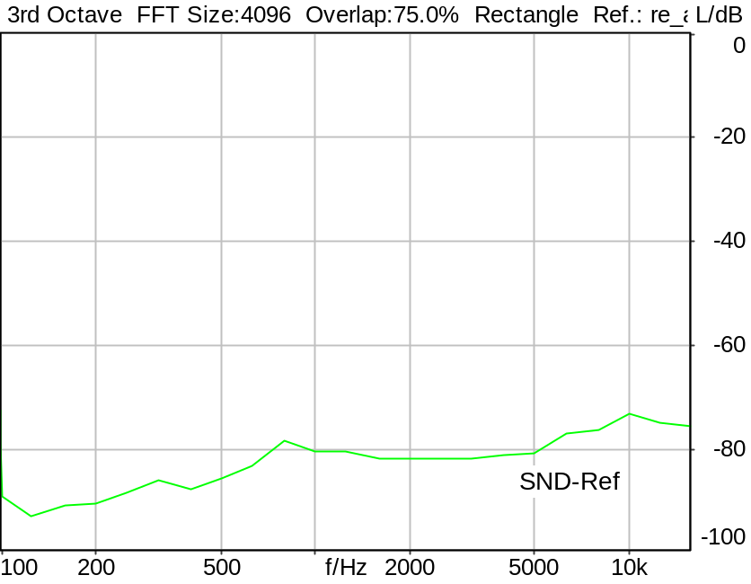

Echo Loss: 81.24 dB Ok

Ok
5/20/2025 11:49 AM ACQUA 6.0.200
Unmodified HEAD acoustics Measurement Descriptor

Limits
 | lower
Run 1 | 55.00 dB

Meas. Setting DRP-off

Underlying Standard: 3GPP TS 26.131 V17.3.0 and 3GPP TS 26.132 V17.2.0
Database Version: 60_UG_TS26131_32_SWB_FB_Rev08_GCF_PTCRB

Source: spco4x3_sb_r16.dat
Level adjustment Channel 1 Gain -90.00 dB
Level adjustment Channel 2 Gain 6.00 dB
SUPERWIDEBAND Compressed Real Speech (ITU-T 12 sentences) at Channel 2
Pause 0.5 s +
Superwideband Compressed Real Speech (3x male speech, 3x female speech, 3x male speech, 3x female speech) +
Pause till end of file
Bandlimited 50-16000Hz
Signal level (ch2): -16dBm0 active speech level
Signal Length: 35.4s

For license information refer to the files >LICENSE_psytechnics.txt< and >LICENSE_nokia.txt<,
see Preparation of Test Setup - Info: Test Signals.

Calibration
SND (1) 0.00 dB (Radio Tester 1 (CMW500))
Output ch. 1 0.00 dB
Output ch. 2 0.00 dB (Radio Tester 1 (CMW500))

Output Equalization/Filter
Mouth Eq. Ch.1 HATS 7 (B&K 5128) (5/28/2024 5:25 PM)

Analysis
Direction Out 2 -> In 1 Calculate Echo loss (300..6700 Hz)
Analyse Channel 1
Range start 16900.00 ms Range length 18100.00 ms
Frequency base 3rd octave DIN Row Row B
Method FFT
FFT size 4096 Overlap 75 %
Window function Rectangle
Reference file re_ac_echo_hasb.fft

Hardware Config Settings
Used Setting HA&HE_5128_volte

labCORE Settings
labCORE Serial 77000280 Nickname
Firmware 3.7.5 Sync Source Internal
Clock Pitch 0.00 ppm
----------
labCORE Routing
Out Channel 1 -> Analog Out 1 -> ExternalAmplifier In -> HATS 7 (B&K 5128) Speaker
Out Channel 2 -> VoIP 2
Out Channel 2 -> VoIP 1 -> Radio Tester 1 (CMW500) RF In/Out
In Channel 1 <- VoIP In/Out 1 <- Radio Tester 1 (CMW500) RF In/Out
In Channel 2 <- BEQ Filter 1 R <- ICP Amp. (Slot 7) In 2 <- HATS 7 (B&K 5128) Mic. Right
----------
Analog Out Mainboard Settings (Analog Out)
Range Ch. 1 0.00 dB Range Ch. 2 0.00 dB
----------
ICP Settings (ICP Amp. (Slot 7))
Channel In 1 Settings
Range 132 dB[SPL] @ 50 mV/Pa Highpass 20Hz
Supply Voltage On
Channel In 2 Settings
Range 132 dB[SPL] @ 50 mV/Pa Highpass 20Hz
Supply Voltage On
Channel In 3 Settings
Range 132 dB[SPL] @ 50 mV/Pa Highpass 20Hz
Supply Voltage Off
Channel In 4 Settings
Range 132 dB[SPL] @ 50 mV/Pa Highpass 20Hz
Supply Voltage Off
----------
VoIP Settings (VoIP)
RTP Connection Streaming SIP Connection Unavailable
SIP Reg. State Unregistered Jitterbuffer Length 100
Jitter Buffer Reset On Playback Enabled Codec EVS/16000/1
Packet Length 20 Encoder Parameter ;evs-mode-switch=0;max-red=0;br=13.2;bw=swb;ch-aw-recv=-1
FMTP Parameter ;evs-mode-switch=0;bw=swb;br=13.2;ch-aw-recv=-1;max-red=220
Impairment Mode Off Impairment Type Off
----------
BEQ Settings (BEQ Filter 1)
Block mode Bypass
----------
Artificial Head Settings (HATS 7 (B&K 5128))
Ser. Nr. BK_3408387 Pinna Type Type 4.3

HIB Settings
HIB Name 60020101 Serial 60020101
HIB Mode Mobile Measurement Impedance 32 Ohm
Gain out 1 -40.00 dB Gain out 2 0.00 dB
Gain in 1 0.00 dB Gain in 2 0.00 dB
Mic 1 Power Supply Off Mic 2 Power Supply Off

9.8.1 Distortion SND 1020 Hz, activation, #1 HASB
Handset Measurements Superwideband and Fullband \ Handset Measurements SuperWideband (HASB) \ Connections with Handset Sending Direction (HASB) \ 9.8.1 Distortion Sending 1020 Hz, activation, HASB
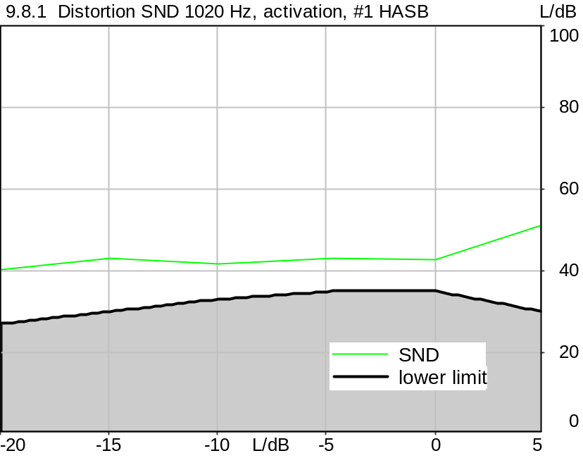

Distortion
Gain | SND
5.0 dB | 51.50 dB (0.27%), 1019.5 Hz | Ok
0.0 dB | 42.77 dB (0.73%), 1019.5 Hz | Ok
-4.7 dB | 43.11 dB (0.70%), 1019.5 Hz | Ok
-10.0 dB | 41.54 dB (0.84%), 1019.5 Hz | Ok
-15.0 dB | 43.05 dB (0.70%), 1019.5 Hz | Ok
-20.0 dB | 40.21 dB (0.98%), 1019.5 Hz | Ok

Ok
5/20/2025 11:49 AM ACQUA 6.0.200
Unmodified HEAD acoustics Measurement Descriptor

Limits
 | lower
Run 1 | 30.00 dB
Run 2 | 35.00 dB
Run 3 | 35.00 dB
Run 4 | 33.00 dB
Run 5 | 30.00 dB
Run 6 | 27.00 dB

Meas. Setting DRP-off

Underlying Standard: 3GPP TS 26.131 V17.3.0 and 3GPP TS 26.132 V17.2.0
Database Version: 60_UG_TS26131_32_SWB_FB_Rev08_GCF_PTCRB

Source: cssfb2b_s-10_1020_.dat
Level adjustment Channel 1 Gain 10.00 dB
FULLBAND Composite Source Signal SND P.501 (2 bursts) at Channel 1
Pause 0.5 s +
voiced signal + 100 to 20000 Hz pseudo noise 0.2 s
Pause 0.101 s +
voiced signal + 100 to 20000 Hz pseudo noise 0.2 s
Pause 0.101 s +
voiced signal 0.0486 s (as activation) +
sine-wave signal 1020 Hz, -10 dBV, 0.36 s +
Pause 0.390 s
Signal level (ch1): -10 dBV from 0.5s to 1.2s for 2048 FFT, Rectangle window,
0 % overlap in frequency range of 100 to 20000 Hz

Calibration
SND (1) 0.00 dB (Radio Tester 1 (CMW500))
Output ch. 1 0.00 dB
Output ch. 2 0.00 dB (Radio Tester 1 (CMW500))

Output Equalization/Filter
Mouth Eq. Ch.1 HATS 7 (B&K 5128) (5/28/2024 5:25 PM)

Analysis
Analyse Channel 1
Range start 1300.00 ms Range length 170.67 ms
Frequency base Transformation
FFT size 4096 Overlap 75 %
Window function Hann Smooth Off
Distortion Total dist. dB weighting psophometric
Freq. range min. 100.0 Hz Freq. range max. 6000.0 Hz
O.132 corr. factor No

Special Features
Compensate delay 257.6000 ms (D_SCRIPT, Original Delay Variable stored to D_SCRIPT: D_SND_EQ_HASB)
Store to variable D1k_SND_HASB_Act_a

Hardware Config Settings
Used Setting HA&HE_5128_volte

labCORE Settings
labCORE Serial 77000280 Nickname
Firmware 3.7.5 Sync Source Internal
Clock Pitch 0.00 ppm
----------
labCORE Routing
Out Channel 1 -> Analog Out 1 -> ExternalAmplifier In -> HATS 7 (B&K 5128) Speaker
Out Channel 2 -> VoIP 2
Out Channel 2 -> VoIP 1 -> Radio Tester 1 (CMW500) RF In/Out
In Channel 1 <- VoIP In/Out 1 <- Radio Tester 1 (CMW500) RF In/Out
In Channel 2 <- BEQ Filter 1 R <- ICP Amp. (Slot 7) In 2 <- HATS 7 (B&K 5128) Mic. Right
----------
Analog Out Mainboard Settings (Analog Out)
Range Ch. 1 0.00 dB Range Ch. 2 0.00 dB
----------
ICP Settings (ICP Amp. (Slot 7))
Channel In 1 Settings
Range 132 dB[SPL] @ 50 mV/Pa Highpass 20Hz
Supply Voltage On
Channel In 2 Settings
Range 132 dB[SPL] @ 50 mV/Pa Highpass 20Hz
Supply Voltage On
Channel In 3 Settings
Range 132 dB[SPL] @ 50 mV/Pa Highpass 20Hz
Supply Voltage Off
Channel In 4 Settings
Range 132 dB[SPL] @ 50 mV/Pa Highpass 20Hz
Supply Voltage Off
----------
VoIP Settings (VoIP)
RTP Connection Streaming SIP Connection Unavailable
SIP Reg. State Unregistered Jitterbuffer Length 100
Jitter Buffer Reset On Playback Enabled Codec EVS/16000/1
Packet Length 20 Encoder Parameter ;evs-mode-switch=0;max-red=0;br=13.2;bw=swb;ch-aw-recv=-1
FMTP Parameter ;evs-mode-switch=0;bw=swb;br=13.2;ch-aw-recv=-1;max-red=220
Impairment Mode Off Impairment Type Off
----------
BEQ Settings (BEQ Filter 1)
Block mode Bypass
----------
Artificial Head Settings (HATS 7 (B&K 5128))
Ser. Nr. BK_3408387 Pinna Type Type 4.3

HIB Settings
HIB Name 60020101 Serial 60020101
HIB Mode Mobile Measurement Impedance 32 Ohm
Gain out 1 -40.00 dB Gain out 2 0.00 dB
Gain in 1 0.00 dB Gain in 2 0.00 dB
Mic 1 Power Supply Off Mic 2 Power Supply Off

9.8.1 Distortion SND 1020 Hz, activation, #2 HASB
Handset Measurements Superwideband and Fullband \ Handset Measurements SuperWideband (HASB) \ Connections with Handset Sending Direction (HASB) \ 9.8.1 Distortion Sending 1020 Hz, activation, HASB
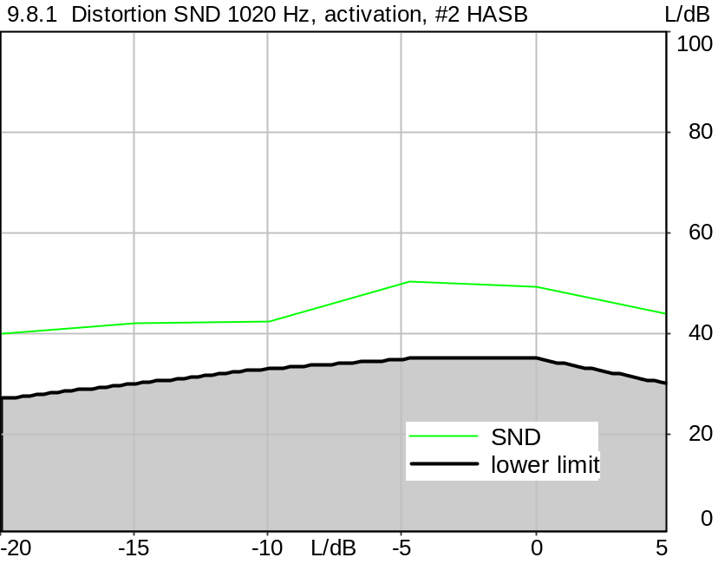

Distortion
Gain | SND
5.0 dB | 43.70 dB (0.65%), 1019.5 Hz | Ok
0.0 dB | 49.22 dB (0.35%), 1019.5 Hz | Ok
-4.7 dB | 50.49 dB (0.30%), 1019.5 Hz | Ok
-10.0 dB | 42.50 dB (0.75%), 1019.5 Hz | Ok
-15.0 dB | 42.05 dB (0.79%), 1019.5 Hz | Ok
-20.0 dB | 39.93 dB (1.01%), 1019.5 Hz | Ok

Ok
5/20/2025 11:50 AM ACQUA 6.0.200
Unmodified HEAD acoustics Measurement Descriptor

Limits
 | lower
Run 1 | 30.00 dB
Run 2 | 35.00 dB
Run 3 | 35.00 dB
Run 4 | 33.00 dB
Run 5 | 30.00 dB
Run 6 | 27.00 dB

Meas. Setting DRP-off

Underlying Standard: 3GPP TS 26.131 V17.3.0 and 3GPP TS 26.132 V17.2.0
Database Version: 60_UG_TS26131_32_SWB_FB_Rev08_GCF_PTCRB

Source: cssfb2b_s-10_1020_.dat
Level adjustment Channel 1 Gain 10.00 dB
FULLBAND Composite Source Signal SND P.501 (2 bursts) at Channel 1
Pause 0.5 s +
voiced signal + 100 to 20000 Hz pseudo noise 0.2 s
Pause 0.101 s +
voiced signal + 100 to 20000 Hz pseudo noise 0.2 s
Pause 0.101 s +
voiced signal 0.0486 s (as activation) +
sine-wave signal 1020 Hz, -10 dBV, 0.36 s +
Pause 0.390 s
Signal level (ch1): -10 dBV from 0.5s to 1.2s for 2048 FFT, Rectangle window,
0 % overlap in frequency range of 100 to 20000 Hz

Calibration
SND (1) 0.00 dB (Radio Tester 1 (CMW500))
Output ch. 1 0.00 dB
Output ch. 2 0.00 dB (Radio Tester 1 (CMW500))

Output Equalization/Filter
Mouth Eq. Ch.1 HATS 7 (B&K 5128) (5/28/2024 5:25 PM)

Analysis
Analyse Channel 1
Range start 1300.00 ms Range length 170.67 ms
Frequency base Transformation
FFT size 4096 Overlap 75 %
Window function Hann Smooth Off
Distortion Total dist. dB weighting psophometric
Freq. range min. 100.0 Hz Freq. range max. 6000.0 Hz
O.132 corr. factor No

Special Features
Compensate delay 257.6000 ms (D_SCRIPT, Original Delay Variable stored to D_SCRIPT: D_SND_EQ_HASB)
Store to variable D1k_SND_HASB_Act_b

Hardware Config Settings
Used Setting HA&HE_5128_volte

labCORE Settings
labCORE Serial 77000280 Nickname
Firmware 3.7.5 Sync Source Internal
Clock Pitch 0.00 ppm
----------
labCORE Routing
Out Channel 1 -> Analog Out 1 -> ExternalAmplifier In -> HATS 7 (B&K 5128) Speaker
Out Channel 2 -> VoIP 2
Out Channel 2 -> VoIP 1 -> Radio Tester 1 (CMW500) RF In/Out
In Channel 1 <- VoIP In/Out 1 <- Radio Tester 1 (CMW500) RF In/Out
In Channel 2 <- BEQ Filter 1 R <- ICP Amp. (Slot 7) In 2 <- HATS 7 (B&K 5128) Mic. Right
----------
Analog Out Mainboard Settings (Analog Out)
Range Ch. 1 0.00 dB Range Ch. 2 0.00 dB
----------
ICP Settings (ICP Amp. (Slot 7))
Channel In 1 Settings
Range 132 dB[SPL] @ 50 mV/Pa Highpass 20Hz
Supply Voltage On
Channel In 2 Settings
Range 132 dB[SPL] @ 50 mV/Pa Highpass 20Hz
Supply Voltage On
Channel In 3 Settings
Range 132 dB[SPL] @ 50 mV/Pa Highpass 20Hz
Supply Voltage Off
Channel In 4 Settings
Range 132 dB[SPL] @ 50 mV/Pa Highpass 20Hz
Supply Voltage Off
----------
VoIP Settings (VoIP)
RTP Connection Streaming SIP Connection Unavailable
SIP Reg. State Unregistered Jitterbuffer Length 100
Jitter Buffer Reset On Playback Enabled Codec EVS/16000/1
Packet Length 20 Encoder Parameter ;evs-mode-switch=0;max-red=0;br=13.2;bw=swb;ch-aw-recv=-1
FMTP Parameter ;evs-mode-switch=0;bw=swb;br=13.2;ch-aw-recv=-1;max-red=220
Impairment Mode Off Impairment Type Off
----------
BEQ Settings (BEQ Filter 1)
Block mode Bypass
----------
Artificial Head Settings (HATS 7 (B&K 5128))
Ser. Nr. BK_3408387 Pinna Type Type 4.3

HIB Settings
HIB Name 60020101 Serial 60020101
HIB Mode Mobile Measurement Impedance 32 Ohm
Gain out 1 -40.00 dB Gain out 2 0.00 dB
Gain in 1 0.00 dB Gain in 2 0.00 dB
Mic 1 Power Supply Off Mic 2 Power Supply Off

9.8.1 Distortion SND 1020 Hz, activation, #3 HASB
Handset Measurements Superwideband and Fullband \ Handset Measurements SuperWideband (HASB) \ Connections with Handset Sending Direction (HASB) \ 9.8.1 Distortion Sending 1020 Hz, activation, HASB
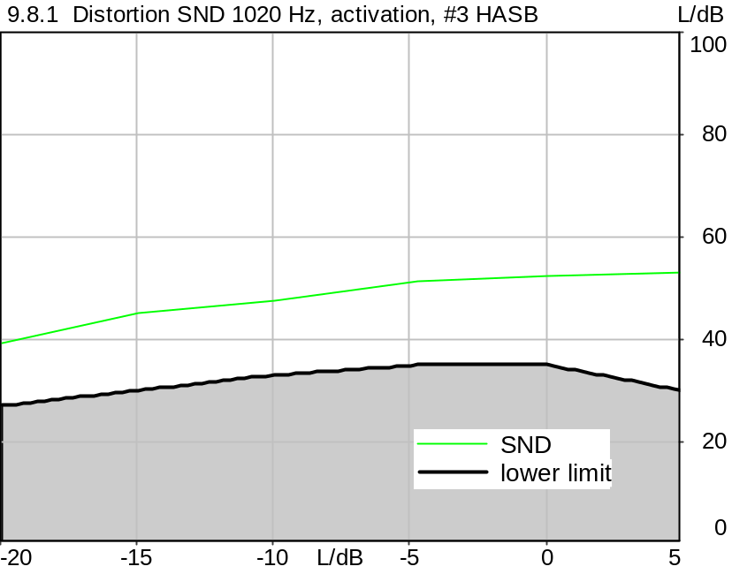

Distortion
Gain | SND
5.0 dB | 52.98 dB (0.22%), 1019.5 Hz | Ok
0.0 dB | 52.39 dB (0.24%), 1019.5 Hz | Ok
-4.7 dB | 51.42 dB (0.27%), 1019.5 Hz | Ok
-10.0 dB | 47.44 dB (0.42%), 1019.5 Hz | Ok
-15.0 dB | 45.14 dB (0.55%), 1019.5 Hz | Ok
-20.0 dB | 39.38 dB (1.07%), 1019.5 Hz | Ok

Ok
5/20/2025 11:50 AM ACQUA 6.0.200
Unmodified HEAD acoustics Measurement Descriptor

Limits
 | lower
Run 1 | 30.00 dB
Run 2 | 35.00 dB
Run 3 | 35.00 dB
Run 4 | 33.00 dB
Run 5 | 30.00 dB
Run 6 | 27.00 dB

Meas. Setting DRP-off

Underlying Standard: 3GPP TS 26.131 V17.3.0 and 3GPP TS 26.132 V17.2.0
Database Version: 60_UG_TS26131_32_SWB_FB_Rev08_GCF_PTCRB

Source: cssfb2b_s-10_1020_.dat
Level adjustment Channel 1 Gain 10.00 dB
FULLBAND Composite Source Signal SND P.501 (2 bursts) at Channel 1
Pause 0.5 s +
voiced signal + 100 to 20000 Hz pseudo noise 0.2 s
Pause 0.101 s +
voiced signal + 100 to 20000 Hz pseudo noise 0.2 s
Pause 0.101 s +
voiced signal 0.0486 s (as activation) +
sine-wave signal 1020 Hz, -10 dBV, 0.36 s +
Pause 0.390 s
Signal level (ch1): -10 dBV from 0.5s to 1.2s for 2048 FFT, Rectangle window,
0 % overlap in frequency range of 100 to 20000 Hz

Calibration
SND (1) 0.00 dB (Radio Tester 1 (CMW500))
Output ch. 1 0.00 dB
Output ch. 2 0.00 dB (Radio Tester 1 (CMW500))

Output Equalization/Filter
Mouth Eq. Ch.1 HATS 7 (B&K 5128) (5/28/2024 5:25 PM)

Analysis
Analyse Channel 1
Range start 1300.00 ms Range length 170.67 ms
Frequency base Transformation
FFT size 4096 Overlap 75 %
Window function Hann Smooth Off
Distortion Total dist. dB weighting psophometric
Freq. range min. 100.0 Hz Freq. range max. 6000.0 Hz
O.132 corr. factor No

Special Features
Compensate delay 257.6000 ms (D_SCRIPT, Original Delay Variable stored to D_SCRIPT: D_SND_EQ_HASB)
Store to variable D1k_SND_HASB_Act_c

Hardware Config Settings
Used Setting HA&HE_5128_volte

labCORE Settings
labCORE Serial 77000280 Nickname
Firmware 3.7.5 Sync Source Internal
Clock Pitch 0.00 ppm
----------
labCORE Routing
Out Channel 1 -> Analog Out 1 -> ExternalAmplifier In -> HATS 7 (B&K 5128) Speaker
Out Channel 2 -> VoIP 2
Out Channel 2 -> VoIP 1 -> Radio Tester 1 (CMW500) RF In/Out
In Channel 1 <- VoIP In/Out 1 <- Radio Tester 1 (CMW500) RF In/Out
In Channel 2 <- BEQ Filter 1 R <- ICP Amp. (Slot 7) In 2 <- HATS 7 (B&K 5128) Mic. Right
----------
Analog Out Mainboard Settings (Analog Out)
Range Ch. 1 0.00 dB Range Ch. 2 0.00 dB
----------
ICP Settings (ICP Amp. (Slot 7))
Channel In 1 Settings
Range 132 dB[SPL] @ 50 mV/Pa Highpass 20Hz
Supply Voltage On
Channel In 2 Settings
Range 132 dB[SPL] @ 50 mV/Pa Highpass 20Hz
Supply Voltage On
Channel In 3 Settings
Range 132 dB[SPL] @ 50 mV/Pa Highpass 20Hz
Supply Voltage Off
Channel In 4 Settings
Range 132 dB[SPL] @ 50 mV/Pa Highpass 20Hz
Supply Voltage Off
----------
VoIP Settings (VoIP)
RTP Connection Streaming SIP Connection Unavailable
SIP Reg. State Unregistered Jitterbuffer Length 100
Jitter Buffer Reset On Playback Enabled Codec EVS/16000/1
Packet Length 20 Encoder Parameter ;evs-mode-switch=0;max-red=0;br=13.2;bw=swb;ch-aw-recv=-1
FMTP Parameter ;evs-mode-switch=0;bw=swb;br=13.2;ch-aw-recv=-1;max-red=220
Impairment Mode Off Impairment Type Off
----------
BEQ Settings (BEQ Filter 1)
Block mode Bypass
----------
Artificial Head Settings (HATS 7 (B&K 5128))
Ser. Nr. BK_3408387 Pinna Type Type 4.3

HIB Settings
HIB Name 60020101 Serial 60020101
HIB Mode Mobile Measurement Impedance 32 Ohm
Gain out 1 -40.00 dB Gain out 2 0.00 dB
Gain in 1 0.00 dB Gain in 2 0.00 dB
Mic 1 Power Supply Off Mic 2 Power Supply Off

9.8.1 Distortion SND 1020 Hz activation Average HASB
Handset Measurements Superwideband and Fullband \ Handset Measurements SuperWideband (HASB) \ Connections with Handset Sending Direction (HASB) \ 9.8.1 Distortion Sending 1020 Hz, activation, HASB
Freq. (Hz) | Level (dBPa) | SDR [dB] | Req. [dB] | Status
1020 | 5.0 | 50.2 | 30.0 | Ok
1020 | 0.0 | 49.0 | 35.0 | Ok
1020 | -4.7 | 49.0 | 35.0 | Ok
1020 | -10.0 | 44.2 | 33.0 | Ok
1020 | -15.0 | 43.5 | 30.0 | Ok
1020 | -20.0 | 39.8 | 27.0 | Ok

5/20/2025 11:50 AM ACQUA

9.8.1 Distortion SND, activation, -4.7 dBPa, #1 HASB
Handset Measurements Superwideband and Fullband \ Handset Measurements SuperWideband (HASB) \ Connections with Handset Sending Direction (HASB) \ 9.8.1 Distortion Sending, activation, -4.7 dBPa, HASB
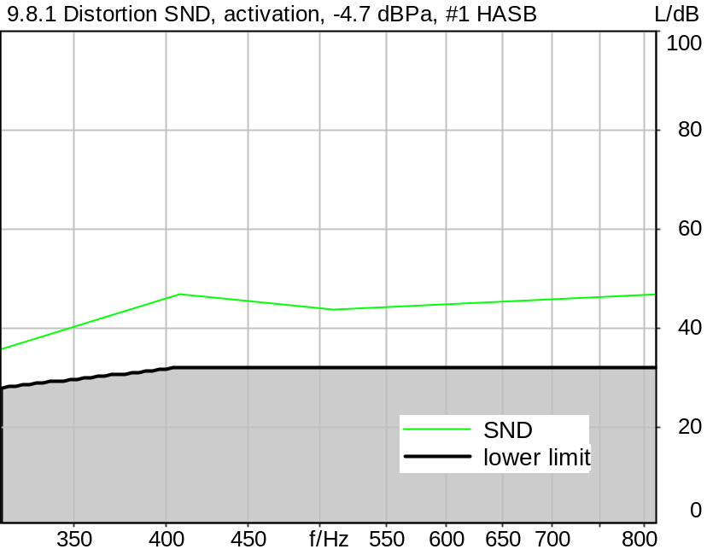

Distortion
Frequency | SND
315.0 Hz | 35.70 dB (1.64%) | Ok
408.0 Hz | 46.96 dB (0.45%) | Ok
510.0 Hz | 43.72 dB (0.65%) | Ok
816.0 Hz | 46.74 dB (0.46%) | Ok

Ok
5/20/2025 11:51 AM ACQUA 6.0.200
Unmodified HEAD acoustics Measurement Descriptor

Limits
 | lower
Run 1 | 28.00 dB
Run 2 | 32.00 dB
Run 3 | 32.00 dB
Run 4 | 32.00 dB

Meas. Setting DRP-off

Underlying Standard: 3GPP TS 26.131 V17.3.0 and 3GPP TS 26.132 V17.2.0
Database Version: 60_UG_TS26131_32_SWB_FB_Rev08_GCF_PTCRB

Source
Source level -14.70 dB
Level adjustment Channel 1 Gain 10.00 dB
Activation file cssfb2b_s147_act.dat

Calibration
SND (1) 0.00 dB (Radio Tester 1 (CMW500))
Output ch. 1 0.00 dB

Output Equalization/Filter
Mouth Eq. Ch.1 HATS 7 (B&K 5128) (5/28/2024 5:25 PM)

Analysis
Analyse Channel 1
Range start 20.00 ms Range length 170.67 ms
Frequency base Transformation
FFT size 4096 Overlap 75 %
Window function Hann Smooth Off
Distortion Total dist. dB weighting psophometric
Freq. range min. 100.0 Hz Freq. range max. 6000.0 Hz
O.132 corr. factor No

Special Features
Compensate delay 257.6000 ms (D_SCRIPT, Original Delay Variable stored to D_SCRIPT: D_SND_EQ_HASB)
Store to variable D47_SND_HASB_Act_a

Hardware Config Settings
Used Setting HA&HE_5128_volte

labCORE Settings
labCORE Serial 77000280 Nickname
Firmware 3.7.5 Sync Source Internal
Clock Pitch 0.00 ppm
----------
labCORE Routing
Out Channel 1 -> Analog Out 1 -> ExternalAmplifier In -> HATS 7 (B&K 5128) Speaker
Out Channel 2 -> VoIP 2
Out Channel 2 -> VoIP 1 -> Radio Tester 1 (CMW500) RF In/Out
In Channel 1 <- VoIP In/Out 1 <- Radio Tester 1 (CMW500) RF In/Out
In Channel 2 <- BEQ Filter 1 R <- ICP Amp. (Slot 7) In 2 <- HATS 7 (B&K 5128) Mic. Right
----------
Analog Out Mainboard Settings (Analog Out)
Range Ch. 1 0.00 dB Range Ch. 2 0.00 dB
----------
ICP Settings (ICP Amp. (Slot 7))
Channel In 1 Settings
Range 132 dB[SPL] @ 50 mV/Pa Highpass 20Hz
Supply Voltage On
Channel In 2 Settings
Range 132 dB[SPL] @ 50 mV/Pa Highpass 20Hz
Supply Voltage On
Channel In 3 Settings
Range 132 dB[SPL] @ 50 mV/Pa Highpass 20Hz
Supply Voltage Off
Channel In 4 Settings
Range 132 dB[SPL] @ 50 mV/Pa Highpass 20Hz
Supply Voltage Off
----------
VoIP Settings (VoIP)
RTP Connection Streaming SIP Connection Unavailable
SIP Reg. State Unregistered Jitterbuffer Length 100
Jitter Buffer Reset On Playback Enabled Codec EVS/16000/1
Packet Length 20 Encoder Parameter ;evs-mode-switch=0;max-red=0;br=13.2;bw=swb;ch-aw-recv=-1
FMTP Parameter ;evs-mode-switch=0;bw=swb;br=13.2;ch-aw-recv=-1;max-red=220
Impairment Mode Off Impairment Type Off
----------
BEQ Settings (BEQ Filter 1)
Block mode Bypass
----------
Artificial Head Settings (HATS 7 (B&K 5128))
Ser. Nr. BK_3408387 Pinna Type Type 4.3

HIB Settings
HIB Name 60020101 Serial 60020101
HIB Mode Mobile Measurement Impedance 32 Ohm
Gain out 1 -40.00 dB Gain out 2 0.00 dB
Gain in 1 0.00 dB Gain in 2 0.00 dB
Mic 1 Power Supply Off Mic 2 Power Supply Off

9.8.1 Distortion SND, activation, -4.7 dBPa, #2 HASB
Handset Measurements Superwideband and Fullband \ Handset Measurements SuperWideband (HASB) \ Connections with Handset Sending Direction (HASB) \ 9.8.1 Distortion Sending, activation, -4.7 dBPa, HASB
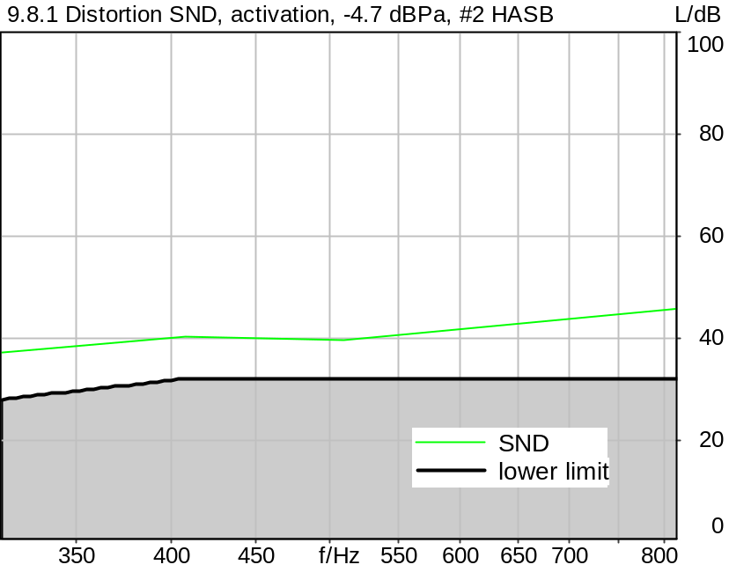

Distortion
Frequency | SND
315.0 Hz | 37.12 dB (1.39%) | Ok
408.0 Hz | 40.40 dB (0.96%) | Ok
510.0 Hz | 39.63 dB (1.04%) | Ok
816.0 Hz | 45.80 dB (0.51%) | Ok

Ok
5/20/2025 11:51 AM ACQUA 6.0.200
Unmodified HEAD acoustics Measurement Descriptor

Limits
 | lower
Run 1 | 28.00 dB
Run 2 | 32.00 dB
Run 3 | 32.00 dB
Run 4 | 32.00 dB

Meas. Setting DRP-off

Underlying Standard: 3GPP TS 26.131 V17.3.0 and 3GPP TS 26.132 V17.2.0
Database Version: 60_UG_TS26131_32_SWB_FB_Rev08_GCF_PTCRB

Source
Source level -14.70 dB
Level adjustment Channel 1 Gain 10.00 dB
Activation file cssfb2b_s147_act.dat

Calibration
SND (1) 0.00 dB (Radio Tester 1 (CMW500))
Output ch. 1 0.00 dB

Output Equalization/Filter
Mouth Eq. Ch.1 HATS 7 (B&K 5128) (5/28/2024 5:25 PM)

Analysis
Analyse Channel 1
Range start 20.00 ms Range length 170.67 ms
Frequency base Transformation
FFT size 4096 Overlap 75 %
Window function Hann Smooth Off
Distortion Total dist. dB weighting psophometric
Freq. range min. 100.0 Hz Freq. range max. 6000.0 Hz
O.132 corr. factor No

Special Features
Compensate delay 257.6000 ms (D_SCRIPT, Original Delay Variable stored to D_SCRIPT: D_SND_EQ_HASB)
Store to variable D47_SND_HASB_Act_b

Hardware Config Settings
Used Setting HA&HE_5128_volte

labCORE Settings
labCORE Serial 77000280 Nickname
Firmware 3.7.5 Sync Source Internal
Clock Pitch 0.00 ppm
----------
labCORE Routing
Out Channel 1 -> Analog Out 1 -> ExternalAmplifier In -> HATS 7 (B&K 5128) Speaker
Out Channel 2 -> VoIP 2
Out Channel 2 -> VoIP 1 -> Radio Tester 1 (CMW500) RF In/Out
In Channel 1 <- VoIP In/Out 1 <- Radio Tester 1 (CMW500) RF In/Out
In Channel 2 <- BEQ Filter 1 R <- ICP Amp. (Slot 7) In 2 <- HATS 7 (B&K 5128) Mic. Right
----------
Analog Out Mainboard Settings (Analog Out)
Range Ch. 1 0.00 dB Range Ch. 2 0.00 dB
----------
ICP Settings (ICP Amp. (Slot 7))
Channel In 1 Settings
Range 132 dB[SPL] @ 50 mV/Pa Highpass 20Hz
Supply Voltage On
Channel In 2 Settings
Range 132 dB[SPL] @ 50 mV/Pa Highpass 20Hz
Supply Voltage On
Channel In 3 Settings
Range 132 dB[SPL] @ 50 mV/Pa Highpass 20Hz
Supply Voltage Off
Channel In 4 Settings
Range 132 dB[SPL] @ 50 mV/Pa Highpass 20Hz
Supply Voltage Off
----------
VoIP Settings (VoIP)
RTP Connection Streaming SIP Connection Unavailable
SIP Reg. State Unregistered Jitterbuffer Length 100
Jitter Buffer Reset On Playback Enabled Codec EVS/16000/1
Packet Length 20 Encoder Parameter ;evs-mode-switch=0;max-red=0;br=13.2;bw=swb;ch-aw-recv=-1
FMTP Parameter ;evs-mode-switch=0;bw=swb;br=13.2;ch-aw-recv=-1;max-red=220
Impairment Mode Off Impairment Type Off
----------
BEQ Settings (BEQ Filter 1)
Block mode Bypass
----------
Artificial Head Settings (HATS 7 (B&K 5128))
Ser. Nr. BK_3408387 Pinna Type Type 4.3

HIB Settings
HIB Name 60020101 Serial 60020101
HIB Mode Mobile Measurement Impedance 32 Ohm
Gain out 1 -40.00 dB Gain out 2 0.00 dB
Gain in 1 0.00 dB Gain in 2 0.00 dB
Mic 1 Power Supply Off Mic 2 Power Supply Off

9.8.1 Distortion SND, activation, -4.7 dBPa, #3 HASB
Handset Measurements Superwideband and Fullband \ Handset Measurements SuperWideband (HASB) \ Connections with Handset Sending Direction (HASB) \ 9.8.1 Distortion Sending, activation, -4.7 dBPa, HASB
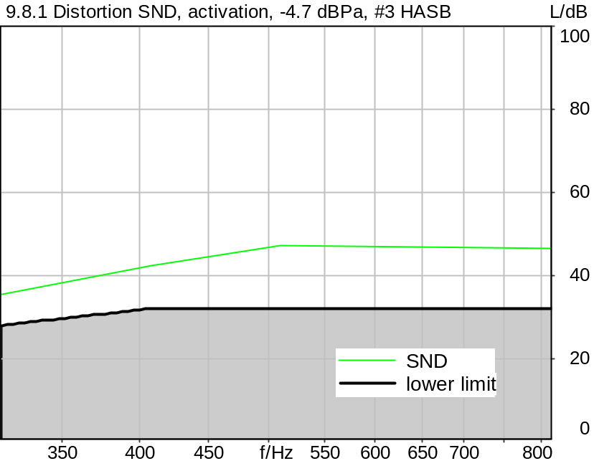

Distortion
Frequency | SND
315.0 Hz | 35.62 dB (1.66%) | Ok
408.0 Hz | 42.35 dB (0.76%) | Ok
510.0 Hz | 47.10 dB (0.44%) | Ok
816.0 Hz | 46.45 dB (0.48%) | Ok

Ok
5/20/2025 11:51 AM ACQUA 6.0.200
Unmodified HEAD acoustics Measurement Descriptor

Limits
 | lower
Run 1 | 28.00 dB
Run 2 | 32.00 dB
Run 3 | 32.00 dB
Run 4 | 32.00 dB

Meas. Setting DRP-off

Underlying Standard: 3GPP TS 26.131 V17.3.0 and 3GPP TS 26.132 V17.2.0
Database Version: 60_UG_TS26131_32_SWB_FB_Rev08_GCF_PTCRB

Source
Source level -14.70 dB
Level adjustment Channel 1 Gain 10.00 dB
Activation file cssfb2b_s147_act.dat

Calibration
SND (1) 0.00 dB (Radio Tester 1 (CMW500))
Output ch. 1 0.00 dB

Output Equalization/Filter
Mouth Eq. Ch.1 HATS 7 (B&K 5128) (5/28/2024 5:25 PM)

Analysis
Analyse Channel 1
Range start 20.00 ms Range length 170.67 ms
Frequency base Transformation
FFT size 4096 Overlap 75 %
Window function Hann Smooth Off
Distortion Total dist. dB weighting psophometric
Freq. range min. 100.0 Hz Freq. range max. 6000.0 Hz
O.132 corr. factor No

Special Features
Compensate delay 257.6000 ms (D_SCRIPT, Original Delay Variable stored to D_SCRIPT: D_SND_EQ_HASB)
Store to variable D47_SND_HASB_Act_c

Hardware Config Settings
Used Setting HA&HE_5128_volte

labCORE Settings
labCORE Serial 77000280 Nickname
Firmware 3.7.5 Sync Source Internal
Clock Pitch 0.00 ppm
----------
labCORE Routing
Out Channel 1 -> Analog Out 1 -> ExternalAmplifier In -> HATS 7 (B&K 5128) Speaker
Out Channel 2 -> VoIP 2
Out Channel 2 -> VoIP 1 -> Radio Tester 1 (CMW500) RF In/Out
In Channel 1 <- VoIP In/Out 1 <- Radio Tester 1 (CMW500) RF In/Out
In Channel 2 <- BEQ Filter 1 R <- ICP Amp. (Slot 7) In 2 <- HATS 7 (B&K 5128) Mic. Right
----------
Analog Out Mainboard Settings (Analog Out)
Range Ch. 1 0.00 dB Range Ch. 2 0.00 dB
----------
ICP Settings (ICP Amp. (Slot 7))
Channel In 1 Settings
Range 132 dB[SPL] @ 50 mV/Pa Highpass 20Hz
Supply Voltage On
Channel In 2 Settings
Range 132 dB[SPL] @ 50 mV/Pa Highpass 20Hz
Supply Voltage On
Channel In 3 Settings
Range 132 dB[SPL] @ 50 mV/Pa Highpass 20Hz
Supply Voltage Off
Channel In 4 Settings
Range 132 dB[SPL] @ 50 mV/Pa Highpass 20Hz
Supply Voltage Off
----------
VoIP Settings (VoIP)
RTP Connection Streaming SIP Connection Unavailable
SIP Reg. State Unregistered Jitterbuffer Length 100
Jitter Buffer Reset On Playback Enabled Codec EVS/16000/1
Packet Length 20 Encoder Parameter ;evs-mode-switch=0;max-red=0;br=13.2;bw=swb;ch-aw-recv=-1
FMTP Parameter ;evs-mode-switch=0;bw=swb;br=13.2;ch-aw-recv=-1;max-red=220
Impairment Mode Off Impairment Type Off
----------
BEQ Settings (BEQ Filter 1)
Block mode Bypass
----------
Artificial Head Settings (HATS 7 (B&K 5128))
Ser. Nr. BK_3408387 Pinna Type Type 4.3

HIB Settings
HIB Name 60020101 Serial 60020101
HIB Mode Mobile Measurement Impedance 32 Ohm
Gain out 1 -40.00 dB Gain out 2 0.00 dB
Gain in 1 0.00 dB Gain in 2 0.00 dB
Mic 1 Power Supply Off Mic 2 Power Supply Off

9.8.1 Distortion SND -4.7 dBPa activation Average HASB
Handset Measurements Superwideband and Fullband \ Handset Measurements SuperWideband (HASB) \ Connections with Handset Sending Direction (HASB) \ 9.8.1 Distortion Sending, activation, -4.7 dBPa, HASB
Freq. (Hz) | Level (dBPa) | SDR [dB] | Req. [dB] | Status
315 | -4.7 | 36.2 | 28.0 | Ok
408 | -4.7 | 43.7 | 32.0 | Ok
510 | -4.7 | 44.0 | 32.0 | Ok
816 | -4.7 | 46.3 | 32.0 | Ok

5/20/2025 11:51 AM ACQUA

9.6 Stability loss, check 100 Hz- 16000 Hz, MAX HASB
Handset Measurements Superwideband and Fullband \ Handset Measurements SuperWideband (HASB) \ Connections with Handset Sending Direction (HASB)
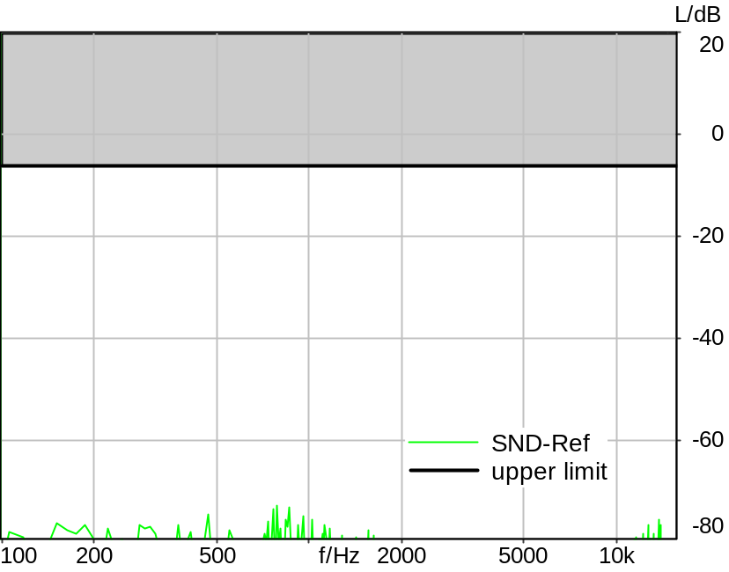

Absolute minimal distance
67.03 dB at 785.2 Hz Ok

Ok
5/21/2025 9:41 PM ACQUA 6.0.200

Limits
 | lower
Run 1 | 6.00 dB

Meas. Setting DRP-off

Underlying Standard: 3GPP TS 26.131 V17.3.0 and 3GPP TS 26.132 V17.2.0
Database Version: 60_UG_TS26131_32_SWB_FB_Rev08_GCF_PTCRB

Source: spst4x3_sb_r16_pn2.dat
Level adjustment Channel 1 Gain -90.00 dB
SUPERWIDEBAND Real Speech Single Talk (ITU-T SG 12 sentences) at Channel 2 used as activation + PN
bandlimited 100 - 16000Hz, (3x male speech, 3x female speech, 3x male speech, 3x female speech)
A silence period of 0.5 s is inserted between each sentence.
Activation Signal: level (ch2): -16.0 dBm0 active speech level, duration: 36.0 s.
Test signal: Pseudo noise 250 ms, "white" spectrum: 100-16000 Hz, crest factor : 6 dB,
Level: -3 dBm0 == -5.2 dBV, FFT length: 4096 points

For license information refer to the files >LICENSE_psytechnics.txt< and >LICENSE_nokia.txt<,
see Preparation of Test Setup - Info: Test Signals

Calibration
SND (1) 0.00 dB (Radio Tester 1 (CMW500))
Output ch. 1 0.00 dB
Output ch. 2 0.00 dB (Radio Tester 1 (CMW500))

Output Equalization/Filter
Mouth Eq. Ch.1 HATS 7 (B&K 5128) (5/28/2024 5:25 PM)

Analysis
Analyse Channel 1
Range start 35050.00 ms Range length 85.33 ms
Frequency base Transformation
FFT size 4096 Overlap 0 %
Window function Rectangle Smooth Off
Reference file re_stab_hasb.fft
Tol. scheme file stab_loss_hasb.tol Min. freq. for tol. 100.0 Hz
Auto adjust No Max. freq. for tol. 16000.0 Hz

labCORE Settings
labCORE Serial 77000280 Nickname
Firmware 3.7.5 Sync Source Internal
Clock Pitch 0.00 ppm
----------
labCORE Routing
Out Channel 1 -> Analog Out 1 -> ExternalAmplifier In -> HATS 7 (B&K 5128) Speaker
Out Channel 2 -> VoIP 2
Out Channel 2 -> VoIP 1 -> Radio Tester 1 (CMW500) RF In/Out
In Channel 1 <- VoIP In/Out 1 <- Radio Tester 1 (CMW500) RF In/Out
In Channel 2 <- BEQ Filter 1 R <- ICP Amp. (Slot 7) In 2 <- HATS 7 (B&K 5128) Mic. Right
----------
Analog Out Mainboard Settings (Analog Out)
Range Ch. 1 0.00 dB Range Ch. 2 0.00 dB
----------
ICP Settings (ICP Amp. (Slot 7))
Channel In 1 Settings
Range 132 dB[SPL] @ 50 mV/Pa Highpass 20Hz
Supply Voltage On
Channel In 2 Settings
Range 132 dB[SPL] @ 50 mV/Pa Highpass 20Hz
Supply Voltage On
Channel In 3 Settings
Range 132 dB[SPL] @ 50 mV/Pa Highpass 20Hz
Supply Voltage Off
Channel In 4 Settings
Range 132 dB[SPL] @ 50 mV/Pa Highpass 20Hz
Supply Voltage Off
----------
VoIP Settings (VoIP)
RTP Connection Streaming SIP Connection Unavailable
SIP Reg. State Unregistered Jitterbuffer Length 140
Jitter Buffer Reset On Playback Enabled Codec EVS/16000/1
Packet Length 20 Encoder Parameter ;evs-mode-switch=0;max-red=0;br=13.2;bw=swb;ch-aw-recv=-1
FMTP Parameter ;evs-mode-switch=0;bw=swb;br=13.2;ch-aw-recv=-1;max-red=220
Impairment Mode Off Impairment Type Off
----------
BEQ Settings (BEQ Filter 1)
Block mode Bypass
----------
Artificial Head Settings (HATS 7 (B&K 5128))
Ser. Nr. BK_3408387 Pinna Type Type 4.3

9.11 Record Echo Control Charact. Speech DT SND HASB
Handset Measurements Superwideband and Fullband \ Handset Measurements SuperWideband (HASB) \ Connections with Handset Sending Direction (HASB) \ 9.11 Echo control during Double Talk (HASB)
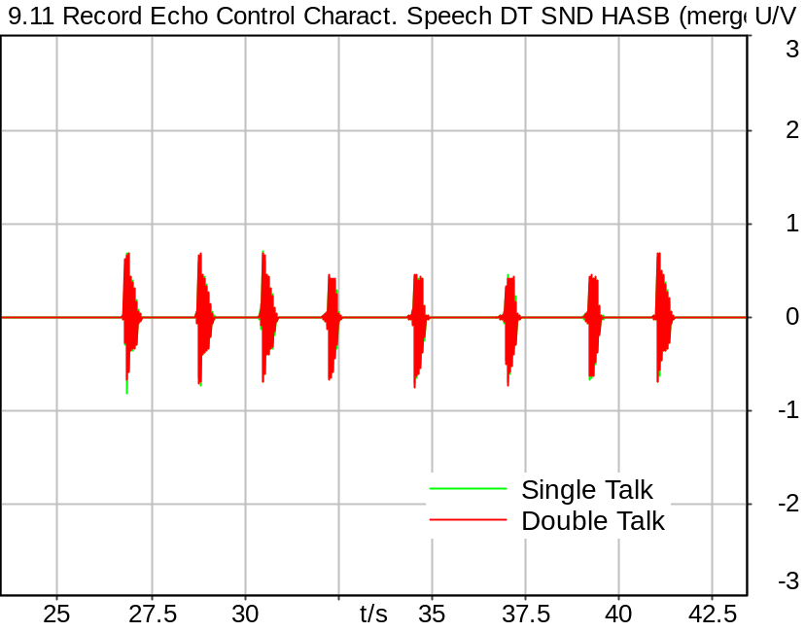
Single Talk & Double Talk

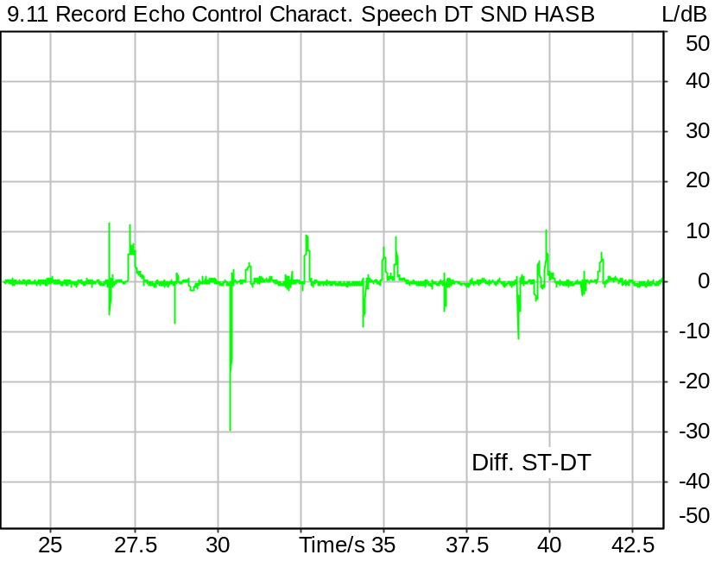
Level vs. Time (Double Talk) - Level vs. Time (Single Talk)

Delay ST vs DT 0.000 s | Delay SND vs Source 0.341 s
DT Class A1 100.00 % | ST Class A1 95.34 %
DT Class A2 0.00 % | ST Class A2 1.80 %
DT Class A1+A2 100.00 % | ST Class A1+A2 97.14 %
DT Class B 0.00 % | ST Class B 0.11 %
DT Class C 0.00 % | ST Class C 0.00 %
DT Class D 0.00 % | ST Class D 0.00 %
DT Class E 0.00 % | ST Class E 0.19 %
DT Class F 0.00 % | ST Class F 1.34 %
DT Class G 0.00 % | ST Class G 1.22 %
DT Avg. Level A1 0.02 dB | ST Avg. Level A1 0.07 dB
DT Avg. Level A2 0.00 dB | ST Avg. Level A2 -6.14 dB
DT Avg. Level B 0.00 dB | ST Avg. Level B -20.55 dB
DT Avg. Level C 0.00 dB | ST Avg. Level C 0.00 dB
DT Avg. Level D 0.00 dB | ST Avg. Level D 0.00 dB
DT Avg. Level E 0.00 dB | ST Avg. Level E 7.21 dB
DT Avg. Level F 0.00 dB | ST Avg. Level F 5.17 dB
DT Avg. Level G 0.00 dB | ST Avg. Level G 4.49 dB

5/20/2025 1:47 PM ACQUA 6.0.200
Unmodified HEAD acoustics Measurement Descriptor

Meas. Setting DRP-off

Underlying Standard: 3GPP TS 26.131 V17.3.0 and 3GPP TS 26.132 V17.2.0
Database Version: 60_UG_TS26131_32_SWB_FB_Rev08_GCF_PTCRB

Source: spdt_cond_echo_sb_2.dat
Source delay 1 Channel 1 Delay 0.0 ms (D_RCV_HASB)
Level adjustment Channel 1 Gain 10.00 dB
Real Speech Double Talk (ITU-T SG 12 sentences) acc. to TS26.132 Rel. 11.0
Signal components: Conditioning + Single words (segment 1) + full sentence (segment 2) double talk
Ch.1: Artificial mouth signal = FB_male_conditioning_seq_long.wav + FB_male_female_double-talk_seq.wav
Ch.2: Far-end signal = FB_female_conditioning_seq_long.wav + FB_male_female_single-talk_seq.wav
Ch.1: FULLBAND, active speech level: -14.7 dBV, overall duration: 60 s, (Pause till end of file)
Ch.2: SUPERWIDEBAND, 100 Hz-16000 Hz band-limited, active speech level: -16.0 dBm0, overall duration: 60 s

For license information refer to the files >LICENSE_psytechnics.txt< and
>LICENSE_nokia.txt<, see Preparation of Test Setup - Info: Test Signals

Calibration
SND (1) 0.00 dB (Radio Tester 1 (CMW500))
Output ch. 1 0.00 dB
Output ch. 2 0.00 dB (Radio Tester 1 (CMW500))

Output Equalization/Filter
Mouth Eq. Ch.1 HATS 7 (B&K 5128) (5/28/2024 5:25 PM)

Analysis
Analyse Channel 1
Range start 23500.00 ms Range length 20000.00 ms

Special Features
Store to file spbsd_dt_hasb.dat

Hardware Config Settings
Used Setting HA&HE_5128

labCORE Settings
labCORE Serial 77000280 Nickname
Firmware 3.7.5 Sync Source Internal
Clock Pitch 0.00 ppm
----------
labCORE Routing
Out Channel 1 -> Analog Out 1 -> ExternalAmplifier In -> HATS 7 (B&K 5128) Speaker
Out Channel 2 -> Analog Out 2 -> Radio Tester 1 (CMW500) In
In Channel 1 <- Analog In In 1 <- Radio Tester 1 (CMW500) Out
In Channel 2 <- BEQ Filter 1 R <- ICP Amp. (Slot 7) In 2 <- HATS 7 (B&K 5128) Mic. Right
----------
Analog In Mainboard Settings (Analog In)
Range Ch. 1 0.00 dB Ch. 0 Float On
Range Ch. 2 0.00 dB Ch. 1 Float On
----------
Analog Out Mainboard Settings (Analog Out)
Range Ch. 1 0.00 dB Range Ch. 2 0.00 dB
----------
ICP Settings (ICP Amp. (Slot 7))
Channel In 1 Settings
Range 132 dB[SPL] @ 50 mV/Pa Highpass 20Hz
Supply Voltage On
Channel In 2 Settings
Range 132 dB[SPL] @ 50 mV/Pa Highpass 20Hz
Supply Voltage On
Channel In 3 Settings
Range 132 dB[SPL] @ 50 mV/Pa Highpass 20Hz
Supply Voltage Off
Channel In 4 Settings
Range 132 dB[SPL] @ 50 mV/Pa Highpass 20Hz
Supply Voltage Off
----------
BEQ Settings (BEQ Filter 1)
Block mode Bypass
----------
Artificial Head Settings (HATS 7 (B&K 5128))
Ser. Nr. BK_3408387 Pinna Type Type 4.3

HIB Settings
HIB Name 60020101 Serial 60020101
HIB Mode Mobile Measurement Impedance 32 Ohm
Gain out 1 -40.00 dB Gain out 2 0.00 dB
Gain in 1 0.00 dB Gain in 2 0.00 dB
Mic 1 Power Supply Off Mic 2 Power Supply Off

9.11 Echo Control Chara. Speech short DT SND 1o2 HASB
Handset Measurements Superwideband and Fullband \ Handset Measurements SuperWideband (HASB) \ Connections with Handset Sending Direction (HASB) \ 9.11 Echo control during Double Talk (HASB)
Single Talk & Double Talk

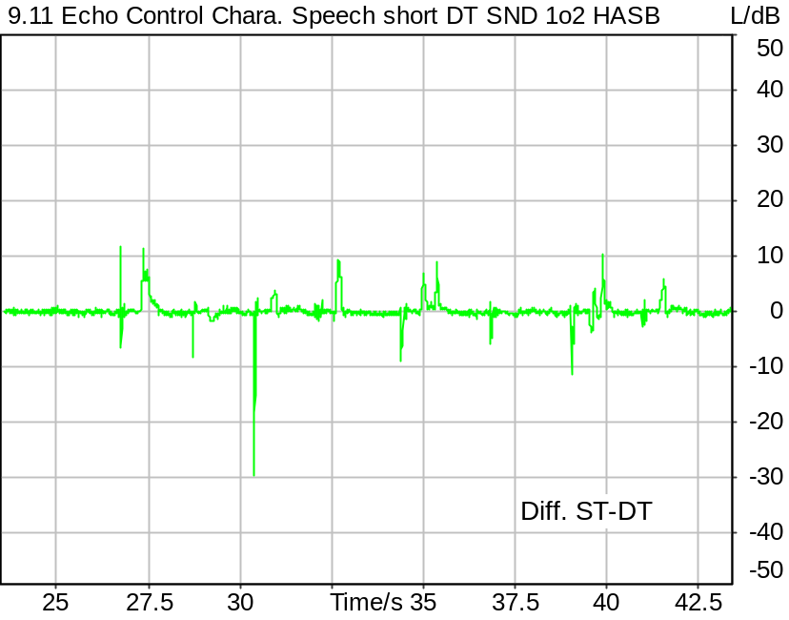
Level vs. Time (Double Talk) - Level vs. Time (Single Talk)

Delay ST vs DT 0.000 s | Delay SND vs Source 0.341 s
DT Class A1 100.00 % Ok | ST Class A1 95.34 %
DT Class A2 0.00 % | ST Class A2 1.80 %
DT Class A1+A2 100.00 % Ok | ST Class A1+A2 97.14 % Ok
DT Class B 0.00 % | ST Class B 0.11 %
DT Class C 0.00 % | ST Class C 0.00 %
DT Class D 0.00 % | ST Class D 0.00 %
DT Class E 0.00 % | ST Class E 0.19 %
DT Class F 0.00 % | ST Class F 1.34 %
DT Class G 0.00 % | ST Class G 1.22 %
DT Avg. Level A1 0.02 dB | ST Avg. Level A1 0.07 dB
DT Avg. Level A2 0.00 dB | ST Avg. Level A2 -6.14 dB
DT Avg. Level B 0.00 dB | ST Avg. Level B -20.55 dB
DT Avg. Level C 0.00 dB | ST Avg. Level C 0.00 dB
DT Avg. Level D 0.00 dB | ST Avg. Level D 0.00 dB
DT Avg. Level E 0.00 dB | ST Avg. Level E 7.21 dB
DT Avg. Level F 0.00 dB | ST Avg. Level F 5.17 dB
DT Avg. Level G 0.00 dB | ST Avg. Level G 4.49 dB

Ok
5/20/2025 1:47 PM ACQUA 6.0.200

Meas. Setting DRP-off

Underlying Standard: 3GPP TS 26.131 V17.3.0 and 3GPP TS 26.132 V17.2.0
Database Version: 60_UG_TS26131_32_SWB_FB_Rev08_GCF_PTCRB

Analysis
Analyse Channel 1
Range start 23500.00 ms Range length 20000.00 ms

9.11 Echo Control Chara. Speech long DT SND 2o2 HASB
Handset Measurements Superwideband and Fullband \ Handset Measurements SuperWideband (HASB) \ Connections with Handset Sending Direction (HASB) \ 9.11 Echo control during Double Talk (HASB)
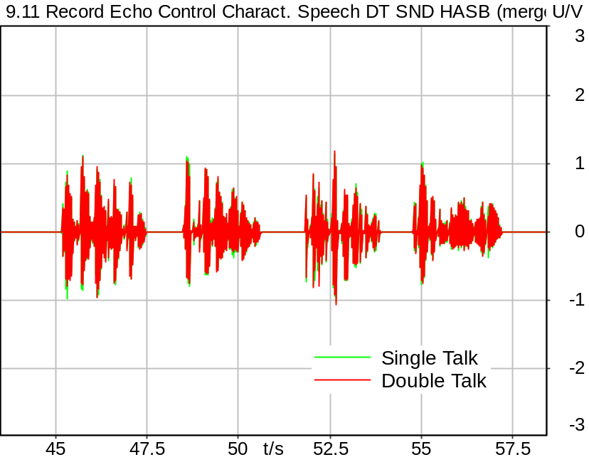
Single Talk & Double Talk

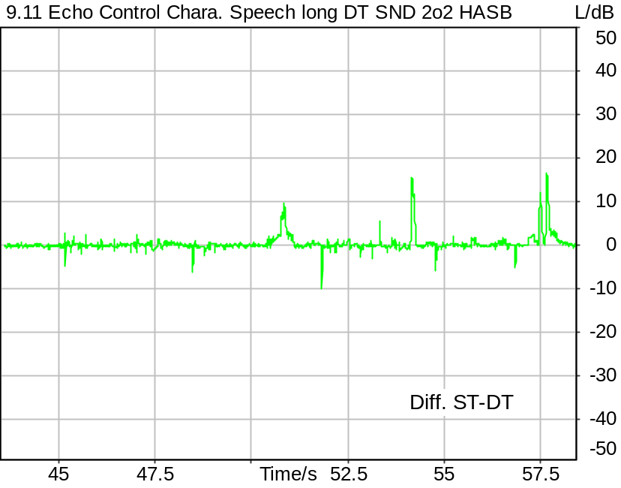
Level vs. Time (Double Talk) - Level vs. Time (Single Talk)

Delay ST vs DT 0.000 s | Delay SND vs Source 0.341 s
DT Class A1 99.74 % Ok | ST Class A1 90.85 % Ok
DT Class A2 0.17 % | ST Class A2 6.00 %
DT Class A1+A2 99.91 % | ST Class A1+A2 96.84 % Ok
DT Class B 0.00 % | ST Class B 0.00 %
DT Class C 0.00 % | ST Class C 0.00 %
DT Class D 0.00 % | ST Class D 0.00 %
DT Class E 0.09 % | ST Class E 0.00 %
DT Class F 0.00 % | ST Class F 3.16 %
DT Class G 0.00 % | ST Class G 0.00 %
DT Avg. Level A1 0.00 dB | ST Avg. Level A1 0.46 dB
DT Avg. Level A2 -4.33 dB | ST Avg. Level A2 -5.05 dB
DT Avg. Level B 0.00 dB | ST Avg. Level B 0.00 dB
DT Avg. Level C 0.00 dB | ST Avg. Level C 0.00 dB
DT Avg. Level D 0.00 dB | ST Avg. Level D 0.00 dB
DT Avg. Level E 4.50 dB | ST Avg. Level E 0.00 dB
DT Avg. Level F 0.00 dB | ST Avg. Level F 7.30 dB
DT Avg. Level G 0.00 dB | ST Avg. Level G 0.00 dB

Ok
5/20/2025 1:47 PM ACQUA 6.0.200

Meas. Setting DRP-off

Underlying Standard: 3GPP TS 26.131 V17.3.0 and 3GPP TS 26.132 V17.2.0
Database Version: 60_UG_TS26131_32_SWB_FB_Rev08_GCF_PTCRB

Analysis
Analyse Channel 1
Range start 43500.00 ms Range length 15000.00 ms

P.863 AC SND Handset SWB 13.2K
Handset Measurements Superwideband and Fullband \ Handset Measurements SuperWideband (HASB)
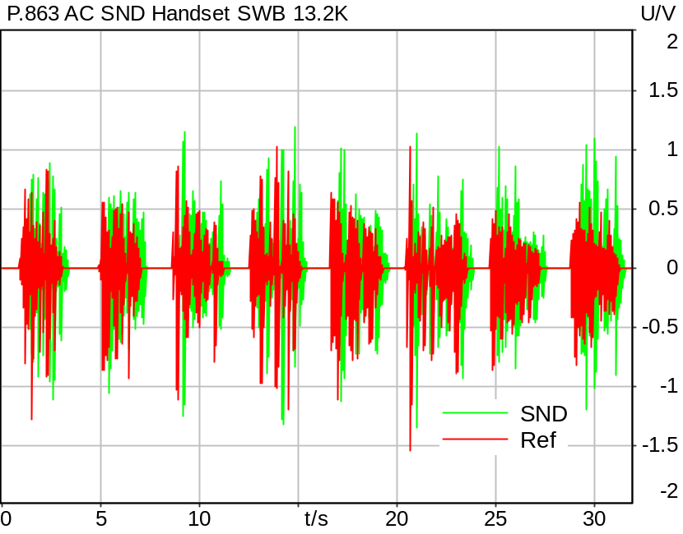

Time range: 0.0 .. 8.0 s
MOS-LQO | 3.79
Time range: 8.0 .. 16.0 s
MOS-LQO | 4.42
Time range: 16.0 .. 24.0 s
MOS-LQO | 4.07
Time range: 24.0 .. 32.0 s
MOS-LQO | 3.97

MOS-LQO (Average) 4.06 Ok

Ok
5/20/2025 1:50 PM ACQUA 6.0.200

Limits
 | lower | upper
Average | 3.70 | 4.80

Meas. Setting DRP-off

Underlying Standard: ACQUA Demo SMDs Rev06
Database Version: ACQUA Demo SMDs Rev06

Source: sp2s_be4x2_fb_sr147.dat
Level adjustment Channel 2 Gain -90.00 dB
Level adjustment Channel 1 Gain 10.00 dB
FULLBAND Real Speech Signals (British English P.501 (from Fullband), 2 sentences per speaker)
(2x male speaker 1, 2x male speaker 2, 2x female speaker 1, 2x female speaker 2).
Edited to fit 4s sequence

Signal Level (Ch1&2): -14.7 dBV active speech level.

Calibration
SND (1) 0.00 dB (Radio Tester 1 (CMW500))
Output ch. 1 0.00 dB
Output ch. 2 0.00 dB (Radio Tester 1 (CMW500))

Output Equalization/Filter
Mouth Eq. Ch.1 HATS 7 (B&K 5128) (5/28/2024 5:25 PM)

Analysis
Analyse Channel 1
Range start 0.00 ms Range length 8000.00 ms
Number of seq. 4 Sequence length 8000.00 ms
Reference from Ref. file Reference file sp2s_be4x2_swb_sr182.dat
Algorithm POLQA
Version 3.0 Mode Fullband
Fixed Speech Level Yes Accuracy Normal

labCORE Settings
labCORE Serial 77000280 Nickname
Firmware 3.7.5 Sync Source Internal
Clock Pitch 0.00 ppm
----------
labCORE Routing
Out Channel 1 -> Analog Out 1 -> ExternalAmplifier In -> HATS 7 (B&K 5128) Speaker
Out Channel 2 -> VoIP 1 -> Radio Tester 1 (CMW500) RF In/Out
Out Channel 2 -> VoIP 2
In Channel 1 <- VoIP In/Out 1 <- Radio Tester 1 (CMW500) RF In/Out
In Channel 2 <- BEQ Filter 1 R <- ICP Amp. (Slot 7) In 2 <- HATS 7 (B&K 5128) Mic. Right
----------
Analog Out Mainboard Settings (Analog Out)
Range Ch. 1 0.00 dB Range Ch. 2 0.00 dB
----------
ICP Settings (ICP Amp. (Slot 7))
Channel In 1 Settings
Range 132 dB[SPL] @ 50 mV/Pa Highpass 20Hz
Supply Voltage On
Channel In 2 Settings
Range 132 dB[SPL] @ 50 mV/Pa Highpass 20Hz
Supply Voltage On
Channel In 3 Settings
Range 132 dB[SPL] @ 50 mV/Pa Highpass 20Hz
Supply Voltage Off
Channel In 4 Settings
Range 132 dB[SPL] @ 50 mV/Pa Highpass 20Hz
Supply Voltage Off
----------
VoIP Settings (VoIP)
RTP Connection Streaming SIP Connection Unavailable
SIP Reg. State Unregistered Jitterbuffer Length 140
Jitter Buffer Reset On Playback Enabled Codec EVS/16000/1
Packet Length 20 Encoder Parameter ;evs-mode-switch=0;max-red=0;br=13.2;bw=swb;ch-aw-recv=-1
FMTP Parameter ;evs-mode-switch=0;bw=swb;br=13.2;ch-aw-recv=-1;max-red=220
Impairment Mode Off Impairment Type Off
----------
BEQ Settings (BEQ Filter 1)
Block mode Bypass
----------
Artificial Head Settings (HATS 7 (B&K 5128))
Ser. Nr. BK_3408387 Pinna Type Type 4.3

HIB Settings
HIB Name 60020101 Serial 60020101
HIB Mode Mobile Measurement Impedance 32 Ohm
Gain out 1 -40.00 dB Gain out 2 0.00 dB
Gain in 1 0.00 dB Gain in 2 0.00 dB
Mic 1 Power Supply Off Mic 2 Power Supply Off

BGN Connection Wizard
Handset Measurements Superwideband and Fullband \ Handset Measurements SuperWideband (HASB) \ Measurements with Background Noise
BGN Connection Settings
The following BGN connection settings were saved as variables:
BGNControl = Automatic
BGNConnection = USB
BGNHostIP = 127.0.0.1
BGNPort = 10032
BGNSoftware = HAE
BGNEQMode = Binaural_Ears
BGNSetup =

5/20/2025 1:51 PM ACQUA

Prep: Measure Correction Factor for 3Quest SWB/FB
Handset Measurements Superwideband and Fullband \ Handset Measurements SuperWideband (HASB) \ Measurements with Background Noise \ 9.12.1 Quality in the Presence of Ambient Noise HASB
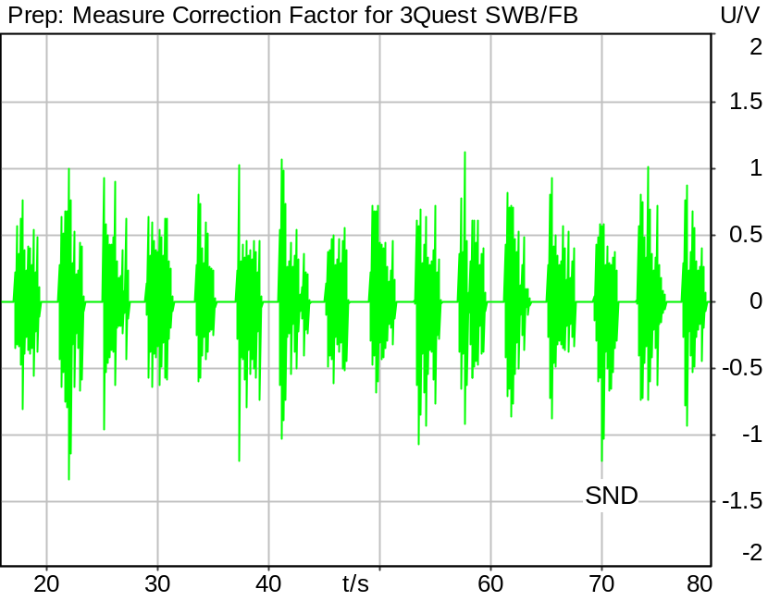

Correction
73 - X

Channel | Speech level | Activity | Corrected speech level
SND | 74.55 dB[SPL] | 57.30% | -1.55 dB[SPL]

5/20/2025 1:54 PM ACQUA 6.0.200
Unmodified HEAD acoustics Measurement Descriptor

Meas. Setting DRP-off

Underlying Standard: 3GPP TS 26.131 V17.3.0 and 3GPP TS 26.132 V17.2.0
Database Version: 60_UG_TS26131_32_SWB_FB_Rev08_GCF_PTCRB

Source: 3quest_ng.dat
Level adjustment Channel 2 Gain -90.00 dB
Level adjustment Channel 1 Gain 10.00 dB
FULLBAND Real Speech (20 sentences) at Channel 1
FULLBAND Real Speech (according to ETSI TS 103 106 Annex C, length 83s, 25 Hz high-pass filtered) +
Pause till end of file
Signal level (ch1): -14.7 dBV active speech level

Calibration
SND (1) 0.00 dB (Radio Tester 1 (CMW500))
Output ch. 1 0.00 dB
Output ch. 2 0.00 dB (Radio Tester 1 (CMW500))

Output Equalization/Filter
Mouth Eq. Ch.1 HATS 7 (B&K 5128) (5/28/2024 5:25 PM)

Analysis
Analyse Channel 1
Range start 16000.00 ms Range length 64000.00 ms
Bandpass filter Full Band Margin (15.9dB nom) 15.90 dB

Special Features
HFRP Corr. Ch.1: -2.4 dB (Nom. Value: 19.6 - HATS 7 (B&K 5128)) Store to variable CORR_3QUEST_HASB

Hardware Config Settings
Used Setting STD:5128_volte_3QUEST

labCORE Settings
labCORE Serial 77000280 Nickname
Firmware 3.7.5 Sync Source Internal
Clock Pitch 0.00 ppm
----------
labCORE Routing
Out Channel 1 -> Analog Out 1 -> ExternalAmplifier In -> HATS 7 (B&K 5128) Speaker
Out Channel 2 -> VoIP 1 -> Radio Tester 1 (CMW500) RF In/Out
Out Channel 2 -> VoIP 2
In Channel 1 <- VoIP In/Out 1 <- Radio Tester 1 (CMW500) RF In/Out
In Channel 2 <- Mic Amp. (Slot 6) In 2 <- Microphone 1 (46AG) Out
----------
Analog Out Mainboard Settings (Analog Out)
Range Ch. 1 0.00 dB Range Ch. 2 0.00 dB
----------
Microphone Settings (Mic Amp. (Slot 6))
Channel In 1 Settings
Range 114 dB[SPL] @ 12.5 mV/Pa Highpass 20Hz
Polarisation Voltage 200V Supply Voltage ±60V
Channel In 2 Settings
Range 114 dB[SPL] @ 12.5 mV/Pa Highpass 20Hz
Polarisation Voltage 200V Supply Voltage ±60V
Channel In 3 Settings
Range 132 dB[SPL] @ 12.5 mV/Pa Highpass 20Hz
Polarisation Voltage Off Supply Voltage ±60V
Channel In 4 Settings
Range 132 dB[SPL] @ 12.5 mV/Pa Highpass 20Hz
Polarisation Voltage Off Supply Voltage ±60V
----------
VoIP Settings (VoIP)
RTP Connection Streaming SIP Connection Unavailable
SIP Reg. State Unregistered Jitterbuffer Length 140
Jitter Buffer Reset On Playback Enabled Codec EVS/16000/1
Packet Length 20 Encoder Parameter ;evs-mode-switch=0;max-red=0;br=13.2;bw=swb;ch-aw-recv=-1
FMTP Parameter ;evs-mode-switch=0;bw=swb;br=13.2;ch-aw-recv=-1;max-red=220
Impairment Mode Off Impairment Type Off
----------
Artificial Head Settings (HATS 7 (B&K 5128))
Ser. Nr. BK_3408387 Pinna Type Type 4.3

HIB Settings
HIB Name 60020101 Serial 60020101
HIB Mode Mobile Measurement Impedance 32 Ohm
Gain out 1 -40.00 dB Gain out 2 0.00 dB
Gain in 1 0.00 dB Gain in 2 0.00 dB
Mic 1 Power Supply Off Mic 2 Power Supply Off

9.12.1 Quality in ambient noise, Pub
Handset Measurements Superwideband and Fullband \ Handset Measurements SuperWideband (HASB) \ Measurements with Background Noise \ 9.12.1 Quality in the Presence of Ambient Noise HASB
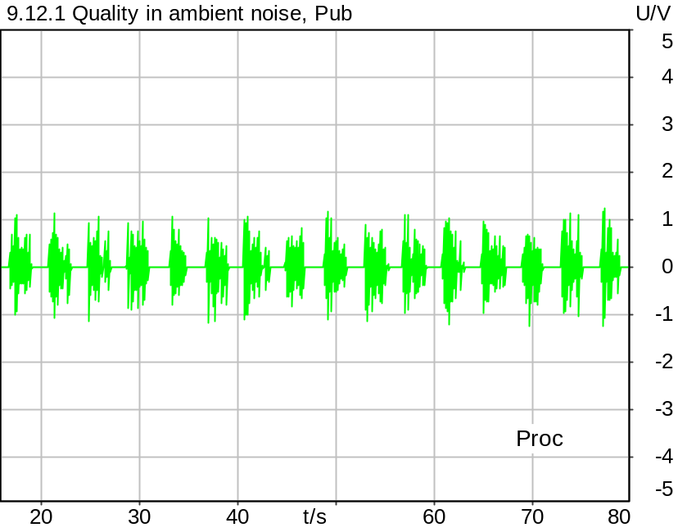

Time range: 16.0 .. 20.0 s
G-MOS (TS 103 281 (Model A)) | 3.49
N-MOS (TS 103 281 (Model A)) | 3.78
S-MOS (TS 103 281 (Model A)) | 3.86
SNR (unweighted) | 28.57 dB
SNR (A-weighted noise) | 30.46 dB
Delay | -47.5 ms
Speech Level | -20.18 dB
Equivalent Rectangular Bandwidth | 14828.42 Hz
Maximum Correlation | 56.40 %
Time range: 20.0 .. 24.0 s
G-MOS (TS 103 281 (Model A)) | 3.34
N-MOS (TS 103 281 (Model A)) | 3.48
S-MOS (TS 103 281 (Model A)) | 3.77
SNR (unweighted) | 23.45 dB
SNR (A-weighted noise) | 25.47 dB
Delay | -48.6 ms
Speech Level | -20.78 dB
Equivalent Rectangular Bandwidth | 16221.21 Hz
Maximum Correlation | 63.39 %
Time range: 24.0 .. 28.0 s
G-MOS (TS 103 281 (Model A)) | 3.03
N-MOS (TS 103 281 (Model A)) | 3.88
S-MOS (TS 103 281 (Model A)) | 3.44
SNR (unweighted) | 25.57 dB
SNR (A-weighted noise) | 28.24 dB
Delay | -48.6 ms
Speech Level | -21.80 dB
Equivalent Rectangular Bandwidth | 15581.62 Hz
Maximum Correlation | 64.28 %
Time range: 28.0 .. 32.0 s
G-MOS (TS 103 281 (Model A)) | 3.49
N-MOS (TS 103 281 (Model A)) | 4.20
S-MOS (TS 103 281 (Model A)) | 3.73
SNR (unweighted) | 31.58 dB
SNR (A-weighted noise) | 35.32 dB
Delay | -48.2 ms
Speech Level | -18.73 dB
Equivalent Rectangular Bandwidth | 14174.29 Hz
Maximum Correlation | 75.53 %
Time range: 32.0 .. 36.0 s
G-MOS (TS 103 281 (Model A)) | 3.54
N-MOS (TS 103 281 (Model A)) | 3.81
S-MOS (TS 103 281 (Model A)) | 4.15
SNR (unweighted) | 25.31 dB
SNR (A-weighted noise) | 27.85 dB
Delay | -47.1 ms
Speech Level | -19.05 dB
Equivalent Rectangular Bandwidth | 16032.46 Hz
Maximum Correlation | 68.49 %
Time range: 36.0 .. 40.0 s
G-MOS (TS 103 281 (Model A)) | 3.33
N-MOS (TS 103 281 (Model A)) | 3.56
S-MOS (TS 103 281 (Model A)) | 3.65
SNR (unweighted) | 25.87 dB
SNR (A-weighted noise) | 28.15 dB
Delay | -48.8 ms
Speech Level | -21.30 dB
Equivalent Rectangular Bandwidth | 15832.64 Hz
Maximum Correlation | 77.39 %
Time range: 40.0 .. 44.0 s
G-MOS (TS 103 281 (Model A)) | 3.11
N-MOS (TS 103 281 (Model A)) | 4.01
S-MOS (TS 103 281 (Model A)) | 3.45
SNR (unweighted) | 33.25 dB
SNR (A-weighted noise) | 35.37 dB
Delay | -48.5 ms
Speech Level | -21.32 dB
Equivalent Rectangular Bandwidth | 14856.43 Hz
Maximum Correlation | 51.82 %
Time range: 44.0 .. 48.0 s
G-MOS (TS 103 281 (Model A)) | 3.48
N-MOS (TS 103 281 (Model A)) | 3.69
S-MOS (TS 103 281 (Model A)) | 3.94
SNR (unweighted) | 30.19 dB
SNR (A-weighted noise) | 32.18 dB
Delay | -48.3 ms
Speech Level | -18.86 dB
Equivalent Rectangular Bandwidth | 13941.46 Hz
Maximum Correlation | 71.84 %
Time range: 48.0 .. 52.0 s
G-MOS (TS 103 281 (Model A)) | 3.38
N-MOS (TS 103 281 (Model A)) | 3.58
S-MOS (TS 103 281 (Model A)) | 3.75
SNR (unweighted) | 18.75 dB
SNR (A-weighted noise) | 21.18 dB
Delay | -48.0 ms
Speech Level | -19.05 dB
Equivalent Rectangular Bandwidth | 16044.20 Hz
Maximum Correlation | 61.12 %
Time range: 52.0 .. 56.0 s
G-MOS (TS 103 281 (Model A)) | 3.49
N-MOS (TS 103 281 (Model A)) | 3.96
S-MOS (TS 103 281 (Model A)) | 3.82
SNR (unweighted) | 26.76 dB
SNR (A-weighted noise) | 30.19 dB
Delay | -48.7 ms
Speech Level | -19.30 dB
Equivalent Rectangular Bandwidth | 17200.89 Hz
Maximum Correlation | 71.56 %
Time range: 56.0 .. 60.0 s
G-MOS (TS 103 281 (Model A)) | 3.26
N-MOS (TS 103 281 (Model A)) | 3.87
S-MOS (TS 103 281 (Model A)) | 3.71
SNR (unweighted) | 26.05 dB
SNR (A-weighted noise) | 28.78 dB
Delay | -48.9 ms
Speech Level | -20.56 dB
Equivalent Rectangular Bandwidth | 14421.14 Hz
Maximum Correlation | 60.03 %
Time range: 60.0 .. 64.0 s
G-MOS (TS 103 281 (Model A)) | 3.40
N-MOS (TS 103 281 (Model A)) | 4.10
S-MOS (TS 103 281 (Model A)) | 3.71
SNR (unweighted) | 26.77 dB
SNR (A-weighted noise) | 28.59 dB
Delay | -48.4 ms
Speech Level | -20.15 dB
Equivalent Rectangular Bandwidth | 14039.92 Hz
Maximum Correlation | 70.71 %
Time range: 64.0 .. 68.0 s
G-MOS (TS 103 281 (Model A)) | 3.44
N-MOS (TS 103 281 (Model A)) | 3.46
S-MOS (TS 103 281 (Model A)) | 3.88
SNR (unweighted) | 22.93 dB
SNR (A-weighted noise) | 25.46 dB
Delay | -47.1 ms
Speech Level | -20.18 dB
Equivalent Rectangular Bandwidth | 15892.34 Hz
Maximum Correlation | 57.62 %
Time range: 68.0 .. 72.0 s
G-MOS (TS 103 281 (Model A)) | 3.64
N-MOS (TS 103 281 (Model A)) | 4.08
S-MOS (TS 103 281 (Model A)) | 4.05
SNR (unweighted) | 33.48 dB
SNR (A-weighted noise) | 34.85 dB
Delay | -49.0 ms
Speech Level | -18.06 dB
Equivalent Rectangular Bandwidth | 17847.00 Hz
Maximum Correlation | 68.73 %
Time range: 72.0 .. 76.0 s
G-MOS (TS 103 281 (Model A)) | 3.39
N-MOS (TS 103 281 (Model A)) | 3.72
S-MOS (TS 103 281 (Model A)) | 3.77
SNR (unweighted) | 27.24 dB
SNR (A-weighted noise) | 29.43 dB
Delay | -47.5 ms
Speech Level | -21.08 dB
Equivalent Rectangular Bandwidth | 16080.60 Hz
Maximum Correlation | 63.38 %
Time range: 76.0 .. 80.0 s
G-MOS (TS 103 281 (Model A)) | 3.44
N-MOS (TS 103 281 (Model A)) | 3.52
S-MOS (TS 103 281 (Model A)) | 4.21
SNR (unweighted) | 24.33 dB
SNR (A-weighted noise) | 26.49 dB
Delay | -48.5 ms
Speech Level | -19.95 dB
Equivalent Rectangular Bandwidth | 14199.77 Hz
Maximum Correlation | 71.28 %
G-MOS (Average, TS 103 281 (Model A)): 3.39
N-MOS (Average, TS 103 281 (Model A)): 3.79
S-MOS (Average, TS 103 281 (Model A)): 3.80
Delay (Average): -48.2 ms
G-MOS (Deviation): 0.15
N-MOS (Deviation): 0.24
S-MOS (Deviation): 0.21
Delay (Deviation): 0.6 ms

*According to TS 26.132, the N-MOS value must be corrected with the following formula:
N-MOS_corr = 1.438 * N-MOS - 1.959
This value will be used to check compliance with requirements.

Corrected N-MOS (Average, TS 103 281 (Model A)): 3.5

5/20/2025 1:57 PM ACQUA 6.0.200
Unmodified HEAD acoustics Measurement Descriptor

Meas. Setting DRP-off

Underlying Standard: 3GPP TS 26.131 V17.3.0 and 3GPP TS 26.132 V17.2.0
Database Version: 60_UG_TS26131_32_SWB_FB_Rev08_GCF_PTCRB

Source: 3quest_ng.dat
Level adjustment Channel 1 Gain 3.00 dB
Level adjustment Channel 2 Gain -90.00 dB
Level adjustment Channel 1 Gain 10.00 dB
FULLBAND Real Speech (20 sentences) at Channel 1
FULLBAND Real Speech (according to ETSI TS 103 106 Annex C, length 83s, 25 Hz high-pass filtered) +
Pause till end of file
Signal level (ch1): -14.7 dBV active speech level

Calibration
SND (1) 0.00 dB (Radio Tester 1 (CMW500))
Output ch. 1 0.00 dB
Output ch. 2 0.00 dB (Radio Tester 1 (CMW500))

Output Equalization/Filter
Mouth Eq. Ch.1 HATS 7 (B&K 5128) (5/28/2024 5:25 PM)

Analysis
Analyse Channel 1
Range start 16000.00 ms Range length 4000.00 ms
Number of seq. 16 Sequence length 4000.00 ms
3QUEST Version TS 103 281 (Model A) Bandwidth SWB/FB
Clean speech from Source File
Correction Level -1.6 dB (CORR_3QUEST_HASB, Corrected Speech Level SND)

Special Features
HFRP Corr. Ch.1: -2.4 dB (Nom. Value: 19.6 - HATS 7 (B&K 5128))
Compensate delay 277.2000 ms (D_SCRIPT, Original Delay Variable stored to D_SCRIPT: D_SND_EQ_HASB)
Store to variable MOS_HASB_pub Run Script after savemosvalues.py

Hardware Config Settings
Used Setting STD:5128_volte_3QUEST

labCORE Settings
labCORE Serial 77000280 Nickname
Firmware 3.7.5 Sync Source Internal
Clock Pitch 0.00 ppm
----------
labCORE Routing
Out Channel 1 -> Analog Out 1 -> ExternalAmplifier In -> HATS 7 (B&K 5128) Speaker
Out Channel 2 -> VoIP 1 -> Radio Tester 1 (CMW500) RF In/Out
Out Channel 2 -> VoIP 2
In Channel 1 <- VoIP In/Out 1 <- Radio Tester 1 (CMW500) RF In/Out
In Channel 2 <- Mic Amp. (Slot 6) In 2 <- Microphone 1 (46AG) Out
----------
Analog Out Mainboard Settings (Analog Out)
Range Ch. 1 0.00 dB Range Ch. 2 0.00 dB
----------
Microphone Settings (Mic Amp. (Slot 6))
Channel In 1 Settings
Range 114 dB[SPL] @ 12.5 mV/Pa Highpass 20Hz
Polarisation Voltage 200V Supply Voltage ±60V
Channel In 2 Settings
Range 114 dB[SPL] @ 12.5 mV/Pa Highpass 20Hz
Polarisation Voltage 200V Supply Voltage ±60V
Channel In 3 Settings
Range 132 dB[SPL] @ 12.5 mV/Pa Highpass 20Hz
Polarisation Voltage Off Supply Voltage ±60V
Channel In 4 Settings
Range 132 dB[SPL] @ 12.5 mV/Pa Highpass 20Hz
Polarisation Voltage Off Supply Voltage ±60V
----------
VoIP Settings (VoIP)
RTP Connection Streaming SIP Connection Unavailable
SIP Reg. State Unregistered Jitterbuffer Length 140
Jitter Buffer Reset On Playback Enabled Codec EVS/16000/1
Packet Length 20 Encoder Parameter ;evs-mode-switch=0;max-red=0;br=13.2;bw=swb;ch-aw-recv=-1
FMTP Parameter ;evs-mode-switch=0;bw=swb;br=13.2;ch-aw-recv=-1;max-red=220
Impairment Mode Off Impairment Type Off
----------
Artificial Head Settings (HATS 7 (B&K 5128))
Ser. Nr. BK_3408387 Pinna Type Type 4.3

HIB Settings
HIB Name 60020101 Serial 60020101
HIB Mode Mobile Measurement Impedance 32 Ohm
Gain out 1 -40.00 dB Gain out 2 0.00 dB
Gain in 1 0.00 dB Gain in 2 0.00 dB
Mic 1 Power Supply Off Mic 2 Power Supply Off

BGN Settings
BGN Software: HAE
BGN Scenario: Pub Noise Binaural
Loops: Infinite

9.12.1 Quality in ambient noise, Road
Handset Measurements Superwideband and Fullband \ Handset Measurements SuperWideband (HASB) \ Measurements with Background Noise \ 9.12.1 Quality in the Presence of Ambient Noise HASB
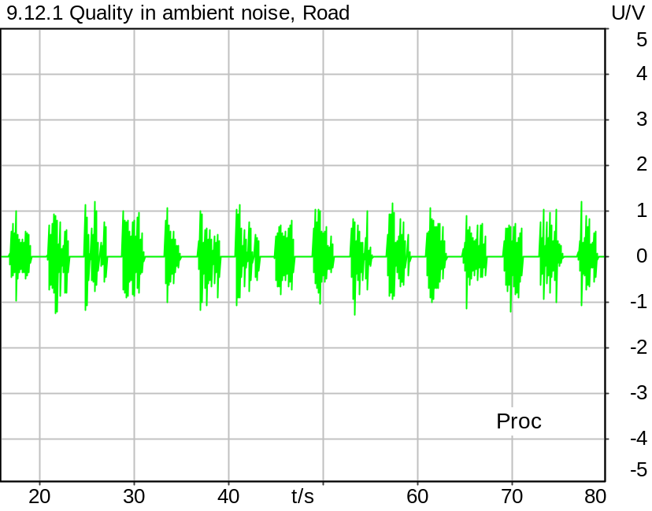

Time range: 16.0 .. 20.0 s
G-MOS (TS 103 281 (Model A)) | 3.40
N-MOS (TS 103 281 (Model A)) | 3.62
S-MOS (TS 103 281 (Model A)) | 3.82
SNR (unweighted) | 22.18 dB
SNR (A-weighted noise) | 31.95 dB
Delay | 31.7 ms
Speech Level | -20.66 dB
Equivalent Rectangular Bandwidth | 15343.48 Hz
Maximum Correlation | 57.44 %
Time range: 20.0 .. 24.0 s
G-MOS (TS 103 281 (Model A)) | 3.45
N-MOS (TS 103 281 (Model A)) | 3.70
S-MOS (TS 103 281 (Model A)) | 3.98
SNR (unweighted) | 27.20 dB
SNR (A-weighted noise) | 34.63 dB
Delay | 30.6 ms
Speech Level | -18.38 dB
Equivalent Rectangular Bandwidth | 17153.66 Hz
Maximum Correlation | 68.57 %
Time range: 24.0 .. 28.0 s
G-MOS (TS 103 281 (Model A)) | 2.77
N-MOS (TS 103 281 (Model A)) | 4.09
S-MOS (TS 103 281 (Model A)) | 3.18
SNR (unweighted) | 30.48 dB
SNR (A-weighted noise) | 35.24 dB
Delay | 30.6 ms
Speech Level | -21.79 dB
Equivalent Rectangular Bandwidth | 14412.56 Hz
Maximum Correlation | 65.15 %
Time range: 28.0 .. 32.0 s
G-MOS (TS 103 281 (Model A)) | 3.71
N-MOS (TS 103 281 (Model A)) | 4.13
S-MOS (TS 103 281 (Model A)) | 4.11
SNR (unweighted) | 36.61 dB
SNR (A-weighted noise) | 40.96 dB
Delay | 31.0 ms
Speech Level | -18.38 dB
Equivalent Rectangular Bandwidth | 14095.62 Hz
Maximum Correlation | 76.98 %
Time range: 32.0 .. 36.0 s
G-MOS (TS 103 281 (Model A)) | 3.31
N-MOS (TS 103 281 (Model A)) | 3.66
S-MOS (TS 103 281 (Model A)) | 3.62
SNR (unweighted) | 20.44 dB
SNR (A-weighted noise) | 27.21 dB
Delay | 32.1 ms
Speech Level | -19.23 dB
Equivalent Rectangular Bandwidth | 12597.03 Hz
Maximum Correlation | 67.38 %
Time range: 36.0 .. 40.0 s
G-MOS (TS 103 281 (Model A)) | 3.25
N-MOS (TS 103 281 (Model A)) | 3.45
S-MOS (TS 103 281 (Model A)) | 3.65
SNR (unweighted) | 25.46 dB
SNR (A-weighted noise) | 27.73 dB
Delay | 30.4 ms
Speech Level | -20.58 dB
Equivalent Rectangular Bandwidth | 15876.17 Hz
Maximum Correlation | 77.10 %
Time range: 40.0 .. 44.0 s
G-MOS (TS 103 281 (Model A)) | 3.18
N-MOS (TS 103 281 (Model A)) | 3.67
S-MOS (TS 103 281 (Model A)) | 3.59
SNR (unweighted) | 29.09 dB
SNR (A-weighted noise) | 30.55 dB
Delay | 30.7 ms
Speech Level | -20.92 dB
Equivalent Rectangular Bandwidth | 15412.25 Hz
Maximum Correlation | 53.00 %
Time range: 44.0 .. 48.0 s
G-MOS (TS 103 281 (Model A)) | 3.91
N-MOS (TS 103 281 (Model A)) | 4.26
S-MOS (TS 103 281 (Model A)) | 4.34
SNR (unweighted) | 35.45 dB
SNR (A-weighted noise) | 43.71 dB
Delay | 30.9 ms
Speech Level | -18.67 dB
Equivalent Rectangular Bandwidth | 14133.27 Hz
Maximum Correlation | 72.84 %
Time range: 48.0 .. 52.0 s
G-MOS (TS 103 281 (Model A)) | 3.17
N-MOS (TS 103 281 (Model A)) | 3.27
S-MOS (TS 103 281 (Model A)) | 3.76
SNR (unweighted) | 23.80 dB
SNR (A-weighted noise) | 26.42 dB
Delay | 31.3 ms
Speech Level | -19.41 dB
Equivalent Rectangular Bandwidth | 15937.91 Hz
Maximum Correlation | 61.76 %
Time range: 52.0 .. 56.0 s
G-MOS (TS 103 281 (Model A)) | 3.44
N-MOS (TS 103 281 (Model A)) | 4.14
S-MOS (TS 103 281 (Model A)) | 3.71
SNR (unweighted) | 27.01 dB
SNR (A-weighted noise) | 32.17 dB
Delay | 30.5 ms
Speech Level | -20.09 dB
Equivalent Rectangular Bandwidth | 14108.77 Hz
Maximum Correlation | 72.38 %
Time range: 56.0 .. 60.0 s
G-MOS (TS 103 281 (Model A)) | 3.41
N-MOS (TS 103 281 (Model A)) | 4.51
S-MOS (TS 103 281 (Model A)) | 3.70
SNR (unweighted) | 39.25 dB
SNR (A-weighted noise) | 44.02 dB
Delay | 30.3 ms
Speech Level | -20.34 dB
Equivalent Rectangular Bandwidth | 14544.65 Hz
Maximum Correlation | 60.61 %
Time range: 60.0 .. 64.0 s
G-MOS (TS 103 281 (Model A)) | 3.47
N-MOS (TS 103 281 (Model A)) | 3.70
S-MOS (TS 103 281 (Model A)) | 4.02
SNR (unweighted) | 31.35 dB
SNR (A-weighted noise) | 33.61 dB
Delay | 30.9 ms
Speech Level | -19.66 dB
Equivalent Rectangular Bandwidth | 15707.52 Hz
Maximum Correlation | 72.57 %
Time range: 64.0 .. 68.0 s
G-MOS (TS 103 281 (Model A)) | 3.20
N-MOS (TS 103 281 (Model A)) | 4.03
S-MOS (TS 103 281 (Model A)) | 3.61
SNR (unweighted) | 32.16 dB
SNR (A-weighted noise) | 37.85 dB
Delay | 32.1 ms
Speech Level | -19.65 dB
Equivalent Rectangular Bandwidth | 13846.83 Hz
Maximum Correlation | 59.93 %
Time range: 68.0 .. 72.0 s
G-MOS (TS 103 281 (Model A)) | 3.67
N-MOS (TS 103 281 (Model A)) | 4.10
S-MOS (TS 103 281 (Model A)) | 4.19
SNR (unweighted) | 29.95 dB
SNR (A-weighted noise) | 41.18 dB
Delay | 30.3 ms
Speech Level | -17.41 dB
Equivalent Rectangular Bandwidth | 17493.70 Hz
Maximum Correlation | 69.63 %
Time range: 72.0 .. 76.0 s
G-MOS (TS 103 281 (Model A)) | 3.59
N-MOS (TS 103 281 (Model A)) | 4.44
S-MOS (TS 103 281 (Model A)) | 3.84
SNR (unweighted) | 37.24 dB
SNR (A-weighted noise) | 41.58 dB
Delay | 31.7 ms
Speech Level | -20.84 dB
Equivalent Rectangular Bandwidth | 16358.55 Hz
Maximum Correlation | 64.85 %
Time range: 76.0 .. 80.0 s
G-MOS (TS 103 281 (Model A)) | 3.49
N-MOS (TS 103 281 (Model A)) | 3.61
S-MOS (TS 103 281 (Model A)) | 4.17
SNR (unweighted) | 19.57 dB
SNR (A-weighted noise) | 30.62 dB
Delay | 30.7 ms
Speech Level | -19.46 dB
Equivalent Rectangular Bandwidth | 16267.85 Hz
Maximum Correlation | 72.87 %
G-MOS (Average, TS 103 281 (Model A)): 3.40
N-MOS (Average, TS 103 281 (Model A)): 3.90
S-MOS (Average, TS 103 281 (Model A)): 3.83
Delay (Average): 31.0 ms
G-MOS (Deviation): 0.26
N-MOS (Deviation): 0.36
S-MOS (Deviation): 0.29
Delay (Deviation): 0.6 ms

*According to TS 26.132, the N-MOS value must be corrected with the following formula:
N-MOS_corr = 1.438 * N-MOS - 1.959
This value will be used to check compliance with requirements.

Corrected N-MOS (Average, TS 103 281 (Model A)): 3.6

5/20/2025 1:59 PM ACQUA 6.0.200
Unmodified HEAD acoustics Measurement Descriptor

Meas. Setting DRP-off

Underlying Standard: 3GPP TS 26.131 V17.3.0 and 3GPP TS 26.132 V17.2.0
Database Version: 60_UG_TS26131_32_SWB_FB_Rev08_GCF_PTCRB

Source: 3quest_ng.dat
Level adjustment Channel 1 Gain 3.00 dB
Level adjustment Channel 2 Gain -90.00 dB
Level adjustment Channel 1 Gain 10.00 dB
FULLBAND Real Speech (20 sentences) at Channel 1
FULLBAND Real Speech (according to ETSI TS 103 106 Annex C, length 83s, 25 Hz high-pass filtered) +
Pause till end of file
Signal level (ch1): -14.7 dBV active speech level

Calibration
SND (1) 0.00 dB (Radio Tester 1 (CMW500))
Output ch. 1 0.00 dB
Output ch. 2 0.00 dB (Radio Tester 1 (CMW500))

Output Equalization/Filter
Mouth Eq. Ch.1 HATS 7 (B&K 5128) (5/28/2024 5:25 PM)

Analysis
Analyse Channel 1
Range start 16000.00 ms Range length 4000.00 ms
Number of seq. 16 Sequence length 4000.00 ms
3QUEST Version TS 103 281 (Model A) Bandwidth SWB/FB
Clean speech from Source File
Correction Level -1.6 dB (CORR_3QUEST_HASB, Corrected Speech Level SND)

Special Features
HFRP Corr. Ch.1: -2.4 dB (Nom. Value: 19.6 - HATS 7 (B&K 5128))
Compensate delay 277.2000 ms (D_SCRIPT, Original Delay Variable stored to D_SCRIPT: D_SND_EQ_HASB)
Store to variable MOS_HASB_Road Run Script after savemosvalues.py

Hardware Config Settings
Used Setting STD:5128_volte_3QUEST

labCORE Settings
labCORE Serial 77000280 Nickname
Firmware 3.7.5 Sync Source Internal
Clock Pitch 0.00 ppm
----------
labCORE Routing
Out Channel 1 -> Analog Out 1 -> ExternalAmplifier In -> HATS 7 (B&K 5128) Speaker
Out Channel 2 -> VoIP 1 -> Radio Tester 1 (CMW500) RF In/Out
Out Channel 2 -> VoIP 2
In Channel 1 <- VoIP In/Out 1 <- Radio Tester 1 (CMW500) RF In/Out
In Channel 2 <- Mic Amp. (Slot 6) In 2 <- Microphone 1 (46AG) Out
----------
Analog Out Mainboard Settings (Analog Out)
Range Ch. 1 0.00 dB Range Ch. 2 0.00 dB
----------
Microphone Settings (Mic Amp. (Slot 6))
Channel In 1 Settings
Range 114 dB[SPL] @ 12.5 mV/Pa Highpass 20Hz
Polarisation Voltage 200V Supply Voltage ±60V
Channel In 2 Settings
Range 114 dB[SPL] @ 12.5 mV/Pa Highpass 20Hz
Polarisation Voltage 200V Supply Voltage ±60V
Channel In 3 Settings
Range 132 dB[SPL] @ 12.5 mV/Pa Highpass 20Hz
Polarisation Voltage Off Supply Voltage ±60V
Channel In 4 Settings
Range 132 dB[SPL] @ 12.5 mV/Pa Highpass 20Hz
Polarisation Voltage Off Supply Voltage ±60V
----------
VoIP Settings (VoIP)
RTP Connection Streaming SIP Connection Unavailable
SIP Reg. State Unregistered Jitterbuffer Length 140
Jitter Buffer Reset On Playback Enabled Codec EVS/16000/1
Packet Length 20 Encoder Parameter ;evs-mode-switch=0;max-red=0;br=13.2;bw=swb;ch-aw-recv=-1
FMTP Parameter ;evs-mode-switch=0;bw=swb;br=13.2;ch-aw-recv=-1;max-red=220
Impairment Mode Off Impairment Type Off
----------
Artificial Head Settings (HATS 7 (B&K 5128))
Ser. Nr. BK_3408387 Pinna Type Type 4.3

HIB Settings
HIB Name 60020101 Serial 60020101
HIB Mode Mobile Measurement Impedance 32 Ohm
Gain out 1 -40.00 dB Gain out 2 0.00 dB
Gain in 1 0.00 dB Gain in 2 0.00 dB
Mic 1 Power Supply Off Mic 2 Power Supply Off

BGN Settings
BGN Software: HAE
BGN Scenario: Outside Traffic Road Binaural
Loops: Infinite

9.12.1 Quality in ambient noise, Crossroad
Handset Measurements Superwideband and Fullband \ Handset Measurements SuperWideband (HASB) \ Measurements with Background Noise \ 9.12.1 Quality in the Presence of Ambient Noise HASB
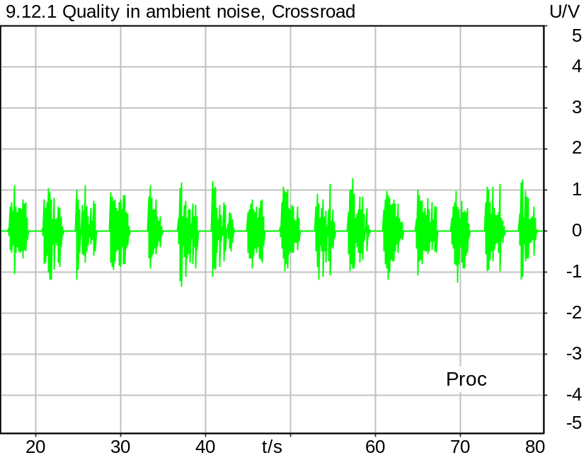

Time range: 16.0 .. 20.0 s
G-MOS (TS 103 281 (Model A)) | 3.90
N-MOS (TS 103 281 (Model A)) | 4.52
S-MOS (TS 103 281 (Model A)) | 3.98
SNR (unweighted) | 37.84 dB
SNR (A-weighted noise) | 43.40 dB
Delay | 31.0 ms
Speech Level | -19.20 dB
Equivalent Rectangular Bandwidth | 15852.13 Hz
Maximum Correlation | 58.08 %
Time range: 20.0 .. 24.0 s
G-MOS (TS 103 281 (Model A)) | 3.55
N-MOS (TS 103 281 (Model A)) | 3.99
S-MOS (TS 103 281 (Model A)) | 4.02
SNR (unweighted) | 20.23 dB
SNR (A-weighted noise) | 30.54 dB
Delay | 29.8 ms
Speech Level | -17.99 dB
Equivalent Rectangular Bandwidth | 16055.06 Hz
Maximum Correlation | 68.28 %
Time range: 24.0 .. 28.0 s
G-MOS (TS 103 281 (Model A)) | 3.51
N-MOS (TS 103 281 (Model A)) | 4.50
S-MOS (TS 103 281 (Model A)) | 3.66
SNR (unweighted) | 34.97 dB
SNR (A-weighted noise) | 38.61 dB
Delay | 29.8 ms
Speech Level | -21.47 dB
Equivalent Rectangular Bandwidth | 16619.61 Hz
Maximum Correlation | 66.29 %
Time range: 28.0 .. 32.0 s
G-MOS (TS 103 281 (Model A)) | 4.08
N-MOS (TS 103 281 (Model A)) | 4.60
S-MOS (TS 103 281 (Model A)) | 4.20
SNR (unweighted) | 30.42 dB
SNR (A-weighted noise) | 43.74 dB
Delay | 30.3 ms
Speech Level | -18.31 dB
Equivalent Rectangular Bandwidth | 15648.62 Hz
Maximum Correlation | 76.93 %
Time range: 32.0 .. 36.0 s
G-MOS (TS 103 281 (Model A)) | 3.54
N-MOS (TS 103 281 (Model A)) | 3.91
S-MOS (TS 103 281 (Model A)) | 4.15
SNR (unweighted) | 33.67 dB
SNR (A-weighted noise) | 38.84 dB
Delay | 31.4 ms
Speech Level | -19.00 dB
Equivalent Rectangular Bandwidth | 15707.08 Hz
Maximum Correlation | 69.14 %
Time range: 36.0 .. 40.0 s
G-MOS (TS 103 281 (Model A)) | 3.70
N-MOS (TS 103 281 (Model A)) | 4.28
S-MOS (TS 103 281 (Model A)) | 4.07
SNR (unweighted) | 36.44 dB
SNR (A-weighted noise) | 41.34 dB
Delay | 29.7 ms
Speech Level | -19.49 dB
Equivalent Rectangular Bandwidth | 17367.91 Hz
Maximum Correlation | 79.76 %
Time range: 40.0 .. 44.0 s
G-MOS (TS 103 281 (Model A)) | 3.80
N-MOS (TS 103 281 (Model A)) | 4.57
S-MOS (TS 103 281 (Model A)) | 3.92
SNR (unweighted) | 36.35 dB
SNR (A-weighted noise) | 40.55 dB
Delay | 30.0 ms
Speech Level | -20.77 dB
Equivalent Rectangular Bandwidth | 16998.76 Hz
Maximum Correlation | 53.24 %
Time range: 44.0 .. 48.0 s
G-MOS (TS 103 281 (Model A)) | 3.67
N-MOS (TS 103 281 (Model A)) | 4.24
S-MOS (TS 103 281 (Model A)) | 4.01
SNR (unweighted) | 28.51 dB
SNR (A-weighted noise) | 38.81 dB
Delay | 30.2 ms
Speech Level | -18.88 dB
Equivalent Rectangular Bandwidth | 14172.89 Hz
Maximum Correlation | 72.86 %
Time range: 48.0 .. 52.0 s
G-MOS (TS 103 281 (Model A)) | 3.80
N-MOS (TS 103 281 (Model A)) | 4.36
S-MOS (TS 103 281 (Model A)) | 4.19
SNR (unweighted) | 36.13 dB
SNR (A-weighted noise) | 43.05 dB
Delay | 30.5 ms
Speech Level | -18.70 dB
Equivalent Rectangular Bandwidth | 16309.14 Hz
Maximum Correlation | 63.00 %
Time range: 52.0 .. 56.0 s
G-MOS (TS 103 281 (Model A)) | 3.72
N-MOS (TS 103 281 (Model A)) | 4.30
S-MOS (TS 103 281 (Model A)) | 3.95
SNR (unweighted) | 24.64 dB
SNR (A-weighted noise) | 38.40 dB
Delay | 29.8 ms
Speech Level | -18.32 dB
Equivalent Rectangular Bandwidth | 14490.31 Hz
Maximum Correlation | 73.07 %
Time range: 56.0 .. 60.0 s
G-MOS (TS 103 281 (Model A)) | 3.72
N-MOS (TS 103 281 (Model A)) | 4.57
S-MOS (TS 103 281 (Model A)) | 3.82
SNR (unweighted) | 38.37 dB
SNR (A-weighted noise) | 45.10 dB
Delay | 29.6 ms
Speech Level | -19.65 dB
Equivalent Rectangular Bandwidth | 14614.86 Hz
Maximum Correlation | 60.55 %
Time range: 60.0 .. 64.0 s
G-MOS (TS 103 281 (Model A)) | 3.65
N-MOS (TS 103 281 (Model A)) | 4.02
S-MOS (TS 103 281 (Model A)) | 4.20
SNR (unweighted) | 15.29 dB
SNR (A-weighted noise) | 25.94 dB
Delay | 30.1 ms
Speech Level | -19.49 dB
Equivalent Rectangular Bandwidth | 15732.45 Hz
Maximum Correlation | 72.28 %
Time range: 64.0 .. 68.0 s
G-MOS (TS 103 281 (Model A)) | 3.65
N-MOS (TS 103 281 (Model A)) | 4.16
S-MOS (TS 103 281 (Model A)) | 4.00
SNR (unweighted) | 30.35 dB
SNR (A-weighted noise) | 35.96 dB
Delay | -45.9 ms
Speech Level | -19.29 dB
Equivalent Rectangular Bandwidth | 14460.67 Hz
Maximum Correlation | 59.93 %
Time range: 68.0 .. 72.0 s
G-MOS (TS 103 281 (Model A)) | 3.78
N-MOS (TS 103 281 (Model A)) | 4.44
S-MOS (TS 103 281 (Model A)) | 4.29
SNR (unweighted) | 30.31 dB
SNR (A-weighted noise) | 44.20 dB
Delay | -47.7 ms
Speech Level | -17.21 dB
Equivalent Rectangular Bandwidth | 17548.51 Hz
Maximum Correlation | 70.09 %
Time range: 72.0 .. 76.0 s
G-MOS (TS 103 281 (Model A)) | 3.43
N-MOS (TS 103 281 (Model A)) | 3.70
S-MOS (TS 103 281 (Model A)) | 3.89
SNR (unweighted) | 29.10 dB
SNR (A-weighted noise) | 33.34 dB
Delay | -46.3 ms
Speech Level | -20.66 dB
Equivalent Rectangular Bandwidth | 16352.73 Hz
Maximum Correlation | 64.71 %
Time range: 76.0 .. 80.0 s
G-MOS (TS 103 281 (Model A)) | 3.86
N-MOS (TS 103 281 (Model A)) | 4.40
S-MOS (TS 103 281 (Model A)) | 4.36
SNR (unweighted) | 38.54 dB
SNR (A-weighted noise) | 44.92 dB
Delay | -47.3 ms
Speech Level | -19.34 dB
Equivalent Rectangular Bandwidth | 14138.75 Hz
Maximum Correlation | 73.11 %
G-MOS (Average, TS 103 281 (Model A)): 3.71
N-MOS (Average, TS 103 281 (Model A)): 4.28
S-MOS (Average, TS 103 281 (Model A)): 4.04
Delay (Average): 10.9 ms
G-MOS (Deviation): 0.16
N-MOS (Deviation): 0.27
S-MOS (Deviation): 0.18
Delay (Deviation): 34.4 ms

*According to TS 26.132, the N-MOS value must be corrected with the following formula:
N-MOS_corr = 1.438 * N-MOS - 1.959
This value will be used to check compliance with requirements.

Corrected N-MOS (Average, TS 103 281 (Model A)): 4.2

5/20/2025 2:02 PM ACQUA 6.0.200
Unmodified HEAD acoustics Measurement Descriptor

Meas. Setting DRP-off

Underlying Standard: 3GPP TS 26.131 V17.3.0 and 3GPP TS 26.132 V17.2.0
Database Version: 60_UG_TS26131_32_SWB_FB_Rev08_GCF_PTCRB

Source: 3quest_ng.dat
Level adjustment Channel 1 Gain 3.00 dB
Level adjustment Channel 2 Gain -90.00 dB
Level adjustment Channel 1 Gain 10.00 dB
FULLBAND Real Speech (20 sentences) at Channel 1
FULLBAND Real Speech (according to ETSI TS 103 106 Annex C, length 83s, 25 Hz high-pass filtered) +
Pause till end of file
Signal level (ch1): -14.7 dBV active speech level

Calibration
SND (1) 0.00 dB (Radio Tester 1 (CMW500))
Output ch. 1 0.00 dB
Output ch. 2 0.00 dB (Radio Tester 1 (CMW500))

Output Equalization/Filter
Mouth Eq. Ch.1 HATS 7 (B&K 5128) (5/28/2024 5:25 PM)

Analysis
Analyse Channel 1
Range start 16000.00 ms Range length 4000.00 ms
Number of seq. 16 Sequence length 4000.00 ms
3QUEST Version TS 103 281 (Model A) Bandwidth SWB/FB
Clean speech from Source File
Correction Level -1.6 dB (CORR_3QUEST_HASB, Corrected Speech Level SND)

Special Features
HFRP Corr. Ch.1: -2.4 dB (Nom. Value: 19.6 - HATS 7 (B&K 5128))
Compensate delay 277.2000 ms (D_SCRIPT, Original Delay Variable stored to D_SCRIPT: D_SND_EQ_HASB)
Store to variable MOS_HASB_Crossroad Run Script after savemosvalues.py

Hardware Config Settings
Used Setting STD:5128_volte_3QUEST

labCORE Settings
labCORE Serial 77000280 Nickname
Firmware 3.7.5 Sync Source Internal
Clock Pitch 0.00 ppm
----------
labCORE Routing
Out Channel 1 -> Analog Out 1 -> ExternalAmplifier In -> HATS 7 (B&K 5128) Speaker
Out Channel 2 -> VoIP 1 -> Radio Tester 1 (CMW500) RF In/Out
Out Channel 2 -> VoIP 2
In Channel 1 <- VoIP In/Out 1 <- Radio Tester 1 (CMW500) RF In/Out
In Channel 2 <- Mic Amp. (Slot 6) In 2 <- Microphone 1 (46AG) Out
----------
Analog Out Mainboard Settings (Analog Out)
Range Ch. 1 0.00 dB Range Ch. 2 0.00 dB
----------
Microphone Settings (Mic Amp. (Slot 6))
Channel In 1 Settings
Range 114 dB[SPL] @ 12.5 mV/Pa Highpass 20Hz
Polarisation Voltage 200V Supply Voltage ±60V
Channel In 2 Settings
Range 114 dB[SPL] @ 12.5 mV/Pa Highpass 20Hz
Polarisation Voltage 200V Supply Voltage ±60V
Channel In 3 Settings
Range 132 dB[SPL] @ 12.5 mV/Pa Highpass 20Hz
Polarisation Voltage Off Supply Voltage ±60V
Channel In 4 Settings
Range 132 dB[SPL] @ 12.5 mV/Pa Highpass 20Hz
Polarisation Voltage Off Supply Voltage ±60V
----------
VoIP Settings (VoIP)
RTP Connection Streaming SIP Connection Unavailable
SIP Reg. State Unregistered Jitterbuffer Length 140
Jitter Buffer Reset On Playback Enabled Codec EVS/16000/1
Packet Length 20 Encoder Parameter ;evs-mode-switch=0;max-red=0;br=13.2;bw=swb;ch-aw-recv=-1
FMTP Parameter ;evs-mode-switch=0;bw=swb;br=13.2;ch-aw-recv=-1;max-red=220
Impairment Mode Off Impairment Type Off
----------
Artificial Head Settings (HATS 7 (B&K 5128))
Ser. Nr. BK_3408387 Pinna Type Type 4.3

HIB Settings
HIB Name 60020101 Serial 60020101
HIB Mode Mobile Measurement Impedance 32 Ohm
Gain out 1 -40.00 dB Gain out 2 0.00 dB
Gain in 1 0.00 dB Gain in 2 0.00 dB
Mic 1 Power Supply Off Mic 2 Power Supply Off

BGN Settings
BGN Software: HAE
BGN Scenario: Outside Traffic Crossroads Binaural
Loops: Infinite

9.12.1 Quality in ambient noise, Train Station
Handset Measurements Superwideband and Fullband \ Handset Measurements SuperWideband (HASB) \ Measurements with Background Noise \ 9.12.1 Quality in the Presence of Ambient Noise HASB
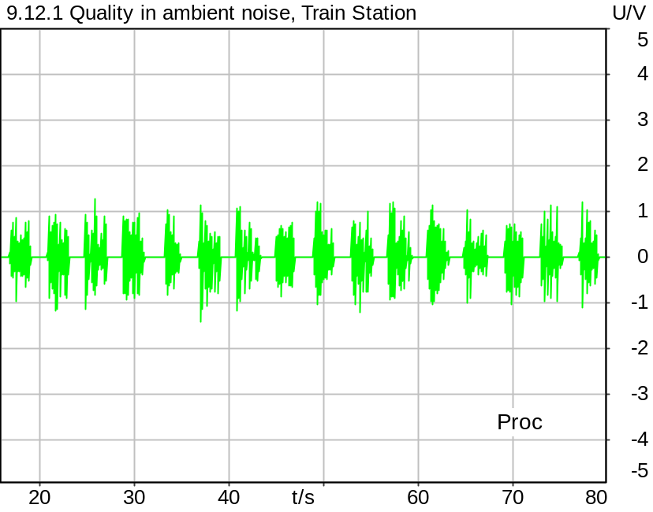

Time range: 16.0 .. 20.0 s
G-MOS (TS 103 281 (Model A)) | 3.68
N-MOS (TS 103 281 (Model A)) | 4.22
S-MOS (TS 103 281 (Model A)) | 4.00
SNR (unweighted) | 35.97 dB
SNR (A-weighted noise) | 38.34 dB
Delay | 33.5 ms
Speech Level | -20.22 dB
Equivalent Rectangular Bandwidth | 15779.83 Hz
Maximum Correlation | 58.54 %
Time range: 20.0 .. 24.0 s
G-MOS (TS 103 281 (Model A)) | 3.63
N-MOS (TS 103 281 (Model A)) | 4.21
S-MOS (TS 103 281 (Model A)) | 3.91
SNR (unweighted) | 36.93 dB
SNR (A-weighted noise) | 43.86 dB
Delay | 31.8 ms
Speech Level | -18.30 dB
Equivalent Rectangular Bandwidth | 16261.50 Hz
Maximum Correlation | 68.53 %
Time range: 24.0 .. 28.0 s
G-MOS (TS 103 281 (Model A)) | 3.60
N-MOS (TS 103 281 (Model A)) | 4.25
S-MOS (TS 103 281 (Model A)) | 3.87
SNR (unweighted) | 37.14 dB
SNR (A-weighted noise) | 41.67 dB
Delay | 31.8 ms
Speech Level | -20.66 dB
Equivalent Rectangular Bandwidth | 15901.18 Hz
Maximum Correlation | 66.20 %
Time range: 28.0 .. 32.0 s
G-MOS (TS 103 281 (Model A)) | 4.13
N-MOS (TS 103 281 (Model A)) | 4.61
S-MOS (TS 103 281 (Model A)) | 4.37
SNR (unweighted) | 40.67 dB
SNR (A-weighted noise) | 46.95 dB
Delay | 32.3 ms
Speech Level | -18.19 dB
Equivalent Rectangular Bandwidth | 14121.97 Hz
Maximum Correlation | 76.89 %
Time range: 32.0 .. 36.0 s
G-MOS (TS 103 281 (Model A)) | 3.73
N-MOS (TS 103 281 (Model A)) | 4.03
S-MOS (TS 103 281 (Model A)) | 4.26
SNR (unweighted) | 35.56 dB
SNR (A-weighted noise) | 39.36 dB
Delay | 33.4 ms
Speech Level | -18.82 dB
Equivalent Rectangular Bandwidth | 15983.10 Hz
Maximum Correlation | 68.43 %
Time range: 36.0 .. 40.0 s
G-MOS (TS 103 281 (Model A)) | 3.42
N-MOS (TS 103 281 (Model A)) | 3.71
S-MOS (TS 103 281 (Model A)) | 3.79
SNR (unweighted) | 30.65 dB
SNR (A-weighted noise) | 33.45 dB
Delay | 31.6 ms
Speech Level | -20.17 dB
Equivalent Rectangular Bandwidth | 14128.89 Hz
Maximum Correlation | 77.99 %
Time range: 40.0 .. 44.0 s
G-MOS (TS 103 281 (Model A)) | 3.44
N-MOS (TS 103 281 (Model A)) | 4.53
S-MOS (TS 103 281 (Model A)) | 3.69
SNR (unweighted) | 38.88 dB
SNR (A-weighted noise) | 42.22 dB
Delay | 31.9 ms
Speech Level | -20.98 dB
Equivalent Rectangular Bandwidth | 15221.40 Hz
Maximum Correlation | 52.65 %
Time range: 44.0 .. 48.0 s
G-MOS (TS 103 281 (Model A)) | 3.83
N-MOS (TS 103 281 (Model A)) | 4.37
S-MOS (TS 103 281 (Model A)) | 4.17
SNR (unweighted) | 41.87 dB
SNR (A-weighted noise) | 45.38 dB
Delay | 32.1 ms
Speech Level | -18.66 dB
Equivalent Rectangular Bandwidth | 14597.04 Hz
Maximum Correlation | 72.71 %
Time range: 48.0 .. 52.0 s
G-MOS (TS 103 281 (Model A)) | 3.79
N-MOS (TS 103 281 (Model A)) | 4.16
S-MOS (TS 103 281 (Model A)) | 4.20
SNR (unweighted) | 36.06 dB
SNR (A-weighted noise) | 39.02 dB
Delay | 32.5 ms
Speech Level | -18.80 dB
Equivalent Rectangular Bandwidth | 16701.43 Hz
Maximum Correlation | 63.04 %
Time range: 52.0 .. 56.0 s
G-MOS (TS 103 281 (Model A)) | 3.57
N-MOS (TS 103 281 (Model A)) | 4.20
S-MOS (TS 103 281 (Model A)) | 3.89
SNR (unweighted) | 29.62 dB
SNR (A-weighted noise) | 35.72 dB
Delay | 31.7 ms
Speech Level | -18.33 dB
Equivalent Rectangular Bandwidth | 14398.17 Hz
Maximum Correlation | 73.73 %
Time range: 56.0 .. 60.0 s
G-MOS (TS 103 281 (Model A)) | 3.85
N-MOS (TS 103 281 (Model A)) | 4.52
S-MOS (TS 103 281 (Model A)) | 3.91
SNR (unweighted) | 41.41 dB
SNR (A-weighted noise) | 46.88 dB
Delay | 31.6 ms
Speech Level | -19.50 dB
Equivalent Rectangular Bandwidth | 15671.67 Hz
Maximum Correlation | 60.86 %
Time range: 60.0 .. 64.0 s
G-MOS (TS 103 281 (Model A)) | 4.02
N-MOS (TS 103 281 (Model A)) | 4.53
S-MOS (TS 103 281 (Model A)) | 4.22
SNR (unweighted) | 37.22 dB
SNR (A-weighted noise) | 45.54 dB
Delay | 32.1 ms
Speech Level | -19.48 dB
Equivalent Rectangular Bandwidth | 15182.01 Hz
Maximum Correlation | 72.49 %
Time range: 64.0 .. 68.0 s
G-MOS (TS 103 281 (Model A)) | 3.42
N-MOS (TS 103 281 (Model A)) | 3.67
S-MOS (TS 103 281 (Model A)) | 3.91
SNR (unweighted) | 28.25 dB
SNR (A-weighted noise) | 32.58 dB
Delay | 33.4 ms
Speech Level | -20.65 dB
Equivalent Rectangular Bandwidth | 15735.42 Hz
Maximum Correlation | 57.01 %
Time range: 68.0 .. 72.0 s
G-MOS (TS 103 281 (Model A)) | 3.74
N-MOS (TS 103 281 (Model A)) | 4.08
S-MOS (TS 103 281 (Model A)) | 4.27
SNR (unweighted) | 37.11 dB
SNR (A-weighted noise) | 40.47 dB
Delay | 31.5 ms
Speech Level | -17.31 dB
Equivalent Rectangular Bandwidth | 14305.53 Hz
Maximum Correlation | 70.39 %
Time range: 72.0 .. 76.0 s
G-MOS (TS 103 281 (Model A)) | 3.57
N-MOS (TS 103 281 (Model A)) | 4.09
S-MOS (TS 103 281 (Model A)) | 3.82
SNR (unweighted) | 35.34 dB
SNR (A-weighted noise) | 39.18 dB
Delay | 32.9 ms
Speech Level | -21.06 dB
Equivalent Rectangular Bandwidth | 16469.86 Hz
Maximum Correlation | 64.52 %
Time range: 76.0 .. 80.0 s
G-MOS (TS 103 281 (Model A)) | 3.97
N-MOS (TS 103 281 (Model A)) | 4.47
S-MOS (TS 103 281 (Model A)) | 4.30
SNR (unweighted) | 36.69 dB
SNR (A-weighted noise) | 40.78 dB
Delay | 32.0 ms
Speech Level | -19.40 dB
Equivalent Rectangular Bandwidth | 16140.96 Hz
Maximum Correlation | 72.46 %
G-MOS (Average, TS 103 281 (Model A)): 3.71
N-MOS (Average, TS 103 281 (Model A)): 4.23
S-MOS (Average, TS 103 281 (Model A)): 4.04
Delay (Average): 32.3 ms
G-MOS (Deviation): 0.21
N-MOS (Deviation): 0.28
S-MOS (Deviation): 0.21
Delay (Deviation): 0.7 ms

*According to TS 26.132, the N-MOS value must be corrected with the following formula:
N-MOS_corr = 1.438 * N-MOS - 1.959
This value will be used to check compliance with requirements.

Corrected N-MOS (Average, TS 103 281 (Model A)): 4.1

5/20/2025 2:04 PM ACQUA 6.0.200
Unmodified HEAD acoustics Measurement Descriptor

Meas. Setting DRP-off

Underlying Standard: 3GPP TS 26.131 V17.3.0 and 3GPP TS 26.132 V17.2.0
Database Version: 60_UG_TS26131_32_SWB_FB_Rev08_GCF_PTCRB

Source: 3quest_ng.dat
Level adjustment Channel 1 Gain 3.00 dB
Level adjustment Channel 2 Gain -90.00 dB
Level adjustment Channel 1 Gain 10.00 dB
FULLBAND Real Speech (20 sentences) at Channel 1
FULLBAND Real Speech (according to ETSI TS 103 106 Annex C, length 83s, 25 Hz high-pass filtered) +
Pause till end of file
Signal level (ch1): -14.7 dBV active speech level

Calibration
SND (1) 0.00 dB (Radio Tester 1 (CMW500))
Output ch. 1 0.00 dB
Output ch. 2 0.00 dB (Radio Tester 1 (CMW500))

Output Equalization/Filter
Mouth Eq. Ch.1 HATS 7 (B&K 5128) (5/28/2024 5:25 PM)

Analysis
Analyse Channel 1
Range start 16000.00 ms Range length 4000.00 ms
Number of seq. 16 Sequence length 4000.00 ms
3QUEST Version TS 103 281 (Model A) Bandwidth SWB/FB
Clean speech from Source File
Correction Level -1.6 dB (CORR_3QUEST_HASB, Corrected Speech Level SND)

Special Features
HFRP Corr. Ch.1: -2.4 dB (Nom. Value: 19.6 - HATS 7 (B&K 5128))
Compensate delay 277.2000 ms (D_SCRIPT, Original Delay Variable stored to D_SCRIPT: D_SND_EQ_HASB)
Store to variable MOS_HASB_TStation Run Script after savemosvalues.py

Hardware Config Settings
Used Setting STD:5128_volte_3QUEST

labCORE Settings
labCORE Serial 77000280 Nickname
Firmware 3.7.5 Sync Source Internal
Clock Pitch 0.00 ppm
----------
labCORE Routing
Out Channel 1 -> Analog Out 1 -> ExternalAmplifier In -> HATS 7 (B&K 5128) Speaker
Out Channel 2 -> VoIP 1 -> Radio Tester 1 (CMW500) RF In/Out
Out Channel 2 -> VoIP 2
In Channel 1 <- VoIP In/Out 1 <- Radio Tester 1 (CMW500) RF In/Out
In Channel 2 <- Mic Amp. (Slot 6) In 2 <- Microphone 1 (46AG) Out
----------
Analog Out Mainboard Settings (Analog Out)
Range Ch. 1 0.00 dB Range Ch. 2 0.00 dB
----------
Microphone Settings (Mic Amp. (Slot 6))
Channel In 1 Settings
Range 114 dB[SPL] @ 12.5 mV/Pa Highpass 20Hz
Polarisation Voltage 200V Supply Voltage ±60V
Channel In 2 Settings
Range 114 dB[SPL] @ 12.5 mV/Pa Highpass 20Hz
Polarisation Voltage 200V Supply Voltage ±60V
Channel In 3 Settings
Range 132 dB[SPL] @ 12.5 mV/Pa Highpass 20Hz
Polarisation Voltage Off Supply Voltage ±60V
Channel In 4 Settings
Range 132 dB[SPL] @ 12.5 mV/Pa Highpass 20Hz
Polarisation Voltage Off Supply Voltage ±60V
----------
VoIP Settings (VoIP)
RTP Connection Streaming SIP Connection Unavailable
SIP Reg. State Unregistered Jitterbuffer Length 140
Jitter Buffer Reset On Playback Enabled Codec EVS/16000/1
Packet Length 20 Encoder Parameter ;evs-mode-switch=0;max-red=0;br=13.2;bw=swb;ch-aw-recv=-1
FMTP Parameter ;evs-mode-switch=0;bw=swb;br=13.2;ch-aw-recv=-1;max-red=220
Impairment Mode Off Impairment Type Off
----------
Artificial Head Settings (HATS 7 (B&K 5128))
Ser. Nr. BK_3408387 Pinna Type Type 4.3

HIB Settings
HIB Name 60020101 Serial 60020101
HIB Mode Mobile Measurement Impedance 32 Ohm
Gain out 1 -40.00 dB Gain out 2 0.00 dB
Gain in 1 0.00 dB Gain in 2 0.00 dB
Mic 1 Power Supply Off Mic 2 Power Supply Off

BGN Settings
BGN Software: HAE
BGN Scenario: Train Station Binaural
Loops: Infinite

9.12.1 Quality in ambient noise, Fullsize Car 130 km/h
Handset Measurements Superwideband and Fullband \ Handset Measurements SuperWideband (HASB) \ Measurements with Background Noise \ 9.12.1 Quality in the Presence of Ambient Noise HASB
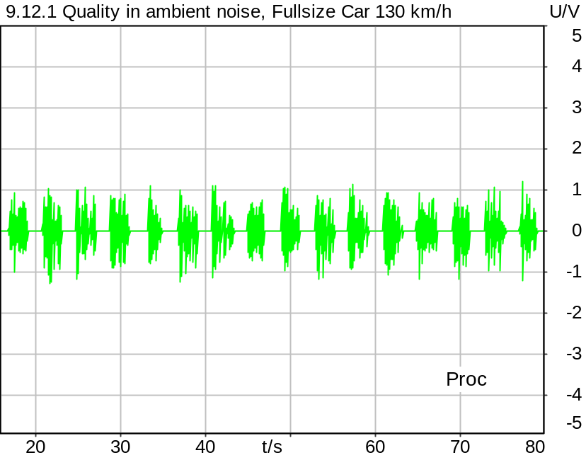

Time range: 16.0 .. 20.0 s
G-MOS (TS 103 281 (Model A)) | 3.71
N-MOS (TS 103 281 (Model A)) | 4.37
S-MOS (TS 103 281 (Model A)) | 3.95
SNR (unweighted) | 31.52 dB
SNR (A-weighted noise) | 39.51 dB
Delay | 32.7 ms
Speech Level | -19.94 dB
Equivalent Rectangular Bandwidth | 14096.44 Hz
Maximum Correlation | 58.56 %
Time range: 20.0 .. 24.0 s
G-MOS (TS 103 281 (Model A)) | 3.59
N-MOS (TS 103 281 (Model A)) | 4.35
S-MOS (TS 103 281 (Model A)) | 3.83
SNR (unweighted) | 32.24 dB
SNR (A-weighted noise) | 39.55 dB
Delay | 31.0 ms
Speech Level | -18.35 dB
Equivalent Rectangular Bandwidth | 14146.72 Hz
Maximum Correlation | 68.54 %
Time range: 24.0 .. 28.0 s
G-MOS (TS 103 281 (Model A)) | 3.14
N-MOS (TS 103 281 (Model A)) | 4.49
S-MOS (TS 103 281 (Model A)) | 3.44
SNR (unweighted) | 31.86 dB
SNR (A-weighted noise) | 39.43 dB
Delay | 31.0 ms
Speech Level | -21.55 dB
Equivalent Rectangular Bandwidth | 15061.44 Hz
Maximum Correlation | 66.52 %
Time range: 28.0 .. 32.0 s
G-MOS (TS 103 281 (Model A)) | 3.50
N-MOS (TS 103 281 (Model A)) | 4.42
S-MOS (TS 103 281 (Model A)) | 3.71
SNR (unweighted) | 23.71 dB
SNR (A-weighted noise) | 36.36 dB
Delay | 31.5 ms
Speech Level | -18.84 dB
Equivalent Rectangular Bandwidth | 14001.72 Hz
Maximum Correlation | 75.91 %
Time range: 32.0 .. 36.0 s
G-MOS (TS 103 281 (Model A)) | 3.53
N-MOS (TS 103 281 (Model A)) | 4.41
S-MOS (TS 103 281 (Model A)) | 3.69
SNR (unweighted) | 30.43 dB
SNR (A-weighted noise) | 37.45 dB
Delay | 32.6 ms
Speech Level | -19.36 dB
Equivalent Rectangular Bandwidth | 15528.85 Hz
Maximum Correlation | 67.62 %
Time range: 36.0 .. 40.0 s
G-MOS (TS 103 281 (Model A)) | 3.63
N-MOS (TS 103 281 (Model A)) | 4.14
S-MOS (TS 103 281 (Model A)) | 3.92
SNR (unweighted) | 23.21 dB
SNR (A-weighted noise) | 37.68 dB
Delay | 30.9 ms
Speech Level | -20.42 dB
Equivalent Rectangular Bandwidth | 14120.38 Hz
Maximum Correlation | 78.07 %
Time range: 40.0 .. 44.0 s
G-MOS (TS 103 281 (Model A)) | 3.07
N-MOS (TS 103 281 (Model A)) | 4.66
S-MOS (TS 103 281 (Model A)) | 3.33
SNR (unweighted) | 39.54 dB
SNR (A-weighted noise) | 44.24 dB
Delay | 31.2 ms
Speech Level | -21.46 dB
Equivalent Rectangular Bandwidth | 16899.00 Hz
Maximum Correlation | 52.47 %
Time range: 44.0 .. 48.0 s
G-MOS (TS 103 281 (Model A)) | 3.63
N-MOS (TS 103 281 (Model A)) | 4.17
S-MOS (TS 103 281 (Model A)) | 3.84
SNR (unweighted) | 20.81 dB
SNR (A-weighted noise) | 36.60 dB
Delay | 31.4 ms
Speech Level | -18.84 dB
Equivalent Rectangular Bandwidth | 14237.89 Hz
Maximum Correlation | 72.42 %
Time range: 48.0 .. 52.0 s
G-MOS (TS 103 281 (Model A)) | 3.65
N-MOS (TS 103 281 (Model A)) | 4.20
S-MOS (TS 103 281 (Model A)) | 4.02
SNR (unweighted) | 28.82 dB
SNR (A-weighted noise) | 38.64 dB
Delay | 31.7 ms
Speech Level | -18.77 dB
Equivalent Rectangular Bandwidth | 16232.34 Hz
Maximum Correlation | 62.60 %
Time range: 52.0 .. 56.0 s
G-MOS (TS 103 281 (Model A)) | 3.80
N-MOS (TS 103 281 (Model A)) | 4.60
S-MOS (TS 103 281 (Model A)) | 3.82
SNR (unweighted) | 33.19 dB
SNR (A-weighted noise) | 42.33 dB
Delay | 31.0 ms
Speech Level | -18.58 dB
Equivalent Rectangular Bandwidth | 16137.08 Hz
Maximum Correlation | 73.31 %
Time range: 56.0 .. 60.0 s
G-MOS (TS 103 281 (Model A)) | 3.63
N-MOS (TS 103 281 (Model A)) | 4.47
S-MOS (TS 103 281 (Model A)) | 3.85
SNR (unweighted) | 25.26 dB
SNR (A-weighted noise) | 38.45 dB
Delay | 30.8 ms
Speech Level | -20.63 dB
Equivalent Rectangular Bandwidth | 14980.86 Hz
Maximum Correlation | 61.75 %
Time range: 60.0 .. 64.0 s
G-MOS (TS 103 281 (Model A)) | 3.51
N-MOS (TS 103 281 (Model A)) | 4.19
S-MOS (TS 103 281 (Model A)) | 3.71
SNR (unweighted) | 25.67 dB
SNR (A-weighted noise) | 33.13 dB
Delay | 31.3 ms
Speech Level | -20.04 dB
Equivalent Rectangular Bandwidth | 15582.44 Hz
Maximum Correlation | 72.42 %
Time range: 64.0 .. 68.0 s
G-MOS (TS 103 281 (Model A)) | 3.67
N-MOS (TS 103 281 (Model A)) | 4.22
S-MOS (TS 103 281 (Model A)) | 3.88
SNR (unweighted) | 24.04 dB
SNR (A-weighted noise) | 35.03 dB
Delay | 32.6 ms
Speech Level | -19.48 dB
Equivalent Rectangular Bandwidth | 15908.78 Hz
Maximum Correlation | 58.65 %
Time range: 68.0 .. 72.0 s
G-MOS (TS 103 281 (Model A)) | 3.81
N-MOS (TS 103 281 (Model A)) | 4.50
S-MOS (TS 103 281 (Model A)) | 3.95
SNR (unweighted) | 34.30 dB
SNR (A-weighted noise) | 42.22 dB
Delay | 30.8 ms
Speech Level | -17.55 dB
Equivalent Rectangular Bandwidth | 16441.51 Hz
Maximum Correlation | 70.05 %
Time range: 72.0 .. 76.0 s
G-MOS (TS 103 281 (Model A)) | 3.54
N-MOS (TS 103 281 (Model A)) | 4.50
S-MOS (TS 103 281 (Model A)) | 3.78
SNR (unweighted) | 31.68 dB
SNR (A-weighted noise) | 38.85 dB
Delay | 32.2 ms
Speech Level | -21.24 dB
Equivalent Rectangular Bandwidth | 16252.15 Hz
Maximum Correlation | 64.04 %
Time range: 76.0 .. 80.0 s
G-MOS (TS 103 281 (Model A)) | 3.96
N-MOS (TS 103 281 (Model A)) | 4.50
S-MOS (TS 103 281 (Model A)) | 4.16
SNR (unweighted) | 28.59 dB
SNR (A-weighted noise) | 38.09 dB
Delay | 31.2 ms
Speech Level | -19.51 dB
Equivalent Rectangular Bandwidth | 14255.08 Hz
Maximum Correlation | 72.16 %
G-MOS (Average, TS 103 281 (Model A)): 3.59
N-MOS (Average, TS 103 281 (Model A)): 4.39
S-MOS (Average, TS 103 281 (Model A)): 3.80
Delay (Average): 31.5 ms
G-MOS (Deviation): 0.22
N-MOS (Deviation): 0.16
S-MOS (Deviation): 0.21
Delay (Deviation): 0.7 ms

*According to TS 26.132, the N-MOS value must be corrected with the following formula:
N-MOS_corr = 1.438 * N-MOS - 1.959
This value will be used to check compliance with requirements.

Corrected N-MOS (Average, TS 103 281 (Model A)): 4.3

5/20/2025 2:07 PM ACQUA 6.0.200
Unmodified HEAD acoustics Measurement Descriptor

Meas. Setting DRP-off

Underlying Standard: 3GPP TS 26.131 V17.3.0 and 3GPP TS 26.132 V17.2.0
Database Version: 60_UG_TS26131_32_SWB_FB_Rev08_GCF_PTCRB

Source: 3quest_ng.dat
Level adjustment Channel 1 Gain 3.00 dB
Level adjustment Channel 2 Gain -90.00 dB
Level adjustment Channel 1 Gain 10.00 dB
FULLBAND Real Speech (20 sentences) at Channel 1
FULLBAND Real Speech (according to ETSI TS 103 106 Annex C, length 83s, 25 Hz high-pass filtered) +
Pause till end of file
Signal level (ch1): -14.7 dBV active speech level

Calibration
SND (1) 0.00 dB (Radio Tester 1 (CMW500))
Output ch. 1 0.00 dB
Output ch. 2 0.00 dB (Radio Tester 1 (CMW500))

Output Equalization/Filter
Mouth Eq. Ch.1 HATS 7 (B&K 5128) (5/28/2024 5:25 PM)

Analysis
Analyse Channel 1
Range start 16000.00 ms Range length 4000.00 ms
Number of seq. 16 Sequence length 4000.00 ms
3QUEST Version TS 103 281 (Model A) Bandwidth SWB/FB
Clean speech from Source File
Correction Level -1.6 dB (CORR_3QUEST_HASB, Corrected Speech Level SND)

Special Features
HFRP Corr. Ch.1: -2.4 dB (Nom. Value: 19.6 - HATS 7 (B&K 5128))
Compensate delay 277.2000 ms (D_SCRIPT, Original Delay Variable stored to D_SCRIPT: D_SND_EQ_HASB)
Store to variable MOS_HASB_FullsizeCar Run Script after savemosvalues.py

Hardware Config Settings
Used Setting STD:5128_volte_3QUEST

labCORE Settings
labCORE Serial 77000280 Nickname
Firmware 3.7.5 Sync Source Internal
Clock Pitch 0.00 ppm
----------
labCORE Routing
Out Channel 1 -> Analog Out 1 -> ExternalAmplifier In -> HATS 7 (B&K 5128) Speaker
Out Channel 2 -> VoIP 1 -> Radio Tester 1 (CMW500) RF In/Out
Out Channel 2 -> VoIP 2
In Channel 1 <- VoIP In/Out 1 <- Radio Tester 1 (CMW500) RF In/Out
In Channel 2 <- Mic Amp. (Slot 6) In 2 <- Microphone 1 (46AG) Out
----------
Analog Out Mainboard Settings (Analog Out)
Range Ch. 1 0.00 dB Range Ch. 2 0.00 dB
----------
Microphone Settings (Mic Amp. (Slot 6))
Channel In 1 Settings
Range 114 dB[SPL] @ 12.5 mV/Pa Highpass 20Hz
Polarisation Voltage 200V Supply Voltage ±60V
Channel In 2 Settings
Range 114 dB[SPL] @ 12.5 mV/Pa Highpass 20Hz
Polarisation Voltage 200V Supply Voltage ±60V
Channel In 3 Settings
Range 132 dB[SPL] @ 12.5 mV/Pa Highpass 20Hz
Polarisation Voltage Off Supply Voltage ±60V
Channel In 4 Settings
Range 132 dB[SPL] @ 12.5 mV/Pa Highpass 20Hz
Polarisation Voltage Off Supply Voltage ±60V
----------
VoIP Settings (VoIP)
RTP Connection Streaming SIP Connection Unavailable
SIP Reg. State Unregistered Jitterbuffer Length 140
Jitter Buffer Reset On Playback Enabled Codec EVS/16000/1
Packet Length 20 Encoder Parameter ;evs-mode-switch=0;max-red=0;br=13.2;bw=swb;ch-aw-recv=-1
FMTP Parameter ;evs-mode-switch=0;bw=swb;br=13.2;ch-aw-recv=-1;max-red=220
Impairment Mode Off Impairment Type Off
----------
Artificial Head Settings (HATS 7 (B&K 5128))
Ser. Nr. BK_3408387 Pinna Type Type 4.3

HIB Settings
HIB Name 60020101 Serial 60020101
HIB Mode Mobile Measurement Impedance 32 Ohm
Gain out 1 -40.00 dB Gain out 2 0.00 dB
Gain in 1 0.00 dB Gain in 2 0.00 dB
Mic 1 Power Supply Off Mic 2 Power Supply Off

BGN Settings
BGN Software: HAE
BGN Scenario: Fullsize Car1 130Km/h Binaural
Loops: Infinite

9.12.1 Quality in ambient noise, Cafeteria
Handset Measurements Superwideband and Fullband \ Handset Measurements SuperWideband (HASB) \ Measurements with Background Noise \ 9.12.1 Quality in the Presence of Ambient Noise HASB
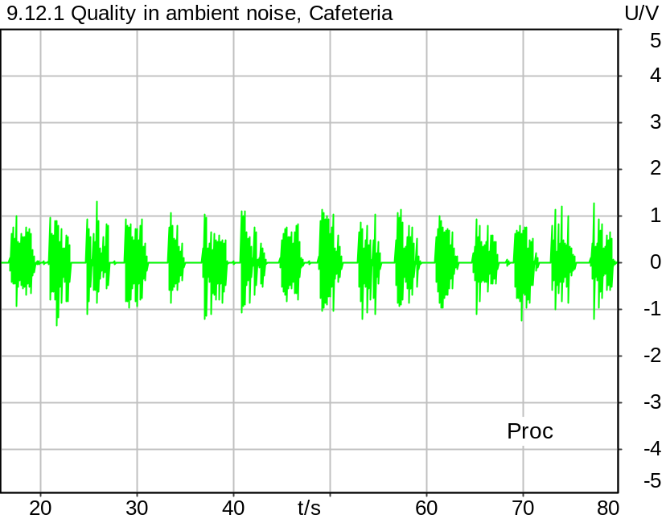

Time range: 16.0 .. 20.0 s
G-MOS (TS 103 281 (Model A)) | 3.07
N-MOS (TS 103 281 (Model A)) | 3.08
S-MOS (TS 103 281 (Model A)) | 3.78
SNR (unweighted) | 12.15 dB
SNR (A-weighted noise) | 15.68 dB
Delay | 31.9 ms
Speech Level | -19.07 dB
Equivalent Rectangular Bandwidth | 16659.27 Hz
Maximum Correlation | 58.40 %
Time range: 20.0 .. 24.0 s
G-MOS (TS 103 281 (Model A)) | 3.30
N-MOS (TS 103 281 (Model A)) | 3.41
S-MOS (TS 103 281 (Model A)) | 3.86
SNR (unweighted) | 25.52 dB
SNR (A-weighted noise) | 27.75 dB
Delay | 30.3 ms
Speech Level | -17.70 dB
Equivalent Rectangular Bandwidth | 15423.08 Hz
Maximum Correlation | 68.20 %
Time range: 24.0 .. 28.0 s
G-MOS (TS 103 281 (Model A)) | 3.39
N-MOS (TS 103 281 (Model A)) | 3.94
S-MOS (TS 103 281 (Model A)) | 3.80
SNR (unweighted) | 28.99 dB
SNR (A-weighted noise) | 32.58 dB
Delay | 30.3 ms
Speech Level | -20.58 dB
Equivalent Rectangular Bandwidth | 15383.95 Hz
Maximum Correlation | 66.10 %
Time range: 28.0 .. 32.0 s
G-MOS (TS 103 281 (Model A)) | 3.92
N-MOS (TS 103 281 (Model A)) | 4.26
S-MOS (TS 103 281 (Model A)) | 4.35
SNR (unweighted) | 36.83 dB
SNR (A-weighted noise) | 43.05 dB
Delay | 30.7 ms
Speech Level | -18.32 dB
Equivalent Rectangular Bandwidth | 14163.68 Hz
Maximum Correlation | 76.90 %
Time range: 32.0 .. 36.0 s
G-MOS (TS 103 281 (Model A)) | 3.56
N-MOS (TS 103 281 (Model A)) | 3.92
S-MOS (TS 103 281 (Model A)) | 4.19
SNR (unweighted) | 31.92 dB
SNR (A-weighted noise) | 36.04 dB
Delay | 31.8 ms
Speech Level | -18.93 dB
Equivalent Rectangular Bandwidth | 12798.08 Hz
Maximum Correlation | 68.55 %
Time range: 36.0 .. 40.0 s
G-MOS (TS 103 281 (Model A)) | 3.13
N-MOS (TS 103 281 (Model A)) | 3.17
S-MOS (TS 103 281 (Model A)) | 3.89
SNR (unweighted) | 12.98 dB
SNR (A-weighted noise) | 16.66 dB
Delay | 30.1 ms
Speech Level | -19.72 dB
Equivalent Rectangular Bandwidth | 16061.43 Hz
Maximum Correlation | 77.85 %
Time range: 40.0 .. 44.0 s
G-MOS (TS 103 281 (Model A)) | 3.07
N-MOS (TS 103 281 (Model A)) | 3.99
S-MOS (TS 103 281 (Model A)) | 3.41
SNR (unweighted) | 30.62 dB
SNR (A-weighted noise) | 31.96 dB
Delay | 31.3 ms
Speech Level | -20.34 dB
Equivalent Rectangular Bandwidth | 15837.28 Hz
Maximum Correlation | 52.92 %
Time range: 44.0 .. 48.0 s
G-MOS (TS 103 281 (Model A)) | 3.45
N-MOS (TS 103 281 (Model A)) | 3.72
S-MOS (TS 103 281 (Model A)) | 4.31
SNR (unweighted) | 25.18 dB
SNR (A-weighted noise) | 28.73 dB
Delay | 30.6 ms
Speech Level | -18.22 dB
Equivalent Rectangular Bandwidth | 13458.90 Hz
Maximum Correlation | 72.81 %
Time range: 48.0 .. 52.0 s
G-MOS (TS 103 281 (Model A)) | 3.04
N-MOS (TS 103 281 (Model A)) | 3.12
S-MOS (TS 103 281 (Model A)) | 3.79
SNR (unweighted) | 14.04 dB
SNR (A-weighted noise) | 17.89 dB
Delay | 31.0 ms
Speech Level | -18.15 dB
Equivalent Rectangular Bandwidth | 15322.84 Hz
Maximum Correlation | 62.73 %
Time range: 52.0 .. 56.0 s
G-MOS (TS 103 281 (Model A)) | 3.63
N-MOS (TS 103 281 (Model A)) | 4.33
S-MOS (TS 103 281 (Model A)) | 3.92
SNR (unweighted) | 38.35 dB
SNR (A-weighted noise) | 43.41 dB
Delay | 30.2 ms
Speech Level | -18.33 dB
Equivalent Rectangular Bandwidth | 14351.88 Hz
Maximum Correlation | 73.45 %
Time range: 56.0 .. 60.0 s
G-MOS (TS 103 281 (Model A)) | 3.18
N-MOS (TS 103 281 (Model A)) | 3.37
S-MOS (TS 103 281 (Model A)) | 3.75
SNR (unweighted) | 23.79 dB
SNR (A-weighted noise) | 25.31 dB
Delay | 30.0 ms
Speech Level | -19.28 dB
Equivalent Rectangular Bandwidth | 15919.25 Hz
Maximum Correlation | 60.15 %
Time range: 60.0 .. 64.0 s
G-MOS (TS 103 281 (Model A)) | 3.47
N-MOS (TS 103 281 (Model A)) | 3.88
S-MOS (TS 103 281 (Model A)) | 4.25
SNR (unweighted) | 33.56 dB
SNR (A-weighted noise) | 36.60 dB
Delay | 30.6 ms
Speech Level | -19.54 dB
Equivalent Rectangular Bandwidth | 15704.32 Hz
Maximum Correlation | 72.42 %
Time range: 64.0 .. 68.0 s
G-MOS (TS 103 281 (Model A)) | 3.47
N-MOS (TS 103 281 (Model A)) | 3.49
S-MOS (TS 103 281 (Model A)) | 3.86
SNR (unweighted) | 18.86 dB
SNR (A-weighted noise) | 23.92 dB
Delay | 31.9 ms
Speech Level | -19.51 dB
Equivalent Rectangular Bandwidth | 13527.92 Hz
Maximum Correlation | 57.08 %
Time range: 68.0 .. 72.0 s
G-MOS (TS 103 281 (Model A)) | 3.42
N-MOS (TS 103 281 (Model A)) | 3.48
S-MOS (TS 103 281 (Model A)) | 4.27
SNR (unweighted) | 17.04 dB
SNR (A-weighted noise) | 20.60 dB
Delay | 30.0 ms
Speech Level | -17.08 dB
Equivalent Rectangular Bandwidth | 17565.74 Hz
Maximum Correlation | 70.42 %
Time range: 72.0 .. 76.0 s
G-MOS (TS 103 281 (Model A)) | 3.41
N-MOS (TS 103 281 (Model A)) | 3.85
S-MOS (TS 103 281 (Model A)) | 3.90
SNR (unweighted) | 29.69 dB
SNR (A-weighted noise) | 32.66 dB
Delay | 31.4 ms
Speech Level | -20.34 dB
Equivalent Rectangular Bandwidth | 16003.03 Hz
Maximum Correlation | 65.54 %
Time range: 76.0 .. 80.0 s
G-MOS (TS 103 281 (Model A)) | 3.13
N-MOS (TS 103 281 (Model A)) | 3.14
S-MOS (TS 103 281 (Model A)) | 3.99
SNR (unweighted) | 9.59 dB
SNR (A-weighted noise) | 13.04 dB
Delay | 30.4 ms
Speech Level | -19.13 dB
Equivalent Rectangular Bandwidth | 16395.05 Hz
Maximum Correlation | 72.79 %
G-MOS (Average, TS 103 281 (Model A)): 3.35
N-MOS (Average, TS 103 281 (Model A)): 3.63
S-MOS (Average, TS 103 281 (Model A)): 3.96
Delay (Average): 30.8 ms
G-MOS (Deviation): 0.24
N-MOS (Deviation): 0.41
S-MOS (Deviation): 0.26
Delay (Deviation): 0.7 ms

*According to TS 26.132, the N-MOS value must be corrected with the following formula:
N-MOS_corr = 1.438 * N-MOS - 1.959
This value will be used to check compliance with requirements.

Corrected N-MOS (Average, TS 103 281 (Model A)): 3.3

5/20/2025 2:09 PM ACQUA 6.0.200
Unmodified HEAD acoustics Measurement Descriptor

Meas. Setting DRP-off

Underlying Standard: 3GPP TS 26.131 V17.3.0 and 3GPP TS 26.132 V17.2.0
Database Version: 60_UG_TS26131_32_SWB_FB_Rev08_GCF_PTCRB

Source: 3quest_ng.dat
Level adjustment Channel 1 Gain 3.00 dB
Level adjustment Channel 2 Gain -90.00 dB
Level adjustment Channel 1 Gain 10.00 dB
FULLBAND Real Speech (20 sentences) at Channel 1
FULLBAND Real Speech (according to ETSI TS 103 106 Annex C, length 83s, 25 Hz high-pass filtered) +
Pause till end of file
Signal level (ch1): -14.7 dBV active speech level

Calibration
SND (1) 0.00 dB (Radio Tester 1 (CMW500))
Output ch. 1 0.00 dB
Output ch. 2 0.00 dB (Radio Tester 1 (CMW500))

Output Equalization/Filter
Mouth Eq. Ch.1 HATS 7 (B&K 5128) (5/28/2024 5:25 PM)

Analysis
Analyse Channel 1
Range start 16000.00 ms Range length 4000.00 ms
Number of seq. 16 Sequence length 4000.00 ms
3QUEST Version TS 103 281 (Model A) Bandwidth SWB/FB
Clean speech from Source File
Correction Level -1.6 dB (CORR_3QUEST_HASB, Corrected Speech Level SND)

Special Features
HFRP Corr. Ch.1: -2.4 dB (Nom. Value: 19.6 - HATS 7 (B&K 5128))
Compensate delay 277.2000 ms (D_SCRIPT, Original Delay Variable stored to D_SCRIPT: D_SND_EQ_HASB)
Store to variable MOS_HASB_Cafeteria Run Script after savemosvalues.py

Hardware Config Settings
Used Setting STD:5128_volte_3QUEST

labCORE Settings
labCORE Serial 77000280 Nickname
Firmware 3.7.5 Sync Source Internal
Clock Pitch 0.00 ppm
----------
labCORE Routing
Out Channel 1 -> Analog Out 1 -> ExternalAmplifier In -> HATS 7 (B&K 5128) Speaker
Out Channel 2 -> VoIP 1 -> Radio Tester 1 (CMW500) RF In/Out
Out Channel 2 -> VoIP 2
In Channel 1 <- VoIP In/Out 1 <- Radio Tester 1 (CMW500) RF In/Out
In Channel 2 <- Mic Amp. (Slot 6) In 2 <- Microphone 1 (46AG) Out
----------
Analog Out Mainboard Settings (Analog Out)
Range Ch. 1 0.00 dB Range Ch. 2 0.00 dB
----------
Microphone Settings (Mic Amp. (Slot 6))
Channel In 1 Settings
Range 114 dB[SPL] @ 12.5 mV/Pa Highpass 20Hz
Polarisation Voltage 200V Supply Voltage ±60V
Channel In 2 Settings
Range 114 dB[SPL] @ 12.5 mV/Pa Highpass 20Hz
Polarisation Voltage 200V Supply Voltage ±60V
Channel In 3 Settings
Range 132 dB[SPL] @ 12.5 mV/Pa Highpass 20Hz
Polarisation Voltage Off Supply Voltage ±60V
Channel In 4 Settings
Range 132 dB[SPL] @ 12.5 mV/Pa Highpass 20Hz
Polarisation Voltage Off Supply Voltage ±60V
----------
VoIP Settings (VoIP)
RTP Connection Streaming SIP Connection Unavailable
SIP Reg. State Unregistered Jitterbuffer Length 140
Jitter Buffer Reset On Playback Enabled Codec EVS/16000/1
Packet Length 20 Encoder Parameter ;evs-mode-switch=0;max-red=0;br=13.2;bw=swb;ch-aw-recv=-1
FMTP Parameter ;evs-mode-switch=0;bw=swb;br=13.2;ch-aw-recv=-1;max-red=220
Impairment Mode Off Impairment Type Off
----------
Artificial Head Settings (HATS 7 (B&K 5128))
Ser. Nr. BK_3408387 Pinna Type Type 4.3

HIB Settings
HIB Name 60020101 Serial 60020101
HIB Mode Mobile Measurement Impedance 32 Ohm
Gain out 1 -40.00 dB Gain out 2 0.00 dB
Gain in 1 0.00 dB Gain in 2 0.00 dB
Mic 1 Power Supply Off Mic 2 Power Supply Off

BGN Settings
BGN Software: HAE
BGN Scenario: Cafeteria Noise Binaural
Loops: Infinite

9.12.1 Quality in ambient noise, Mensa
Handset Measurements Superwideband and Fullband \ Handset Measurements SuperWideband (HASB) \ Measurements with Background Noise \ 9.12.1 Quality in the Presence of Ambient Noise HASB
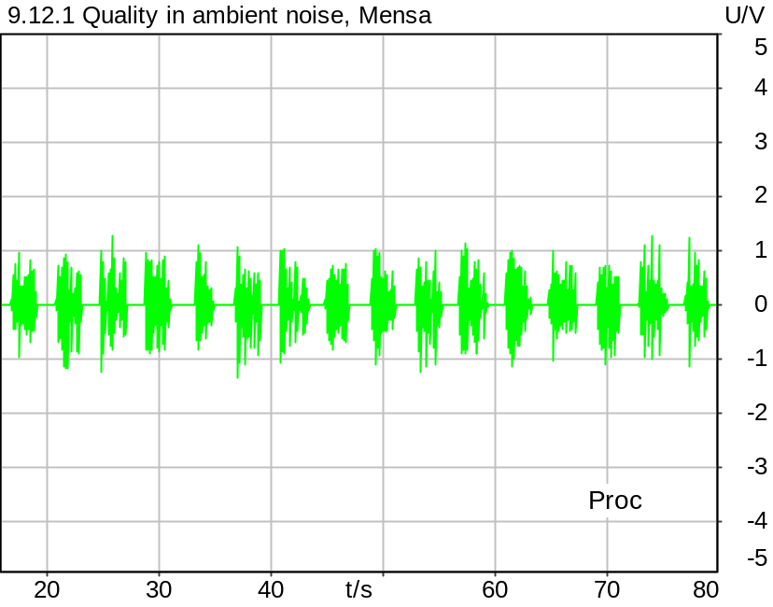

Time range: 16.0 .. 20.0 s
G-MOS (TS 103 281 (Model A)) | 3.66
N-MOS (TS 103 281 (Model A)) | 4.09
S-MOS (TS 103 281 (Model A)) | 4.07
SNR (unweighted) | 37.21 dB
SNR (A-weighted noise) | 40.26 dB
Delay | 34.0 ms
Speech Level | -19.55 dB
Equivalent Rectangular Bandwidth | 14101.98 Hz
Maximum Correlation | 59.10 %
Time range: 20.0 .. 24.0 s
G-MOS (TS 103 281 (Model A)) | 3.76
N-MOS (TS 103 281 (Model A)) | 4.26
S-MOS (TS 103 281 (Model A)) | 4.11
SNR (unweighted) | 40.50 dB
SNR (A-weighted noise) | 45.15 dB
Delay | 32.1 ms
Speech Level | -18.07 dB
Equivalent Rectangular Bandwidth | 17234.13 Hz
Maximum Correlation | 68.57 %
Time range: 24.0 .. 28.0 s
G-MOS (TS 103 281 (Model A)) | 3.42
N-MOS (TS 103 281 (Model A)) | 3.90
S-MOS (TS 103 281 (Model A)) | 3.81
SNR (unweighted) | 31.37 dB
SNR (A-weighted noise) | 31.75 dB
Delay | 32.2 ms
Speech Level | -20.49 dB
Equivalent Rectangular Bandwidth | 16338.14 Hz
Maximum Correlation | 66.29 %
Time range: 28.0 .. 32.0 s
G-MOS (TS 103 281 (Model A)) | 3.96
N-MOS (TS 103 281 (Model A)) | 4.50
S-MOS (TS 103 281 (Model A)) | 4.20
SNR (unweighted) | 34.07 dB
SNR (A-weighted noise) | 39.05 dB
Delay | 32.6 ms
Speech Level | -18.31 dB
Equivalent Rectangular Bandwidth | 14108.80 Hz
Maximum Correlation | 76.76 %
Time range: 32.0 .. 36.0 s
G-MOS (TS 103 281 (Model A)) | 3.53
N-MOS (TS 103 281 (Model A)) | 3.89
S-MOS (TS 103 281 (Model A)) | 4.25
SNR (unweighted) | 32.51 dB
SNR (A-weighted noise) | 35.43 dB
Delay | 33.7 ms
Speech Level | -18.83 dB
Equivalent Rectangular Bandwidth | 13380.43 Hz
Maximum Correlation | 69.01 %
Time range: 36.0 .. 40.0 s
G-MOS (TS 103 281 (Model A)) | 3.76
N-MOS (TS 103 281 (Model A)) | 4.18
S-MOS (TS 103 281 (Model A)) | 4.13
SNR (unweighted) | 38.40 dB
SNR (A-weighted noise) | 41.66 dB
Delay | 32.0 ms
Speech Level | -19.86 dB
Equivalent Rectangular Bandwidth | 17179.25 Hz
Maximum Correlation | 78.21 %
Time range: 40.0 .. 44.0 s
G-MOS (TS 103 281 (Model A)) | 3.60
N-MOS (TS 103 281 (Model A)) | 4.31
S-MOS (TS 103 281 (Model A)) | 4.06
SNR (unweighted) | 42.19 dB
SNR (A-weighted noise) | 44.77 dB
Delay | 33.5 ms
Speech Level | -20.29 dB
Equivalent Rectangular Bandwidth | 14927.26 Hz
Maximum Correlation | 52.20 %
Time range: 44.0 .. 48.0 s
G-MOS (TS 103 281 (Model A)) | 3.96
N-MOS (TS 103 281 (Model A)) | 4.19
S-MOS (TS 103 281 (Model A)) | 4.45
SNR (unweighted) | 38.83 dB
SNR (A-weighted noise) | 39.96 dB
Delay | 32.5 ms
Speech Level | -18.37 dB
Equivalent Rectangular Bandwidth | 15287.21 Hz
Maximum Correlation | 72.73 %
Time range: 48.0 .. 52.0 s
G-MOS (TS 103 281 (Model A)) | 3.84
N-MOS (TS 103 281 (Model A)) | 4.16
S-MOS (TS 103 281 (Model A)) | 4.21
SNR (unweighted) | 34.24 dB
SNR (A-weighted noise) | 39.00 dB
Delay | 33.6 ms
Speech Level | -18.72 dB
Equivalent Rectangular Bandwidth | 16291.35 Hz
Maximum Correlation | 63.16 %
Time range: 52.0 .. 56.0 s
G-MOS (TS 103 281 (Model A)) | 3.67
N-MOS (TS 103 281 (Model A)) | 4.28
S-MOS (TS 103 281 (Model A)) | 3.98
SNR (unweighted) | 35.83 dB
SNR (A-weighted noise) | 41.33 dB
Delay | 32.1 ms
Speech Level | -18.32 dB
Equivalent Rectangular Bandwidth | 13602.64 Hz
Maximum Correlation | 73.04 %
Time range: 56.0 .. 60.0 s
G-MOS (TS 103 281 (Model A)) | 3.64
N-MOS (TS 103 281 (Model A)) | 4.33
S-MOS (TS 103 281 (Model A)) | 3.94
SNR (unweighted) | 41.02 dB
SNR (A-weighted noise) | 43.91 dB
Delay | 31.9 ms
Speech Level | -19.44 dB
Equivalent Rectangular Bandwidth | 14729.26 Hz
Maximum Correlation | 60.47 %
Time range: 60.0 .. 64.0 s
G-MOS (TS 103 281 (Model A)) | 3.53
N-MOS (TS 103 281 (Model A)) | 3.89
S-MOS (TS 103 281 (Model A)) | 4.17
SNR (unweighted) | 32.73 dB
SNR (A-weighted noise) | 32.69 dB
Delay | 32.4 ms
Speech Level | -19.46 dB
Equivalent Rectangular Bandwidth | 15813.03 Hz
Maximum Correlation | 72.64 %
Time range: 64.0 .. 68.0 s
G-MOS (TS 103 281 (Model A)) | 3.89
N-MOS (TS 103 281 (Model A)) | 4.48
S-MOS (TS 103 281 (Model A)) | 4.15
SNR (unweighted) | 40.44 dB
SNR (A-weighted noise) | 44.20 dB
Delay | 33.7 ms
Speech Level | -19.20 dB
Equivalent Rectangular Bandwidth | 16065.68 Hz
Maximum Correlation | 59.42 %
Time range: 68.0 .. 72.0 s
G-MOS (TS 103 281 (Model A)) | 3.90
N-MOS (TS 103 281 (Model A)) | 4.21
S-MOS (TS 103 281 (Model A)) | 4.30
SNR (unweighted) | 39.43 dB
SNR (A-weighted noise) | 42.37 dB
Delay | 31.9 ms
Speech Level | -17.07 dB
Equivalent Rectangular Bandwidth | 17610.20 Hz
Maximum Correlation | 70.32 %
Time range: 72.0 .. 76.0 s
G-MOS (TS 103 281 (Model A)) | 3.51
N-MOS (TS 103 281 (Model A)) | 3.98
S-MOS (TS 103 281 (Model A)) | 3.92
SNR (unweighted) | 30.63 dB
SNR (A-weighted noise) | 34.05 dB
Delay | 33.3 ms
Speech Level | -20.60 dB
Equivalent Rectangular Bandwidth | 16150.51 Hz
Maximum Correlation | 65.20 %
Time range: 76.0 .. 80.0 s
G-MOS (TS 103 281 (Model A)) | 3.96
N-MOS (TS 103 281 (Model A)) | 4.13
S-MOS (TS 103 281 (Model A)) | 4.38
SNR (unweighted) | 37.02 dB
SNR (A-weighted noise) | 39.63 dB
Delay | 32.3 ms
Speech Level | -19.21 dB
Equivalent Rectangular Bandwidth | 14397.99 Hz
Maximum Correlation | 72.64 %
G-MOS (Average, TS 103 281 (Model A)): 3.73
N-MOS (Average, TS 103 281 (Model A)): 4.17
S-MOS (Average, TS 103 281 (Model A)): 4.13
Delay (Average): 32.7 ms
G-MOS (Deviation): 0.18
N-MOS (Deviation): 0.19
S-MOS (Deviation): 0.17
Delay (Deviation): 0.8 ms

*According to TS 26.132, the N-MOS value must be corrected with the following formula:
N-MOS_corr = 1.438 * N-MOS - 1.959
This value will be used to check compliance with requirements.

Corrected N-MOS (Average, TS 103 281 (Model A)): 4.0

5/20/2025 2:11 PM ACQUA 6.0.200
Unmodified HEAD acoustics Measurement Descriptor

Meas. Setting DRP-off

Underlying Standard: 3GPP TS 26.131 V17.3.0 and 3GPP TS 26.132 V17.2.0
Database Version: 60_UG_TS26131_32_SWB_FB_Rev08_GCF_PTCRB

Source: 3quest_ng.dat
Level adjustment Channel 1 Gain 3.00 dB
Level adjustment Channel 2 Gain -90.00 dB
Level adjustment Channel 1 Gain 10.00 dB
FULLBAND Real Speech (20 sentences) at Channel 1
FULLBAND Real Speech (according to ETSI TS 103 106 Annex C, length 83s, 25 Hz high-pass filtered) +
Pause till end of file
Signal level (ch1): -14.7 dBV active speech level

Calibration
SND (1) 0.00 dB (Radio Tester 1 (CMW500))
Output ch. 1 0.00 dB
Output ch. 2 0.00 dB (Radio Tester 1 (CMW500))

Output Equalization/Filter
Mouth Eq. Ch.1 HATS 7 (B&K 5128) (5/28/2024 5:25 PM)

Analysis
Analyse Channel 1
Range start 16000.00 ms Range length 4000.00 ms
Number of seq. 16 Sequence length 4000.00 ms
3QUEST Version TS 103 281 (Model A) Bandwidth SWB/FB
Clean speech from Source File
Correction Level -1.6 dB (CORR_3QUEST_HASB, Corrected Speech Level SND)

Special Features
HFRP Corr. Ch.1: -2.4 dB (Nom. Value: 19.6 - HATS 7 (B&K 5128))
Compensate delay 277.2000 ms (D_SCRIPT, Original Delay Variable stored to D_SCRIPT: D_SND_EQ_HASB)
Store to variable MOS_HASB_Mensa Run Script after savemosvalues.py

Hardware Config Settings
Used Setting STD:5128_volte_3QUEST

labCORE Settings
labCORE Serial 77000280 Nickname
Firmware 3.7.5 Sync Source Internal
Clock Pitch 0.00 ppm
----------
labCORE Routing
Out Channel 1 -> Analog Out 1 -> ExternalAmplifier In -> HATS 7 (B&K 5128) Speaker
Out Channel 2 -> VoIP 1 -> Radio Tester 1 (CMW500) RF In/Out
Out Channel 2 -> VoIP 2
In Channel 1 <- VoIP In/Out 1 <- Radio Tester 1 (CMW500) RF In/Out
In Channel 2 <- Mic Amp. (Slot 6) In 2 <- Microphone 1 (46AG) Out
----------
Analog Out Mainboard Settings (Analog Out)
Range Ch. 1 0.00 dB Range Ch. 2 0.00 dB
----------
Microphone Settings (Mic Amp. (Slot 6))
Channel In 1 Settings
Range 114 dB[SPL] @ 12.5 mV/Pa Highpass 20Hz
Polarisation Voltage 200V Supply Voltage ±60V
Channel In 2 Settings
Range 114 dB[SPL] @ 12.5 mV/Pa Highpass 20Hz
Polarisation Voltage 200V Supply Voltage ±60V
Channel In 3 Settings
Range 132 dB[SPL] @ 12.5 mV/Pa Highpass 20Hz
Polarisation Voltage Off Supply Voltage ±60V
Channel In 4 Settings
Range 132 dB[SPL] @ 12.5 mV/Pa Highpass 20Hz
Polarisation Voltage Off Supply Voltage ±60V
----------
VoIP Settings (VoIP)
RTP Connection Streaming SIP Connection Unavailable
SIP Reg. State Unregistered Jitterbuffer Length 140
Jitter Buffer Reset On Playback Enabled Codec EVS/16000/1
Packet Length 20 Encoder Parameter ;evs-mode-switch=0;max-red=0;br=13.2;bw=swb;ch-aw-recv=-1
FMTP Parameter ;evs-mode-switch=0;bw=swb;br=13.2;ch-aw-recv=-1;max-red=220
Impairment Mode Off Impairment Type Off
----------
Artificial Head Settings (HATS 7 (B&K 5128))
Ser. Nr. BK_3408387 Pinna Type Type 4.3

HIB Settings
HIB Name 60020101 Serial 60020101
HIB Mode Mobile Measurement Impedance 32 Ohm
Gain out 1 -40.00 dB Gain out 2 0.00 dB
Gain in 1 0.00 dB Gain in 2 0.00 dB
Mic 1 Power Supply Off Mic 2 Power Supply Off

BGN Settings
BGN Software: HAE
BGN Scenario: Mensa Binaural
Loops: Infinite

9.12.1 Quality in ambient noise, Callcenter
Handset Measurements Superwideband and Fullband \ Handset Measurements SuperWideband (HASB) \ Measurements with Background Noise \ 9.12.1 Quality in the Presence of Ambient Noise HASB
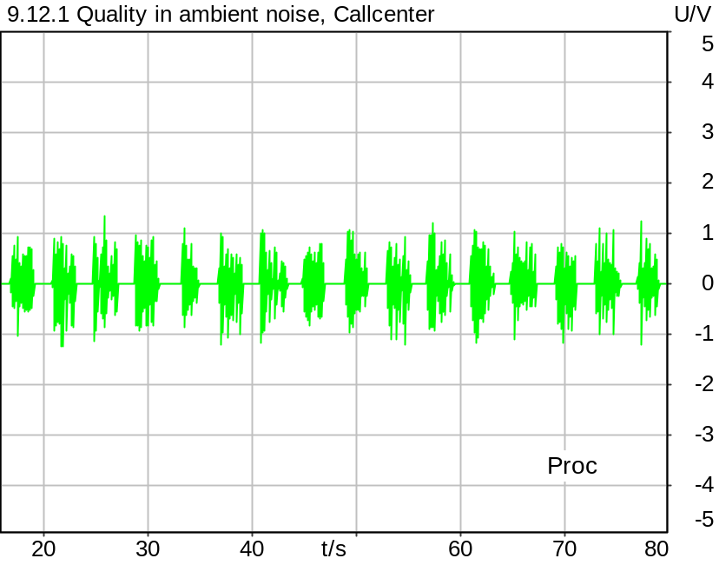

Time range: 16.0 .. 20.0 s
G-MOS (TS 103 281 (Model A)) | 3.96
N-MOS (TS 103 281 (Model A)) | 4.55
S-MOS (TS 103 281 (Model A)) | 4.04
SNR (unweighted) | 43.73 dB
SNR (A-weighted noise) | 44.79 dB
Delay | 33.0 ms
Speech Level | -19.42 dB
Equivalent Rectangular Bandwidth | 15975.00 Hz
Maximum Correlation | 59.09 %
Time range: 20.0 .. 24.0 s
G-MOS (TS 103 281 (Model A)) | 3.91
N-MOS (TS 103 281 (Model A)) | 4.28
S-MOS (TS 103 281 (Model A)) | 4.21
SNR (unweighted) | 40.87 dB
SNR (A-weighted noise) | 46.54 dB
Delay | 31.4 ms
Speech Level | -17.97 dB
Equivalent Rectangular Bandwidth | 16074.73 Hz
Maximum Correlation | 68.68 %
Time range: 24.0 .. 28.0 s
G-MOS (TS 103 281 (Model A)) | 3.65
N-MOS (TS 103 281 (Model A)) | 4.26
S-MOS (TS 103 281 (Model A)) | 3.93
SNR (unweighted) | 40.93 dB
SNR (A-weighted noise) | 42.77 dB
Delay | 31.4 ms
Speech Level | -20.71 dB
Equivalent Rectangular Bandwidth | 16263.23 Hz
Maximum Correlation | 65.95 %
Time range: 28.0 .. 32.0 s
G-MOS (TS 103 281 (Model A)) | 4.21
N-MOS (TS 103 281 (Model A)) | 4.58
S-MOS (TS 103 281 (Model A)) | 4.34
SNR (unweighted) | 42.89 dB
SNR (A-weighted noise) | 48.10 dB
Delay | 31.9 ms
Speech Level | -18.19 dB
Equivalent Rectangular Bandwidth | 14346.79 Hz
Maximum Correlation | 76.90 %
Time range: 32.0 .. 36.0 s
G-MOS (TS 103 281 (Model A)) | 4.19
N-MOS (TS 103 281 (Model A)) | 4.68
S-MOS (TS 103 281 (Model A)) | 4.29
SNR (unweighted) | 41.50 dB
SNR (A-weighted noise) | 43.42 dB
Delay | 32.9 ms
Speech Level | -18.93 dB
Equivalent Rectangular Bandwidth | 16068.26 Hz
Maximum Correlation | 69.34 %
Time range: 36.0 .. 40.0 s
G-MOS (TS 103 281 (Model A)) | 3.80
N-MOS (TS 103 281 (Model A)) | 4.31
S-MOS (TS 103 281 (Model A)) | 4.15
SNR (unweighted) | 41.80 dB
SNR (A-weighted noise) | 46.33 dB
Delay | 31.3 ms
Speech Level | -19.85 dB
Equivalent Rectangular Bandwidth | 15968.04 Hz
Maximum Correlation | 77.82 %
Time range: 40.0 .. 44.0 s
G-MOS (TS 103 281 (Model A)) | 3.93
N-MOS (TS 103 281 (Model A)) | 4.49
S-MOS (TS 103 281 (Model A)) | 4.10
SNR (unweighted) | 42.85 dB
SNR (A-weighted noise) | 45.32 dB
Delay | 31.6 ms
Speech Level | -20.33 dB
Equivalent Rectangular Bandwidth | 14752.80 Hz
Maximum Correlation | 52.18 %
Time range: 44.0 .. 48.0 s
G-MOS (TS 103 281 (Model A)) | 3.94
N-MOS (TS 103 281 (Model A)) | 4.17
S-MOS (TS 103 281 (Model A)) | 4.46
SNR (unweighted) | 42.13 dB
SNR (A-weighted noise) | 44.88 dB
Delay | 31.8 ms
Speech Level | -18.28 dB
Equivalent Rectangular Bandwidth | 14450.11 Hz
Maximum Correlation | 72.68 %
Time range: 48.0 .. 52.0 s
G-MOS (TS 103 281 (Model A)) | 3.79
N-MOS (TS 103 281 (Model A)) | 4.14
S-MOS (TS 103 281 (Model A)) | 4.21
SNR (unweighted) | 35.86 dB
SNR (A-weighted noise) | 41.40 dB
Delay | 32.1 ms
Speech Level | -18.59 dB
Equivalent Rectangular Bandwidth | 16179.73 Hz
Maximum Correlation | 63.34 %
Time range: 52.0 .. 56.0 s
G-MOS (TS 103 281 (Model A)) | 3.95
N-MOS (TS 103 281 (Model A)) | 4.56
S-MOS (TS 103 281 (Model A)) | 3.99
SNR (unweighted) | 39.95 dB
SNR (A-weighted noise) | 45.13 dB
Delay | 31.3 ms
Speech Level | -18.18 dB
Equivalent Rectangular Bandwidth | 14291.46 Hz
Maximum Correlation | 73.21 %
Time range: 56.0 .. 60.0 s
G-MOS (TS 103 281 (Model A)) | 3.91
N-MOS (TS 103 281 (Model A)) | 4.51
S-MOS (TS 103 281 (Model A)) | 3.95
SNR (unweighted) | 42.61 dB
SNR (A-weighted noise) | 46.85 dB
Delay | 31.1 ms
Speech Level | -19.45 dB
Equivalent Rectangular Bandwidth | 15861.92 Hz
Maximum Correlation | 60.30 %
Time range: 60.0 .. 64.0 s
G-MOS (TS 103 281 (Model A)) | 3.91
N-MOS (TS 103 281 (Model A)) | 4.40
S-MOS (TS 103 281 (Model A)) | 4.32
SNR (unweighted) | 42.58 dB
SNR (A-weighted noise) | 45.63 dB
Delay | 31.7 ms
Speech Level | -19.36 dB
Equivalent Rectangular Bandwidth | 15575.26 Hz
Maximum Correlation | 72.03 %
Time range: 64.0 .. 68.0 s
G-MOS (TS 103 281 (Model A)) | 4.08
N-MOS (TS 103 281 (Model A)) | 4.63
S-MOS (TS 103 281 (Model A)) | 4.20
SNR (unweighted) | 43.51 dB
SNR (A-weighted noise) | 47.42 dB
Delay | 33.0 ms
Speech Level | -19.15 dB
Equivalent Rectangular Bandwidth | 15985.24 Hz
Maximum Correlation | 59.47 %
Time range: 68.0 .. 72.0 s
G-MOS (TS 103 281 (Model A)) | 3.91
N-MOS (TS 103 281 (Model A)) | 4.43
S-MOS (TS 103 281 (Model A)) | 4.28
SNR (unweighted) | 41.60 dB
SNR (A-weighted noise) | 46.63 dB
Delay | 31.1 ms
Speech Level | -17.10 dB
Equivalent Rectangular Bandwidth | 17395.23 Hz
Maximum Correlation | 70.13 %
Time range: 72.0 .. 76.0 s
G-MOS (TS 103 281 (Model A)) | 3.64
N-MOS (TS 103 281 (Model A)) | 4.36
S-MOS (TS 103 281 (Model A)) | 3.99
SNR (unweighted) | 43.93 dB
SNR (A-weighted noise) | 46.16 dB
Delay | 32.5 ms
Speech Level | -20.63 dB
Equivalent Rectangular Bandwidth | 16245.06 Hz
Maximum Correlation | 65.13 %
Time range: 76.0 .. 80.0 s
G-MOS (TS 103 281 (Model A)) | 4.31
N-MOS (TS 103 281 (Model A)) | 4.71
S-MOS (TS 103 281 (Model A)) | 4.38
SNR (unweighted) | 44.62 dB
SNR (A-weighted noise) | 50.33 dB
Delay | 31.5 ms
Speech Level | -19.20 dB
Equivalent Rectangular Bandwidth | 15097.61 Hz
Maximum Correlation | 72.86 %
G-MOS (Average, TS 103 281 (Model A)): 3.94
N-MOS (Average, TS 103 281 (Model A)): 4.44
S-MOS (Average, TS 103 281 (Model A)): 4.18
Delay (Average): 31.8 ms
G-MOS (Deviation): 0.18
N-MOS (Deviation): 0.17
S-MOS (Deviation): 0.17
Delay (Deviation): 0.7 ms

*According to TS 26.132, the N-MOS value must be corrected with the following formula:
N-MOS_corr = 1.438 * N-MOS - 1.959
This value will be used to check compliance with requirements.

Corrected N-MOS (Average, TS 103 281 (Model A)): 4.4

5/20/2025 2:14 PM ACQUA 6.0.200
Unmodified HEAD acoustics Measurement Descriptor

Meas. Setting DRP-off

Underlying Standard: 3GPP TS 26.131 V17.3.0 and 3GPP TS 26.132 V17.2.0
Database Version: 60_UG_TS26131_32_SWB_FB_Rev08_GCF_PTCRB

Source: 3quest_ng.dat
Level adjustment Channel 1 Gain 3.00 dB
Level adjustment Channel 2 Gain -90.00 dB
Level adjustment Channel 1 Gain 10.00 dB
FULLBAND Real Speech (20 sentences) at Channel 1
FULLBAND Real Speech (according to ETSI TS 103 106 Annex C, length 83s, 25 Hz high-pass filtered) +
Pause till end of file
Signal level (ch1): -14.7 dBV active speech level

Calibration
SND (1) 0.00 dB (Radio Tester 1 (CMW500))
Output ch. 1 0.00 dB
Output ch. 2 0.00 dB (Radio Tester 1 (CMW500))

Output Equalization/Filter
Mouth Eq. Ch.1 HATS 7 (B&K 5128) (5/28/2024 5:25 PM)

Analysis
Analyse Channel 1
Range start 16000.00 ms Range length 4000.00 ms
Number of seq. 16 Sequence length 4000.00 ms
3QUEST Version TS 103 281 (Model A) Bandwidth SWB/FB
Clean speech from Source File
Correction Level -1.6 dB (CORR_3QUEST_HASB, Corrected Speech Level SND)

Special Features
HFRP Corr. Ch.1: -2.4 dB (Nom. Value: 19.6 - HATS 7 (B&K 5128))
Compensate delay 277.2000 ms (D_SCRIPT, Original Delay Variable stored to D_SCRIPT: D_SND_EQ_HASB)
Store to variable MOS_HASB_Callcenter Run Script after savemosvalues.py

Hardware Config Settings
Used Setting STD:5128_volte_3QUEST

labCORE Settings
labCORE Serial 77000280 Nickname
Firmware 3.7.5 Sync Source Internal
Clock Pitch 0.00 ppm
----------
labCORE Routing
Out Channel 1 -> Analog Out 1 -> ExternalAmplifier In -> HATS 7 (B&K 5128) Speaker
Out Channel 2 -> VoIP 1 -> Radio Tester 1 (CMW500) RF In/Out
Out Channel 2 -> VoIP 2
In Channel 1 <- VoIP In/Out 1 <- Radio Tester 1 (CMW500) RF In/Out
In Channel 2 <- Mic Amp. (Slot 6) In 2 <- Microphone 1 (46AG) Out
----------
Analog Out Mainboard Settings (Analog Out)
Range Ch. 1 0.00 dB Range Ch. 2 0.00 dB
----------
Microphone Settings (Mic Amp. (Slot 6))
Channel In 1 Settings
Range 114 dB[SPL] @ 12.5 mV/Pa Highpass 20Hz
Polarisation Voltage 200V Supply Voltage ±60V
Channel In 2 Settings
Range 114 dB[SPL] @ 12.5 mV/Pa Highpass 20Hz
Polarisation Voltage 200V Supply Voltage ±60V
Channel In 3 Settings
Range 132 dB[SPL] @ 12.5 mV/Pa Highpass 20Hz
Polarisation Voltage Off Supply Voltage ±60V
Channel In 4 Settings
Range 132 dB[SPL] @ 12.5 mV/Pa Highpass 20Hz
Polarisation Voltage Off Supply Voltage ±60V
----------
VoIP Settings (VoIP)
RTP Connection Streaming SIP Connection Unavailable
SIP Reg. State Unregistered Jitterbuffer Length 140
Jitter Buffer Reset On Playback Enabled Codec EVS/16000/1
Packet Length 20 Encoder Parameter ;evs-mode-switch=0;max-red=0;br=13.2;bw=swb;ch-aw-recv=-1
FMTP Parameter ;evs-mode-switch=0;bw=swb;br=13.2;ch-aw-recv=-1;max-red=220
Impairment Mode Off Impairment Type Off
----------
Artificial Head Settings (HATS 7 (B&K 5128))
Ser. Nr. BK_3408387 Pinna Type Type 4.3

HIB Settings
HIB Name 60020101 Serial 60020101
HIB Mode Mobile Measurement Impedance 32 Ohm
Gain out 1 -40.00 dB Gain out 2 0.00 dB
Gain in 1 0.00 dB Gain in 2 0.00 dB
Mic 1 Power Supply Off Mic 2 Power Supply Off

BGN Settings
BGN Software: HAE
BGN Scenario: Work Noise Office Callcenter Binaural
Loops: Infinite

9.12.1 Quality in the Presence of Ambient Noise AVG
Handset Measurements Superwideband and Fullband \ Handset Measurements SuperWideband (HASB) \ Measurements with Background Noise \ 9.12.1 Quality in the Presence of Ambient Noise HASB
BGN | S-MOS | N-MOS* | G-MOS
Pub | 3.8 | 3.5 | 3.4
Road | 3.8 | 3.6 | 3.4
Crossroad | 4.0 | 4.2 | 3.7
TStation | 4.0 | 4.1 | 3.7
FullsizeCar | 3.8 | 4.3 | 3.6
Cafeteria | 4.0 | 3.3 | 3.4
Mensa | 4.1 | 4.0 | 3.7
Callcenter | 4.2 | 4.4 | 3.9
AVG | 4.0 | 3.9 | 3.6

*The N-MOS values are corrected according to TS 26.132:
N-MOS_corr = 1.438 * N-MOS - 1.959

5/20/2025 2:14 PM ACQUA

9.12.1 Average N-MOS (Noise) HASB
Handset Measurements Superwideband and Fullband \ Handset Measurements SuperWideband (HASB) \ Measurements with Background Noise \ 9.12.1 Quality in the Presence of Ambient Noise HASB
Correction
N_MOS_AVG_HASB | 3.925 MOS | 5/20/2025 | Measured
N_MOS_AVG_HASB

Calculated Value: 3.93 MOS Ok

Ok
5/20/2025 2:14 PM ACQUA 6.0.200

Limits
 | lower
Run 1 | 3.70 MOS

Underlying Standard: 3GPP TS 26.131 V17.3.0 and 3GPP TS 26.132 V17.2.0
Database Version: 60_UG_TS26131_32_SWB_FB_Rev08_GCF_PTCRB

9.12.1 Average S-MOS (Speech) HASB
Handset Measurements Superwideband and Fullband \ Handset Measurements SuperWideband (HASB) \ Measurements with Background Noise \ 9.12.1 Quality in the Presence of Ambient Noise HASB
Correction
S_MOS_AVG_HASB | 3.973 MOS | 5/20/2025 | Measured
S_MOS_AVG_HASB

Calculated Value: 3.97 MOS Ok

Ok
5/20/2025 2:14 PM ACQUA 6.0.200

Limits
 | lower
Run 1 | 3.80 MOS

Underlying Standard: 3GPP TS 26.131 V17.3.0 and 3GPP TS 26.132 V17.2.0
Database Version: 60_UG_TS26131_32_SWB_FB_Rev08_GCF_PTCRB

9.12.1 Average G-MOS (Speech) HASB
Handset Measurements Superwideband and Fullband \ Handset Measurements SuperWideband (HASB) \ Measurements with Background Noise \ 9.12.1 Quality in the Presence of Ambient Noise HASB
Correction
G_MOS_AVG_HASB | 3.603 MOS | 5/20/2025 | Measured
G_MOS_AVG_HASB

Calculated Value: 3.60 MOS Not Ok

Not Ok
5/20/2025 2:14 PM ACQUA 6.0.200

Limits
 | lower
Run 1 | 3.70 MOS

Underlying Standard: 3GPP TS 26.131 V17.3.0 and 3GPP TS 26.132 V17.2.0
Database Version: 60_UG_TS26131_32_SWB_FB_Rev08_GCF_PTCRB

9.2.2.3 RLR max. with BGN - BGN only Rec. #1 HASB
Handset Measurements Superwideband and Fullband \ 9.2.2.3 RLR maximum Volume with BGN
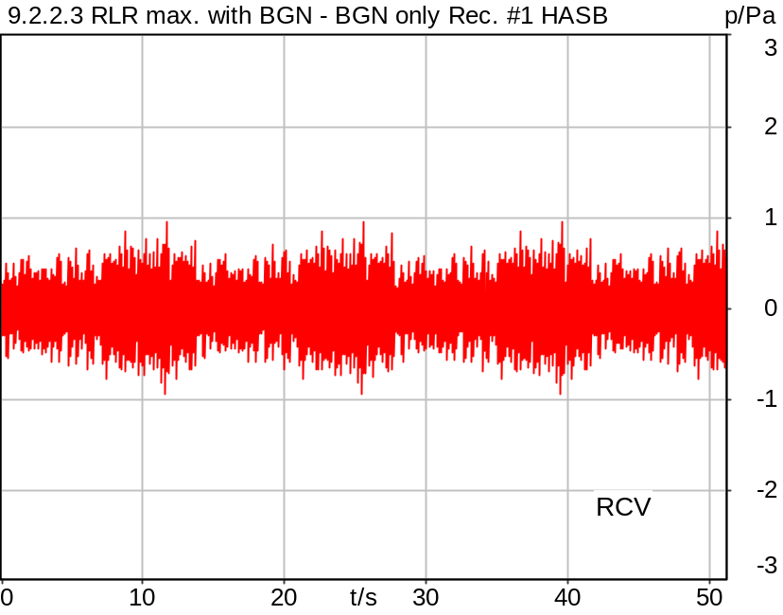

5/20/2025 2:48 PM ACQUA 6.0.200
Unmodified HEAD acoustics Measurement Descriptor

Meas. Setting DRP-off

Underlying Standard: 3GPP TS 26.131 V17.3.0 and 3GPP TS 26.132 V17.2.0
Database Version: 60_UG_TS26131_32_SWB_FB_Rev08_GCF_PTCRB

Source: spst_fmcond_mf4x3_sb_r16_pulse.dat
Level adjustment Channel 1 Gain -90.00 dB
Level adjustment Channel 2 Gain -90.00 dB
Bandwidth: SWB
Pulse Channels: 00, 01 (50ms)

The signal is composed from the British-English material of clause 7.3 in ITU-T Recommendation P.501. The signal is a concatenation of the following parts:

1) The complete female short conditioning sequence (which includes a leading 5 s silence which is here used for conditioning the UE under noise-only conditions). The level is -16 dBm0 active speech level.
2) Pause 1 sec.
3) The first 5 s of the male short conditioning sequence. The level is -16 dBm0.
4) The complete single-talk sequence. The test signal level is -16 dBm0. The test signal level is calculated over the complete single-talk test sequence.

For license information refer to the files >LICENSE_psytechnics.txt< and >LICENSE_nokia.txt<, see Preparation of Test Setup - Info: Test Signals

Calibration
RCV (2) 1.06 dB 4/29/2025 (HATS 7 (B&K 5128))
Output ch. 1 0.00 dB
Output ch. 2 0.00 dB (Radio Tester 1 (CMW500))

Output Equalization/Filter
Mouth Eq. Ch.1 HATS 7 (B&K 5128) (5/28/2024 5:25 PM)

Analysis
Analyse Channel 2
Range start 0.00 ms Range length 51411.65 ms

Special Features
Compensate delay 130.4000 ms (D_SCRIPT, Original Delay Variable stored to D_SCRIPT: D_RCV_EQ_HASB)
Store to file rlr_bgn_hasb.dat

Hardware Config Settings
Used Setting HA&HE_5128_volte

labCORE Settings
labCORE Serial 77000280 Nickname
Firmware 3.7.5 Sync Source Internal
Clock Pitch 0.00 ppm
----------
labCORE Routing
Out Channel 1 -> Analog Out 1 -> ExternalAmplifier In -> HATS 7 (B&K 5128) Speaker
Out Channel 2 -> VoIP 1 -> Radio Tester 1 (CMW500) RF In/Out
Out Channel 2 -> VoIP 2
In Channel 1 <- VoIP In/Out 1 <- Radio Tester 1 (CMW500) RF In/Out
In Channel 2 <- BEQ Filter 1 R <- ICP Amp. (Slot 7) In 2 <- HATS 7 (B&K 5128) Mic. Right
----------
Analog Out Mainboard Settings (Analog Out)
Range Ch. 1 0.00 dB Range Ch. 2 0.00 dB
----------
ICP Settings (ICP Amp. (Slot 7))
Channel In 1 Settings
Range 132 dB[SPL] @ 50 mV/Pa Highpass 20Hz
Supply Voltage On
Channel In 2 Settings
Range 132 dB[SPL] @ 50 mV/Pa Highpass 20Hz
Supply Voltage On
Channel In 3 Settings
Range 132 dB[SPL] @ 50 mV/Pa Highpass 20Hz
Supply Voltage Off
Channel In 4 Settings
Range 132 dB[SPL] @ 50 mV/Pa Highpass 20Hz
Supply Voltage Off
----------
VoIP Settings (VoIP)
RTP Connection Streaming SIP Connection Unavailable
SIP Reg. State Unregistered Jitterbuffer Length 140
Jitter Buffer Reset On Playback Enabled Codec EVS/16000/1
Packet Length 20 Encoder Parameter ;evs-mode-switch=0;max-red=0;br=13.2;bw=swb;ch-aw-recv=-1
FMTP Parameter ;evs-mode-switch=0;bw=swb;br=13.2;ch-aw-recv=-1;max-red=220
Impairment Mode Off Impairment Type Off
----------
BEQ Settings (BEQ Filter 1)
Block mode Bypass
----------
Artificial Head Settings (HATS 7 (B&K 5128))
Ser. Nr. BK_3408387 Pinna Type Type 4.3

HIB Settings
HIB Name 60020101 Serial 60020101
HIB Mode Mobile Measurement Impedance 32 Ohm
Gain out 1 -40.00 dB Gain out 2 0.00 dB
Gain in 1 0.00 dB Gain in 2 0.00 dB
Mic 1 Power Supply Off Mic 2 Power Supply Off

BGN Settings
BGN Software: HAE
BGN Scenario: Pub Noise Binaural
Loops: Infinite

9.2.2.3 RLR max. with BGN - Speech + BGN Rec. #2 HASB
Handset Measurements Superwideband and Fullband \ 9.2.2.3 RLR maximum Volume with BGN
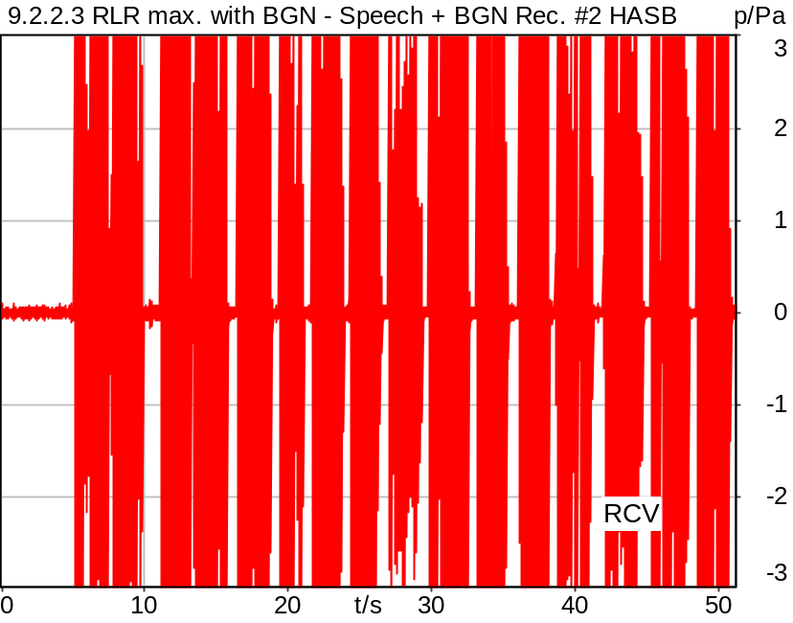

5/20/2025 2:49 PM ACQUA 6.0.200
Unmodified HEAD acoustics Measurement Descriptor

Meas. Setting DRP-off

Underlying Standard: 3GPP TS 26.131 V17.3.0 and 3GPP TS 26.132 V17.2.0
Database Version: 60_UG_TS26131_32_SWB_FB_Rev08_GCF_PTCRB

Source: spst_fmcond_mf4x3_sb_r16_pulse.dat
Bandwidth: SWB
Pulse Channels: 00, 01 (50ms)

The signal is composed from the British-English material of clause 7.3 in ITU-T Recommendation P.501. The signal is a concatenation of the following parts:

1) The complete female short conditioning sequence (which includes a leading 5 s silence which is here used for conditioning the UE under noise-only conditions). The level is -16 dBm0 active speech level.
2) Pause 1 sec.
3) The first 5 s of the male short conditioning sequence. The level is -16 dBm0.
4) The complete single-talk sequence. The test signal level is -16 dBm0. The test signal level is calculated over the complete single-talk test sequence.

For license information refer to the files >LICENSE_psytechnics.txt< and >LICENSE_nokia.txt<, see Preparation of Test Setup - Info: Test Signals

Calibration
RCV (2) 1.06 dB 4/29/2025 (HATS 7 (B&K 5128))
Output ch. 1 0.00 dB
Output ch. 2 0.00 dB (Radio Tester 1 (CMW500))

Output Equalization/Filter
Mouth Eq. Ch.1 HATS 7 (B&K 5128) (5/28/2024 5:25 PM)

Analysis
Analyse Channel 2
Range start 0.00 ms Range length 51411.65 ms

Special Features
Compensate delay 130.4000 ms (D_SCRIPT, Original Delay Variable stored to D_SCRIPT: D_RCV_EQ_HASB)
Store to file rlr_speech_tnc_hasb.dat

Hardware Config Settings
Used Setting HA&HE_5128_volte

labCORE Settings
labCORE Serial 77000280 Nickname
Firmware 3.7.5 Sync Source Internal
Clock Pitch 0.00 ppm
----------
labCORE Routing
Out Channel 1 -> Analog Out 1 -> ExternalAmplifier In -> HATS 7 (B&K 5128) Speaker
Out Channel 2 -> VoIP 1 -> Radio Tester 1 (CMW500) RF In/Out
Out Channel 2 -> VoIP 2
In Channel 1 <- VoIP In/Out 1 <- Radio Tester 1 (CMW500) RF In/Out
In Channel 2 <- BEQ Filter 1 R <- ICP Amp. (Slot 7) In 2 <- HATS 7 (B&K 5128) Mic. Right
----------
Analog Out Mainboard Settings (Analog Out)
Range Ch. 1 0.00 dB Range Ch. 2 0.00 dB
----------
ICP Settings (ICP Amp. (Slot 7))
Channel In 1 Settings
Range 132 dB[SPL] @ 50 mV/Pa Highpass 20Hz
Supply Voltage On
Channel In 2 Settings
Range 132 dB[SPL] @ 50 mV/Pa Highpass 20Hz
Supply Voltage On
Channel In 3 Settings
Range 132 dB[SPL] @ 50 mV/Pa Highpass 20Hz
Supply Voltage Off
Channel In 4 Settings
Range 132 dB[SPL] @ 50 mV/Pa Highpass 20Hz
Supply Voltage Off
----------
VoIP Settings (VoIP)
RTP Connection Streaming SIP Connection Unavailable
SIP Reg. State Unregistered Jitterbuffer Length 140
Jitter Buffer Reset On Playback Enabled Codec EVS/16000/1
Packet Length 20 Encoder Parameter ;evs-mode-switch=0;max-red=0;br=13.2;bw=swb;ch-aw-recv=-1
FMTP Parameter ;evs-mode-switch=0;bw=swb;br=13.2;ch-aw-recv=-1;max-red=220
Impairment Mode Off Impairment Type Off
----------
BEQ Settings (BEQ Filter 1)
Block mode Bypass
----------
Artificial Head Settings (HATS 7 (B&K 5128))
Ser. Nr. BK_3408387 Pinna Type Type 4.3

HIB Settings
HIB Name 60020101 Serial 60020101
HIB Mode Mobile Measurement Impedance 32 Ohm
Gain out 1 -40.00 dB Gain out 2 0.00 dB
Gain in 1 0.00 dB Gain in 2 0.00 dB
Mic 1 Power Supply Off Mic 2 Power Supply Off

BGN Settings
BGN Software: HAE
BGN Scenario: Pub Noise Binaural
Loops: Infinite

9.2.2.3 RLR max. with BGN #3 HASB
Handset Measurements Superwideband and Fullband \ 9.2.2.3 RLR maximum Volume with BGN
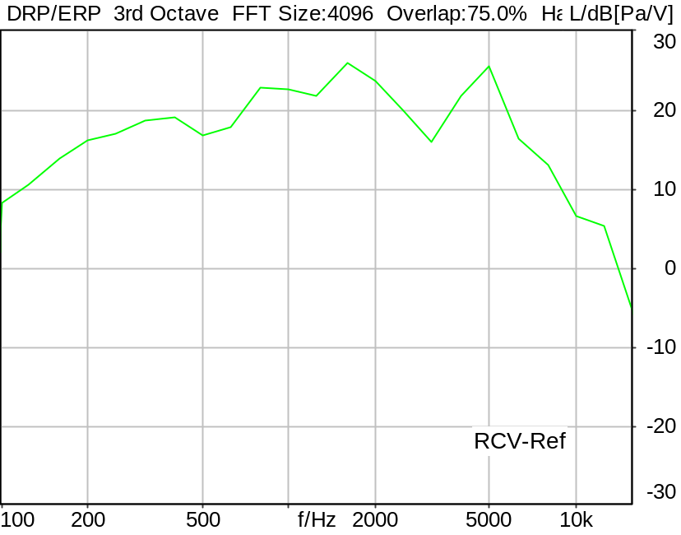

RLR: -11.20 dB Ok

Ok
5/20/2025 2:49 PM ACQUA 6.0.200
Unmodified HEAD acoustics Measurement Descriptor

Limits
 | lower
Run 1 | -13.00 dB

Meas. Setting DRP-off

Underlying Standard: 3GPP TS 26.131 V17.3.0 and 3GPP TS 26.132 V17.2.0
Database Version: 60_UG_TS26131_32_SWB_FB_Rev08_GCF_PTCRB

Analysed: rlr_speech_tnc_hasb.dat
9.2.2.3 RLR max. with BGN - Speech + BGN Rec. #2 HASB

Analysis
Analyse Channel 2
Range start 16000.00 ms Range length 35000.00 ms
DRP/ERP Ch.1 P.57 (4.3/4.4) DRP/ERP Ch.2 P.57 (4.3/4.4)
Frequency base 3rd octave DIN Row Row B
Method FFT
FFT size 4096 Overlap 75 %
Window function Hann
Reference file re9223rlr.fft
LR kind RLR Method ITU-T P.79
Bands for LR calc. 1..20
Leakage correction No

