**Student ID: 11205898**

**Name: Keponi, Johnson Junior**

**README FILE  
Department of Computer Science Website**

Welcome to the Department of Computer Science Website project! This project aims to create a user-friendly and informative website for the Department of Computer Science. Whether you're a student, faculty member, or visitor, this website will serve as a central hub for all things related to the department.

The purpose of this website is to provide a completely new interface to the existing department website. This website features a simple design but does not sacrifice quality.

**Table of Contents**

* Features
* Getting Started
* Languages Used
* Screenshots
* What I learnt from this project

**Features**

1. **Home Page**: A welcoming introduction to the Department of Computer Science.
2. **About Us**: Learn about the department's history, mission, and values.
3. **Programs**: Explore undergraduate and graduate programs offered by the department.
4. **Faculty and Staff**: Get to know the talented individuals who make up the department.
5. **Research**: Discover ongoing research projects and achievements.
6. **Events**: Stay updated on upcoming departmental events and seminars.
7. **Contact Us**: Find contact information and ways to connect with the department.

**Getting Started**

**Prerequisites**

Before you begin, ensure you have the following tools installed:

* [Node.js](https://nodejs.org/)

Languages Used:

In the creation and design of this website I used:

1. Hypertext Markup Language (HTML)
2. Cascading Style Sheet (CSS)

Extra Features of the page:

All the pages typically have a background color of a light shade of yellow.

All pages have a navigation bar.

The home page has an image relevant to the website right underneath the navigation bar.

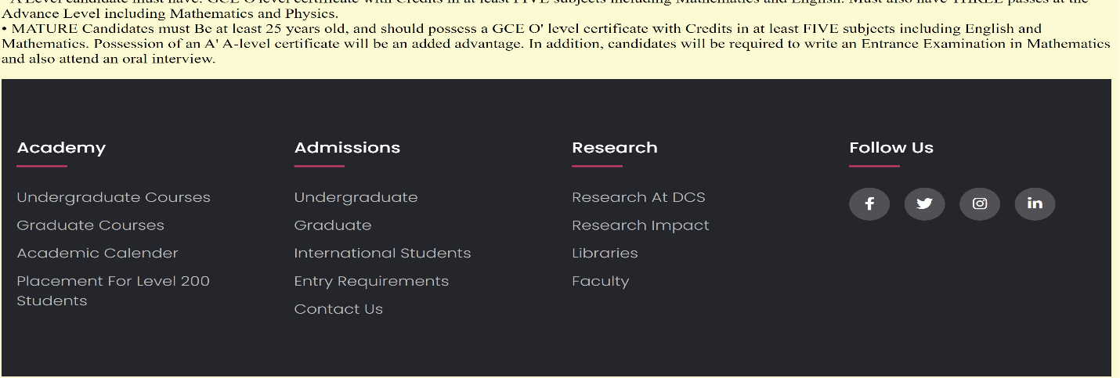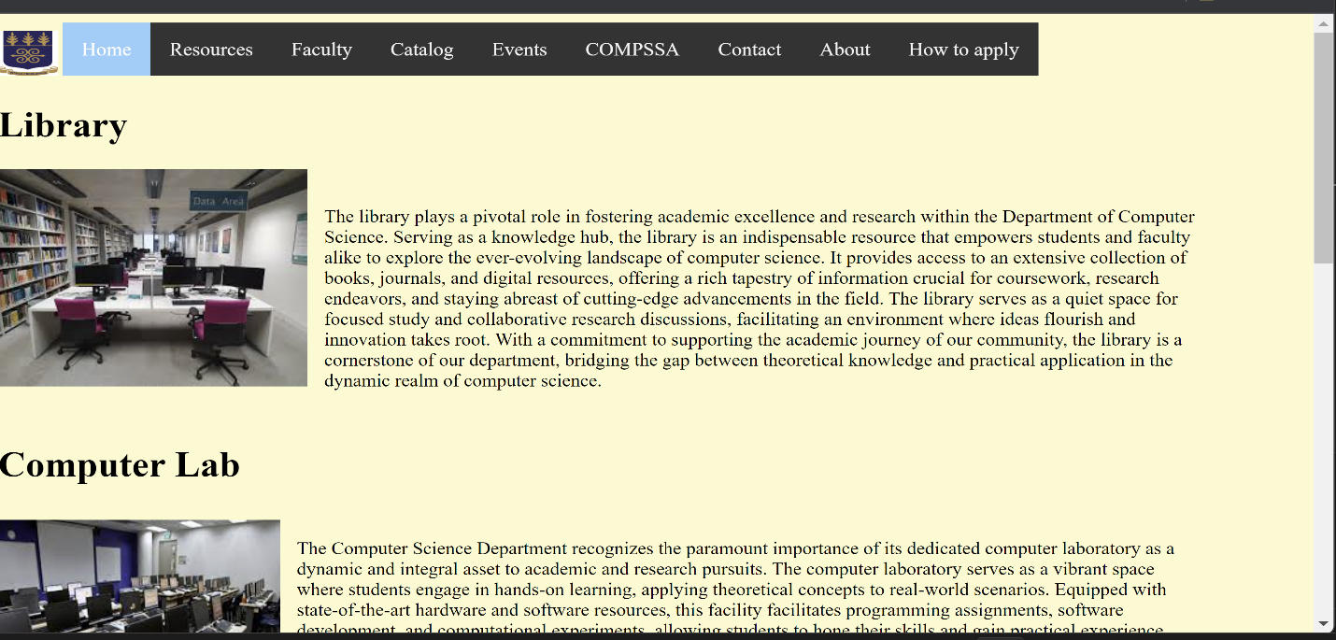See SCREENSHOTS BELOW

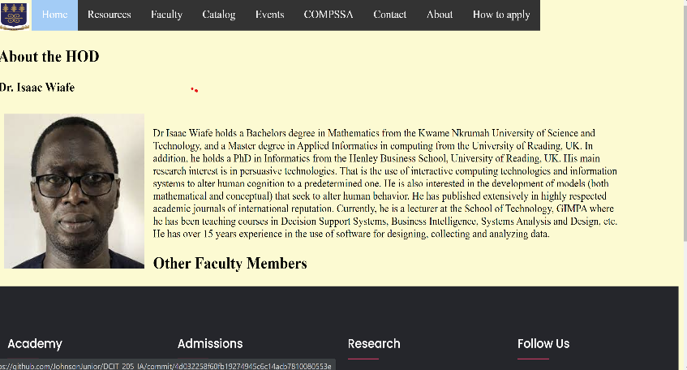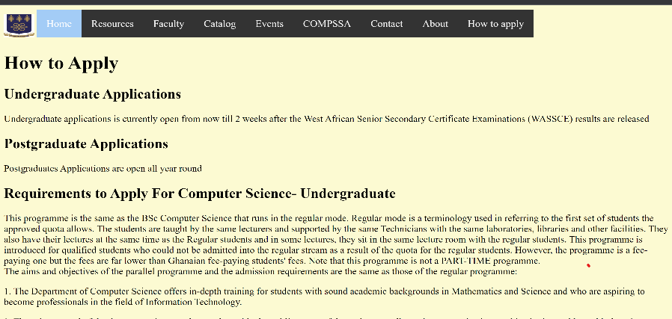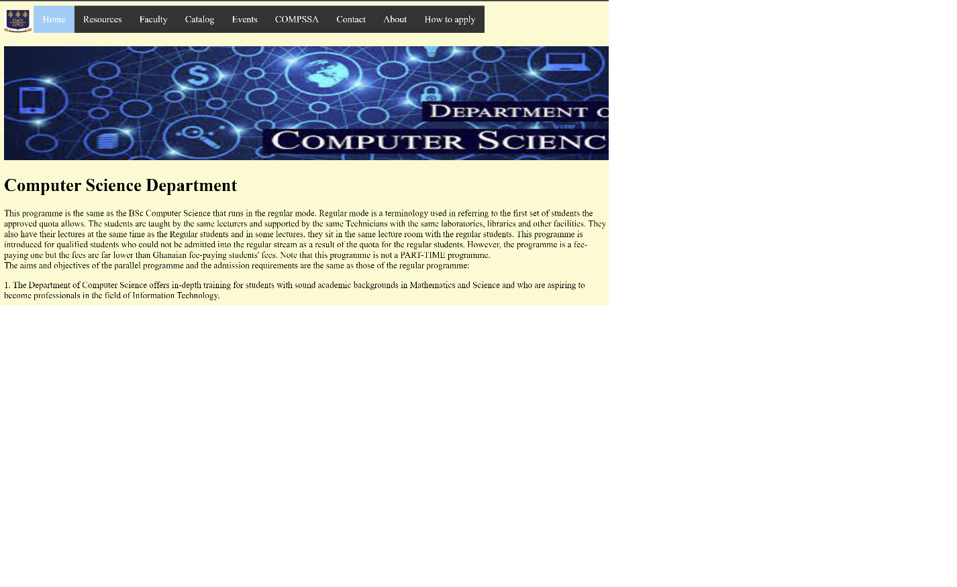

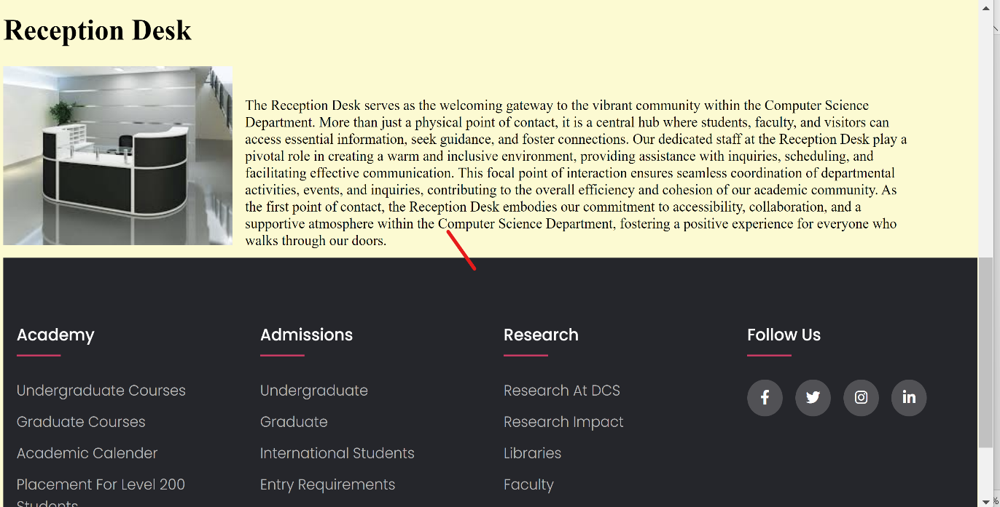

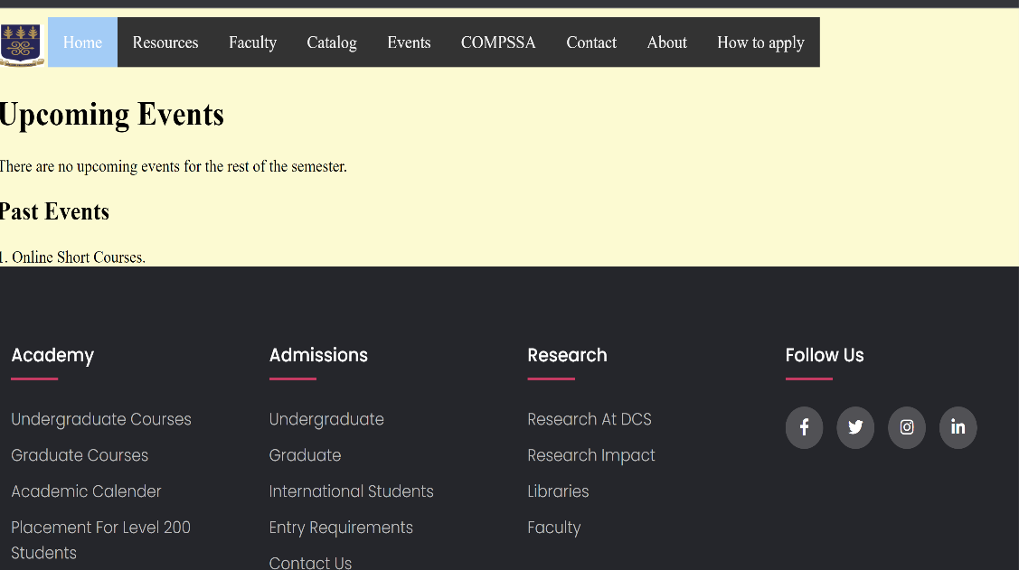

WHAT I LEARNT FROM THIS PROJECT:

1. I learnt the importance of having a comprehensive outline of the project before starting the project.
2. I also used github for the first time and I was impressed by its version control feature.
3. I embraced the importance of being consistent in every project.
4. I became more alert in the regards that I had to pay more attention to detail to effectively complete this project.
5. Time management was also a very important lesson for during this project.