

*CSE 305: Final Project*



*User Guide*

*Created By:*

*Marisa DePasquale: marisa.depasquale@stonybrook.edu*

*Xiang Gao: xiang.gao.1@stonybrook.edu*

*Johnson Lu: johnson.lu@stonybrook.edu*

Index

Section 1.0

Introduction ………………………………………………………………………………………………………… Page 3

Section 2.0 Customer………………………………………………………………………………………………………………..Page 4

2.1 Queue

2.2 History

2.3 Your Personalized List

2.4 Current Movies Held

2.5 Rate Your Movies

2.6 Logout

Section 3.0

Customer Representatives………………………………………………………………………………………Page 8

* 1. Add Customer
  2. Edit Customers
  3. Delete Customers
  4. Produce Customer Mailing List
  5. Produce a list of movie suggestions
  6. Record an Order
  7. View Employees
  8. View Available Movies
  9. Logout

Section 4.0

Managers………………………………………………………………………………………………………………..Page 13

* 1. Add Employees
  2. Edit Employees
  3. Delete Employees
  4. Add Movies
  5. Edit Movies
  6. Delete Movies
  7. List Active Movies
  8. List Rentals
  9. Sales Report
  10. All Movie Listings
  11. All Available Movie Listings
  12. Backup Database
  13. Logout

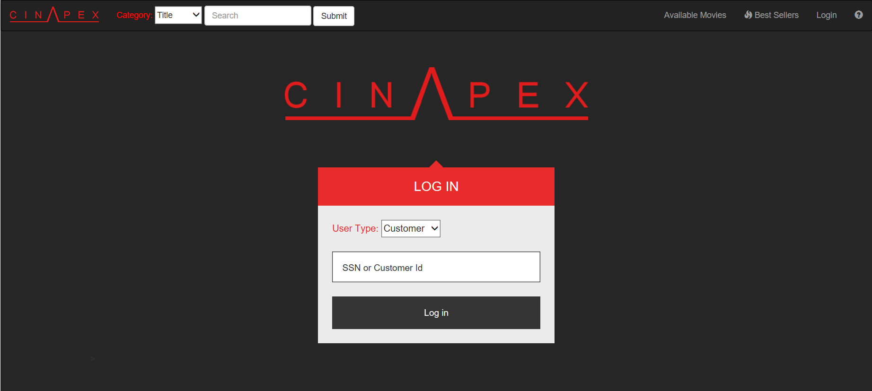

*Figure 1.0 – CinApex Login Screen*

1. Introduction and Non-Users

Welcome to CinApex! Upon arriving at our website, you will be greeted with a log-in screen. To log in, you must specify which type of user you are (either Customer or Employee) and then type either your SSN or Customer Id. If you do not have an account, you must contact your customer representative and they will add you to our database.

When not logged in, you are able to do a few things:

1. View the Best Sellers List
2. View all Available Movies
3. Search all Available Movies by keyword (Either title, actor, or genre)
4. Help *(you’re currently here)*

To get more access to all of our movies and account information, you must log in.

1. Customer

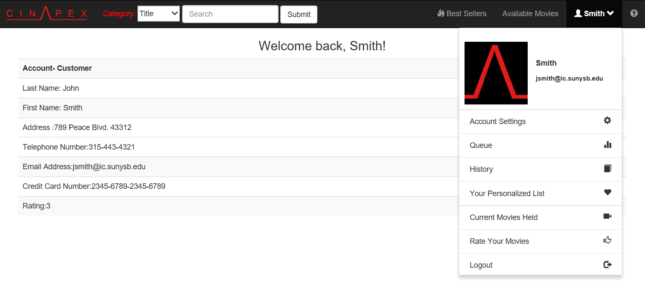

*Figure 2.0 – Customer Success Sign in Screen*

After logging in as a customer, you will see your account information. You will also gain many more links to choose from including:

1. *Account Settings* (Currently being displayed)
2. Queue
3. History
4. Your Personalized List
5. Current Movies Held
6. Rate Your Movies
7. Logout

Your first name and email address will be displayed along with a profile picture (default one shown above) when clicking on your name on the top right corner.

2.1 Queue

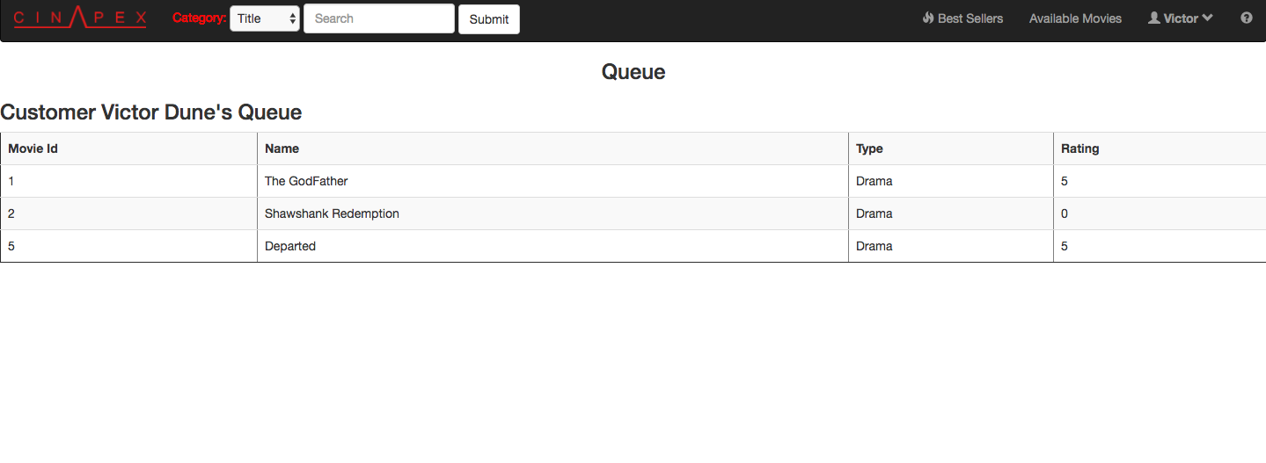

Your queue is a list of movies currently waiting to be watched by you. The order of movies are placed based on the order you added them to the list.

2.2 History

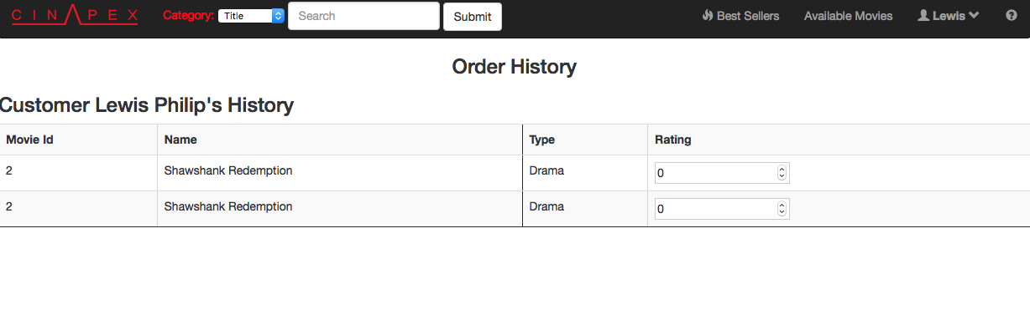

Order History and Rate Your Movies is the same page that serves two purposes. The order history displays all the movies that were previously rented.

2.3 Your Personalized List

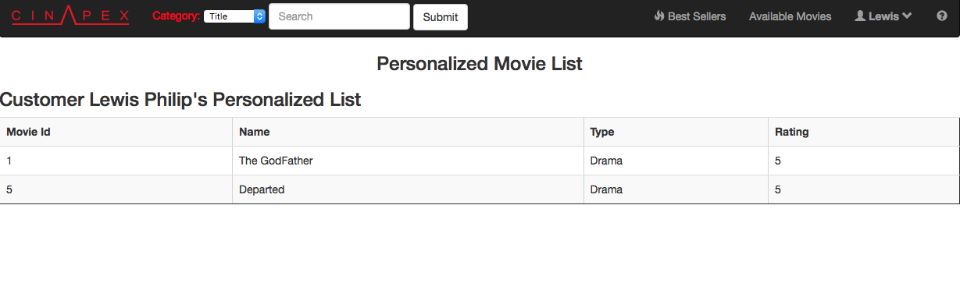

Your personalized list is a list of movies recommended by employees. The employees generate the lists based on your previous rental history. If it’s seen that you watch a lot of a certain genre, it will recommend movies based on that genre.

2.4 Current Movies Held

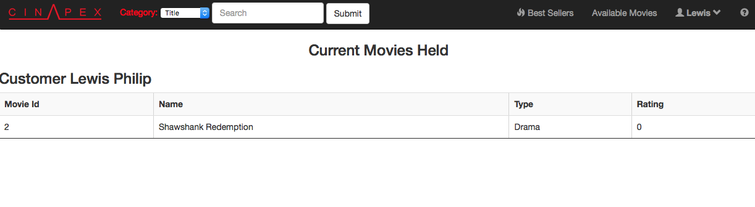

Current movies held is directly related to your account type. You will be able to hold more movies as you buy the more expensive plans. A movie held is a movie that is currently being rented.

2.5 Rate Your Movies



Order History and Rate Your Movies is the same page that serves two purposes. Rate your movies provides a list of movies that you previously rented and allows you to rate that movie from 1 to 5.

2.6 Logout

Clicking “Logout” will log you out of your account and take you back to the Login screen.

1. 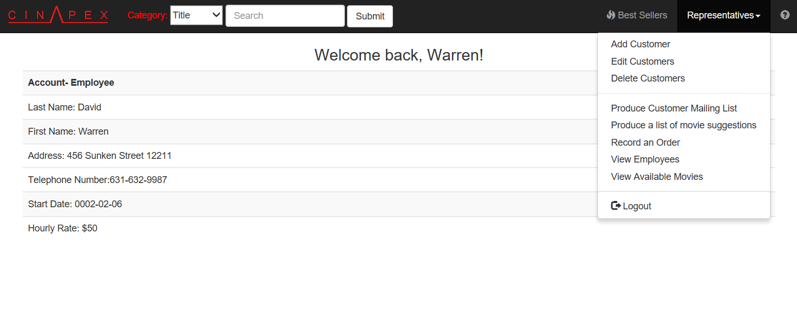Customer Representatives

After logging in as a customer representative, you will see your account information. You will also gain many more links to choose from including:

1. Add Customer
2. Edit Customers
3. Delete Customers
4. Produce Customer Mailing List
5. Produce a list of movie suggestions
6. Record an Order
7. View Employees
8. View Available Movies
9. Logout

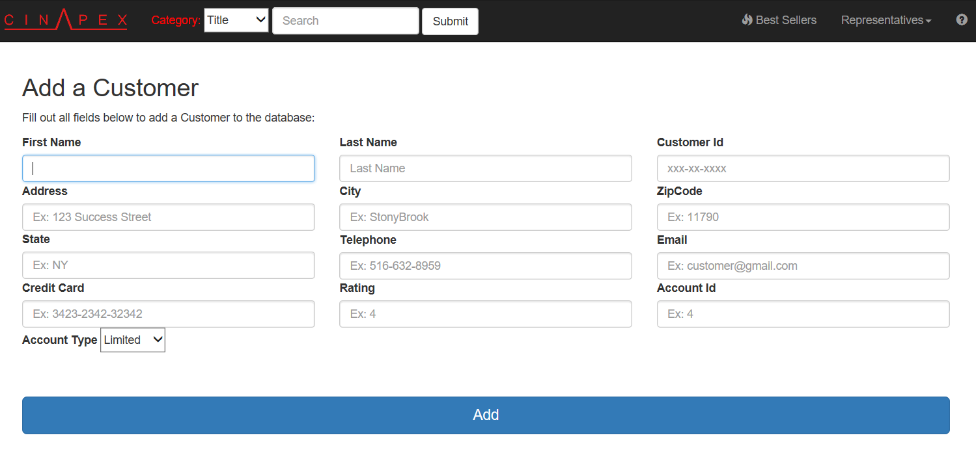3.1 Add Customer

When adding a customer to the database, you must fill out all fields appropriately. Examples are given in the placeholder text. Once you have all necessary information, click on the “Add” button and the database will be updated.

3.2 Edit Customer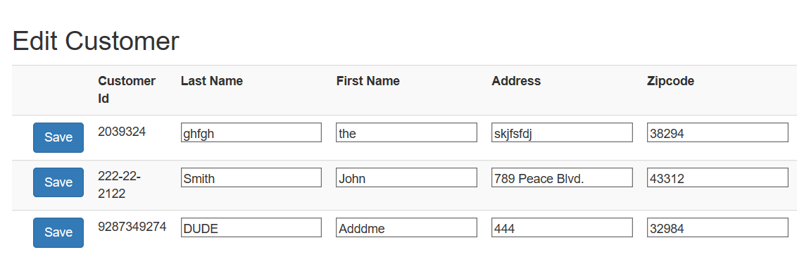

You can edit any field that looks editable by clicking on the textbox and typing in the new value. Click on the “save” button next to the row you want to update and it will update that information for you.

3.3 Delete Customer

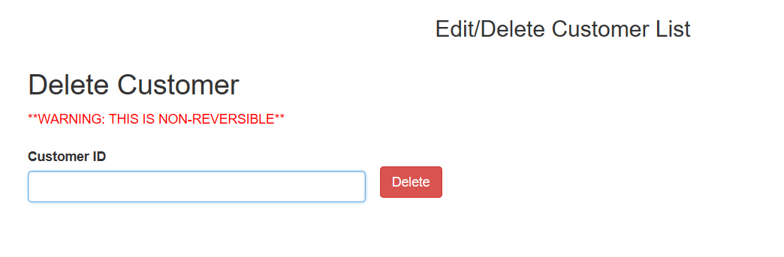

It is simple to delete a customer. To delete a customer, just enter in their customer Id number and click delete. They will no longer be in the database after.

3.4 Produce Customer Mailing List

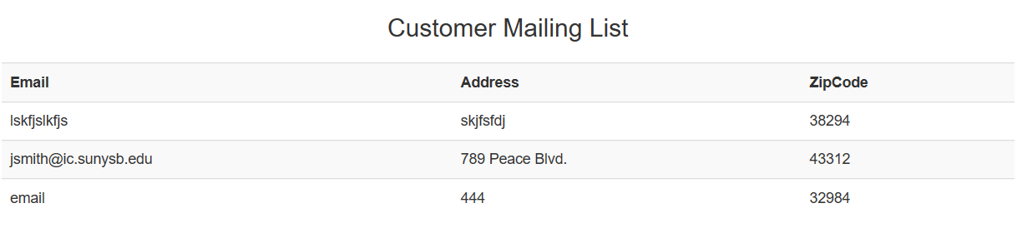

When you click on “Produce Customer Mailing List”, there is no input required. It will automatically generate a list of all emails and addresses of customers in the database.

3.5 Produce List of Movie Suggestions

To get a list of movie suggestions for a customer, all you should do is type in their Customer Id number and it will generate a list of suggestions based on the genre type.

3.6 Record an Order

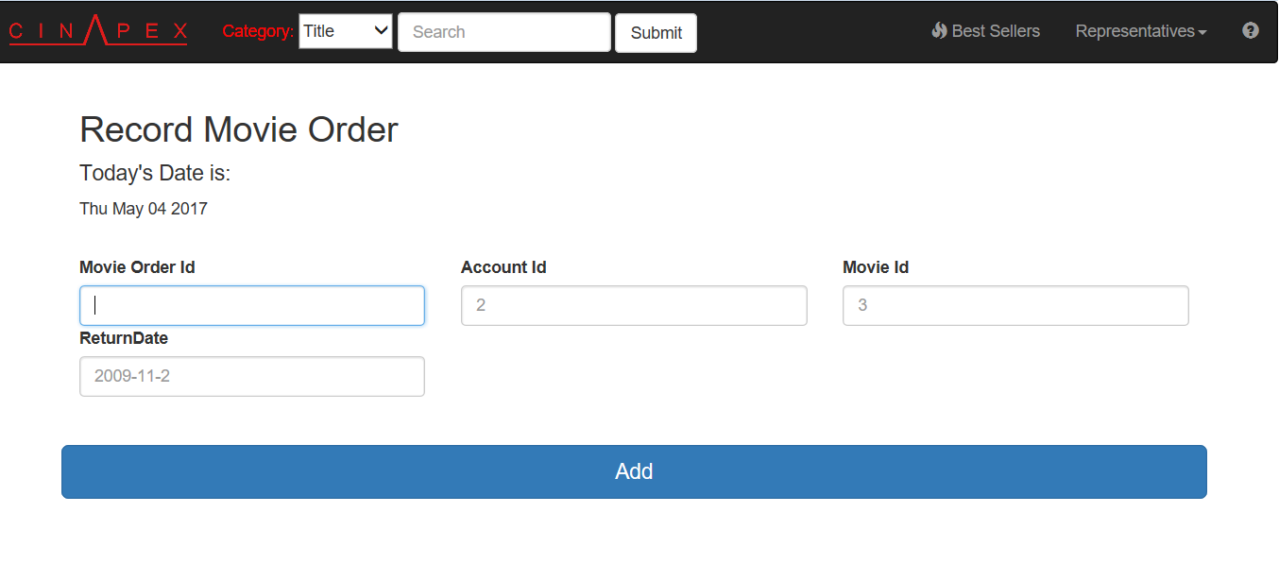

As a customer representative, you can record orders for customers by entering information in the following fields.

3.7 View Employees

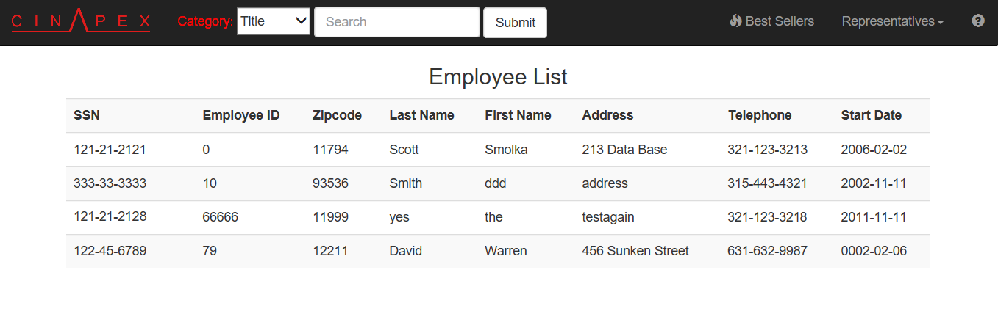

You can see all of the employees that work at CinApex. We do not give away salary information though.

3.8 View Available Movies

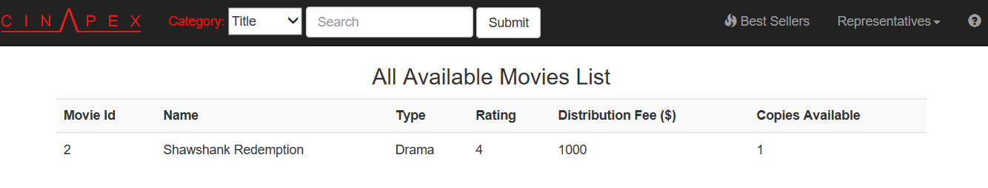

The “All Available Movies List” will return a list of movies that are available. Everything in the list has at least one copy of itself available for customers to rent.

3.9 Logout

Clicking “Logout” will log you out of your account and take you back to the Login screen.

1. 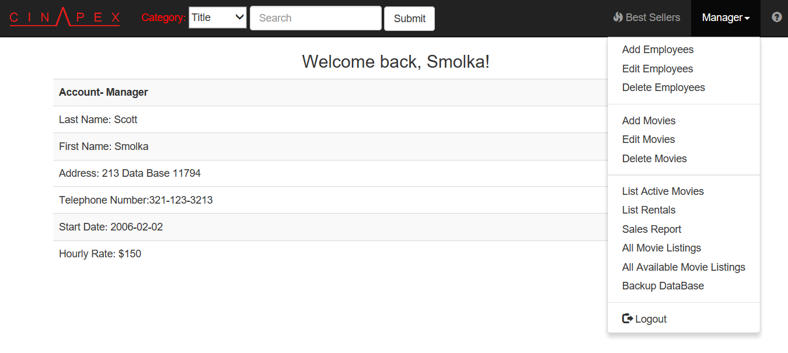Managers

After logging in as a manager, you will see your account information. You will also gain many more links to choose from including:

1. Add Employees
2. Edit Employees
3. Delete Employees
4. Add Movies
5. Edit Movies
6. Delete Movies
7. List Active Movies
8. List Rentals
9. Sales Report
10. All Movie Listings
11. All Available Movie Listings
12. Backup Database
13. Logout

4.1 Add Employees

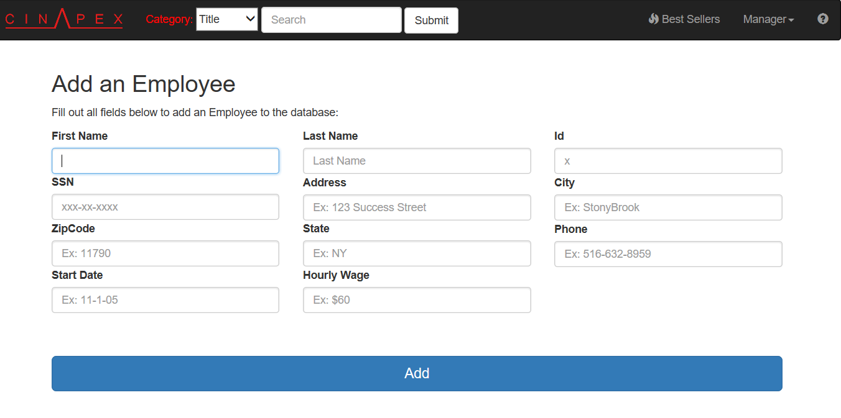

When adding an employee to the database, you must fill out all fields appropriately. Examples are given in the placeholder text. Once you have all necessary information, click on the “Add” button and the database will be updated.

4.2 Edit Employees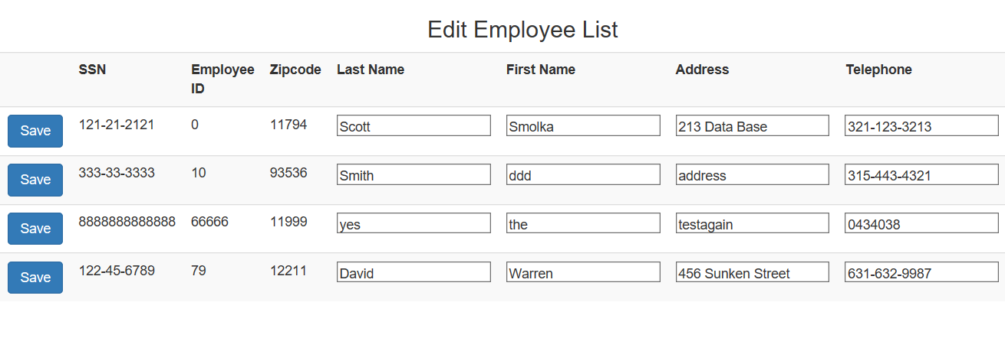You can edit any field that looks editable by clicking on the textbox and typing in the new value. Click on the “save” button next to the row you want to update and it will update that information for you.

4.3 Delete Employees

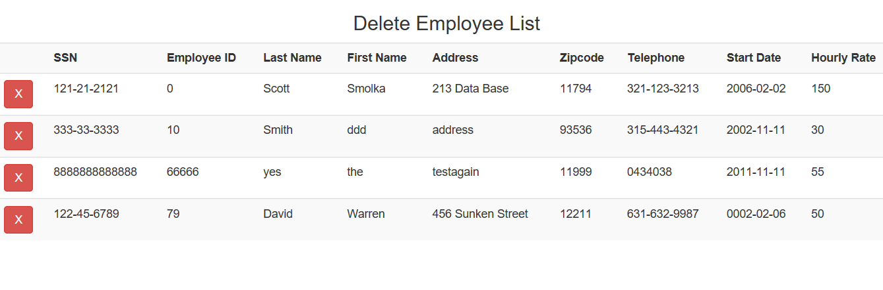

It is simple to delete an employee. To delete an employee, click the “x” button next to the SSN number/row of the employee you want to remove.

WARNING: THIS IS NON REVERSIBLE!

4.4 Add Movies

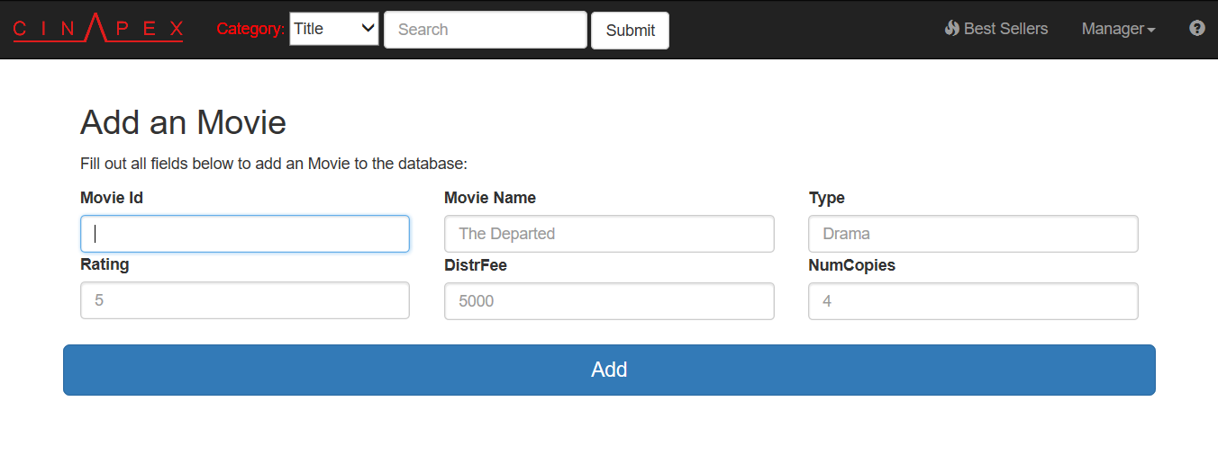

When adding a movie to the database, you must fill out all fields appropriately. Examples are given in the placeholder text. Once you have all necessary information, click on the “Add” button and the database will be updated.

4.5 Edit Movies

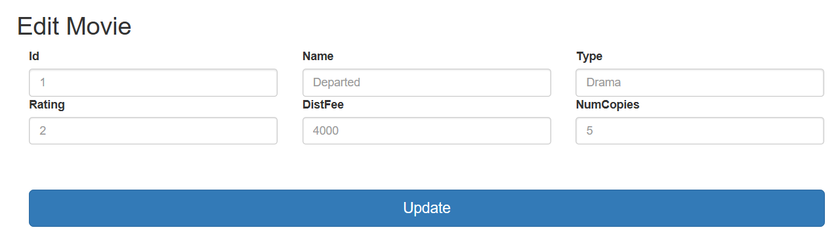

To edit a movie, you MUST write the movie id of the movie you want to edit. All other fields are optional. You can update one to all five if you want.

4.6 Delete Movies

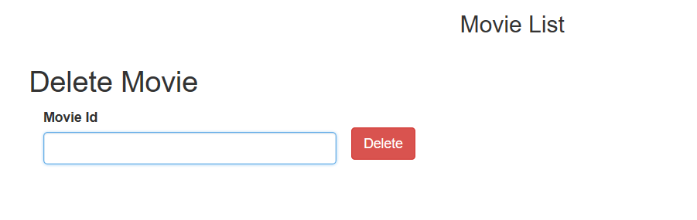

It is simple to delete a movie. To delete a movie, just enter in the movie Id number and click delete. The movie will no longer be in the database.

4.7 List Active Movies

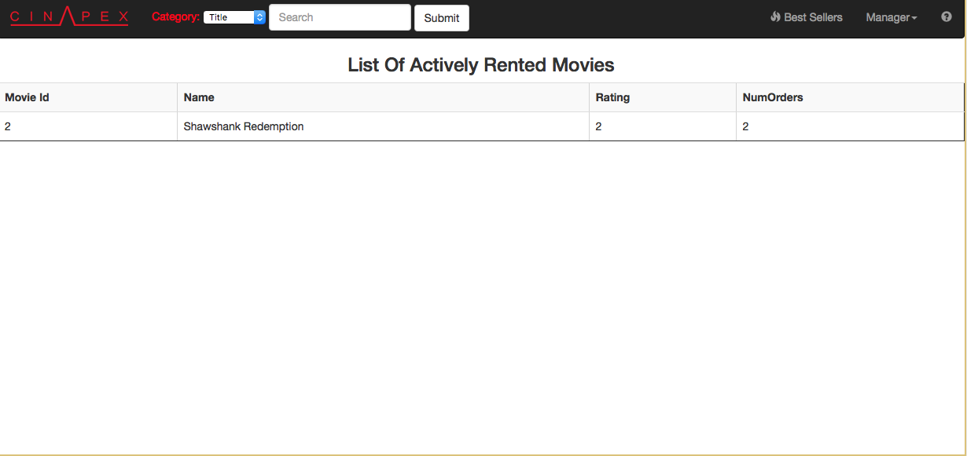

Movies that are rented the most often are active movies and will show up in the list.

4.8 List Rentals

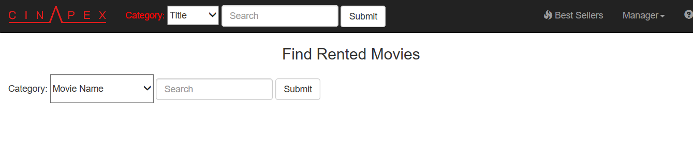

You can find a list of rented movies based on movie name, type, and customer name. This will generate a list of movies generated in that respective category.

4.9 Sales Report

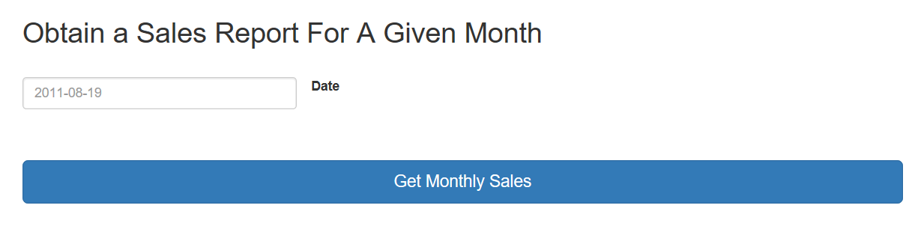

Enter in the date in the given format that the placeholder text specifies in order to get a sales report for that given month. This will generate a sum money that each user paid for that given month.

4.10 All Movie Listings

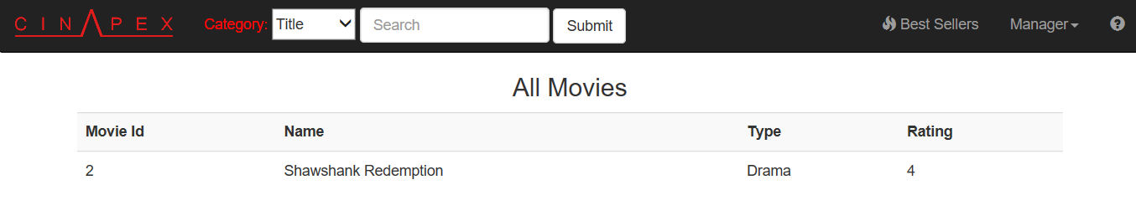

This will produce the listing for all movies. This listing includes movies with 0 copies as well as those with 1 or more copies currently available.

4.11 All Available Movie Listings

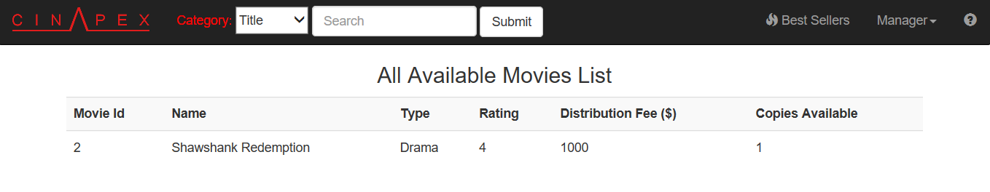

This will produce the listing for all available movies. Available are defined as movies with at least 1 or more copies.

4.12 Backup Database

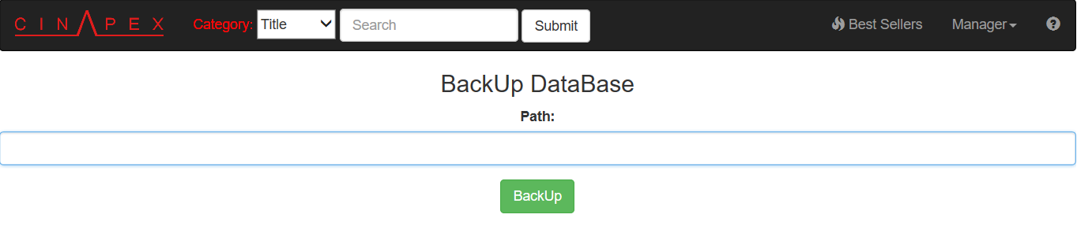

4.13 Logout

Clicking “Logout” will log you out of your account and take you back to the Login screen.