# Practicing using R Markdown by Johnson Amoah

## This is a markdown file

**Part 1**

data(cars)  
str(cars)

## 'data.frame': 50 obs. of 2 variables:  
## $ speed: num 4 4 7 7 8 9 10 10 10 11 ...  
## $ dist : num 2 10 4 22 16 10 18 26 34 17 ...

summary(cars)

## speed dist   
## Min. : 4.0 Min. : 2.00   
## 1st Qu.:12.0 1st Qu.: 26.00   
## Median :15.0 Median : 36.00   
## Mean :15.4 Mean : 42.98   
## 3rd Qu.:19.0 3rd Qu.: 56.00   
## Max. :25.0 Max. :120.00

plot(cars)

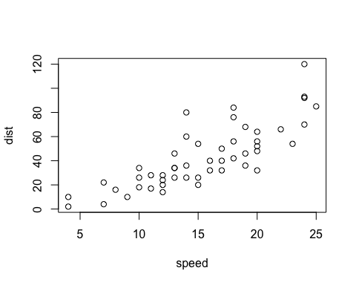

**Part 2**

hist(cars$speed)

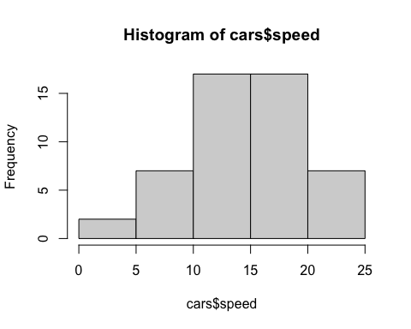

boxplot(cars$dist)

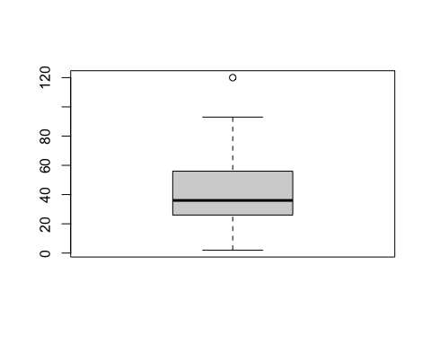

#The end