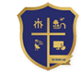**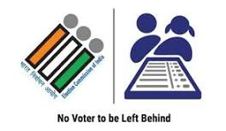Electoral Literacy Club**

**DON BOSCO COLLEGE (CO-ED)**

Guezou Nagar , Athanavur , Yelagiri Hills -635 683

**CIRCULAR**

Join Us in Celebrating International Day of Democracy

"Empowering the Next Generation"

The Electoral Literacy Club is excited to announce the upcoming celebration of the International Day of Democracy on September 15th, 2023. This year, our theme will be "**Empowering the Next Generation**," underlining the pivotal role that young people like you will play in advancing democracy and ensuring that your voices will be integrated into decisions that will significantly shape your world.

To make this day even more engaging and meaningful, we will be organizing two exciting activities for you to participate in:

**1. Flash Mob:**

Date: September 15th, 2023

Time: 11:20AM to 11:35AM

Venue: In-front of Jubilee Hall

Activities: Speech, Mime, Dance

**2. Democracy Rally:**

Date: September 15th, 2023

Time: 04:00PM to 05:00PM

Rout Point: DBCY Gate - Boat House

We will encourage all students to participate in these activities and help us make a powerful statement about the importance of empowering the next generation in the democratic process.

**President Animator Coordinator Principal**