Contents

**I.** **Introduction** 2

1. Purpose: 2

2. Team member 2

3. Planning 2

**II.** **Analysis Requirement** 3

1. Functionalities Analysis 3

2. Database Analysis 3

3. Use-Case 4

**III.** Method Development 4

1. What is ***Scrum***? 4

2. How to do ***Scrum***? 4

2.1. Role 4

2.2. Meeting 5

2.3. Artifact : 6

**IV.** **Result** 6

1. Completed tasks 6

2. Remaining tasks 6

**V.** **Conclusion** 7

1. Good point 7

2. Weak point 7

3. Problem 7

4. Perspective 7

1. **Introduction**
2. Purpose:

Being year five student, we have to do many projects. Especially, in this final year we are asked to do a project called project at the end of study by grouping of four of student. After we made group, we decided to create a project named ***Real Estate.***

***Real Estate***, web application,was decided to create in order to facilitate to find something such as rent house or room .etc. Because of this web application consist information of house such as address and owner’s contact. So; we can get that information easily.

1. Team member

For doing this project we are asked to make a group of four students. Here is my team member:

* Ann Liratanak
* Chhon Tonglin
* Chhorn Nypisit
* Som Chanpiset

1. Planning

Before project is established, we have to make plan in order to control what we are going to do and which process we are in.

|  |  |  |  |  |  |  |  |  |  |  |
| --- | --- | --- | --- | --- | --- | --- | --- | --- | --- | --- |
| Task | Week | | | | | | | | | |
| 1 | 2 | 3 | 4 | 5 | 6 | 7 | 8 | 9 | 10 |
| Analysis Requirement |  |  |  |  |  |  |  |  |  |  |
| Design Database |  |  |  |  |  |  |  |  |  |  |
| Implementation |  |  |  |  |  |  |  |  |  |  |
| Test |  |  |  |  |  |  |  |  |  |  |

1. **Analysis Requirement**
2. Functionalities Analysis

***Real Estate*** is established arming much functionality:

* View all houses
* View one house detail
* Search house (all key work related to house attribute)
* Show result
* Create owner profile
* Update owner profile
* Delete owner profile
* View owner profile
* Create house
* Update house
* Deleted house
* Vote house
* Comment
* Allow user authorities

1. Database Analysis

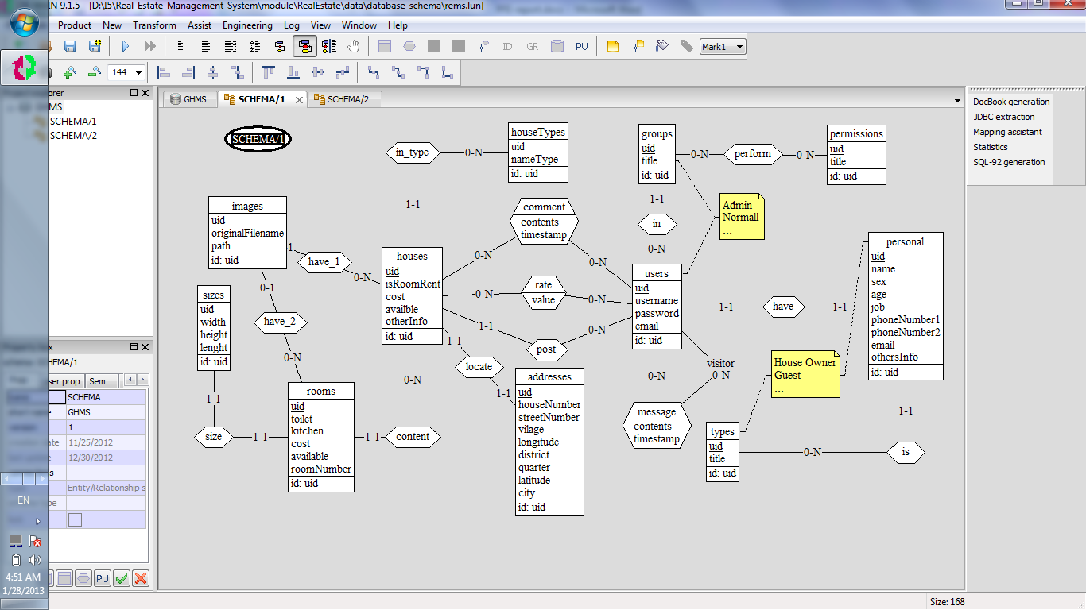

1. Authorities Table

|  |  |  |  |
| --- | --- | --- | --- |
|  | ***Users*** | | |
| *Functionalities* | Admin | Owner | Visitor |
| Allow user’s authority | **√** |  |  |
| Search house | **√** | **√** | **√** |
| Show result | **√** | **√** | **√** |
| View all house |  |  |  |
| View one house detail |  |  |  |
| Create house |  |  |  |
| Update house |  |  |  |
| Delete house |  |  |  |
| Create owner profile |  |  |  |
| Update owner profile |  |  |  |
| Delete owner profile |  |  |  |
| View owner profile |  |  |  |
| Vote house |  |  |  |
| Comment |  |  |  |

1. **Method Development**

My team is able to produce significantly better and faster project because of ***Scrum.*** In this section I will briefly describe about it.

1. What is ***Scrum***?

***Scrum*** is an iterative and incremental *agile software development* framework for managing software project and application development. It is a type of software engineering.

1. How to do ***Scrum***?
   1. Role

* Product Owner: The Product Owner represents the stakeholders and is the voice of the customer. He or she is accountable for ensuring that the team delivers value to the business. The Product Owner writes customer-centric items prioritizes them, and adds them to the product backlog.

For my project Mr. Tal Tongsreng, project supervisor, is product owner.

* ScrumMaster:  Scrum is facilitated by a ScrumMaster, who is accountable for removing impediments to the ability of the team to deliver the sprint goal/deliverables.  The ScrumMaster that the team is fully functional and productive

Ann Liratanak is ScrumMaster.

* The Team: A group is made up of 4-9 people with cross-function skills. They do actual work (analyse, design, test, program, etc.). The Development Team in Scrum is self-organizing, even though they may interface with project management organizations

My team consist 4 people they are:

- Ann Liratanak  
 - Chhon Tongling  
 - Chhorn Nypisit  
 - Som Chanpiset

* 1. Meeting
* Spring Plan:

At the beginning of the sprint cycle, a “Sprint planning meeting” is held.

* Select what work is to be done
* Prepare the Sprint Backlog those details the time it will take to do that work, with the entire team.
* Identify and communicate how much of the work is likely to be done during the current sprint.
* Eight-hour time limit
* Daily Scrum : is a daily 10-15 minutes meeting. Is not for solve the problem and only the ScrumMaster, product owner and team member can talk.

In my team we always do daily 10-minutes-meeting in the evening. Our team members are asked to join. Moreover, during meeting we asked the three questions.

+ What did you do yesterday?

+ What will you do today?

+ Is anything in your way?

* Sprint review :
* Review the work that was completed and not completed
* Present the completed work to the stakeholders (a.k.a. “the demo”)
* Incomplete work cannot be demonstrated
* Four-hour time limit
* Sprint retrospective :
* All team members reflect on the past sprint
* Make continuous process improvements
* Two main questions are asked in the sprint retrospective: What went well during the sprint? What could be improved in the next sprint?
* Three-hour time limit
* This meeting is facilitated by the Scrum Master
  1. Artifact :
* Product backlog : is an ordered list of "requirements" that is maintained for a product. It contains Product Backlog Items that are ordered by the Product Owner based on considerations like risk, business value, dependencies, date needed, etc. The features added to the backlog are commonly written in story format (See terminology below). The product backlog is the “What” that will be built, sorted in the relative order it should be built in
* Sprit backlog : is the list of work the Development Team must address during the next sprint. The list is derived by selecting stories/features from the top of the product backlog until the Development Team feels it has enough work to fill the sprint. This is done by the Development Team asking "Can we also do this?" and adding stories/features to the sprint backlog. The Development Team should keep in mind the velocity of its previous Sprints (total story points completed from each of the last sprints stories) when selecting stories/features for the new sprint, and use this number as a guide line of how much "effort" they can complete.

1. **Result**
2. Completed tasks

* Comment
* Allow user authority
* View all house
* View house detail
* Create owner profile
* Update owner profile
* Delete owner profile
* View owner profile
* Create house
* Delete house
* Update house

1. Remaining tasks

* Search
* Show result
* Vote house

1. **Conclusion**
2. Good point

* Security
* Performance
* Extensible
* Dynamic content
* Robust

1. Weak point

* Dependency to others projects and plugins

1. Problem

During the development of project, it is inevitable for us to meet some difficulties such as:

* Not enough time
* Learning new framework

1. Perspective

Due to the time limitation, we have implemented only the main functionalities for the development of the application. These functionalities are not sufficient to develop the project. Consequently, we will

* Improve application performance
* Finish the remaining functionality