**Blue = To Do**

**Green = Done**

**Purple = Important Notes**

**Thursday 3rd September**

* Meeting with Kunal
  + DC blocker code for RLS

**Friday 4th September**

* Smart Helmet -Wearable Multichannel ECG and EEG
  + Research on Matched Filtering and QRS complex
    - “Wave digital matched filter for ECG preprocessing”
  + Neural networks for adaptive matched filtering
    - “Neural-network-based adaptive matched filtering for QRS detection”
  + Real-Time matched filtering
    - QRS detection by template matching using real-time correlation on a microcomputer”
* Setting up RLS algorithm code

**Saturday 5th September**

* Rest day

**Sunday 6th September**

* Read Papers
  + “Wave digital matched filter for ECG preprocessing”
  + “Neural-network-based adaptive matched filtering for QRS detection”
  + “QRS detection by template matching using real-time correlation on a microcomputer”

**Monday 7th September**

* RLS Code
  + Main block
* MIT Data
  + Able to read on matlab
  + Convert data for reading on Python

**Tuesday 8th September**

* Read papers
  + Adaptive noise cancelling of motion artifact in stress ECG signals using accelerometer
    - Compared LMS and RLS algorithm. Implemented on MATLAB’s built-in functions. Results show RLS works better than LMS
* Set up Google Colab with Kunal

**Wednesday 9th September**

* MIT Data
  + Converted to csv.
  + Data looks promising. Accelerometer data links closely with PPG motion artifacts. Especially y-axis.

**Thursday 10th September**

* Ask for paper:
  + “Acceleration driven adaptive filter to remove motion artifact from EMG recordings in Whole Body Vibration”
* Paper to read:
  + Application of multivariate empirical mode decomposition and canonical correlation analysis for EEG motion artifact removal
  + Adaptive interference canceler for EEG movement and eye artifacts
    - RLS and LMS mentioned (with RLS being more fast and accurate but LMS and EWRLS (exponentially weighted RLS) is much simpler to implement)
  + Movement Artifact Detection from Electroencephalogram Utilizing Accelerometer
    - Contains matlab source code
    - Mainly motion artifact **detection**
  + Accelerometer-based method for correcting signal baseline changes caused by motion artifacts in medical near-infrared spectroscopy
  + Model- based filtering for artifact and noise suppression with state

estimation for electrodermal activity measurements in real time

* + Kalman filtering of accelerometer and electromyography (EMG) data in

pathological tremor sensing system

* + - Irrelevant
  + Comparison of Motion Artefact Reduction Methods and the Implementation of Adaptive Motion Artefact Reduction in Wearable Electrocardiogram Monitoring
    - Proves that adaptive filters(RLS used in this one) are good for removing motion artifact in ECG
    - Data used was also gathered from MIT

Friday 11th September

* Algorithms Proposal
  + EEG - Adaptive Filter
  + PPG - Adaptive Filter
  + ECG - Adaptive Filter
  + GSR/EDA - TBA
  + EMG - couldnt find much
  + EOG?
* Adaptive Filters - RLS, LMS, X-LMS, EWRLS
* Papers to read:
  + Empatica E3 — A wearable wireless multi-sensor device for real-time computerized biofeedback and data acquisition
* <https://www.empatica.com/en-int/research/e4/>
  + Interesting?

**Monday 14th September**

* How to compare results
  + “Wavelet-Based Motion Artifact Removal for Electrodermal Activity”
    - Artifact power attenuation
    - Normalized mean squared error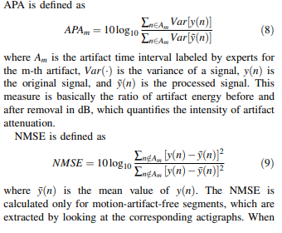
  + “A Data Driven Empirical Iterative Algorithm for GSR Signal Pre-processing”
    - SNR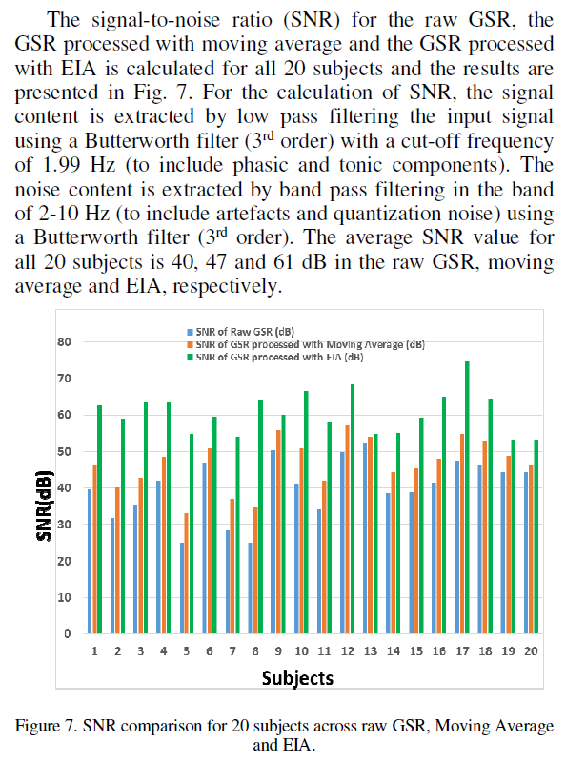
  + “Adaptive interference canceler for EEG movement and eye artifacts”
    - Minimizing norm of e(n) is equivalent to maximising SNR (for EWRLS)
  + “Adaptive Motion Artifacts Reduction Using 3-axis Accelerometer in E-textile ECG Measurement System”
    - Uses Ag/AgCl electrode for reference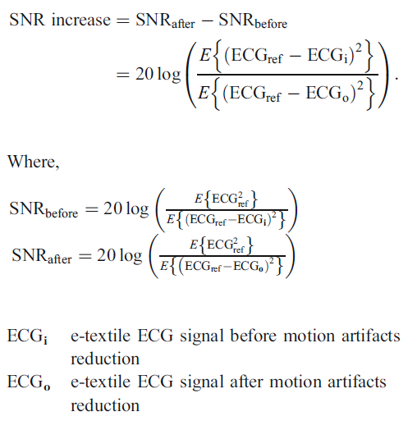
  + “An-implementation-of-motion-artifacts-elimination-for-ppg-signal-2017”
    - Bland-Altman agreement analysis
    - Correlation coefficient analysis
      * Compares HR derived from PPG to ECG
  + “Improved elimination of motion artifacts from a ppg signal using a kalman smoother”
    - Uses artificial motion artifacts to resting state data with different SNR to test between algorithms (gaussian white noise + sine)
  + “Model- based filtering for artifact and noise suppression with state estimation for EDA activity measurements in real time”
    - More artificial motion artifacts (gaussian white noise + single point noise
  + “Motion Artifact Reduction from PPG Signals During Intense Exercise Using Filtered X LMS”
    - ECG used as ground truth for HR

Tuesday 15th September

* Summary for how results are compared
  + For PPG, the heart rate measured by ECG was used as ground truth.
  + When using SNR, resting data was recorded and used as reference while adding artificial noise
  + For artifact detection, manually label artifacts (valid?)
* EDA/GSR algorithms
  + “Driver’s Stress Detection using Skin Potential Response Signals”
    - Not GSR but similar?
    - Compares RLS/LMS/Kalman adaptive filters
    - Uses steering wheel as ref instead
  + EIA
  + Wavelet Transform

16th -28th September

* EDA explorer + EDA Artifact Detection Machine Learning

30th September

* More EDA research
  + Efficient wavelet based artifact removal for electrodermal activity in real world applications
  + <https://3250199c-a-62cb3a1a-s-sites.googlegroups.com/site/kevinshuaixu/ISWC_2017_EDA_Artifacts.pdf?attachauth=ANoY7craSY02qhesUMBS9YHHhYwnJ8jhTB7oKBvW6HgpEI4hQMpkkm4uvLeIFeOX0lALOBQIgZ5q637GBp_9tVp9VlwGBpoLOiVKjeLzwfnvOceK0P0pUeBSWZC5-IjThpKpNRlQi_q3xAioaGGt4ew7nwJYieVKM_32isi0aWhRoKh1yDBf3PEECabdac7odKUdcaIun_KQaujHVl1d4FOqER9PlK58DObhHVvp91PyhvV_kMaAP5I%3D&attredirects=0>
  + Concluded that GSR is not impacted much by motion artifacts (or at least the data from accelerometer)
  + Wavelet transform using Laplace distribution to remove artifacts

1st October

* More Artifact Detection Testing
  + Made changes to some parameters(e.g no. of folds) to look at differences
  + Turn results into something more visually appealing
  + Gather more data for easy artifact labelling?