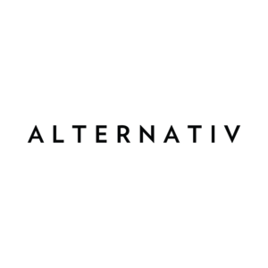
100ml/$25.00 – 00, 03, 06mg

Alpha
Grape and apple candy menthol

Beta
Green apple and peach candy menthol

Iota
Mango and peach gummy candy menthol

Omega
Strawberry pineapple lemonade candy menthol

