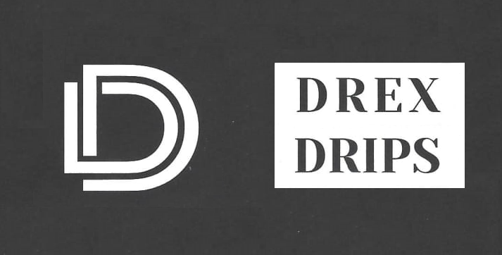

60ml/$20.00 – 00 | 03 | 06 | 12mg

No Filter
Apple pie infused with Vanilla Bean Ice Cream.

That Ish
A fluffy banana cream cookie with a hint of caramel.

