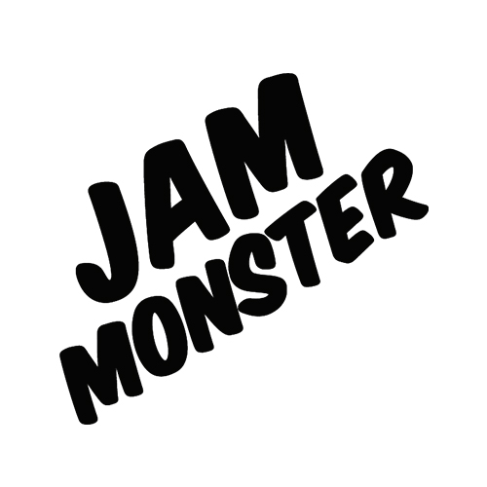
100ml/$25.00 – 00 | 03 | 06mg

Blackberry
50% Blackberry jam, 25% butter, 25% toast.

Blueberry
50% Blueberry jam, 25% butter, 25% toast.

Raspberry
50% Raspberry jam, 25% butter, 25% toast.

100% amazing.

