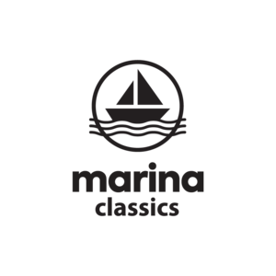
60ml/$20.00 – 00, 03, 06mg

Kronuts
Glazed croissant-doughnut + a glass of milk

Strawberry
Delicious strawberry doughnut + a glass of milk

Fruity
Fruity cereal doughnut + a glass of milk

Strawberry Marshmallow
Delicious Strawberries + marshmallow

