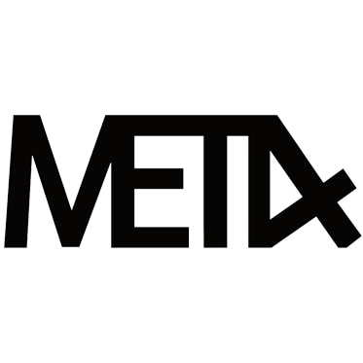
60ml/$25.00 – 00, 03, 06mg

Golden Ticket
Rich, creamy, chocolate milk, as accurate as they come. Some boxes may0 contain a golden ticket.

Strawberry Milk
Sweet strawberry with a touch of creamy milk.

Fairgrounds Deep Fried Cream Cake
A tasty reiteration of a fluffy yellow sponge cake topped with a dollop of light whipped cream deep fried to a golden finish

