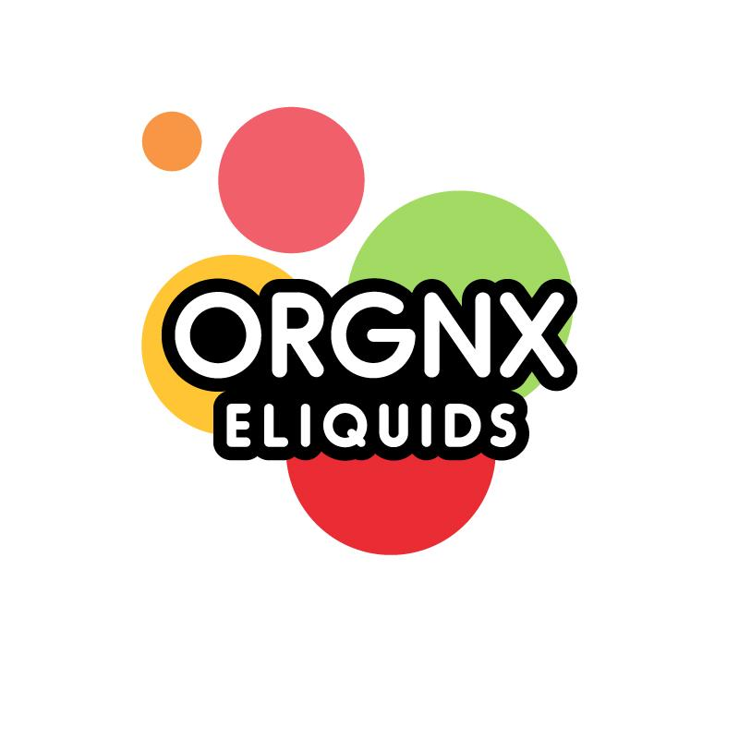

60ml/$18.00 – 00, 03, 06mg

Apple
The red one.
Orange
Rhymes with door hinge.

Peach
Did you hear the joke about the peach? It was pit-iful.

Honeydew
The green one.

Lychee
Citrus with rose water, kind of like a white grape?

