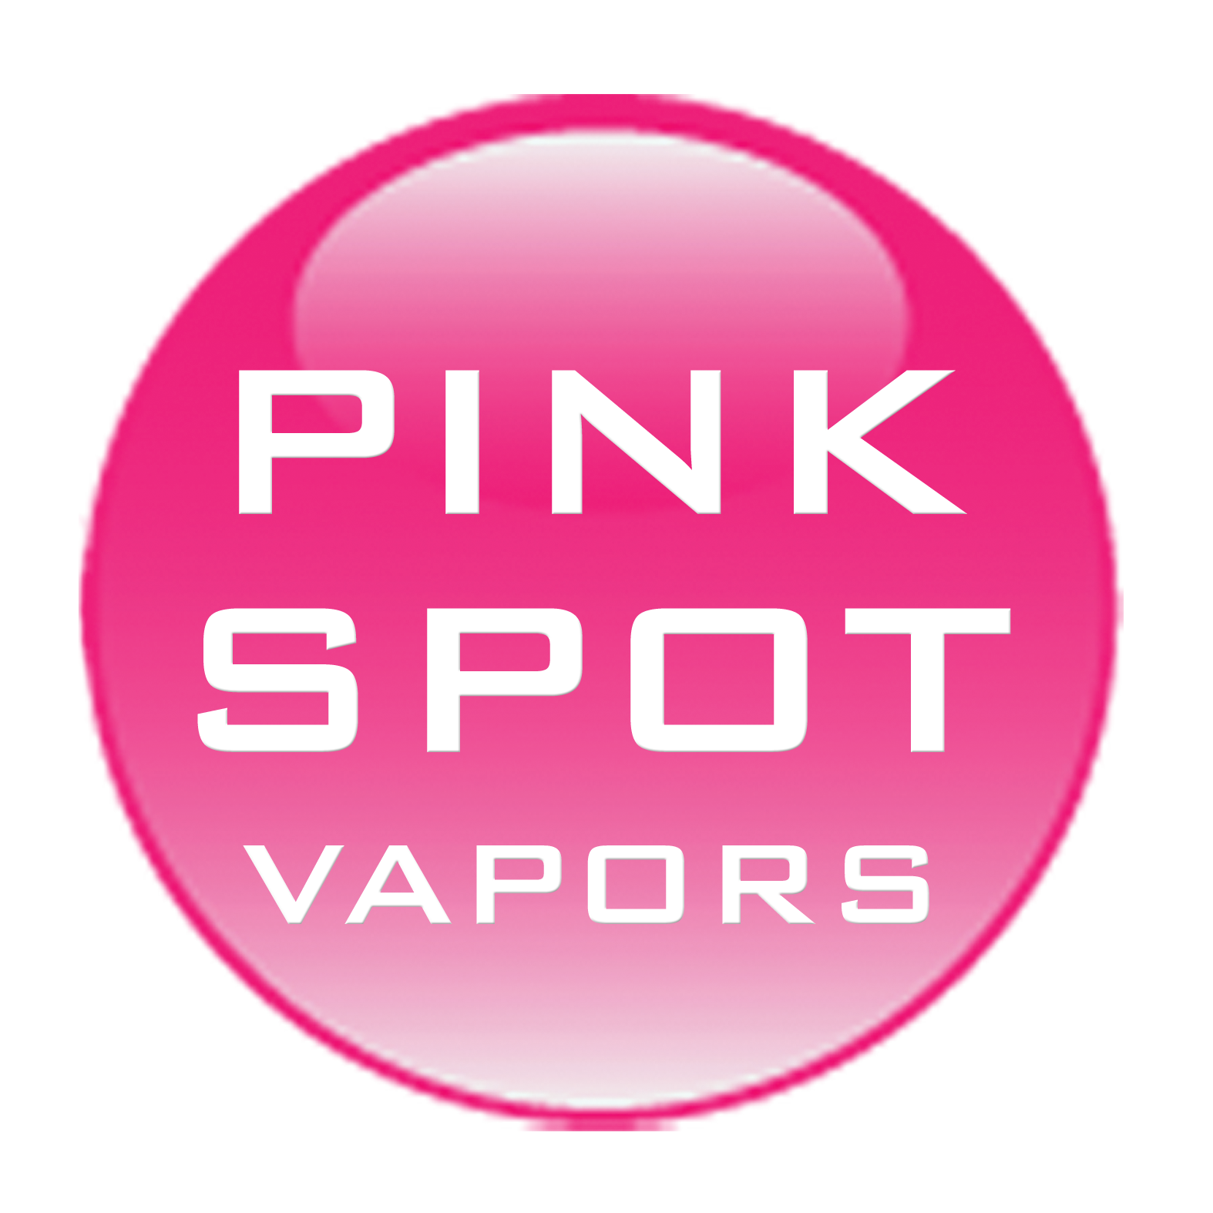

30ml/$12 – 00 | 03 | 06 | 12 | 18mg

Butterscotch
Sweet and delicious Butterscotch is the answer to your savory craving

Caramel
Perfectly creamy caramel in the smoothest vapor form

Cinnamon
A bold and powerful cinnamon punch

Fresh Strawberry
Fresh Strawberry gourmet e-Liquid will tantalize your taste buds

Honey Cured Tobacco
An all-American smoky tobacco with just a touch of real honey

Juicy Watermelon
A delicious, fruity flavor that is just as advertised. A sweet, juicy summertime favorite

Menthol
A menthol that is cool, crisp, and refreshing

Outlaw (555)
A smooth, classic tobacco flavor with a nutty undertone

30ml/$12 – 00 | 03 | 06 | 12 | 18mg

Peppermint Stick
Santa Claus himself requested this sweet, minty treat

Snowman’s Kiss
Cool peppermint layered with crisp menthol will chill your senses

Sub Zero
A unique menthol inspired tobacco flavor with a crisp minty undertone

Swagger
The smoothest and most flavorful tobacco based flavor

The Pink Spot
a tempting fusion of raspberry, pineapple, and citrus

Tobacco
Classic all-American tobacco

Washington Red Apple
An amazing apple cocktail inspired e-Juice flavor

Wild Blueberry
Freshly picked tangy and sweet blueberries

French Vanilla
A simple, plain, creamy french vanilla.

