  60ml/$21.99 – 00 | 03 | 06mg  Pink & Blue  Mix of sweet blended blue and pink cotton candy. |   100ml/$25.00 – 00 | 03 | 06mg  Yellow100  One part peanut butter; two parts whipped Cream. Three parts delicious.
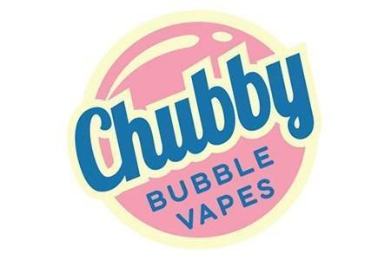  60ml/$20.00 – 00 | 03 | 06mg  Bubble Razz  Sweet blue raspberries infused with a chewy bubble gum finish. |   60ml/$20.00 – 00 | 03 | 06mg  Mystic Magic  This paranormal vapor that tastes like ripe mangoes, sweet tangerine and fresh raspberries.

