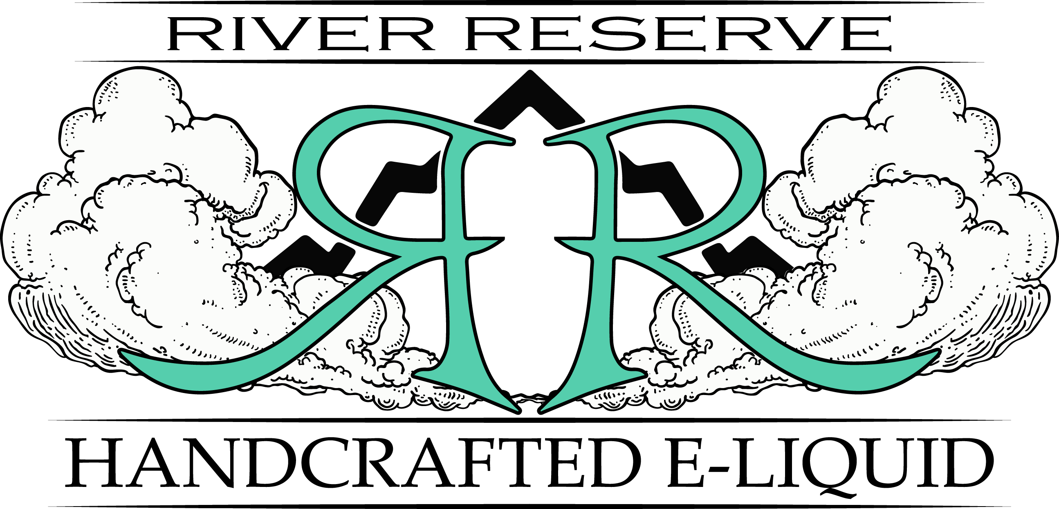
60ml/$19.99 – 00, 03, 06, 12, 18mg

Acid Worm
Fruity gummy worm
Bandit
Blackberry Custard Tobacco
Blackberry Waffle Cone
Delicious Blackberry ice cream in a warm waffle cone
Blue Island punch
Blue Raspberry Fruit Punch
Caramel Cove
Smooth caramel mixed with marshmallow and hazelnut
Castaway
Coconut, mango, and watermelon
Drifter
Fresh yogurt combined with sweet blueberries
Drifter X
Classic drifter with blackberries instead of blueberries
Eddy
A clash of mango, pomegranate lemonade
Great Wall
Complex blend of graham cracker, coconut and bourbon
Island Punch
A classic sweet and tangy fruit punch drink
Lemon Drifter
River’s signature yogurt blend with lemons
Midori Sour
Honeydew nectar, with lemon-lime and cherry
Northwest
A classic tobacco with caramel and hazelnut finish
60ml/$19.99 – 00, 03, 06, 12, 18mg

Old Wolf
Old Fashioned Root Beer
PBG
Peanut butter, banana, and graham cracker
Raspberry Crumble
Raspberries and vanilla ice cream and a cookie crumble topping
Raspberry Lemon Italian Ice
Juicy raspberries and tart lemons blended together.
River Colada
Fresh island coconut with sweet, tangy pineapple and rum.
Strawberry Drifter
River’s signature yogurt blended with strawberries
Strawberry Waffle Cone
Fresh strawberry ice cream in a warm waffle cone
Strawnana Drifter
River’s signature yogurt blended with strawberries and banana.
Swamp Mama
Delightfully smooth strawberry custard
Tiger’s Blood
River’s take on a classic strawberry and coconut
Vanilla Bandit
Vanilla custard infused with a malty air cured tobacco.
Vanilla Graham
Taste of vanilla wafers fused with crispy graham crackers
Vanilla Waffle Cone
Fresh baked waffle cone with Vanilla ice cream.
Wiki
An exotic blend of tart tropical fruits

