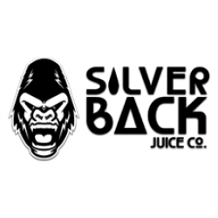
120ml/$25.00 – 00 | 03 | 06mg

BooBoo
A delicious blend of grape extract, with a kick of hand picked blueberries

Jenny
Feel Refreshed with the cool taste of minty watermelon bubblegum and a tangy strawberry candy shell

Lola
Feel exotic with the taste of ripe strawberries with notes of banana and tropical dragon fruit extract

