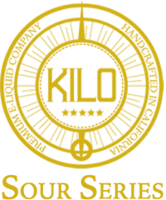
100ml/$25.00 – 00, 03, 06mg

Blue Raspberry Sours
Blue Raspberry Sours offers a sweet blue raspberry & sugary tartness taste.

Green Apple Sours
Green Apple Sours offers a long strip of chewy green apple goodness. The flavor is potent with the bite of a tart granny smith apple coated with sweet and sour sugar

Strawberry Sours
Strawberry Sour Straws packs juicy sweet strawberry into sour straw candy. First sour, then sweet

Watermelon Sours
Watermelon Sour hits the mark with this rendition of sour straw inspired vape juice. The fruity watermelon flavor is coated with subtle sour notes that sweeten as you exhale

