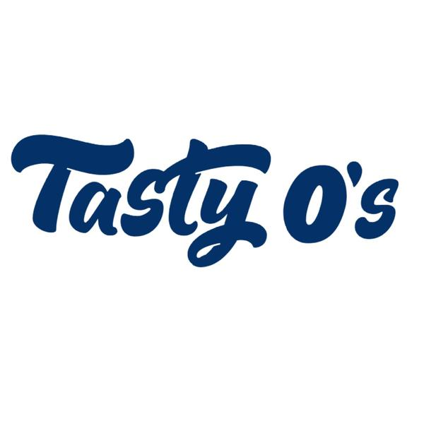

100ml/$25.00 – 00, 03, 06mg

Banana Nut O’s
Banana flavored cereal hoops with chopped up nuts that are covered in a fine dusting of powdered sugar

Berry O’s
Sweet hoops of berry flavored cereal with plenty of powdered sugar sprinkled on top

Frosted O’s
An irresistible taste of honey grain oats coated in sweet powdered sugar

-
.1

