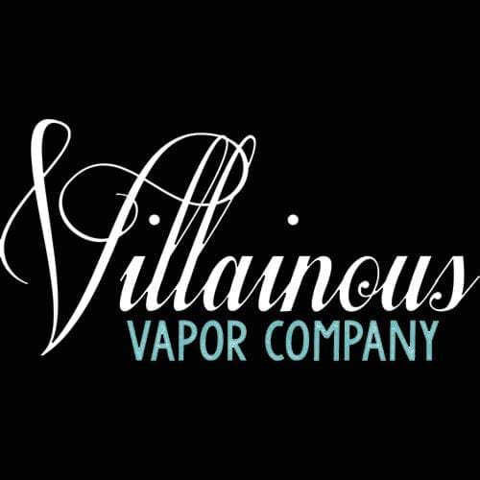

60ml/$25.00 – 00, 03, 06mg – 80/20

Kentucky Sin
This delectable flavor finds its roots from the rolling hills of Kentucky. This creamy vanilla bourbon sweet leaf pairs nicely with your next bootleg run to your local speakeasy.

Wicked Red
Wicked Red by Villainous Vapor Co. is a Watermelon Citrus vape! Experience that rush of crisp citrus flavor mixed with a note of sweet ripe watermelon. It's so good, it's almost wicked.

