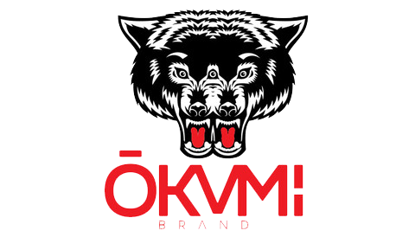
$18.00/30ml – 50mg

Sour Menace
A sour green apple bubble gum

O.G. Bubba
Sweet watermelon with iconic pink bubble gum

Blu Rza
Sweet blue raspberry slushy bursting with flavor

Dolce & Guava
Juicy mango coupled with sweet pink guava

