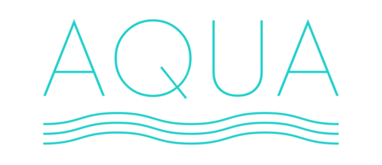
$20.00/30ml – 35mg & 50mg

Flow
A combination of pineapple, sweet guava, and juicy mango flavors.

Mist
A crisp green apple, tangy peach, and sweet kiwi blend.

Oasis
A refreshing blend of peaches, papaya, and cantaloupe.

Pure
A combination of sweet strawberries, crisp red apples, and cool watermelon slices.

Blue Razz
A tart, yet sweet blue raspberry candy.

Rainbow Drops
Strawberry, orange, lemon, green apple, blue raspberry, and grape. Vape the rainbow!

Sour Melon
A sweet and sour candied watermelon.

