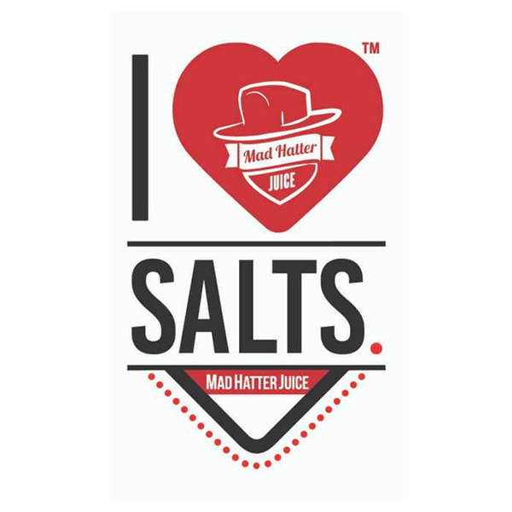
30ml/$20.00 – 25mg & 50mg

Grapleberry
Presenting a sensational combination of blueberry, apple, and grape for a luscious burst of fruity flavors

Island Squeeze
The ultimate nicotine salt blend featuring a blast of tropical guavas followed by a healthy mix of vine-ripened strawberries and exotic kiwi’s

Luau Lemonade
Borrowing the essence of tart pineapples and combining it with a splash of refreshing watermelons for a revitalizing juice that will awaken the senses

Tropic Mango
An intense mango flavor that tastes exactly like the real thing. Every hit provides your taste buds with an escape to paradise

