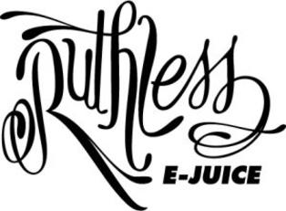

$20.00/30ml – 35mg

Antidote on Ice
Mango, Blue Raspberry, and Menthol

Ez Duz It
Strawberry and Watermelon

Ez Duz It on Ice
Strawberry and Watermelon with Menthol

Grape Drank
Grape soda
Skir Skirrr On Ice
Apple, Honeydew Melon, Menthol

Strizzy
Raspberry, Kiwi, Strawberry

Swamp Thang
A delicious burst of sour candied apples

Tropic Thunda
Guava and Berries

