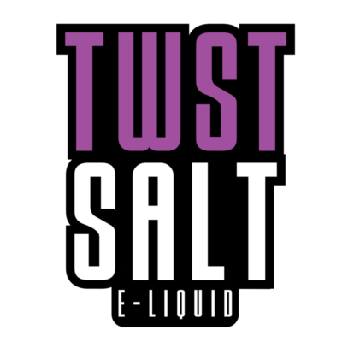
30ml/$15.00 – 50mg

Honeydew Melon Chew
A complimentary mix of sweet melon and honeydew candy blended to perfection.

Watermelon Madness
A juicy watermelon dessert blend.

Pink Punch Lemonade
A sweet mix of raspberries and lemonade for a refreshing blend. Also available in menthol.

